# A Parametric Investigation of the Effects of Curvature and Skew on a Box Type Bridge

# Vineet Kumar Singh1, Jyoti Yadav2

# 1M.Tech Scholar, Dept. Of Civil Engineering, Sarvepalli Radhakrishnan University, Bhopal, M.P, India

# 2Assistant Professor, Dept. Of Civil Engineering, Sarvepalli Radhakrishnan University, Bhopal, M.P, India

# Abstract – For the objective of the parametric research, six box girder bridge models were created with variable curvature and constant span length. Additionally, five models were created with variable skew angle, and thirty models were created for combined effect. An example of a box Girder Bridge is chosen from the available literature so that a validation study may be carried out on it. This is done in order to validate the finite element modelling approach. After modelling and analysing the example box girder in SAP 2000, it was discovered that the replies fairly matched the findings that were provided in the relevant literature. In order to carry out the parametric investigation, SAP2000 representations of all forty-two box girder bridges were created. The length of the span, the cross-section, as well as the material quality, have not altered. The only parameters that are subject to modify are the skew angle and the radius of curvature. The single cell box makes up the box girder bridge's superstructure, which can be seen in the cross section of the bridge. The bridges' curvature only changes in a horizontal manner over their whole length. Every model is tested for both its own weight and the moving load that the vehicle will experience. A static analysis taking into account both dead load and moving load in addition to a modal analysis is carried out. Recordings are made of the longitudinal stress at the top and bottom of the cross sections, as well as the bending moment, torsion, and deflection. When contrasted with the reactions of a straight bridge, the responses of a box girder bridge with a curved plan are examined.

# *Keywords-* Radius of curved bridge, skew angle, bending moment, longitudinal stress, deflection, torsion.

# 1. INTRODUCTION

# Roads are connected by bridges, which fill the gaps between any man-made or natural ground feature, such as a waterway, road, railway, or valley. A bridge is a building that carries moving goods across an obstruction such a waterway, road, railway, or valley while maintaining communication for both rail and vehicle traffic. Over Bridge allows a road, railroad, or pipeline to over an obstruction. Road, a railway, or a pipeline may travel under an obstruction under a bridge. To reroute traffic over the roads, a flyover is built above a bridge.

# As the necessity for intricate junctions and the issues with space limitations in urban areas expand, there is an increasing need for skewed bridges. Skewed bridges are helpful in locations where environmental impact is a concern as well as when changing the alignment of the road is neither practical nor cost-effective owing to the site's terrain. A skew crossing may be required if a road alignment crosses a river or other impediment at an angle other than 90 degrees. A skew bridge requires substantially more study and design work than a right bridge. In instances like intricate interchanges or river crossings, where geometric limits and the limitations of a small site area make the adoption of a normal straight superstructure very challenging, horizontally curved bridges are more demanding than straight bridges. Finite element analysis is particularly helpful for curved and skew bridge analysis, however it is a more difficult approach. Therefore, the designer should come up with a more straightforward solution to the issue.

# 2. PROBLEM DESCRIPTION

# In the current effort, a straight bridge is thought to have a trapezoidal cross section with a constant span length of 50 meters. Only take into account the bridge's own weight plus the super dead load and moving load when analyzing class 70 R tracked vehicles. The material for bridges is concrete. In the table, sectional and material properties are discussed. For all bridge models, the Span length, Load, Material Property, and Cross Section stay the same. Bending moment, torsion, time period, and longitudinal stress at top of center are the outcomes of the analytical model.

# 3. ANALYSIS & METHODOLOGY

# Super dead load calculation is given below:

# Railing weight Wearing coat weight

# Height of railing = 1m. Weight of wearing coat = 22 KN/m3.

# Width of railing = 0.25m. Thickness of wearing coat = 0.075m.

# Length of railing = 1.47m. Total area load = 22*0.75 = 1.65 KN/m2. Total load = 25*0.25*1.47*1 = 9.2 KN.

|  |  |  |  |  |
| --- | --- | --- | --- | --- |
| **Material property** | |  | **Sectional property** | |
| Weight per unit volume = | 25 KN/m3 | Length of span = | 50m |
| Young’s modulus (E) = | 32500 X 10^3 KN/m2 | Width of top flange = | 8.4m |
| Poisson’s ratio (µ) = | 0.15 | Depth of box girder = | 2.31m |
| Shear modulus (G) = | 1.413 X 10^7 KN/m2 | Thickness of top flange = | 0.38m |
| Coefficient of thermal expansion (A) = | 1.17 X 10^-5/°C | Width of web = | 0.38m |
| Specific compressive strength of concrete (Fc') = | 45 X 103 KN/m2 | Width of bottom flange = | 3.68m |
| Thickness of bottom flange = | 0.38m |

# Table 1: Materials and Section Properties of Bridge

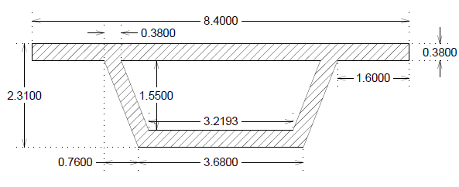

Fig. 1: cross section of bridge deck

# 4. EFFECT OF RADIUS ON CURVED BRIDGE

# The SAP2000 bridge module with shell components is used to create the straight and curved box girder models. Bridge Wizard's horizontal alignment is made curved by doing so. A single straight bridge with a 50m span is modelled. Models of six curved bridges of 200 m, 225 m, 250 m, 275 m, 300 m, and 350 m radiuses of curvature have been created. The cross section of the box girder is trapezoidal. For a 200m radius, the analytical model is notated as 50C200S90. Results for both curved and straight models should be considered. A graphical comparison of the outcomes for the straight bridge model and the all-curvature bridge model.

Fig 2: comparison of time period Fig. 3: comparison of deflection due to D.L. +S.D.L.

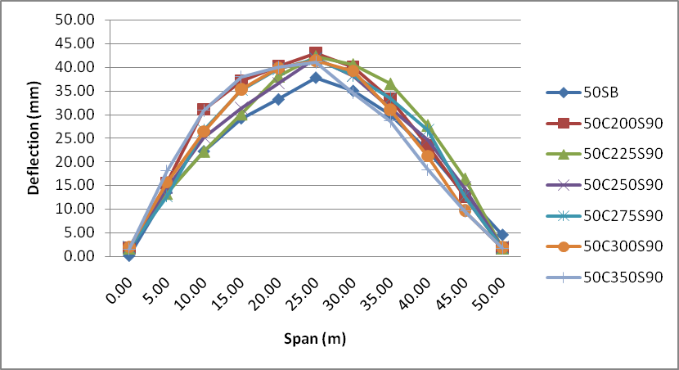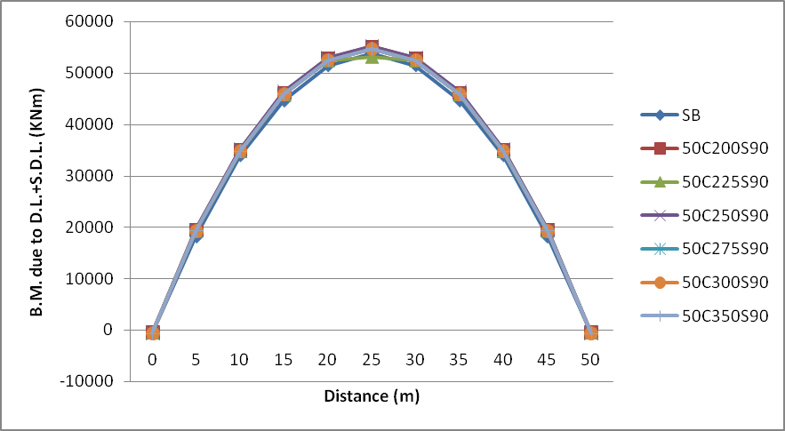

Fig. 4: comparison of deflection due to moving load Fig. 5: Comparison of B.M. due to D.L. +S.D.L.

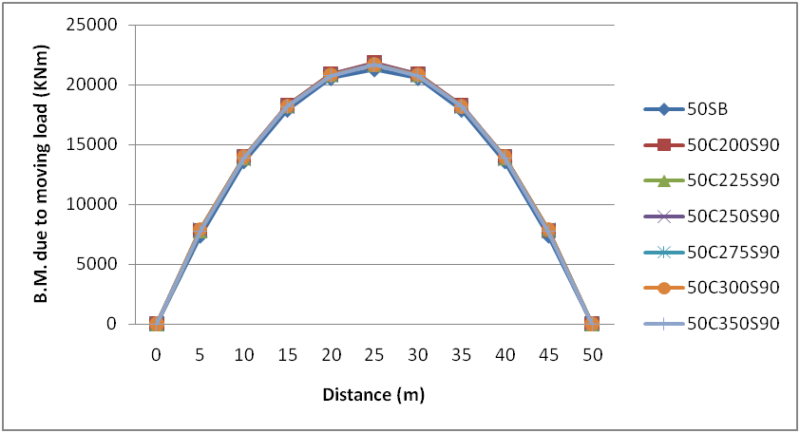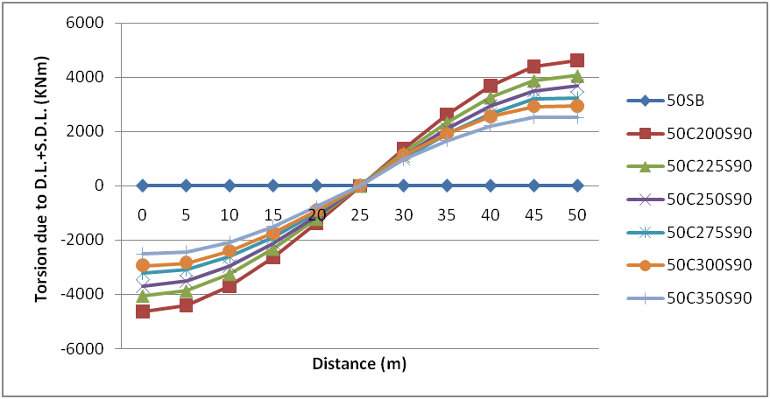

Fig. 6: Comparison of B.M. due to moving load Fig. 7: Comparison of torsion due to D.L. +S.D.L.

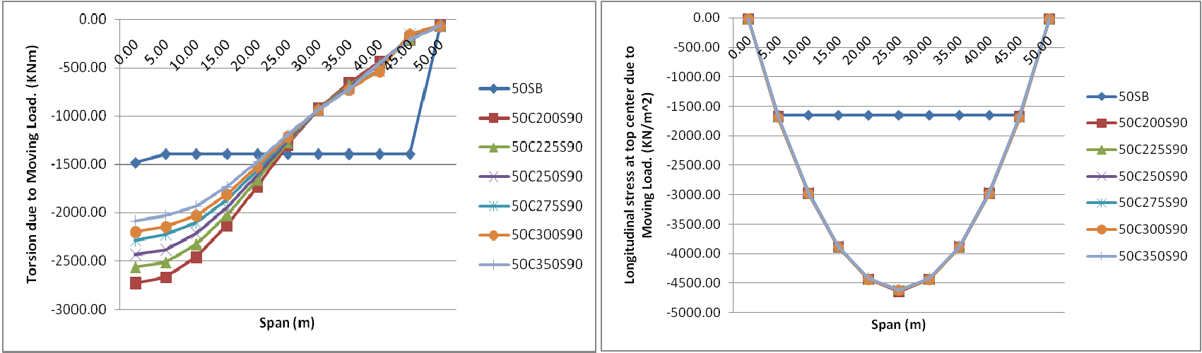

Fig. 8: Comparison of torsion due to moving load Fig. 9: Comparison of long. Stress at top center

# 5. EFFECT OF ANGLE ON SKEW BRIDGE

# Five skew bridges are modelled having radius infinite and angle 30°, 40°, 50°, 60° and 70°. The box girder has trapezoid cross section. Skew angle taken with respect to horizontal axis. Notation of analytical model is given like 50C∞S30 for 30° skew angle. Comparison of result for all skew bridge model for straight span in graphical form.

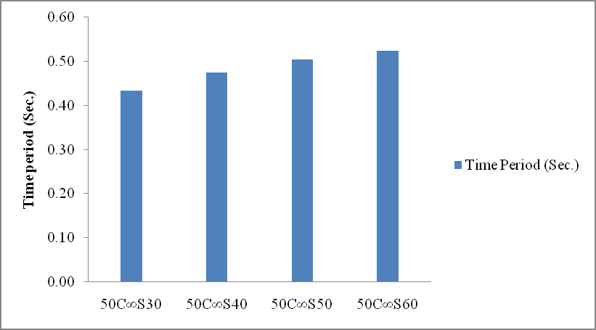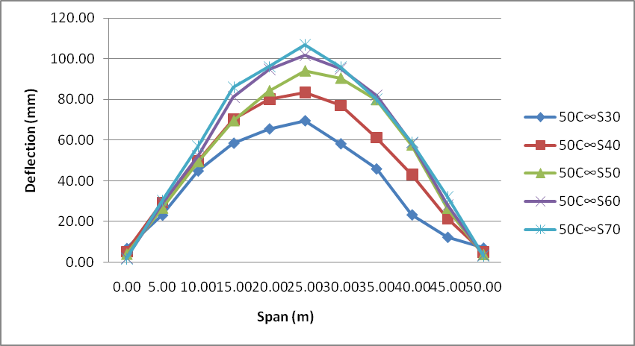

Fig. 10: comparison of time period Fig. 11: comparison of deflection due to D.L.+S.D.L.

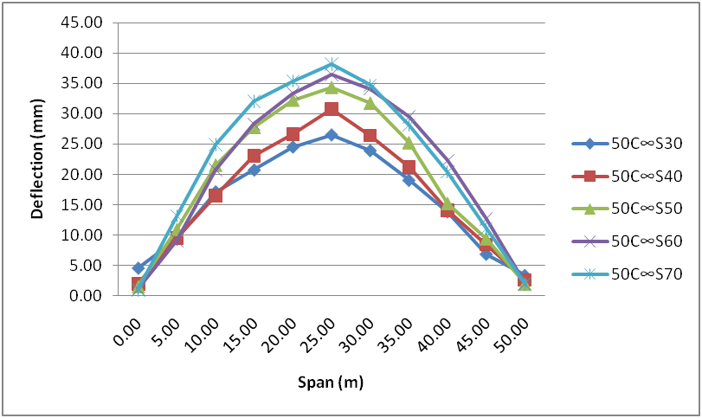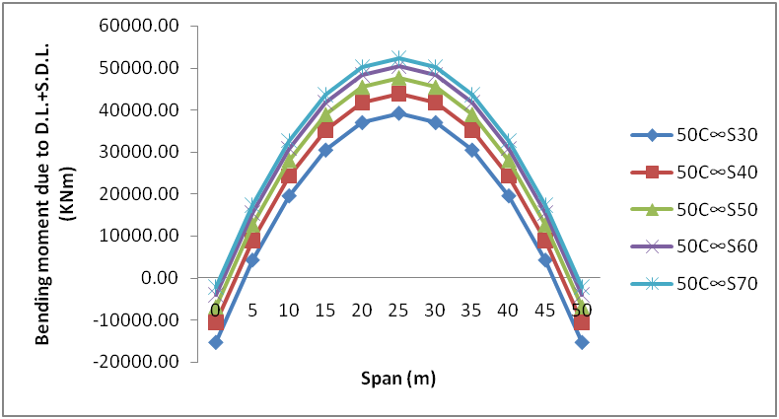

Fig. 12: comparison of deflection due to moving load Fig. 13: Comparison of B.M. due to D.L.+S.D.L.

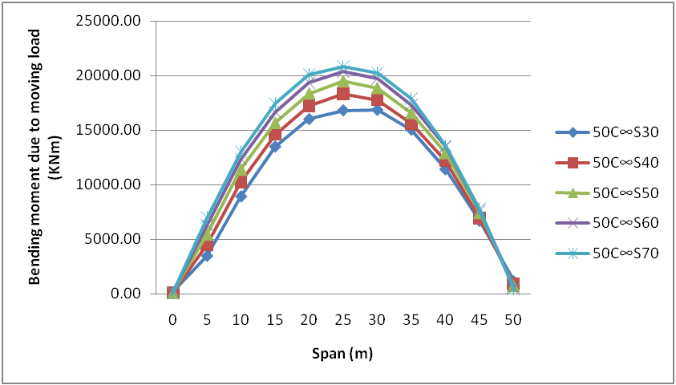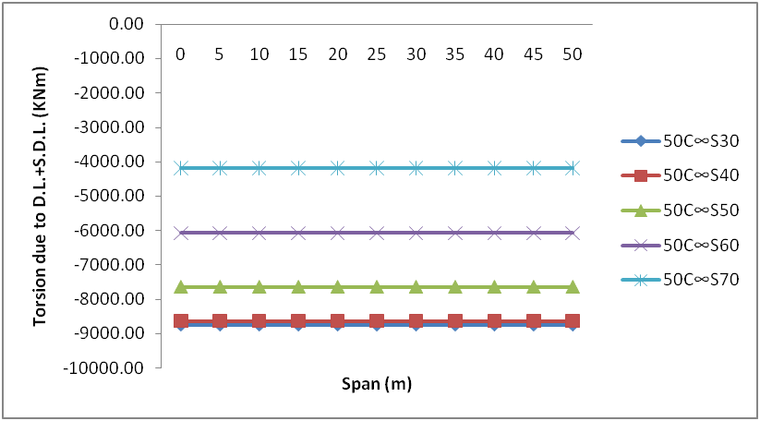

Fig. 14: Comparison of B.M. due to moving load Fig. 15: Comparison of torsion due to D.L. +S.D.L.

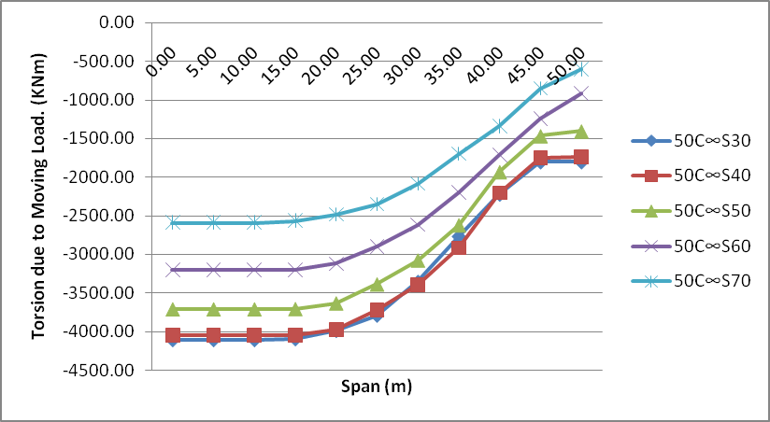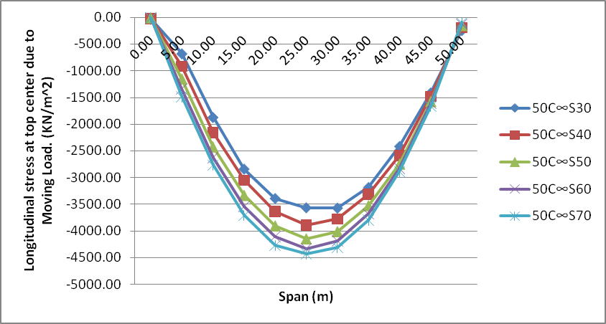

Fig. 16: Comparison of torsion due to moving load Fig. 17: Comparison of long. Stress at top center

# 6. CONCLUSION

# Time is reduced by increasing the radius of curvature for a given skew angle. As a result, that time period's worth is greater than a straight bridge.

# When the radius of curvature is increased for a given skew angle, the deflection value decreases. Deflection occurs greater on curved bridges as a result.

# In the cases of dead load plus super dead load and moving load, the value of the bending moment decreases as the radius of curvature increases.

# Torsion's effects are not present in a straight bridge under static loads. For a curved bridge, the torsion value is larger near the support than at the center. Torsion value decreases as radius increases.

# When a moving load is present, the torsion value of a straight bridge remains constant across the bridge's span.

# In a straight bridge, the longitudinal stress value is constant.

# A curved bridge has a larger longitudinal stress value at the top and bottom of the cross section than a straight bridge.

# For all radii and straight bridges, the value of time period increases as the skew angle increases.

# For all radii and all load cases taken into consideration in the research, the value of deflection increases with increasing skew angle.

# For all radii and all load cases taken into consideration in the research, the value of the bending moment increases with increasing skew angle.

# For all radii and all load cases taken into consideration in the research, the value of torsion decreases as the skew angle increases.

# Increased skew angle for shifting load at top and bottom faces results in an increase in longitudinal stress value at the midpoint of the bridge.

# REFERENCES

# 1.Wilson T, Mahmoud H, Chen, Seismic Performance of skew and curved reinforced concrete bridge in mountainous states, ELSEVIER, Engineering Structures 70 (2014) 158-167.

# 2. Khaled M. Sunnah, John B. Kennedy, literature review in analysis of box-girder bridges, ASCE 1084- 0702(2002)7:2(134).

# 3.P.K. Gupta, K. K. Singh, A. Mishra, Parametric Study on Behavior of box-girder Bridges Using Finite Element Method, Asian journal of civil engineering 11:1(2010)135-148.

# 4.Ansuman k, Vikash k, P. Maiti & P. Singh, Study on Effect of Skew Angle in Skew Bridges, International Journal of Engineering Research and Development,2:12(2012)13-18.

# 5. Luo m, Jing-hong G., Sensitivity analysis of continuous curved bridge under different curvature radius, applied mechanics and materail, 587-589(2014)1650-1654.

# 6. Yaping Wu, Shizhong Liu, Yuanlin Zhu and Yuanming Lai, Matrix analysis of shear lag and shear deformation in thin- walled box beams,(ASCE)0733-9399(2003) 129:8(944).