**ALARMING SYSTEM FOR FACE MASK DETECTION AND DISTANCE TO PREVENT THE SPREAD OF COVID USING IMAGE PROCESSING TECHNIQUE**

**Dr.Anita Harsoor1 , Ratna2 , Shriya3 , Shivani4**

1Professor, Department of Computer Science and Engineering, PDA College of Engineering, Kalaburagi, Karnataka, India.

2,3,4Student, Department of Computer Science and Engineering, PDA College of Engineering, Kalaburagi, Karnataka, India.

# ABSTRACT

The COVID-19 Pandemic caused by the new Corona virus is the cause of this 21st-century global health crisis. It has forced the government to impose a lockdown to prevent the transmission of the virus. This led to the unprecedented shutdown of economic activities. Many different types of safety measures are being taken in order to reduce the risk of the spread of this disease at unprecedented times. Hence, we decided on an approach that is effective and economic by using deep learning techniques to create a safe environment in setups such as manufacturing plants, markets, malls, and other such places. To demonstrate our approach, the training dataset is composed of people, the images with and without the masks, which are collected from a variety of sources and use it in order to build a robust algorithm in order to measure the social distance with the help of the classic geometry methods. We hope that this study will serve as a useful tool for reducing the spread of this dangerous infectious disease in the world.

# 1. INTRODUCTION

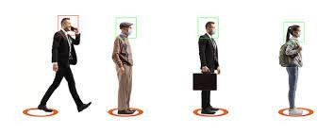Corona virus is a virus that affects both humans and animals. Covid-19, a coronavirus family member, was first detected in Wuhan, China, in December 2019[1]. The epidemic spread quickly around the world, prompting the World Health Organization (WHO) to declare it a pandemic . Although many countries continue to battle Covid-19, the number of cases in Malaysia has plateaued . On the 10th of June 2020, the Malaysian government declared the Recovery Movement Control Order (RMCO) in order to achieve a flatter curve of Covid-19 cases in Malaysia. The coronavirus is transmitted from person to person through small droplets from the nose and mouth, according to WHO data. To put it another way, social distancing is the best practice for minimizing physical interaction with potential coronavirus carriers by maintaining a distance of at least one meter between individuals. 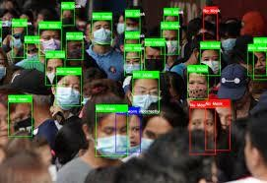

Fig .1 Mask Detection and Social Distancing

The magnitude of infectious spread has affected more than 3.2million peoples causing 239K deaths, according to the European Centre for Disease

Prevention and Control.

|  |
| --- |
| Capture  video from  gathering  Separate  frames  Perform  N  oise  remove  Locate Human  structure from frame  *  Segment  face  Locate  boundry  boxes  around  face and  identify mask  Next Video frame  Alarm to  alert others  **\***  Maintaining  social  distance  If  Mask not present  No  YES  YES  If  Mask  Present  **Fig.2 Block Diagram of Proposed System** |

First(Fig2)its starts with capturing the video footage from gathering then separate the frames, in Fig.2 the overall process is visualized. detection an advanced form of image classification where a neural network predicts objects in an image and points them out in the form of bounding boxes. Object detection thus refers to the detection and localization of objects in an image that belong to a predefined set of classes. Then Open CV for the image processing used for capturing the video .

The MobileNet Single Shot Multibox Detector SSD) object tracking model YOLO is used and the OpenCV library for image processing are used in this study to detect people in areas

**2.METHODOLOGY**

* The distance between the persons identified in the captured footage will be calculated and compared to a set of fixed pixel values.
* the segmented tracking region, the distance between the central points and the overlapping boundary between people is measured.
* When precarious distances between people are detected, alarms or warnings may be given to keep the distance secure.
* In addition to measuring social distance, fig 3. the device can also detect the presence of people in restricted areas, which can be used to prompt alerts.
* Some research has been done to see if the software is successful for both purposes.
* The mask detection is also proposed by the device. If the mask is not worn, the device will warn the user to do so.

In this study, the proposed idea is developed based on Python 3, OpenCV. OpenCV library is used to

|  |
| --- |
| Capture the live video from the  gathering using Image Processing  Separate the frames from the  video  Applying Object Detection  model using  YOLO  Loading the Face mask  model and identify with  boundary boxes  Ident  ify a  pers  With mask  No mask  Red Color Boundry box  Gives a Alarm to  alert  Calculating the distance  between two person using  midpoint and Euclidean  Formula  Green Color  Boundry box  Dist  ance  >  maxim  Yes  NO  Next  **Fig 3. System Architecture** |

we pre-process the data set so that it can be fed to the model. The aim of this is to improve the features by suppressing or enhancing the image features. The steps included are:

1. Reading the Image At this point, on the path, we set the image dataset in a variable, and then create a function to convert images into arrays from the folder that contains the images.
2. 2. Resizing image We resize our image during the pre-processing phase and as the images captured by a camera and fed to our algorithm vary in size. Therefore, we should always establish a base size for all images fed into our AI algorithms. In classification tasks, we usually see images with 224×224 dimensions. It is a suitable dimension that keeps the most structure of the pictures. This doesn't keep the ratio but it's not an enormous problem thanks to resizing images while test time.
3. Image Scaling Before passing the inputs to the model we scale the input pixels between -1 to 1.
4. Importing libraries The first thing we do is to import libraries necessary for data preprocessing. Lots of libraries are available, but the most important and popular Python libraries for data are Matplotlib, Pandas and NumPy. For all mathematical things NumPy is generally used Pandas are the best way to import and manage the data. Matplotlib (Matplotlib.pyplot) is the best library to create charts.
5. Encoding categorical data Category details must be coded before we can use them to match the test model. There are some ways to encode with a variety of models, although the three most common are: We use a hot encoder i.e., we use this data encoding method where the features are named (without an order). In inserting one hot coding, at each level of the category feature, we create new variables. Each category is represented by a binary variant containing 0 or 1. Here, 0 stands for non-existent, and 1 represents the presence of that category.
6. Splitting the Data At this stage, we split the data into a training set, and the program includes a number of pictures to be trained and tested in the CNN model. Database partitioning is important for the randomized test of the performance prediction. In most cases, we only randomly split the database into three sub-systems the output. To train the model a training set is used. For example, you can use a training set to find the appropriate weights or coefficients of a linear regression or neural networks. 2. This particular set is used for testing the neutral model. For example, if you find the total number of neurons in a neural network or two main vectors supported by a machine, you need to find different values. For each hypothetical hyper parameter setting, you need to measure the model by examining and evaluating its performance with a set of validation tools.

utilize the image processing methods. The main purpose of this system is to process captured video footage for person detection and further processing for social distancing or safety violation. So, the process starts with reading the frames of a video feed one by one.

**3.MODELING AND ANALYSIS**

**Object Detection Model** Caffe deep learning model framework is used to run the object detection model. The model chosen is MobileNet SSD due to the short time taken for the execution.

Width (bw)

Height (bh)

Class of object (c)

The Probability that there is an object in the bounding box (pc) Example,

y=(pc, bx, by, bh, bw, c)

**What is YOLO?**

YOLO algorithm **employs convolutional neural networks (CNN) to detect objects in real-time**. As the name suggests, the algorithm requires only a

single forward propagation through a neural network to detect objects. This means that prediction in the entire image is done in a single algorithm run.

**How does YOLO work?**

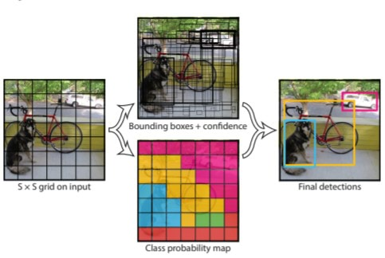

**Fig.4 Working of YOLO**

The YOLO algorithm (Fig4)works by dividing the image into *N* grids, each having an equal dimensional region of SxS. Each of these *N* grids is responsible for the detection and localization of the object it contains.

Correspondingly, these grids predict B bounding box coordinates relative to their cell coordinates, along with the object label and probability of the object being present in the cell.

This process greatly lowers the computation as both detection and recognition are handled by cells from the image, but—

It brings forth a lot of duplicate predictions due to multiple cells predicting the same object with different bounding box predictions.

Learning. In a YOLO algorithm, each bounding box has four descriptions:

Centre of the bounding box (bxby)

Unlike previous algorithms, the YOLO algorithms split the image into many cells, with each cell predicting multiple bounding boxes depending on how many objects are covered in the image. This results in the generation of a vast number of bounding boxes, some of which may or may not include any objects at all, as well as intersecting bounding boxes that share the same picture spaces. To solve this problem, a non-max suppression strategy is utilized, in which shared spaces are nullified and the pc value is projected to locate and remove boxes with no items. The Pascal VOC detection dataset served as the foundation for the YOLO model. Convolution's first layers aid in the extraction of features from images, while the fully connected layers forecast output probabilities. There are 24 convolutional layers and two fully linked layers in this image.

* **Masking** frame for ROI area estimation Masking is a technique in image processing which define as a small image piece and use it to modify a larger image. Masking involves setting some of the pixel values in an image to zero and some other background value. Video for an instance is a series sequence of images that been play in a certain amount of time. In this study, OpenCV masking method will be used to create ROI for each frame of the input frame
* **Open Cv**OpenCV is a great tool for image processing and performing computer vision tasks. It will perform ,
* [**Video I/O**](https://docs.opencv.org/4.x/dd/de7/group__videoio.html)(**videoio**) - an easy-to-use interface to video capturing and video codecs.
* [**Image Processing**](https://docs.opencv.org/4.x/d7/dbd/group__imgproc.html)(**imgproc**) - an image processing module that includes linear and non-linear image filtering, geometrical image transformations (resize, affine and perspective warping, generic table-based remapping), color space conversion, histograms, and so on
* [**Video Analysis**](https://docs.opencv.org/4.x/d7/de9/group__video.html)(**video**) - a video analysis module that includes motion estimation, background subtraction, and object tracking algorithms.
* **Determine person location** In determining the position of a person’s bounding box as well as the segment involved, each ground plane point is used to compare the ROI range. Surveillance cameras are usually placed at high places as the overhead camera especially to monitor a certain area e.g. high risk area or areas of interest for an organization. In this case, it is more suitable to compare the ground plane for the detection box instead of using the center point value.
* **Calculate the center point of a bounding box** To measure the center point, of the bounding box for the detected person, midpoint equation is used. Each of the minimum and maximum value for the corresponding width, and height, the bounding box will be used to calculate the center point of the bounding box.

# (x,y) = (x2 + x1)/2, (y2+y1)/2 ….. (1)

•**Calculate distance between bounding box** To measure the distance, between each of the detected person in the frame, distance equation is used .In this study, the center point of the bounding boxes is taken to determine between two different locations of the bounding boxes. After getting the center points value, the algorithm will calculate if

the distance is lower or higher than 300 pixels

 **……. (2**

**4.RESULTS AND DISCUSSION**

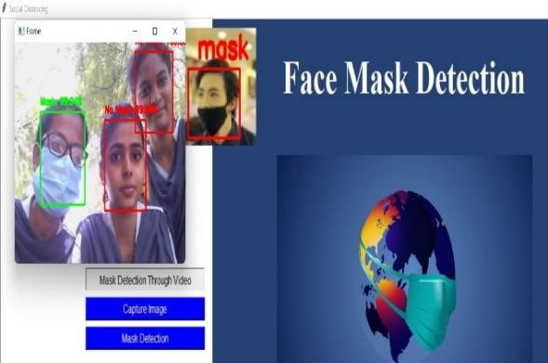

**Fig.5 When the is Person Wearing Mask. A Green Bounding Box Drawn over the Face of the Person Describes that the Person Wearing Mask.**

**Fig 6 : when a person Identifies the not wearing Mask And a Red bounding box drawn over the face of the person describes weather the person is wearing a mask**

**Fig 7. Showing distance between person in an**

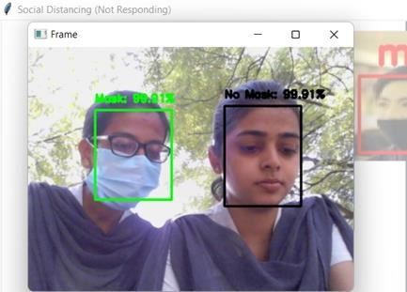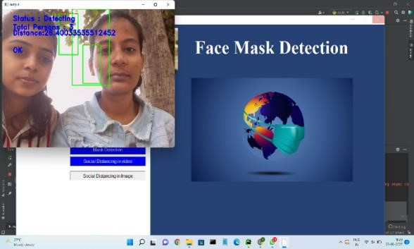

(Fig 6) shows whether the person is wearing a mask or not .person with mask is bounded by green bounding box and person without wearing mask is bounded by red bounding box. (Fig 7) shows that if the person is not wearing mask than than red bounding box is surrounded and alaram is given. distance between the people through an input video using Euclidean distance formula. distance between a two persons through an live capture .

**5.CONCLUSION**

One of the most effective precautions in minimizing physical contact that could lead to the spread of coronavirus is social distancing. Viral transmission rates would be higher as a result of non-compliance with these guidelines. To implement two proposed features, a framework was created using Python and the OpenCV library. The first feature detects social distancing violatideanons, while the second feature detects violations of entering restricted areas. Both features have undergone extensive testing to ensure their accuracy.

**6.References**

[1]World Health Organization, “Corona virus Disease 2019,” Corona virus disease (COVID-19) pandemic, 2020. https://www.who.int/emergencies/diseases/novelcoronavirus-2019 (accessed Jun. 19, 2020).

[2]M. Hatt, C. Parmer, J. Qi and I. El Naqa, "Machine (Deep) Learning Methods for Image

Processing and Radiomics," in IEEE Transactions on Radiation and Plasma Medical Sciences,

vol. 3, no. 2, pp. 104-108, March 2019, doi: 10.1109/TRPMS.2019.2899538.

[3]P. P. Shinde and S. Shah, "A Review of Machine Learning and Deep Learning Applications,

" 2018 Fourth International Conference on Computing Communication Control and Automation (ICCUBEA),

Pune, India, 2018, pp.

[4]M. Sewak, S. K. Sahay and H. Rathore, "Comparison of Deep Learning and the Classical Machine

Learning Algorithm for the Malware Detection," 2018 19th IEEE/ACIS International Conference on Software

Engineering, Artificial Intelligence, Networking and Parallel/Distributed Computing (SNPD), Busan, 2018, pp. 293-296,doi: 10.1109/SNPD.2018.8441123.