**AN EFFICIENT SPAM DETECTION TECHNIQUE FOR**

**IOT DEVICES USING MACHINE LEARNING**

*Chekuri Krishna Chakravarthy*

*Student in Andhra University*

*krishnachakri18@gmail.com*

**ABSTRACT**

*The Internet of Things (IoT) is a group of millions of devices having sensors and actuators linked over wired or wireless channel for data transmission. IoT has grown rapidly over the past decade with more than 30 billion devices are expected to be connected by 2030. The volume of data released from these devices will increase many-fold in the years to come. In addition to an increased volume, the IoT devices produces a large amount of data with a number of different modalities having varying data quality defined by its speed in terms of time and position dependency. In such an environment, machine learning algorithms can play an important role in ensuring security and authorization based on biotechnology, anomalous detection to improve the usability and security of IoT systems. On the other hand, attackers often view learning algorithms to exploit the vulnerabilities in smart IoT-based systems. Motivated from these, in this paper, we propose the security of the IoT devices by detecting spam using machine learning. To achieve this objective, Spam Detection in IoT using Machine Learning framework is proposed. In this framework, five machine learning models are evaluated using various metrics with a large collection of inputs features sets. Each model computes a spam score by considering the refined input features. This score depicts the trustworthiness of IoT device under various parameters. REFIT Smart Home dataset is used for the validation of proposed technique. The results obtained proves the effectiveness of the proposed scheme in comparison to the other existing schemes.*

**1.INTRODUCTION**

Machine Learning is a system of computer algorithms that can learn from example through self-improvement without being explicitly coded by a programmer. Machine learning is a part of artificial Intelligence which combines data with statistical tools to predict an output which can be used to make actionable insights.

The breakthrough comes with the idea that a machine can singularly learn from the data (i.e., example) to produce accurate results. Machine learning is closely related to data mining and Bayesian predictive modeling. The machine receives data as input and uses an algorithm to formulate answers.

A typical machine learning tasks are to provide a recommendation. For those who have a Netflix account, all recommendations of movies or series are based on the user's historical data. Tech companies are using unsupervised learning to improve the user experience with personalizing recommendation.

Machine learning is also used for a variety of tasks like fraud detection, predictive maintenance, portfolio optimization, automatize task and so on.

**Machine Learning vs. Traditional Programming**

Traditional programming differs significantly from machine learning. In traditional programming, programmers code all the rules in consultation with an expert in the industry for which software is being developed. Each rule is based on a logical foundation; the machine will execute an output following the logical statement. When the system grows complex, more rules need to be written. It can quickly become unsustainable to maintain.

Traditional programming differs significantly from machine learning. In traditional programming, a programmer code all the rules in consultation with an expert in the industry for which software is being developed. Each rule is based on a logical foundation; the machine will execute an output following the logical statement. When the system grows complex, more rules need to be written. It can quickly become unsustainable to maintain.

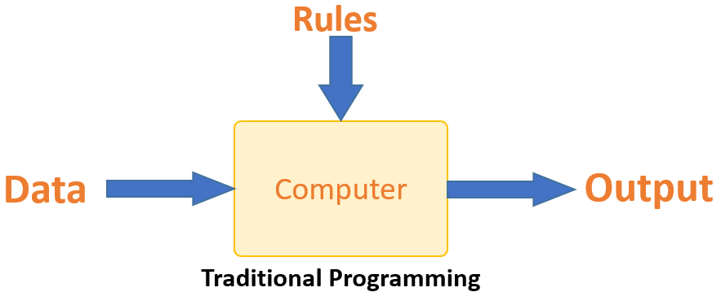

Machine learning is supposed to overcome this issue. The machine learns how the input and output data are correlated and it writes a rule. The programmers do not need to write new rules each time there is new data. The algorithms adapt in response to new data and experiences to improve efficacy over time.

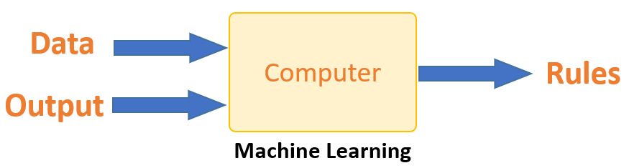

Machine learning is the brain where all the learning takes place. The way the machine learns is similar to the human being. Humans learn from experience. The more we know, the more easily we can predict. By analogy, when we face an unknown situation, the likelihood of success is lower than the known situation. Machines are trained the same. To make an accurate prediction, the machine sees an example. When we give the machine a similar example, it can figure out the outcome. However, like a human, if its feed a previously unseen example, the machine has difficulties to predict.

The core objective of machine learning is the **learning** and **inference**. First of all, the machine learns through the discovery of patterns. This discovery is made thanks to the **data**. One crucial part of the data scientist is to choose carefully which data to provide to the machine. The list of attributes used to solve a problem is called a **feature vector.** You can think of a feature vector as a subset of data that is used to tackle a problem.

The machine uses some fancy algorithms to simplify the reality and transform this discovery into a **model**. Therefore, the learning stage is used to describe the data and summarize it into a model.

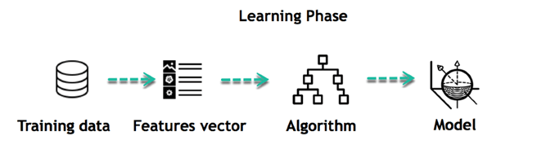

For instance, the machine is trying to understand the relationship between the wage of an individual and the likelihood to go to a fancy restaurant. It turns out the machine finds a positive relationship between wage and going to a high-end restaurant: This is the model

**Inferring**

When the model is built, it is possible to test how powerful it is on never-seen-before data. The new data are transformed into a features vector, go through the model and give a prediction. This is all the beautiful part of machine learning. There is no need to update the rules or train again the model. You can use the model previously trained to make inference on new data.

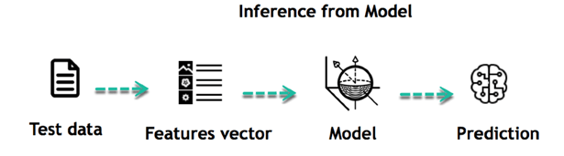

**2.Methodology**

**SYSTEM ARCHITECTURE:**

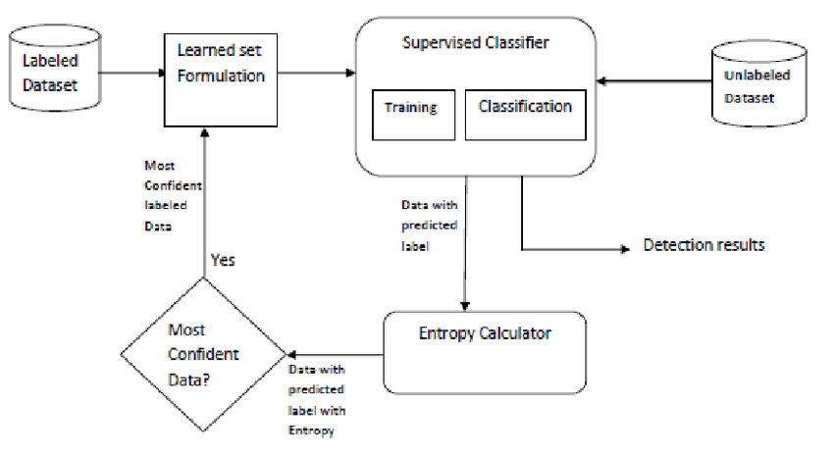

**DATA FLOW DIAGRAM:**

1. The DFD is also called as bubble chart. It is a simple graphical formalism that can be used to represent a system in terms of input data to the system, various processing carried out on this data, and the output data is generated by this system.
2. The data flow diagram (DFD) is one of the most important modeling tools. It is used to model the system components. These components are the system process, the data used by the process, an external entity that interacts with the system and the information flows in the system.
3. DFD shows how the information moves through the system and how it is modified by a series of transformations. It is a graphical technique that depicts information flow and the transformations that are applied as data moves from input to output.
4. DFD is also known as bubble chart. A DFD may be used to represent a system at any level of abstraction. DFD may be partitioned into levels that represent increasing information flow and functional detail.

Input data

Preprocessing

Training dataset

Feature Extraction

Testing Data

Prediction/Classification

No spam

spam

**UML DIAGRAMS**

UML stands for Unified Modeling Language. UML is a standardized general-purpose modeling language in the field of object-oriented software engineering. The standard is managed, and was created by, the Object Management Group.

The goal is for UML to become a common language for creating models of object oriented computer software. In its current form UML is comprised of two major components: a Meta-model and a notation. In the future, some form of method or process may also be added to; or associated with, UML.The Unified Modeling Language is a standard language for specifying, Visualization, Constructing and documenting the artifacts of software system, as well as for business modeling and other non-software systems.

The UML represents collection of best engineering practices that have proven successful in the modeling of large and complex systems.

The UML is a very important part of developing objects oriented software and the software development process. The UML uses mostly graphical notations to express the design of software projects.

**3.GOALS:**

The Primary goals in the design of the UML are as follows:

1. Provide users a ready-to-use, expressive visual modeling Language so that they can develop and exchange meaningful models.
2. Provide extendibility and specialization mechanisms to extend the core concepts.
3. Be independent of particular programming languages and development process.
4. Provide a formal basis for understanding the modeling language.
5. Encourage the growth of OO tools market.
6. Support higher level development concepts such as collaborations, frameworks, patterns and components.
7. Integrate best practices.

**USE CASE DIAGRAM:**

A use case diagram in the Unified Modeling Language (UML) is a type of behavioral diagram defined by and created from a Use-case analysis. Its purpose is to present a graphical overview of the functionality provided by a system in terms of actors, their goals (represented as use cases), and any dependencies between those use cases. The main purpose of a use case diagram is to show what system functions are performed for which actor. Roles of the actors in the system can be depicted.

User

Inputdata

Preprocessing

Training

Classification

**CLASS DIAGRAM:**

In software engineering, a class diagram in the Unified Modeling Language (UML) is a type of static structure diagram that describes the structure of a system by showing the system's classes, their attributes, operations (or methods), and the relationships among the classes. It explains which class contains information.

Input

Input data

Preprocessing ( )

Output

Features extraction

Classification

Finally get Classified &Display Result: spam and no spam

**4. CONCLUSION**

The proposed framework, detects the spam parameters of IoT devices using machine learning models. The IoT dataset used for experiments, is pre-processed by using feature engineering procedure. By experimenting the framework with machine learning models, each IoT appliance is awarded with a spam score. This refines the conditions to be taken for successful working of IoT devices in a smart home. In future, we are planning to consider the climatic and surrounding features of IoT device to make them more secure and trustworthy.

**5. REFERENCES**

# [1] N. Kumar, S. Sonowal and Nishant, "Email Spam Detection Using Machine Learning Algorithms," 2020 Second International Conference on Inventive Research in Computing Applications (ICIRCA), 2020, pp. 108-113, doi: 10.1109/ICIRCA48905.2020.9183098.

[2] **Crawford, M., Khoshgoftaar, T.M., Prusa, J.D**. *et al.* Survey of review spam detection using machine learning techniques. *Journal of Big Data* **2**, 23 (2015). <https://doi.org/10.1186/s40537-015-0029-9>

[3] **Zeeshan Bin Siddique, Mudassar Ali Khan, Ikram Ud Din, Ahmad Almogren, Irfan Mohiuddin, Shah Nazir**, "Machine Learning-Based Detection of Spam Emails", *Scientific Programming*, vol. 2021, Article ID 6508784, 11 pages, 2021. https://doi.org/10.1155/2021/6508784

[4] **A. Karim, S. Azam, B. Shanmugam, K. Krishnan and M. Alazab**, "A Comprehensive Survey for Intelligent Spam Email Detection", IEEE Access, vol. 7, pp. 168261-168295, 2019.

[5] **Suryawanshi Shubhangi, Goswami Anurag and Patil Pramod**, Email Spam Detection: An Empirical Comparative Study of Different ML and Ensemble Classifiers, pp. 69-74, 2019.

[6] **A. K. Ameen and B. Kaya**, "Spam detection in online social networks by deep learning", 2018 International Conference on Artificial Intelligence and Data Processing (IDAP), pp. 1-4, 2018.

[7] **V Niranjani, Y Agalya, K Charunandhini, K Gayathri, R Gayathri**, "Spam Detection for Social Media Networks Using Machine Learning", *2022 8th International Conference on Advanced Computing and Communication Systems (ICACCS)*, vol.1, pp.2082-2088, 2022

[8] Review Spam Detection Using Machine Learning Techniques **Rohit Narayan** 2016