**Enhancement of Speech Signals for Hearing Aid Devices using Kalman Filter and Adaptive Filters**

**Gaurav Sharma1, Gaurav Patil2, Ashish Kumar Singh3**

123School of Electronics Engineering, Vellore Institute of Technology, Vellore, Tamil Nadu, India

1 Corresponding Author: gauravrajiv.sharma2019@vitstudent.ac.in

**ABSTRACT**

Hearing loss is a serious problem that affects many individuals around the world. Hearing loss occurs when a person loses the ability to hear and can affect any component of the ear. Hearing aids come in a variety of styles to help people with hearing loss improve their speech signals. Initially, people used analog hearing systems that worked on the idea of ​​using an amplifier. Incoming sound the signal to the ear was amplified by an analog hearing aid. The analog hearing aids did not use any minimization strategies speech signal noise. For listeners with hearing loss, a new signal processing strategy is offered to improve the voice signal. Speech enhancement methods are used to improve the quality of such signals. As a result, many filtering techniques are used such as traditional, fast adaptive and others. Using the Fast Adaptive Kalman Filter (FAKF) method, this technique is aimed at improving the quality and intelligibility of voice signals. Consequently, the goal of noise reduction algorithms is to estimate the clean speech signal from noisy recordings in order to enhance it

signal enhancement.

One approach to time-domain speech enhancement is the traditional Kalman filter. It requires the use of an AR (autoregressive) model to calculate the parameters as well as a non-adaptive inverse matrix operation. FAKF is based on masking the human auditory system function. It periodically changes the initial value of the state vector and automatically adjusts the estimate of the surrounding environment noise based on observational data. The speech enhancement system (FAKF) has the ability to continuously update the estimated noise. The current frame of speech is identified based on the threshold level, reducing execution time. As a result, matrix operations are less complex. According to the simulation results, FAKF is more effective in extracting pure speech signal and also provides the best results for stationary sounds. Objective measurements show excellent quality even at an input noise level of 15dB, resulting in an output SNR of 41.6dB, thanks to the implementation of this speech enhancement algorithm.

**Keywords**—Digital signal processing, LMS, Fixed filters, Digital aid, Kalman Filter

1. **INTRODUCTION**

The purpose of human speech enhancement is to improve the quality of speech using different methods. Improving the performance of noisy systems is one of the key problems in speech signal processing. Among them, we can mention hearing aids, forensic applications, cellular environments, speech recognition system front-ends, improving communication signals, military and other applications. The main problems limiting communication systems are noise and distortion.

Consequently, their modeling and elimination are central to the theory and practice of communication and signal processing. For this purpose, several strategies have been modeled to increase the speech signal-to-noise ratio, which depends on the quality and intelligibility of the processed speech signal.

Kalman filter-based noise suppression is used in hearing aids because it relies on spatial information to distinguish between appropriate speech and sound models. Basically, the parameters are important for the Kalman filter to estimate the speech and noise model. Implementing the Kalman filter technique for effective noise detection is a bit difficult. Real-time adaptive methods should be used to assess ambient noise. Kalman filter method to create signals from random processes like

It is represented using state space modeling and can be monitored and processed using time-recursive estimation algorithms. Based on the accuracy of predicted parameters using autoregressive (AR) models, noise-suppressed signals can degrade the quality of speech signals. Fast adaptive Kalman filter algorithms are divided into three categories:

1. Normal Kalman filter algorithm (matrix).

2. A modified fast adaptive Kalman filter algorithm.

The classical Kalman filter is the method of choice for recursive data processing. A Kalman filter combines all the information provided. This is one of the general characteristics of optimality. [1]-[5] each suggested a different strategy. The filtering process becomes more complicated when LPC (Linear Predictive Coding) coefficients and matrix inverse are calculated. Assume that the system model is linear and can tolerate incremental Gaussian noise up to a certain amount. As a result, the known variance continuously updates the initial value of the state vector, eliminating the need for matrix operations. As a result, a modified fast adaptive Kalman filter is used to minimize the complexity of the noise estimation method. This method is compatible with all kinds of environmental noises and works best with static background sounds [6]. The proposed method significantly improves speech signal understanding compared to current methods.

Figure 1 shows the implementation of the noise reduction system. The input audio signal is filtered by a noise reduction system that separates the audio signal from background noise before outputting it as a filtered audio signal. Noise reduction systems use different types of noise removal techniques to reduce the noise of audio signals [4]. Fixed filters, adaptive filters and spectral analysis techniques were used in the noise removal system. Fixed filters used bandstop, bandpass, highpass and lowpass filters. Use a bandstop to pass low frequencies and block high frequencies. A low-pass filter is used to remove low frequencies, a band-stop filter is used to remove a specific frequency range, and a band-pass filter is used to pass a specific frequency range. An adaptive filter is used to reduce background noise from the speech signal. Background noise fluctuates over time. Adaptive filters may change settings in response to background noise. The term "spectral analysis" refers to the study of the spectrum of a signal. Speech signals are recovered using this method by approximately subtracting the noise signal spectrum from the noise signal spectrum [1].

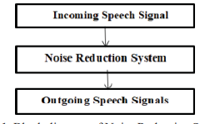

**Fig. 1.** Block diagram of Noise Reduction System

1. **NORMAL CHARACTERISTICS OF THE HUMAN EAR**

It is common for the human ear to hear sounds in the frequency range of 20 Hz to 20,000 Hz. The human ear is very sensitive in the frequency range of 1000 Hz to 5000 Hz [6]. Sound wave power, which is one of the basic characteristics of sound waves, is loudness. The power of a sound wave is traditionally measured in decibels. Figure 3 shows the audible sound pressure as heard by the human ear. This value varies from 0dB to 120dB.

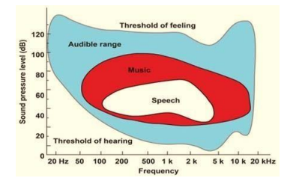

**Fig. 2.** Audible Range of normal human Ear [7]

1. **LITERATURE REVIEW**

The human ear helps us to hear the sounds that are made outside our ears. Figure 3 shows sound waves from the outer ear to the inner ear. When sound waves from outside reach the ear canal, the eardrum vibrates(eardrum). To transmit from outside, sound waves use a medium of free space. The eardrum directs the sound waves to the small vibrating bones of the middle ear. Sound waves are directed to the inner ear. middle ear The middle ear contains bones that help amplify sound waves. A solid medium is used to transmit sound waves in the middle ear. The cochlea converts mechanical sound vibrations into electrical signals (pulses) or nerve impulses. It is sent to the brain (temporal lobe) through the auditory nerve. A liquid medium is used to guide sound waves in the inner ear [5].

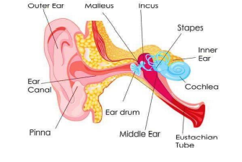

**Fig. 3**. Working of human ear

1. **CLASSIFICATION OF HEARING LOSS**

There are different forms of hearing loss that people experience. Table 1 shows how they are classified. Hearing loss is classified into mild, mild, moderate, severe or profound. Based on the figure, people with mild hearing loss

have trouble understanding normal conversation. For people with moderate hearing loss, it may be difficult to hear loud conversations. People with severe hearing loss can only understand amplified speech, while people with severe hearing loss Even amplified speech is difficult to understand [1]. Signal-to-noise ratio (SNR) is one of the oldest and most widely used objective measures. Mathematical computations require both distorted signals and undistorted (clean) speech samples. SNR can be calculated as follows:



where x(n) represents undistorted speech, x(n) represents distorted speech, and N is the number of samples. For various deviations, this traditional meaning of SNR is independent of known speech quality. Consequently, there are several versions of traditional SNR that are significantly more closely related to subjective quality. Although it is not a speech Traditional SNR usually does not correspond to audio quality. Instead, it averages the ratios between the signals. Speech energy varies over time, so you may find that the speech energy is high and the noise is barely audible.



The fwSNRseg can be defined as follows:

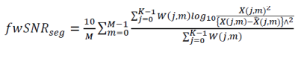

where W(j,m) is the weight of subband j of the mth frame, K is the number of subbands, and X(j,m) is the spectrum of subband j of the mth frame. magnitude, and ˆX(j, m) the magnitude of its distorted spectrum.

TABLE I PERFORMANCE OF FAKF- OUTPUT SNR VERSES INPUT SNR AT DIFFERENT NOISE LEVEL

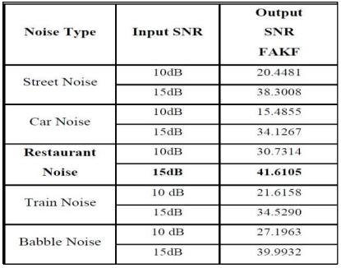

1. **ANALOG HEARING AID DEVICE**

All ringtones are amplified by analog hearing aids (voice and noise). As shown in Figure 4, we use a small battery, a microphone, a speaker, and basic electronics to amplify and convert sound [8] from the outside world.

A transistor is used. Noise can interrupt constructive discussions because it cannot distinguish between the desired signal (voice) and the unwanted signal (noise), and both voice and noise are amplified. It cannot offer any form of noise cancellation. Some of them are programmable Analog hearing aids are better than analog hearing aids

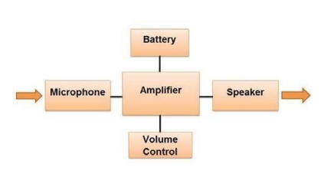

**Fig. 4**. Block diagram of simple analog hearing aid device

1. **DIGITAL HEARING AID DEVICE**

In 1996, digital hearing aids were introduced to the public for the first time. This device is fully digital and programmable, offers more flexibility than analog hearing aid systems, and is more precisely tuned to the patient's needs [8].

Its purpose is to amplify the audio signal while reducing the noise level. Audio signals and noise are perceived by the wings of digital equipment. Noise reduction and sound amplification Inside the hearing aid is a microprocessor that processes the signal and sends it to a small speaker, which then sends the signal to the ear canal. A computer chip was used to analyze speech and other sounds. Digital hearing aids are much more advanced than analog hearing aids that use complex processing and noise reduction algorithms during sound amplification to reduce all types of noise. Digital Aid used multiple memories, each of which was programmed to use a specific location according to its function, and the memories were changed by pressing a button [8]. Each memory worked in a specific location. One of them talked in a quiet and quiet place, another in a noisy place, and the rest worked on things like music. A digital hearing aid microphone receives the input signal, which is converted to a digital signal (1, 0) as shown in Figure 5.

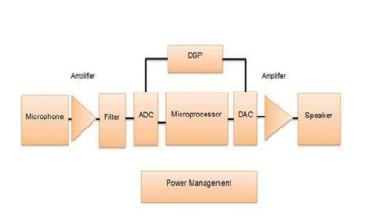

**Fig. 5**. Block diagram of digital hearing aid device

1. **NOISE CANCELATION USING FIXED FILTER**

Using static filters to remove unwanted signals or noise from your system.Fixed area filters are also classified based on their characteristics. The type of each of these types serves a specific purpose and is important in its own way. Each fixed filter is designed to remove a specific type of noise. A low-pass filter accepts low frequencies but not high frequencies, thus creating a higher cutoff frequency for high frequencies [1]. When creating a low-pass filter, the cutoff frequency is a matter of taste. Korean filters were used as low pass filters in MATLAB. A high-pass filter is the inverse of a low-pass filter. It allows frequencies above a certain threshold [9]. Also called low-cut filter. Pass down and A highpass filter is combined with a bandpass filter. Accepts frequencies between two cutoff frequencies. When designing the filter, two cutoff frequencies are defined. Chevy 1 filters are used as bandpass filters in MATLAB. A bandstop filter, also called a bandstop filter, is a filter that passes all frequencies unchanged and reduces a certain range of frequencies to a very low level. This is exactly the opposite of a bandpass filter.

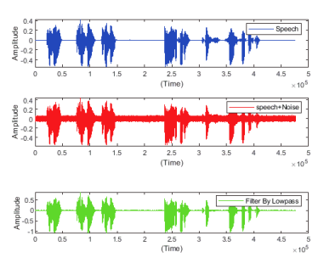

**Fig 6**. Output of Fixed Filter

1. **NOISE CANCELLATION USING ADAPTIVE FILTER**

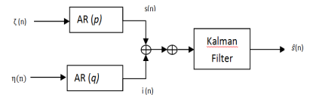

**Fig 7.** Flow chart of an Adaptive Filter

Adaptive filter is a system containing linear filters. A transfer function controlled by variable parameters determined by the algorithm (see Figure 8). Adaptive filters are very difficult to implement due to algorithmic complexity. LMS algorithm is the most important adaptive filter algorithm. Adaptive filters are usually found in signal processing, but can also be found in mobile phones.

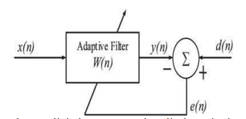

**Fig 8.** Block Diagram of an Adaptive Filter

Adaptive filters are used to reduce noise caused by speech and response to the environment [10]. The Least Mean Squares (LMS) algorithm is an adaptive filter that is used to mimic a desired filter by determining the filter coefficients:

This is related to the generation of the least squares mean of the error signal (the difference between the desired signal and the actual signal).

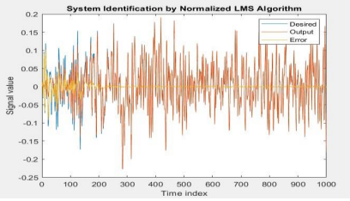

**Fig 9.** System Identification by LMS Algorithm

1. **NOISE CANCELLATION USING Kalman Filter**
   1. **Conventional Kalman Filter**

A state space model is required when using the Kalman filter for speech enhancement. The speech signal s(n) and the interference signal i(n) can be efficiently described by autoregressive (AR) processes of order p and q, respectively, according to one model commonly used in [13]. Excitation signals (n) or (n) are treated as independent zero-mean white Gaussian noise with variance. State vector x(n) =



can be used to create a state space model.

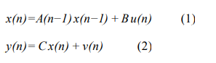

Where ν(n) is the white, Gaussian measurement error with variance and the input u(n) = ζ η

Note that the transition matrix computation is time invariant, while in fact, the parameters and may change at every time step n in [7] and [8]. This ability of the Kalman filter to deal with a time variant signal and speech model is essential for the use of the Kalman filter instead of a Wiener filter. Since in real world applications the input u(n) is unknown, one will consider it to be zero. Based on this implication one will have an uncertainty in the state vector x(n). The covariance matrix of the corresponding state error can be calculated as follows:

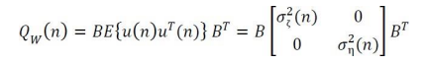

Based on this state space model, a Kalman filter can be used to estimate the state vector x(n) based on the noisy measurements y(k) (k up to n). This estimate (n) as given in [9]. K(n) is the Kalman gain vector and I is the identity matrix of order p+q.

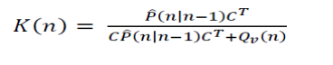

The estimated speech signal (n) can be found at the pth position of the estimated state vector (n|n). Note that because of the special structure of the vector x(n), one will estimate not only s(n) but also s(n−1)···s(n−p + 1). Since these estimates are all based on measurements y(k) with k up to n, they correspond to fixed-lag estimates [7]

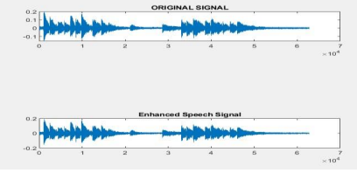

**Fig 10.** Enhanced Signal Output(Kalman)

* 1. **Fast Adaptive Kalman Filter**

In FAKF, process noise and measurement noise can be estimated on-line according to the measured value and filtered value with real-time monitoring of noise changes to adjust the filtering parameters to improve the filter effect. This is achieved by setting a reasonable threshold value in the adaptive method that is used to evaluate the current speech frame as noise or not. It mainly consists of two steps: (a) Updating the ambient noise variance by [11],



In (5) d is the loss factor and it is given by



b is a constant and it is assumed as 0.99

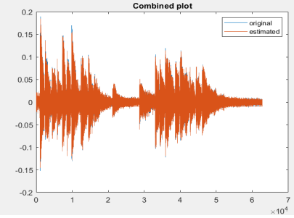

**Fig 11**. FAKF Output Plot

1. .**SPECTRAL ANALYSIS TECHNIQUE**

The term "spectral analysis" refers to the study of a signal spectrum. Optics, speech, sonar, radar and medicine are just that several areas where it can be used. Spectral analysis they developed is used to detect noise in voice signals [4]. If the speech signal with (n) is degraded by uncorrelation additive signal v(n), then the corrupted noise signal is:

x(n) = s(n) + v(n) (1)

Taking the Discrete Fourier Transform (DFT) of x(n)gives:

x(k) = s(k) + v(k) (2)

Assuming that is zero-mean and uncorrelated with, the v(n) s(n) estimate of can be |s(k)| expressed as:

|s(k)| = |x(k)| - e|v (k)| (3)

Given |s(k)| the estimate, the speech can be expressed as:

|S`(k)| = |S`(k)|ej0 (k) (4)

Ej0 (k) = x(k)/ |x(k)| (5)

Where The phase of the observed noisy signal is 0x(k). As a result of the processing complexity of the clean speech phase, it is sufficient to employ the loud speech phase for all practical applications.

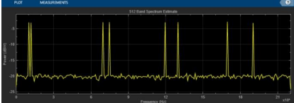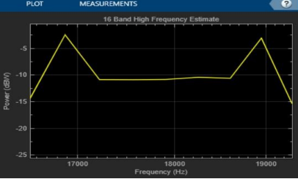

**Fig 12**. Band Spectrum Estimate **Fig 13**. Band High Frequency Estimate

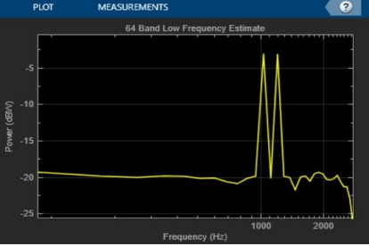

**Fig 14**. Band Low Frequency Estimate

1. . **CONCLUSION**

A fast adaptive Kalman filter is used to create a speech enhancement approach that is more flexible for stationary noise. It uses a coefficient to simplify matrix operations while improving human auditory properties. According to the simulation findings, FAKF is more effective in retrieving a clean voice signal. At different noise levels, assessment parameters like SNR give better results. The highest SNR value achieved with FAKF is 41.6105 dB for 15 dB input noise level and shorter operating time. As can be seen from the above, the proposed system outperforms the current system. The proposed approach was found to be simple to implement and implement offer effective noise reduction without loss of quality voice signal.

1. **REFERENCES**

[1 ] Halawani, Sami Mohammed, Abdul Rahman Al-Talhi, and Abdul Waheed Khan. "Speech Enhancement Techniques for Hearing Impaired People: Digital Signal Processing based Approach." Life Science Journal 10, no. 4 (2013).

[2 ] Ryoo, Kwangki, Manu Chilukuri, and Sungyong Jung. "A low power and low noise preamplifier circuit for hearing aid devices." In 2016 IEEE Dallas Circuits and Systems Conference (DCAS), pp. 1-4. IEEE, 2016.

[3 ] Edwards, Brent. "The future of hearing aid technology." Trends in amplification 11, no. 1 (2007): 31-45

[4].Boll, Steven. "Suppression of acoustic noise in speech using spectral subtraction." IEEE Transactions on acoustics, speech, and signal processing 27, no. 2 (1979): 113-120.

[5] Gan, Rong Z., and Xuelin Wang. "Multifield coupled finite element analysis for sound transmission in otitis media with effusion." The Journal of the Acoustical Society of America 122, no. 6 (2007): 3527- 3538.

[6] Rodman, Jeff. "The effect of bandwidth on speech intelligibility." Polycom inc., White paper (2003).

[7] Várallyay, G., S. V. Legarth, and T. Ramirez. "Music lovers and hearing aids. AudiologyOnline, Article 16478." (2016)

[8] Devis, Tomson, and Manju Manuel. "Multirate and filterbank approaches in digital hearing aid design: A review." In IOP Materials Science and Engineering Conference. IOP Publishing, pp. 1-8. 2018.

[9] Shpak, D. J., and A. Antoniou. "A generalized Remez method for the design of FIR digital filters." IEEEtransactions on circuits and systems 37, no. 2 (1990): 161-174

[10] Haykin,S.,& Widrow.B(Eds).(2003) Least Mean square adaptive filter(vol.31)John Wiley &Sons ).Adaptive filter theory .Pearson Education India.

[11] Mai Q, He D, Hou Y, Huang Z. A fast adaptive Kalman filtering algorithm for speech enhancement. In: IEEE International Conference on Automatic Science and Engineering Trieste, Italy, 2011.

[12] Gao Y, Zhang J. Kalman filter with wavelet based unknown measurement noise estimation and its application for information fusion. Acta Electronica Sinica 2007;35 1:108– 111.

[13] R. K. Mehra, “Approaches to adaptive filtering”,IEEE Trans. on Automatic Control, Vol. 17, pp. 693-698 (1972).

[14] B. Carrew and P. Bellanger, “Identification of optimum filter steady state gain for systems with unknown noise parameters”, IEEE Trans. Automatic Control, Vol. 18, N.6, pp. 582-587 (1973).

[15] R. K. Mehra, “On the identification of variance and adaptive Kalman filtering” , IEEE Trans. on Automatic Control, Vol. 15, N.2, pp. 175-184 (1970).

[16] P. Sorqvast, P. Handel, B. Ottersten, “Kalman filtering for low distortion speech enhancement in mobile communication” in IEEE International Conference on Acoustics, Speech, and Signal Processing, 1997.

[17] V. Grancharov, J. Samuelsson, B. Kleijn, “On Causal Algorithms for Speech Enhancement” in IEEE Transactions on Audio, Speech, and Language Processing, 2006.

[18] Sage, A.P. and Husa,G.W. (1969a).Adaptive filtering with unknown prior statistics. In Proceedings of joint automatic control conference, Boulder, 760–769