**“REVIEW OF TRIPLE HETEROGENEOUS ARCHITECTURE IN BWSN”**

Mohd Younus Dar (M.tech Student) ,Tejbir Singh(Asst.Prof)

*Department of Computer Engineering*

*GNIT, Mullana, Ambala-133 203, Haryana, India*

[Unisidar.91@gmail.com](mailto:Unisidar.91@gmail.com), tejbirrana662@gmail.com

***Abstract***: **This research was conducted in the following phases: Study the basic principal of wireless sensor networks. Review existing energy efficient routing protocols in WSNs. Design a Triple Heterogeneous WSNs Architecture to achieve energy efficiency in wireless sensor networks using custom simulator designed in Mat Lab. Compare the results of proposed system with the existing schemes. Formulate future scope of this research work. Further we went to create a Relationship between low energy of node in WSN and high energy of node in WSN. We will final result also when low energy nodes transmit data to high energy nodes then energy will be saved.**

**Keywords: WSN; LEACH cluster-head selection charge balanced; Sensor Node, Network life time Mat Lab.**

**WIRELESS SENSOR NETWORK**

**Introduction**: Wireless Sensor networks(WSN)[2] have emerged as a promising tool for monitoring (and possibly actuating) the physical world, utilizing self-organizing networks of battery powered wireless sensors that can sense, process and communicate. A WSN typically consists of a large number of low-cost, low power, and multifunctional wireless sensor nodes, with sensing, wireless communications and computation capabilities. These small sensing devices are called nodes and consist of CPU (for data processing), memory (for data storage), battery (for energy) and transceiver (for receiving and sending signals or data from one node to another). These nodes form a network by communicating with each other either directly or through other nodes. One or more nodes among them will serve as sink(s) that are capable of communicating with the user either directly or through the existing wired networks. The primary component of the network is the sensor, essential for monitoring real world physical conditions such as sound, temperature, humidity, intensity, vibration, pressure, motion, pollutants.



Fig1.1: WSN Architecture

**Applications of Wireless Sensor Network [2]:**

1. **Military Applications**:

Since sensor networks are based on the dense deployment of disposable and low-cost sensor nodes, destruction of some nodes by hostile actions does not affect a military operation as much as the destruction of a traditional sensor, which makes sensor networks concept a better. Some of the military applications of sensor networks are approach for battlefields.

1. **Health Applications:**

Some of the health applications for sensor networks are providing interfaces for the disabled; integrated patient monitoring; diagnostics; drug administration in hospitals; monitoring the movements and internal processes of insects or other small animals; telemonitoring of human physiological data; and tracking and monitoring doctors and patients inside a hospital.

1. **Home Appliances**:

As technology advances, smart sensor nodes and actuators can be buried in appliances, such as vacuum cleaners, micro-wave ovens, refrigerators, and VCRs. These sensor nodes inside the domestic devices can interact with each other and with the external network via the Internet or Satellite.

1. **Environmental Applications:**

Some environmental applications of sensor networks[3] include tracking the movements of birds, small animals, and insects; monitoring environmental conditions that affect crops and livestock; irrigation; macro instruments for large-scale Earth monitoring and planetary exploration; chemical/ biological detection; precision agriculture; biological, Earth, and environmental monitoring in marine, soil, and atmospheric contexts; forest fire detection; meteorological.

**Existing Work (LEACH):-**

In existing work, the network (WSN) is homogenous in nature i.e. each node in the N/w has same resources in terms of memory, energy and processing power. In each round a no. of cluster head are chosen on probability basis. Any sensor that has a pending then a predefined threshold energy is consider to be alive otherwise is declared as dead sensor. All sensors join a cluster head which is nearest to it. The drawbacks of this scheme are that a sensor is declared to be dead is the pending energy is less than the predefined threshold energy (t) so this energy is wasted. So to use this wasted energy we combine the energy of two sensors into single sensor.

The benefit of this scheme is that only the energy of single sensor is wasted whenever its energy level is less than (t1). So instead of wasting (n*t) energy (when n is the total no. of sensor in the network). We have introduced the concept of heterogeneous WSN. Where some sensor are given more energy instead of giving them a normal energy and the method of choosing a cluster head is changed in such a way that the sensors with more energy will be elected more time as a CH than normal sensors. To balance the energy level with the existing network we have increase the number of normal sensors in the existing network in the same ratio to compare the results.

**SEP (Stable Energy Protocol):**

LEACH protocol is not heterogeneity-aware, in the sense that when there is an energy imbalance between these nodes in the network, the sensors die out faster than they normally should have if they were to maintain their energy uniformly. In real life situation it is difficult for the sensors to maintain their energy uniformly, thus, introducing energy imbalances. LEACH assumes that the energy usage of each node with respect to the overall energy of the system or network is homogeneous. Stable Election Protocol (SEP), was proposed in [9], a heterogeneous aware protocol, based on weighted election probabilities of each node to become cluster head according to their respective energy. This approach ensures that the cluster head election is randomly selected and distributed based on the fraction of energy of each node assuring a uniform use of the nodes energy.

**Problem Formulation**: The purpose of dissertation is to find a stable and reliable routing protocol that can support real-time traffic for environments like habitat monitoring or area surveillance and prolongs the effective network life-time.

Three major functions are performed by three sensor subsystems: the subsystem which senses the environment; the processing subsystem which performs local computations on the data sensed and the communication subsystem that performs information exchange between neighboring nodes. Each sensor is mostly limited in their energy level, processing power and sensing ability. Thus, a network of these sensors give rise to a more robust, reliable and accurate network. Large sized cluster consumes more energy than small sized cluster because it has long intra cluster distance (total distance from cluster members to cluster head).The energy conservation decreases as cluster density increases.

An inefficient use of the available energy leads to poor performance and short life cycle of the network. To this end, energy in these sensors is a scarce resource and must be managed in an efficient manner. Energy dissipation is a major factor in WSNs during communication among the nodes. Energy should be used uniformly, so that the batteries do not get depleted or drained quickly as these are not easily replaceable in applications such as surveillance.

**Need and proposed work**

In this dissertation, we are needed to increase the energy of nodes or saving the energy of nodes in large WSN.A heterogeneous wireless sensor network consisting in several resource-rich super nodes used for data relaying and a large number of energy constrained wireless sensor nodes. Sensor nodes are deployed randomly to monitor a number of clusters. Since clusters are redundantly covered by more sensors, in order to conserve energy resources, we organize the sensors in clusters that are activating successively. We are need to finding the sensor nodes according to their energy in large area of WSN using LEACH (Low Energy Adaptive Clustering Protocol) [1], SEP (Stable Election Protocol) [9], and three level of heterogeneity[8]. Wireless sensor networks consist of a number of sensing nodes which are distributed in a wide area. They sense an event occurring in the environment and these sensing nodes are distributed or placed according to the requirements of the application.

1. Firstly, make cluster.
2. Choose low energy of nodes in WSN.
3. Choose high energy of nodes in WSN.
4. Choose super energy of nodes in WSN.
5. Compare above energy of nodes with each other for finding compromise energy in WSN.

Thus, when low energy nodes transmit data to high energy nodes then energy will be saved.

**Methodology:**

Comprehensive literature survey in the areas specific to the proposed work will be done so that a better methodology over the prior art may be developed. For each proposed protocol various parameters (fault tolerant, scalability, remaining energy, etc.) will be considered so that an energy efficient system may be developed. Execution scenario for various protocols will be implemented in MATLAB over the recent computer hardware configuration. Simulation of the protocols will be done in order to support the expected results of the proposal. We have to improve more efficient to generate energy execute more time. Because when low energy nodes transmit data to energy nodes then energy will be save. Now we have to implement new energy source to direct transmit energy.

**System Model:**

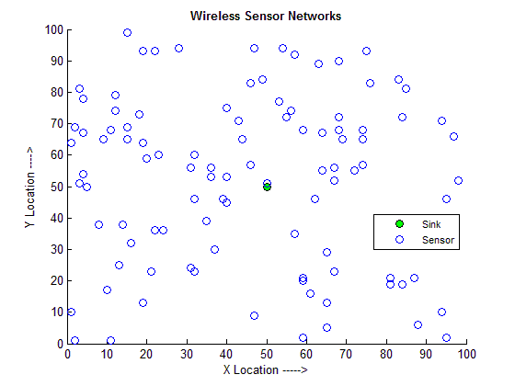

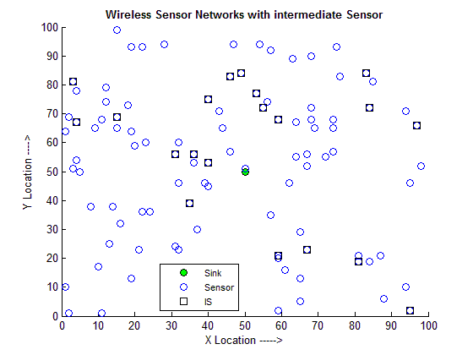

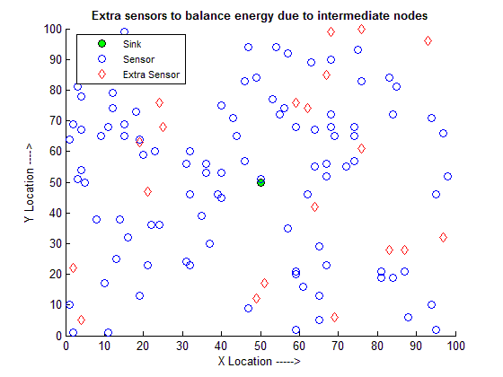

.

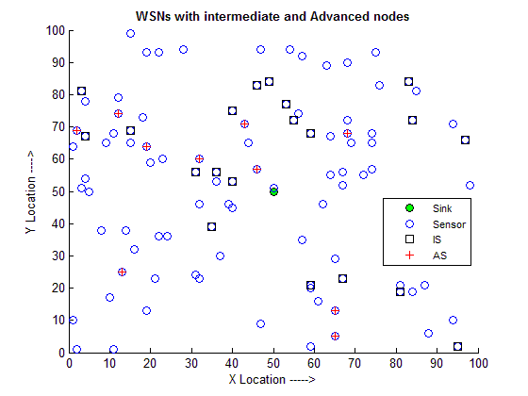

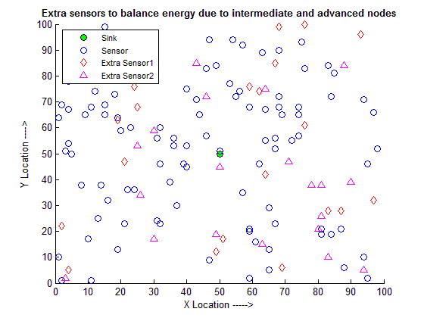

**ACKNOWLEDGEMENT**: The heterogeneity is increased to three levels in the network. There are three types of sensors i.e. Normal sensor, Advance sensor, and more advance sensors. The results are compared to calculate the life time of the network of three level hierarchies with two level hierarchies and a single level hierarchy (homogenous sensor network). The no. of sensors is different in all types of network in such a way that total energy that is given in all types of network is same. Finally we will be made a sensor network to relate as well as to compare homogenous sensor network and our proposed sensor network more efficient.

**References**

1. Sanjeev Kumar Gupta1,Neeraj Jain2,Poonam Sinha3 “Energy Efficient clustering Protocol for Minimizing Cluster Size and Inter Cluster Communication in Heterogeneous Wireless Sensor Network Research Scholar” ABV,IIITM,2013.
2. W. Heinemann, A. Chandrakasan, and H. Balakrishnan, “An Application –Specific Protocol Architecture for Wireless Micro sensor Networks” ‖ Proc. Hawaii Conf. System Sciences, Jan. 2000.
3. N. Xu, “A Survey of Sensor Network Applications” IEEE Communications Magazine, Vol. 40, 2002. Available.
4. R. Rugin, G. Mazzini, “A simple and efficient MAC-routing integrated algorithm for sensor network”, IEEE International Conference on Communications, Volume: 6, Pages: 3499 - 3503, 20-24 June 2004.
5. Jiun-Jian Liaw, Lin-Huang Chang and Hung-Chi Chu, "Improving lifetime in Heterogeneous Wireless Sensor Networks with the Energy Efficient Grouping Protocol". International Journal of Innovative Computing, Information and control. Volume 8, Number 9, September 2012.
6. A. Dhawan, "Maximizing the Lifetime of Wireless Sensor Networks," Physical Sciences, Engineering and Technology, Wireless Sensor Networks, Book 1, ISBN 979- 953-307-825-9, 2012.
7. S. Thiripura Sundari, P. Maheswara Venkatesh, Dr. A. Sivanantharaja, (2013) “A Novel Protocol for Energy Efficient Clustering for Heterogeneous Wireless Sensor Networks”, International Journal of Scientific & Engineering Research, Volume 4, Issue 8, ISSN 2229-5518.
8. Satish Chand, Samayveer Singh and Bijendra Kumar,”3-Level Heterogeneity Model for Wireless Sensor Network”, I.J.Computer Network and Information Security, 2013, 4, 40- 47.
9. G. Smaragdakis, I. Matta, A. Bestavros, SEP : A Stable Election Protocol for clustered heterogeneous wireless sensor networks, in: Second International Workshop on Sensor and Actor Network Protocols and Applications (SANPA 2004), 2004.