**THP: Triple Heterogeneous Protocol for Energy Efficient With BWSN**

Mohd Younus Dar (M.tech Student) ,Tejbir Singh(Asst.Prof)

*Department of Computer Engineering*

*GNIT, Mullana, Ambala-133 203, Haryana, India*

[Unisidar.91@gmail.com](mailto:Unisidar.91@gmail.com), tejbirrana662@gmail.com

*Abstract*: - Wireless sensors network is a network to collect data with the help of randomly deployed sensors nodes. This data is collected at the centralized resource rich node also known as base station. So every sensor in the network senses the phenomena and converts this phenomenon in the form of data. Now this data is transferred by the sensor nodes to the base station. The role of base station is to collect data sent by individual sensor in the network. Every sensor node in the network is resource constrained in terms of energy, processing power and memory. Whenever an operation is performed by sensor node, a small amount of energy is consumed which depends upon the type of operation. LEACH (Low-Energy Adaptive Clustering Hierarchy), is a clustered based energy efficient protocol that utilizes randomized rotation of local cluster head to evenly distribute the energy load among the sensors in the network. LEACH uses data fusion into the routing protocol to reduce the amount of information that must be transmitted to the base station which saves energy in the network. LEACH is a homogenous routing protocol in which only one type of sensor nodes are there in the network. Every node has same amount of resource as compared to any other node in the network. Stable Election Protocol (SEP) is a modification in LEACH protocol which is heterogeneous wireless sensor network. In SEP protocol, two types of sensor nodes are there in the network, one with limited amount of energy and second more powerful nodes with more energy. SEP protocol is more energy efficient as compared to LEACH protocol. In this research work, we design Triple Heterogeneous Protocol (THP) network. In THP network, the heterogeneity of Stable Election Protocol (SEP) is extended from 2-Level heterogeneity into 3-Llevels heterogeneity. In THP network, there are three types of sensor nodes, i.e. normal, intermediate and advanced sensor nodes. This leads to a network refers to as a 3-Tiers WSNs architecture. Simulation result proves that THP network protocol is better in terms of energy as compared to LEACH and SEP protocol.

**Keywords:-**WSN; LEACH cluster-head selection charge balanced, cluster size, Network life time Mat Lab.

INTRODUCTION: Wireless Sensor network(WSN)[2] has emerged as a promising tool which can monitor (and possibly actuating) the physical world, utilizes self-organizing networks of battery powered wireless sensors that can sense, process and communicate with each other. There are a large number of nodes in WSN of low-cost, low power, and multifunctional with sensing capability, communications and computation capabilities. Resources like CPU (for data processing), memory (for storing), battery (for energy) and transceiver (for receiving and sending signals or data from one node to another) are used by sensor nodes. These sensor nodes can communicate with each other either directly or through other nodesand form a network. There will be one or more sink nodes which are elected among the sensors nodes. These sink nodes can communicate with the user either directly or through the existing wired networks. In wireless sensor network, sensor is the primary component that senses real world physical conditions for example sound, temperature, humidity, intensity, vibration,pressure, motion..

Sink

Sensor node

WSN

internet

Mobilizer

Position finding system

Processing unit

Transmission unit

Sensing unit

Power unit

**Fig1.1: WSN Architecture**

1. PROBLEM STATEMENT

The purpose of work is to find a stable and reliable routing protocol that can support real time sensor node for environments like habitat monitoring or area surveillance and prolongs the effective network time.

In this paper there major function are performed by three node, Normal node which senses low energy conception and intermediate energy node which senses low to high energy conception and finally Advance node which sensor to highly adopted sensor energy node is that perform information exchange between neighboring node’s and each node is limited energy level processing power and sensor ability energy to conception depends upon cluster size[3] .So it has super energy node to increase power of cluster save. The energy will be generating to cluster head.

1. PROPOSED WORK

In this paper, we are needed to increase the energy of nodes or saving the energy of nodes in large WSN[4][5].A heterogeneous wireless sensor network consisting of several resource-rich super nodes used for data relaying and a large number of energy constrained wireless sensor nodes. Sensor nodes are scattered randomly to monitor a number of clusters. Since clusters are redundantly covered by more sensors, in order to conserve energy resources, we organize the sensors in clusters that are activating successively. We need to find the sensor nodes according to their energy in large area of WSN using LEACH (Low Energy Adaptive Clustering Protocol) [7], SEP (Stable Election Protocol) [7][10], and three level of heterogeneity [1]. Wireless sensor networks consist of a number of sensing nodes which are scattered in a wide area. In this, we are using three types of node such as Normal node, Intermediate node, and Advance node. The intermediate nodes are the nodes whose energy level lies exactly between the normal and advanced nodes. The advanced nodes i.e. long living nodes which have greater energy. They sense an event occurring in the environment and these sensors nodes are distributed according to the requirements of the application.

1. Firstly, make cluster.
2. Choose low energy of nodes in WSN.
3. Choose high energy of nodes in WSN.
4. Choose super energy of nodes in WSN.
5. Compare above energy of nodes with each other for finding compromise energy in WSN.

Thus, when low energy nodes send data to high energy nodes then energy will be saved.

In SEP2, We are using Normal node and Intermediate Node. In this, cluster heads are randomly selected in each round from normal nodes and intermediate nodes.

In LEACH2, all normal nodes are used due to intermediate node. From these nodes cluster heads are randomly selected in each round.

After that compare the result of SEP2 and LEACH2 and find out how much energy will be save.

In SEP3, we are using normal node, intermediate node, and advance node. In this, cluster heads are randomly selected in each round.

In LEACH3, all normal nodes are used due to intermediate node and advance node. From these nodes cluster head are randomly selected in each round.

1. ALGORITHM:

Initialization:

Step I: cluster head change over time for minimum

Energy dissipation. Decision is made by random

Number between 0 and 1become cluster head.

P=%CH, r=current round.

Step II: Header selection:

If the number are less than theefollowing

Threshold

If (temp-round<= (p/1-p*mod (r.round (1/p)))

If (count CHs<=10)

Count CHs=count CHs+1;

Step III: Advertisement:

After the selection of cluster head choose in

Between the threshold.

The node broadcast a CHs-ADV to normal

Node.

Set the function of cluster head

Set the energy of cluster head

If energy will be saving next round is executed until r-max value.

Step IV: Header switch:

If E (CH) <=E0: the node become header

If E of the node greater than E0, go to Step II.

Total energy of the network

Remaining these hold energy=0

Total energy=n*(1-m)*E0+m*(1+a)*E0

For i=1-n

Remaining energy=remaining energy+s (i)*E0.

Energy consume=total energy-saving energy

End

1. RESULTS

Here, we plotted various graphs that shows the life time of communication, network energy in communication and dead nodes in communication per round for SEP2 V/S LEACH2 In these graphs, we are using approximately 491 no. of nodes for SEP2 and 401no. of nodes for LEACH2. Because SEP2 using intermediate node (powerful as compare to normal node) and LEACH2 using normal node.So that for creating equal energy in network, we are using extra node in LEACH2 and compare both with each other. These graphs clearly shows that there is a considerable increase in the stability period (which is the time until the death of the first node) of ʺSEP 2ʺ than LEACH-2. we can see that the graphs for LEACH 2 go down earlier than that of ʺSEP-2ʺ. This means that Stability period of ʺSEP2 ʺ is more than LEACH 2

Simulation Result:

|  |  |  |  |
| --- | --- | --- | --- |
| **Protocol** | No. of rounds when nodes dead | | |
| stability period  (First node dead) | 15% nodes dead | 80% nodes dead |
| LEACH | 401 | 450 | 550 |
| SEP | 491 | 540 | 650 |

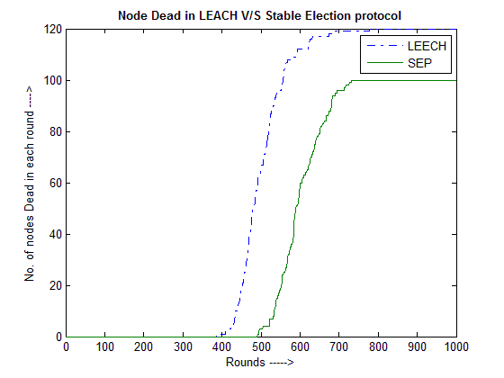

Figure 1.1 shows the number of dead nodes after each round. Simulation results proves that nodes start dyeing from 401st round in LEACH simulation whereas it is started in round number 491 in case of SEP simulation. In LEACH protocol, the gap between a first node dead and last node dead is only 150 numbers of rounds where as in case of SEP protocol, this gap is more than 200 numbers of rounds

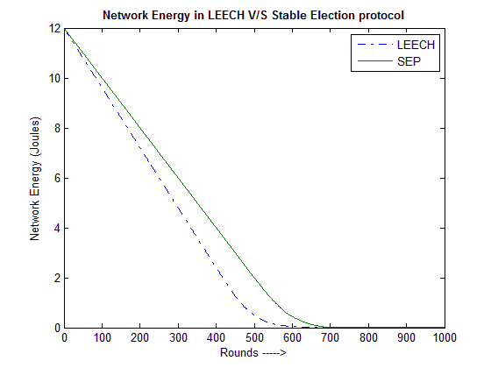Figure 1.2 shows the network energy consumption between LEACH and SEP simulation. It is clear that 100% Energy consumption is done after 550 numbers of rounds in LEACH communication but in case of SEP simulation, after round number 650 the network consumes 90% of energy.

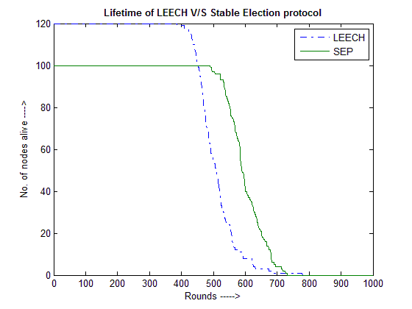

Figure 1.3 shows the network lifetime comparison between LEACH and SEP simulation. The stability period is 491 rounds in case of SEP simulation where as the stability period is 401 numbers of rounds in case of LEACH simulation. Further, a time gap between first and last node dead is very small in LEACH simulation, i.e. 150 numbers of round but this gap is more than 200 numbers of round in SEP simulation.

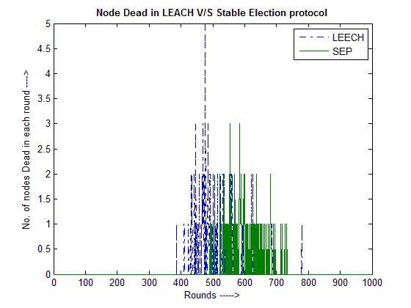

Figure 1.4 ***s***hows the number of dead nodes in each round. Simulation results proves that nodes start dyeing from 401th round in LEACH simulation whereas it is started in round number 491 in case of SEP simulation. In case of LEACH simulation, the maximum number of nodes dead in any round is 5 but in case of SEP protocol, it is maximum 3 only.

1. CONCLUSION:

Wireless Sensor networks(WSN) have developed as a promising tool for monitoring (and possibly actuating) the physical world, utilizing self-organizing networks of battery powered wireless sensors that can sense, process and communicate..Routing in sensor networks has attracted a lot of attention in the recent years and introduced unique challenges compared to traditional data routing in wired networks.

In this dissertation, we studied triple heterogeneous protocol for energy efficient WSN. Using a heterogeneous three-tier node setting in a clustering algorithmic approach, nodes elect themselves as cluster heads based on their energy levels, retaining more uniformly distributed energy among sensor nodes. Our simulation results show that –

* The stability period of ʺSEP with three heterogeneous levelsʺ was prolonged than LEACH and SEP.
* The instability period was shortened for ʺTHP with three heterogeneous levelsʺ as compared to LEACH and SEP.
* The overall network lifetime is better than SEP and LEACH protocol.

To sum up, in our simulation, we obtained a prolonged stability period and a reduction in the instability region. Ideally the advance nodes are chosen as cluster heads more than both the intermediate and normal nodes. The intermediate nodes take up the part of cluster head more frequently than the normal nodes, also as expected according to our model estimation.

1. FUTURE SCOPE:

Wireless Sensor Networks provide assurance in applications where gathering sensing information by sensing nodes in remote locations is required.WSN is an evolving field, It offers scope for lots of research. Different Routing Protocols have been developed in wireless sensor network. Although the performance of these protocols is favorable in terms of energy efficiency, further research would be needed to address issues such as better quality of service and real-time applications. Energy-aware QoS routing in sensor networks will ensure guaranteed bandwidth through the duration of connection as well as providing the use of most energy efficient path. QoS routing in sensor networks has several applications which includes real time target tracking in military applications, emergent event originating in monitoring applications etc.

1. REFERENCES
2. W. Heinzelman, A. Chandrakasan, and H. Balakrishnan, ―Energy-efficient routing protocols for wireless microsensor networks, in Proc. 33rd Hawaii Int. Conf. System Sciences (HICSS), Maui, HI, Jan. 2000.
3. Stephanie Lindsey Cauligi S. Raghavendra. "PEGASIS: Power-Efficient Gathering in Sensor Information Systems". In Proceedings of IEEE Aerospace Conference, Vo1.3, pp. 1125-1130. Big Sky Montana, March 9-16 2002.
4. S. Lindsey, C. S. Raghavendra, PEGASIS: Power Efficient GAthering in Sensor Information Systems, IEEE Aerospace Conference, 2002. RECENT ADVANCES in NETWORKING, VLSI and SIGNAL PROCESSING ISSN: 1790-5117 27 ISBN: 978-960-474-162-5
5. C. Karlof, D. Wagner, ―Secure routing in wireless sensor networks: attacks and counter measures‖, Ad Hoc Networks, Vol. 1 (2003) pp. 293315.
6. T. He et al., SPEED: a stateless protocol for real-time communication in sensor networks, in: Proceedings of International Conference on Distributed Computing Systems,Providence, RI, May 2003.
7. G. Smaragdakis, I. Matta, A. Bestavros, SEP: A Stable Election Protocol for clustered heterogeneous wireless sensor networks, in: Second International Workshop on Sensor and Actor Network Protocols and Applications (SANPA 2004), 2004
8. J.-H. Chang and L. Tassiulas, "Maximum lifetime routing in wireless sensor networks," IEEE/ACM TRANSACTIONS ON NETWORKING, vol. 12, no. 4, Aug. 2004, pp. 609-619. RECENT ADVANCES in NETWORKING, VLSI and SIGNAL.
9. Kemal Akkaya, Mohamed Younis,‖ A survey on routing protocols for wireless sensor networks‖, Ad Hoc Networks 3 (2005) 325–349.
10. Zhou, J. and De Roure, D., Designing Energy-Aware Adaptive Routing for Wireless Sensor Networks, The 6th International Conference on ITS Telecommunications, 21-23 June 2006, Chengdu,China.
11. Li Qing, Qingxin Zhu, Mingwen Wang, Design of a distributed energy-efficient clustering algorithm for heterogeneous wireless sensor networks, Computer Communications, Volume 29, Issue 12, 4 August 2006, Pages 2230-2237.
12. Ameer Ahmed Abbasia, Mohamed Younisb, A survey on clustering algorithms for wireless sensor networks, Computer Communications, 30(15), October 2007, pp2826-2841
13. Abhishek Pandey,R.C. Tripathi, ―A Survey on Wireless Sensor Networks Security, International Journal of Computer Applications (0975 – 8887) Volume 3 – No.2, June 2010.
14. Jiun-Jian Liaw, Lin-Huang Chang and Hung-Chi Chu, "Improving lifetime in Heterogeneous Wireless Sensor Networks with the Energy Efficient Grouping Protocol". International Journal of Innovative Computing, Information and control. Volume 8,Number 9,September 2012.
15. Satish Chand, Samayveer Singh and Bijendra Kumar,”3-Level Heterogeneity Model for Wireless Sensor Network”, I.J.Computer Network and Information Security, 2013,4,40-47.
16. Sanjeev Kumar Gupta1,Neeraj Jain2,Poonam Sinha3 “Energy Efficient clustering Protocol for Minimizing Cluster Size and Inter Cluster Communication in Heterogeneous Wireless Sensor Network Research Scholar” ABV,IIITM,2013.