**FUNDUS IMAGES FOR DIAGNOSIS OF DIABETIC RETINOPATHY USING SEGMENTATION OF BLOOD VESSELS**

K. RENU SREE1, K. DIVYA VANI2, G. SAMYUKTHA RANI3, N. SHILPA REDDY4, N SREENIVASA RAO5

1, 2, 3, 4 Department of Electronics and Communication, Santhiram Engineering College, India,

5Asst. Prof. Department of Electronics and Communication, Santhiram Engineering College, India

**ABSTRACT**

In this major project, our team will analyze and able to get strategy yields competitive results for both pre-processing modalities, i.e., Contrast Limited Adaptive Histogram Equalization (CLAHE) and Generalized Linear Model (GLM) of Sensitivity (Sn), Specificity (Sp), Accuracy (Acc) parameters.

Computer-Aided Diagnosis (CAD) is a widely used technique to detect and diagnose diseases like tumors, cancers, edemas, etc. Several critical retinal diseases like diabetic retinopathy (DR), hypertensive retinopathy (HR), Macular degeneration, retinitis pigmentosa (RP) are mainly analyzed based on the observation of fundus images. The raw fundus images are of inferior quality to represent the minor changes directly. To detect and analyze minor changes in retinal vasculature or to apply advanced disease detection algorithms, the fundus image should be enhanced enough to visibly present vessel touristy, for contrast enhancement, various retinal-vessel segmentation methods apply image-contrast enhancement as a pre- processing step, which can introduce noise in an image and affect vessel detection.

Specifically, for retinal vessels segmentation, accurate segmentation of fundus images is highly challenging due to low vessel contrast, varying widths, branching, and the crossing of vessels most vessel segmentation strategies utilize contrast enhancement as a pre-processing step, which has an inherent tendency to aggravate thenoise and therefore, impede accurate vessel detection. To alleviate this problem, we propose to use the state-of-the-art Probabilistic Patch Based (PPB) denoiser within the framework of an unsupervised retinal vessel segmentation strategy based on the Frangi filter.

The performance evaluation of the proposed method is evaluated on two recognized open-access datasets, viz: DRIVE. The proposed strategy yields competitive results for both pre-processing modalities, i.e., Contrast Limited Adaptive Histogram Equalization (CLAHE) and Generalized Linear Model (GLM) of Sensitivity (Sn), Specificity (Sp), Accuracy (Acc) parameters.

**Keywords:** Contrast Limited Adaptive Histogram Equalization (CLAHE), Generalized Linear Model (GLM) of Sensitivity (Sn), Accuracy (Acc), hypertensive retinopathy (HR), retinitis pigmentosa (RP)

# 1 INTRODUCTION

## 1.1 Introduction to Retina

The retina is the photosensitive (light sensitive) tissue that covers approximately 65% of the interior surface of the eye. The retina is not actually attached to the vascular choroid layer that it lays directly against, but is held in place by the pressure of a jelly-like fluid known as the vitreous humor that fills the chamber of the eye behind the lens.

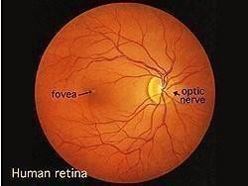

**Figure 1**: Retina

Above figure 1.1 shows the structure of retina. In the center of the retina is the optic nerve, a circular to oval white area measuring about 2 x 1.5 mm across. From the center of the optic nerve radiates the major blood vessels of the retina. Approximately 17 degrees (4.5-5 mm), or two and half disc diameters to the left of the disc, can be seen the slightly oval-shaped, blood vessel-free reddish spot, the fovea, which is at the center of the area known as the macula by ophthalmologists.

A circular field of approximately 6 mm around the fovea is considered the central retina while beyond this is peripheral retina stretching to the ora serrata, 21mm from the center of the retina (fovea). The total retina is a circular disc of between 30 and 40 mm in diameter. The retina works much like the film of a camera. It takes the visual information transmitted by beams of light reflecting off of objects and converts that information into a neural 'image' that it then transmits to the brain through the bundle of nerve fibers called the optic nerve. When a beam of light enters the eye, it passes through accessory structures - such as the iris, pupil and lens - all of which serve the singular. It houses all of the photoreceptor cells, called rods and cones, which, when triggered by photons of light, result in a cascade of electrochemical events that generate a nerve impulse. It is this nerve impulse that, when received and translated by the brain, allows us the amazing feat of sight!

Rods are the specialized photoreceptor cells that allow us to see in dim lighting. You could think of them as the high-speed black and white film of the eye (back before the days of digital cameras) in that they are ultra- sensitive to dim light (enabling us to see gradations of blacks and grays in low light settings), as well as very sensitive to high-speed movement.

Retina contains about 125 million rod cells, giving you both a very acute awareness for anything trying to sneak up on you, as well as the ability of twilight sight (the ability for your eyes to adjust and see in dim lighting). What's interesting is that rods are completely insensitive to red light frequencies, so if someone were to shine a red frequency light in your eyes after your eyes had adjusted to the dark, your night vision would be undisturbed. This is why navigational instruments use red lights for night illumination.

Cones are the specialized photosensitive cells that allow us to see color. Cones are like the low-speed color film of the eye because they are great at sensing bright light and detailed colors but are insensitive to low lights and high speed.

## 1.2. Diabetic Retinopathy

In the recent years, there has been a gradual increase in the number of diabetic patients and it is approximately 65,000 million persons in India. Among the Diabetesrelated eye disease, Diabetic Retinopathy (DR) is the most chronic disease which affects nearly one out of every ten persons with diabetes, according to point prevalence estimates. DR is one of the most important reasons which make the key cause of vision loss, especially in middle-aged people. India has the highest number of diabetics in world with DR steering it to the 6th biggest cause of vision impairment in the country. In addition, this disease will experience a high growth in the future due to diabetes incidence increase and ageing population in the current society.

The early diagnosis allows, through appropriate treatment, to reduce costs generated when they are in advanced states and may become chronic. This fact justifies screening campaigns However, a screening campaign requires a heavy workload for trained experts in the analysis of anomalous patterns of each disease which, added to the at-risk population increase, makes these campaigns economically infeasible. Therefore, the need for automatic screening systems is highlighted. The working process of an automatic screening system follows an organized procedure in which the system tries to learn the characteristics of disease through the retinal images and then the testing is carried out.

The automatic system requires a clear and distortion free retinal image to learn its characteristics. Hence there is a need to develop an approach which produces a clear and distortion free image even though the image captured through camera is not clear and contains distortions. As a standard image modality, fundus camera is usually used to acquire retinal images, showing structures like optic disc, retinal vessels and several others. The changes detected in these structures indicate the pathological condition associated with diabetic retinopathy. Therefore, the analysis of retinal images is a useful and helpful diagnostic tool.

Diabetic retinopathy (DR), the major cause of poor vision, is an eye disease that is associated with longstanding diabetes. If the disease is detected in its early stages, treatment can slow down the progression of DR. However, this is not an easy task, as DR often has no early warning signs. Earliest signs of DR are damages of the blood vessels and then formation of lesions. Lesions such as exudates are normally detected and graded manually by clinicians in time consuming and it is susceptible to observer error. Diabetic retinopathy results from the leakage of small vessels in the retina correlated to a prolonged period of hyperglycemia. In the early stages of the disease, known as non-proliferative retinopathy, there may be hemorrhages due to bleeding of the capillaries or exudates resulting from protein deposits in the retina. There is usually no vision loss unless there is a build-up of fluid in the center of the eye.

As the disease progresses, new abnormal vessels grow in the retina, known as revascularization. This stage of the disease is called proliferative retinopathy and may cause severe visual problems.

## 1.3 Exudates:

Exudates are common abnormalities in the retina of diabetic patients. Exudates are bright lipids leaked from a blood vessel. The leaked fluid tends to stay close to the lesion, giving a generally well-defined edge suitable for computer analysis. Figure (1.2) gives an example of exudates, which show up as small, light- yellow region.

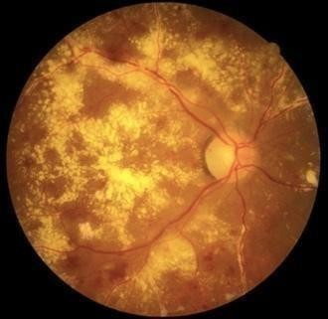The chief cause of exudates is leaking of proteins and lipids from the bloodstream into the retina through damaged blood vessels. In retinal images, exudate exhibits as hard white or yellowish localized regions with varying sizes, shapes and locations. Generally, they materialize near the leaking capillaries within the retina. The hard exudates are

**Figure 2**: Exudate

formations of lipid that are leaking from these weakened blood vessels. This kind of the retinopathy is termed as non-proliferative diabetic retinopathy. Optic disk is also bright yellow region which have similar appearance of exudates. The optic disk, which can be seen in Figure 1, is also a light-yellow region. Therefore, before searching for exudates based on their yellow color, an algorithm is developed for automatic detection of the optic disk to eliminate this physiologically valid, yet it has similar structure. The localization of the optic disk as the identification of the center of disk is either by specifying the center of the optic disk or placing a mask within a particular region of the retina.

Segmentation of the optic disk usually refers to the subsequent task of determining the contour of the disk. Localization and segmentation of the optic disk are important tasks in retinal image Detection of exudates by computer could offer fast and precise diagnosis to specialist inspection. Also, it assists the clinician to take timely the right treatment decision.

## Problem Statement

Retinal vessel segmentation is used for diagnosis of Diabetic Retinopathy (DR) is very deadly one, which may cause blindness, but the exact output we are not getting and the accuracy also. For this problem, we are trying to get the classification results exactly and trying to get the accuracy more.

## Proposed System

Retinal vessel segmentation is more important in the diagnosis eye related diseases. Though there are so many approaches developed in earlier to extract the vascular structure from a retinal fundus image, still there exist some problems due to the internal feature like exudates and Micro Aneurysms and Hemorrhages (MAHMs) etc. along with these aspects, the presence of some external disturbances also effects the segmentation performance. To achieve an optimal segmentation performance in the retinal vessel segmentation, this paper proposes a new three phase framework based on optimal feature set extraction and supervised machine learning. The complete accomplishment of proposed method is done in three phases, preprocessing, classification of vessel pixels and post processing. The overall accomplishment of proposed mechanism is depicted in the following figures.

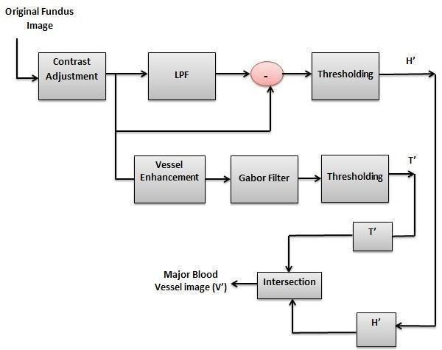

Frangi

**Figure 3 :** Block diagram of proposed system

In the initial preprocessing phase (Figure.4.1), a major blood vessel image is extracted from the original retinal image such that the major portion of the image is obtained. For this purpose, the initial fundus image is subjected to contrast enhancement such that brighter will appear brighter and dark regions will appear darker. Here the main objective is to extract the maximum possible retinal vasculature from the retinal image and it is possible only when the background pixels are darker than retinal pixels. The contrast enhancement process will achieve this through an adaptive normalization process. Further, two threshold binary images are obtained; one is through high pass filtering and another is through the accomplishment of frangi filter over the red regions of the green plane of retinal fundus image. Next, from these two binary images, major blood vessel is extracted and the remaining pixels left in the two images are combined to form a vessel sub image. This vessel sub image is subjected to second phase processing to extract the further pixels which have ability to represent the retinal vessels.

In the second phase, the vessel sub image is subjected to classification to separate the vessel pixels from background pixels through support vector machine (SVM) classifier. This process is mainly to extract the minor pixels which are representing the vessels in retinal image. Since the minor vessel pixels are not much brighter and they look like background, a proper differentiation is required to separate them form background pixels and the proposed new feature extraction technique fulfills this requirement. A feature set integrated with thirteen different features is formulated for vessel sub image and trained to SVM classifier to classify the minor vessel pixels form background pixels.Finally, in the last phase (post processing), the minor vessel

obtained in second phaseare combined with major blood vessel pixels (extracted in first phase) to obtain a complete retinal vasculature.

Initially for a given color retinal fundus image, the green plane is extracted and scaled in the range from 0 to 1. The preprocessing stage requires a green planeof fundus image and a fundus mask. Initially the fundus image is subjected to vessel enhancement by superimposing the fundus mask over followed by a contrast adjustment and vessel enhancement. Here the vessel enhancement involves the squaring the pixel intensities and re-normalizing to the range from 0 to 1. Due to thisoperation, the bright regions will become brighter and the dark regions will becomedarker which provides a perfect discrimination between the vessel pixels and background pixels, resulting in enhanced blood vessel regions. In the green planeimage, the red regions of the blood vessels segments appear as dark regions which has the pixel intensities close to 1. To extract the blood vessels from the green plane of fundus image, initially the green plane is scaled in the range from 0to 1 and then it is passed through the low pass filter. Before passing it through an LPF, it is subjected to contrast enhancement Then the vessel enhanced image is passed through the LPF and the obtained output is subtracted from the vessel enhanced image, resulting a high pass filtered image. Here the size of LPF is takenas 20*20. The high pass filtered image then threshold to obtain the pixels less than0 and then absolute pixel strengths of the threshold image and contrast adjusted to extract the vessel regions. This is the first stage preprocessed image which has only the major blood vessels. Further, the second stage preprocessing is accomplished to extract the minor blood vessels which are not distinguishable. Thissecond stage preprocessing is applied over the negative of vessel enhanced image. After obtaining the negative image, the Frangi filter is applied over it to extract thedominant features in the various orientations.

# 4 EXPERIMENTAL RESULTS AND EVALUATION

In this chapter, experimental results and evaluation of analysis are described. The algorithm efficiency and resource utilization are calculated by using MATLAB. **Results**

By performing the followings steps, we can get the output.

**Step 1**: open the MATLAB and write the code in editor window.

**Step 2**: Now choose the picture, which we are going to give as an input by clicking ctrl + o.

**Step 3**: run the code

**Step 4**: if there are any errors modify it, and again run the code

**Step 5**: After running thecode successfully, it will pop up the figures, and gives the output as percentage values of sensitivity, specificity, accuracy.

**Output 1:**

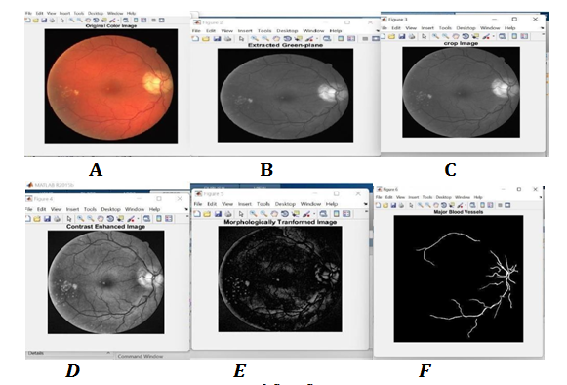

**Figure 4** output of first figure

In the figure 4, A, B, C, D, E, F represents the Original image, Extracted Green Plane, Crop Image, Contrast Enhanced Image, Morphological Transformed Image, Major Blood Vessel are the output of the first sample image. The output percentage values of sensitivity, specificity, accuracy is 0.7194, 0.9575, 0.9528respectively.

#### Output 2:

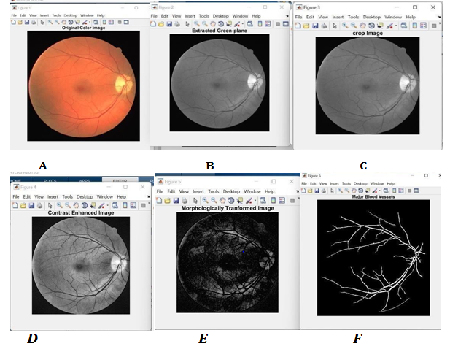

**Figure 5** output of second figure.

In the figure 5, A, B, C, D, E, F, represents the Original image, Extracted Green Plane, Crop Image, Contrast Enhanced Image, Morphological Transformed Image, Major Blood Vessel are the output of the second sample image. The output percentage values of sensitivity, specificity, accuracy is 0.7172, 0.9575, 0.9565 respectively.

#### Output 3:

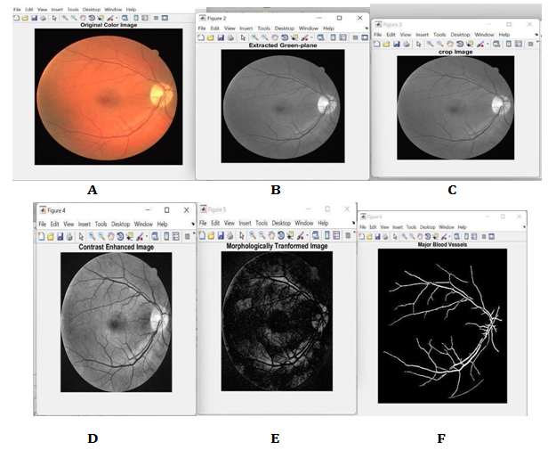

**Figure 6**: Output of third figure

In the figure 6, A, B, C, D, E, F represents the Original image, Extracted Green Plane, Crop Image, Contrast Enhanced Image, Morphological Transformed Image, Major Blood Vessel are the output of the third sample image. The output percentage values of sensitivity, specificity, accuracy is 0.7200, 0.9580, 0.9519 respectively.

**Table 1. Output Values of Different Samples**

|  |  |  |  |
| --- | --- | --- | --- |
| Image Sample |  | DRIVE |  |
| Sensitivity | Specificity | Accuracy |
| S1 | 0.7194 | 0.9575 | 0.9528 |
| S2 | 0.7172 | 0.9545 | 0.9565 |
| S3 | 0.7200 | 0.9580 | 0.9519 |

# 5 CONCLUSION AND FUTURE SCOPE

## Conclusion

In this paper, a novel vessel segmentation method based on Gabor transformation and Gradient features is presented. The abnormal signs of retinal images complicated the vessel segmentation algorithm. Given the high ability of the proposed algorithm in separating orientations in image components, the use of this algorithm with appropriate Gabor transform could extracts the retinal regions from retinal images. The experimental results over the standard datasets DRIVE and STARE indicate the ability of the proposed method in segmenting blood vessels in images. After the simulation of proposed mechanism over the DRIVE dataset, the average sensitivity, specificity and accuracy are observed as 0.7564, 0.9531, and 0.9534 respectively. Further the average results over the STARE dataset are observed as 0.7525, 0.9553, and 0.9601 of sensitivity, specificity and accuracy respectively.

## Future Scope

Further this work can be extended to extract the remaining features such as exudates, optic disk and macula form the retinal image by which an effective automatic diabetic retinopathy diagnosis system can be developed which reduces the manual effort.

# REFERENCES

* + 1. Hoover, “Locating blood vessels in retinal images by piecewise threshold probing of a matched filter response,” IEEE Transactions on Medical Imaging, vol. 19, no. 3, pp. 203–210, 2000.
    2. B D Barkana, “Performance analysis of descriptive statistical features in retinal vessel segmentation via fuzzy logic, ANN, SVM, and classifier fusion”, Knowledge-Based Systems, Volume 118, 15February 2017, Pages 165-176
    3. B.R. Mcclintic, J.I. Mcclintic, B.S. Ba, J.D. Bisognano, R.C. Block, A relationship between microvascular abnormalities and coronarydisease

– a review, Am. J. Med. 123 (4) (2011) 1–12.

* + 1. D. Marin, A. Aquino, M. Gegundez-Arias, and J. Bravo, “A new supervised method for blood vessel segmentation in retinal images byusinggray-level and moment invariants-based features,” IEEE Transactions on Medical Imaging, vol. 30, no.

1, pp. 146–158, 2011.

* + 1. F. Zana and J. C. Klein, “Segmentation of vessel-like pattern using mathematical morphology and curvature evaluation,” IEEE Transactions on Image Processing, vol. 10, no. 7, pp. 1010–1019, 2001.
    2. G. Azzopardi, N. Strisciuglio, M. Vento, and N. Petkov, “Trainable COSFIRE filters for vessel delineation with application to retinal images,” Med. Image Anal., vol. 19, no. 1, pp. 46–57, 2015.
    3. G. B. Kande, P. V. Subbaiah, and T. S. Savithri, “Unsupervised fuzzy based vessel segmentation in pathological digital fundus images,” Journal of Medical Systems, vol. 34, no. 5, pp. 849–858, 2010.
    4. Liskowski P, Krawiec K. Segmenting Retinal Blood Vessels with Deep Neural Networks. IEEE Transactions on Medical Imaging. 2016.
    5. Mohan V, Shah SN, Joshi SR, Seshiah V, Sahay BK, Banerjee S, Current status of management, control, complications a n d psychosocial aspects of patients with diabetes in India: Results from the DiabCare India 2011 Study. Indian J EndocrinolMetab 2014; 18:3708.
    6. N. Memari, A R Ramil, M I B saripan, S. Mashohor, M Moghbel, Supervised retinal vessel segmentation from color fundus images based on matched filtering and AdaBoost classifier, PLoS ONE 12(12): e0188939, 2017.