Attendance system with image processing and machine learning

An Enhanced Local Binary Pattern based Attendance System using machine learning

Dr.Shridevi Soma , Vinayak Patil , Praveen N S, Shivshankar Biradar Department of computer science and engineering

PDA College of engineering Kalaburagi [shridevisoma@gmail.com](mailto:shridevisoma@gmail.com)

[shivshankarbiradarkmnr@gmail.com](mailto:shivshankarbiradarkmnr@gmail.com)

**Abstract**

Face is the representation of one’s identity. Hence, an automated student attendance system based on face recognition is proposed in the paper. Face recognition system is very useful in life applications especially in security control systems in this proposed approach, video framing is performed by activating the camera through a user-friendly interface. The region of interest from input image which is segmented from the video frame by using Viola-Jones algorithm. In the pre-processing stage, scaling of images is performed, in order to prevent loss of information. The median filtering is applied to remove noise followed by conversion of colour images to grayscale images. In face recognition stage, enhanced local binary pattern (LBP) is applied correspondingly in order to extract the features from facial images. In this proposed approach, the enhanced local binary pattern outperforms the original LBP by reducing the illumination effect and increasing the recognition rate. Then the features extracted from the test images are compared with the features extracted from the training images. The facial images are then classified and recognized based on the best result obtained from SVM classifier which gives better efficiency as compared to KNN. Then, the attendance of the recognized student will be marked and saved in the data base. The efficiency of the proposed algorithm is 94%.

**Keywords—Face Recognition, Class Attendance, Haar Cascade,**

**LBPH**

# INTRODUCTION

The technology is evolving and is becoming a very essential part of our life. People love and enjoy our new way of life which is supposedly called “The Smart Life” as it reduces human efforts and saves ample amount of time. Using the technology in the tiniest thing, say for toasting the bread is what people are used to. The question arises when you’re in the school or college and you find your professors struggling with management of class attendance. The question arises when you see the professors wasting their time, energy, and efforts just to record the list of present students.

The traditional approach of calling out students' names, passing the attendance sheet is not only limited to being time- consuming but also gives rise to malpractices like manipulation in the attendance, proxy, etc. There are a few attendance systems which use technology like sensors and

biometrics like fingerprint, iris scanning (which at times can be unreliable). However, the system proposed in this conference stands out as it is a one-stop system to manage and record the class attendance.

The system follows four steps of working. Firstly, the record of each student is added (Roll Number and Name) and a video is captured, the images are taken from the frames of the video. In the training process - the second step, the images of the student are trained using LBPH and Haar Cascade and saved in the form of a YML file. In the tracking process - the third step, the database of trained images is compared with the student’s face to track the student’s face. Lastly, the attendance is marked in the CSV file for the tracked student with respective time and date. In this system, the list of students in the class can be viewed and the record of the particular student can be deleted as well. The efforts put and the skills used for this project will transform and smarten the classrooms.

Few of the terms used in the paper are explained in brief:

1. Local Binary Patterns Histogram (LBPH)

The local Binary Patterns Histogram or simply, LBPH is used widely for face recognition because of the computational simplicity offered by this algorithm. This algorithm is OpenCV’s part and it follows a few steps to recognise the face. It first creates the database, performs face acquisition, extracts the features from the face, and classifies the database to check if it matches with the input or not.

1. Haar Cascade Algorithm

Haar Cascade is a face detection algorithm. To train the classifier, this algorithm needs a few images, it extracts the features from the image and calculates it. The irrelevant features calculated are removed by the Adaboost - a training process where the facial and non-facial features are classified. Since the non-facial regions are more in the image, the cascade classifier removes it in a single shot and hence the algorithm gets facial regions for detection. The OpenCV has both - the trainer as well as the detector and it also contains a lot of pre-trained classifiers which are available in the form of XML file.

Department of computer science and engineering PDA college of engineering Kalburgi

# LITERATURE SURVEY

There have been many people who understood the need for the automated attendance management system in education technology. There are many projects and researches made regarding automated attendance systems. A few of the systems are closely related to the system is proposed in this paper. Here is a literature survey for getting a clear idea about the related work done in the past and for analysing these systems.

Shubhobrata Bhattacharya et al [1] designed a system which needs a video sequence as an input, the face is detected using the Viola-Jones algorithm and the facial features are extracted. The facial features are then normalized for which they used parameters like pose detection, sharpness, image size or resolution, and brightness. Lastly, a final quality score is displayed.

Whereas, the authors in [2] proposed a system which captures the face, carries out a face detection process in which the skin colour and face motion is detected and tracked. It also localizes the position of eyes, lips, and face borders. Further, the face is aligned, normalized and then the features are extracted to be used in the matching process.

In [3] the authors made a system which captures a video and converts it into frames. The face is detected using the CNN algorithm. These detected faces in the database are then matched with the input to recognise the face. On completion of this process, the name of students is updated in the CSV file - on a weekly or monthly basis.

On a similar lines, in the paper [4] developed a system which captures video, convert it into frames which are further used as the student image, detects the face using Viola-Jones algorithm, recognises the face using LBPH algorithm, and lastly, once the face is matched with the database, the student attendance is marked in the CSV file.

Mayank Srivastava et al [5] developed a system which consists of three steps - Firstly, the face image is detected, extracted, and stored in a YML file such that it can be used in the future. In the second step, the image is trained and thus the Eigenvector and Eigenvalue of the image is computed. Finally, the images stored in the YML format are used to compare and recognize the face.

In the paper [6], the authors used a two-dimensional face recognition by implementing LBP. This system also controls the door for allowing the students in the class, It is an online web server and hence is accessible to any individual who is an authenticated web client.

Kennedy Okokpujie et al [7] served the camera as an input device. The camera acquires the detected face for which the Viola-Jones algorithm is used. To create the templates of the captured images, Fisherfaces algorithm is used. The verified face images form the basis for the attendance. The attendance recorded is relayed to the authorized handheld devices via cellular network. The database capacity is up to twenty persons with twenty to fifty image databases per person.

There are a lot of insightful papers regarding attendance using face recognition. These systems have recorded some or other drawbacks which the proposed system tries to overcome. A few of the observed drawbacks are - limited database capacity, expensive systems, lack of accuracy, in the process, attendance on a weekly or monthly basis.

Mentioned below are a few attendance systems other than face recognition and also a few existing face recognition algorithms are discussed:

* 1. *Attendance using pen and paper*

In this method, there are two types. One in which the teacher calls out the name of the students to mark their attendance. And the other in which the sheet is passed in the class and the students mark their attendance by entering the required details. This approach not only takes up time and disturbs the class but also leads to malpractices like manipulation in attendance and proxy and hence is not a reliable option.

* 1. *Attendance using physiological biometrics •* To automate the attendance system, there are several fingerprint and hand sensing attendance systems. For example, Mohamed Basheer K P and Raghu CV [8] proposed a system in which a handheld device (LCD Display) can be used in the classroom to mark the attendance using the fingerprint sensor. This device is managed by the faculty using a host computer. The student data can be added, and attendance data can be imported or exported.

Considering the current Covid-19 pandemic situation, using a fingerprint or hand scanner is indeed not a reliable system since it contains contact of every student with the device and hence can be dangerous.

* + - The attendance can also be recorded automatically using iris recognition. Amena Khatun et al [9] proposed a system in which an image of a person is taken through a web-cam and sent to a computer for further processing. The transfer of data is through a USB connection between the webcam and computer. In the image acquisition process, the iris is localized, the image is adjusted, and the iris is checked. If the required conditions are matched, the iris is extracted and is saved as an iris template database. This iris when matched with the person, is then authenticated else the above steps are repeated. This system can be reliable but there is a probability of lack of accuracy.
  1. *Attendance using physiological biometrics*

Biometrics like voice can be used for attendance management. Benfano Soewito et al [10] made research in which they used a smartphone for fingerprint and voice recognition. For voice recognition, the recorded electronics signal is converted into a spectrogram or voiceprint. The next voiceprint is stored in the form of a sequence of numbers and each dominant frequency in each segment is expressed as a binary number. Thus, they get a sound template which can be used to match for the authentication process.

* 1. *Existing face recognition algorithms*

There are several types of face recognition algorithms. The Eigenfaces, LBPH, Fisherfaces, SIFT, and SURF are few of the most known face recognition algorithms. These algorithms are compared in Table No. 1 based on the approximate standard maximum accuracy which each algorithm offers.

**Table No. 1. Face recognition algorithms**

|  |  |
| --- | --- |
| Face Recognition Algorithm | Accuracy |
| Eigenfaces | ≈ 93% |
| Local Binary Patterns Histograms (LBPH) | ≈ 94% |
| Fisher faces | ≈ 92% |
| Scale Invariant Feature Transform (SIFT) | ≈ 96.44% |
| Speed Up Robust Features (SURF) | ≈ 90.2% |

# METHODOLOGY

The system proposed in the basis of face recognition. When a student come across the camera module, then his/her image/photo will be captured and recognize with validation. When recognition and validation is succeeded, then his/her attendance will mark automatically. In this system, user gets a login interface to interact with the system. The proposed block diagram of the automatic attendance system is shown in the Fig. 1. The system block diagram and explained as follows.

*Training*



DB

S V M

Attendance marked

Feature Extraction

Feature Extraction

Image Acquisition

Pre- processing

*Testing*

Input video

Pre- processing

## Fig. 1. Architecture of ELBAS

1. **Capturing the Video**

The camera is used to take the video of students present in the class which will then be divided into frames to get the images.

## Face Detection

In this part, implements face detection, which helps to determines captured image with location and sizes of student faces. The image will be captured from detected faces using haar cascade classifier.

## Image Pre-processing

There is a pre-processing requirement for enhance the input image for improve the quality of image and convert input image to grey scale image using colour to grey image conversion technique.

## Training Set

Comparing the faces which to be recognized with some other similar faces to did recognition process. Supply algorithm faces in training set for tell which person who belongs. When recognize face by algorithm, it uses the training set to make recognition.

## Face Recognition

The important part of this system is face recognition. Face recognition of an automatic method of identifying and verifying a person from images and videos from camera.

## Attendance marker

The particular student will be marked as present in attendance when if a face from the particular date folder is matched. That is, collect the list of all students who were present in the class, and rest of the students belongs the class will be marked as absent. This is the following procedure. Face Detection using Haar cascade classifier Paul Viola and Michael Jones are proposed the effective object detection method Haar cascade classifier. This is machine learning based approach. From this, a cascade method analyses from the positive and negative images.

# RESULT AND DISCUSSION

The developed project is a face recognition-based class management and attendance system which is expected to take the student details and images as input. The image is trained using Haar Cascade algorithm and a YML file is created out of these trained images. The trained image data is compared with the tracked image using SVM classifier which works better when compared KNN as shown in the below chart then the attendance is marked for the student whose face matches with the existing database.

Comparision of SVM & KNN

SVM

KNN

Accuracy of Training Data

Accuracy of Test data

|  |  |  |  |  |  |
| --- | --- | --- | --- | --- | --- |
|  |  |  |  |  | |
|  |  |  |
|  |  |
|  |  |

*A. Add Details*

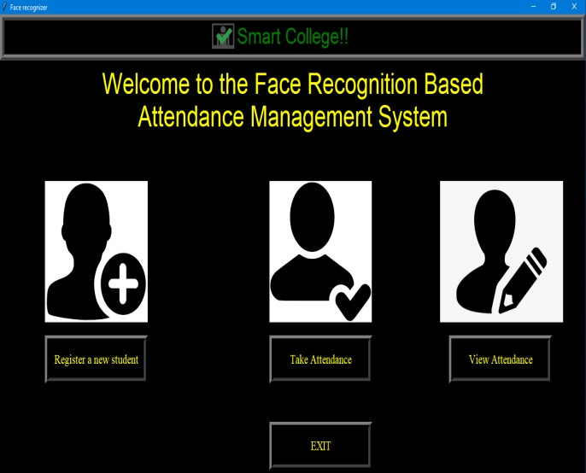

## Fig. 2. Student Detail Input

The details of the student - Roll number and Name are added in the table created namely “student.” The roll number is a primary key and the name is a text. Fig. 2 shows the GUI of Add Details page.

*B. Take Image*

On clicking “Take Image,” the webcam opens up and records a real-time video and converts it in frames to be used as an image of the student. On images being taken, the status will be updated as “Images taken for ID: *roll no*

Name: *name.* ”

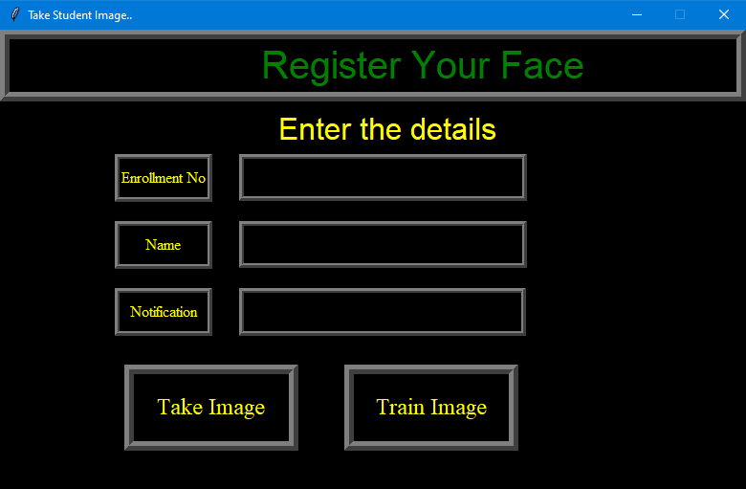

## Fig.3 student details

*C. Train Image*

The image is trained using the haar cascade algorithm. The label to the image is assigned as the name and roll number of the student. This trained data set is saved as “trainer.” The status is updated to “Image trained”



## Fig. 4. Status Update

*D. Attendance Record*

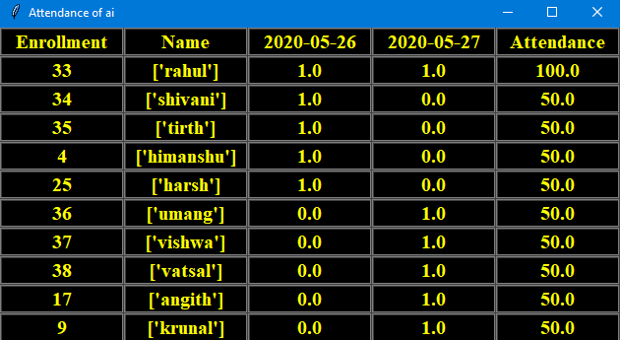

## Fig. 5. Attendance marked

The attendance is marked in the CSV file for the students whose face matches with the existing database.shows how the attendance is marked in the sheet in “Attendance,date” format.

*G. View List*

On clicking the “View List,” the list of students in the class whose database has been recorded can be viewed. In case a student is not recognised by the system, the faculty can view the list and make sure if the database of the student has been added or not.

# CONCLUSION

The process of conducting attendance automatically by using the face recognition and detection algorithms like LBPH and Haar Cascade is a reliable and efficient system. The Haar Cascade provides a high accuracy level irrespective of the illumination. The system can give an accuracy of about 94%. To get better results and accuracy, the class should be well illuminated. This system improves the productivity of the class since there is no longer any source of disturbance caused by taking attendance manually and also an ample amount of time is saved.

.

# FUTURE SCOPE

1. The newer version of the system can be updated where this system will not only be limited to a classroom. This system can be made available for any place where attendance is a need. For example - in an office, in the hospital.
2. This system can be developed as a product. It can be made available on the webserver so that it can be accessible to anyone, anywhere across the globe.

# REFERENCES

1. S. Bhattacharya, G. S. Nainala, P. Das and A. Routray, "Smart Attendance Monitoring System (SAMS): A Face Recognition Based Attendance System for Classroom Environment," *2018 IEEE 18th International Conference on Advanced Learning Technologies (ICALT)*, Mumbai, 2018, pp. 358-360, doi: 10.1109/ICALT.2018.00090.
2. R. Hartanto and M. N. Adji, "Face Recognition for Attendance System Detection," 2018 10th International Conference on Information Technology and Electrical Engineering (ICITEE), Kuta, 2018, pp. 376- 381, doi: 10.1109/ICITEED.2018.8534942.
3. Nandhini R, Duraimurugan N, S.P.Chokkalingam, “Face Recognition Based Attendance System,” International Journal of Engineering and Advanced Technology (IJEAT) ISSN: 2249 – 8958, Volume-8, Issue- 3S, February 2019
4. Smitha, & Hegde, Pavithra & Afshin,. (2020). Face Recognition based Attendance Management System. International Journal of Engineering Research and. V9. 10.17577/IJERTV9IS050861.
5. M. Srivastava, A. Kumar, A. Dixit and A. Kumar, "Real Time Attendance System Using Face Recognition Technique," 2020 International Conference on Power Electronics & IoT Applications in Renewable Energy and its Control (PARC), Mathura, Uttar Pradesh, India, 2020, pp. 370-373, doi: 10.1109/PARC49193.2020.236628.
6. O. A. R. Salim, R. F. Olanrewaju and W. A. Balogun, "Class Attendance Management System Using Face Recognition," 2018 7th International Conference on Computer and Communication Engineering (ICCCE), Kuala Lumpur, 2018, pp. 93-98, doi: 10.1109/ICCCE.2018.8539274.
7. K. Okokpujie, E. Noma-Osaghae, S. John, K. Grace and I. Okokpujie, "A face recognition attendance system with GSM notification," 2017 IEEE 3rd International Conference on Electro-Technology for National Development (NIGERCON), Owerri, 2017, pp. 239-244, doi: 10.1109/NIGERCON.2017.8281895.
8. Basheer, Mohamed & Raghu, C.V.. (2012). Fingerprint attendance system for classroom needs. 433-438. 10.1109/INDCON.2012.6420657.
9. B. Soewito, F. L. Gaol, E. Simanjuntak and F. E. Gunawan, "Smart mobile attendance system using voice recognition and fingerprint on smartphone," 2016 International Seminar on Intelligent Technology and Its Applications (ISITIA), Lombok, 2016, pp. 175-180, doi: 10.1109/ISITIA.2016.7828654.
10. A. Khatun, A. K. M. Fazlul Haque, S. Ahmed and M. M. Rahman, "Design and implementation of iris recognition based attendance management system," 2015 International Conference on Electrical Engineering and Information Communication Technology (ICEEICT), Dhaka, 2015, pp. 1-6, doi: 10.1109/ICEEICT.2015.7307458.