Effects of *Buchholzia coriacea* aqueous seed extract on white blood cell counts of saccharin - induced hyperglycemic Wistar rats

Ajiboso, Semiu O.

Department of Biochemistry & Molecular Biology, Nasarawa State University, Keffi – Nigeria.

email address: [ajibososemiu@nsuk.edu.ng](mailto:ajibososemiu@nsuk.edu.ng)

ABSTRACT

Effects of *Buchholzia coriacea* aqueous seed extract on white blood cell counts of saccharin-induced hyperglycaemic rats were carried out using standard procedures. Twenty-four (24) healthy Wistar rats, both sexes of mean body weight of 210.0 ± 3.1g were divided into six different cages of four animals (same sex), the cages were labelled groups A to F. Group A contained normal rats without saccharin induction and administered distilled water only; group B rats were induced with saccharin without treatment; group C rats were induced with saccharin and treated with 2ml of metformin drug; group D rats were induced with saccharin and treated with 2ml of 50 mg/kg b.w. of *B. coriacea* aqueous seed extract; group E rats were induced with saccharin and treated with 2ml of 100 mg/kg b.w. of *B. coriacea* aqueous seed extract and group F rats were induced with saccharin and treated with 2ml of 200 mg/kg b.w. of *B. coriacea* seed aqueous extract. Results revealed significant elevation (P>0.05) of blood glucose at low dose (8g/100ml dw) of saccharin. Dosages of extract administered mostly 200 mg/kg b.w. showed significant decreased (P>0.05) of induced hyperglycemia by lowering blood glucose, gain in body weight of animal was observed in extract administered groups. Elevated monocytes, eosinophil and white blood cell were returned back to normal values in extract administered groups. However, basophil was not altered by both *B. coriacea* aqueous seed extract and saccharin. The potency of *Buchholzia coriacea* aqueous seed extract in amelioration of saccharin - induced hyperglycemia and alteration of body weight and white blood cell counts was dose – dependent, at higher doses abnormally increased and decreased observed in investigated parameters were reversed back to normal. Toxicity study on *Buchholzia coriacea* seed for safe consumption is hereby recommended.

Keywords: extract, white blood cell counts, hyperglycemia, dose dependent.

INTRODUCTION

Plants are primary source of medicines, fibers, food, shelter and other items. In everyday use by humans with roots, stems, leaves, flowers, fruits and seeds providing food for humans (Hemingway, 2004). Among these seeds is seed of *Buchholzia Coriacea* popularly known as "Wonderful kola". *Buchholzia Coriacea* is a perennial plant which grows as a tree, it belongs to the family Capparaceae and its plant parts commonly eaten are the seeds which are either cooked of eaten raw. *Buchholzia Coriacea* seeds contain high percentage of carbohydrate which makes it a good source of energy for human nutrition. The seed of *Buchholzia Coricea* is normally covered in a purple aril; the extract of the seed is also taken when allowed to ferment in water, dry gin or any other drinkable alcohol aside beer.

Aside the medicinal efficacy of *Buchholzia Coriacea* seed, it is a known fact that the seed when fresh; has a sharp pungent taste with hot spicy flavor. According to Ajaiyeoba *et al*., (2010), the hot spicy flavor could be the cause for its painful sensation when placed on the skin especially on parts of the skin with soft tissues such as the eyelids etc. its leaves and seeds are reputed scientifically to have good anti-helmintic properties.

Traditional medicine which involves the use of plant and plant materials to cure diseases is as old as mankind on earth, the practice has been given different name such as botanical medicine, alternative medicine, complimentary medicine, research have shown that medicinal plants possess bioactive compounds that exhibit physiological activity against bacteria and other microorganisms. Plants serves as any indispensable constitute of human diet supplying the body with mineral salts, vitamins and certain hormone precursors, In addition to protein and energy (Oyenuga and Fetuga, 1995). Nigeria as a nation in the west-africa region of the continent is blessed with nutritional and medicinal trees and shrubs.

White blood cells are a heterogeneous group of nucleated cells that can be found in circulation for at least a period of their life. They play a most important role in phagocytosis and immunity and therefore in defense against infection (Blumenreich, 1990).

Therefore the objective of this work was to study the effects of *Buchholzia Coriacea* aqueous seed extract on white blood cell counts of saccharin - induced hyperglycemic Wistar rats.

MATERIALS AND METHODS

Materials

Collection of Animals

Twenty-four (24) matured healthy rats (Wistar strain) of both sexes with mean body weight of 210.0±3.1g were obtained from the small animal holding unit of the Department of Biochemistry, Bingham University Karu, Nasarawa – Nigeria. The rats were allowed access to food (rat pellets) and water.

Collection of Plant Material

Matured seeds of *Buccholzia coriacea* were purchased from PMB International Market, Karu, Nasarawa – Nigeria.

Chemicals and Reagents

All chemicals and reagents used in this study were of analytical grade Poole – England. The reagents were prepared with distilled water unless otherwise stated.

10g of saccharin pellet was purchased from a local Small Market Market in Karu Local Government Area, Nasarawa – Nigeria.

METHODS

Grouping of Animals

The animals were labeled using genital violet in four different parts of the body (head, tail, back and neck) for identification after which they were grouped into six different cages, four animals per cage. The cages were labeled A, B, C, D, E and F, the animals were acclimatized to the new environment and fed *ad libitum* for two (2) weeks

Preparation of Saccharin

The procedure described by Ajiboso and Adeyemo (2007) was used to prepare the saccharin in which 8 g of saccharin was weighed and dissolved in 100ml of distilled water.

Preparation of Metformin and aqueous seed extract

Metformin and aqueous extract of seed were prepared according to standard procedures described by Yakubu *et al.,* (2010).

Induction of Saccharin and Administration of *Buchholzia coriacea* aqueous seed extract

Dosage administration was based on body weight i.e. 2ml of saccharin solution per 1000g body weight of animal. Animals were induced with saccharin intraperitoneally, blood glucose level was determined before and after administration of saccharin and also on days 5 and 10. Extract was orally administered 6 hours after saccharin induction, oral administration of extracts was done daily with monitoring of blood glucose level for 10 days of experimental period (Yakubu *et al.,* 2010). Group A contained normal rats without saccharin induction and administered distilled water only; group B rats were induced with saccharin without treatment; group C rats were induced with saccharin and treated with 2ml of metformin drug; group D rats were induced with saccharin and treated with 2ml of 50 mg/kg b.w. *B. coriacea* aqueous seed extract; group E rats were induced with saccharin and treated with 2ml of 100 mg/kg b.w. *B. coriacea* aqueous seed extract and group F rats were induced with saccharin and treated with 2ml of 200 mg/kg b.w. *B. coriacea* seed aqueous extract. Results revealed significant elevation (P>0.05) of blood glucose at low dose (8g/100ml dw) of saccharin.

Body Weight Determination

The weight of the animals was determined using digital weighing balance () on days 0, 5 and 10, each of the animals was placed in a covered basket of known weight (W1), new weight including the basket and animal was carried out as W2. The weight of the animal (W) was calculated using the equation below:

W = W2 – W1

Collection of blood sample

Blood sample was collected through cardiac dislocation technique.

Determination of white blood cell counts

The procedures described by Sood (1999) were used to determine the white blood cell counts (monocyte, eosinophil and basophil).

Statistical analysis

Mean values of data obtained were represented with column graph of 2007 Microsoft spreadsheet Excel package. Students’t-test was used to test for significant difference at 5% level of confidence level.

RESULTS AND DISCUSSI0N

The result of effect of aqueous extract of *Buchholzia coriacea* on blood glucose of saccharin-induced hyperglycaemic rats was presented in Figure 1. From the work carried out, saccharin induction significantly increased (P>0.05) blood glucose level in all the induced groups.

On day 5, the untreated group B showed 2.4 times increase of day 0 blood glucose value, the non-induced group A showed the range of mean value of blood glucose of 3.30 – 3.40 mg/dl throughout the experimental period. Treatment with different doses of extract in saccharin – induced groups (D to F) showed significant decreased (P>0.05) in their blood glucose levels. The effect of the extract was observed to be dose – dependent with dose of 200 mg/kg b.w showing the most potent anti- hyperglycemic property.

The result of effect of aqueous extract of *Buchholzia coriacea* on blood weight of saccharin-induced hyperglycaemic rats was presented in Figure 2. Mean body weights of non-induced group A and untreated group B significantly increased and decreased (P>0.05) respectively throughout the period of the experiment. Administration of extract increased the body weight of saccharin-induced groups (B to F). Activity of 200 mg/kg b.w dose of the extract correcting alteration in level of blood glucose and body weight of saccharin – induced groups compared favourably with activity of metformin (conventional drug).

The result of effect of aqueous extract of *Buchholzia coriacea* on white blood cell and differential counts of saccharin-induced hyperglycaemic rats is presented in Figure 3. Mean values of 75% of the white blood cell counts (WBC, monocytes and eosinophil) showed similar responses to extract treatment by showing decreased levels with increased dosage of extract. The untreated group B showed increase in level of investigated parameters while the non-induced group A showed no change in values of its monocytes and eosinophil. Both saccharin induction and extract administration did not show any effect on the basophil level in the untreated and extract administered groups.

Saccharin exerts its diabetogenic action when it is administered intravenously, intraperitoneally or subcutaneously (Szkudelski, 2001). In the present study, the animals exposed to low dosage of saccharin manifested hyperglycemia (increased blood glucose), this is an indication that saccharin is a potent diabetogenic agent. According to Szkudelski (2001), The dose of saccharin required to induce diabetes depends on the animal species, route of administration and nutritional status, which make fasted animals to be more susceptible to saccharin induced hyperglycemia. Thus the finding agrees with report of Szkudelski (2001) on saccharin as diabetes mellitus causing agent.

The reduction of blood glucose in the presence of aqueous seed extract of *Buchholzia coriacea* in this study validated the use of *Buchholzia coriacea* seed in the management of diabetes mellitus in Nigeria folklore tradition medicine. The findings on hypoglycemic property of aqueous extract of *Buchholzia coriacea* in this present study agrees with the report of Lapshak *et al.,* (2016) on a similar study.

Muscle wasting syndrome accounts for depletion of muscular protein due to impairment of glycolysis in untreated diabetes subject, this explains the loss in body weight of the animals in untreated group B. Although a compensatory mechanism through gluconeogenesis plays a rescue role from non-carbohydrate precursors such as amino acids, glycerol for production of ATP (Ajiboso *et al,* 2016).

Basophils account for less than 1% of blood leukocytes, which suggest a tightly controlled regulation of basopoiesis. Normally, a healthy range of basophils is 0 to 3 in each microliter of blood. A low basophil level is called basopenia, it can be caused by infections, severe allergies, overactive thyroid gland (Watson, 2018).

According to Pardanani *et al.,* (2006), a number of immunologic and other pathologic conditions can cause reactive hypereosinophilia. These include: infectious diseases (helminth infections, HIV, certain fungi), allergic disorders (asthma, food and drug allergies, including DRESS syndrome, atopic dermatitis), chronic inflammatory and autoimmune diseases. Generally allergies are accompanied by mild to moderate hypereosinophilia, while parasitic infections may lead to severe hypereosinophilia. It is noteworthy that blood hypereosinophilia (HE) is not necessarily accompanied by organ damage (criteria for Hypereosinophilic syndrome HES not fulfilled), mostly when it is detected in early stages of disease. The normal range of eosinophils in the peripheral blood is 3-5%, with a corresponding absolute eosinophil count (AEC) of 350-500/mmc with division of severity of eosinophilia into mild (AEC from the upper limit of normal to 1500/mmc), moderate (AEC between 1500-5000/mmc) and severe (AEC > 5000/mmc). Hypereosinophilia observed in the present study is a reflection of allergies from saccharin.

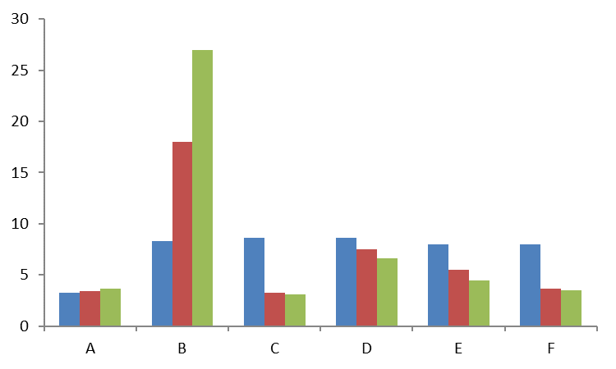

Figure 1: showing effect of aqueous extract of *Buchholzia coriacea* on blood glucose of saccharin-induced hyperglycaemic rats

A= non-induced + distilled water only; B= induced and untreated; C= induced+ metformin treated; D= induced + 50mg/kg dose of extract treated; E= 100mg/kg dose of extract treated; F= induced + 200mg/kg dose of extract treated.

Blue = day 0; wine = day 5; lemon = day 10.

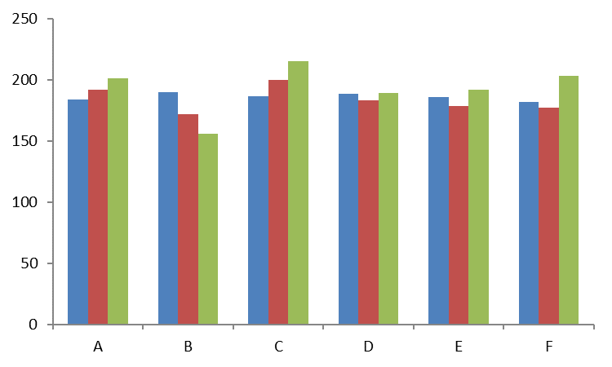

Figure 2: showing effect of aqueous extract of *Buchholzia coriacea* on body weight of saccharin-induced hyperglycaemic rats

A= non-induced + distilled water only; B= induced and untreated; C= induced+ metformin treated; D= induced + 50mg/kg dose of extract treated; E= 100mg/kg dose of extract treated; F= induced + 200mg/kg dose of extract treated.

Blue = day 0; wine = day 5; lemon = day 10.

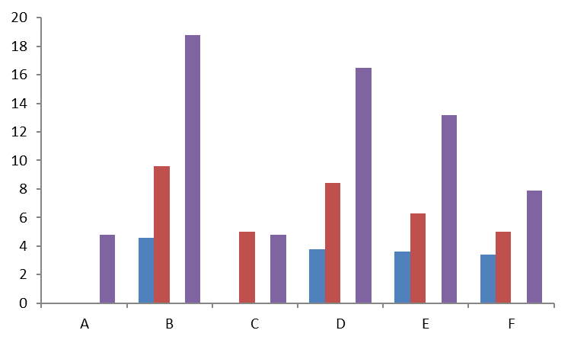

Figure 3: showing effect of aqueous extract of *Buchholzia coriacea* on differential counts and white blood cell of saccharin-induced hyperglycaemic rats

A= non-induced + distilled water only; B= induced and untreated; C= induced+ metformin treated; D= induced + 50mg/kg dose of extract treated; E= 100mg/kg dose of extract treated; F= induced + 200mg/kg dose of extract treated.

Blue = monocytes; wine = eosinophil; white = basophil; purple = white blood cell.

CONCLUSION

The potency of *Buchholzia coriacea* aqueous seed extract in amelioration of saccharin - induced hyperglycemia and alteration of body weight and white blood cell counts was dose – dependent, at higher doses abnormally increased and decreased observed in investigated parameters were reversed back to normal.

RECOMMENDATION

Toxicity study on *Buchholzia coriacea* seed for safe consumption is hereby recommended.

REFERENCES

Ajaiyeoba, E.O., Onocha, P.A., Olanrewaju,O.T .(2001). Invitro anthelmintic properties of *Buchholzia coriacea* and *gynandropsis gynandra*. Pharm Biol.39:217-220.

Ajiboso, S.O. and Adeyemo, S.O. (2010). Effects of chromium supplemented diets in saccharin-induced hyperglycemic rats. *Journal of Pharmaceutical Sciences*, 2:1:78-92.

Ajiboso, S.O., Yakubu, T.M. and Oladiji, A.T. (2016). Antidiabetic activity of aqueous extract of Calotropis procera leaf in alloxan-induced diabetic rats. *European Journal of Biomedical and Pharmaceutical Sciences,* 3(7): 67-74.

Blumenreich, M.S. (1990). The white blood cell and differential count. In: Walker H.K., Hall W.D. Hurst, J.W., editors. Clinical methods: the history, physical and laboratory examinations. 3rdedition. Boston: Butterworths; Chapter 153.

Hemingway, C.A. (2004). *Plants and People. Edible plant J*., P.1.

Lapshak, l.j., Luka, C.D. and Larfa, S.N. (2016). The effect of aqueous extract of *Buchholzia coriacea* seeds on some biochemical parameters in normal and alloxan-induced diabetic rats. *International Journal of Biochemistry Research & Review,* 11(1): 1-10.

Oyenuga, V.A. and Fetuga, B. (1995). First nutritional seminar on fruits and vegetables.in: Proc and Recon, papers by NIHORT, Ibadan.

Pardanani A., Patnaik, M,N. and Tefferi, A. (2006). Eosinophilia: Secondary, clonal and idiopathic. *Br. J. Haematol*. 133:468-492.

Sood, R. (1999). Medical laboratory technology: Methods and interpretations. Jaypee Brothers Medical Publisher. New Delhi: 55-57.

Szkudelski, T. (2001). The mechanism of saccharin action in B cells of the rat’s pancreas. Physiol. Res., 50:537-546

Watson, S. (2018). Basophilia. <https://www.healthline.com/health>, medically reviewed by Suzanne Falck. Updated on September 18, 2018.

Yakubu, T. M., Akanji, M. A. and Nafiu, M. O. (2010). Anti-diabetic activity of aqueous extract of Cochlospermum planchonii root in alloxan-induced diabetic Rats. Cameroon Journal of Experimental Biology, 6(2): 91 - 100.