**Cold Chain Infrastructure of Frozen Foods: A Weak Link in the Indian Retail Sector.**

**By Adeesh Jain, Aarti Purswani**

**Table of Contents:**

1. **Abstract**
2. **Introduction**
3. **Methodology**
4. **Literature Review**
5. **Key Areas of Focus**
6. **Data Analysis and Findings**
7. **Future Trend Analysis**
8. **Suggestions**
9. **Conclusion**
10. **Acknowledgements.**
11. **Bibliography.**

**Abstract:**

Due to the recent unforeseen changes in the dynamics of the economies of the world , national GDP as well the change in the consumer perception and habits has evolved enormously. There has been an evident incline towards the retail market as well as the online market industry. Particularly when we focus on online and retail we will be closely looking at the insights of the frozen food industry. We know how Indian demographics, the geography and its habitat is large and helpful for an organized retail supply chain. In the past couple of years the market has witnessed that the food & groceries segment is considered as a bigger opportunity for organized retail. As this category is viewed as the largest segment of Retail. However the flip side of the food chain industry in India is due to its ill equipped infrastructure which is resulting in staggering losses in this opportunity. To boost the GDP, build a strong supply chain, generate employment and all the parties involved like stakeholders, partnership, cartels and cooperatives can be significantly enhanced by a union effort.

India is a country of geographic diversities- varied soil-types, habitats, climates and vegetations. India is a major producer of food (fruits, vegetables, wheat, pulse, milk, spices, etc.) in the world after China. This industry is the front end of the agriculture sector, which is a significant economic component, employing nearly 60% of the country’s population and contributing to around25% of India’s gross domestic product. With access to a large natural resource base of 161 million hectares of arable land, 15 million hectares of fresh water reservoirs, the largest livestock population in the globe and diverse agro-climatic conditions, India is a favourable destination for growth in the food industry. The Indian food industry is expected to reach $258 billion from the current level of $181 billion.

Though India's share in the global market is still nearly 1% only, there is increasing acceptance of horticulture produce from the country. However, on the other side, there have been staggering losses in the frozen food sector due to ill-equipped and weak cold chain infrastructure of the country ensuing post post-harvest losses. However, the current scenario reveals that there is a tremendous scope for the development of cold chain facilities. This article is an attempt to draw the attention of the reader towards the potential as well as the challenges that exist in the frozen food business in India.

**Keywords: Cold chain, frozen food, geographic diversities, infrastructure.**

**Introduction**

The ready-made frozen food (RMFF) is viewed favorably by consumers as wholesome, scrumptious, and healthy. Customers are moving to this substance item as a result and are willing to pay the higher price. The experiment had been planned to determine what influences buyers of ready-made frozen food the most. There are evaluations of the literature that show how women's participation in our society's economic activity is quickly changing people's eating habits. Socio-demographic factors such as age, education, income, marital status, and others have an impact on a consumer when they are making a decision to purchase RMFF. In addition to these socioeconomic demographic impacting elements, the results have demonstrated that customers are interested in purchasing this cuisine due to its ease of preparation, delectability, accessibility, quality, low cost, etc. It was also found that the main consumers of this food are people who are employed. Additionally, buying RMFF is positively impacted by gender, age, education, family income, and career.

When we talk about income and career we need to focus on how the Indian meat frozen food industry supports farmers' long-term growth and development, creating jobs in the process. The meat industry has developed into a number of processing businesses that produce frozen fruits, vegetables, frozen meat products, ready-to-eat foods, and beverages. All parts of India are experiencing rapid growth in the frozen meat industry. The market for frozen meat products is seeing the emergence of numerous businesses both locally and nationally, along with the launch of numerous product kinds. Since Indian consumers have grown to choose a convenient quality of food, frozen meat products have become a more promising food business potential. Weighing all the pros of the growth of the frozen food industry, what are the limitations that are outweighing the pros are its weak supply chain. The retail infrastructure was disrupted for many industries in the past couple of years due to COVID-19 lockdown.

The supply chains of almost all manufacturers are clearly being impacted by the coronavirus (COVID-19) outbreak. The supply chain has been dealing with a number of challenges, whether they pertain to frozen meals, supermarket products, emergency supplies, or even services. In reality, developing crisis management plans is essential for manufacturing sectors with intricate supply chains. Because the production sectors are experiencing certain difficulties due to the lockout, some products became more desirable due to strong demand and limited supply, leading to price increases and price extortion. The five primary supply chain constraints—a lack of labor, local law enforcement, inadequate transportation, a shortage of raw materials, and a lack of cash flow—have been highlighted by this research for the lockdown-affected Indian industrial sectors.

The Indian retail sector has improved since the country adopted the policy of liberalization and opened its gates to the world. The term ‘organized retail’ in India, became the buzzword. Not very long ago, in the metros and tier II cities of India, Reliance Fresh launched its stores with the promise of not only fresh and hygienic produce of fruits, vegetables and other frozen food, but also a format that made shopping a pleasurable routine. The retail stores offering an assortment of products (food and grocery) was not

only well accepted by customers, it also became a way of life. The opportunity for catering to the most sizable population of the world lay open to all the prominent business houses and there was mushrooming of various stores like More, Spencer’s, Subhiksha, Hyper City, etc. The opportunity also generated interest from global giants of organized retail like Walmart, Tesco and Carrefour.

Food sector of India, in the last decade or so, has attracted the attention of the world owing to the tremendous potential the geography, climate and soil offers. Though a leading producer of food in the world, it is not known for the exports of food products. The poor export figures are attributed to inadequacies in infrastructure for supporting the supply chains of perishables in the country, the cold chain. There are issues of concern that need attention, like huge losses in perishables (food) because of infrastructural deficiencies. The huge wastage of perishable food occurs due to factors like: lack of precooling and storage facilities, dearth of refrigerated carriers, fragmented supply chains, poor scarce application of latest tools and technologies, poor product knowledge and lack of professionals. The collaboration among stakeholders like government bodies, private corporations, cooperatives, farmers and federations is imperative but the building up phase is still in the nascent stage. A well-organized cold chain reduces spoilage, retains the quality of the harvested products and guarantees a cost- efficient delivery to the consumer given adequate attention for customer service. The main feature of the chain is that if any of the links is missing or is weak, the whole system fails. In spite of high production of food, the demand for food remains highly unfulfilled within the country and outside.

India contributes less than 1.5% to the international food trade. This is primarily attributed to highly inefficient, inadequate and weak supply chains for food that requires temperature-controlled conditions to retain quality, safety and curb the decay process – the cold chain. Thus, the food retail supply chain is vital.

**Methodology**

This paper is backed by both quantitative and qualitative data. The research has been thoroughly done in both ways primary as well as secondary. When we talk about primary data collection The process o was preparation of a Google form which had both quantitative and qualitative questions. The responses from those questions were gathered and that is used as evidence to back up the paper. When we talk about the primary data we have collected both quantitative and qualitative data using different research papers from Google scholar. We have also gone through many articles and books published in Google scholar. Hence this paper is backed up by enough evidence of both quantitative and qualitative data however the writing of the paper is more concentrated on the qualitative research done.

We did quantitative and qualitative research on primary data. We prepared a questionnaire which covered all the domains of this research. We conducted more than 50 responses for the research. The analysis of that 50+ reponses on our topic is represented below.

**Literature Review**

**Definitions:**

1. Frozen Food: It is food that has undergone quick freezing and is stored in the freezer until required. Any item that is used as food or drink for people or other animals that is processed, packaged, and maintained by freezing in line with sound business standards, and that is intended for sale in the frozen state is considered frozen food.
2. Meat Frozen Food: Frozen meat is defined as meat that has been frozen to a temperature of -8 °C or less after being killed; it also refers to meat that was introduced onto the customs territory of the Community with an interior temperature of -12 °C or less.
3. Supply Chain: A supply chain is a system that connects a business with its suppliers to manufacture and deliver a certain product to the customer. Different activities, people, entities, information, and resources are included in this network. The process of getting a good or service from its starting point to the customer is also represented by the supply chain.
4. Retail Marketing: The variety of promotional efforts made by a retailer defines retail marketing. Examples of retailers include large organizations, franchises, and independent small businesses. The success of a retailer depends on its ability to employ retail advertising to raise product sales and brand recognition. Because of the elements of the retail trade, such as selling finished items to the consumer or end user in modest quantities, typically from a fixed location, retail marketing is distinct from other types of marketing. The marketing mix's fundamental principles, such as product, price, place, and promotion, are used frequently in retail marketing.
5. Ready Made Frozen Food: A prepackaged frozen or fresh meal that only has to be heated is referred to as a ready-made meal.
6. Supply Chain Management: Because a supply chain that is optimized results in cheaper costs and a quicker production cycle, supply chain management is an essential procedure. It is a method of managing every link in the supply chain.

The temperature-controlled supply chains or cold chains are a significant proportion of the retail food market. The market shares of fast foods, ready meals and frozen products have increased in recent years. There are several food temperatures levels to suit different types of products. Freezing has been successfully employed for the long-term preservation of many foods, providing a significantly extended shelf life. The extreme cold simply retards the growth of microorganisms and slows down the chemical changes that affect quality or cause food to spoil [10]. Competing with new technologies of minimal processing of foods, industrial freezing is the most satisfactory method for preserving quality during long storage periods [11]. With the growing demands to keep and distribute temperature sensitive products in potent condition, organizations are seeking better solutions to maintain and monitor cold chains. The success of implementing cold chain management involves continual monitoring of product temperature throughout distribution and having appropriate corrective action plans in place. A streamlined, well maintained cold chain helps to: Reduce costs Improve product integrity Increase customer satisfaction Reduce wastage and returns of expired stocks.

**Key Areas of Focus:**

1. **The Indian Retail Sector:**

**1.1 Opportunity**

The phrase "organized retail in India'' quickly gained popularity. In India's metropolises and tier II cities, not so long ago. In addition to fresh and clean fruits, vegetables, and other frozen goods, Reliance Fresh began its stores with the promise of a layout that would make everyday shopping enjoyable. Customers not only embraced the retail outlets that offered a variety of goods (food and groceries), but they also adopted them as a way of life. The possibility to serve the largest population on earth was available to all notable corporate organizations, and a variety of businesses like Dmarts, Magsons, Hyper marts, etc. The possibility also attracts international retailers like Walmart, Tesco etc.

The opportunity for the Indian retail sector and frozen food is that the economy of India has been growing for over 6.7% per annum which is a very positive indicator for the retail sector. The growth that the Indian economy has been facing is a credit boom and a demographic transition which is making the retail sector more lucrative. This is because the disposable income of the consumers has increased due to Covid time. In a recent survey India was placed on the third position in the entire Asia-Pacific region when they measured the retail revenue. The first country was Japan and the second was China. According to our retail and fashion research firm which is images multimedia India has the potential to grow by $45 billion. Now when we look into the opportunity in food retail it is enormous as there is a momentous growth in the Indian economy. There has been a growth in the organized retail sector which is contributing to over 10% of the GDP and 6.7% of the employment. There has been an increase in both private and public investment in recent years India has been recognised as the second most attractive retail destination in the world. A second study that we will be looking at was conducted by Mishra and – on Indian consumers The result of that study showed that there has been a lot of behavioral changes when it comes to the retail scenario. They have proven how organized retail is spreading faster in India and has an impact on the consumer's society. There has been a conventional growth in the organized retail sector leading into the decrease of traditional retailing sectors. Which proves why that there has been an increase in the frozen food industry as it is a part of the organized retail sector.

**1.2 Threats**

When we particularly talk about the Indian retail sector we cannot neglect the challenges that the Indian retail sector has been facing. Even though it has promising and enormous economic growth it still holds various challenges in terms of their supply chain management and the infrastructure that is needed for the frozen food business. The challenges that they have been facing R for example rail and road network, communications, electricity, storage facilities and transportation. All these factors are creating a cold chain infrastructure and a block in the retail growth. This has been resulted as a weakling or is causing a concern for India and is causing heavy losses for the retail sector.

If you look back at around 2008 a study indicated that there has been warning signs for economic slowdown worldwide which obviously affected the Indian retail sector two. But as we’ve seen in the past two years even in the recession phase there are many sectors of some particular countries like India or China which are expected to show a positive trend in the markets this is due to the overall economic growth, demographic changes as we talked about how people are now choosing organized retail sectors, easy availability of credit, potential market opportunities and et cetera.

**1.3 Categories in indian retail sector**

There are two particular categories in the Indian retail sector which are organized and unorganized sectors. When we talk about organized, those are the retailing sectors that refer to different trading activities which are undertaken by the licensed retailers. Some examples of organized retailers or sales tax, income tax or privately owned retail chains like reliance fresh Hypercity et cetera. Whereas organized retailing is using different formats for example low-cost retailing and local shops, general stores, convenience stores and et cetera. In the past years there has been an increase in organized retail sectors, due to Covid times people didn’t wish to go to faraway shops or shops like organized retailers because of more population or foot falls in those stores. People started to buy from their local or nearby convenience stores.

1. **Food Production in India: Facts & Statistics**

India has always had a strong agricultural production base however what is undeniable is that the wastage is also extremely large. The colossal wastage can be reduced by increasing the processing level of agricultural produce which is only about 2.2% of fruits and vegetables. According to facts stated by Ministry of food processing industries of India there has always been constraints faced by food industry such as nonavailability of critical infrastructural facilities, packaging and grading centers, cold chain lack of adequate quality control and testing infrastructure, inefficient supply chain, storage of the process able varieties of farm produce. Few more constraints faced by the food industry which causes the cold chain infrastructure or shortage of seasonality Raw material, high inventory carrying cost, high taxation, high packaging cost, affordability and lastly add the cultural preferences for fresh food.

India is the second-highest producer of fruits and vegetables in the world, behind only China, according to the FICCI report (October 2004). It is also the second-highest producer of milk, with a huge capacity for cold storage of 70.000 tonnes, the fifth-largest producer of eggs, and the sixth-largest producer of fish, with harvesting volumes of 5.2 million tonnes.

The biodiversity of plants, animals, insects, and microorganisms is centered in India, which also has a 17 percent animal population. 10 percent of the genetic resources in fish and 12 percent in plants. India accounts for 16% of the world's cattle, 57% of its buffalo, 17% of its goats, and 5% of its sheep in terms of livestock. India ranks low in exports despite having great numbers and a large country.

1. **Weak link in Supply Chain**

India's food production figures show that the industry is undergoing a change. Although it is predicted that food production in India would increase over the next ten years, post-harvest losses of roughly 35.40 percent of the total crop—or Rs. 58.000 crore annually—are worrying. It is clear from numerous studies on post-harvest losses in India that the amount of food wasted there annually is equal to the food consumed in the UK. Poor cold chain infrastructure is the main cause of the post-harvest losses. India's cold chain distribution is still in its infancy. The current projected size of the Indian cold chain industry.

**3.1 Frozen Food Management**

A robust cold chain infrastructure can guarantee the desired properties of frozen food. A cold chain is a supply chain that is temperature-controlled and is primarily utilized in the pharmaceutical and food (vegetables, fruits, meat, fish, mik and mik products, and ice cream) industries. The supply chain for perishables makes sure that there aren't any major temperature changes when the commodities are being transported from the location of production to the place of consumption. The type of the product (items like offal, seafood, dairy products, butter, meat, and meat products) under transit determines the temperature needed in a cold chain.

Creating intelligent supply (cold) chains for frozen food is urgently needed to reduce losses, lengthen the shelf life of perishable food, and maintain consistency and desired quality. The cost of waste for the businesses is enormous without an efficient supply chain. The largest problem is connecting India's remote villages to reliable supply chains so that everyone benefits and waste may be minimized to the greatest extent possible.

1. **Cold Chain Infrastructure**

According to Maheshwar and Chanakwa (2006) they estimate that about 30% of the fruits and vegetables grown in India (40 million tonnes, or $13 billion) are lost each year due to gaps in the cold chain, including subpar infrastructure, inadequate cold storage capacity, a lack of cold storage facilities nearby farms, subpar transportation infrastructure, etc. This causes price volatility, underpayment of farmers, and rural poverty, which leads to farmers' dissatisfaction and death. - Operations are a crucial component of cold chain management since there are many locations from points of production to points of consumption where temperature abuse can happen.

The cold chain is an important enabler in minimizing post-harvest losses in the Indian food processing sector as it helps increase shelf life and prevent spoilage across the entire gamut of transportation and storage (warehousing) of temperature-sensitive products from the production hub to the point of consumption.

Cold chain is a temperature-controlled supply chain and the term is specifically used in the context of food (vegetable, fruits, meat, fish, milk and milk products, ice cream etc.) and pharmaceutical industries. It is a supply chain for perishables that ensures that there are minimal temperature fluctuations for goods in transit from place of production to the point of consumption. The temperature required in a cold chain depends on the nature of the product (foodstuffs like fish, dairy products, butter, meat and meat product) under transit. Cold chain management refers to maintaining the proper temperature of the products through all the handoffs in the cold chain until it reaches the consumer [1]. Freezing foods can preserve them in a good condition, as acceptable to the customer as the fresh product, for long periods by preserving the wholeness and quality. It restrains bacteria and slows down the biological reaction that deteriorates the food. Developing countries acutely require institutions, infrastructure and human capital in place to improve efficiency in cold chains and also to exploit the competitive advantage that these countries (like China, India) may possess by virtue of climatic conditions, vast spans of arable land or other factors. Increasing efforts have been made by developed countries to help countries lagging behind to minimize product losses and increase profitability. With technological advancement and improved equipment, as well as continuous improvement of cold chain management, the logistics of moving perishables around the world will be greatly enhanced.

**4.1 Logistics**

Numerous businesses that see it as a sizable opportunity have discovered the cold chain logistics gap in India. The logistics industry in India should be considered a separate industry, as evidenced by the fact that it is a Rs. 4 trillion ($90 trillion) industry worldwide. While many other businesses are essentially transporters, only a few have dared to offer logistical solutions. Rajeev Kumar Singh, Snowman Frozen Food Limited's deputy general manager, claims that the expansion of cold storage facilities and transportation services is required as a result of the recent boom in the food industry. The Indian cold storage market is expected to reach a value of $1.2 billion by 2010. Overall, India spends more on logistical tasks than wealthy countries do—13 percent of its GDP more. The primary cause of this is the system's generally higher level of inefficiencies, which is caused by slower average trucking speeds. The cost of administrative delays and longer port turnaround times are only a few examples. However, as a result of a growing industry demand for robust backend activities, the state of affairs in India is changing.

**4.2 Warehousing**

Warehousing plays a crucial role in the logistics of the cold chain. India's food production and retail industries are expanding, and this growth will continue in the years to come. This necessitates the use of up-to-date, well-equipped cold chain infrastructure, particularly with regard to warehousing. "Considering the globalization of commerce coupled with the growing need of food merchants, this has resulted in a boom in food transport logistics companies," says India, the world's largest producer of fruits and the second largest producer of vegetables. The INPT at Kandla will house packaging and warehousing facilities that will be built by the National Agricultural Cooperative Marketing Federation of India (NAFED). Cold chain trucks are something that Mitsubishi and Reliance Industries Ltd. are starting. Cold chain trucks are something that Mitsubishi and Reliance Industries Ltd. are starting. Lower wastage and more potential for exports will result from the distribution channels, warehousing, and cold storage facilities ensuring that farmers sell their products to merchants quickly and fresh. Fieldfresh, a retail location of Bharti Enterprises, plans to export 50% of its goods. An effort by ITC's International Business Division called E-Choupal has produced an effective delivery channel for rural development and transformed villages in Chandigarh into prospective potential marketplaces.

Bangalore and Hyderabad (Matani, 2007). In addition to reducing post-harvest losses, establishing efficient and effective cold chains and creating cold storages as needed would extend the shelf life of produce. This would assist the manufacturers in making wise marketing decisions. The following figures were made public by the Indian government on December 31, 2006, according to the Directorate of Marketing and Inspection (DMI): India has 5101 cold storage facilities with a 21.6 million tonne capacity overall. Experts in the field estimate that India's cold storage capacity utilization is between 30 and 40 percent, and that the private sector owns and maintains more than 80 percent of the country's cold storage capacity. Only 200 cold storage facilities existed, and they could hold 69,947 million tonnes of milk and milk products.

**Findings & Analysis**

The survey we took consisted of 50 plus respondents. The mean age of the group is 21 years old. Over 96% of the group was unmarried and 69% of the population were non working professionals. Considering them being aged around 21 this data was considered effectively true. Over 86% of the population was in the age group of 16-25.

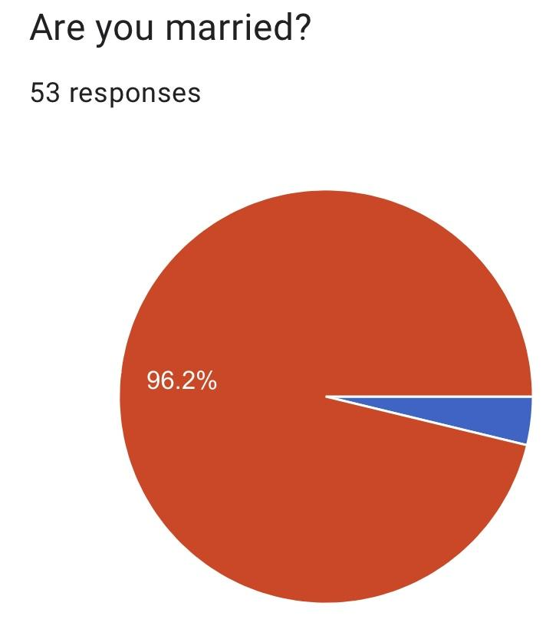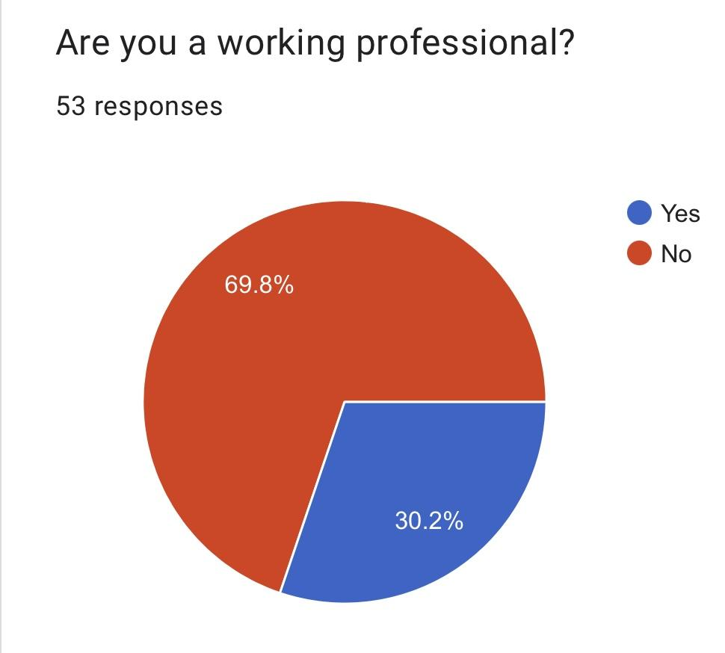

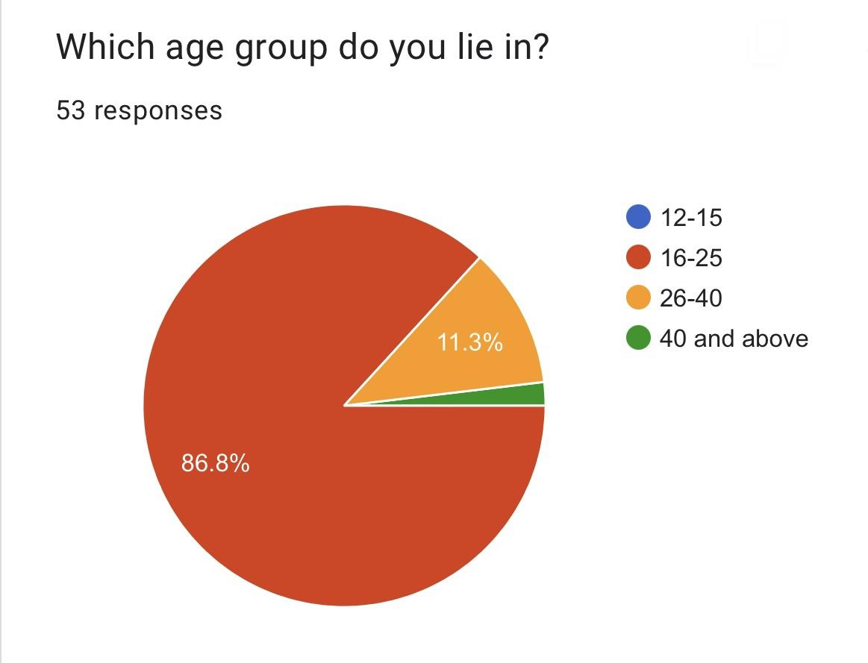

This was all about the demographics of our data set. The average data of our research showed the age group of 21-25, who were non working professionals and unmarried.

When we shift our focus to frozen food the first finding which was common and what we assumed that more than 70% people consume frozen foods. Till now we don’t know if the consumers are buying it from retailers or distributors, if retailers than which type of retailers. But, as stated in our paper the consumption of frozen food has increased.

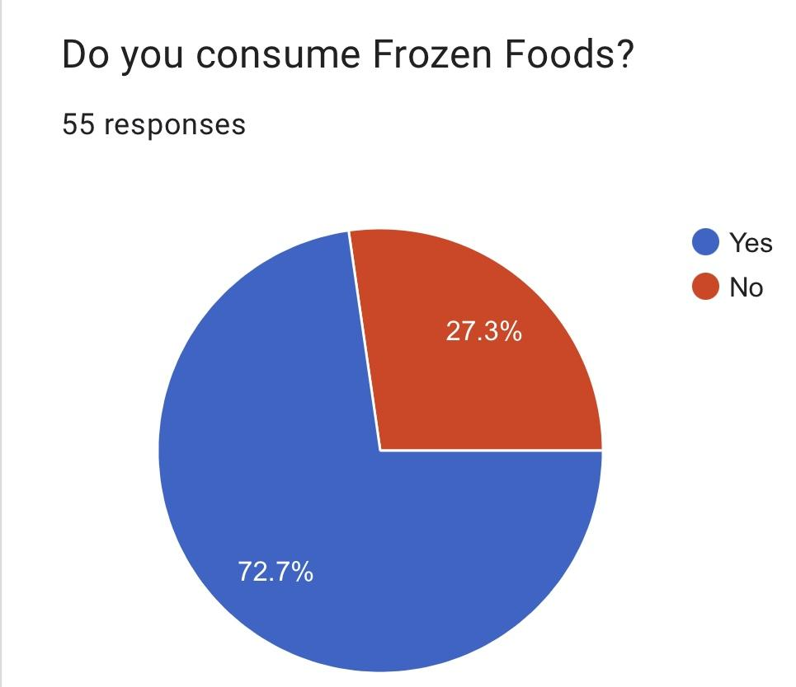

In our paper we didn’t separately talk about vegetarian or non vegetarian food. But, in our study we clearly found out that people were consuming more frozen fruits and vegetables than non vegetarian. In vegetarian when we see the proper segregation we can understand that veg ready to eat for example; frozen pizza’s, mccan, are having maximum demand. The second highest consumption is of fruits and vegetables, later is non vegetarian. Also another significant findings here is more than 20% people still don’t consume frozen foods. This can be because of lack of quality, lack of awareness, lack of proper displac etc. Also I feel that non vegetarian retailers are organised retailers. Thus, as we see there is an increase in unorganised retailers there is a hand in hand decline of non veg consumption of frozen foods.

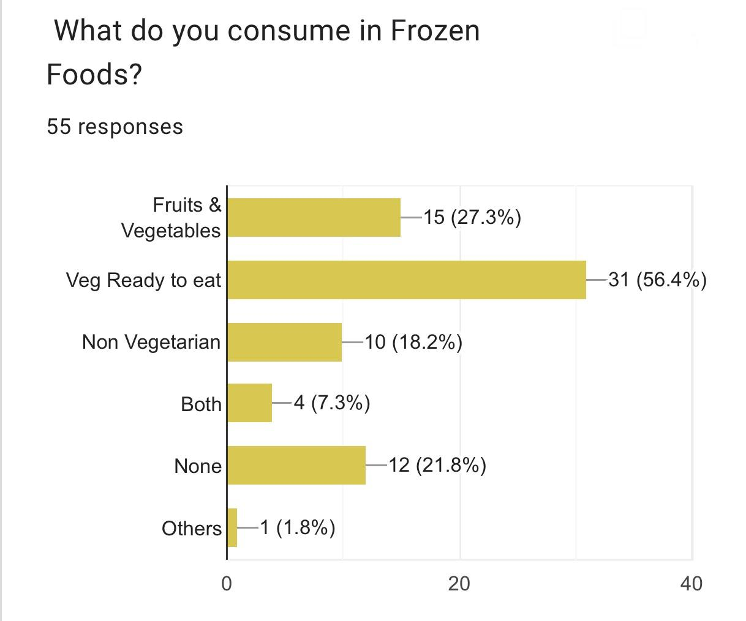

Our secondary data showcased that the consumption of frozen food rose after covid-19, whereas our primary data showed the opposite. Only 20% of people felt that their demand and consumption of frozen foods increased after covid-19. Also another main finding here is 21.8% of the people didn’t know whether their consumption has increased or not. This shows us more about consumer behaviour and our assumption of it. We assume that due to an increase in awareness there might be an increase in demand. Also, we thought that people think frozen food demand has increased because people feel it is safer to eat, but both our secondary and primary data has negated this.

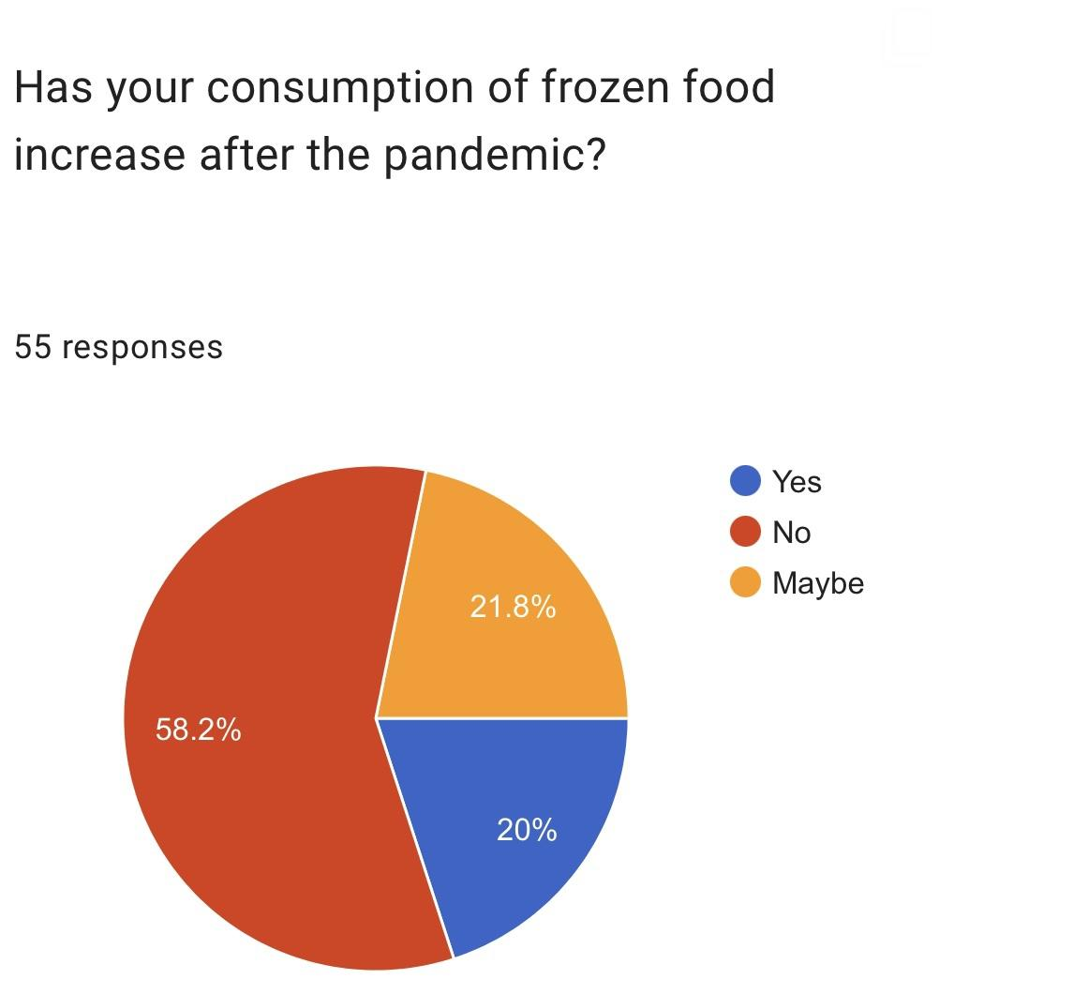

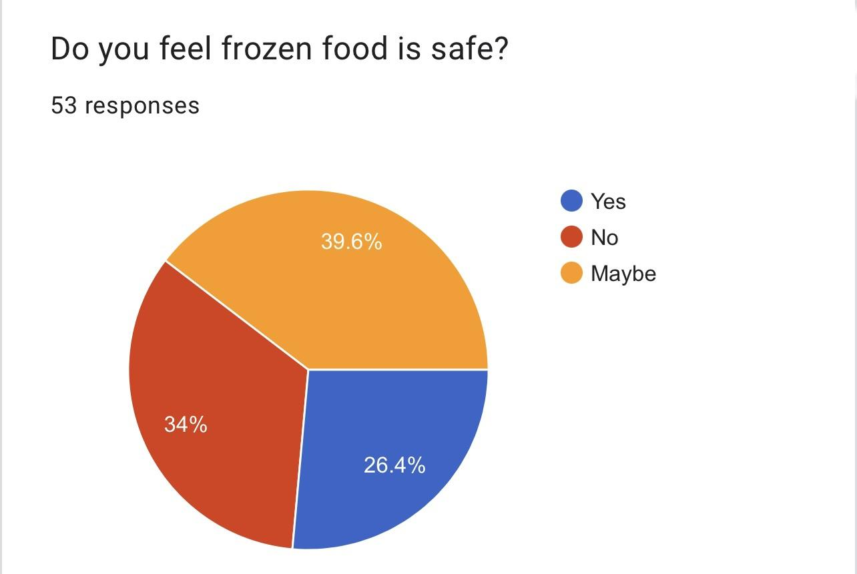

Only 26% of the group feels that frozen food is safe, 40% feel maybe and 34% feel it isn’t safe.

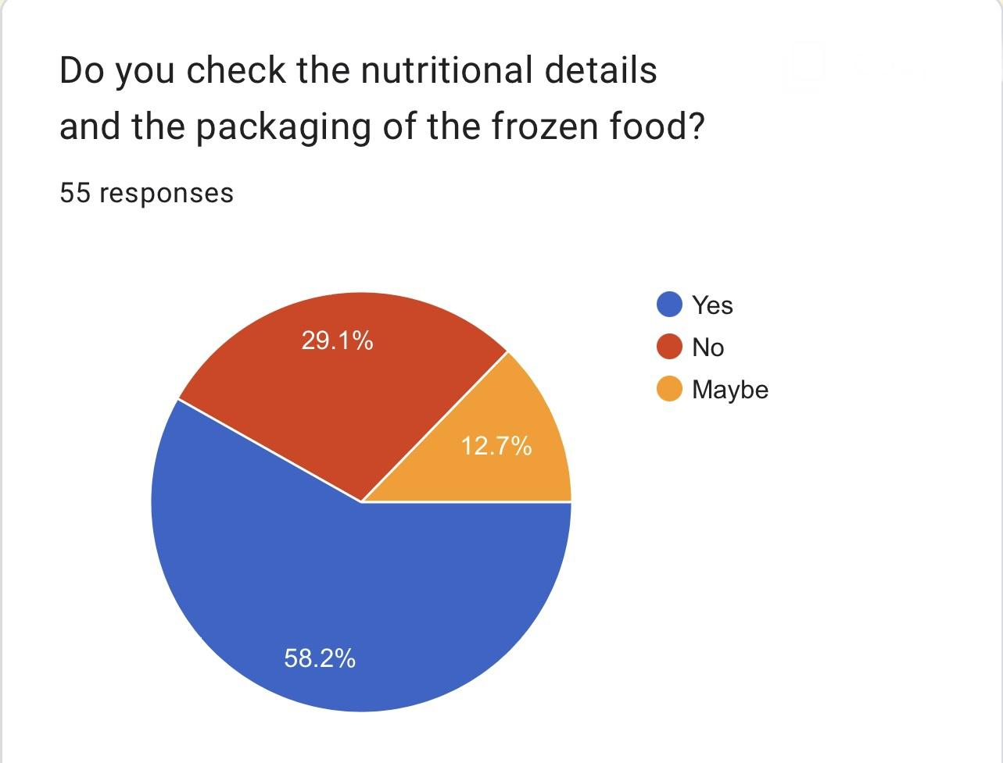

When we talk about safety and how measurity don't feel safe while eating frozen food, we check whether or not people check the nutritional details of the packet. Over 58 % check the nutritional value of frozen food. So the measurity checks the value and we can say that they feel it is unhealthy.

Now lets focus on the retail sector part of our study.

The maximum sales of frozen foods is from the retail sector, it is similar to our findings from the secondary data. Only 30-35% of the population don’t buy their frozen foods from retailers. Also when we say they buy from retailers in our study we focused on both organized and unorganised retailers. So in our primary study we found out that people prefer branded or organized retailers over nearby convenience stores. Whereas in our secondary data we found out that because of the pandemic there is an increase of sales and awareness of unorganised retailers.

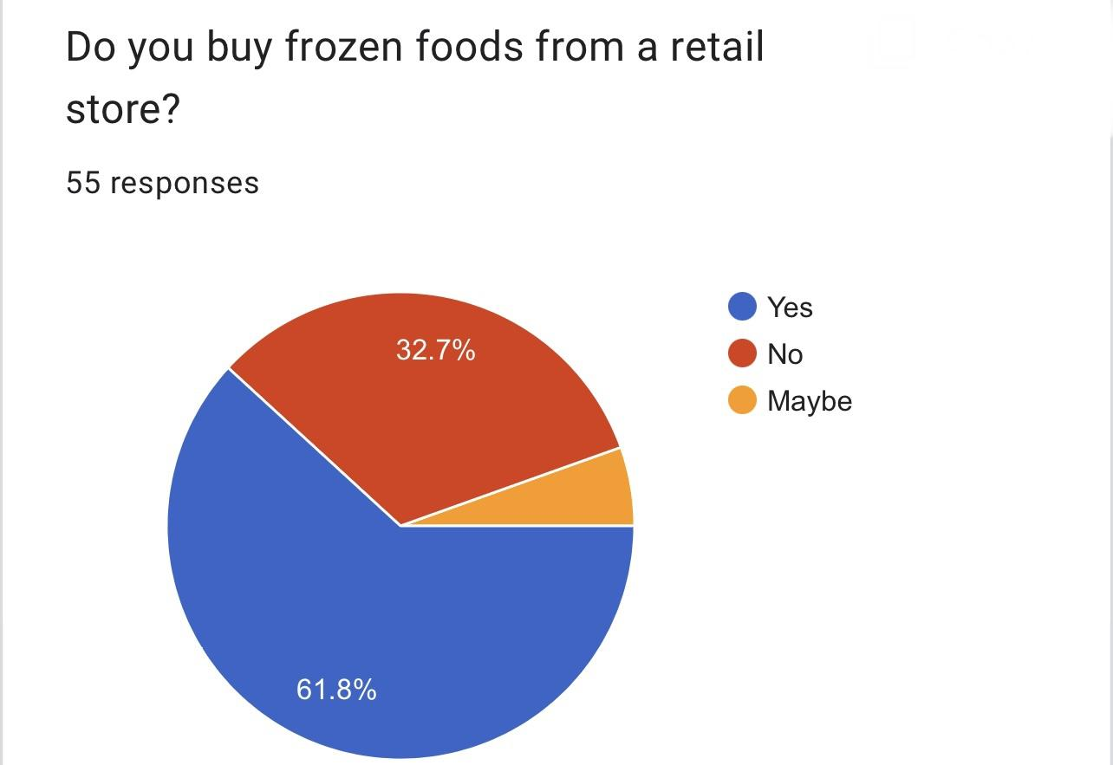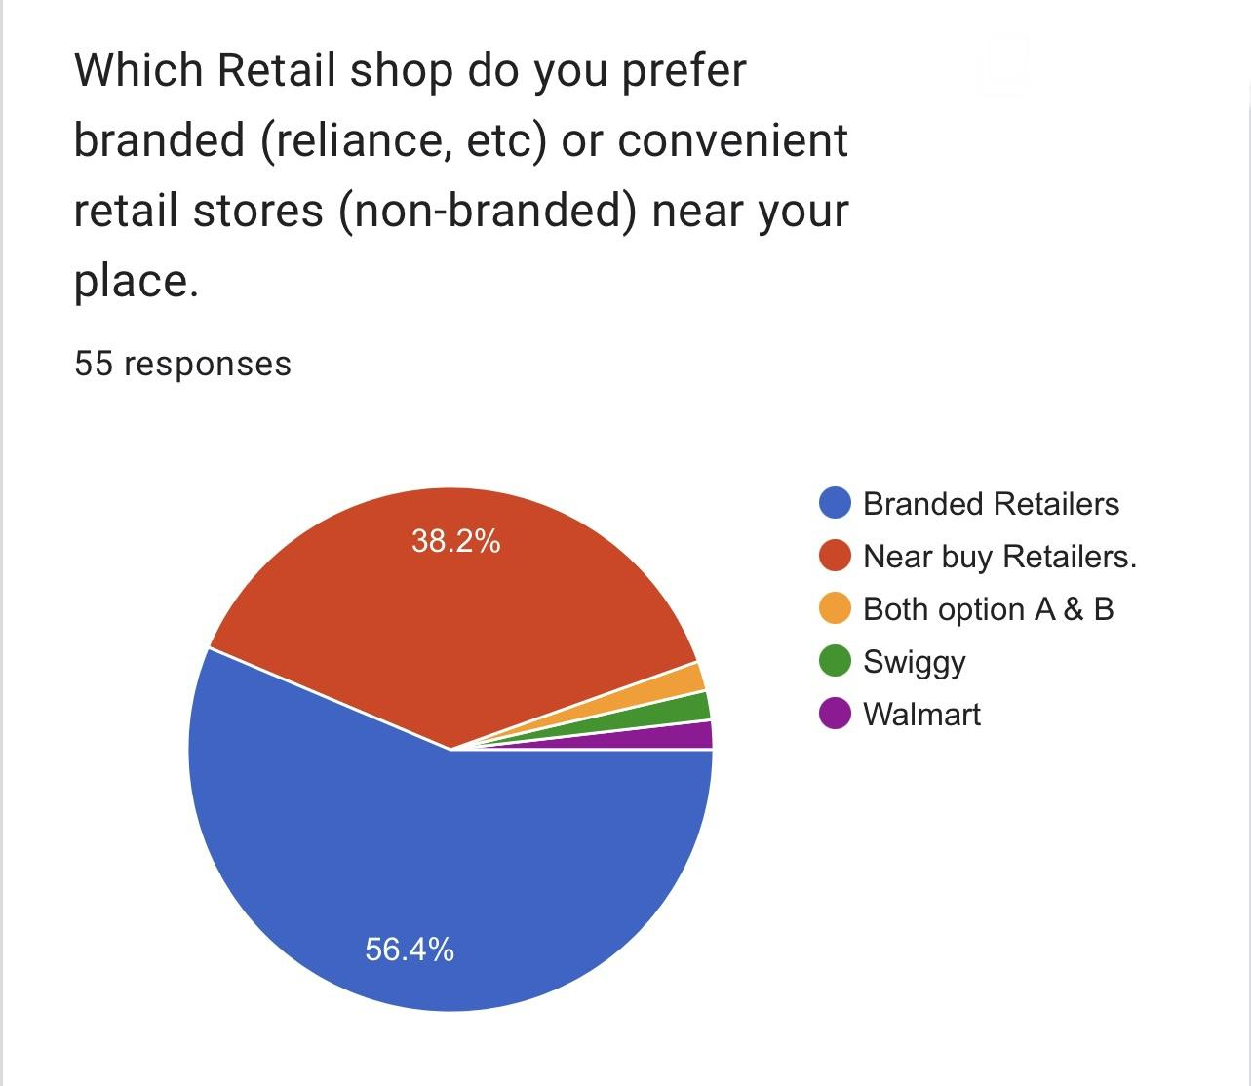

So because our secondary data showcased the decreased demand of organized retailers we need to focus on why? So our primary data showcased that there can be multiple reasons for the same. Through help of this we can understand what is the weak link in the Indian Retail Sector.

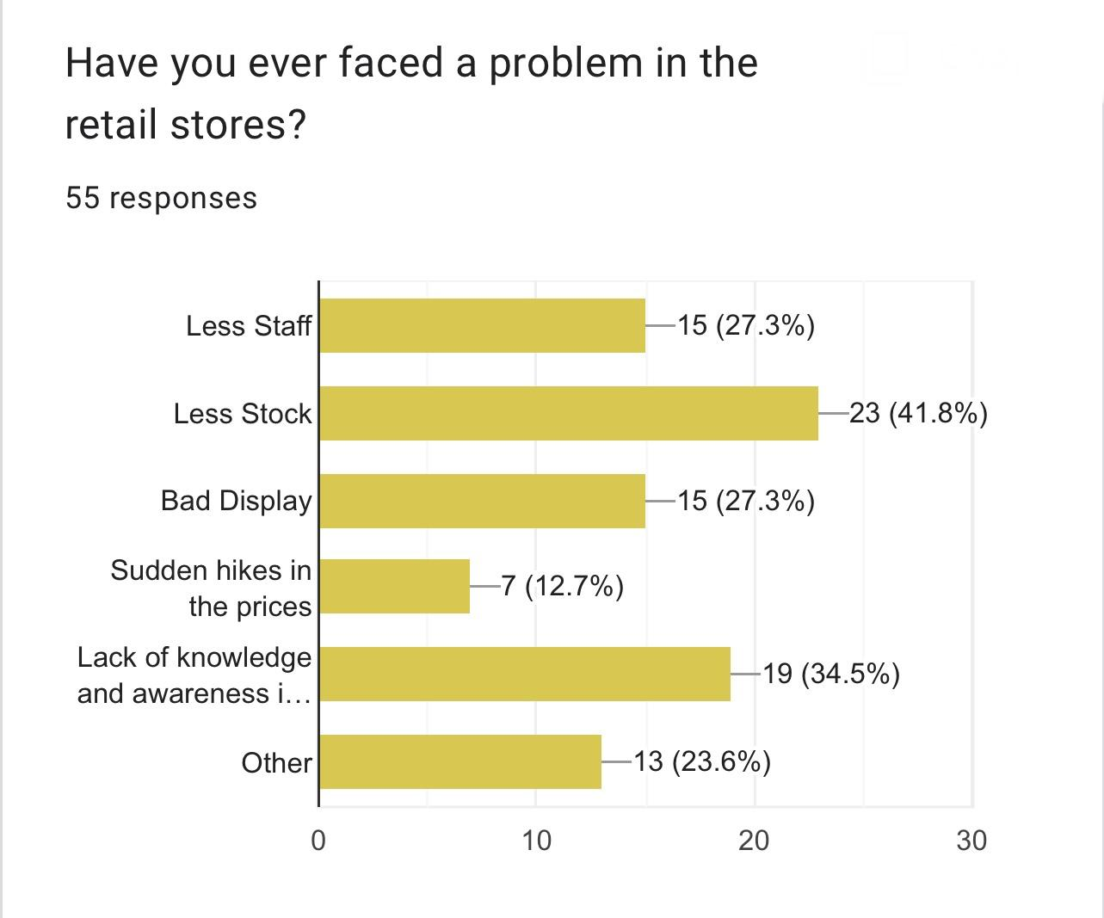

As we can see, the maximum people feel there is less stock to match the demand. Second, people feel that there is still a lack of knowledge and awareness of frozen food and its nutritional value. This causes less demand. Third, people feel that there is a bad display and less staff, both these are related and proportionate to each other. Also, the sudden hikes in prices leads to decrease in demand. As we know the direct relation between price and demand.

Thus we can here conclude our findings:

1. People have started consuming RMFF. The awareness has increased and so have their prices. However the primary data didn’t show any relation of the demand to the pandemic.
2. People still prefer branded retailers as they have a habit of checking the nutritional value. As they still don't trust RMFF as safe.
3. People feel that the gap in the retail sector is due to lack of stock, awareness, staff and bad display.

**Discussion**

**FACTORS AFFECTING EFFECTIVENESS OF COLD CHAIN -** India has a huge opportunity to become a leading global food supplier if only it has the right marketing strategies and of course agile, adaptive and efficient supply chain. In spite of high production of food, the demand for food remains highly unfulfilled within the country and outside. The huge wastage of perishable food occur due to factors like: lack of pre-cooling and storage facilities, dearth of refrigerated carriers, fragmented supply chains, poor scarce application of latest tools and technologies, poor product knowledge and lack of professionals. There is also a need to bring inefficiency in existing cold chain networks.

Without an efficient supply chain there is a high cost of wastage for the companies. The cold chain network can be made efficient by development of basic infrastructure. The initiative would lead to improvement of roads, railways, ports, airports and power. Developing Countries acutely require institutions, infrastructure and human capital in place to improve efficiency in cold chains and also to exploit the competitive advantage that these counties (like China, India) may possess by virtue of climatic conditions, vast spans of arable land or other factors. With technological advancement and improved equipment, as well as continuous improvement of cold chain management, the logistics of moving perishables around the world will be greatly enhanced . The study would also pave the way for corporations to venture into the food industry in a big way.

**Future trend & analysis**

Because of advancements in variety and material management between harvest and processing, I think consumers will demand more frozen food products in the future, and those foods will have a higher nutritional content. New manufacturing techniques, including pressure shift freezing, which permits the formation of smaller ice crystals during freezing, will improve the textural quality and preserved nutritional content of frozen foods after thawing. These products will be more stable since antifreeze proteins and other unique ice actives have been incorporated, which will cause the ice crystals to stay tiny during distribution. Additionally, formulation, along with knowledge of the unfrozen component's mobility and biochemistry, will improve stability. I believe that using predictive modelling and monitoring with time-temperature integrators will improve control over the supply chain. Finally, consumers will be offered a broader selection of foods that will be more beautifully and effectively exhibited when they are shopping.

There will be changes done for the good which are:

1. More nutritious frozen foods.
2. Better display at Retail markets.
3. Increase in Unorganised retail.
4. The supply chain of frozen food will be managed effectively.
5. Change in behaviour of consumers which will be driven by the need for more frozen food markets.

**Opportunities**

"Where there are gaps, there are opportunities" In India, the architecture of the supply chain for frozen foods has enormous gaps. Large chance for a nation that produces a lot of food. Profits from an investment in infrastructure development would last for many years, but it would necessitate a strong and dedicated private public cooperation.

The primary occupation of the 70% of Indians who live in villages is farming. Access to isolated places that are very productive for producing a wide variety of fruits, vegetables, and food can be made easier by developing infrastructure in the form of rail and road networks, power plants, and storage facilities.

India's food consumption is projected to increase significantly to a staggering $310 billion by the year 2015. Given that it accounts for 54 percent of all retail sales, "food and groceries" is one of the most alluring retail categories. The cold chain gaps are real, as was previously discussed, but major corporations are taking notice. Shubhlabh FieldFresh by Mahindra (Bharti Group). Reliance Industries Ltd., ITC., Godrei Agrovet, and other companies have previously entered this market. These stakeholders' activities will provide the project the needed impetus and help create effective cold chains.

The Foreign Direct Investment (FDI) rules for several industries, including retail, have been loosened by the Indian government.This will entice international participants from similar industries to enter India. With the opening of new supermarkets/hypermarkets, shopping malls, and fast food restaurants, as well as changing lifestyles, readv-to-eat food demand is on the rise. These factors, along with positive industry trends, are about to cause significant changes in the Indian food and beverage industry.

The present cold chain capacity in India stands at 19.5 million tonnes which is less than 15%of the annual horticulture production. The positive future outlook for food processing, agriculture and retail, calls for the development of integrated and intelligent cold chain networks across the country.

According to industry analysts, integrated cold chains and supply chain management would help India in saving INR 750 bn annually by reducing wastage of perishable horticulture produce by 30%, besides garnering additional export revenue of INR 250 billion. India is facing a shortage of cold storages, leading to a loss of about 40% of the Agri-produce post-harvest. The Indian cold chains market is largely untapped and dominated by the unorganized sector thus offering immense investment and development opportunities. Though India has potential of becoming a food supplier of the world it lacks right marketing strategies and efficient supply & cold chains management.

Additionally, Ministry of Food Processing Industries is implementing a scheme for cold chain, value addition and preservation of infrastructure whereby financial assistance is provided for strengthening cold chain infrastructure.

**The Challenges**

Numerous gaps, obstacles, and difficulties need to be addressed. Within a few kilometers, India's demographics and dynamics can change significantly, but there are some persistent problems.

Numerous of them had to do with infrastructure-related things, including roads. Nearly 80% of all transportation is dependent on roads, compared to only 20% relying on the rail system. However, the state of the roads and their appropriateness for large freight vehicles are still issues. The issue is made worse by the growing traffic on the highways. Another issue with power is the demand-supply discrepancy. India's rural areas struggle with electricity backup (uninterrupted power supply is accessible only to a few villages).

Additionally, there aren't many storage facilities (such cold storages, warehouses, and godowns) close to the producing region. The shelf life of farm products is shortened by exposure to ambient temperature. Only ten to fifteen percent of the food can be stored in the cold (Table 3). There are 5101 cold storage facilities with a total storage capacity of 21.6 million tonnes of produce. 20 Food goods (fruits and vegetables) lose a significant amount of value as a result of infrastructure deficiencies. This is also true because supply-driven supply networks are currently more common than demand-driven ones. Controlling theft, fraud, and poor oversight of products in transit continue to be challenges. The presence of high excise and customs taxes is another barrier. Lack of experts in the field of cold chain management, inadequate or no training in handling post-harvest produce for those in charge of managing cold chains, and a lack of use of cutting-edge technology and information technology tools and techniques for efficient management of cold chains (technologies like Radio Frequency Identification (RFID) for tracking produce in transit) are some other issues that present challenges.

1)Damaged cooler/freezer doors

Cooler and freezer doors that are damaged are one of the most common problems cold storage facilities face. The initial impact of damaged freezer doors is that it can’t hold the specified temperature. Since that’s its main purpose, it’s a big deal.

Certain freezer door designs actively combat damage done by loading machinery. Look for tight sealing, impactable freezer doors that snap back onto their tracks if hit by a forklift. The GUI, included with every purchase of a cooler door & freezer door, tracks the number of times a door has opened and closed (due to impacts from a forklift or false activations without an object pass-through). Opti-Vu collects that data tracked from the GUI and provides an in-depth analysis and recommendations for improving certain frequent events to help better manage energy as well as maintain security and safety at your facility.

If not addressed, the immediate consequence of damage to these cold storage industrial doors is spoiled product, but it can also lead to some of the other common issues in the cold chain that can affect worker safety, consumer safety and ultimately business relationships and your bottom line.

2) The biggest challenge lies in connecting the remote villages of India to the robust supply chains so that all stakeholders benefit and wastages can be mitigated to the extent possible. By building an efficient and effective supply chain using state of the art techniques it is possible to serve the population with value added food while simultaneously ensuring remunerative prices to the farmers.

Few challenges:- Lack of an integrated approach and efforts for effective policy

formulation. Viability of cold chains continues to remain a question mark for many reasons; existing facilities are outdated and poorly maintained. Awareness and hence demand for Cold Chain services continues to be low. Lack of availability of technically qualified people to support efficient operations

3) Condensation

Build-up of condensation in coolers and freezers is a common problem in facilities where operations include both cool and warm processes. Products can generate excessive moisture if it moves from one temperature to the next too quickly. This can cause both slippery surfaces, affecting workers, as well as product adulteration that can create a health risk for consumers.

One of the best ways to mitigate and control condensation on food products is to use tools like HVLS fans to produce air flow in the facility to help regulate humidity levels and air flow.

4) Microbial Growth in the Freezer

Another common problem in industrial freezers is the growth of mould and mildew. Mismanaged temperatures or broken freezer doors can create this issue. If properly maintained, however, freezer walls will minimize microbial harbourage and particulate build-up. Some of the best ways to prevent mould growth in industrial freezers include:

● Keeping freezers free from spills

● Tapering freezer surfaces

● Using lubrication-free components

If freezer mold becomes an issue, make sure to clean the freezer thoroughly to avoid any future problems that could affect both safety and the integrity of your cold chain output.

5) Excessive heat exposure

Sometimes the problem occurs before the temperature-sensitive item even makes it to the freezer or cooler. Prolonged exposure to warm outside temperatures during loading and unloading is a common problem that can degrade temperature-reliant foods, pharmaceuticals and other goods.

Implementing a drive-through dock design with a strong loading dock seal can avoid this cold chain problem by keeping the product away from the outside heat, preventing the safety hazards associated with temperature irregularities for sensitive products.

6) Damaged Goods

Even areas outside the immediate control of your cold storage facility, like receiving damaged shipments, can have a huge impact on profitability. There can be several problems with shipments in cold chain logistics, from broken products or exposing products to improperly warm temperatures in the trailer.

The best way to keep merchandise safe in transit is to use RFID tracking technology. This can alert recipients to this issue so they’re prepared to rectify the situation.

**Suggestions**

By building an efficient and effective supply chain using state of the art techniques it is possible to serve the population with value added food while simultaneously ensuring remunerative prices to the farmers. The surplus of cereals, fruits, vegetables, milk, fish, meat and poultry can be processed as value added food products and marketed aggressively both locally and internationally. Investments in cold chain infrastructure, applied research in post harvest technologies, installation of food processing plants in various sectors and development of the food retailing sector are mandatory for achieving gains in this sector. Strategic growth plans for achieving both national and international competitiveness of the food industry are essential. However, lack of electricity, power supply and other supporting infrastructure are a big deterrent insetting up such facilities. The economic impact of cold chains will be felt in the villages. Farmers will get better realization for their produce due to improved quality and shelf life.

**Conclusion**

The analysis and research done on India's cold chains indicate a lack of infrastructure, which is obviously a sign of the potential that lay ahead. The creation and upkeep of new infrastructure would initially be very expensive.

But in the long run, all parties involved must work together if they are to prosper in the future.

India is the second-largest producer of fruits and vegetables in the world, behind China.

Although it may not be accurate to refer to India as the world's food bowl, the study shows that there is a tremendous amount of unrealized potential in the frozen food industry. The beginning of the revolution also ushers in the hope and promise that those entering this industry would not only be financially capable of changing the course of the frozen food industry, but will also have valuable experience dealing with their foreign counterparts.

All parties involved in designing and creating integrated, effective cold chain networks—producers, middlemen, organised retail players, local village bodies, cooperatives, and the government—must work together. By growing GDP and increasing export profits, this can help the nation become richer. improving employment, increasing farmer wealth, and achieving self-sufficiency all at once.

The business system is tuned to the food habits (cooking at home) and convenience (kirana stores) of rural and urban folks of the previous generation. Factors such as rapid growth in the economy, the technological innovations in home appliances such as refrigerators, microwave ovens, rise of families with dual incomes and the changing food habits of the population all point to the increasing need for healthy processed food. The safety and nutritional quality of frozen products is to be emphasized only when high quality raw materials will be used, good manufacturing practices to be employed in the preservation process, and the products kept in accordance with specified temperatures. The frozen food market is one of the largest and most dynamic sectors of the food industry. In spite of considerable competition between the frozen food industry and other sectors, extensive quantities of frozen foods are being consumed all over the world. The food supply chain needs the attention of the academicians, the industry and the Government for its enhancement.

**Acknowledgement**

I would like to thank HaldiRam for giving me this opportunity to complete my research, particularly my co-author for the enthusiastic way in which they have contributed. I would like to thank Asheesh Jain who has spent many hours reading and correcting our typographic errors and grammatical slips. His help during the editing of this report has been invaluable to me.

**Bibliography:**

1. [**https://books.google.co.in/books?hl=en&lr=&id=URpSoisC8BkC&oi=fnd&pg=PA49&dq=info:3BJm5ixRvfAJ:scholar.google.com/&ots=QzlVX3tud_&sig=oowARVmZ3rfdqRe91CMFDb7Nf48&redir_esc=y#v=onepage&q&f=false**](https://books.google.co.in/books?hl=en&lr=&id=URpSoisC8BkC&oi=fnd&pg=PA49&dq=info:3BJm5ixRvfAJ:scholar.google.com/&ots=QzlVX3tud_&sig=oowARVmZ3rfdqRe91CMFDb7Nf48&redir_esc=y#v=onepage&q&f=false)
2. [**https://www.investopedia.com/terms/s/supplychain.asp**](https://www.investopedia.com/terms/s/supplychain.asp)
3. [**https://www.google.co.in/search?q=ready+made+frozen+food+definition&client=safari&hl=en-in&ei=5YLWYun_O9aP3LUP0aOiKA&oq=ready+made+frozen+food+defi&gs_lcp=ChNtb2JpbGUtZ3dzLXdpei1zZXJwEAEYADIFCCEQoAEyBQghEKABMgUIIRCgAToFCAAQgAQ6BggAEB4QBzoFCAAQhgM6BggAEB4QFjoJCAAQHhDJAxAWSgQIQRgAUPMHWNoPYNoaaABwAXgBgAH4AYgB5gmSAQUwLjIuNJgBAKABAcABAQ&sclient=mobile-gws-wiz-serp**](https://www.google.co.in/search?q=ready+made+frozen+food+definition&client=safari&hl=en-in&ei=5YLWYun_O9aP3LUP0aOiKA&oq=ready+made+frozen+food+defi&gs_lcp=ChNtb2JpbGUtZ3dzLXdpei1zZXJwEAEYADIFCCEQoAEyBQghEKABMgUIIRCgAToFCAAQgAQ6BggAEB4QBzoFCAAQhgM6BggAEB4QFjoJCAAQHhDJAxAWSgQIQRgAUPMHWNoPYNoaaABwAXgBgAH4AYgB5gmSAQUwLjIuNJgBAKABAcABAQ&sclient=mobile-gws-wiz-serp)
4. [**https://smallbusiness.chron.com/definition-retail-marketing-40196.html**](https://smallbusiness.chron.com/definition-retail-marketing-40196.html)
5. [**https://www.investopedia.com/terms/s/supplychain.asp**](https://www.investopedia.com/terms/s/supplychain.asp)
6. [**https://www.lawinsider.com/dictionary/frozen-meat**](https://www.lawinsider.com/dictionary/frozen-meat)
7. [**https://www.lawinsider.com/dictionary/frozen-food**](https://www.lawinsider.com/dictionary/frozen-food)
8. [**https://oresta.rabek.org/index.php/oresta/article/download/62/46**](https://oresta.rabek.org/index.php/oresta/article/download/62/46)
9. [**https://www.thepharmajournal.com/archives/2020/vol9issue8S/PartA/S-9-7-20-684.pdf**](https://www.thepharmajournal.com/archives/2020/vol9issue8S/PartA/S-9-7-20-684.pdf)
10. [**https://link.springer.com/article/10.1007/s12144-019-00201-4**](https://link.springer.com/article/10.1007/s12144-019-00201-4)
11. [**https://web.p.ebscohost.com/abstract?direct=true&profile=ehost&scope=site&authtype=crawler&jrnl=09729267&asa=Y&AN=48722522&h=zkUb%2faxREA3av2z8jhUACQIwXAQOrP04F4QQbWPJUNhPpmdKjRTUGk8vmcq5PSpKzRpena%2f2gMdX%2f9imXHygUQ%3d%3d&crl=c&resultNs=AdminWebAuth&resultLocal=ErrCrlNotAuth&crlhashurl=login.aspx%3fdirect%3dtrue%26profile%3dehost%26scope%3dsite%26authtype%3dcrawler%26jrnl%3d09729267%26asa%3dY%26AN%3d48722522**](https://web.p.ebscohost.com/abstract?direct=true&profile=ehost&scope=site&authtype=crawler&jrnl=09729267&asa=Y&AN=48722522&h=zkUb%2faxREA3av2z8jhUACQIwXAQOrP04F4QQbWPJUNhPpmdKjRTUGk8vmcq5PSpKzRpena%2f2gMdX%2f9imXHygUQ%3d%3d&crl=c&resultNs=AdminWebAuth&resultLocal=ErrCrlNotAuth&crlhashurl=login.aspx%3fdirect%3dtrue%26profile%3dehost%26scope%3dsite%26authtype%3dcrawler%26jrnl%3d09729267%26asa%3dY%26AN%3d48722522)
12. [**https://search.ebscohost.com/login.aspx?direct=true&profile=ehost&scope=site&authtype=crawler&jrnl=09729267&asa=Y&AN=48722522&h=zkUb%2FaxREA3av2z8jhUACQIwX**](https://search.ebscohost.com/login.aspx?direct=true&profile=ehost&scope=site&authtype=crawler&jrnl=09729267&asa=Y&AN=48722522&h=zkUb%2FaxREA3av2z8jhUACQIwXAQOrP04F4QQbWPJUNhPpmdKjRTUGk8vmcq5PSpKzRpena%2F2gMdX%2F9imXHygUQ%3D%3D&crl=c)[**https**](https://medcentral.net/doi/pdf/10.1016/j.bsheal.2020.11.003)[**AQOrP04F4QQbWPJUNhPpmdKjRTUGk8vmcq5PSpKzRpena%2F2gMdX%2F9imXHygUQ%3D%3D&crl=c**](https://search.ebscohost.com/login.aspx?direct=true&profile=ehost&scope=site&authtype=crawler&jrnl=09729267&asa=Y&AN=48722522&h=zkUb%2FaxREA3av2z8jhUACQIwXAQOrP04F4QQbWPJUNhPpmdKjRTUGk8vmcq5PSpKzRpena%2F2gMdX%2F9imXHygUQ%3D%3D&crl=c)
13. [**https://medcentral.net/doi/pdf/10.1016/j.bsheal.2020.11.003**](https://medcentral.net/doi/pdf/10.1016/j.bsheal.2020.11.003)
14. [**http://www.bharatbook.com/Warehouses-and-Cold-Chains-in-India.asr**](http://www.bharatbook.com/Warehouses-and-Cold-Chains-in-India.asr)
15. [**http://www.tradechakra.com/indian-economv/service-sector**](http://www.tradechakra.com/indian-economv/service-sector)
16. [**http://www.indianmha.com/racurv**](http://www.indianmha.com/racurv)
17. [**http://www.bharatbook.com/Warehouses-and-Cold-Chains-in-India.asr**](http://www.bharatbook.com/Warehouses-and-Cold-Chains-in-India.asr)
18. [**http://www.topnews.in/agriculture-growth-likelv-stav-4-sharad-pawar-292543**](http://www.topnews.in/agriculture-growth-likelv-stav-4-sharad-pawar-292543)
19. [**http://www.ciilogistics.com**](http://www.ciilogistics.com)
20. [**https://books.google.co.in/books?hl=en&lr=&id=ehWkAgAAQBAJ&oi=fnd&pg=PA263&dq=info:TAVRz_NQyjEJ:scholar.google.com/&ots=xmAMHvTHKr&sig=vSBfzkrpOx4Yy_qZfzFGSUDBpaA&redir_esc=y#v=onepage&q&f=false**](https://books.google.co.in/books?hl=en&lr=&id=ehWkAgAAQBAJ&oi=fnd&pg=PA263&dq=info:TAVRz_NQyjEJ:scholar.google.com/&ots=xmAMHvTHKr&sig=vSBfzkrpOx4Yy_qZfzFGSUDBpaA&redir_esc=y#v=onepage&q&f=false)
21. [**https://www.coursehero.com/file/56709018/Cold-Chain-Infrastructure-for-Frozen-Foodpdf**](https://www.coursehero.com/file/56709018/Cold-Chain-Infrastructure-for-Frozen-Foodpdf)
22. [**www.wikipedia.org**](http://www.wikipedia.org)
23. [**https://www.ritehite.com/en/am/news/2019/blog/five-common-cold-chain-challenges**](https://www.ritehite.com/en/am/news/2019/blog/five-common-cold-chain-challenges)
24. **Moureh,J and Flick,D.(2004).Airflow pattern and temperature distribution in a typical refrigerated truck configuration loaded with pallets. International journal of refrigeration,27 (2004),464-474**
25. **https://www.google.com/search?q=examining-market-challenges-pertaining-to-cold-chain-in-the- frozen-food-industry-in-indian-retail-sector.pdf&oq=examining-market-challenges-pertaining-to-cold- chain-in-the-frozen-food-industry-in-indian-retail- sector.pdf&aqs=chrome..69i57j69i60.855j0j15&sourceid=chrome&ie=UTF**