**IJPREMS UPDATE**

1. Change impact factor to 2.625
2. Active all url links of boxes in home page
3. Place call for paper below WELCOME to IJPREMS

Call For Paper

Submission Last Date : **31-Jul -2022**  
Review Status : **48 to 72 Hours**  
Paper publication : **4 hours**

1. Paper id IRJMETS ki generate ho rhi he
2. <https://www.ijprems.com/forms/fmwebcontactmaster.php> (not working after submission)
3. <https://www.ijprems.com/forms/fmpapermaster.php> (some times not working – site cant be reached error
4. After publishing paper on website pdf file url contains IRJMETS word-

Example url- <https://www.ijprems.com/uploadedfiles/paper//issue_7_july_2022/1026/final/fin_irjmets1656780846.pdfa>

1. All 3 email NOT working,
2. Email contains content of IRJMETS, change it
3. Right side home page table is mandatory in all the pages.
4. Publication fee page is same as irjmets change it.
5. Set the indexing bar only in single column
6. After paper submitted is show the same massage as shown in irjmets.

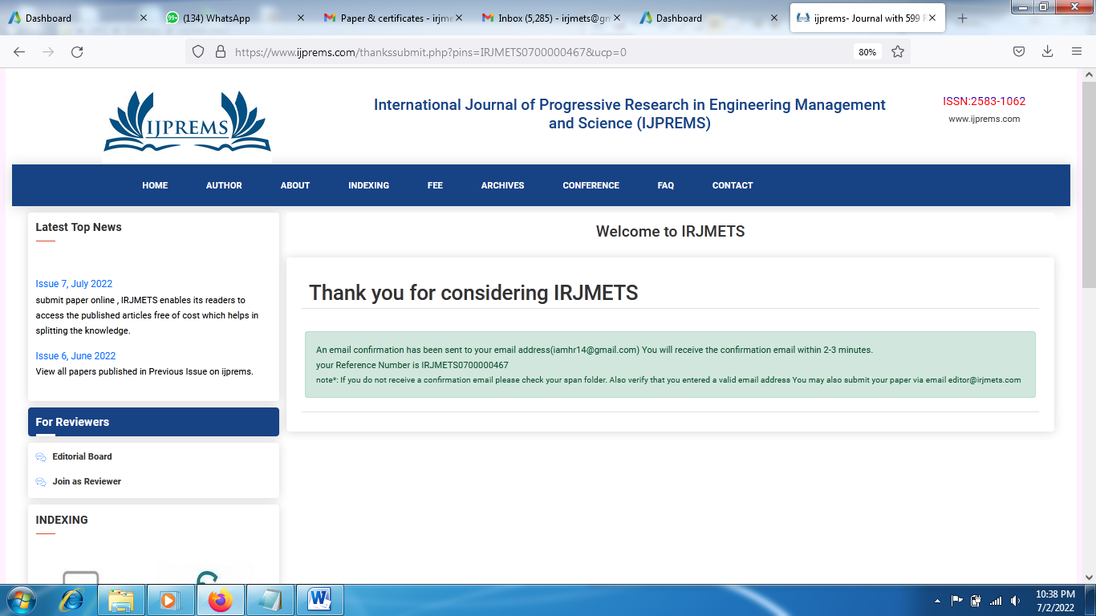

1. Kindly make some change is the site structure as it is completely same as irjmets.
2. Give search option in past and current issue.
3. Change the view of current and past issue.
4. No Doi link option.-(it should be provided below paper and author name on website in current and past issue) for DOI folder structure should be - https://www.ijprems.com/uploadedfiles/paper.pdf

Panel-

1. Make some change in panel colour of ijprems so we easily known of panel belongs to which site.
2. No Doi link option

for DOI folder structure should be - https://www.ijprems.com/uploadedfiles/paper.pdf