BIG DATA RECOMMENDER MODEL FOR PUBLISHERS

# SHUBHAM BABASO PACHIMBARE *1, SHRUTI SUDESH SURYAWANSHI *2, PRAJAKTA PRAKASH LANDGE *3 MRUNAL RAMESH HIWARE *4.

*1,2,3,4Jaywant College Of Engineering And Polytechnic, Kmgad, Maharashtra, India.

Professor, Department Of Computer Engineering, JCEP, Kmgad, Maharashtra, India.

# ABSTRACT

The advancement of several significant technologies, such as artificial intelligence, cyber intelligence, and machine learning, has made big data penetrate the industry and academic field and our daily life and a variety of cyber-enabled applications. This article focuses on a deep correlation mining method in heterogeneous big data environments. A hierarchical hybrid network (HHN) model is constructed to describe multitype relationships among different entities.

**INDEX TERMS**:

Correlation mining, cyber intelligence, heterogeneous big data, hierarchical hybrid network (HHN), reinforcement learning, social influence.

# INTRODUCTION

* The development of emerging technologies has enabled big data to quickly penetrate both industry areas. Some recommendation systems consider multiple relationships, they measure these relationships separately, rather than combining them in an associative way. When dealing with different types of entities in a constructed network model, most studies calculate the relevance among the same type of entities in a non-discriminatory way, and thus, do not take multilevel factors into account.
* Analysis of complex relationships across heterogeneous networks usually requires extracting multimodality features from different data sets. a hierarchical architecture to fully consider the various relationships from multisource data sets for deep correlation mining. An intelligent router based on deep reinforcement learning framework is proposed to generate optimal actions to route across the HHN model, which efficiently improves the RWR process when handling the heterogeneous network.
* An improved RWR-based algorithm is developed to provide intelligent recommendations, which is applied in the scholarly big data environments to support users’ collaboration works.

# LITERATURE SURVEY

In [X. Wang, L. T. Yang, H. Liu, and M. J. Deen, “A big data-as-a-service framework: State-of-the-art and perspectives,” IEEE Trans. Big Data, vol. 4, no. 3, pp. 325–340, Sep. 2018] references about the details about big data and their services provided, the big data as a framework

In [J. Qi, P. Yang, L. Newcombe, X. Peng, Y. Yang, and Z. Zhao, “An overview of data fusion techniques for Internet of Things enabled physical activity recognition and measure,” Inf. Fusion, vol. 55, pp. 269–280, Mar. 2020] referenced about the basic part of NLP- Natural Language Processing and Activity recognitions and the mixture of techniques for the IOT.

In [W. Zhang, F. Kong, L. Yang, Y. Chen, and M. Zhang, “Hierarchical community detection based on partial matrix convergence using random walks,” Tsinghua Sci. Technol., vol. 23, no. 1, pp. 35–46, Feb. 2018.] references about the algorithms and details of Hybrid Hierarchical network, which is mainly used for the Reinforcement Learning.

In [G. Yu, G. Fu, J. Wang, and Y. Zhao, “NewGOA: Predicting new GO annotations of proteins by bi-random walks on a hybrid graph,” IEEE/ACM Trans. Comput. Biol. Bioinf., vol. 15, no. 4, pp. 1390–1402, Jul. 2018.] references about the algorithms and details about the Random Walk with Restart technique which is mainly used for getting the randomly user and item relations.

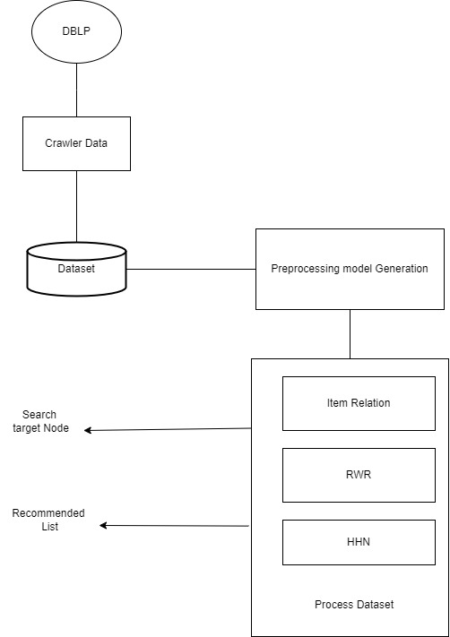

Fig 2.1Architecture diagram for Project working flow

## Project Scope:

# SOFTWARE REQUIREMENTS AND SPECIFICATIONS

* Furthermore, to evaluate the accuracy of the algorithm, especially when handling smart recommendations with big data, we tested both the user attributes and item attributes recommendations in the experiment with the heterogeneous data.
* For future studies, the policy of IR within a heterogeneous network can be further investigated.
* More evaluations needed for the heterogeneous data and The model should be further expanded into in application.

# LIMITATIONS

The Big Data Recommender model is the model used for just the recommending purpose, it will not provide any direct link for accessing that paper which was recommended by the model.

It is not still an application nor the webpage, nor the web application, It is just a trained model.

# CONCLUSION

* Experiments based on DBLP data demonstrated the practicability and effectiveness of the proposed HHN model in providing users with collaboration work support.
* We designed a hierarchical architecture to capture multitype relationships among different users and items across multiple layers. An RWR-based algorithm was improved to provide an intelligent recommendation.
* An intelligent router was then developed based on the deep reinforcement learning to obtain optimal decisions of whether jump into or jump out across the hierarchical network during the RWR process.
* Experiments based on DBLP and ResearchGate data demonstrated the practicability and effectiveness of the proposed HHN model in providing users with collaboration work support.

# ACKNOWLEDGEMENTS

It gives us a great pleasure to remain deeply indebted to our project guide **Prof. Mr. Kadam S. R** whom we have privilege to work. The faith & confidence shown by his in us boost our moral and motivate us to perform better in this project.

We convey our sincere thanks to **Prof. Mr. Kadam S. R** (H.O.D., Computer Science and Engineering Department) for his timely co-operation. Finally, thanks to all **Staff Members** and all friends and colleagues who support us in the development of project.

.

# REFERENCES

* [1] X. Wang, L. T. Yang, H. Liu, and M. J. Deen, “A big data-as-a-service framework: State-of-the-art and perspectives,” IEEE Trans. Big Data, vol. 4, no. 3, pp. 325–340, Sep. 2018.
* [2]J. Qi, P. Yang, L. Newcombe, X. Peng, Y. Yang, and Z. Zhao, “An overview of data fusion techniques for Internet of Things enabled physical activity recognition and measure,” Inf. Fusion, vol. 55, pp. 269–280, Mar. 2020.
* [19] W. Zhang, F. Kong, L. Yang, Y. Chen, and M. Zhang, “Hierarchical community detection based on partial matrix convergence using random walks,” Tsinghua Sci. Technol., vol. 23, no. 1, pp. 35–46, Feb. 2018.
* [20] G. Yu, G. Fu, J. Wang, and Y. Zhao, “NewGOA: Predicting new GO annotations of proteins by bi-random walks on a hybrid graph,” IEEE/ACM Trans. Comput. Biol. Bioinf., vol. 15, no. 4, pp. 1390–1402, Jul. 2018.
* Dblp.org
* Google.com