IoT based Smart City

# Aishwarya Dhote1, Bhumika Gaikwad2, Elvin Gajbhiye3, Ankit Pakhale4, Kiran Prajapati5

1,2,3,4 B. Tech students, Department of Information and Technology, JD College of Engineering, Nagpur-441501 Maharashtra, India

5 Associate Professor and project guide, Department of Information and Technology, JD College of Engineering, Nagpur-441501 Maharashtra, India

**Abstract: *In today’s modern world people preferred to live the sophisticated life with all facilities. The science and technological departments are rapidly growing to meet the above requirements. With advanced innovations, Internet of things plays an important role to automate different areas like street lights, homes, parking lots and door systems, etc. Currently we use manual systems to operate the above-mentioned things. In this project we studied about how IoT is used to develop the street lights, homes, parking lots and door systems in the smart way for our modern era. In addition, with the study on smart city we analysed and described different sensors and components which are used in IoT environment***

**Keywords:** IoT, LDR Sensors, Relay, Wi-Fi Module ESP8266, NodeMCU, IR Sensors

# 2. Literature Survey

**1. Introduction**

Smart city solutions of IoT are focused to develop cities of future that promote economic development, smart city use IoT devices to such as connected sensors, lights and meters to collect and analyse data and improve infrastructure and environment, and digitally optimize public assets. The Internet of Things can be defined as connecting various types of objects like smart phones, personal computers and tablets to internet, which brings in very new-fangled type of communication between things and people. This project consists of four major aspects of IoT: -

**Smart Home:** A smart home incorporates sensors, actuators, middleware and a network and has two major interacting components which is a smart network and smart load. The smart home is known as Home Automation, with the use of new technology, to make the domestic activities more convenient, comfortable, secure and economical.

**Smart Street Light:** IoT based smart street light system is the conversion of energy by reducing electricity wastage as well as to reduce manpower. The saved energy can be utilized in various purposes like residential, commercial etc. This is done by using the LDR sensor. Here the LDR sensor is used to ON- OFF the street light based on the ambient intensity level.

**Smart Parking Lot:** Efficient and smart way to automate the management the of the parking system that allocates the efficient parking space using IoT technology. The IoT provides a wireless access to the system and the user can keep a track of the availability of the parking area. T he user usually wastes his time and efforts in search of availability of free space in the specified parking area. The parking information is sent to the user via notification. Thus, the waiting time for the user is minimized. RFID technology is being used to avoid car theft.

**Smart Garage Door:** Design an automatic door system using a unique wireless id by using infrared ray or Bluetooth technology. That consists of a sensing unit and drive unit to open and closes door at the entrance of a car that has the unique id. This process is controlled by using Arduino that receives the signal code from the car which sends the id through IR LED or Bluetooth by using a BLYNK APP, decode it and switch on the driver that controls the DC motor.

A very simple explanation of the internet is that it is an intricately linked worldwide computer network. The network enables global communication by moving computerized information, known as data from one place to another. The connections between the computers are a mixture of old- fashioned copper cables, fibre-optic cables [which send messages in pulses of light], wireless radio connections [which transmit information by radio. waves], and satellite [Woodward, 2014]. Although it is not this paper's objective to discuss in detail the working of the internet, we do need to acknowledge the importance of the internet's addressing system or IP a series of digits separated by dots or colons. The world is moving from people connectivity to machine connectivity. This is being possible as electronic devices each have a unique address or IP. We thus have devices which are being called 'smart'. What differentiates the internet from the internet of things is that connectivity is possible among devices which are not only computers, smartphones and tablets but also a variety of sensors and monitors. The end result of this connectivity is to make life easier for people by anticipating need and arranging to fulfil the same.

Various home automation systems were proposed in literature with different specifications and functionality proposed a home automation by implementing ZigBee with Arduino to control the home appliances. This system controls small home appliances by using various till date technological sensors. Users are able to check the status of their home appliances using web server. A web application is designed to control and manage the system.

The project is usually a multi-functional prototype that has an aptitude to get rid of the manual operation of the old street lightning system by strategy of the self-automation. It aims at designing and executing the advanced development in embedded systems for energy saving of street lights and their maintenance at reduced cost with modern development. Street Lightning system has a feature as two sensors are used which are Light Dependent Resistor (LDR) to point a day/night time and therefore the passive infrared sensor (PIR) to detect the movement on the road.

The sensors used in IoT based smart parking system stores and accesses data from remote locations with the help of the cloud these factors give raise to cloud of things (COT). The nodes

could be monitored and controlled from any location the system that we propose provides information regarding the availability of the parking slots with the help of the mobile application the users from the remote location can book the parking slots. An algorithm is used to increase efficiency of cloud-based parking system and network architecture technology is used. This algorithm is used to find the lowest cost parking space. Considering the number of parking space available and also considering the distance of the parking space from the user. The user can directly access the cloud-based server and find the information on the parking space. The user can also install an application in their mobile phones to access this information. With the help of this algorithm, waiting time of the user to find a parking space can be minimised. Security aspects are not included in this paper. A wireless sensor node along with smart phone application is being used to find the parking space. Since, wireless technology is used here the system has high accuracy and efficiency. In this system, onboard units are used to communicate with other vehicles. The user parks his vehicle in any one of the several bays available a mechanical lift lifts the vehicle out. A ticket key and id are given to the user and it is only known to the user which is used to retrieve the vehicle. The user need not carry any paper ticket since a RFID card is given to the user. The technology used here is economical. Security features must be improved to protect the user's privacy.

Electric gates are an easy way to ensure the security of private premises (Rouse, 2016). The advancement of technology has increased the safety and security of people physically and emotionally. One of the reasons for the emergence of smart home is the in-creasing risk of burglary and busy lifestyle (Win et al., 2016). The busy lifestyle has influenced the needs to remotely control and monitor their home. Internet of Things (Lee and Lee, 2015) solves this problem as ubiquitous devices such as smart phone, Internet TV, sensors and etc. are connected to the Internet combine together to form a communication between human and machine**.** These days, the issues like keys that have been left behind and missing keys frequently happens in our daily lives (Jeong, 2016). In addition, the remote key can be also be duplicated. It is essential to strengthen the smart home system through administrative aspects. The smart home project by (Jeong, 2016; Mowad et al., 2014; Win et al., 2016) proposed an authentication method to the system to strengthen the security in home site. However, the alert is only notified to the buzzer or to the site only. For this project, we want to add the access control method on the server side to the smart home project. Chowdhury et al., (2013) and Sahani et al., (2015) proposed face recognition in home security system. Contrary to our study, the authentication is based on access control system.

# System Design

* 1. *Block Diagram*

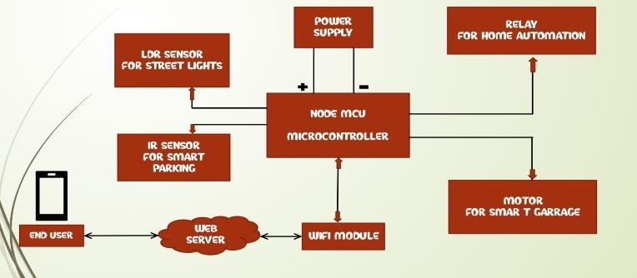

**Figure 1**: Block Diagram

The proposed system has low cost and efficient monitoring by utilizing IoT based devices. Different modules are used with NodeMCU ESP8266

* 1. *Hardware Required*

Following hardware devices and sensors are used to build the proposed system

* + - Power Supply Unit
    - LDR Sensors
    - Motors
    - IR Sensors
    - Relay Module
    - Node MCU ESP8266

# Power Supply Unit

It is the main circuit to provide energy to all components it is an electronic circuit which takes 230V single phase AC supply and converts it into 5V DC to all particulars of the project

# LDR Sensors

Photo resistors, also known as light dependent resistors (LDR), are light sensitive devices most often used to indicate the presence or absence of light, or to measure the light intensity. The sensor that can be used to detect light is an LDR. Since the LDR gives out an analog voltage, it is connected to the analog input pin on the Arduino. The Arduino, with its built-in ADC (analog-to-digital converter), then converts the analog voltage (from 0-5V) into a digital value in the range of (0-1023).



**Figure 2:** LDR Sensor

# Motors

To open and close the garage doors automatically. The motor is driven by motor driver circuit which controls the direction of motor by reading or receiving the signals from microcontroller.

# IR Sensors

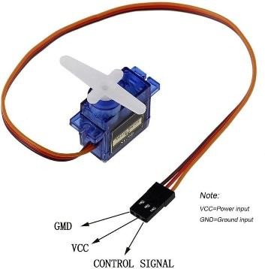

**Figure 3:** Motor

# Node MCU ESP8266

The NodeMCU (Node Microcontroller Unit) is an open-source software and hardware development environment that is built around a very inexpensive System-on-a-Chip (SoC) called the ESP8266. And, you have to program it in low-level machine instructions that can be interpreted by the chip hardware.

The ESP-8266 may be a low-cost Wi-Fi microchip with full TCP/IP Transfer control protocol/ Internet protocol). It makes the web connectivity possible for the IOT panel. ESP8266 offers a whole and self-contained W-Fi.

* + 2.4 GHz Wi-Fi (802.11 b/g/n, supporting WPA/WPA2).

An infrared sensor is basically an electronic device which is used to detect the presence of objects. Infrared light is emitted by this device. If this device does not detect any IR light reflected back that means there is no object present. If the light is detected by the sensor there is an object present

* General-purpose input/output (16 GPIO).
* Inter-Integrated Circuit (PC) serial communication protocol. Analog-to-digital conversion (10-bit ADC).
* Serial Peripheral Interface (SPI) serial communication protocol.

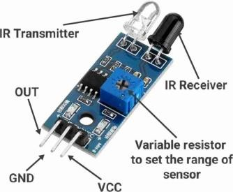

# V) Relay Module

**Figure 4:** IR Sensor

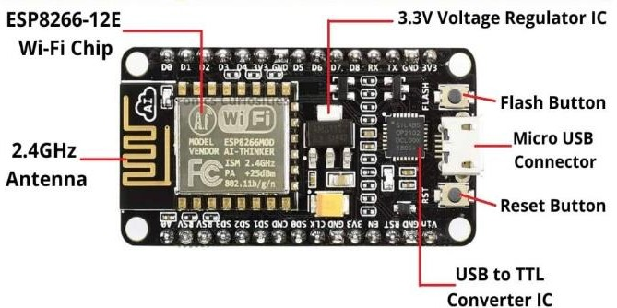**Figure 6:** Node MCU ESP8266

A relay is usually an electromechanical device that is actuated by an electrical current. The current flowing in one circuit causes the opening or closing of another circuit. Relays are like remote control switches and are used in many applications because of their relative simplicity, long life, and proven high reliability. Although relays are generally associated with electrical circuitry, there are many other types, such as pneumatic and hydraulic. Input may be electrical and output directly mechanical, or vice versa. Relays are mainly made up for two basic operations. One is low voltage application and the other is high voltage. For low voltage applications, more preference will be given to reduce the noise of the whole circuit. For high voltage applications, they are mainly designed to reduce a phenomenon called arcing.

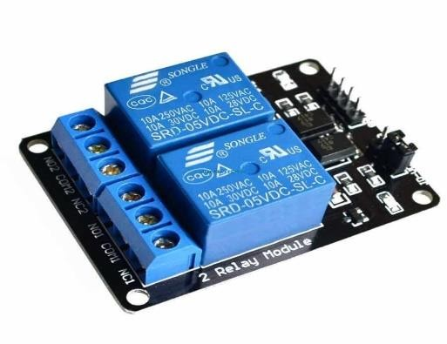

**Figure 5:** Relay Module

* 1. *Software Required*

1. **Arduino IDE (Integrated Development Environment)** – It is used to program the microcontroller
2. **Blynk Android Application –** It is a platform that allows us to quickly build interfaces for controlling and monitoring the hardware project from our android device.
   1. *Language Used*

A) **C language**

**Framework used – Embedded C:** - It is a set of language extensions for the C programming language by the C standards committee to address commonality issues that exist between C extensions for different embedded systems

# Working

Internet of Things is a term of opening new possibilities of interacting with electronic devices by digitally interfacing them possibly providing information in a very simple user-friendly format to a smart device and connected to the same network as the rest of the system. In this system, every device is required to be operate in the basis of IoT, are connected to each other on the same network and connected to the cloud.

The system architecture of our smart city is adaptive system and it consist of four parts Smart Home Automation, Smart Light, Smart Parking and smart garage door. In this system Node MCU microcontroller acts as the brain of the entire system. All the sensors used in system are connected to microcontroller. So, in:

1. **Smart Home Automation** - In this project all the sensors are connected to the Node MCU board and the results can be seen in Smart phone. Under the Home Automation we can control all electrical appliances from long distance through a mobile phone. In this project we are controlling Lights and Fans through an Internet. Even though if Wi-Fi is not available, we can go to 3G or 4G services to operate the system. This will help us to operate our home appliances through a long distance. This will help the handicapped and aged people to control their home appliances easily.
2. **Smart Street Light -** All the sensors used in this system are connected to micro controller. LDR is light dependent resistor. When the day time sunlight falls on it, its resistance decreases and makes the light to switch off. When the night time, light do not fall on the sensor, so its resistance increases and triggers the light to switch On. Relay acts an automatic switch and electromagnetic switch it is connected to the micro controller by relay driver. It is highly reliable and automatically switches ON and OFF the lights.
3. **Smart Parking Lot -** Every user who enters the parking slot contains a RFID card which contains the details of the user. When the RFID card is scanned by the reader module, the details of the user are transferred into the module. Now the IR sensor checks whether the parking space if free. If, there is no space available the parking barrier gate will not open. A message is sent to the user with the help of a GSM module which sends a registered message depending upon the availability and unavailability of the parking space. The WIFI module supports the system by storing all the data in the cloud. It connects the devices with the cloud server. Here, the user scans the RFID card provided to the user. If space is available, the user receives a message "Welcome username" the barrier gate will open and the user can park the car. When the user exits the parking space the user again has to scan the RFID and a message will be received by the user "thanks for using smart parking username". The database about the user's activity in the parking space will be stored in cloud database. The user will know that a particular space is available with the help of the cloud status. When the car is parked the IR sensor detects the presence of an object and updates the cloud status from 0 to 1 and when the car leaves, the cloud status is updated from 1 to 0. So, the user can park his car where the cloud

status is 0. The cloud status is updated every 2 minutes.

1. **Smart Garage Door -** Circuit requires 12V DC for Arduino board, motor driver 5V for microcontroller IC, LCD display and sensor. This power supply can be provided by 12V step down transformer with rectifier-filter for converting AC ripples in to pure DC and regulator of 5V. Microcontroller has very low current output it cannot drive current consuming sources, such like relay hence relay driver circuit requires. We can implement this circuit using transistor or relay driver IC also. when we open the BLYNK in our mobile phone, PC from that we can access the door. By using atmega328 Arduino IC Wi-Fi module& motor driver IC. The main advantage of this project is that we can know the the door is ON or OFF.

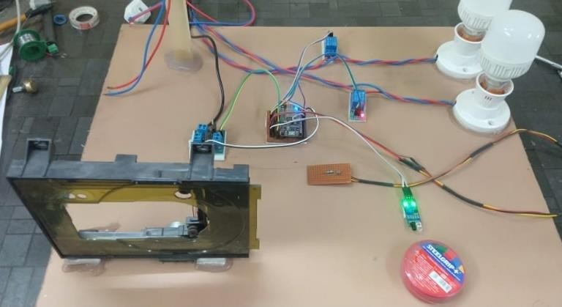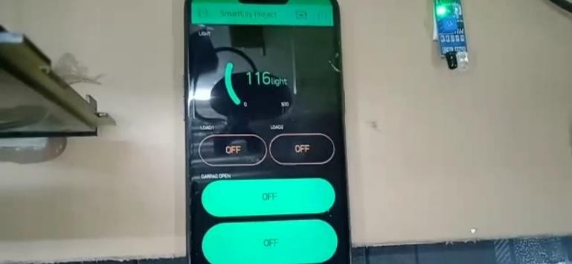

**Figure 6 &7:** Prototype of IoT based Smart City

# Conclusion

***In Smart Home Automation*** Wiring and switching cost is reduced by utilizing wireless networks. Power consumption also condensed inside the building when loads condition is off. The sensed data is analysed at cloud and real time statistics provided via mobile application. A prototype is implemented to elaborate the performance and functionality of proposed approach. Fans, lights, curtains and door are automated. Home appliances can be easily controlled via mobile application. Furthermore, the proposed system provides the real time statistics of environmental factors.

***In Smart Street Light*** the system can be further enhanced by writing logic into the code and that can be able to retrieve information of the time of sunset and sunrise from a reliable weather reporting source and automate the process completely

by turn ON the street light at the time of sunset and turn it OFF by sunrise. This further eliminates human intervention and a manual visit to the location of the street lights will be required only in case of a malfunction. The efficiency of automated systems is more than the manual systems. We can also reprogram these devices with respect to our needs.

***In Smart Parking Lot*** parking facilities and traffic management systems have always been at the core of constructing smart cities. In this paper, we address the issue of parking and present an IoT based Cloud integrated smart parking system. The system that we propose provides real time information regarding availability of parking slots in a parking area. Users from remote locations could book a parking slot for them by the use of our mobile application. The efforts mad 6/10 i paper are indented to improve the parking facilities of a city and thereby aiming to enhance the quality of life of its people.

Nowadays ***In Smart Garage Door*** especially for people who have difficulty opening the door, the garage door enables the user to open the remote or close the door. In the detection of fingerprints, safety features on the remote are used to prevent unauthorized use and entry. An automatic air opening door opens or closes the door with the help of an electrically controlled deadbolt or lock or open door.

# References

* Cristea V., Dobre C., Pop F., "Context-aware Environments for the Internet of Things". (2013).
* D. Evans. (2011). The Internet of Things: How the Next Evolution of the Internet Is Chang Everything. [Online]. Available:

<http://www.cisco.com/c/dam/en_us/about/ac79/docs/i> nnov/IoT IBSG_0411FINAL. pdf

* P. Bellavista, G. Cardone, A. Corradi, and L. Foschini "Convergence of MANET and WSN in IoT urban scenarios." IEEE Sens. J., vol. 13, no. 10, pp. 3558 3567, Oct. 2013.
* B. Hammi, R. Khatoun, S. Zeadally. A. Fayad and L. Khoukhi. "IoT technologies for smart cities," in IET Networks, vol. 7, no. 1, pp. 1-13, 1 2018
* Anandhavalli, D.; Mubina, N.S.; Bharath, P. Smart Home Automation Control Using Bluetooth and GSM. Int. J. Inf. Futur. Res. 2015, 2, 2547-2552
* Khanna, A., Anand, R.: IoT based smart parking system. In: International Conference on Internet of Things and Applications (IOTA) 22 Jan 2016, pp. 266- 270. IEEE (2016).
* 9. Rao, Y.R.: Automatic smart parking system using Internet of Things (IOT). Int J Eng. Technol Sci Res, 4
* (2007:2). safety standards for automatic residential garage door operations 2013. The chamberlain group, Inc.Hearst. "How It Works: Garage Door Opener." How It Works: Garage Door Opener. Hearst Communications, Inc.,
* ans, V., Sethi, P.S., Kinra, J.: An approach to loT- based car parking and reservation system on Cloud. In: International Conference on Green Computing and Internet of Things (ICGCIOT) 8 Oct 2015, pp. 352- 354. IEEE (2015).
* A. Laya, V. I Bratu, and J. Markendahl, "Who is investing in machine-to machine communications?" in Proc. 24th Eur. Reg. ITS Conf., Florence, Italy, Oct. 2013, pp. 20 23.
* Soledad Escolar, Jesus Carretero, Maria-Cristina Marinescu and Stefano Chasse "Estimating Energy Savings in Smart Street Lighting by using an Adaptive Control System" International Journal of Distributed Sensor Networks Volume 2014, Article ID 9715.
* 2017 IEEE Region 10 humanitarian Technologyconference (R10-H) and N.
* Isah Abdulazeez Watson, Oshomah Abdulai Braimah, Alexander Omoregie "Design and Implementation of an Automatic Street Light Control System" International Journal of Emerging Technology and Advanced Engineering, Volume 5, Issue 3, March 2015
* Deepanshu Khandelwal, Bijo M Thomas, Kritika Mehndiratta, Nitin Kumar "Sensor Based Automatic Street Lighting system" International Journal of Education and Science Research Review Volume-2, Issue-2 April-2015.