

International Research Journal of Modernization in Engineering Technology and Science

ISSN: 2582-5208

Volume

3

ISSUE

8

August: 2021

www.irjmets.com

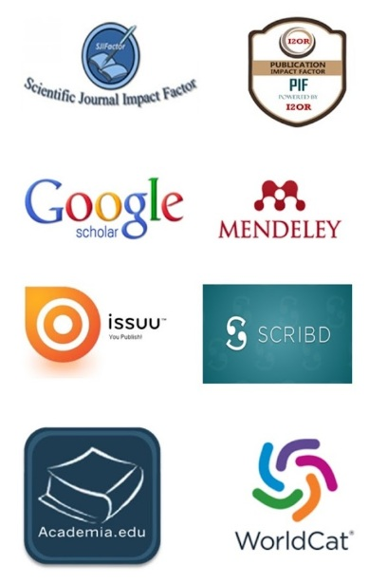

Many more….

[www.irjmets.com](http://www.irjmets.com)

Contact: 7869696794, E-mail: editor@irjmet.com

7869862710 irjmets@gmail.com