**MACHINE LEARNING ALGORITHM FOR TYPE OF OFFENSE AND INCIDENCE PREDICTION**

**Sushmitha T*1, Mrs Shivaleela S*2**

*1Student, Department of Master of Computer Applications, Dr. Ambedkar Institute of Technology, Bangalore, Karnataka, India.

*2Assistant Professor, Department of Master of Computer Applications, Dr. Ambedkar Institute of Technology, Bangalore, Karnataka, India

**ABSTRACT**

Throughout this period of continuing times, wrongdoing has been a clear method of rising people and society into hell. An growing misbehaviour component contributes to an irregularity in a nation's electorate. To analyse and respond to these kinds of crimes, one has to be aware of the faulty designs. This study uses data on poor behaviour obtained from Kaggle free-open source, which is used as the assumption for most problematic actions, to drive one such plan assessment. Recently, there have been some infractions. The most crucial part of this effort is figuring out what kinds of misbehaviour, and when and where they happened, are the biggest contributors. When compared to works that were already generated, several AI computations, such

**Keywords:** K-Nearest Neighbor, Random Forest Classifier, Artificial Neural Network, Artificial Intelligence

1. **INTRODUCTION**

The act of wrongdoing has grown into a powerful force that is now considered to be a key thread. A wrongdoing is defined as a behaviour that is fundamentally unfavourable, breaches public authority regulations, and violates the standard. The misbehaviour design test requires a concentrate on a number of criminal science topics in addition to the capacity to provide plans. The government must invest a lot of time and energy in inferring innovation in order to administrate a fraction of these criminal exercises. As a result, it is anticipated that using AI techniques and data would enable prediction of both the nature and patterns of misbehaviour. It enforces the goals of current information on poor behaviour and evaluates the type of bad behaviour and incident in light of the locale.

1. **METHODOLOGY**

There are many different types of wrongdoing and they happen all around the world. Numerous scholars have suggested a tool to examine the connection between bad behaviour and socioeconomic factors including unemployment, income, and educational achievement. Two AI models for assumptions, K nearest neighbour estimation (KNN), and the decision tree method were introduced by Suhong Kim and Param Joshi. The accuracy attained while foreseeing wrongdoing examples and identifying the wrongdoing sort ranges from 39 to 44 percent. The Benjamin. David H pushed an information mining strategy, which incorporates perusing and analysing enormous prior databases, in order to communicate extra facts. Extracted new instances are compared to pre-established datasets. Shraddha S. Kavathekar used alliance rule mining to forecast wrongdoings. Artificial neural network (ANN) and profound neural network (DNN)

1. **EXISTING SYSTEM**

Pre-work is done on the dataset that was obtained from an open source source in order to remove duplicated values and items. The use of decision trees is vast and includes not only extracting the components from a lot of information but also differentiating undesirable behaviour plans. It provides a crucial framework for the subsequent characterisation procedure. The characteristic wrongful designs are extracted using deep neural organisation. According to the gauge, the presentation is chosen for both the arranged and test values. Expecting misbehaviour helps law enforcement forecast the recurrence of any form of crime in the future and helps them come to a resolution.

1. **PROPOSED SYSTEM**

The data is first first pre-processed utilising an AI method channel and covering in request to remove irrelevant and rehashed information values. Additionally, it reduces dimensionality, indicating that the data has been cleansed. The dataset then goes through a separation process. A test index and a prepared informative index make up its two portions. The model is prepared by testing and preparing the dataset. The next step is planning. To make collection easier, the poor behaviour type, year, month, time, date, and location are excellent to go to a whole number. Using Nave Bayes, the free relationship between the attributes is initially investigated. The separated autonomous elements are described using the Bernouille Nave Bayes method. The major transgressions

1. **BENEFITS**

The proposed estimate is appropriate for the wrongdoing design identification because the bulk of the included ascribes depend on time and location. It also resolves the issue of calculating the free influence of the qualities. Because it represents true, apparent value and also concerns the region with insufficient information, the introduction of ideal worth is not anticipated. The exactness has often been strong when compared to other AI expectation models.

1. **MODULES DESCRIPTION**

**A. Information Pre-Processing**

Information collected from free sources should be pre-processed to prevent unwanted infringement. The dataset was chosen for the city of Denver because it has a lot of data on misconduct that spans more than six years. The AI strategy channel and covering are suggested to be the missing component in determined property estimations. Data cleansing is necessary for the creation of an expectation model and the execution of the initiated interaction. The case has been separated, and the datasets have been cleared of superfluous parameters. Determining the relevance of the pieces is made easier by using separation procedures. When choosing an element, the relationship to ward values is taken into account. By building a forecast model on a component subset, the forced covering method determines how useful it is**.**

**B. Mapping**

The characteristics of the wrongdoing, such as the type of wrongdoing, the date and time of the infraction, are first isolated. Then, in order to make nomenclature simpler, it is turned over totally to a whole number. The indicated data are further examined and used to generate charts. Python was chosen as the programming language to complete the suggested work because it is suitable for AI. The tool matplotlib is used to create a graphic that illustrates the occurrence of criminal behaviour. The graphic allows for the plotting of the wrongdoings that occurred most frequently, supporting the interaction theory.

**C. Guileless Bayes Classification**

The use of Nave Bayes is justified by the fact that information that is temporary and geographically specific is typically relevant to wrongdoing expectation. The autonomous influence among the characteristic values is first separated since the selected misbehaviour credits have a free impact on them. By offering a preparation based on wrongdoing data connected to theft, robbery, murder, sexual assault, equipped burglary, chain grabbing, assault, and roadway burglary, they are employed in the building of a model. A portion of Nave Bayes' intricate methods have been discovered.

1. Gaussian Nave Bayes and genuine esteemed trait selection are related. In any case, it is stated as projected circulation, which is completed by calculating the standard deviation and mean using the data that has already been prearranged.

2. It has several ostensibles.

**D. Wrongdoing Prediction**

The usual misbehaviour kind is anticipated by broadening the upheld wrongdoing highlights. The elements are then applied to qualities with outward appearances. It may be understood well by utilising a single tuple as an event.

**Considering a tuple:**

1. "Gateway Town," Friday, October 20, 2020, 2:30 PM => A crime called "larceny" also includes breaking into someone else's property.

Considering a feasible occurrence in light of the extricated include:

Gateway Town = 2. Theft took place.

3. October: A theft took place.

4. 2020 => Theft took place

5. 2:30 PM: Theft took place

6. "Friday" Theft took place.

In addition, free event have being framed, and contingent likelihood has been computed. By doing so, we could forecast the sort of misbehaviour.

Making use of pictures

1. m addresses Addresses from month

2. Time

3. an area addresses

4.addresses Day

5. y gifts

The Formula including the chain to find the prohibitive probability:-

P(c|m, y, a, t, d) = [P(m|c, y, a, t, d) * P(y|c, a, t, d) * P (t|d, c) * P(d|c) * P(c)]/[P(m|y, a, t, d) * P(y|a, t, d) * P (a|t, d) * P(t|d)]

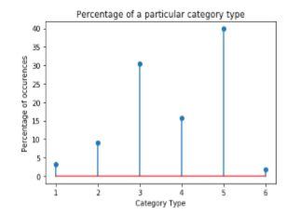 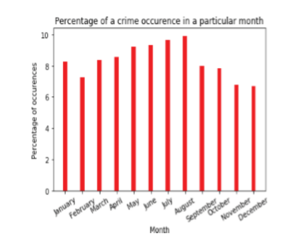

**Figure 1:** Plotting the most noteworthy crime type **Figure 2:** Plotting the most noteworthy occurrence month

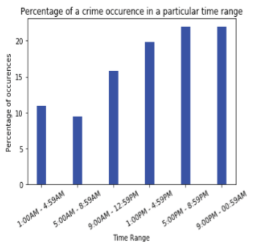 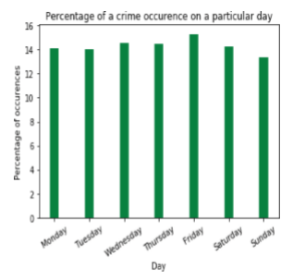

**Figure 3:** Plotting the most noteworthy event time range **Figure 4:** Plotting the most noteworthy occurrence day

1. **CONCLUSION**

In this focus, two classifiers Multi-ostensible NB and Gaussian NB are used to overcome the challenge of regulating ostensible circulations and real esteemed ascribes. It is the best option for continuing expectations because it requires less preparation time. Additionally, it takes on the challenge of controlling an objective arrangement of elements that is constant, something that past attempts failed to do. Therefore, the most frequent crimes might be predicted and detected using Nave Bayesian Classification. Several common metrics are used to gauge the algorithm's success. The main criteria for the algorithm assessment are average precision, recall, F1 score, and accuracy. The accuracy value may be significantly increased by using machine learning.

1. **REFERENCES**
2. "Crime Analysis Through Machine Learning," IEEE Transactions, November 2018. Suhong Kim, Param Joshi, Parminder Singh Kalsi, and Pooya Taheri
3. Ben Fredrick Survey on Crime Analysis and Prediction Using Data Mining Techniques, David H. and A. Suruliandi, ICTACT Journal on Soft Computing, April 2012.
4. A Survey on Crime Occurrence Detection and Prediction Techniques, International Journal of Management, Technology And Engineering, Volume 8, Issue XII, December 2018. Shruti S.Gosavi and Shraddha S. Kavathekar
5. Abraham Chandy wrote in Journal of Information Technology, no. 02, "Smart resource utilization prediction utilizing cloud computing for big data processing systems."
6. Learning "Crime Pattern Detection, Analysis & Prediction Using Machine," International Research Journal of Engineering and Technology, (IRJET) e-ISSN: 2395-0056, by Rohit Patil, Muzamil Kacchi, Pranali Gavali, and Komal Pimparia.
7. Spatial and Temporal Crime Hotspot Detection and Prediction: A Systematic Literature Review, by Umair Muneer Butt, Sukumar Letchmunan, Fadratul Hafinaz Hassan, Mubashir Ali, Anees Baqir, and Hafiz Husnain Raza Sherazi, IEEE Transactions on September 2020.
8. A failure prediction model for corrosion in gas transmission pipes was developed by Nasiri, Zakikhani, Kimiya, and Tarek Zayed and published in Proceedings of the Institution of Mechanical Engineers, Part O: Journal of Risk and Reliability (2020).
9. A Survey Paper on Crime Prediction Technique Using Data Mining, Nikhil Dubey and Setu K. Chaturvedi, 2014, Corpus ID: 7997627.
10. Sustainability Journals, Volume 12, Issue, Rupa Ch, Thippa Reddy Gadekallu, Mustufa Haider Abdi, and Abdulrahman Al-Ahmari, "Computational System to Classify Cyber Crime Offenses Using Machine Learning." 10, May 2020 will have snow.
11. Hyeon-Woo Kang and Hang-Bong Kang, "Prediction of crime incidence from multi-modal data using deep learning," published in an April 2017 peer-reviewed journal.