**DESIGN OF SMART HELMET**

**R. Srinivasa Rao *1, N. Sreelekha*2, R. Keerthi Reddy *3, D. Akhila*4**

*1 Associate Professor, Electronics and Communication Engineering, ACE Engineering College, Hyderabad, Telangana, India

*2,3,4 Student, Electronics and Communication Engineering, ACE Engineering College, Hyderabad, Telangana, India

**ABSTRACT**

A smart helmet is a type of protective headgear used by the rider which makes bike driving safer than before. The main purpose of this helmet is to provide safety for the rider. This can be implemented by using features like alcohol detection, accident identification, location tracking, use as hands free device, fall detection. This device uses three sensors namely – IR sensor, MQ-3 sensor, accelerometer-gyroscope sensor. Using GPS & GSM technology the location will be tracked and information is transferred to the nearby hospitals & police stations. This makes it not only a smart helmet but also a feature of a smart bike. An RF Module can be used as wireless link for communication between transmitter and receiver. The components like 8052 micro controllers, a GPS module, GSM module. In case of an accident, it will send a message through GSM along with location with the help of GPS module.

**keywords:** 8052 Microcontroller, GPS and GSM Modules, IR Sensor, MQ-3 Sensor, Telephonic Antenna.

1. **INTRODUCTION**

The A **smart helmet** is a special idea which makes motorcycle driving safer than before. The main aim of the smart helmet is to prevent the biker from starting his bike until and unless he/she actually wears the helmet. The system will connect from the transmitter at helmet to the receiver at bike. Many sensors are being used such as alcohol Sensor, vibration sensor, limit switch, GPS, GSM, etc. If the system identified that the rider or user not wearing their helmet properly the signal won’t be sent to the receiver at bike which will cause the bike cannot start. Intelligent safety helmet for bike is a project undertaken to increase the rate of road safety among bikes. The idea is obtained after knowing that the increasing number of fatal road accidents over the years the cause for concerns among motorcycles. It incorporates the concepts of **GSM** and **GPS** to track a location of the accident and to provide the victim prompt medical attention. The project also carries the concept of a **vibration sensor** which senses the fall of the helmet and informs the family and friends of the biker about the accident by the concepts of **GSM** and **GPS**. Therefore, this project introduces security system for motorcyclist to wear the helmet properly. The project excepted to improve the safety and reduce the accidents.

1. **LITERATURE SURVEY**

In today’s era, especially in the young generation, the craze of motorbikes is really remarkable. The middle-class families prefer to buy motorbikes rather than four wheelers, because of their low prices. As the bikes in our country are increasing, the road mishaps are also increasing day by day, due to which many deaths occur, most of which are caused due to most common negligence of not wearing a helmet. According to a survey of India, there are around 698 accidents occurring due to bike crashes per year. If accidents are one issue, lack of proper treatment is another reason for deaths. In India out of the 698 deaths occurring annually, nearly half of the people die due to lack of proper treatment in proper time. The many reasons for this are late arrival of an ambulance, no person at the place of accident to give information to the ambulance or parents, etc.

There is an alarming increase in the morbidity and mortality due to two-wheeler road traffic accidents. This has been a matter of great concern globally. In India, it is estimated that one accident takes place every 2 minutes. Data from the National Crime Records Bureau indicates that deaths and injuries related to road traffic accident has increased two and four-fold respectively during the period of 1991–2005. Reportedly 98,254 persons were killed in 2005 on Indian roads. The occupants and riders of two-wheeler vehicles are among the majority to be affected in road traffic accidents. Two-wheeler accidents have also been shown to have maximum case fatality in accidents. Smart Helmet is a system which makes all motorcycles in Malaysia aware and compulsory to wear helmet whether the distance is 100-meter radius or long distance. Helmets having integrated electronics have been utilized for some time in work place and recreational settings. One such device has been invented by Kawaguchi et al**.**

1. **BLOCK DIAGRAM OF HELMET AND BIKE BLOCK AND THEIR WORKING**

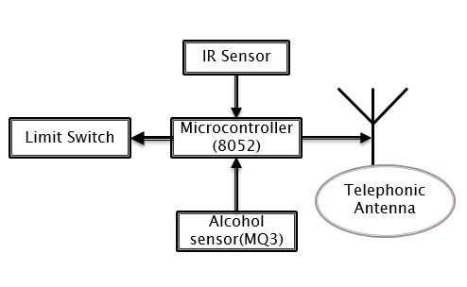

**Figure 1:** Helmet Block

**1.Working**

The helmet is worn or not is known by the limit switch. If the limit switch is in ON state (not released) indicates that the rider is wore his/her helmet and the microcontroller sends the information to the bike through the telephonic antenna. Alcohol sensor used is MQ-3 sensor which detects the alcohol and if it crosses the limit (10mg/L) then the bike won’t start i.e., bike won’t receive the signal. IR sensor senses the distance between two vehicles. It is used for maintaining minimum distance between the vehicles (2~10) cm.

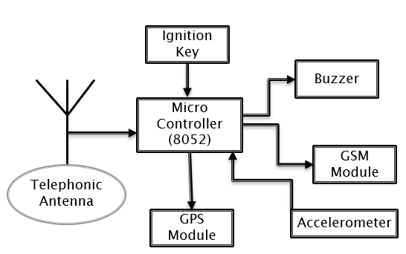

**Figure 2:** Bike Block

**2.Working**

The bike will start if and only if the limit switch is in ON state after pressing the ignition key. Whenever the telephonic antenna receives the information of IR sensor, if it is ON state then the buzzer alert will switch on. Whenever the rider mets with an accident then the controller activates the GPS and GSM module by using the accelerometer sensor. Tracing of location whenever accident occurs is done by using the GPS module and the information reaches the family members/ hospitals/police station through the SMS by GSM module.

1. **RESULTS AND DISCUSSION**

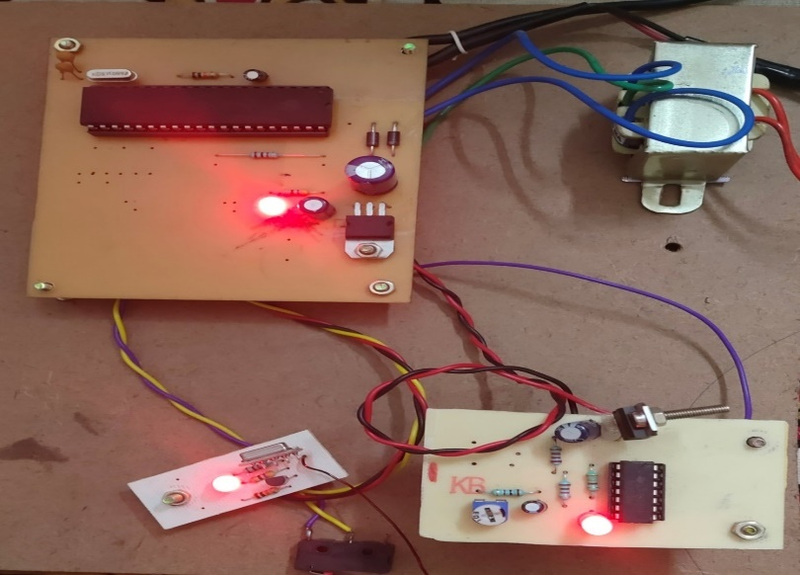

**Figure 3:** Alcohol Detection

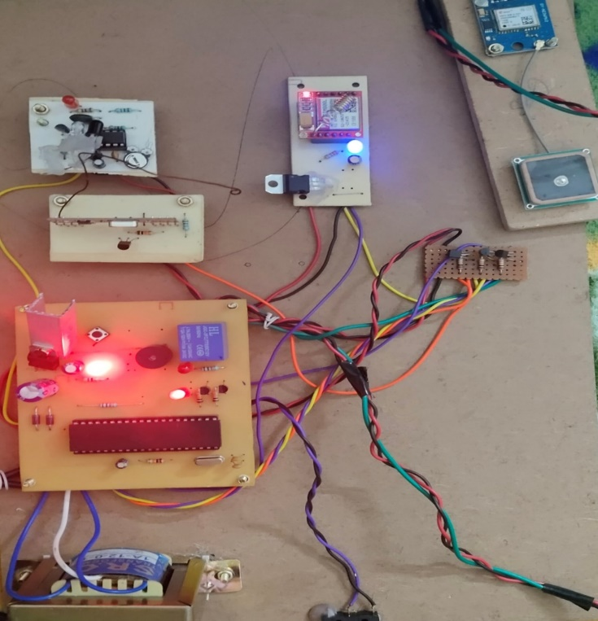 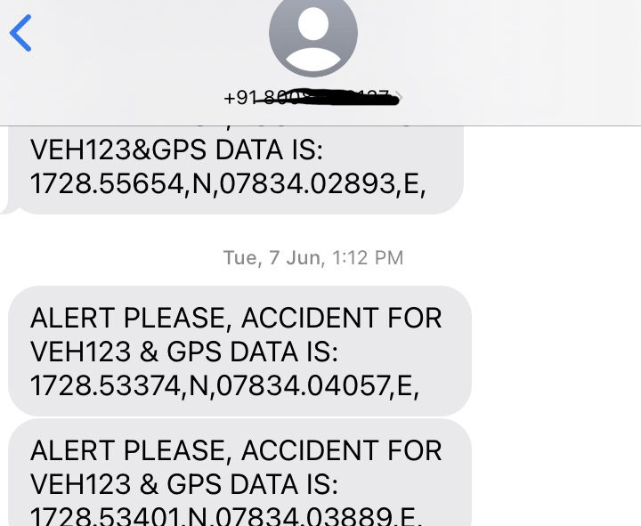

**Figure 4:** Result of Alcohol Detection

First step is to check weather helmet is worn or not is designed which helps in following the government rules. Second step is to check the condition of drunk, if rider is drunken, then bike will not start. Next step is to detect the accident and trace the location using the GPS module and a message is sent to the registered mobile number /Family members, police station and nearby hospitals through the GSM module by glowing the LED, which reduces the consumption of alcohol and increases the safety of rider.

1. **CONCLUSION**

The designed Smart helmet ensures the safety of the rider by making it necessary to wear helmet, and also ensures that the rider hasn’t consumed alcohol more than the permissible limit. If any of these prime safety rules are violated, the proposed system will prevent the biker from starting the bike. As the distance between the vehicles is maintained by IR sensor the probability of dashing of vehicle is totally decreased. And whenever the rider meet with an accident the location of the accident is traced by GPS module and sent to the nearby hospitals / police station and to the family member through the GSM module.

**ACKNOWLEDGEMENTS**

We wish to avail this opportunity to acknowledge our profound debt and extend our sense of guidance to our Guide, prof. R. Srinivasa Rao for his valuable guidance, advice, and encouragement that he led to the successful completion of this project.

Our sincere thanks to our honorable Principal, Dr. B. L. Raju for his genuine support and for providing us with the necessary facilities to carry out the project work. We are exceedingly grateful to our Head of the Department, Dr. P. Satish Kumar for his co-operation in this project’s completion.

We are also thankful to our parents for providing us with financial assistance and moral support for project completion.

1. **REFERENCES**

[1]. Bindu Sebastian Priyanka Kp, Hridhya Kuttikrishanan, “Smart Helmet” International Journal of Technology & Advanced Engineering, Volume5, Issue:12, December 2015.

[2]. Professor Chitte P.P., Salunke Akshay S., Thorat Aniruddha, N Bhosale, “Smart Helmet & Intelligent Bike System”, International Research Journal of Engineering and Technology (IRJET) Volume: 03 Issue: 05,May 2016.

[3]. Jianyun Ni; Jing Luo; "Microcontroller-based engineering education innovation, " Educational and Information Technology (ICEIT), 2010 International Conference on, vol.3, no., pp. V3-109-V3-112, 17-19 Sept. 2010.

[4]. S. Chandran, S. Chandrashekhar, E. Elizabeth N, “Konnect: An Internet of Things (IoT) based Smart Helmet for Accident Detection and Notification”, India Conference (INDICON), 2016 IEEE Annual.

[5]. Jennifer William, Kaustubh Padwal, Nexon Samuel, Akshay Bawkar, Smita Rukhande “intelligent Helmet” International Journals of Scientific& Engineering Research, volume 7, issue 3, March-2016.

[6]. Shoeb Ahmed Shabbeer, Merin Melleet “Smart helmet for accident detection and notification “2nd IEEE international conference on computational systems and information technology 2017.

[7]. Manjesh N., Sudarshan Raj, Smart Helmet using GSM & GPS Technology for Accident detection and Reporting System, International Journal of Electrical and Electronics Research, 2, 4 (2014).

[8].“ Programming and customizing the 8051 Micro-controller” by Myke Predko.

[9]. “Embedded Systems Architecture” by Daniele Lacamera

[10]. “Architecting High-Performance Embedded Systems” by Jim Ledin