**BUS ROLLOVER ANALYSIS ACCORDING TO AIS 031 REGULATION WITH HELP OF LS-DYNA**

**Ajay Ranaware1, R. R. Kulkarni2, Dr. P. A. Makasare3**

1PG Student, Mechanical Engineering, Siddhant College of Engineering, Pune, Maharashtra, India

2Project Guide, Mechanical Engineering, Siddhant College of Engineering, Pune, Maharashtra, India

3Head of Department, Mechanical Engineering, Siddhant College of Engineering, Pune, Maharashtra, India

**ABSTRACT**

This article presents the modelling of a bus superstructure and its strength analysis and evaluates the requirements of Regulation No. AIS 031 using the finite element method, with consideration of nonlinearity of materials and geometry. The analysis includes a strength test simulation in the form of a rollover test, which was performed in accordance with the requirements specified in Regulation No. 031 of AIS. The article presents the results of the dynamic analysis which uses the finite element method.

**Keywords:** Rollover analysis, Regulation AIS-031

1. **INTRODUCTION**

Now a day’s occupant and driver safety are primary concern of all big automotive companies. To ensure this Automotive Industry Standard (AIS-031) propose a vehicle regulation. Every big vehicle manufacturer company should follow this regulation to avoid major fatality during accidental events. Today buses are an integral part of the national transportation system. According to National Transportation Statistics from 2000 to 2015, the number of buses in the India has increased 30 percent. Although buses are one of the safest means of transportation, occupant injuries and fatalities in bus crashes do occur. Rollover strength has become an important issue for bus and coach manufacturers. To make uniformity in structural strength every different country has propose their own regulation of testing for rollover case so that every manufacturer has to satisfy criteria of testing. After testing if bus is satisfying all the safety standards, then that bus manufacturer will get approval certificate with the help of that bus body manufacturer will continue their production. The automotive research association of India (ARAI) has proposed Automotive Industry Standard (AIS031) regulation for rollover accident event. Every Indian bus manufacturer should follow the regulation. Therefore, rollover is simulated using the finite element analysis (FEA) program, and researcher have found out good agreement between tested and simulation analysis

1. **AIM AND OBJECTIVE**

To check the rollover strength of the vehicle according to AIS 031 so that it will ensure maximum safety of passenger. We have to avoid physical test so that cost of prototype will reduce and we are going to do this physical test with help of CAD CAM and CAE.

* Check the strength of superstructure against rollover event.
* Check either residual space is affected by superstructure or not. We have to change it designs that residual space should be safe.
* Estimate reference energy of superstructure.

1. **MODELING AND ANALYSIS**

Initially literature review is carried out by collecting from various published resource related to this work. This involves the current recent trends in automotive sector, requirements of OEM’s, legal requirements, material testing and existing test results. In this project study we are using solid works for the modelling of the design of vehicle which we are using for rollover study. For solver we are using nonlinear LS-DYNA which is for nonlinear crash analysis. For pre-processing purpose, we are using Altair Hypermesh’s using different elements and for post processing or for interpretation of results we are going to use LS-DYNA pre-post. For authentication of input received from supplier which is use for FEA, three points bending testing of standard specimen is done which are generally done in to the industries to study the material behavior in bending kind of loading. Since the main structure of vehicle that is bus side wall super structure undergoing bending kind of load under rollover event. So according to this or existing test results we must make conclusions.

.

1. **EXPERIMENTAL SETUP AND PROCEDURE**
2. **Physical Setup**

Bus rollover is the lateral tilting event in which bus is rolls around the axis which is parallel to the longitudinal central plane. Bus rolls when it cornering a road at high speed at this situation bus is at highest unstable position. When bus is cornering at high speed there are three forces are acting on the bus i.e. cornering force at tire, inertial force which is kwon as centripetal force it acts towards center of gravity and last one is centrifugal force which is acts outward from center of gravity. The body weight of total bus is acting downward from center of gravity and bus is rolls when this body force is overcome by this centrifugal and centripetal force. In this phenomenon bus is rolls from road at particular angular velocity.

1. **Rollover is lateral tilting test and its specification**

* The complete vehicle is standing on the tilting platform, with blocked suspension and is tilted slowly to its unstable equilibrium position. If the vehicle type is not fitted with occupant restraints it will be tested at unladen kerb mass. If the vehicle type is fitted with occupant restraints it will be tested at total effective vehicle mass.
* The rollover test starts in this unstable vehicle position with zero angular velocity and the axis of rotation runs through the wheel-ground contact points. At this moment the vehicle is characterized by the reference energy ER.
* The vehicle tips over into a ditch, having a horizontal, dry and smooth concrete ground surface with a nominal depth of 800 mm.

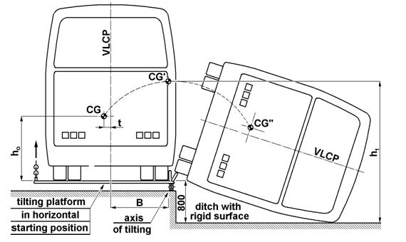

**Figure 1:** Specification of bus rollover

1. **Non-Linear Model Creation and Validation**

The main target of finite element model of the bus is to capture the deformation and interaction of bus subsystems during rollover impact. The accuracy of results depends upon the accuracy of CAD geometry and quality of meshing. As the rollover impact takes place on the sides of the bus, the main load bearing members are the superstructure members of the bus. The parts of the bus model lying below the position of center of gravity contribute very little in absorbing kinetic energy. The major part of kinetic energy is absorbed by the superstructure members in the form of deformations. Therefore, dense mesh is used for the superstructure compared to the other parts. The complete bus structure along with chassis was modelled using shell elements. To ensure computational convergence and to keep computational time reasonably low, minimum element length used is 8 mm. The mesh quality criteria followed for shell meshing is given in Table 1. When time is no constraint, appropriate selection of elements, mesh flow lines and good mesh quality is recommended. Sometimes due to very tight deadline analyst is forced to submit report quickly.

* Automatic or batch meshing tools are used instead of time consuming but structured& good quality providing methods.
* For 3-d meshing tetras are preferred over hexas.
* If assembly of several components is involved then only critical parts are meshed appropriately.

**Table 1.** Mesh quality criteria

|  |  |  |
| --- | --- | --- |
| Sr. No. | Quality parameter | Allowable Value |
| 1 | Minimum Side Length | 2 mm |
| 2 | Maximum Side Length | 10mm |
| 3 | Maximum Aspect Ratio | 5 |
| 4 | Maximum Warpage Angle | 15 |
| 5 | Minimum Quad Internal Angle | 45 |
| 6 | Maximum Quad Internal Angle | 135 |
| 7 | Minimum Tria Internal Angle | 20 |
| 8 | Maximum Tria Internal Angle | 120 |
| 9 | Percent of Triangular Elements | 5% |

1. **Meshing of Superstructure**

Altair Hypermesh software is used for meshing purpose. The CAD model of the bus was imported into Hypermesh. The mid-surfaces were extracted from the CAD model. The features like fillet, small holes having dimensions less than 2 mm were deleted because of less structural significance.

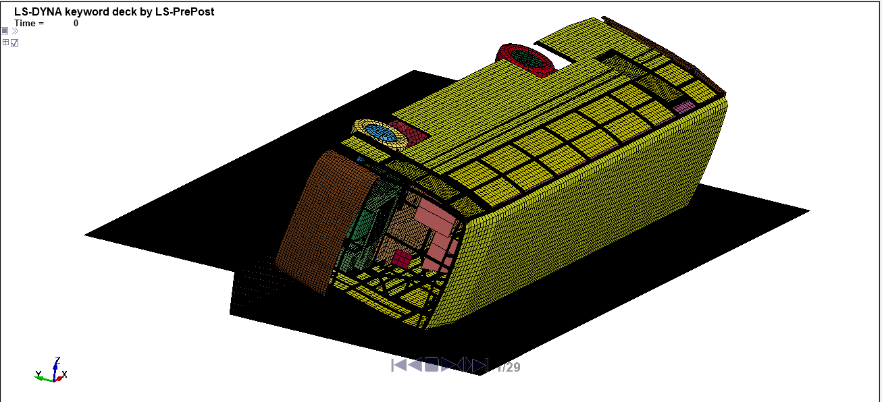

**Figure 2:** Meshing of Superstructure

Unless or otherwise specified specific gravity, values reported shall be based on water at 270C. So, the specific gravity at 270C in our case we are taking time step as an input parameter. From time step empirical relationship, we will get characteristic length and from that we will get minimum length. According to automotive associations thumb rule time step for full vehicle crash analysis time step should be taken 0.3 to 0.4µsec.

According to time step $=\frac{L_{c}}{\sqrt{\frac{E}{ρ}}}$

Where,

$L_{c}$ = Characteristic length, E = young’s modulus. And $ρ=density.$

0.35 $=\frac{L_{c}}{\sqrt{\frac{210000}{7.81x{10}^{-9}}}}$

$$L_{c}=1.8923=2mm$$

We are taking minimum size as 2mm.

1. **Physical test setup in FEA**

The bus is placed on a platform in order to be rolled over on weak side of the structure. It is ensured that the axis of rotation of the bus is parallel to the longitudinal axis of the bus as per figure 1.

1. **Deformation of component**

Figure 3 shows that plastic strain occurred in the full buss rollover simulation. The plastic strain above 10% shown in red colour.

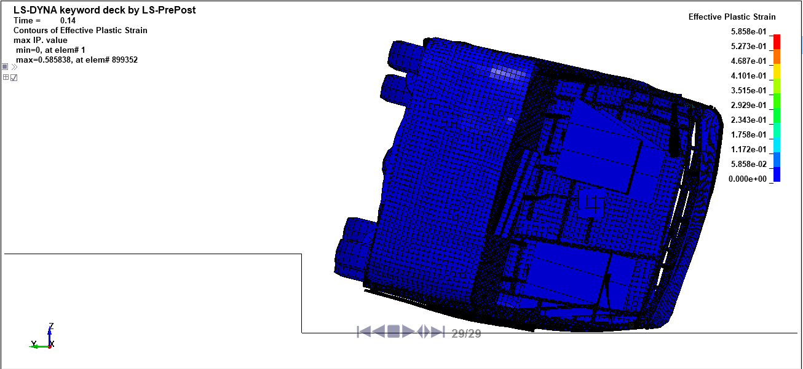

**Figure 3**: Plastic stain in superstructure

1. **CONCLUSION**

The following conclusions are made from finite element analysis of bus roll over:

* The numerical simulation of the bus model showed that it fulfils the requirements of minimum structural resistance described in AIS-031. There are no intrusions of structure into residual space throughout the length of the bus.
* No structural part is intruding in to the residual part from outside before and after the rollover test according to the regulatory requirement
* No structural part is intruding in to the residual part from inside before and after the rollover test according to the regulatory requirement.
* Hence structural part that is superstructures having sufficient strength so that it will resist and it will protect passenger from severe injuries.

1. **REFERENCES**
2. T Automotive Industry Standard – Automotive Vehicles – The Strength of Super Structure of Large Passenger Vehicles, AIS031.
3. Traffic Safety Facts 2015.
4. Somesh G Ayyanagoudar, “Rollover analysis of complete bus super structure as per AIS031 using steel and composite material with advanced finite element method, 2018
5. Satrio Wicaksono, “Finite element analysis of Bus Rollover Test in accordance with UN ECE R66 standard,2017
6. [L. Castejón](https://www.researchgate.net/profile/L-Castejon), “Intercity Bus Rollover Simulation,2018
7. R. P. S. a. O. L. Nikolaevich, Verification of Computer Simulation Results of Bus Body Section Rollover, Journal of Traffic and Transportation Engineering 3,2015,118-127.