**DESIGN AND CONSTRUCTION OF FM TRANSCEIVER**

**Salif Simeon Imaben1, Jagboro Victoria Olusola2, Alaiyemola Oluwafemi Dave3, 4Mohammed Yakub Adinoyi**

1Physics Department, Kogi State College of Education (Technical), Kabba, Kogi State, Nigeria.

2Physical and Health Education, Kogi State College of Education (Technical), Kabba, Kogi State, Nigeria.

3Computer Science Department, Kogi State College of Education (Technical), Kabba, Kogi State, Nigeria

4 Electrical Electronics Technology Department, Kogi State College of Education (Technical), Kabba, Kogi State, Nigeria.

**ABSTRACT**

Institutions and people have an increasing need to employ FM transmitters, which use frequency modulation. However, FM transmitters are sophisticated pieces of machinery that necessitate a high-power supply, a high voltage system design, vital maintenance, and a hefty price tag. Institutions and people that may want to use radio transmission as a form of electronic media face significant obstacles as a result of these transmitter issues. Thus, the goal of this study was to develop and build an FM transmitter that would be affordable, easy to maintain, effective to use, and require little power. The FM transmitter is intended to be picked up in open space at a distance of around 100 meters. The transmitter has a transistor, resistors, inductor, capacitors, and a capacitor microphone that can pick up very faint sound signals. A transmitter output must be changed as part of the design process. One of the specific conclusions based on the methodologies used and the tests conducted is that a transmission range of 102.2MHz from a 9V DC battery is one of the specific conclusions based on the tests conducted. The research demonstrated the feasibility of designing and building a low-power frequency-modulated (FM) transmitter.

**Key words:** Frequency modulation, FM transmitter, radio broadcast, and antenna.

1. **INTRODUCTION**

A transmitter, also known as a radio transmitter, is an electronic device used in electronics and telecommunications that generates radio waves with the use of an antenna. A radio frequency alternating current is produced by the transmitter and applied to the antenna. The antenna emits radio waves after being stimulated by this alternating current. Transmitters are essential parts of many electronic devices that communicate by radio, including cell phones, wireless computer networks, Bluetooth-enabled devices, garage door openers, two-way radios in aircraft, ships, and spacecraft, radar sets, and navigational beacons, in addition to their use in broadcasting. Typically, the term "transmitter" only refers to devices that produce radio waves for radiolocation or communication, such as radar and navigational transmitters. Despite frequently having identical circuits, radio wave generators for heating or industrial uses, such as microwave ovens or diathermy equipment, are typically not referred to as transmitters.

The phrase is more commonly used to refer to a broadcast transmitter, also known as a transmitter used for broadcasting, such as an FM radio transmitter. This usage typically includes the transmitter, the antenna, and, in some cases, the structure in which it is housed [1]. A transmitter could be a standalone electronic device or an electrical circuit housed inside another electronic gadget. A transceiver is a transmitter and a receiver assembled into a single device. Technical texts frequently use the abbreviations “XMTR” or “TX” for the word “transmitter.” The majority of transmitters are designed for long-distance radio exchange of information. The data is sent as an electronic signal to the transmitter, such as an audio (sound) signal from a microphone. The radio frequency signal, commonly referred to as the carrier, and the information signal that needs to be transmitted are combined in the transmitter. “Modulation is the name given to this procedure. There are numerous methods and transmitter kinds for adding the information to the carrier.

* It is added by slightly changing the frequency of the radio signal in a frequency modulation (FM) transmitter. There are other different modulation types in use.
* In portable devices like cell phones, walkie-talkies, and garage door openers, the antenna may be built into the case or fastened to the outside of the transmitter. In stronger transmitters, the antenna could be mounted on a separate tower or on the top of a building and connected to the transmitter by a feed line, or transmission line.[2]

A radio or FM receiver is an electrical device that receives radio waves and transforms the information they carry into usable form. With an antenna, it is utilized. Electromagnetic waves are intercepted by the antenna, which then transforms them into minute alternating currents that are applied to the receiver, which then extracts the needed information. The receiver employs electronic filters to distinguish the intended radio frequency signal from all other signals picked up by the antenna, an electronic amplifier to boost the signal’s power for additional processing, and then demodulation to extract the desired information.

The receiver may produce sound as part of the information it receives. A radio receiver could be a standalone electronic device or an electronic circuit built into another gadget. The phrase “FM receiver,” historically the first mass-market commercial radio application, is frequently used in consumer electronics to refer to receivers made to duplicate the audio (sound) signals sent by radio broadcasting stations.

1. **METHODOLOGY (MODELING AND ANALYSIS)**

**2.1** Circuit Design

The audio amplifier, oscillator, frequency multiplier, buffer amplifier, filter and drive, power amplifier, and filtering are the sections that make up the design. These parts perfectly complement one another to make the device function as a whole.

Figure displays the block diagram. Each of these sections is explained below:

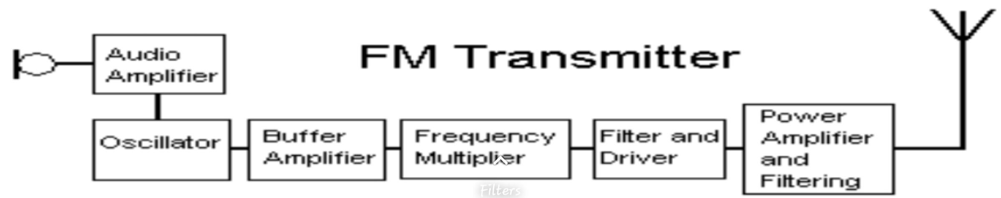**Figure 1: Block diagram of the FM Transmitter**

* 1. **Audio Amplifier**

Anything electronic that amplifies electrical signals whose vibrations are limited to the audio frequency range. The audio amplifier is the range that the human ear can hear. Audio amplifiers are used in every device that transmits, records, or otherwise processes voice sounds electronically.

**2.3 DC Voltage Source**

With 12 V DC (Direct Current), all of the components utilized in this design can be appropriately powered. Because it can support the load and the minimum need of 2 V over the regulated voltage requirement, a 9 V, 1.2 Ampere DC (Direct Current) battery was selected as the DC supply.

**2.3 Oscillator**

A circuit known as an oscillator generates an uninterrupted, repetitive, and alternating waveform without any input. In essence, oscillators change a DC (Direct Current) source's unidirectional current flow into an alternating waveform with the desired frequency, as determined by the elements of its circuit.

**2.4 Frequency Multiplier**

An electrical circuit known as a frequency multiplier produces an output signal with an output frequency that is a harmonic (multiple) of the input frequency. The required harmonic frequency is then chosen via a bandpass filter, which also filters out the undesirable fundamental and other harmonic frequencies from the output.

**2.5 Buffer Amplifier**

In order to avoid the signal source from being impacted by any currents (or voltages, for a current buffer), that the load may be created with, a buffer amplifier (also referred to as a buffer) is one that performs electrical impedance transformation from one circuit to another.

1. **MODELING AND ANALYSIS**

**3.1 Building Techniques and Materials**

The following materials were used to test the circuit:

* **Board of the Project:** This white electrical kit can be used to build and test electronic circuits without having to solder the components together. If necessary, it allows for circuit reconfiguration.
* **Connecting Wires:** These are minuscule copper wire fragments with a diameter of 0.2 mm2. On the project board, they are used to put the pieces together.
* **Battery:** A high-power 9-volt battery serves as the source of the dc supply.
* **Cutter:** This is used to precisely cut components and connecting wires to size.
* A digital multi-meter is a versatile electrical measuring device that may be used to check a variety of electrical circuit parameters.
* Insulation tape
* A full set of pliers
  + - A screwdriver.

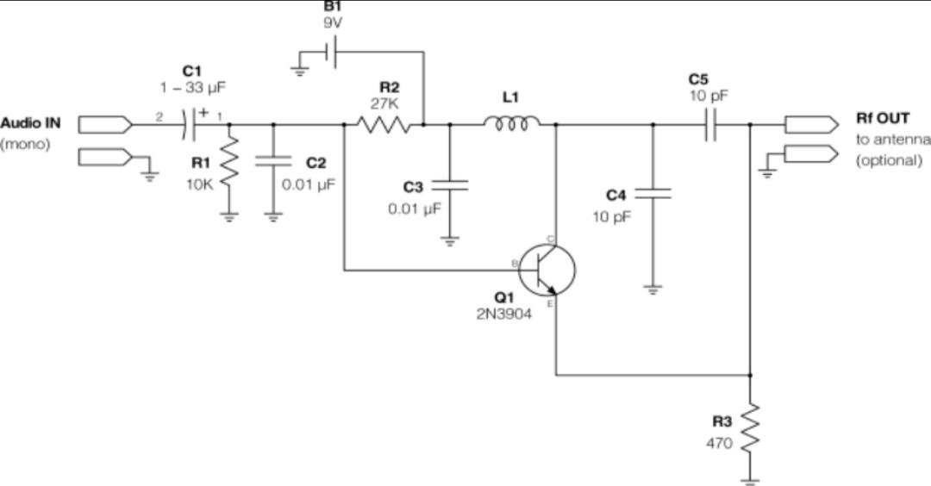

**Figure 2: FM Transmitter Circuit Diagram**

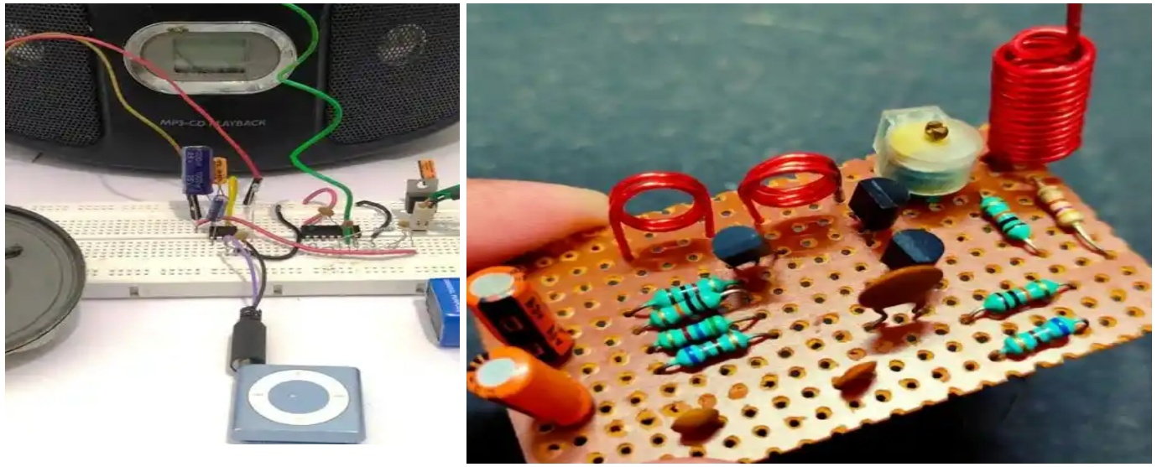

**Figure 3: FM Transmitter Designed Board**

**3.1.1 Planning and Building**

The design was actually implemented in accordance with circuit schematics. Initially put together on a bread board, then moved to a Copper Clad board (CCB). Low cost was a consideration in the selection of the electronic materials and components.

**3.1.2 Design Procedure**

The project's design process was dependent on a working frequency modulation (FM) transmitter circuit. The transmitter circuit that the researchers built and tested displayed a few positive traits. Operating effectively with 9 V DC (Direct Current), which processes few safety issues.

The transmitter’s low power (2.52 105 mw) output stage, which uses transistor 2N3904, results in a range that is too small for practical use. Following that, the design process included the calculations, trials, and exercises needed to successfully replace the present transmitter’s low output with a lower output stage with useful broadcast value.

**Design Calculation**

1. **Transmitter Distance (d)**

As the overall range to be reached by the transmitter, a total distance of 1.375km=1375m was calculated from the Global Positioning System (GPS) using the fields Area measurement software.

1. **The radio transmitters P1 required output power**

$$Using the formula Pₜ=\frac{E²×d²}{30}$$

$$Where E=20µv=20×10ˉ^{6}v,d=1375m$$

$$Therefore, the distance \left(d\right) will be 1375m$$

$$Pₜ=\frac{(20×10ˉ^{6})²×(1375)²}{30}$$

$$Pₜ=2.52×10ˉ^{5}mw$$

A transmitter's output must be measured in the far field, and the power received per unit area from an isotropic antenna can be determined using the equation below.

$$Pᵣ=\frac{Pₜ}{\left(4πd^{2}\right)}$$

Where Pᵣ = received power

Pₜ = transmitted power

d = distance from transmitter in meters

Pₜ = 2.52 ×10ˉ⁵mw, d = 1375m

$$Pᵣ=\frac{2.52×10ˉ⁵}{(4π×{\left(1375\right)}^{2})}$$

$$Pᵣ=\frac{2.52 ×10ˉ⁵}{2.375 ×10⁷}$$

$$Pᵣ=1.06×10ˉ^{12}mw$$

Therefore, 1.06 ×10ˉ¹²mw is the receiver power from the transmitter.

Pₜ is the transmitted power and d is the distance from the transmitted in meters.

$$Pₜ=2.52×10ˉ^{5}mw, d=1375m$$

Let Eꜰꜱ be the field strength

$$Eꜰꜱ=\frac{√(30×2.52×10ˉ^{5})}{1357}$$

$$Eꜰꜱ=\frac{√7.56×10ˉ⁴}{1357}$$

$$Eꜰꜱ=1.99×10ˉ^{5}v/m$$

⁖ 1.99 ×10ˉ⁵v/m is the field strength in the transmitter.

The output frequency of the one-stage circuit in Figure 2 was measured to be 102.2MHz and it is powered by a 9V battery. There are three different approaches to compute the power that is created in the coil during the circuit's last common emitter stage before being transferred to the antenna in the tank circuit.

P =VIcosθ (1)

P = I²V (2)

P = $\frac{v²}{z}$ (3)

In the circuit, Vе (voltage emitter) was measured at 2.99v across the 470Ω emitter resistor.

n

As Iе = Iс then collector current is:

Where Vе = 2.99v

Rе= 470Ω or 0.47k

Iе = $\frac{2.99V}{0.47k}=6.362mA$

The ac collector current will be replaced with this value. Now that the tank circuit impedance has been discovered. The following equation, where R is the DC (Direct Current) resistance of the coil in the tank circuit, gives the impedance at resonance.

R (resistor) was found to be 0.15𝜇 ohm in value.

Z = $\frac{L}{CR}$

L = 0.15μH = 0.15 ×10ˉ⁶H

C = 15 ×10ˉ¹², R = 0.1Ω

Z $=\frac{0.15 ×10ˉ⁶}{15 ×10ˉ^{12}×0.1}$

Z $=\frac{0.15 ×10ˉ^{6}}{1.5 10ˉ¹²}$

**⁖ Z = 100k**

**3.1.3 Small Signal Analysis**

The equivalent output circuit for the transmitter must now be drawn in order to calculate overall impedance. The output power will then be calculated as I 2Z. The transistor's output impedance hoe is parallel to the tank circuit's (100k) impedance. Although it fluctuates with collector current, it is roughly 27k at 6mA.

Looking at the circuit, a 470Ω resistor with a grounded end is connected in series with a 10pf capacitor across the base and emitter. A 22pf capacitor that is used to decouple the power rails is seen as a short circuit at RF.

* 1. **Diagram of the FM receiver circuit**

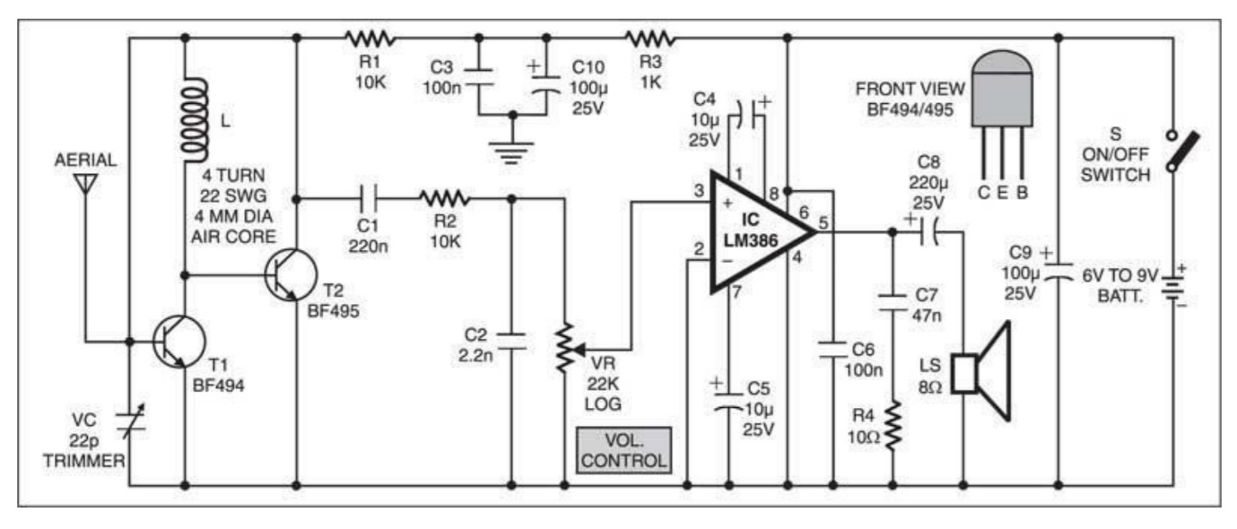Here is a straightforward FM receiver for obtaining local FM signals. The Colpit oscillator is made up of transistor BF495 (T2), a 10k resistor (R1), coil L, a 22pF variable capacitor (VC), and the internal capacitances of transistor BF494 (T1). Trimmer VC sets the resonance frequency of this oscillator to the transmitting station's frequency that we want to listen to. It must be tuned to a frequency between 88 and 108 MHz’s. The audio amplifier receives the information signal via resistor R1 and a 220nF coupling capacitor. This information signal is used in the transmitter to carry out the modulation (C1).

The variable capacitor’s capacitance should be adjustable between a few Pico farads and roughly 20pF. Therefore, a 22pF trimmer is a suitable choice for the circuit’s VC. The market has it freely available. Change the value of VC if you are using a different capacitor with a higher capacitance and are having trouble receiving the entire FM band (88-108 MHz). Experimental analysis is required to ascertain its capacitance.

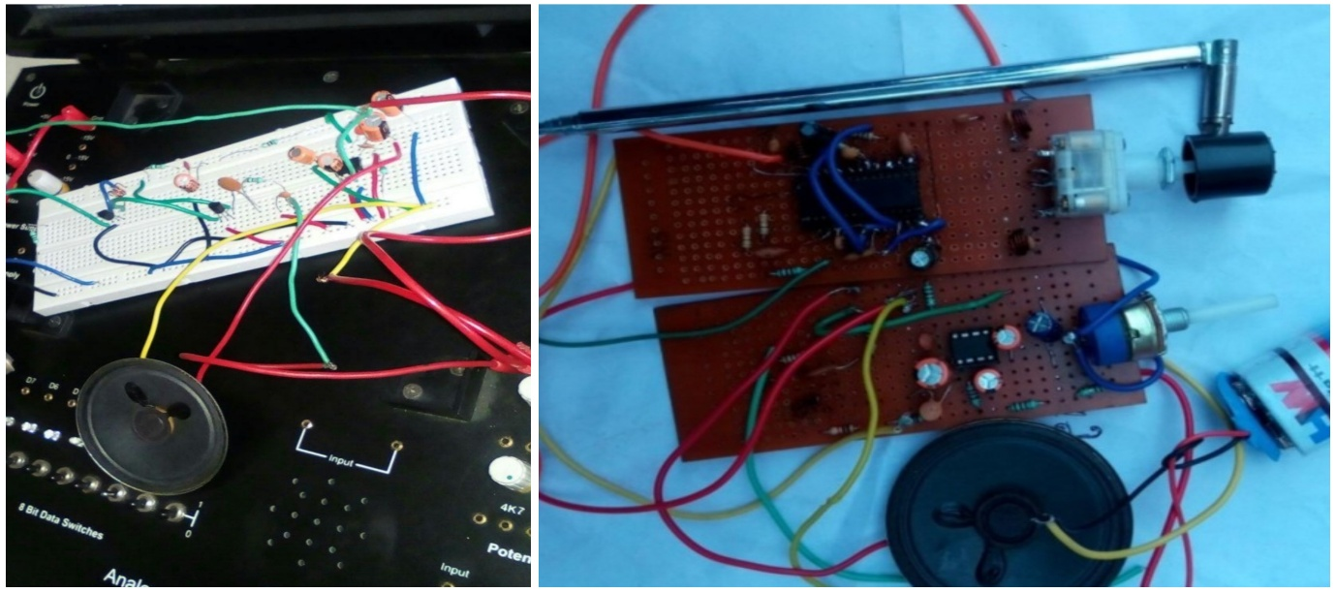**Figure 4: FM Receiver Circuit Diagram**

**Figure 5: FM Receiver Designed Board**

The self-supporting coil L has an air core with a 4mm internal diameter and four turns of 22 SWG enamelled copper wire. It can be built on any cylindrical object with a diameter of 4 mm, like a pencil or pen. When the coil has achieved the desired number of turns, it is removed from the cylinder and slightly stretched to prevent the turns from touching one another.

The band-pass filter for very low frequencies, which is employed in the receiver to separate the low-frequency signal from the high-frequency signal, is made up of capacitors C3 (100nF) and C10 (100F, 25V), together with R3 (1k).

The telescopic antenna of any disused equipment can be used; however, antennas are a little tricky. A 60 cm long isolated copper wire can also be used to get a decent reception. Experimental research can be used to determine the ideal copper wire length.

The quality and number of turns in the coil L, the type of aerial, and the distance from the FM transmitter are all factors that affect how well this little receiver performs. An audio power amplifier made for low-voltage consumer applications is the IC LM386. It offers 1 to 2 watts, which is plenty to power any little speaker. A logarithmic potentiometer called the 22k volume control (VR) is connected to pin 3 of the IC LM386 and the amplified output is obtained at pin 5. A 6V-9V battery can power the receiver.

**3.2.1** FM receiver IC CXA1019

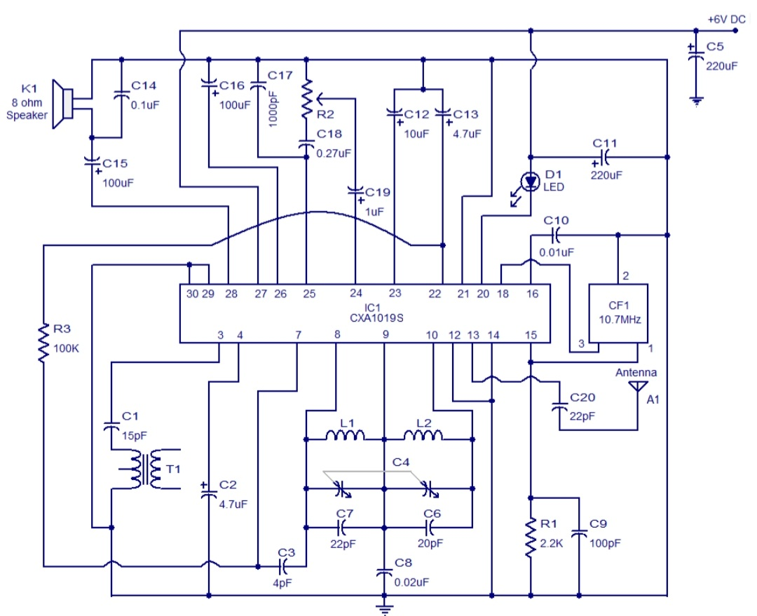Here is an illustration of a high-quality FM receiver circuit based on the CXA1019 IC. Sony’s CXA1019 is a monolithic bipolar silicon FM/AM radio receiver IC. RF amplifier, mixer, oscillator, IF amplifier, quadrature detection circuit, tuning LED driver electronic volume control, detector, and other circuits are built within the CXA1019. Only in this circuit does the FM part of the IC come into play. The IC can drive an 8Ω loudspeaker and is powered by any DC source between 3 and 7V.

**3.2.2** Circuit Explanation

The tank circuit for the oscillator component of the IC is made up of the inductors L1, L2, and capacitors C4, C6, and C7. Through resistor R1, the IF output available at pin 15 is grounded. The AC bypass capacitor for R1 is called C1. Ripple filtering is the purpose of capacitor C16. A tuning indicator is LED D1. Through capacitors C19, POT R2, and C18, the input (pin 25) of the integrated AF amplifier stage is connected to the output (pin 24) of the integrated detector stage. Due to its

**Figure 6: Circuit schematic**

ability to regulate the input supplied to the audio amplifier stage, the POT R2 can be utilized as a volume control. C14 is a noise bypass capacitor, while C15 ties the audio output to the speaker. While C20 connects the antenna to the FM RF input (pin13) of the IC, C5 merely serves as a power supply filter. The 10MHz ceramic filter is applied to the FM intermediate frequency input pin 18 after the FM intermediate frequency output, which is available at pin 15, has been filtered. Noise from the audio power amplifier part of the IC is bypassed using capacitor C2. This power amplifier section has a 500mW or so output. The circuitry for the FM discriminator inside the IC is connected to capacitor C1 and transformer T1. The feedback capacitor for the AGC portion is resistor R3.

**3.2.3 IC LM386**

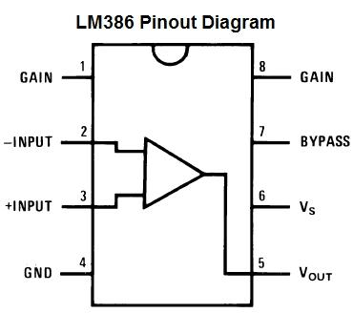Low voltage audio amplifiers like the LM386 are widely found in battery-operated musical instruments like radios, guitars, toys, etc. Gain can be raised from 20 to 200, with a default setting of 20 (without the use of an external component), by using a resistor and capacitor between PINs 1 and 8, or only by using a capacitor. Voltage gain simply denotes a 200-fold increase in voltage from input to output. The wide supply voltage range of the LM386 is 4-12v. The pin diagram for the LM386 is shown below. Eight pins make up the LM386 pin diagram, and each pin serves a specific purpose.

**Pin 1 and 8:** The gain is internally set to 20 but can be increased to 200 by using a capacitor between PINs 1 and 8. These are the gain control PINs. The 10uF capacitor C1 is what we used to achieve the highest gain, or 200. By utilizing the right capacitor, the gain may be changed to any amount between 20 and 200.

**Pin 2 and 3:** These are the sound signal input PINs. The negative input terminal at Pin 2 is wired to the ground. The sound signal is supplied onto pin 3's positive input terminal, which will then be amplified. A 100k potentiometer RV1 is used in our design to connect it to the condenser mic's positive line.The potentiometer functions as a volume dial.

In order to exclude the DC component of the input signal and just enable audio (the AC component) to be sent into LM386, a capacitor C5 of 0.1uF has also been employed in conjunction with a potentiometer.

**Pin 4 and 6:** The IC’s power supply pins are as follows: Pin 6 is for +Vcc, while Pin 4 is for Ground. The circuit can be powered by voltage ranging from 5 to 12 volts.

**Pin 5:** This is the output pin from which the amplification of the sound signal is obtained. Both an AC and a DC component are present in the output signal; the DC component is unwanted and cannot be sent to the speaker. In order to eliminate this DC component, a 220uF capacitor, C2, was employed. This performs the same duty as input-side capacitor C5 (0.1uF). At the output PIN 5, a filter circuit consisting of Capacitor C3 (.05uF) and Resistor R1 (10k) has also been employed. This electrical filter, commonly known as the “Zobel network,” is used to filter out abrupt high frequency oscillations or noise.

**Pin 7:** The bypass terminal is this. For stability, it can be left open or grounded with a capacitor.

**3.2.4Gain Control of LM386**

Two pins (1 and 8) are provided for gain adjustment in order to make the LM386 a more adaptable amplifier. The 1.35 kW resistors set the gain to 20 (26 dB) with pins 1 and 8 open. The gain will increase to 200 if a capacitor is connected between pins 1 and 8, bypassing the 1.35 kW resistors (46 dB). The gain can be adjusted to any value between 20 and 200 if a resistor is connected in series with the capacitor. Another method of controlling gain is to capacitively couple a resistor (or FET) from pin 1 to ground. The internal feedback resistors can be paralleled with additional external main components to adjust the gain and frequency responsiveness for certain applications.

For instance, frequency tailoring the feedback path can be used to make up for weak speaker bass response. A series RC from pins 1 to 5 is used to accomplish this (paralleling the internal 15 kW resistor). The lowest value for acceptable, steady functioning for a 15 kW, 6 dB effective bass booster is R = 10 kW if pin 8 is open. R as low as 2 kW can be used if pins 1 and 8 are ignored. This limitation results from the amplifier’s ability to compensate being limited to closed-loop increases greater than 9.

track's ends are linked to the device's two terminals. The wiper that controls the track's motion is attached to the third terminal. The resistance can be increased and decreased with the assistance of the wiper's passage through the track.

**Figure 7: Variable Resistor**

The track is often built of a ceramic and metal alloy, though carbon can also be used. Variable resistors of the carbon film type are typically utilized because a resistive substance is required. They are used in TV receivers, audio amplifier circuits, and radio receiver circuits. The resistance track could simply be a coil of wire for applications involving tiny resistances. The track is available in straight and rotary versions. Some of them in a rotary track might have a switch. The switch will have an operating shaft with one of its ends easily detachable from the body of the variable resistor switch, allowing for simple axial movement.

There are two uses for the rotary track resistor. The first is to alter the resistance. By turning the switch on and off, the switch mechanism is employed for both electric contact and noncontact devices. For the control of equipment, switch mechanism variable resistors with an annular cross-section are available.

To make this kind of variable resistor compatible with complex electronic circuits, more components are added to it. An illustration would be a focus pack, which is a high-voltage variable resistor. Both a variable focus voltage and a screen voltage can be generated by this device. In order to adjust the applied voltage, it is additionally connected to a fixed resistance circuit and a variable resistance circuit (bleeder resistor).

Both the fixed and variable resistors are linked together in series for this. A slider is a track that is created in a straight line. Since a slider’s position cannot be viewed or verified by adjusting resistance, a stopping mechanism is typically provided to limit the risks brought on by excessive rotation.

**3.3.5 Resistor Connection with Variable**

When one end of the resistance is tracked, the wiper terminal is connected to the circuit, and the other terminal of the resistance track is left open, a variable resistor is utilized as a rheostat. The location of the wiper (slider) on the resistances track determines how the electrical resistance is connected between the track terminal and wiper terminal in this instance.

When both ends of the resistance track are linked to the input circuit and one of the aforementioned ends of the resistance track and wiper terminal is connected to the output circuit, a variable resistor can also be used as a potentiometer.

Here, all three terminals are in operation. Adaptable resistance may occasionally be needed in electronics circuits; however, this change is rarely or never necessary. Connecting pre-set resistors to the circuit does this.

One type of variable resistor is the pre-set resistor, whose associated adjustable screw can be used to change the electrical resistance value.

1. **RESULTS AND DISCUSSION**

The results of this research led to the development of an FM transmitter with powerful search and discovery capabilities for radio transmission. Plate 1 displays a photograph of the apparatus.

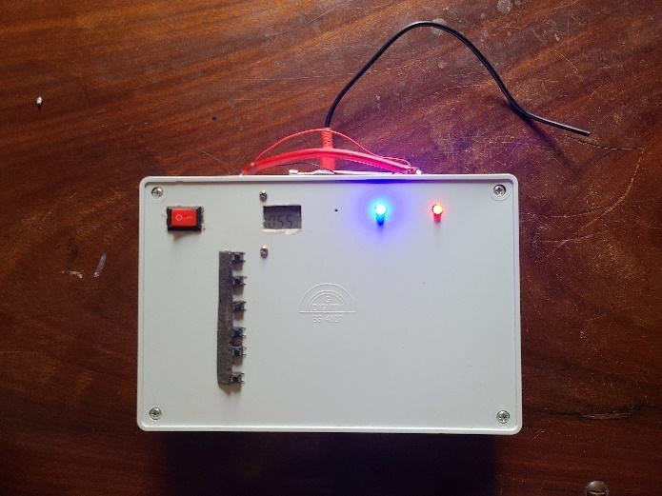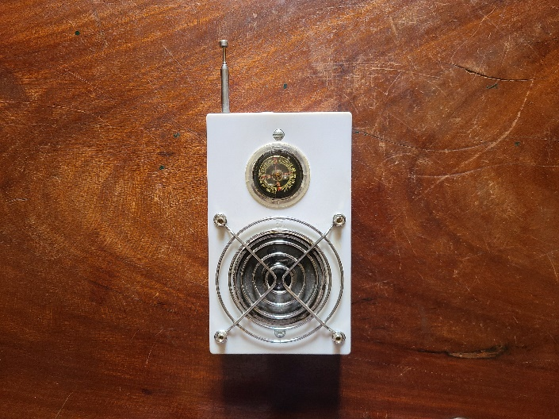

**Transmitter Receiver**

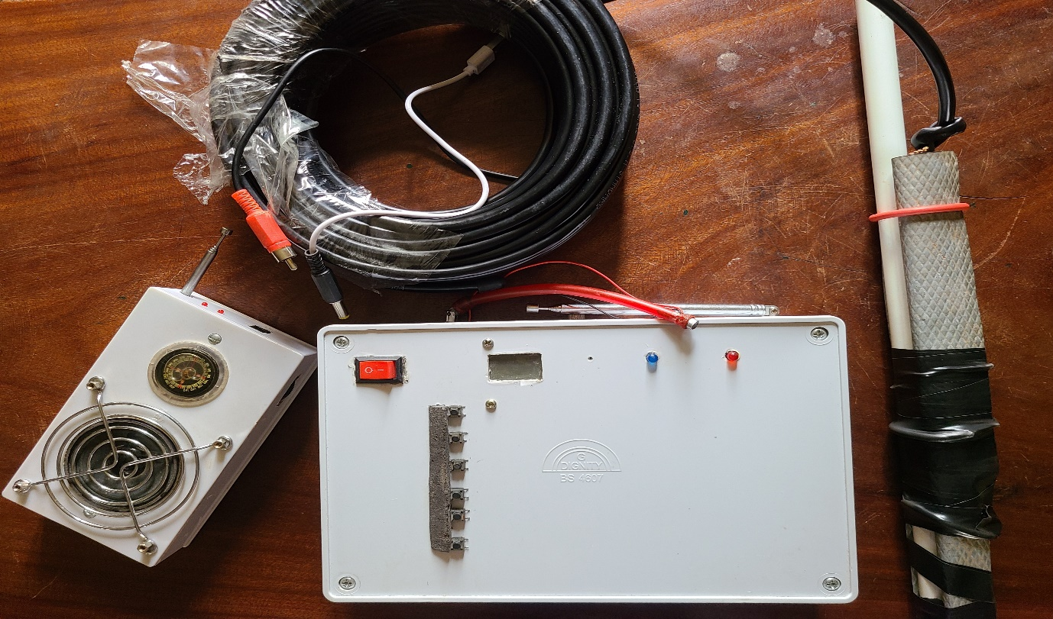

**Figure 15: Designed and built FM transmitter and Receiver**

An evaluation test was performed on the device inside a lab in order to evaluate its functionality. During the experimental procedure the following test was carried out on the transmitter components using a digital multi-meter.

* Tests for frequency
* Polarity
* Inductance

**Test for polarity:** There is a requirement to use the digital multi-meter at each stage of mounting the components, especially those with polarity.

**Frequency test:** To determine the frequency range at which the transmitter frequency varies, the experiment’s standard frequency test was conducted using a digital multi-meter.

**Inductance test:** When an electrical circuit acquires voltage as a result of a change in another circuit, this phenomenon is known as inductance, also known as mutual inductance. Inductance, which is measured in a unit called a Henry and is defined as 1 volt-second per ampere, is, in another sense, a ratio of voltage to current.

**4.1 Discussion**

The aforementioned works demonstrate that the FM transmitter developed for this project, which broadcasts at a frequency of 102 MHz with an output power of 18dBm and a range of more than 1kilometer, can successfully compete with those developed elsewhere in the world.

1. **CONCLUSION**

The design and building of an FM transmitter with a useful range of 1.5 km that runs on 12 volts has so far been successfully accomplished, according to test results from this project, which are the results of construction operations. The FM transmitter is now prepared for either educational or business uses thanks to the impressively positive result from the usability test. The satisfactory conclusion of this study has shown that a realistic FM transmitter that can operate between ranges of 1.5 km and low power input can be conceived and built did not materialize.

Therefore, we also draw another conclusion on the receiver that this project is appropriate for electrical engineering students, particularly for those pursuing FM Reception as a part of their Electronic Communications Theory course. We implemented the audio amplifier and FM receiver parts, respectively. When first developing the FM receiver circuit, we ran across some unique issues with employing transistors. An IC is used in place of transistors, and we get good response. Our lectures on topics like wireless communication, FM modulation, demodulation, reception, amplifiers, and more have now been applied precisely. It is truly amazing to be able to receive information using wireless FM communication. The FM receiver allows us to hear the sound signal that was delivered by the transmitter. The receiver’s audio quality is excellent, and some frequency ranges showed less noise than others.

1. **REFERENCES**

[1] Yoshida S., Rappaport T.S., and Anderson J.B. (1994). Measurements and Models of Propagation for Wireless Communication Channels UK audio-technical publication "IEE" Communication Magazine (2016). Journal of Radio Frequency Signals, page 254

[2] C. Bacchius (2005). Operation and Design of Antennas. third edition, Macmillan Publishing Company, New York.

[3] Chen T. (2002). Journal of Radio Frequency Transmission Systems, page 245

[4] Computer Prediction of Service Area for VHF Mobile Radio Networks by Edward R. and Durkin J. (1969), Proceedings of the IEE Canada, vol. 116, no. 9, pp. 1493–1501.

[5] Electronics International Edition, George H.O., 1970 Heineniemi; London-based Professional Publishing Ltd.

[6] John C.W. (1991). Canadian Journal of Radio Frequency Transmission Systems, page 235.

[7] A Frequency Test for 88-108 MHz., by Jmeph Moraski, K4stJM, and Charles Spie, W4API, was published in 1969. German publisher, Radio, page 40.

[8] McCarthy and Davis (2001). Systems for Electronic communications. Edition Publisher, Fourth U.K pg. 125

[9] Mobile Land Service (1968), VHF and UHF, “Review of Electrical Communications Laboratory,” vol. 16, nos. 9 and 10, pp. 2935–2971, McGraw-Hill Publishers, New York, 4th ed. Pg. 216.

[10] M Electronics Mouser (2016). Soldering U.S.A. in Instructible Journals, pages 99–100.

[11] TS Okumura (1968). Page 123–134 of the Radio Spectrum Journals.

[12] Michael Baxandall (1790). Wireless audio power amplifier Wordless Journal U.S.A pg. 88-97.

[13] (1992) 108MHz Path Loss Prediction Models for Indoor, Seidel S.Y. and Rappaport T.S.

[14] C. Verhoeven (2003). Wikipedia’s definition of an audio frequency amplifier What Is the 2016 Radio Wave?

[15] Time-Frequency Signal Analysis and Processing – A Comprehensive Reference, edited by B. Boashash, Elsevier Science, Oxford, 2003.

[16] Frequency Modulation (FM) Tutorial, Lawrence Der, Ph.D.

[17] IEEE Proceedings, Vol. 112, No. 9, September 1965, p. 1664, “FM Systems Of Exceptional Bandwidth”

[18] Google.com

[19] Sanjay Sharma’s Analog and Digital Communication.

[20] Interestingengineering.com