**Sustainable Affordable Housing in India: Challenges and opportunities**

**Ar. Kritika Gupta, Ar. Harshita Mishra**

Student, MUP, Madhav Institute of Technology and Science, Gwalior, (M.P.)

Professor, Dept. of Architecture, M.I.T.S., Gwalior, (M.P.)

**Abstract**-

Sustainable and affordable housing aims to meet the needs of large-scale housing by providing better social conditions and minimizing the environmental impacts of the life cycle. This study explores the various challenges and opportunities in designing such a system in the Indian context. It is learned that the biggest obstacles to integrating sustainability and affordability of the Indian housing sector are; inconsistencies in the existing regulatory framework, as well as the assumption that consolidation integration means additional costs.

This study concludes by providing important suggestions for implementing the concept of sustainable and affordable housing in India, such as establishing consensus policies and strengthening a chain of the sustainable supply chain.

Keywords - Affordable Housing, Environmental Sustainability, Affordable Housing, Public Housing

1. **Introduction**

India's contribution to instability is very low compared to other major contributors. But the ongoing challenges to India's rapid urban growth and a large number of people around the world could threaten global stability. Therefore, there is a need to introduce sustainability in India.

The study seeks to highlight the need for sustainable Development in India. Urbanization in India has led to a stable environment. It provides proven benefits for economic growth and development.

In a country like India with a rapidly growing population, these housing programs are very important. However, simplifying the high demand for affordable housing and developing it through flexible policies and programs could have a significant impact on the environment in terms of depletion of natural resources, soil erosion, and climate change. Therefore, it is also important to consider factors related to energy and sustainability in the rules of affordable housing. In recent times, the interests of government and stakeholder partners in sustainable housing have increased because worldwide, issues such as climate change and sustainable infrastructure development are on the rise.

Globally, buildings use a lot of energy and resources in both the construction and operational phases, and especially the construction industry in India accounts for about 24 percent of its total greenhouse gas (GHG) emissions. This reinforces the need to integrate sustainability into affordable housing projects, maintaining the necessary balance between current social needs, and the needs of future generations to thrive in urban areas. Therefore, this study is intended to investigate the current state of the industry globally, followed by a summary of the challenges and opportunities in achieving sustainable and affordable housing projects in India.

Before analyzing the state of public housing, the term needs to be defined in the context of India, where the term 'affordable housing is more commonly used than 'public housing' by both public and foreign houses. sector analysts. A common understanding of what ‘affordable housing’ means is listed in Table 1

|  |  |
| --- | --- |
| Government Organisation Pradhan Mantri Awas Yojana (Ministry of Housing and Urban Poverty Alleviation, Government of India) | Size of DU for EWS:<30sqm (super built-up area) for LIG: 0-60sqm for MIG: 60-120 sqm  Repayment of home loans in monthly installments not exceeding 30% to 40% of the monthly income of the buyer |
| Research Institute Making Urban Housing Work in India (RICS, LEVEL, CBRE) | Provision of ‘adequate shelter’ on a sustained basis, ensuring the security of tenure within the means of the common urban household  Affordable housing is that provided to those whose needs are not met by the open market |
| Private Sector Affordable Housing – A Key Growth Driver in the Real Estate Sector by KPMG Size of DU for EWS: | Defined in terms of three main parameters  income level (independent variable)  the size of the dwelling unit (independent variable)  affordability (dependent variable) |

**1.2 Current Housing Shortage**

The shortage of urban housing (except the acute shortage of rural housing) is estimated to be 18.78 million housing units, integrated households living in overcrowded, obsolete, homeless, or irreparable fires. Housing houses include so-called ‘census houses’ which are used as residential, residential, and other used houses and non-residential houses whether occupied or unoccupied (see Error! Reference source not found.). According to a recent study by MoHUPA (2015), a total of 25% of houses built under the JNNURM7 project will be used by the project as it expires in March 2014

Figure 3 Distribution of urban housing shortage (2021)

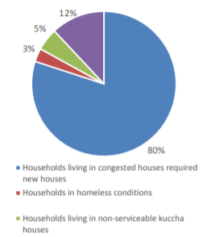 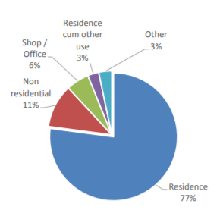

Figure 3: Use of census houses, India, 2021

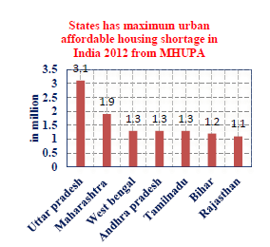

A household that lives in congestion is the main cause of housing shortages. Among ethnic and racial groups, housing shortages were found to be higher in Caste's planned families than in Organized tribes and other cities, largely due to overcrowding.

1. **Housing issues: A framework for conceptualization**

Housing construction, and building a basic unit of human habitation in a built-up area is also important to factor in the development of a community. It plays an important role in achieving sustainable development. Social and cultural factors determine basic housing needs. The financial strength or affordability of an individual has the immediate effect of turning this need or need into reality. Technology serves as an incentive to help achieve this by providing affordable options suitable for each House building, building a basic unit of human habitation in a built-in area is also an important factor in community development. It plays an important role in achieving sustainable development. Social and cultural factors determine basic housing needs. The financial strength or affordability of an individual has the immediate effect of turning this need or need into reality. Technology catalyzes to help achieve this by providing affordable options that are tailored to each individual.

* 1. **Socio-cultural needs**

The concept of a shelter varies from person to person depending on the culture, tradition, occupation, and lifestyle. Social and cultural sustainability in the home includes several measures such as flexibility, equity, integration of resources and services; self-help houses, or the participation of beneficiaries, and community involvement.

Sustainable housing must address the social and cultural needs and processes of beneficiary households and communities. At the same time, it accelerates the development of community development, relationships, and partnerships.

* 1. **Economic aspects**

Since development and social development are closely linked to economic development, social and cultural stability is closely linked to economic stability. Economic growth is key to providing the means to meet basic needs, alleviate poverty and create jobs, essential elements for sustainable development. Although housing problems are rising as a sign of poverty, financial assistance often does not help the poor to meet their housing needs.

Economic stability or access to housing should be included in the economic development strategy, which strengthens the economic independence of family members. The poor are often unable to accept social housing assistance due to a lack of economic stability or access to programs.

* 1. **Technology concerns**

Ordinary building materials are beyond the reach of most people in the world because of their inability to afford them. In addition to the rising cost of building materials, rising environmental concerns due to the widespread exploitation of natural resources related to conventional construction and other housing development activities encourage the need to explore alternative technologies. Other building materials, methods, and techniques that replace conventional construction can lead to a reduction in natural resources and save energy.

* 1. **Environmental aspects**

It is now agreed that development in low-income countries should continue in line with the global use of new, less resource-intensive, and environmentally friendly technologies. For sustainability, economic development and social change must be able to support the environment and develop potential resources for future generations. Environmental sustainability in households can be achieved by tackling the limitations of natural resources through the efficient use of non-renewable resources, reducing the impact of waste and land pollution through appropriate technology, and harnessing local labor capacity.

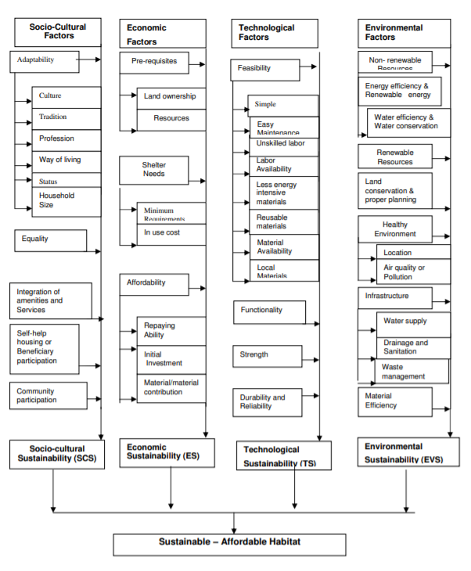

Figure 4: Elements of Sustainable- Affordable habitat

1. **Sustainable – Affordable Habitat**

Sustainable development is often defined as development that meets current needs without compromising the ability of future generations to meet their needs (World Commissions for Environment and Development, 1987: 23). ‘Meeting current needs’ refers to developmental aspects of sustainability, including economic, social, cultural and political issues. The second category of the definition ‘without risking future needs’ mainly refers to environmental issues (Ebsen. C and Ramboll, 2000). Human settlements should be planned, developed, and improved in a way that fully takes into account the principles of sustainable development. Affordable housing can be defined as the process of developing and maintaining a living environment that supports human health (both physical and mental), satisfying shelter needs, and protecting and conserving the environment for future generations. A conceptual framework for sustainable and affordable housing has been developed to achieve housing development by measuring social progress, promoting economic growth, spreading new technologies, and conserving and protecting the environment and natural resources for future life and development.

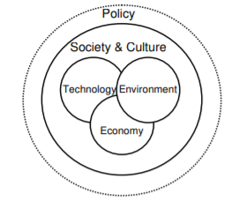

Figure 5: Sustainable – Affordable Habitat

This figure shows the relationship between the four sustainability factors and encourages the need for an effective policy framework. A strategic framework must be developed to determine needs and to develop strategies to support social, cultural, economic, technological, and environmental sustainability. During the economic development process three stages of change can be divided (but not divided): 'Development-development-revitalization'. In each of these categories the 'direct interaction between culture, structure, and technology 'can be recognized. The process of promoting sustainable development and environmental improvement has been made and developed over the decades supported by policy plans and **industrial** efforts (Jansen, L 2002).

1. **Strategies for Sustainable – Affordable Habitat**

Proper housing is closely linked to policies, land reform programs, infrastructure, finance, the construction industry, and the provision of building materials. The existence of inadequate regulations and inefficient planning systems can also wreak havoc on the provision of housing to many poor people. Therefore, the poor housing policy has many goals and many institutions (UNCHS- GSS 2000). Housing, as a spatial activity, Government especially local government is considered to play a key role in the housing process or in helping people to live (Ebsen, C, and Ramboll, B 2000). An integrated policy framework is essential for coordinating the activities of all actors to ‘pull’ the beneficiary side rather than ‘push’ the authorities. At the strategic level, the principles and mechanisms for sustainable development should be integrated with the strategic policy and planning process. An effective organizational structure is essential during project implementation and after the project is completed. It is also inevitable that the effectiveness of the implementation plans, the expansion of limited resources, and the integration of various stakeholders to achieve sustainable housing and affordable housing.

* 1. **Recent Housing and Urban Development Policies, Codes, and Regulations**

India has a long history of making house policies. According to Tiwari and Rao (2016), their impact on shortages has been small due to limited resources allocated to their implementation, but also a clear gap between housing costs and ongoing low-income levels. Two recent housing policies are listed below.

* + 1. National Urban Housing and Residential Policy (NUHHP), 2007: The purpose of the NUHHP is to promote and ensure sustainable development in the country with a focus on urban sprawl, which is effectively provided by ensuring the equitable provision of land, housing, and resources. at affordable prices. NUHHP has carefully analyzed ways and means to provide ‘Affordable Housing for All’ with special emphasis on the EWS and LIG sectors to be fully integrated into well-balanced urban ecosystems.
    2. Urban Housing Affordable Housing Policy (MSAHPUA), 2014: This Policy aims to provide “affordable housing for all” with particular emphasis on the EWS and LIG and other vulnerable sections of society such as Organized / Organized Nations, back. Classes, Junior and senior citizens, and people with physical disabilities in Government, and ensuring that no one is left homeless.
    3. National Urban Rental Housing Policy (NURHP), 2015: NURHP focuses on promoting rental housing provided by the private sector, co-operatives, NGOs, industry (labor housing), and institutional services (labor housing). It also promotes partnerships between the private and public sectors in the employment sector.
    4. Indian Standard IS 8888-1 (1993) - Low-cost Housing Requirements (Guide): This standard provides planning guidelines as well as general construction requirements for low-cost housing in houses with a height of 40m2. It applies to 'housing colonies' of low income by government agencies and private agencies.
    5. Jawaharlal Nehru National Urban Renewal Mission (JNNURM), 2005-2014: Focuses on the provision of basic infrastructure services, and heritage sites based on the PPP and the redevelopment of local (old) urban areas; switching industries/trading centers into the right places.
    6. Rajiv Awas Yojana (RAY), early 2011-2022, was placed under PMAY-HFA (U) in 2015: - Preparation phase (2011-2013), implementation phase (2013-2022). A two-step strategy: redevelopment of the ‘Free City Action Plan’ and redevelopment of selected informal settlement projects.
    7. Atal Mission for Rejuvenation and Urban Transformation (AMRUT), 2015-2035: - Focus on providing basic infrastructure, but also on greenfield development, parks and recreation areas, capacity building, and transformation initiatives.
    8. Smart Cities Mission (SCM), 2015-2020: - Aims to address broad-based sustainability to develop cities that provide basic infrastructure and a decent standard of living, a clean and sustainable environment, and the use of 'smart' solutions. -50 (city renewal), 250 hectares (green city extension), or 500 hectares (city development through redevelopment), which provides a repetitive model for some emerging cities.
    9. Pradhan Mantri Awas Yojana (PMAY) OR Housing for All Scheme (HFA), 2015-2022: - You are considering providing housing to all people by the end of 2022 through the rehabilitation of slums through the participation of independent engineers who use the land as a resource, promotion. low-cost EWS housing with debt-related support and partnerships with public and private companies and beneficiary housing subsidies; - It is divided into three phases to include 4041 official cities in less than 500 class-I / States / UTs cities, either through their agencies or in partnership with the private sector ‘encouraged to develop affordable housing projects.

**5. Building Sustainability Benchmarking and Assessment Systems**

5.1: National Systems

Below are four specific national or Indian sustainability assessment tools: GRIHA, IGBC-CII, CPWD Sustainability Tool, and Environment Prescriptive. Although they pursue the same goals and follow the same pattern as the structure to measure the performance of the structure, their measurement method is very different (Kshirsagar, Mane, Saharkar, & Salunke, 2015).

5.1.1 Green Integrated Environmental Assessment Scale (GRIHA) The Green Integrated Environmental Assessment Scale (GRIHA) evaluates the natural functioning of a building throughout its life cycle. Based on accepted power and environmental principles, it seeks to balance established processes and emerging concepts, both nationally and internationally.

5.1.2 Skills and Awareness Benefits: Funding of up to Rs. 2.00 lakh (US $ 2,950) for one to two days and Rs. 3.0 lakhs (USD 4,421) for three-day training programs, workshops, conferences, seminars, publications, awareness campaigns, and awareness programs will be awarded to user agencies.

5.1.3 IGBC-CII Measurement Tool the Indian Green Building Council (IGBC) was established in 2001 with the vision, "Creating a sustainable and inclusive environment for India to become one of the world’s leaders in sustainable development. -2025 ". The Indian Green Building Council (IGBC) has licensed the LEED Green Building Standard from USGBC to get used in the area.

5.1.4 CPWD Sustainability Tool the Sustainability Tool, released by the Department of Public Works in 2014, is a series of sustainable environmental guidelines. The guidelines are divided into four sections: 1) building and building materials, 2) CPWD Sustainability Index and building materials guidelines, 3) electrical and mechanical service equipment selection, and 4) guidelines for reuse and recycling of construction and demolition waste

1. **Policy Framework**

Sustainability is the most important element to be considered in the planning of urban areas. Even though the concept is much more considered in the city, less attention has been given to the planning of sustainable housing itself. Urbanization has led to varying challenges in India. Climate Change leading to Environmental distress, Spatial Planning, Social Issues Governance, Sustainable development Framework in India, Issue on Lack of Coordination between Key Stakeholders, Issue on Social Equity and Justice, Issue on Provision of Public Open Space, Issue on Squatters

This framework can be considered as a mechanism to achieve the objectives as derived from the analysis. It identifies four essential strategies to realize sustainable- affordable housing: Policy measures for socio-cultural sustainability (PSC), Policy measures for economic sustainability or Affordability (PES), Policy measures for technological sustainability (PTS), and Policy measures for environmental sustainability (PEVS).

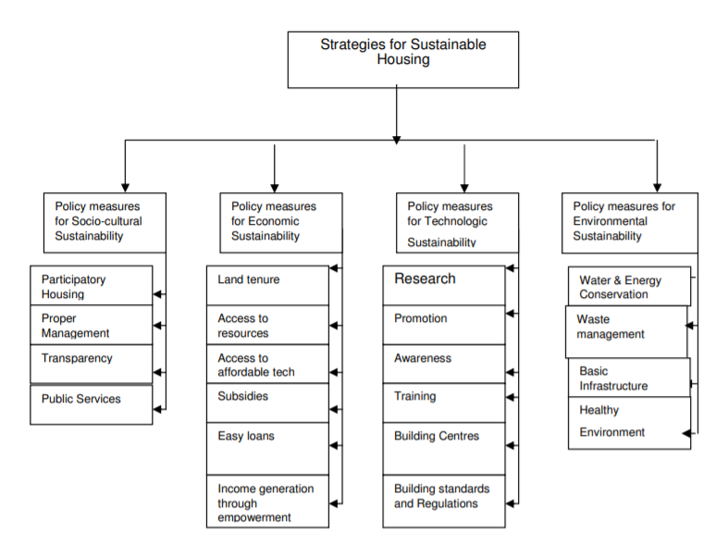

Figure – 5 Policy framework for sustainable- Affordable Habitat

1. **Main Findings and Recommendations**

The key findings of this report relate to both the project strategy to influence policy development, government tools that are likely to have an impact and its delivery mechanism, and the best national and international approaches that can provide practical guidance going forward.

• “Public Housing” rather than “Affordable Housing” Even the most expensive houses will be ‘accessible’ to someone else. So, the term “public housing” may be a more accurate term for low-income people. Considering the large number of low-income housing providers operating without government support, Indian public housing will no longer be equal to “public housing” in other countries.

• Green market segregation there is no consensus on which green building valuation schemes, namely, GRIHA, LEED India, or ECBC, receive support from national, regional, or local authorities, leading to the fragmentation of green building certificates. a 'market' that could limit the overall impact of systems.

• Policy compensation for registration instead of obtaining a certificate Currently, in most cases, registering for accreditation in one of the main programs is sufficient to qualify for government support, as opposed to the certificate itself. This may not work and lead to a ‘green wash’ of large projects.

• Potential impact of green compensation based on regulatory benefits and prizes Certificate Compensation is primarily a ‘regulatory’ type that gives FSI a slightly higher increase of 1-5% in projects registered as green. The Singapore case may refer to strong points that may be made despite the diversity of development, e.g., focusing on a single contextual certification scheme, training of multiple experts, evaluating pre-submission regulations, research and development support, and public awareness. campaigns.

• International examples adapted to the conditions of India Several international housing projects and programs provide solutions to existing and emerging housing challenges in India, such as vacancies and homelessness, restructuring and increasing labor efficiency, cultural satisfaction, builders' training, and professional support - construction, and solutions of rural housing.

The first global survey reveals that ‘Insufficiency in the regulatory framework’ is also perceived.

“Social Housing” rather than “Affordable Housing” Even the most expensive housing will be ‘affordable’ to somebody. “Social housing” may thus be a more useful term to signify housing for lower-income populations. Considering a large number of low-income housing providers acting independently of government support, Indian social housing would furthermore not be equivalent to “public housing” as in other countries.

**8. PROBLEMS, CHALLENGES, AND RISKS IN PPPS**

The PPP sector in India is still new and recent. To gauge the effects and impact of any economic phenomenon, a passage of a minimum period is imperative. Only then and then can meaningful conclusions be drawn. As said earlier the public-private partnerships in India are only 12 to 15 years old (or new) and a major part of the activity on those grounds has taken place during the last 7 to 10 years. The reports and reviews which have come out about the PPP sector in India point toward the positive stance taken by the economy towards such partnerships. The enabling environment created by the central and state governments to harness the private sector investments in such projects has generated a very conducive environment for such partnerships. Yet there are some instances and cases where the PPPs have not been an outright success. The literature and the particular case studies on the subject reflect that most of the problems that have been encountered and experienced in these have emerged along the way and the fact remains that these problems. (N.S.R.K. Prasad Kethineni, April 2019)

could not be envisaged or imagined by both parties at the time of entering into the contract. PPPs are long-term in nature and this fact makes them more vulnerable to bottlenecks. It is because more the time is involved, the greater the probability of a problem cropping up. The formulation of every PPP contract is unique. No two PPP contracts are the same. It is thus *difficult to standardize* a PPP format. This is because the parameters used in the structuring of a PPP cannot be the same every time and therefore a PPP can differ on various grounds such as the nature and type of infrastructure required, the sector involved, the model adopted, etc. (N.S.R.K. Prasad Kethineni, April 2019)

The stake of the Central and State governments and the revenue, responsibility, and risk sharing in the project are circumstantial and are likely to vary from one contract to another. Thus, apart from sharing the construction of the infrastructure by the public and the private sector which can be on technical and financial grounds nothing else can be standardized for such partnerships. According to the research article ‘How to improve PPP projects in India: learning from the past’3, any PPP project has to mainly pass through four main phases project preparation, project procurement, project development, and operations. Careful handling, planning, and clear-cut demarcating lines of work are required at every stage. (N.S.R.K. Prasad Kethineni, April 2019)

The framing of contracts can define only the formal mechanism of fulfilling the contract. However, it is difficult to incorporate steps and solutions to circumstantial issues which may crop up while the project is underway in a PPP contract. Currently, there is no *PPP regulation* in India. Since the whole concept of public-private partnership is quite new in our country, enough thought has probably not been given to this aspect. However, the National PPP Policy 2011 draft has been put up for further suggestions and comments. The above problem of the non-standardization of PPP contracts can to some extent be taken care of by creating an independent regulatory PPP body. This may lead to better and more robust participation by the private sector and also attract more international funding. which is certainly not without reason. The entire process of creating a PPP arrangement is very long and ridden with a lot of formalities. There have been many cases where the private party has gained undue political favors from their public sector counterpart making the whole process seem dubious. (SINGH, September 2011).

**Conclusion**

Preliminary international research reveals that an ‘Inadequate regulatory framework’ and the assumption that integration of sustainability may lead to increased project costs are the main barriers to the implementation of sustainable and affordable housing.

In India, therefore government programs should include additional grants to ensure sustainable processes in affordable housing projects. Innovative business models that promote sustainable strategies involving high initial investment should be developed, including foreign corporate investors who will lease these facilities as a return on long-term payments or grants and tax benefits from the government. Similarly, the focus should be on strengthening the supply chain and thus making it more accessible at a lower cost. Above all, better environmentally friendly building methods should be encouraged for affordable housing projects that have a small impact on the project budget.

Housing development can be seen as the first step towards sustainable development with multiple goals and the integration of multiple institutions. Since the needs of individual households vary from person to person depending on a variety of factors the integrated approach can be very helpful in defining the problem in general. The framework presented in this paper can be used as a common tool to address the housing problems of the rural poor in any developing economy.

In short, although there is a great need for major housing projects in India to meet the needs of the community, the natural impact of this mass construction should also be properly considered. This is a continuous research and computer-based simulation framework is being developed that helps to analyze the impacts of various challenges and opportunities associated with obtaining sustainable and affordable housing

**References**

* Deepa Gopalakrishnan, N., 2006. Sustainable-Affordable Housing for the Poor in Kerala (Doctoral dissertation, Birla Institute of Technology and Science)
* Development alternatives research, 2014. Sustainable Social Housing Initiative-Stakeholder assessment report, Sustainable Social Housing Initiative, Development Alternatives, New Delhi. https://smartnet.niua.org/sites/default/files/resources/Sustainable%20Social%20Housing%20Initiative.pdf (accessed on 30 March 2018)
* Henry, M., Ross, J., & Harold, J. 2013, Barriers to Developing Sustainable Housing in Palmerston North. Palmerston North: Massey University http://www.massey.ac.nz (accessed on 30 November 2017)
* affordable-housing-a-contradiction-in-terms (accessed on 21st January 2018)
* Anangpur Building Centre. (n.d.). Jaunapur Slum Resettlement. Retrieved from <http://www.anangpur.org/>
* 2008. Deepak Parekh Committee. *Affordable Housing for All*. Delhi: National Real Estate Development Council under the Ministry of Housing and Urban Poverty Alleviation. http://www.naredco.in/pdfs/report-high-level-task.pdf (retrieved on 4 Jan 2016).
* 2006. Government of India. Constitution of India. Seventh Schedule, Article 246. doi:12/12/2014.
* 2003. Government of India, Centre for Good Governance. *Housing for the Poor in India*. Delhi: Centre for Good Governance. <http://www.cgg.gov.in/workingpapers/WP-4-PKM> Housing%20for%20the%20Poor.pdf (retrieved on 6 Dec 2015).
* 2011. Government of India, Ministry of Home Affairs. Census of India. http://www.censusindia.gov.in (retrieved on 4 Dec 2015).
* 2013. Government of India, Ministry of Housing and Urban Poverty Alleviation (MHUPA). *Affordable Housing in Partnership: Scheme Guidelines*. New Delhi: MHUPA. http://mhupa.gov.in/w_new/ahp-guidelines.pdf (retrieved on 2 Jan 2016).
* 2007.Government of India, Ministry of Housing and Urban Poverty Alleviation, National Buildings Organization (NBO). *Report of the Technical Group on Estimation of Urban Housing Shortage*. New Delhi: Government of India, Ministry of Housing and Urban Poverty Alleviation. http://mhupa.gov.in/ministry/housing/housingshortage-rept.pdf (retrieved on 29 Dec 2015).