**EMOTION RECOGNITION BASED ON EEG USING LSTM RECURRENT NEURAL NETWORK**

**Happy1, Ram Avtar Jaswal2**

M. Tech Scholar1, Assistant Professor2, Department of Electrical Engineering1,2 University Institute of Engineering and Technology1,2 kurukshetra,India1,2

**Abstract:** Electrical activity on the scalp has been proven to mirror the activity on the brain's surface layer underneath, which is captured by electroencephalography (EEG). Numerous researches have been done on EEG signal quality. This study's focus was on the ability to recognise emotional states in others Despite the fact that previous study has taken a long time and been erroneous, a solution has been found. This study also found that the system has a very limited capacity to adapt and scale. It is imperative that we develop a sophisticated EEG signal analysis method. In order to increase both accuracy and speed, it's critical to purge the database of less relevant data. LSTM, EEG signals processing and emotion detection are all being investigated as part of this project. In order to better understand how to detect emotions, scientists must first examine the prior system in use and the factors that contributed to its success. LSTM and overhead reduction using KNN should be used in a single process to cut down on processing time while also improving accuracy. The proposed work is compared to previous work in terms of accuracy and performance.

**Keywords:** EEG Signal, Deep Learning, compression, Emotion Detection

**[1] Introduction**

For decades, biomedical engineering experts have been interested in the concept of brain-computer interface (BCI). Humans can now alter their brain waves to control external electronics, a possible new breakthrough. The majority of BCI applications have been designed for non invasive processing of brain signal, making them easy to deploy in real-world applications. Many EEG-based BCI applications, such as word spellers and wheelchair controls, have been a great success. As well as being able to use BCI to operate electronic equipment, it may also be used to study our own mental processes. One such use is emotion recognition. Algorithms that automatically detect and categorise human emotions hold the promise of bridging the communication gap between humans and machines.

* 1. **EEG**

An electroencephalography (EEG) method captures an electrogram of electrical activity on the scalp, which has been shown to mirror the macroscopic activity of the brain's surface layer below They are typically inserted on the scalp and non-invasive. It is called "intracranial EEG" when invasive electrodes are utilised for electrocorticography. EEG measures the ionic currents generated by neurons in the brain. In electroencephalography (EEG), electrodes placed on the scalp are used to capture the brain's spontaneous electrical activity throughout time. Diagnostic methods for EEG analysis include event-related potentials and the EEG's spectral composition. When a'stimulus onset' or 'button press' happens, the first analyses any changes in time that may have occurred. Neuronal oscillations (commonly referred to as "brain waves") in the frequency domain are investigated by the latter group..

Anomalies in EEG data are often seen to diagnose epilepsy. A coma or death caused by encephalopathy, for example, may be determined with this test, as can the amount of anaesthesia. When it comes to identifying brain tumours, strokes, and other localised illnesses, MRI and CT have superseded EEG (CT). It is still possible to employ electroencephalography (EEG) for research and diagnosis even if it has a limited spatial resolution. As a result of its millisecond-range temporal resolution, this is the only transportable technology that can be used. For instance, evoked potentials (EP) are EEG activity that is time-locked to a stimulus (such an image or phrase) being presented . These EEG responses are time-locked to more complicated information processing in cognitive science, cognition psychology and psychophysiology.

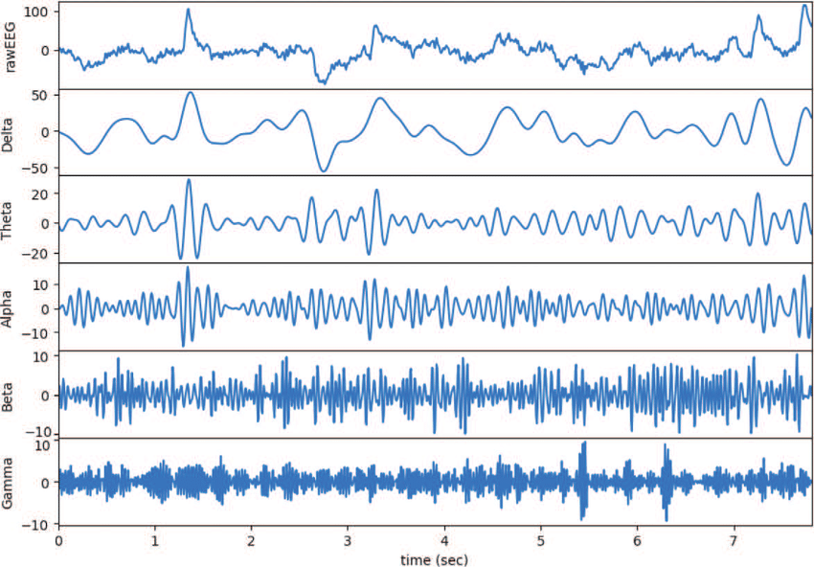

**Fig 1** [Epileptic](https://en.wikipedia.org/wiki/Epilepsy) spike and wave discharges monitored EEG

* 1. **LSTM**

LSTM, an artificial recurrent neural network (RNN) architecture, is used. LSTM features feedback connections, as opposed to conventional feed forward neural networks. Single data points and full data sequences may both be processed using it. LSTM may be useful for a variety of tasks, including handwriting recognition, speech recognition, and network anomaly detection.

A cell, an input gate, an output gate, and a forget gate comprise a standard LSTM unit. The three gates regulate the flow of information into and out of the cell throughout the course of time.

There may be delays of uncertain length between critical events in a time series that make it well-suited for the classification, processing, and prediction tasks handled by LSTM networks. The vanishing gradient issue that may occur while training conventional RNNs was the impetus for the development of LSTMs. LSTMs offer an edge over RNNs, hidden Markov models, and other sequence learning algorithms in a number of domains, including:

Gradient descent and back propagation across time may be used in conjunction with a set of training sequences and an optimization technique like gradient descent to generate the gradients needed throughout the optimization phase. Each weight in the LSTM network may be modified in proportion to a derivative of the error.

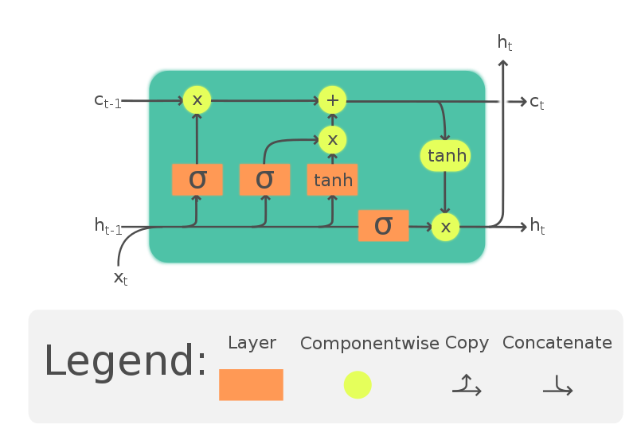

Fig 2 LSTM

* 1. **Over Head Reduction in LSTM from Dataset**

Gradient descent and back propagation across time may be used in conjunction with a set of training sequences and an optimization technique like gradient descent to generate the gradients needed throughout the optimization phase. Each weight in the LSTM network may be modified in proportion to a derivative of the error. By sending a fixed-size data transfer through the network and noting how many additional bytes of data are needed to complete the task, researchers may determine network overhead.

Communication overhead is the total amount of packets that must be moved or communicated from one node to another. Routing procedure, routing database and packet preparation are all included in this overhead.

Overhead memory holds the frame buffer and other virtualized data structures, such as shadow page tables. Overhead memory is affected by the number of virtual CPUs and the guest operating system's memory setup.

* 1. **Emotional Detection**

Face and voice recognition, biosensing (biometrics), machine learning (machine-learned), and pattern identification may all be used to detect and recognise human emotions (pattern recognition).

Emotion detection methods are becoming increasingly common in intelligent systems' interactions with humans. A human's emotional state may influence how the systems react and behave, which is critical.

Gabor Features, HOG, and LBP were used to compare the three different ways of extracting feature data (B DFE, CK, JAFFE, and one of our own). A number of well-known machine learning (ML) methods were used to identify the intensity of emotions.

When interviewing candidates, employers may utilise emotion recognition to see how they feel and how they answer to particular questions. This data may be used to enhance the application process for future candidates, as well as for future interviews.

An emotional model's fundamental properties are its valence and arousal. A person's valence determines whether or not they are drawn to or repelled by a certain object or event. From a bummer to a high roller, you never know what to expect. Being awake or sensitive to stimuli is a state that may be passive or active, depending on the individual. The valence-arousal dimensional model shown in Figure 3 is often used in emotional investigations.

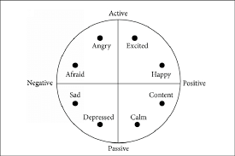

**Fig 3 Valence-arousal dimensional model**

**[2] Literature Review**

Recently, multimodal emotion recognition in conversational videos (ERC) has increased dramatically as shown by a study by Ke Zhang, et al.1. Real-time ERC is hindered by research that depends on the whole dialogue to extract context from video fragments. This paper proposes a novel multimodal emotion recognition model for conversational films, unlike prior research, that is based on reinforcement learning and domain knowledge (ERLDK). ERC may be performed in real time in ERLDK using reinforcement learning. In the corpus of historical utterances, an emotion-pair represents the multi-modal context of the following speech. DQN is designed to learn the correct action from the different emotion types using gated recurrent unit layers. Domain knowledge is gathered from a publicly available dataset based on the preceding information about emotion-pairs. Using the collected domain knowledge, a new dataset is constructed, which is then used to verify the accuracy of the RL module. On huge datasets, experiments show that ERLDK is capable of achieving the best results in terms of weighted average and the majority of specific emotional categories. [1]

When it comes to studying human behaviour, the role of motivation cannot be overstated. The term "motivation" comes from the Latin word "movere," which meaning "to move." The majority of the time, our behaviours are explained in terms of our reasons. What drives you to go to school or university, and how do you go about it? Some of the more common reasons for going back to school include: the desire to learn or make new friends, the need for formal education in order to get a good career, or even the desire to impress your parents. You may have made the decision to go back to school for one of these reasons or another. When they know what drives individuals, it is much simpler to predict future behaviour. As long as you've got a strong desire to achieve, you'll put in the work to get there. Consequently, the universal levels of motivation enable us to predict action in many settings. [2]

The first large-scale rag recognition experiment was carried out by Parag Chordia, et al. Indian classical music is built on the basis of ragas, each of which has its own set of melodic motions. From audio input, we calculate PCD and PCDD directly to develop a system that can recognise and discriminate between distinct rhyming patterns. There are more than 20 hours of recorded performances by 19 different performers in 31 different raags that were used to train and test the algorithm For the classification of the data, we employed SVMs, MVNs, and RFs (random forest models). Random Forests and the MAP rule were also used. When 60s segments were categorised in a cross-validation exercise, classification accuracy reached 99.0 percent. In a more difficult, secret generalisation testing, the accuracy percentage was 75%. This research shows that PCDs and PCDDs can differentiate rags even when the melodic changes are minor. Chai Tong Yuen,et al. developed a statistical technique to categorising human emotions based on electroencephalograms, which was researched (EEGs). To conduct this study, scientists looked at the electroencephalograms (EEGs) of six healthy adults who had been exposed to emotional stimuli. An experiment based on visual stimuli was also proposed in this study. EEG data is utilised to produce six statistical traits, and a neural network is used to characterise human emotions. In the trial, the emotions of anger, sadness, surprise, joy, and neutral were all identified. This results in an overall classification rate of 95 percent. [4]

a statement by Arturo Nakasone and others Games and e-learning systems are becoming more reliant on the capacity to evoke and detect the emotional state of their users in order to increase their usefulness. According to the model in this research, EMG and skin conductance may be utilised to identify emotions in real time. The emotion identification component developed in partnership with the University of Bielefeld brought real-time emotion detection to a gaming scenario combining a human player and a 3D humanoid creature dubbed Max. [5]

A music therapist may easily generalise from Joseph Moreno, et alfew .'s examples in order to create musical experiences that are applicable to any client group's ethnic music history. There is an extra consideration to be made when using non-Western music in music therapy. This is particularly evident in religious traditions where the arts of music, painting, dance, and theatre are all entwined. As well as providing a beautiful backdrop, the music in these ceremonies has a considerable therapeutic benefit. When dealing with clients from non-Western cultures, ethnic music therapy may be able to elicit emotions beyond those evoked by more traditional forms of music. The music has the capacity to reach a consumer on the most fundamental level of their worldview, culture, and beliefs. Aside from music, non-Western cultures have a long tradition of incorporating other types of art and literature into their work. This non-Western approach to the creative arts may lead to a more natural process of collaboration among the numerous creative arts practitioners in Western culture. In many cases, music therapists customise the music they use to their clients' cultural and musical backgrounds. Customers who share a musical and cultural past with them will surely benefit from this sort of approach. [6]

Many diseases, including mental disorders, may be induced or aggravated by long-term, severe stress, according to a study published by Takuto Hayashi, et al. (2018). This research uses an electroencephalogram (EEG) and an electrocardiogram (ECG) to examine whether or not stress levels may be reliably quantified using objective physiological responses. Two categories of stress were created from the responses of the twenty-two healthy volunteers who took part in the study. EEG and ECG data from emotional stress tasks including auditory and visual input were examined using a discrete Fourier transform (DFT). Non-Stress Group individuals had greater beta activity in the frontal areas after emotionally unpleasant stimuli than Stress Group participants. There seems to be a greater degree of stress resistance in the brain and bodily reactions of those with lower levels of stress (the Non-Stress Group). [7]

Murugappan Murugappan, and others (2010) used to summarise human emotion identification using a range of EEG channels in the study's explanation. A more dynamic emotional content has been produced for the purpose of generating diverse emotions using audio-visual induction (disgust, happy, surprise, fear and neutral). To collect EEG data, 20 volunteers were each fitted with 64 electrodes using the International 10-10 method. The DWT is used to decompose the alpha, beta, and gamma frequency bands of the raw EEG data processed using the SL filtering approach (DWT). To classify emotions using the "db4" wavelet function, we used the EEG data to construct a set of standard and modified energy-based characteristics. Emotional states are classified using KNN and LDA, two fundamental pattern classification algorithms. Experimentation shows that ALREE has the greatest average classification rate of 83.26 percent with KNN and 75.21 percent with LDA compared to traditional features. The average and subgroups of emotions classification rates of these two classifiers are utilised to illustrate the effectiveness of our emotion recognition system. [8]

Including Noor Hayatee Abdul Hamid and others (2010) EEG Power Spectrum beta and alpha bands were employed in this research to compare data from human stress questionnaires. An assessment of stress was made by administering Cohen's Perceived Stress Scale to the participants (PSS). EEG recordings of 13 people were collected as soon as they finished answering the stress questionnaires. There was a link between the Beta and Alpha band power ratios and ratings based on stress questionnaire answers. According to the study results, the PSS had a negative connection with the EEG Power Spectrum ratio. According to a recent research, PSS and the ratio of EEG Power Spectrum may be used to accurately quantify human stress. [9]

Elizabeth A. Stanley, et al (2011) There has been an increase in interest in preventative methods to decrease the impact of prolonged and repetitive stress on mental and physical health as a result of current military deployments. When it comes to lowering stress, mindfulness training has been shown helpful. The following case study focuses on a Marine detachment that has completed Mindfulness-Based Mind Fitness Training (MMFT) before to deployment. According to their findings, researchers looked at the degree of mindfulness and stress reported by participants and the determinants of mindfulness practise compliance and time spent engaged in it. More practise time was linked to greater levels of self-reported mindfulness, and lower levels of stress were linked to higher levels of mindfulness. [10]

Ann Hackmann and coauthors (2011) This article provides an overview of how pictures may be used to modify meanings and relieve post-traumatic stress disorder (PTSD). When dealing with this illness, the phenomenology is often described by the client expressing a few repeated visions of the trauma, each of which depicts an occurrence that indicated a risk to his or her health. Suddenly, a series of disturbing, terrifying, and unsettling sensory shards appear, as if warning of an imminent threat. The exploration of theoretical ideas of PTSD's persistence emphasises the role of imagery as a therapeutic focus. They next evaluate the likelihood of spontaneous cognitive change, as well as strategies to stimulate additional meaning shifts linked to "hot zones" in memories, and they conclude. Techniques for correcting erroneous memories and expressing trauma-related emotions are included in the programme. There are also suggestions for dealing with childhood memories that have contributed to one's traumatization. [11]

J. Wild and coworkers (2011) suffer from social anxiety have unfavourable self-images, which may be linked to early memories of stressful social experiences, according to research. Re-imagining undesired or distressing experiences is becoming more common in CBT programmes. Imagery restriping outperformed a control condition in terms of reducing negative attitudes, image and memory pain, anxiety about negative appraisal, and social anxiety. In this piece, they go into great depth on the restripping technique we use. When it comes to social phobia, for example, they explore the importance of keeping unpleasant images fresh and the theoretical basis for imagery restripping as well as possible future study goals. [12]

**Table 1** Literature Survey

|  |  |  |  |  |  |  |
| --- | --- | --- | --- | --- | --- | --- |
| **Review Paper** | **Proposed Work** | **Accuracy** | **Optimization Techniques** | **Classifiers used** | **Numbers of Deep Data** | **Limitations** |
| 1 | To implement Real-Time Video Emotion Recognition depending on reinforcement learning as well as domain knowledge | Not Calculated | LSTM | Multi-modal Emotion Recognition, Reinforcement Learning | 1400 dialogues and 13000 utterances | Research improve recognition ability on all emotion classifications |
| 2 | Motivation and Emotion | Not Calculated | Not Considered | Maslow’s model, frustration | 81 Emotion Expression is considered | There is no technical work |
| 3 | Performing Raag Recognition by making use of Pitch-Class along with Pitch-Class Dyad distributions | 99% (CV) and 75% (unseen) success rates | RAAG recognition | multivariate likelihood model (MVN) | The segment was considered 128 sample regions | Containing much time for performance of recognition process |
| 4 | To classify human emotions from EEG Signals by making use of Statistical characteristics along with neural network | 97.50% | Time compution | Neutral Network and Statistial Features | No. of input learning data is 150. | They are considering the dataset which has large in size |
| 5 | Making use of Electromyography and Skin Conductance for emotion recognition | No applied | Emotional state detection and THE BAYESIAN NETWORK LAYER | Emotion Recognition, Biosignal Interpretation, Affective Computing. | No dataset is consider | There is lack of technical work |
| 6 | To propose system for music therapy | Not applied | Not applicable | Characterization | Dataset is not consider | Research did limited work on emotion |
| 7 | To perform Anterior brain activities that are related to emotional stress | 99% (CV) and 75% (unseen) success rates | RAAG recognition | multivariate likelihood model (MVN) | The segment was considered 128 sample regions | Containing much time for performance of recognition process |
| 8 | To develop electronic Stress Relief Device that should be capable to view Physical Activity | 97.50% | Time compution | Neutral Network and Statistial Features | No. of input learning data is 150. | They are considering the dataset which has large in size |
| 9 | To provide solution for educational stress | 98.5% | Feature Extraction Emotions and Color Model Neural Network | Human computer interaction, Emotion recognition and Haar classifier | There were 100 input data used for this network. | There is not providing proper frontal face view these algorithms and methods give very less accurate recognition of emotion. |
| 10 | To perform classification of human emotion | 99% (CV) and 75% (unseen) success rates | RAAG recognition | multivariate likelihood model (MVN) | The segment was considered 128 sample regions | Containing much time for performance of recognition process |

**[3] Problem Statement**

The reliability of EEG signals has been investigated in a variety of research. Researchers wanted to learn how to spot people's emotions via this kind of study. Despite the fact that previous study has taken a long time and been erroneous, a solution has been found. In contrast, the breadth and flexibility of these investigations were severely restricted. For EEG data processing, there is a requirement for a high-tech system that can discern emotions. Removing unnecessary information is another way to boost accuracy and overall performance.

**[4]Need of Research**

Electroencephalography (EEG) has shown that electrical activity on the scalp is a reflection of activity in the brain's surface layer below (EEG). EEG signal precision has been the subject of several studies. The goal of this study was to determine the emotions participants were experiencing. Despite past study that was time-consuming and incorrect, there is a solution. This research also indicated that the system has a very limited capability for adaptability and growth. The detection of emotional states requires a more

advanced analysis of EEG data. Additionally, removing unused information from the database is essential if you want to improve the database's accuracy and performance. EEG signal processing, overhead, LSTM, and emotion recognition are the focus of the study. Researchers must first investigate the previous system in use and the reasons that led to its success before they can better grasp how to identify emotions. Using Overhead with LSTM algorithms should be done in a unique approach that reduces operation time and improves accuracy. On the basis of correctness and performance, the planned work is compared to the preceding work.

**[5] Conclusion**

It has been observed that there have been several research in area of EEG but there is need to improve the accuracy along with performance. Moreover it has been observed that previous research have provided limited scalability and flexibility. Integration of KNN and LSTM would provide better solution for accuracy and performance. Table 2 is presenting the comparative features of existing research.

**Table 2 Comparison analysis of feature for research work**

|  |  |  |  |  |
| --- | --- | --- | --- | --- |
| **Citation** | **EEG Signal** | **Imagery Rescripting** | **Music Therapy** | **Emotion Detection** |
| [1] | No | No | No | Yes |
| [2] | No | No | No | Yes |
| [3] | No | No | No | Yes |
| [4] | Yes | No | No | Yes |
| [5] | No | No | No | Yes |
| [6] | Yes | No | No | Yes |
| [7] | Yes | No | No | Yes |
| [8] | No | No | No | Yes |
| [9] | No | Yes | No | Yes |
| [10] | No | Yes | No | No |

**[6] Scope of Research**

Emotion detection via deep learning is an intriguing concept that might lead to more accurate, safe, and unbiased results for users. Humans may respond to various situations by showing diverse emotions, which allows Overhead to address issues about emotional recognition. LSTM enables several actors to construct a valid machine learning model for recognising various emotions, which is vital for solving critical difficulties.

**References**

[1] K. Zhang, Y. Li, J. Wang, E. Cambria, S. Member, and X. Li, “Real-Time Video Emotion Recognition based on Reinforcement Learning and Domain Knowledge,” pp. 1–14.

[2] B. Motives, P. Motives, E. Expression, and E. Labeling, “Motivation and Emotion.”

[3] P. Chordia and A. Rae, “raag recognition using pitch-class and pitch-class dyad distributions.”

[4] U. Tunku and A. Rahman, “Classification of Human Emotions from EEG Signals using Statistical Features and Neural Network.”

[5] A. Nakasone, H. Prendinger, and M. Ishizuka, “Emotion Recognition from Electromyography and Skin Conductance,” pp. 1–4.

[6] J. Moreno, “Multicultural Music Therapy : The World Music Connection,” no. 1, pp. 17–27, 1988.

[7] C. Paper, T. Hayashi, O. General, R. Ishii, and A. Municipal, “Anterior brain activities related to emotional stress,” no. May 2014, 2008.

[8] A. Grewal and A. Shekar, “The Development of an Electronic Stress Relief Device that Monitors Physical Activity,” pp. 2–4, 2008.

[9] A. Sharma and R. Singh, “Combating Educational Stress in Adolescents : The Miraculous Role of Chanting Mantras,” vol. 1, no. 1, pp. 25–37, 2009.

[10] M. Murugappan, N. Ramachandran, and Y. Sazali, “Classification of human emotion from EEG using discrete wavelet transform,” vol. 2010, no. April, pp. 390–396, 2010, doi: 10.4236/jbise.2010.34054.

[11] N. Hayatee, A. Hamid, N. Sulaiman, S. Armiza, M. Aris, and Z. H. Murat, “Evaluation of human stress using EEG Power Spectrum Evaluation of Human Stress Using EEG Power Spectrum,” no. June, 2010, doi: 10.1109/CSPA.2010.5545282.

[12] E. A. Stanley, J. M. Schaldach, A. Kiyonaga, and A. P. Jha, “Mindfulness-based Mind Fitness Training: A Case Study of a High-Stress Predeployment Military Cohort,” *Cogn. Behav. Pract.*, vol. 18, no. 4, pp. 566–576, 2011, doi: 10.1016/j.cbpra.2010.08.002.

[13] A. Hackmann, “Imagery Rescripting in Posttraumatic Stress Disorder,” *Cogn. Behav. Pract.*, vol. 18, no. 4, pp. 424–432, 2011, doi: 10.1016/j.cbpra.2010.06.006.

[14] J. Wild and D. M. Clark, “Imagery Rescripting of Early Traumatic Memories in Social Phobia,” *Cogn. Behav. Pract.*, vol. 18, no. 4, pp. 433–443, 2011, doi: 10.1016/j.cbpra.2011.03.002.

[15] G. Yang, “Study of Emotion Recognition Based on Surface Electromyography and Improved Least Squares Support Vector Machine,” vol. 6, no. 8, pp. 1707–1714, 2011, doi: 10.4304/jcp.6.8.1707-1714.

[16] S. Yang and G. Yang, “Emotion Recognition of EMG Based on Improved L-M BP Neural Network and SVM,” vol. 6, no. 8, pp. 1529–1536, 2011, doi: 10.4304/jsw.6.8.1529-1536.

[17] G. Valenza and E. P. Scilingo, “Emotion Recognition Based on DEAP Database using EEG Time-Frequency Features and Machine Learning Methods Emotion Recognition Based on DEAP Database using EEG Time-Frequency Features and Machine Learning Methods,” 2020, doi: 10.1088/1742-6596/1501/1/012020.

[18] A. S. Aljaloud, H. Ullah, and A. A. Alanazi, “Facial Emotion Recognition using Neighborhood Features,” vol. 11, no. 1, pp. 299–306, 2020.

[19] D. Ss, “A review on deregulation of power system,” no. May, 2020, doi: 10.37896/whjj16.05/063.

[20] F. E. Recognition, “Facial Emotion Recognition,” no. 1, pp. 1–5, 2021.

[21] Y. Wan, H. Ni, E. Tensile, and A. A. Mochtar, “Emotion Recognition Using Convolutional Neural Network ( CNN ) Emotion Recognition Using Convolutional Neural Network ( CNN ),” 2021, doi: 10.1088/1742-6596/1962/1/012040.

[22] R. Chaudhary, R. A. Jaswal, and S. Dhingra, “Emotion Recognition Based on EEG using DEAP Dataset,” vol. 08, no. 03, pp. 3509–3517, 2021.

[23] H. O. F. Information, “Handbook of information 2021,” 2021.

[24] S. Kaur and N. Kulkarni, “Emotion Recognition – A review,” vol. 16, no. 2, pp. 103–110, 2021.

[25] W. Sato, K. Murata, Y. Uraoka, K. Shibata, and S. Yoshikawa, “Emotional valence sensing using a wearable facial EMG device,” *Sci. Rep.*, pp. 1–11, 2021, doi: 10.1038/s41598-021-85163-z.