TRANSIT ORIENTED DEVELOPMENT: ELIXIR TO URBAN CHALLENGES
Himanshi Chachondia¹, Ar. Satyam Shukla²
¹P.G. Student, Department of Town & Country Planning, Madhav Institute of Technology & Science, Gwalior, Madhya Pradesh, India
²Assistant Professor, Department of Town & Country Planning, Madhav Institute of Technology & Science, Gwalior, Madhya Pradesh, India

ABSTRACT
Transit Oriented Development (TOD) is attaining admiration as a technique of planning and design strategies to achieve sustainable development. Represents unique opportunities for Indian cities to meet the challenges of rapid motorization, rising inequity, deteriorating quality of the urban realm and climate change. TOD significantly manage blend land-utilize, for example, private, business, public space and serve around travel stations for person on foot cordial development. TOD coordinates land use and transport arranging and means to foster arranged maintainable metropolitan development habitats, having walkable and bearable cooperatives with high thickness blended land-use. Residents approach open green and public spaces and simultaneously travel offices are proficiently used. This paper studies the concept of TOD, its advantages, Challenges and one of the best international case studies with respect to Indian case studies.
Keywords: Transit Oriented Development, Transit system, Mixed-use, Sustainability.

1. INTRODUCTION
Transit Oriented Development (TOD) is the creation of compact, walkable, mixed-use communities centered around high-quality transit system especially the BRTs and MRTs. Compact mixed uses developments near public transport stations or nodes within the walking distance of 500m to 800m or 10 min distance with designed walkable areas with a high quality of public spaces. TOD is a type of urban development that clusters jobs, housing, services and amenities around public transport hubs. Peter Calthorpe was known as father of TOD) was San Francisco based architect urban designer & urban planner. Peter Calthorpe explained the concept of TOD as “Moderate and high-density housing along with the complementary public uses jobs, retails and services are concentrated in mixed-use development at strategic points along the regional transit system.
2. AIM
Research paper is about the Transit oriented development to promote sustainable planned growth by reducing transportation demand and generate alternatives for improving transportation system to meet future demand with proper evaluation.
3. OBJECTIVE
- To analyze the effect of urban Sprawl on the city.
- To identify and evaluate the potential of rapid urban growth, globally.
- To establish the concept of transit-oriented development: focused on Indian Context.
4. SCOPE/LIMITATIONS
This study will be focused on-
- The main idea behind the urban transportation is to fuse with surroundings.
- Appreciation towards natural materials.
This study will not include- (a) Construction details and techniques. (b) Barriers.
This study will not be exhausting the philosophy is being mention and exhausted study of architects is not possible.
5. METHODOLOGY
- Grouping of scholarly writing and reports in space of transit-oriented from research data sets and Government reports. The course of fitting future exploration will be drawn.
- Approach in order to achieve the main objective of the research.
Study is to analyze the urban growth which gives an idea about the role of TOD with the guidance of faculty.
6. LITERATURE REVIEW
6.1 WHY TOD IS SMART?
- Living near transportation more convenient people spend less on housing & less on transportation.
- Vibrant walk-able neighbourhood near shops and restaurant
- Transit connects hooks them up too many more jobs training education, health and recreational opportunities
- Last mile connectivity is farthest location well connected therefore streetscaping design plays an important role.
- TOD typically includes a central transit stop such as train station, light rail station or a bus stop surrounded by a high-density mixed-use area with low density area spread out from the centre. ((US High Speed Rail Association), 2022)
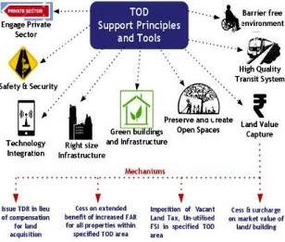
6.2 KEY FEATURES OF TOD
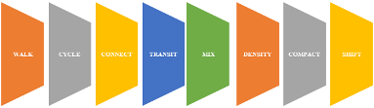
8 Principles of the TOD standard for designing better streets & better cities:

6.3 PRINCIPLES OF TOD
- Developing neighbouring that promote walking
- Focus on non-mechanized transport organization
- Form condensed network of streets and paths.
- Settle development near public transit zones.
- Plan for mixed use, income and demographics
- Form zones with short transit commutes.
- Increment versatility by managing parking and road use.
Figure 1: TOD Principle and Tools
- Enhance density and match transit limit. ((US High Speed Rail Association), 2022)
6.4 COMPONENTS OF TOD
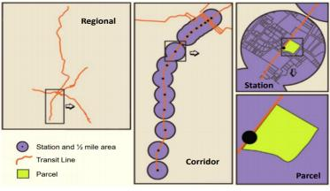
- Mixed uses & compact Higher land development
- 1st and last mile connectivity
- Interconnected street network
- Non-motorized Network
- Multimodal Integration
- Great pedestrian environment
- Parking management with proper transit service
- Casual Travel Reconciliation
- Strong connectivity between transit & development
- Public amenities ((US High Speed Rail Association), 2022)
6.5 BENEFITS OF TOD
- Less expensive than building roads & sprawl
- Prominent portability with ease of moving around
Figure 2: Scale of TOD

- Expanded transit ridership.
- Higher, more stable property values
- Increased foot traffic and customers for area businesses
- Reduced traffic congestion, car accidents and injuries
- Healthier lifestyle with more walking, and less stress
- Enhanced ability to maintain economic competitiveness
- Reduced household spending on transportation, resulting in more affordable housing
- Greatly reduced dependence on foreign oil, reduced pollution and environmental damage.
- Higher quality of life with better places to live, work, and play
- Reduced incentive to sprawl, increased incentive for compact development. (US High Speed Rail Association, 2022)
6.6 KEY PARAMETERS OF TOD THE TOD
Parameters are the 3 Ds below
- Density (For adequate population density for transit ridership transit)
- Diversity (Mixed Use, Mixed Income that use transit)
- Design (Safe, comfortable, Active (24X7) Environment created by promoting walkability and access to transit.
The 3 Ds define the density, mix of uses and connectivity required within walking distance of transit stations to encourage transit use and a 24-hour environment around transit station. ((US High Speed Rail Association), 2022)
6.7 FACTORS DRIVING TREND TOWARDS TOD
- Rapidly growing, mind-numbing traffic congestion nation-wide.
- Growing distaste for suburbia and fry-pit strip development.
- Developing thirst for quality urban lifestyle.
- Developing thirst for walk-capable ways of life away from traffic
- Changes in family structures: more singles, empty-nesters, etc.
- Growing national support for Smart Growth.
- New focus of Federal policy. ((US High Speed Rail Association), 2022)

7. CASE-STUDY
7.1 CASE-STUDY: CURITIBA, BRAZIL - TRANSFORMING CITY WITH BUS TRANSIT
Figure 3: Map of Brazil
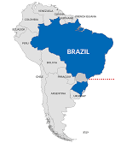

Study about the integrated transit and land-use planning through adaptive and bus transit system for the manage urban sprawl – to preserve the historic city centers.
7.1.1 CITY PROFILE:
- Curitiba is the capital city of Parana, Brazil
- Total area – 432km²
- Total population - 1.95 million
- Density - 4,062person/km²
Figure 4: World Map
- Town Planner & Ex: mayor - Jaime Lerner.
SOURCE: https://www.esmap.org/s
SOURCE: https://www.esmap.org/s
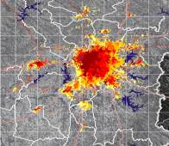
- City was started in 1970’s by developing building regulations
Figure 5: Aerial View of Curitiba
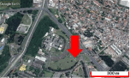

Figure 6: Plan of Brazil
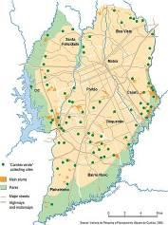

Figure 7: Picture Showing Urban sprawl
SOURCE: Suzuki,et.al, 2020
SOURCE: dspacedirect.org
YEAR
1955
1965
1975
1985
2000
SOURCE: https://www.esmap.org/sites/default/files/esmap-files/CS_Curitiba.pdf

Figure 8: Population Growth
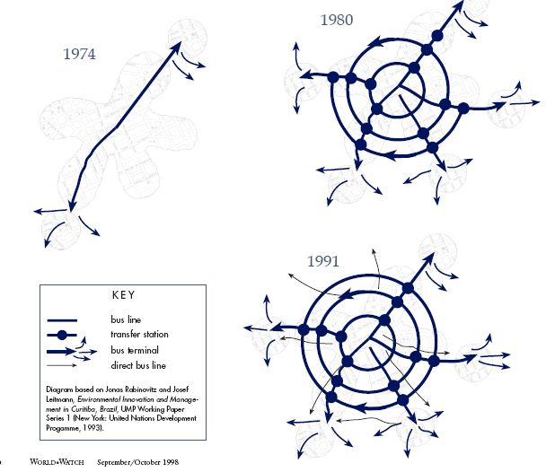
1974
1980
DOWNTOWN
1943
SOURCE: world-cities/curitiba-population
7.1.2 HISTORY
- 1943 - 1st Master plan - Alfred Agache - Radial Structure
- monumental public works projects
- Sprawling overpass in central core (destroy historical buildings)
(Curitiba city planning, Accessed:9/9/2022)
- 1964 – Master Plan - Architect Jaime Lerner- Linear Structure
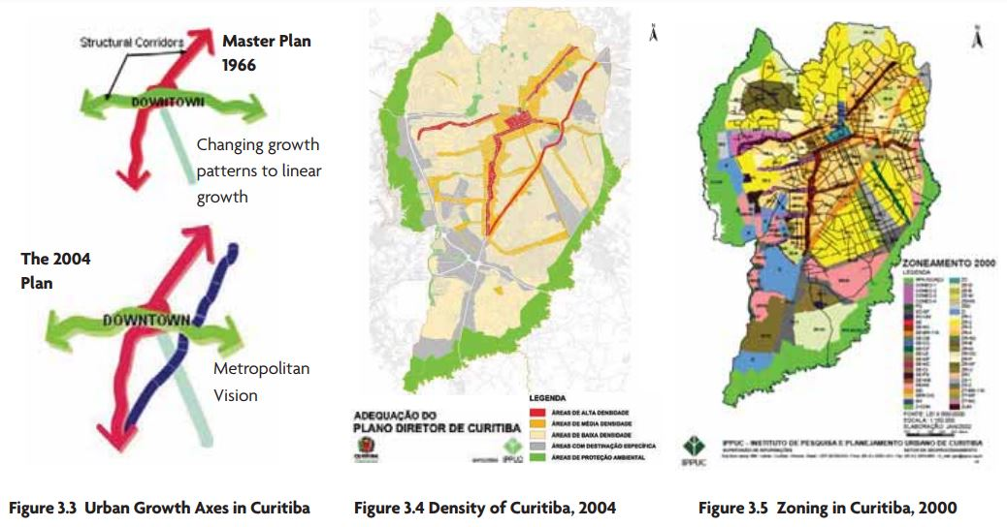
- Strict control on urban sprawl (Preservation of historic sector).
- Reduction in traffic congestion CBD
- Convenient and affordable public transit system
- 1965- Curitiba Master Plan
- Funneled development along axis from central city
Structural Axes
Green line
- Prioritised public transit, developed bi-directional traffic pattern
Figure 9: Urban Growth along the Axes in Curitiba
- Pedestrian right of way on CBD streets (preserved city’s core)
SOURCE: https://www.esmap.org/sites/default/files/esmap-files/CS_Curitiba.pdf
(Curitiba city planning, Accessed:9/9/2022)
- 2004- Revised Master plan- Linear Structure & Metro-politization
- Maintaining 1966 Master Plan guidelines
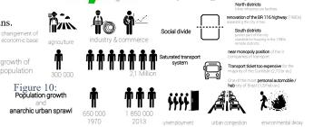
- Consolidation Urban Policies & new urban tools

- Promotes public participation in complementary plans. (Curitiba city planning, Accessed:9/9/2022)

7.1.3 ISSUES
- Massive Industries & agriculture sector.
- Employment Migration: Japan, Syria, Lebanon, European.
- Rapid growth (Urban Sprawl).
- Fewer open/green spaces & city lost character.
- Demand increase: Housing, Services, Transportation.
(R. Adam Dastrup Introduction to world regional geography, Published:1/06/2020)
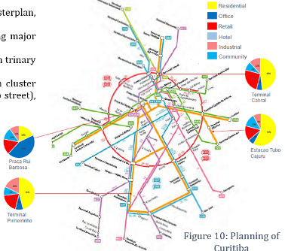
7.1.4 KEY TOOLS & MEASURE:

Figure 10: Planning of Curitiba
- Implementation of corridor by legal framework (Masterplan, zoning regulations & Incentives like green exchange)
- Built transit lines (BRTS due to funding restraint) along major corridors within city
- Promote dense, high rise & mixed land development with trinary road system.
- Car free pedestrian malls surrounding BRT lines with cluster shops & services called Ruas da Cidadania (citizenship street), promote walking.
- Measures for location efficient development for density along transit corridors
- Single flat subsidization between short & long rides & promotes ridership.
- A national policy mandates employers transportation subsidies for their workers.
- In 2009, City has green line: 18 km corridor bus system to operate 100% biodiesel.
SOURCE: Volume-3-Benchmarking-Transit-Oriented-Development (1)
- Recent Legislation turning green line into Pedestrian friendly, mixed-use corridor, sidewalk improvement, construction of cycle paths. (Volume 3-Benchmarking Transit Oriented Development, Published: Nov.2018)
7.1.5 APPROACHES (SOUTH AMERICAN MODEL)
- High Density corridors connecting parts of the city (focus on integrate land use and transport)
- Preserve the historical district of Curitiba
- Minimize urban sprawl.
- provide affordable & easily accessible public transportation
- Reduce downtown traffic. (Volume 3-Benchmarking Transit Oriented Development, Published: Nov.2018)

Figure 11: Concept for the Planning of Curitiba

SOURCE: researchgate.net

7.1.6.1 URBAN PLANNING PROCESS
- 5 structural transport arteries axis corridors:
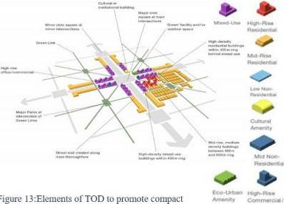
- Spider-web effect created in 90% of city: Integrated bus network
- Bi-articulated buses used: 3 compartments (each holding 270 people)
- Ensure inhabitants only walk 500m to access public transport.
- Created Articulated density:
- Converted Brownfield to high concentration housing, shops & services are planned along corridors.
- Promotes mixed commercials use offices, business and housing
- Incentives with rules & regulations: density bonuses
- Areas don’t have any height limits.
Figure 12:Elements of TOD to promote compact development with combination of mixed use and high density
- 1st two floor of busways are devoted to retail use.
- Above 2nd floor building- set back 5 m from property line to allow sun cast on the transit way.
SOURCE: IB Group
- Upper-level housing entitles property owners to density bonuses
- Large-scale shopping centers only allowed in transit corridors
- Public housing for low-income families built along the transit ways
- Create supportive environment to leverage TOD by accommodating streetscaping Linear parks etc.
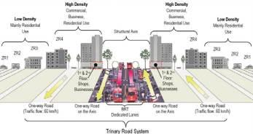
- Mass transit lanes were placed Trinary lanes.
- No subway was built because it is too expensive and takes too long.
- reducing carbon emissions & greenhouse gasses
- Restriction of parking in CBD: streetscaping
- City bought lands for affordable housing along the corridor & near industries
- Built Cycle tracks, Racks & public bikes. (Volume 3-Benchmarking Transit Oriented Development, Published: Nov.2018)
Figure 13: Trinary Road System
Figure 14: Pie charts showing landuse Percentage
SOURCE: https://www.esmap.org/sites/default/files/esmap-files/CS_Curitiba.pdf
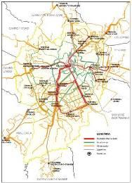
Figure 15: Master Plan of Curitiba

SOURCE: https://www.esmap.org/sites/default/files/esmap-files/CS_Curitiba.pdf

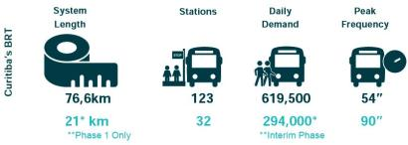

SOURCE: Volume-3-Benchmarking-Transit-Oriented-Development
SOURCE: smartnet.niua.org
Figure 16: Curitiba Integrated Planning
SOURCE: Institute for Research and Planning Curitiba Urban
7.1.6.2 URBAN PLANNING PROCESS
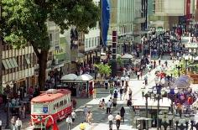
1. Physical Changes: Mobility 2. Cultural Changes
Figure 17: Preservation of cultural / historical heritage

Figure 19: Present day Downtown Curitiba.
Figure 18:Priority for pedestrians in downtown - 1972
Source: INF UFPR
Source: Rua XV de novembro
Source: alnap.org

3. Linear Growth towards periphery
Figure 21:Building the Structural Axes for urban development - TOD
Figure 20: Percentage of Mode use

Source: alnap.org
One-Way Rapid Avenues
Exclusive Lanes for Buses
One-Way Rapid Avenues
Source: https://memoriaemfotos.wordpress.com/2014/03/30/rua-xv-anos-1970/
SOURCE: Suzuki,et.al, 2020
Figure 22: Trinary Road System

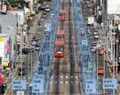
4. Consolidation of TOD
5. Land Use / Transport
Figure 23: Consolidation of Curitiba

Source: eria.org
Figure 24: Trinary Road System with Landuse
Source: world bank.org
Source: Daily motion
SOURCE: https://www.esmap.org/sites/default/files/esmap-files/CS_Curitiba.pdf
6. Green Line
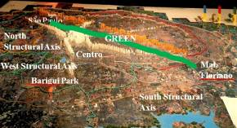
South Structural Axis

Figure 25:Mixed land use with integration of metro rail

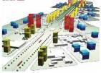
Figure 26: Green Line

SOURCE: https://www.esmap.org/sites/default/files/esmap-files/CS_Curitiba.pdf
Figure 28: Green Line in Curitiba
Figure 27:Implementing Cycle tracks
SOURCE: IPPUC
7.1.7 INFERENCE:
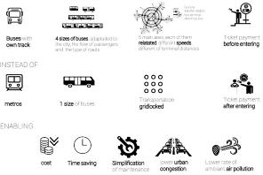
- Some of the Innovative initiatives taken for city to enhance it:
- Social Housing Strategies Along the BRT Corridors
- Shanty Town Regeneration
- Heritage Conservation Methodology
- Public Private Partnerships in Transport Framework.
- BRT & bus network in support of economic transformation of the city.
- Environmental policies & open space accessible to all
- Inventive waste management drives; “Garbage That is Not Garbage” Program
- ¾ Of Curtibian using the public transportation/ day.
- Make system efficient target should be 270 passenger per bus.
- Elaborated tube use as bus stops
- 10 private companies paid length of the roads ≠ no. of passenger
Figure 29: Characteristics of an Appropriate transit system
- Only 10% income spent in transport (low for Brazil)
- Old buses can be recycled.
- Saving money reinvested (in surrounding dwellings for example with an easy access to transport).

7.2 CASE-STUDY: DELHI, INDIA - TRANSIT ORIENTED DEVELOPMENT STRATEGIC PLAN
Urban challenges & creating Transit Corridors to reduce congestion from central area and connect the multiple nuclei of the city encouraging public to use public transport.

7.2.1 CITY PROFILE
Population: 11,007835 (2011)
Land area: 1484 km²
Gross Density: 7,418 person/ km²
Urban Area Density: 11,297 Person/ km²
Per capita: 2.01 lakh (2012-2013)

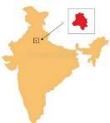
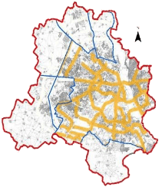
7.2.2 INTRODUCTION
Delhi is the National Capital Territory and it is bordered by Haryana on three sides and by Uttar Pradesh in the east. It is located at North.
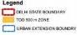
Public transport in India’s capital city New Delhi is provided by buses and a metro rail system. The Delhi Metro, a mass rapid transit system serves many parts of Delhi as well as the satellite cities of Gurgaon and Noida. (Economic survey of Delhi, 2005-2006)
7.2.3 FACTORS AFFECTING
Figure 30: Map of India
- Capital of Nation
- Influx of immigrants
Figure 31: TOD Zone map of Delhi
- Change in the economy from a primary (agriculture) to tertiary (service) sector throughout the long term.
- Job creation in the assistance area draws in additional immigrants to the city
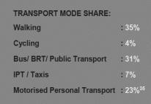
- Job creation leads to population increases. (Planning Department of Delhi, Environment Concern Published: 29/06/2018)
Figure 32: Population Growth in Urban and rural area of Delhi
Figure 33: Graph showing Population growth
7.2.4 HISTORY
- At the time of the 1961 census, Delhi was composed of one district & one tehsil.
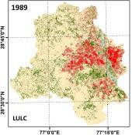
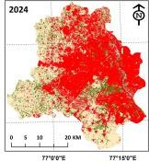
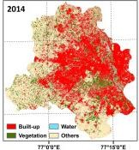
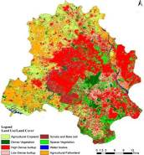
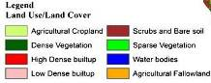
1638-48: Shahjahanabad – Shahjahan as Emperor.
2009
Land Use & Land cover Map
Source: https://www.sciencedirect.com/ science/article/abs/pii/S026427 5118303871
Red Fort, Jama Masjid built.
1803: British East India Company Intrusion.
1911-31: Sir Edwin Lutyens planned New Delhi
1912: Capital moved from Kolkata to New Delhi.
1931: New Delhi Capital initiated & Delhi Improvement
Trust comprised.
1947: Independence and partition of the country.
Movement of half million populace to Delhi.
1948: Rehabilitation townships planned.
1957: DDA constituted.
1962: First Delhi Master Plan passed.
(Economic survey of Delhi, 2005-2006)
7.2.5 ISSUES IN DELHI
- Urban Sprawl: 54 sq.km/ year or 20.85 sq. mile/ year
- Increase in Population
- Housing Shortage
- Traffic congestion
- Parking issues- Majority Road Space given to
private vehicles
- Segregated Land uses Cause
- Uneven population Distribution
- Large Travel distances
- Pollution
- High Traffic Generation
- Improper connectivity & Street Network
- Density
- Unsafe Streets due to Setbacks & Boundary Walls.
- Degradation of QOL & inefficiency of city.
(Planning Department of Delhi, Environment Concern Published: 29/06/2018)

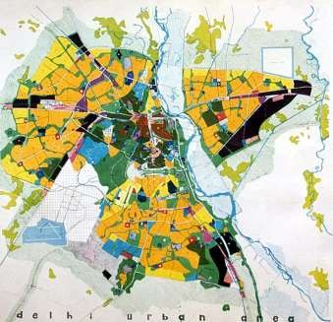
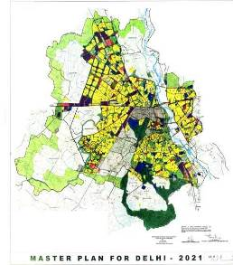
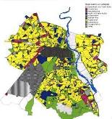
7.2.6 MASTER PLANS FOR DELHI
1st Master Plan for Delhi,1961- 81, was published by DDA in 1962, conceived improvement of urbanisable area of 448km² by 1981, catering to an urban Population of 4.6 million. (MPD -DDA, Released: 1961)
Third Master Plan of Delhi, projected Population 23 million by the year 2021 on about 978 km² of total urbanisable area. (MPD -DDA, Released: 2021)
Figure 34: Plan showing the metro line connectivity all over Delhi

Figure 35: Master Plan of Delhi 1961 - 1981

Accommodate 12.2 million population by 2001, the 2nd Master Plan envisaged expanding urbanisable area to 688 km²(MPD -DDA, Released 2001)

Figure 37: Master Plan for Delhi 2001
Figure 36: Master Plan for Delhi 2021

7.2.7 DELHI- 1ST TOD PROJECT AT KADKARDOOMA
Delhi in specifically is viewing at TOD as a solution to its portability and air quality challenges by fostering the regions around metro stations.” Govt. endorses Transit Oriented Development Policy for Delhi
- In 2010, the DDA decided that UTTIPEC would conduct a TOD pilot project at MRTS stations.
- This Pilot Project based on TOD Norms to provide easy accessibility to metro stations.
- Located Next to 2 Metro stations, Anand Vihar Railway Station, ISBT & DTC Bus Terminal
- Project will have Plazas, Public space, Commercial Areas, Office Spaces, Residential Areas, Restaurants, etc.
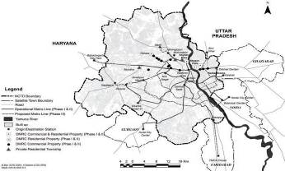
One 80 storey Iconic tower with retail, Offices & Hotels. (Transit Oriented Development (TOD) Policy Case Study-East Delhi Hub, Accessed: 10/09/2022)
Figure 38: Plan of Delhi
- SITE DETAIL
AREA OF SITE | 30 Hac.
GROSS FAR | 1.9
TOTAL BUILT-UP AREA | 57Hac.
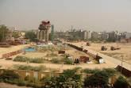
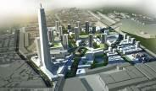

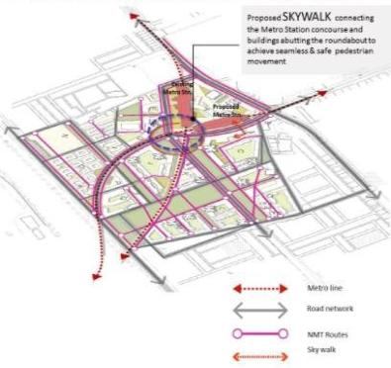
Figure 39: Group housing site & Mass Rapid Transport System around Karkardooma Metro Station

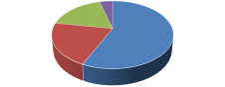
Mixed Use, 16.6, 57%
Open Space, 6.1, 21%
Roads, 5.3,
18%
Pathways, 1.2,
4%
Mixed Use
Open Space
Roads
Pathways
Source: © Jin Murakami. Used with permission. Further permission required for reuse.

Figure 41: Integrated NMT route with skywalk & Cycle track
Figure 40: Land Area Distribution
7.2.8 TOD POLICY NOTIFIED IN JULY,2015
Figure 42: Mixed Land Use Development
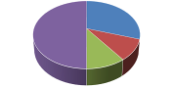
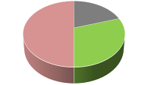
- Applicable: 500 M Belt along Metro Corridors
Residential Use, 30%
Commercial Use, 10%
Remaining
As Per Zonal Plan 50%
Commercial Use
Residential Use
Community Facilities
Remaining As Per Zonal Plan
Community Facilities, 10%
Green Open Space, 30%
Buildable Land Area, 50%
Roads
Green Open Space
Buildable Land Area
Roads, 20%
- Covers 20% of Delhi Urban Area
- Exceptions:
- Lutyen’s Delhi & Chanakyapuri
- Civil Lines Area
- Zone-O (Yamuna River Bed)
Highlights of Policy
- Mixed land use
- Removal of setbacks & boundary wall
- Emphasis on pedestrians
Figure 43:Pie chart showing Land Distribution
- Water recycling & reuse
- Optimum utilization of land
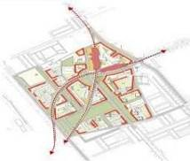
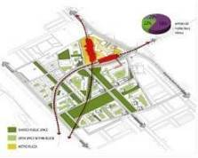
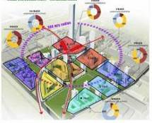
(Transit Oriented Development (TOD) Policy Case Study-East Delhi Hub, Accessed: 10/09/2022)

Figure 44: Mixed Use Development- Horizontal Mixes
Figure 45: TOD Principle Interconnected Open Spaces
Figure 46: TOD Principle- Active Edges
7.2.9.1 ANALYSIS
Challenges In Indian Cities
- Regulations & Bye-Laws of most Municipalities is not supportive of TOD Areas
- Mandate rules to be made in Town Planning act for TOD Areas
- Resolving the conflict between transit node and desirable place
- Parking continues at former level.
- TODs degenerating into TAD (transit-adjacent development)
- Gentrification
- Willingness from stakeholders
7.2.9.2 INFERENCE
- Falling in a high seismic zone region, Delhi is always under an acute risk of severe earthquakes. Approval of Transit Oriented Development has raised questions on the security measures and infrastructural anomalies that the city faces.
- TOD FAR will be offered only on plots sized above 1 hectare. Such land parcels are scantily available within the specified 500 meters of the transit corridors of Delhi and hence, there would be only limited developments possible under the scheme.
- Delhi TOD policy &EIA provision do not harmonize with each other. Green areas for 1-hectare plots falling in TOD zones, Parking ECS for TOD plots is less compared to the provisions prescribed in construction manual of EIA.
- EIA provisions need amendment for incorporating TOD concept provisions so that TOD projects can be facilitated for implementation.
- Though it is mentioned in the policy that adequate space for IPT, Bus, private bus, truck and commercial parking must be provided for all layout plans, the policy does not provide for or mention any standards that may be referred for making such provisions.
- The policy does not specify that the social infrastructure ought to compliment the larger catchment area or neighborhood and the missing services need to be provided.
- Setback: Of the area taken up for development as integrated scheme, at least 20% of land shall be used as ungated constructed roads/ circulation areas for common use versus Setback to be handed back to local body as public roads (at least 20% of plot/scheme area): should this 20% public road area be restricted to the setbacks only. To what extent can the basement be utilized for parking purposes when there is zero setback (WRI 2016).
- It is framed like that it can be applied on an area which is already dense/influence area of a mass transit line, it will lead to more congestion problem rather than solving it.
- It promotes active frontages.

8. CONCLUSION
- Revitalizing the city with the help of TOD Corridors- In Curitiba, Development has-been done along the corridors, Ahmadabad they have connected the population development from core to the outer periphery, In Delhi, uniformly spread the Population throughout the city by resolving the multi nuclei issue, Copenhagen:
- TOD approaches with different cases – Curitiba: 5 axis bidirectional structural transport arteries, Delhi: Transit corridors to reduce congestion from central area & e and connect the multiple nuclei,
- Revitalization of Open green spaces with public participation: through density bonus, restructure dead green spaces with streetscaping
- Improvement of quality of life, cheaper public transport, better livable environment with reduction of carbon footprint
- It implies that TOD focuses on PPP development opportunities to provide the required infrastructure at an affordable and timely manner
- integrating existing infrastructure, land-use and future transportation options with walking distance: Curitiba has 500m walking distance with transit station, Ahmadabad has 200m to 500m walking distance with transit station, Delhi also has 500m walking distance transit station, Copenhagen
- Reduction of parking: Ahmadabad, on street parking was provided in Business district
- Reduce private vehicle dependency and promote public transport use through design, policy and incentives
- Provide public transport access to the maximum number of people through densification & multimodal connectivity.

9. REFERENCES
- History of Curitiba - Prefeitura de Curitiba. (n.d.). Retrieved from http://www.curitiba.pr.gov.br/idioma/ingles/historia
- History and Demographics. (1999, August 6). Curitiba Research and Urban Planning Institute. Retrieved February 23, 2015, from http://epat.wisc.edu/.energy/.metro/.format/.history.html
- Population. (n.d.) Retrieved February 10, 2015, from http://www.agencia.curitiba.pr.gov.br/
- Rabinovitch, J. (1996). A Success Story of Urban Planning: Curitiba. Scientific American). (Reprinted in Cities Built for People, U. Kirdar, 1997, New York: United Nations)
- Macedo, J. (2004). City Profile: Curitiba. Cities, 21(6), 537-549.
- History of Planning (n.d.) Retrieved March 2, 2015, from http://www.ippuc.org.br/default.php?idioma=5
- Macedo, J. (2013). Planning a Sustainable City: The Making of Curitiba, Brazil. Journal of Planning History, 12(4), 334-353.
- Higher Education in Regional and City Development. (2011). State of Parana, Brazil. Retrieved from https://books.google.com/books?isbn=9264089020
- Cervero, R. (1998). Creating a Linear City with a Surface Metro: Curitiba, Brazil. In The Transit Metropolis: A Global Inquiry (1st ed., pp. 265-293). Washington, D.C.: Island Press.
- Ababa, A. (2015, March 12). CODATU XV The Role of Urban Mobility In (Re)shaping Cities. Lecture presented at Curitiba: More than 40 Years of Urban Development and Transport Planning, Curitiba.
- Gnatek, T. (2003, December). Retrieved March, 2015, from http://www.pbs.org/ frontlineworld/fellows/brazil1203/
- Hidalgo, D. (2014, May 27). Urbanism Hall of Fame: Jaime Lerner – The architect of Curitiba. Retrieved February 24, 2015, from http://thecityfix.com/blog/urbanism- hall-fame-jaime-lerner-architect-curitiba-dario-hidalgo/
- Reconstituted History Architecture and Urbanism. (2001, June). Retrieved March, 2015, from http://au.pini.com.br/arquitetura-urbanismo/96/artigo23735-1.aspx

