AN EFFECTIVE WAY OF FINDING LUNG CANCER USING DEEP LEARNING TECHNIQUES

# Karavadi Abhishek1, s

*\** Department of MCA, Chaitanya Bharati Institute of Technology, India.

[E-mail:pgs20001_mca.abhishek@cbit.org.in](mailto:pgs20016_mca.laxmi@cbit.org.in)

*\** Ascend Author, sr.Assistant Professor, Department of MCA, Chaitanya Bharati Institute of Technology, India.

E-mail:[kalidas_mca@cbit.ac.in](mailto:kalidas_mca@cbit.ac.in)

**Abstract**

According to world health organization , Cancer is a leading cause of death worldwide, accounting for nearly 10 million deaths in 2020, or nearly one in six deaths. The most common cancers are breast, lung, colon and rectum and prostate cancers. Around one-third of deaths from cancer are due to tobacco use, high body mass index, alcohol consumption, low fruit and vegetable intake, and lack of physical activity. Cancer-causing infections, such as human papilloma virus (HPV) and hepatitis, are responsible for approximately 30% of cancer cases in low- and lower-middle-income countries. Many cancers can be cured if detected early and treated effectively. Computer programming used to improve cancer diagnosis, drug development, and precision medicine. AI involves programming a computer to act, reason, and learn. It’s great at finding patterns in large amounts of data, which is particularly helpful in scientific research. NCI, the Department of Energy, the Frederick National Laboratory for Cancer Research, and a transdisciplinary group of investigators are using AI to advance development of digital twins for people with cancer. Others use it to analyze imaging data and electronic health records to tailor patients’ radiation doses. AI is even being harnessed to quickly analyze population-based cancer data and estimate the probability of certain cancers. And these examples just scratch the surface—Artificial Intelligence has the potential to truly transform cancer care. Lung cancer can cause complications, such as: Shortness of breath. People with lung cancer can experience shortness of breath if cancer grows to block the major airways. Lung cancer can also cause fluid to accumulate around the lungs, making it harder for the affected lung to expand fully when you inhale. In this study, lung patient Computer Tomography (CT) scan images are utilised to identify and categorise lung nodules as well as to determine the nodules' malignancy degree in relation to parameters including radon gas exposure, air pollution, and chemical exposure. CNN is being used at work for this assignment. With the help of image processing and deep learning techniques, it is now much easier to diagnose lung cancer at an early stage. Computer tomography (CT) scan images are now utilised to identify and categorise lung nodules and determine their level of malignancy. In order to put this idea into practise, we have employed the CNN algorithm to identify lung cancer from CT-SCAN images, and we have a dataset of CT-SCAN images to train CNN.

Keywords : Lung Cancer, CT-Scan, CNN, human papilloma virus, Artificial Intelligence

* + 1. **INTRODUCTION**

The leading cause of cancer-related death is lung cancer. The windpipe, major airway, or lungs can all be the site of lung cancer onset. It results from the unregulated proliferation and dissemination of some lung cell types. Lung cancer diagnosis rates are higher in people with lung conditions including emphysema and a history of chest pain. The main risk factor for developing lung cancer in Indian men is excessive tobacco use, which includes smoking cigarettes and other smoking-related products. However, Indian women are less likely to smoke, suggesting that there may be additional risk factors. Other danger Early lung cancer identification has become crucial and simple thanks to image processing and deep learning techniques.

Lung cancer, which has the greatest fatality rate of any cancer kind, is the most serious type of the disease. Many lives can be saved by early detection. Along with breast cancer in women and prostate cancer in men, lung cancer is the second most frequent type of cancer. According to the International Association of Cancer Society's (IACS) projections, there will be approximately: About 131,880 people have died from lung cancer, with 235,760 new cases reported (119,100 males and 116,660 women) (69,410 in men and 62,470 in women) Small lesions called pulmonary glands can be found inside the lungs. We can use an algorithm to identify lung cancer using CT-SCAN images and a dataset of CT-SCAN images to train CNN. Lung cancer, which has the greatest fatality rate of any cancer kind, is the most serious type of the disease. Many lives can be saved by early detection. Along with breast cancer in women and prostate cancer in men, lung cancer is the second most frequent type of cancer. The primary goal of this study is to investigate the performance of a classification algorithm to aid in the early diagnosis of lung cancer. There are two main methods for detecting lesions using DL: detection and segmentation. The detection method is a region-level classification, whereas the segmentation method is a pixel-level classification [1].

# 2. ALGORITHMS USED

We will construct a 6-layer neural network that will distinguish between one image and another in order to show how to construct a convolutional neural network-based image classifier. We will construct a very modest network that can also be operated by a CPU. Traditional neural networks that are excellent at classifying images have many more parameters and need a lot of training time on a standard CPU. However, our goal is to demonstrate how to use TENSORFLOW to create a convolutional neural network in the real world.

In essence, neural networks are mathematical models that can be used to address optimization issues. Neurons, the fundamental computational component of neural networks, make them up. A neuron receives an input (let's say x), processes it by multiplying it by a variable (let's say w) and adding another variable (let's say b), and then outputs a result (let's say z=wx+b). To create the final output (activation) of a neuron, this value is transferred to a non-linear function called the activation function (f). The many activation functions are varied. Sigmoid is a well-liked activation function. The term "sigmoid neuron" refers to a neuron that uses the sigmoid function as an activation function. There are several other types of neurons, including RELU and TanH, that have names based on their activation roles.

## If you stack neurons in a single line, it’s called a layer; which is the of the LUng Nodule Analysis 2016 (LUNA16) next building block of neural networks. See below image with Challenge demonstrate the superior detection performance of the proposed approach on nodule detection (average FROC-score of 0.893, ranking the 1st place over all submitted results), which outperforms the best result on the leaderboard of the LUNA16 Challenge (average FROC-score of 0.864).

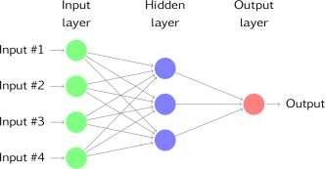

Multiple layers work together to find the best match layer when predicting the image class, and this process is repeated until there is no more room for improvement. Deep learning not only expedites the crucial process but also enhances computer precision and CT image detection and classification effectiveness. The issue of classifying benign and cancerous tissue is discussed in this essay. It is suggested to use the convolution neural network (CNN) and deep neural network, respectively (DNN). The input data, which consists of image data, is quite resilient against deformation. To forecast the image class, numerous layers interact with one another to find the best match layer. This procedure is repeated until there is no more room for improvement. In addition to speeding up the crucial task, deep learning enhances computer accuracy and the performance of CT image detection and classification. This essay considers the issue of classifying benign and malignant growths. Convolution neural networks (CNN) and deep neural networks are suggested for use, respectively (DNN). Strong robustness against distortion exists in the input data (image data).

# 3. SYSTEM ARCHITECTURE

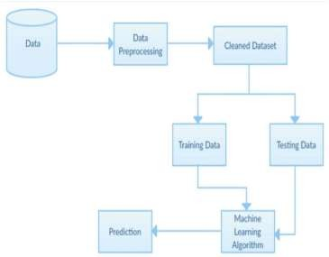

**4. RESULT ANLAYSIS**



Figure : In above screen click on ‘Upload Lung Cancer Dataset ’button to upload CT-SCAN images.



Figure :In above screen selecting and uploading ‘Lung_Image_Dataset ’folder and then click on ‘SelectFolder ’button to load images and to get below screen

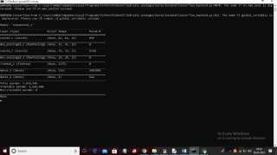

Figure : In above console to train CNN we created multiple layers where first layer process images of size 62 X 62 and second layer process 31 X 31 and goes on and now click on ‘Accuracy & Loss Graph ’ button to get below graph.

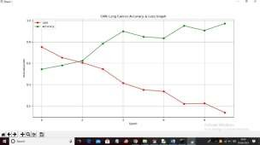

Figure : In above graph x-axis represents Epoch and Y-axis represents accuracy and loss values and in above graph we can see to train CNN we took 10 Epoch and at each increasing Epoch Loss values get decrease and accuracy gets increase and in above graph red line represents loss and green line represents accuracy. Now click on ‘Upload Test Image & Predict Cancer ’button to upload test image and then detect cancer

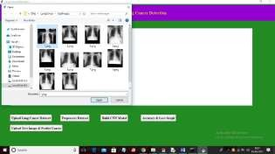

Figure :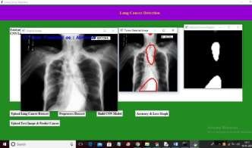 In above screen selecting and uploading ‘1.png ’file and then click on ‘Open ’button to get below result

Figure : In above screen in first image in blue colour text we can see predicted result as CT-SCAN contains abnormality and in second image we are detecting places were abnormality detected and in third image we extracted all abnormality patches from original image and then displaying. Now test other image

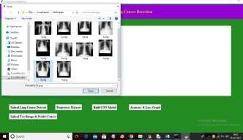

Figure : In above screen selecting and uploading ‘9.png ’file and then click on ‘Open ’button to get below result In above screen CT-SCAN is predicted as NORMAL. Similarly you can upload and test other images

**CONCLUSION**

With 2.09 million new cases and 1.76 million deaths from lung cancer in 2018 [2], lung cancer is the leading cause of cancer death globally. Characteristics for analysing the risk of breast cancer in the near future. Med In the past, a doctor would need to do a number of tests to determine whether a patient had lung cancer or not. However, this was a lengthy procedure. A patient may occasionally be required to undergo pointless examinations or further tests in order to diagnose lung cancer. There needs to be a preliminary test in which both the HealthCare to reduce the process time and unneeded Collaborative Media Service Framework for check-ups. With 2.09 million new cases and 1.76 million fatalities from lung cancer in 2018 alone, it is the leading cause of cancer-related death globally [2]. The characteristics for a short-term examination of breast cancer risk. Med To determine whether a patient has lung cancer or not in the past, the doctor had to do a number of tests. However, the process took a long time. To diagnose lung cancer, a patient may occasionally need to submit to pointless examinations or additional tests. There must be a preliminary test in which both the HealthCare, in order to reduce process time and needless Collaborative Media Service Framework for check-ups.

**References**

[1] Shimazaki, A., Ueda, D., Choppin, A. *et al.* Deep learning-based algorithm for lung cancer detection on chest radiographs using the segmentation method. *Sci Rep* **12**, 727 (2022). https://doi.org/10.1038/s41598-021-04667-w

[2] Bray, F. *et al.* Global cancer statistics 2018: GLOBOCAN estimates of incidence and mortality worldwide for 36 cancers in 185 countries. *CA Cancer J. Clin.* **68**, 394–424. https://doi.org/10.3322/caac.21492 (2018).

[3] DSharma GJindal ‘‘Computer aided diagnosis system for detection of lung cancer in CT scan images International Journal of Computer and Electrical Engineering 3(5): 714-718 2011.

[4] Janarthanan R Balamurali R Annapoorani A and Vimala V 2020 Prediction of rainfall using fuzzy logic Materials Today: Proceedings

[5] DBhatnagar AKTiwari VVijayarajan AKrishnamoorthy ‘‘Classification of normal and abnormal images of lung cancer IOP Conference Series: Materials Science and Engineering Vol 263 2017.

[6] Rendon-Gonzalez, E., & Ponomaryov, V. (2016, June). Automatic Lung nodule segmentation and classification in CT images based on SVM. In 2016 9th International Kharkiv Symposium on Physics and Engineering of Microwaves, Millimeter and Submillimeter Waves (MSMW) (pp. 1- 4). IEEE. DOI: <https://doi.org/10.1109/MSMW.2016.7537995>.

[7] American Cancer Society, Key Statistics for Lung Cancer, 2020, Available from https:/[/www.c](http://www.cancer.org/cancer/lung-)ancer.org/cancer/lung- cancer/about/key- statistics.html.

[8] K. Kuan, M. Ravaut, G. Manek, H. Chen, J. Lin, B. Nazir, C. Chen, T. C. Howe, Z. Zeng, and V. Chandrasekhar, ‘‘Deep learning for lung cancer detection: Tackling the kaggle data science bowl 2017 challenge, ’’2017, arXiv:1705.09435. [Online]. Available: http://arxiv.org/abs/1705.09435