A

STUDY ON FINANCIAL ANALYSIS THROUGH RATIOS WITH REFERENCE TO BDL

AT

BHARAT DYNAMICS LIMITED,KANCHANBAGH,HYDERABAD BY

N.GOWTHAMI 2021BM010011

Semester - 4

Name of the Program-MBA Nme of the Faculty Guide: Dr. Vidya Sagar

Associate professor Date of Submission:



MALLA REDDY UNIVERSITY

Maisammaguda,Dullapally,Hyderabad

2021-2022



**DECLARATION**

The Research Report entitled **“A STUDY ON FINANCIAL ANALYSIS THROUGH RATIOS WITH REFERENCE TO BHARAT DYNAMICS LIMITED”**is record of Bonafide

Work of Ms.N.Gowthami(2021BM010011)submitted in partial fulfillment for the award of Master of Business Administration during the academic year 2021-22.

We also declare that this report is of our own effort and it has not been submitted to any other university for the award of any degree.

N.Gowthami 2021BM010011



**CERTIFICATE**

This is to certify that the Research Report entitled **“A STUDY ON FINANCIAL ANALYSIS THROUGH RATIOS WITH REFERENCE TO BHARAT DYNAMICS LIMITED”** is being

submitted by **Ms.N.Gowthami(2021BM010011)**,in Partial Fulfillment For the award of Master of Business Administration during the academic year 2021-22

## Signature of the Project Guide

**ACKNOWLEDGEMENT**

I would like to place on record the deep sense of gratitude to the honorable Vice Chancellor **Prof.V.S.K.Reddy** Sir, Malla Reddy University for providing the necessary facilities to carry the concluded research work.

I express my gratitude to **Dr.Anjaneyulu, Registrar & Dean, MBA** and **Dr.P.Venkateswara rao SOMC** for providing me the ways and means by which I am able to complete this research work.

My sincere thanks to **Prof Dr. Vidya Sagar,** for outstanding support throughout the research for the successful completion of the work.

Last but not the least, I thank all Teaching and Non-Teaching Staff of our department and especially my classmates and my friends for their support in the completion of my research work.

N.Gowthami 2021BM010011

## TABLE OF CONTENTS

CHAPTER 1:

Introduction to the study Need to the study

Scope of the study Objective to the study Period of the study Methodology of the study Limitations of the study

CHAPTER 2:

Review of literature

Theoretical framework of financial ratio analysis

CHAPTER 3:

Bharat Dynamics Limited profile CHAPTER 4:

Data analysis and Interpretation CHAPTER 5:

Findings Suggestions Conclusions Bibliography

## CHAPTER 1 INTRODUCTION

**INTRODUCTION TO THE STUDY**

RATIO: The term RATIO refers to the mathematical relationship between any two interrelated variables. In other words, it establishes a relationship between two items expressed in quantitative terms.

Ratio analysis is a widely used tool of financial analysis, It is defined as the Systematic use of ratios to interrupt the financial statement so that the strengths and weaknesses of a firm as well as its historical and current financial conditions/ states can be determined.

The financial statements are the best media documenting the results of managerial efforts to the owners of the business, its employees, its Customers and the public at large and thus become excellent tools of the public relation.

The financial analysis is helpful in obtaining the following objectives:

1. Assessing corporate excellence.
2. Judging credit worthiness.
3. Forecasting bond ratings.
4. Predicating bankrupting.

To assess the performance strengths and weaknesses of the company- 5 years financial statements are being analyzed for liquidity, profitability and turnover of assets.

## NEED FOR THE STUDY:

In the modern oriented economy "FINANCE" is the basic foundation of all kinds of economic activities. The success of the company to a grand extent depends on its financial performance. A careful and well planned financial management is needed for raising funds and utilizing them effectively.

## OBJECTIVES OF THE STUDY:

1. To evaluate the financial position of the company by using ratios as a yardstick to measure the efficiency of the company.
2. To analyze profitability position of the company by using ratio analysis
3. To study the liquidity and efficiency position of the company during the study period
4. To offer suitable suggestions for improving financial position of the company

## SCOPE OF THE STUDY:

The study intends to evaluate the financial position of "BHARAT DYNAMICS LIMITED," The areas where the study stressed mainly in the firm's liquidity, financial leverage, operating efficiency and profitability.

The scope of the study is limited to collecting financial data published in the annual report of the company every year. The analysis is done to suggest the possible solutions. The study is carried out for 5years.

However the complete financial analysis can be done through many tools like ratio analysis, funds flow analysis, cash flow analysis, trend analysis horizontal or vertical comparing statements.

The tool i.e., ratio analysis used and which can have limitations and some fields may not be analyzed by this technique. Another aspect is that the data collected is from a secondary source. No primary data is used. The ratio has been calculated on the basis of previous year's data, which need not hold forever.

The firm should generate enough profits not only to meet the expectations of the owner but also expansion activities.

#### RESEARCH METHODOLOGY

**DATA COLLECTION**

The information was gathered from secondary sources like financial statements and annual reports and that to the original report of BHARAT DYNAMICS LIMITED.

#### TOOLS USED:

* Profitability ratios
* Long term solvency
* Activity ratios
* Short term solvency

#### LIMITATIONS OF THE STUDY:

* The study was conducted for 50 days
* It was limited to BDL
* The ratios may not always give accurate results

## CHAPTER 2

REVIEW OF LITERATURE AND RESEARCH DESIGN

## Ratio and Frontier Analysis for Assessing Corporate Performance: Evidence from the Grocery Industry in the UK

This paper considers the use of alternative methodology for assessing corporate performance of sectors within the economy. It is argued that the use of ratio analysis in itself is insufficient for assessing and that more advanced tools like data envelopment analysis should be used to complement ratio analysis. Data envelopment analysis is used in the paper to address a series of issues concerning the measurement of corporate performance, which includes an assessment of sales efficiency, the effects of economies of scale, benchmarking of a firm's performance and the association between industry groups and performance. The paper uses data drawn from the grocery industry in the UK

(Ballantine, Published online: 20 Dec 2017)

**A Review of the Theoretical and Empirical basis of Financial Ratio analysis:**

Moderator's Note: Due to the limited circulation of the Finnish Journal of Business Economics, I decided to classify this paper as substantially unpublished" for the purpose of applying the newsgroup charter. This is an experiment that may or may not be continued as the newsgroup matures. I would appreciate any comments from readers as to whether this kind of interpretation should be considered in the future. Moderator's address: [mailto:arnie@iastate.edu.](mailto:arnie@iastate.edu) This paper provides a critical review of the theoretical and empirical basis of four central areas of financial ratio analysis. The research areas reviewed are the functional form of the financial ratios, distributional characteristics of financial ratios, classification of financial ratios, and the estimation of the internal rate of return from financial statements. It is observed that it is typical of financial ratio analysis research that there are several unexpectedly distinct lines with research traditions of their own. A common feature of all the areas of financial ratio analysis research seems to be that regularities can be observed, they are not necessarily stable across the different ratios, industries, and time periods. This leaves much space for the significant development of a more robust theoretical basis and for further empirical research.

(Martikainen, 1994)

## Bank Performance Analysis: Methodology and Empirical Evidence (Estonian Banking System, 1994-2002)

Banks and other financial institutions are a unique set of business firms whose assets and liabilities, regulatory restrictions, economic functions and operating make them an important subject of research, particularly in the conditions of the emerging financial sectors in the EU accession countries from central and eastern Europe(CEE). Bank's performance monitoring, analysis and control needs special analysis in respect to their operation and performance results from the viewpoint of different audiences like investors/owners regulators, Customers/clients and management themselves .some historical notes on the development of the Estonian banking system and the capital structure of banks are presented in this article .different versions of financial ratio analysis are used for the bank performance analysis using financial statement items as initial data sources. The usage of a modified version of DuPont financial ratio analysis and a novel matrix approach is discussed in the article Empirical results of the Estonian commercial banking system performance analysis are also presented in the article(1994-2002).

(VelloVensel, 1994-2002)

## Portfolio Constraints and the Fundamental Law of Active Management:

Active portfolio management typically co do not allow managers to fully exploit their ability to forecast returns. Constraints on short positions and turnover, for example, are fairly common and materially restrictive. Other constraints, such as market-cap and value/ growth neutrality with respect to the benchmark, or economic sector constraints, can further restrict an active portfolio's composition. We derive ex-ante and ex-post correlation relationships that facilitate constrained portfolio performance analysis. The ex-ante relationship is a generalized version of Grinold's (1989) fundamental law of active management, and provides an important strategic perspective on the potential for active management to add value. The ex-post correlation relationships represent a practical decomposition of performance into the success of the return prediction process and the noise associated with portfolio constraints. We verify the accuracy of these relationships with a Monte-Carlo simulation and illustrate their application with equity portfolio examples based on the S&P 500 benchmark. ducted within constraints that

(Thorley, November 2001)

## The Financial Detective, 1996

This case provides a foundation for student discussion of financial ratios and the insights that may be gained through their use. The case presents textual descriptions of pairs of companies in eight different industries and asks the students to match the text description with the correct financial ratios for each company. Classroom discussion of students attempting to match results and companies reveals the strong influence of both industry and corporate strategy on the

financial results and ratios for firms. A key lesson is that good financial and ratio analysis requires learning about both an industry's and a company's strategy. The case is also a good vehicle for discussing different financial ratios and their meaning.

(Robert F. Bruner, 21 Oct 2008)

## Using the Residual- Income Stock Price Valuation Model to Tech and Learn Ratio Analysis

This article provides an overview of the residual- income stock price valuation model and demonstrates its use in interpreting the DuPont return on equity (ROE) decomposition. The model provides theoretical support for the DuPont model's focus on ROE and aids in understanding the implications of the price-to-book and price-earnings ratios. I conclude with an application of the model in the valuation of Nordstrom, Inc.

(Halsey, 21 Jan 2001)

## Ratio Analysis and Equity Valuation

This paper outlines a financial statement analysis for use in equity valuation. Standard profitability analysis is incorporated, and extended, and is complemented with an analysis of growth. The perspective is one of forecasting payoffs to equities. So financial statement analysis is presented first as a matter of pro forma analysis of the future, with forecasted ratios viewed as building blocks of forecasts of payoffs. The analysis of current financial statements is then seen as a matter of identifying current ratios as predictors of the future ratios that drive equity payoffs. The financial statement analysis is hierarchical, with ratios lower in the ordering identified as finer information about those higher up. To provide historical benchmarks for forecasting, typical values for ratios are documented for the period 1963-1996, along with their cross sectional correlation. And, again with a view to forecasting, the time series behavior of many of the ratios is also described and their typical "long-run, steady state" levels are documented.variation and

(DoronNissim, March 1999)

## Aggregate Return on Investment and Investment Decisions:

**A Cash- Flow Perspective**

The recent notion of Average Internal Rate of Return (AIRR) Magni, 2010, [The Engineering Economist, 55(2), 150-180] completely solves the long- standing problem of the internal rate of

return (IRR). While the AIR is a return measure, this paper presents a cash flow measure, namely the ratio of net cash flow (i.e., cash inflows minus cash outflows) to capital invested, which we call Aggregate Return On Investment (AR0I). It is purely an internal measure because, unlike the AIRR, it does not depend on the market rate, and is a return measure, for it is a mean of

one-period return rates, weighted by the outstanding capitals. The AROI is reliable in both accept/ reject decisions and project ranking, in association with an appropriate hurdle rate, economically significant: the comprehensive cost of capital (CCOc), which takes into account not only the interest foregone on the capital actually employed, but also the interest foregone on the capital that is given up by the investor. This perspective enables one to decompose the project NPV into an excess- rate share and an excess- capital share. The traditional IRR is just a particular case of both AIR and AROI, but the later approach has the advantage that the IRR's nature (rate of return versus rate of cost) does not depend on the market rate and is unambiguously determined by the capital invested.

(Magni, 2011)

## INTRODUCTION TO FINANCIAL STATEMENT ANALYSIS

Financial analysis is also known as "Analysis and Interpretation of Financial Statements" refers to the process of determining financial strengths and weaknesses of the firm by establishing strategic relationships between the terms of the balance sheet, profit and loss account and other operative data.

* + It is a traditional financial statement comprising the balance sheet and profit and loss account regarding financial operation of a firm.
  + A balance sheet reports the firm's assets and liabilities at the appointed time.
  + The profit and loss account presents summary items relating to revenue and expenses of the firm during a particular period of time.

According to Metcalf & Tetrad:-

Analyzing financial statements is the process of evaluating relationships between component parts of a financial statement to obtain better understanding of a firm's position and performance".

Financial statement analysis may be done for a variety of purpose ranging from a simple analysis of short term liquidity position of a firm to a comprehensive assessment of strengths and weaknesses of the firm in various areas.

The financial statement is the best media documenting the results of managerial efforts to the owner of the business- its customers and the public at large and thus becomes excellent tools of the public relation.

* 1. The first task of financial analyst is to select information relevant to decision under consideration from total information in financial statement.
  2. Second step in financial analysis is to arrange information in a way to highlight significant relationships.
  3. Final step is interpretation and drawing of inferences and conclusions.: The financial analysis is helpful in obtaining following objectives:

1. Assessing corporate excellence.
2. Judging credit worthiness.
3. Valuing equity shares.
4. Forecasting bond ratings. 5.Predicting bankrupting and 6.Assessing market risk

## TECHNIQUES/ METHODS AND TOOLS OF FINANCIAL ANALYSIS

Financial analysis is done by using a number of methods or techniques to study the relationship between statements. The methods generally used for this purpose for are:

Comparative financial statement. Common size statement. Trend analysis. .Ratio analysis. . Statement of changes in working capital. Funds flow and cash flow analysis.

## Study methodology/techniques implemented

In my project, I choose to implement the techniques of ratio analysis for financial analysis of BHARAT DYNAMICS LIMITED.

To assess the performance; strengths and weaknesses of the company- four years financial statements are being analyzed for liquidity, profitability and turnover of assets.

The balance sheet and profit and loss account of the company are utilized to complete these ratios for further analysis.

## RATIO ANALYSIS

**Ratio:** A Ratio is an arithmetical relationship between two figures.

According to the Accountant's handbook by Wixon, Kell and Bedford, "A ratio is an expression of the quantitative relationship between two members."

## Ratio Analysis:

Ratio analysis is an important and age-old technique analysis. Financial ratio analysis is the study of ratios of various items or groups of items in financial statements. Ratio analysis is a widely used tool of financial analysis. It is defined as the systematic use of ratios to interpret the financial statement so that the strengths and weaknesses of a firm as well as its historical performance and current financial conditions/ states can be determined.

## Meaning and Scope:

Ratio analysis is a widely used tool of financial analysis. The term RATI10 refers to the representation expressed in mathematical terms between two individuals and a group of figures connected with each other in some logical manner and are selected from financial statements of the concern. A financial ratio helps to express the representation between two accounting figures in such a way that users can draw conclusions about performance, strength and weakness of the firm. A ratio reflecting a quantitative representation helps to form a qualitative judgment.

## Standard of Comparison:

A single ratio doesn't convey such meaning and has to be compared with some standard. Standard of comparison may consist of Past ratios: These ratios are calculated from the past financial statements of the same firm.

* Project ratios**:** These ratios are developed using the projected financial statements of the firm.
* Competitor ratios**:** Ratios of some selected firm, especially the most progressive and successful competitor at the same point of time. Industry ratios: These ratios are of the industry to which the firm belongs

## Modes of expression:

The term ratio refers to the numerical or quantitative relationship between two items or variables. These relationship can be expressed by different modes as:

* 1. **Pure ratio OR Simple ratio**:

It is expressed by the simple division of one number by another E.g.: if the current assets of a business are Rs.20,000 and its current liabilities are 10,000, then the ratio of "current assets to current liabilities" will be 2:1.

* 1. **Rate OR So many times:**

In this type, it is calculated how many times a figure is in comparison to another figure. E.g.: If a firm's credit sales during the year are Rs.30,000 and its debtors at the end of the year 6000, its debtors turnover ratio is 30,000/6000=5times. It shows that the credit sales are 5 times in comparison to debtors.

* 1. **Percentage:**

In this type, the relation between two figures is expressed in hundredths.

E.g.: If a firm's capital is 1,000,000 and its profit is Rs.2,00,000, then the ratio of profit capital, in terms, is 2% of profit.

## Steps in ratio analysis:

* + Selection of relevant data from financial statements according to the objectives for the analysis.
  + Calculation of the appropriate ratio from the selected data.
  + Comparison of the calculated ratios with the previous year ratios of the same firm.
  + Interpretation of the ratios.

### Importance of ratio analysis:

* + Aid to measure general efficiency: Ratios acts as an index of the efficiency of the enterprise. As such, they serve as an instrument of management control.
  + Facilitate decision-making: Provides a meaningful analysis and interpretation of the data contained in the financial statement. Thus, ratio analysis facilitates the managers to make correct decisions.
  + Aid in forecasting and planning: Ratios contribute significantly towards effective planning and forecasting. A study of a trend in the past works as the helpful guide for the future.
  + Aid in intra firm comparison: Ratios facilitates intra firm comparison. They bring out the strengths, weaknesses and efficiency of the firms and their departments.
  + Effective tool: Ratio analysis helps in making effective control of the business by measuring performance. Control of the cost effective control is the key notice of better management. A ratio ensures secrecy.

## Limitations of ratio analysis:

* + Difference in definitions: Ratio analysis suffers from lack of consistency. Ratios are defined directly by various experts and hence,are prone to manipulation.
  + Limitations of Accounting periods: Ratios are based on past data. They cannot be a reliable guide to future performance as the future is dependent on various other factors.
  + Price level changes: Since ratios are computed for historical data no consideration is made to change in price levels and this makes the interpretation of ratios invalid.

## Variation in accounting method:

Ratios may not prove to be ideal tools because two firms may adopt different accounting methods. This makes intra firm corporations meaningless.

Limited use of single ratio: A single ratio doesn't convey a meaningful message. As such a number of ratios will have to be calculated for a better understanding of a particular situation. Thus a series of ratios computed may create confusion instead of revealing meaningful conclusions.

## Advantages of ratio analysis:

* + Estimates about the trends of the business.
  + Study of financial soundness.
  + Helpful in forecasting.
  + Helpful in analysis of financial statements.
  + Helpful in locating the weak spots of the business.
  + Effective control.

## Disadvantages of ratio analysis:

* + False accounting data gives a false ratio.
  + Lack of proper standards.
  + Ratio analysis becomes less effective due to price level changes.
  + Ratios alone are not adequate for proper conclusion.
  + Effect of personal ability and bias of the analyst.

## UTILITY OF RATIO ANALYSIS

* + The ratio analysis is the most powerful tool of financial analysis with the help of ratios on can determine:
  + The ability of the firm to meet its current obligations.

●

* + The extent to which the firm has used its long term solvency by borrowing funds.
  + The efficiency with which the firm is utilizing its assets in generating sales revenue and
  + The overall operating efficiency and performance of the firm.

## Performance Analysis:

A short term creditor will be interested in the current financial position of the firm, while a long term creditor will pay more attention to the solvency of the firm. He will also be interested in the profitability of the firm. The equity shareholders are generally concerned with their return and also about financial conditions only when their earning is depressed.

## Credit Analysis:

In credit analysis, the analyst will usually select a few important ratios. We may use the current ratio or quick ratio to judge a firm's liquidity or debt paying ability; debt equity ratio to determine stake of the owners in business and firm's capacity to survive in the long run and any one of the profitability ratios.

## Security Analysis:

The ratio analysis is also useful in security analysis. The major focus in security analysis is on long term profitability. The detailed analysis of earning power is important for security analysis.

## Competitive Analysis:

The ratios of the firm by themselves don't reveal anything. For meaningful interpretation, the ratios of a firm should be compared with the ratio of similar firms and industry. The comparison will reveal whether the firm is significantly out of line with its competitors. If it is significantly out of line the firm should undertake a detailed analysis to spot out the trouble areas.

## Trend Analysis:

Trend analysis of ratios adds considerable significance to financial analysis because it studies ratios of several years and isolates exceptional instances occurring in one or two periods.

Although trend analysis of a company's ratio is informative, it is more informative to compare the trends in the company's ratios with the trends in the industry ratios.

## Objectives or Purpose of Ratio Analysis:

The nature of analysis will differ depending on the purpose of the analyst. It can be undertaken by the management of the firm, or by parties outside the firm namely owners, creditors, investors and others.

## Trade Creditors:

They are interested in a firm's ability to meet their claims over a very short period of time. Hence their analysis is confined to evaluating the firm's liquidity position.

## Suppliers of Long term Debts:

They are concerned with the firm's long term solvency and survival. They analyze a firm's profitability over time, its ability to generate cash to be able to pay interest and repay principal and representation between various sources of funds.

## Investors:

They are most concerned about the firm's earnings. They are also interested in every aspect of the firm's financial structure to the extent it influences the firm's earnings ability and risk.

## Management:

They would be interested in every aspect of financial analysis. It is their overall responsibility to see that resources of the firm are used most effectively and efficiently and that the firm's financial conditions are sound.

## Government:

Government is interested to know the overall strength of the industry. Government may base its future policies on the basis of industrial information available from various units. In the absence of reliable economic information, governmental plants and policies may not prove successful.

## Cautions in using Ratio Analysis (Limitations):

The ratio analysis is a widely used technique to evaluate financial position and performance of business. But there are certain problems in using ratios. The analyst should be aware of these problems. Some of the limitations of ratio analysis are:-

1 It is difficult to decide on the proper bias of comparison.

1. The comparison is rendered difficult because of the differences in situations of two companies or of one company over years.
2. The price level changes make the interpretations of ratios involved. e ratios calculated at the point of time are less informative and defective as they suffer from short term changes.
3. The ratios calculated at the point of time are less informative and defective as they suffer from short term changes
4. The ratios are generally calculated from past financial statementS and there are no indicators of future.
5. Ratios of a company have meaning only when they are compared with some standards. It is difficult to find out proper basis of comparison. Usually it is recommended that ratios should be compared with industry averages. But industry averages are not easily available.

## Company Differences

:Situations of two companies are never the same. Similarly, the factors influencing the performance of a company in one year may change in another year.

## Price level changes:

The interpretation and comparison of ratios are also rendered invalid by changing the value of money. In fact, price changes over years which affect accounting earnings.

## Changing situations:

Trend analysis helps in analyzing the trends of ratios over years. But the analysis is still to an extent. They don't reveal the changes which have taken place between dates of balance sheets.

## CLASSIFICATIONS OF RATIOS

The use of ratio analysis is not confined to financial managers. These are the various parties that are interested in knowing the position of the concern. Everyone doesn't require all the ratios.

Depending on the parties and their purpose a different set of ratios is required for instance, bankers, goods Suppliers, and short term creditors are interested in knowing the short term financial position of the concern. So, they analyze the liquidity ratio. Various ratios can be classified as follows:

|  |  |  |
| --- | --- | --- |
| **TRADITIONAL CLASSIFICATION** | **FUNCTIONAL CLASSIFICATION** | **SIGNIFICANCE CLASSIFICATION** |
| * Balance sheet ratios | * Liquidity ratios | * Primary ratios |
| * Profit and loss ratios | * Leverage ratios | * Secondary ratios |
| * I nter statement ratios | * Activity ratios |  |
|  | * Profitability ratios |  |

## TRADITIONAL CLASSIFICATION OR STATEMENT RATIOS

|  |  |  |
| --- | --- | --- |
| BALANCE SHEET RATIOS | PROFIT AND LOSS RATIOS | INTER STATEMENT RATIOS |
| * Current ratio | * Gross profit ratio | * Inventory turnover ratio |
| * Liquid ratio | * Operating ratio | * Debtors turnover ratio |
| * Absolute liquidity ratio | * Net profit ratio | * Payable turnover ratio |
| * Debt equity ratio | * Interest coverage ratio | * Return of equity |
| * Proprietary ratio |  | * Return on shareholders funds |
| * Capital gearing ratio |  | * Return on capital employed |
| * Assets proprietary ratio |  | * Working capital turnover ratio |
| * Capital to inventory ratio |  | * Total assets turnover ratio |
| * Working capital ratio |  |  |
| * Ratio of current assets to fixed assets |  |  |

1. **Balance sheet of position statement ratios:**

These ratios deal with the relationship between two balance sheet items, e.g. the ratio of current assets to current liabilities, or the ratio of proprietor's funds to fixed assets. Both the items must, however, pertain to the same balance sheet. The various balance sheet ratios have been named in the chart classifying statement ratios.

## Profit and Loss account or Revenue/ Income statement ratios:

These ratios deal with the relationship between two profit and loss account items, e.g. the ratio of gross profit to sales, or the ratio of net profit to sales. Both items must, however, belong to the same profit and loss account.

## Composite/ mixed ratios of classification according to tests:

These ratios relate to two items in a profit and loss account or an income statement items and balance sheet items, e.g. stock turnover assets to the ratio of total assets to total sales, most commonly used inter statements given in the above chart.

Functional Classification or Classification according to tests

* + .Liquid ratios.
  + Long term solvency and Leverage ratios.
  + .Activity ratios.
  + Profitability ratios.

## Liquid ratios/ short term solvency ratios:

These ratios measure the short term solvency or financial position of the firm. These ratios are calculated to comment upon the short term capacity of the concern or the firm's ability to meet its current obligations.

* + Current ratio.
  + Quick ratio
  + Absolute ratio.

# Long term solvency and Leverage ratios:

Long term solvency ratio conveys a firm's ability to meet the interest cost and repayment schedules of its long term obligations. Leverage ratios show the proportions of debt and equity in financial firms. These ratios measure the contribution of financing by the owner as Compared to financing by outsiders. The leverage ratio can be further classified as

* + Financial leverage
  + Operating leverage.
  + Composite leverage.

Classification of ratios is

* + Debt equity ratio.
  + Proprietary ratio.
  + Fixed assets ratio.
  + Capital gearing ratio.
  + Interest coverage ratio.

## Turnover ratios/ Activity ratios :

Activity ratios are calculated to measure the efficiency with which the resources of a firm have been employed. These ratios are also called TURNOVER RATIOS as they indicate the speed with which assets are being turned over into sales.

* + .Stock/ Inventory turnover ratio
  + . Debtors/ Receivables turnover ratio.
  + .Creditors/ Payable turnover ratio. .
  + Working capital turnover ratio.
  + Fixed assets turnover ratio.

## Profitability ratios:

These ratios measure the results of business operations or overall performance or effectiveness of the firm. Generally two types of profitability ratios are calculated

* + In relation to sales Gross profit ratio.

Net profit ratio.

Operating profit ratio.

Operating expenses ratio.

* + In relation to investments
  + Return on capital employed.
  + Return on net worth.
  + Return on assets.
  + Dividend payout ratio.

## Classification according to Significance

The ratios have also been classified according to their significance or importance. Some ratios are more important than others and the firm may classify them as primary and secondary ratios. The PRIMARY ratio is the one which is of the prime importance to concern. Thus return on capital employed is named as Primary Ratio. The other ratios which support or explain the primary ratio are called SECONDARY ratio, e.g., the relationship of sales to total assets of the firm.

## EXPLANATION OF RATIOS

**Liquidity Ratios Current ratio:**

The current ratio is a liquidity ratio that measures whether or not a firm has enough resources to meet its short-term obligations. It compares a firm's current assets to its current liabilities.

Current ratio = current Assets /current Liabilities

**Quick Ratio:** The quick ratio also known as acid test ratio, measures the firm ability to meet its short term liabilities by having assets that are readily convertible to cash. High ratios are generally preferable.

Quick ratio = Quick Ratio = Quick assets/Current Liabilities

Quick assets = current assets inventory- Prepaid expenses

## Absolute liquid ratio:

This ratio measures the total liquidity available to the company. This ratio only considers marketable securities and cash available to the company. This ratio only tests short-term liquidity in terms of cash, marketable securities, and current investment. Generally, high liquid ratios are preferable.

**Absolute Liquid ratio = cash+ short term securities/ current liabilities.**

## Current cash debt coverage ratio:

The cash flow-to-debt ratio is the ratio of a company's cash flow from operations to its total debt.This ratio is a type of coverage ratio and can be used to determine how long it would take a company to repay its debt if it devoted all of its cash flow to debt repayment.

## Current cash debt coverage ratio = cash flow from operations/ Total debt.

**Profitability Ratios Gross profit ratio:**

Gross profit ratio is a profitability ratio that shows the relationship between gross profit and total net sales revenue. It is a popular tool to evaluate the operational performance of the business.

**Gross profit ratio = gross profit/Net sales *100**

## Net profit ratio:

Net profit ratio is a popular profitability ratio that shows the relationship between net profit after tax and net sales. It is computed by dividing the net profit (after tax) by net sales.

**Net profit ratio = Net profit/Net sales *100**

## Price earnings ratio:

Measures how many times the earnings per share (EPS) has been covered by current market price of an ordinary share

**Price earnings ratio= Market capitalization/ Net income**

## Operating Ratio:

The operating ratio Compares production and administrative expenses to net sales. The ratio reveals the cost per sales dollar of operating a business. A lower operating ratio is a good indicator of operational efficiency.

**Operating ratio= Operating expense/net sales* 100**

## Return on investment:

ROI measures the gain or loss generated on an investment relative to the amount of money invested. ROI is usually expressed as a percentage and is typically used for personal financial decisions, to compare a company's profitability or to compare the efficiency of different investments.

**Return on investment=net income/total assets *100**

## Return on Net worth:

Return on Net worth (RONW), also known as Return on Equity (ROE) is the calculation that reveals how much profit a company generates to their shareholders from the Share Equity.

**Return on net worth= Net income/shareholders equity**

## Return on assets:

The return on assets ratio, often called the return on total assets, is a profitability ratio that measures the net income produced by total assets during a period by comparing net income to the average total assets.

**Return on assets = Net income/average total assets**

## Dividend per share:

Dividend per share (DPS) is the sum of declared dividends issued by a company for every ordinary share outstanding.

**Dividend per share= Annual dividends/no of share**

## Dividend payout ratio:

The dividend payout ratio measures the percentage of net income that Is distributed the shareholders in the form of dividends during the year,

**Dividend payout ratio= Total dividends/net Income**

## Earning yield ratio:

in other words, earnings yield is the annual earnings of a stock, individual company, or market index compared to the price.

**Earning yield ratio=Net income/Market capitalization**

Where, Market capitalization=no of shares *market value of each share

## Dividend Yield ratio:

The dividend yield is a financial ratio that measure the amount of cash dividends distributed to common shareholders relative to the market value per share.

**Dividend yield ratio= Dividend per share/market value per share**

# Turnover Ratios

## Inventory Turnover Ratio:

The inventory turnover ratio is an efficiency ratio that shows how effectively inventory is managed by comparing cost of goods sold with average inventory for a period. This measures how many times average inventory is "turned" or sold during a period.

**Inventory Turnover Ratio=cost of the goods sold/average inventory**

## Debtors Turnover Ratio:

The accounts receivable turnover ratio, also known as the debtor's turnover ratio, is an efficiency ratio that measures how efficiently a company is using its assets. The accounts receivable turnover ratio measures the number of times over a given period that a company collects its average accounts receivable.

**Debtors turnover ratio= net credit sales/average accounts receivable Average collection period= 365/debtors turnover ratio**

## Creditors Turnover Ratio:

Creditor's turnover ratio is also known as Payable Turnover Ratio. It finds out how efficiently the assets are employed by a firm and indicates the average speed with which the payments are made to the trade creditors.

**Creditors Turnover ratio=Net credit Purchases/average accounts Payables Average Payment Period= 365/Creditors turnover ratio**

## Working capital turnover ratio:

The working capital turnover ratio measures how well a company is utilizing its working capital to support a given level of sales. A high turnover ratio indicates that management is being extremely efficient in using a firm's short-term assets and liabilities to support sales and vice versa.

**Working capital turnover ratio=net sales/average working capital**

Where, average working

**capital=opening working capital closing working capital/100**

## Fixed Assets turnover ratio:

The fixed asset turnover ratio is an efficiency ratio that measures a company, return on their investment in property, plant, and equipment by comparing net sales with fixed assets. It calculates how efficiently a company is a making sales with its machines and equipment

**Fixed assets turnover ratio=net sales/average fixed assets**

## Total assets turnover ratio:

The asset turnover ratio is an efficiency ratio that measures a company's ability to generate sales from its assets by comparing net sales with average total assets. This ratio shows how efficiently a company can use its assets to generate sales.

**Total assets turnover ratio=net sales/average total assets**

## Leverage Ratio Debt Equity ratio:

The debt to equity ratio compares a company's total debt to total equity. The debt to equity ratio shows the percentage of company financing that comes from creditors and investors. A lower debt to equity ratio usually implies a more financially stable business. Companies with a higher debt to equity ratio are considered more risky to creditors and investors than companies with a lower ratio.

**Debt equity Ratio = Total Liabilities/Total Equity**

## Times Interest Earned Ratio:

The interest coverage ratio, also known as Interest coverage ratio, is a financial ratio that measures a company's ability to make interest payments on its debt in a timely manner.

A company with a calculation less than 1 can't even pay the interest on its debt. This type of company is beyond risky and probably would never get bank financing. If the coverage equation equals 1, it means the company makes just enough money to pay its interest. If the coverage

measurement is above 1, it means that the company is making more than enough money to pay its interest obligations with some extra earnings leftover to make the principal payments.

## Interest Coverage ratio:

Earnings before interest and tax/Interest expense

## EQUITY RATIO:

The equity ratio also known as, solvency ratio measures the amount of assets that are financed by owners' investments by comparing the total equity in the company to the total assets. In general, higher equity ratios are typically favorable for companies.

**Equity Ratio: Total Equity/Total Assets**

## Fixed assets to equity ratio:

The fixed-asset-to-equity ratio provides a snapshot of how financially strong a company would be if its revenues, for whatever reason, dried up. Companies with a high ratio know that they at least have valuable fixed assets that they can turn into cash if needed.

**Fixed assets to equity ratio= Equity / Total Fixed Assets**

## Current assets to Equity ratio:

Current assets to equity ratio, also known as current assets to proprietors' fund ratio shows the stockholders' funds invested in current assets.

**Current assets to equity ratio=Current assets stockholders equity**

## Capital gearing Ratio:

This ratio is a useful tool to analyze the capital structure of a company.

**Capital gearing ratio Equity / Fixed cost bearings securities**

Where,

**Equity = Equity share capital + Free reserves + Profits and loss account credit balance**

**Fixed cost bearing securities Debentures + Long term loans**

## CHAPTER 3

BHARAT DYNAMICS LIMITED PROFILE

## Introduction

Bharat Dynamics Limited (BDL) is a Government of India Enterprise, which was founded in 1970 in Hyderabad, Telangana., under the Ministry of Defense is a Manufacturer of Surface to Air Missile (SAM), Anti Tank Guided Missile (ATGM), Heavyweight torpedoes, and allied defense equipment. It is headquartered at Hyderabad and it has three manufacturing units at Kanchanbagh, Hyderabad in Telangana State, Bhanur, Medak district in Telangana State and Visakhapatnam in Andhra Pradesh. During the recent years, the company also commenced export of the defense equipment and have entered into strategic alliances with public and private sector companies.

**Some highlights:**

With a pool of engineers drawn from DRDO and aerospace industries, BDL began by producing a first generation anti-tank guided missile, the French SS11B1. This product was a culmination of a license agreement the Government of India entered into with Aerospatiale. BDL has forayed into the field of underwater weapon systems and air-to-air missiles and associated equipment with technology support from DRDO and other players in this domain.

Responding to the Concurrent Engineering Approaches adopted by DRDO in IGMDP, BDL was seen as a reliable and trustworthy ally and resulted in the induction of India's first state-of-

the-art Surface-to-Surface Missile Prithvi.

As a part of expansion plan, BDL is planning to set up 2 more units- one at Amaravathi district of Maharashtra and another one at Ibrahimpatnam in Telangana district.

## Vision

To be a world class enterprise producing international standard quality products for the Defense industry.

## Mission

To establish itself as a leading manufacturer in the aerospace & underwater weapons industry and emerge as a world class sophisticated, State-of-the- art, global enterprise, providing solutions to the security system needs of the country

## Objectives

To become self-reliant and competitive in Guided Missile and Underwater Guided Weapon Technology and Production. To maximize utilization of existing production capacities.JN

## Awards and Achievements

* + RakshaMantri's Award for Excellence in the year 2010.
  + Global HR Excellence Awards 2011-12 has awarded the "Innovative HR practices Award" in the year 2012.
  + RakshaMantri's Award for excellence for indigenization in the year 2013.
  + Green tech Environmental Award silver Award in Engineering sector for outstanding achievement in environment management in the year 2014.
  + Indian Chamber of Commerce PSE EXcellence award for operational Performance Excellence in the year 2015
  + Golden Peacock Management Excellence Award in the year 2015.
  + RakshaMantri's Award for Excellence in the year 2015.
  + GreenTech HR Award for best HR Strategy in the year 2015.
  + Skoch BSE award for Business Excellence in the year 2017.

## Products of BDL

BDL is the leading DPSU in India in manufacturing guided missile systems. The company has a product portfolio consisting of Surface to Air missiles (SAMs), Anti-

Tank Guided Missiles (ATGMs), underwater weapons, launchers, counter measures and test equipment. The company also undertakes life extension and refurbishment of missile systems. Currently, it is the sole supplier of SAMs and ATGMs to the Indian Armed Forces.

## AKASH SAM

The Akash Surface to Air Missile (SAM) is an all weather area defense system which can engage multiple targets simultaneously. The Akash SAM can target helicopters, fighter aircraft and unmanned aerial vehicles. In addition to the Akash SAM, they also supply the ground support system and construct infrastructure facilities for the Akash SAM to their customers.

**Long Range SAM (LR SAM) and Medium Range SAM (MR SAM)**

The SAM is a high response quick reaction vertical launch supersonic missile to neutralise enemy aerial threats such as missiles, aircraft, guided bombs and helicopters.The Milan 2T ATGM

## The Milan 2T ATGM

The milan 2T is a man portable, second generation ATGM with a tandem warhead to destroy tanks. The Milan 2T ATGM can target both moving and stationary targets.

## The Konkurs M ATGM

The Konkurs M ATGM is a second generation, semi-automatic tube launched optically tracked, wire guided and canard controlled missile which has been designed to destroy moving and stationary armored targets. The Konkurs MATGM can be launched from vehicles and ground launchers.

## The INVAR (3 UBK 20) ATGM

The INVAR (3 UBK 20) ATGM is a second generation plus mechanized infantry weapon which can be fired from the gun barrel of a T-90 tank to destroy armored vehicles.

## LightWeight Torpedo

The light weight torpedo can be launched from a ship or a helicopter. The light weight torpedo is used for anti-submarine warfare.

## CMDS

The CMDS is a micro controller chaff and flare based airborne defense system. The CMDS can be activated by the pilot or the radar warning receiver of the aircraft. The CMDS provides protection to the aircraft against radar guided and heat seeking missiles (air and ground) dispensing chaff and/ or flare payloads.

C- 303 Anti Torpedo Decoy Launching System (Anti Torpedo System).

The Anti Torpedo System is meant to counter the threat posed to any Submarine by any active and / or passive homing torpedo

## Exports of BDL

* + CMDS Countermeasures dispensing system
  + Akash Weapon System.
  + LWT-XP(Lightweight Torpedo - export version).
  + Varunastra or Heavy weight Torpedo.
  + Submarine Fired Decoy.

## Board of Directors

* + .**Shri Siddharth Mishra**

-Chairman and Managing Director

Commodore Siddharth Mishra (Retd) has assumed charge today, as the Chairman and Managing Director of Bharat Dynamics Limited (BDL), a Miniratna Category 1 PSU under the Ministry of Defense, Govt. of India. He succeeds Shri V. Udaya Bhaskar who retired on 28 Feb 2019, on attaining superannuation. Commodore Mishra was commissioned in the Electrical Branch of the Indian Navy in 1985. Post-retirement from Navy in Sep 2016, Commodore Mishra served ECIL, a Schedule "A" Central Public Sector Enterprise. Prior to joining BDL, he was General Manager (Defense) at ECIL, Hyderabad.

## Shri Chandraker Bharti

-Joint Secretary (Aero)

Shri Chandraker Bharti was appointed as Government Nominee Director of our Company with effect from February 02, 2021. Shri Chandraker Bharti has more than 22 years of experience in Civil Services. He has held various important assignments, which include Additional Commissioner, Department of Sales Tax, Govt. of NCT of Delhi; Director, Ministry of Commerce & Industry, Govt. of India; Development Commissioner in various Government Departments such as Agriculture, Finance & Planning, Industries & Commerce, Information Technology, etc. in the Union Territory of Pondicherry. He had also served for a short period as Secretary, Health & Family Welfare and Environment & Forest Departments of Government of NCT of Delhi. Shri Chandraker Bharti had joined as Joint Secretary in the Department of Defense Production, Ministry of Defense in April, 2017 and has been entrusted with the responsibility of Aerospace Division. He is also a Government Nominee Director (Part-Time Official Director) on the Board of Hindustan Aeronautics Limited.

### Dr BHVS Narayana Murthy

-Director General (Missiles and Strategic Systems)

Dr BHVS Narayana Murthy, DG (MSS) & Distinguished Scientist was appointed as Government Nominee Director of Our Company. As Director and Programme Director, he spearheaded Research Centre Imarat (RCI), an avionics laboratory of Dr APJ Abdul Kalam Missile Complex steering the design, development and delivery of Avionics and a wide range of missiles & guided

weapon systems. He graduated in Electronics and Communication Engineering from REC, Warangal, completed his M.Tech from JNTU, Hyderabad and received Ph.D in Computer Science from IIIT, Hyderabad. He joined DRDO in the year 1986.Dr Murthy is the Chief Architect of advanced Onboard Computer (OBC) technologies for missile systems and other defense applications. His sustained contributions and technology leadership over the last three decades has been transformative for making India self-reliant in advanced Real Time Embedded Computers, mission computing systems and other avionics technologies.

## Shri Nuka Srinivasulu

-Director (Finance)

Shri Nuka Srinivasulu assumed charge on 01 July 2020 as Director (Finance) of Bharat Dynamics Limited (BDL), a *Miniratna* Category - 1 Public Sector Undertaking under the Ministry of Defence, Govt. of India. A Bachelor in Commerce and an MBA in Finance from Osmania University, Hyderabad, Shri Srinivasulu has a rich experience in various areas of Finance spanning over 30 years, which includes 24 years in BDL. Prior to his new assignment, he has served as General Manager (Finance) at BDL., During his tenure at BDL, he has played an instrumental role in coordinating with anchor investors for the maiden IPO of the Company, implementation of Indian Accounting Standards, Treasury Management, Taxation, Budgetary Control and Policy formulation.

## Shri P.Radhakrishna

-Director (Production)

Shri. P.Radhakrishna has assumed charge on 1 June 2019 as Director (Production) of Bharat Dynamics Limited (BDL). He played a key role in modernizing and establishing state-of-the-art manufacturing facilities to improve the productivity. He actively involved in the preparation, implementation of ISO9001:2008 Quality Management System throughout BDL, Bhanur Unit, which is now operating as aerospace standard AS9100D.He has been nominated as Member of Technical Oversight Committee by the Ministry of Defence for procurement of modular combat management systems for the Indian Navy and preparation of Long Term Orders for Draft Indigenization Policy.

## Shri Sunil Chintaman Mone

-Independent Director

Shri Sunil Chintaman Mone is a Mumbai based practising Chartered Accountant. After passing Bachelor of Commerce degree he cleared his CA exams in the year 1981. Presently he is associated as staff consultant of Asian Development Bank as Senior Financial Management Specialist for projects. He is also associated as Financial Management Specialist with Grant Thornton projects. Prior to this he has rich experience in private sector audits, taxation and was empaneled with SBI for industries loans assessments. He has 22 years experience also with Government sector and has been very active in Finance aspects of CSS schemes, PMGSY, MGNREGS, IWMP, IRRIGATION CORP, ULBs PFMS. Tourism etc.

## Prof. (Dr.) Sanghamitra Mishra

-Independent Director

Prof. (Dr.) Sanghamitra Mishra is working as Additional Dean of Super specialty - DM/MCH program and Head of the department Critical Care Medicine at the Institute of Medical Sciences and Sum hospital, SIKHA ‘O’ Anusandhan University (A Deemed University declared u/s 3 of UGC Act 1956). She is one of the rare faculty having degree from Indian College of Critical Care medicine (Indian Diploma in Critical Care Medicine and Fellowship in Indian College of Critical Care Medicine), Fellowship in Cardiac Anesthesia from Narayan Hrudayalaya, Bengaluru, Certificate Course in Research Methodology from Indian Institute of Public Health, Research University Gandhinagar and Fellowship in 2D ECHO Cardiography (Medvarsity), Curriculum Design Course, NIHFW, New Delhi, in addition to her regular degree of M.D in Anesthesiology. She has 22 years of clinical and administrative experience in both private and public / Govt. health sectors namely MKCG Medical College Berhampur, SCB Medical college Cuttack, Kalinga Hospital Bhubaneswar, Narayan Hrudayalaya, Bengaluru, Sir Ganga Ram Hospital, New Delhi and IMS & SUM Hospital Bhubaneswar. She had been instrumental in starting the DNB program at Kalinga hospital, BBSR. She has immense academic contribution as a faculty to many professional societies like ISA, ISCCM, IMA, ISSP, IACTA & IRC and recipient of many best paper & peer reviewer awards from these societies for her research work. She had significant healthcare contribution in the recent covid pandemic. She has also been associated with “Beti Bachao Beti Padhao” a Govt.of India initiative.

## Shri Rajendra Singh Shekhawat

-Independent Director

Shri Rajendra Singh Shekhawat has degree in B.SC (Science Graduate) and LLB and Retired as Add. Superintendent of Police (Rajasthan Police). He worked as Astt. Commissioner of Police and Addl SP Anti-Corruption Bureau in Rajasthan Police. He has received the President Police Medal, the highest award of the Police Department for Distinguished service awarded by the former President Shri APJ Abdul Kalam.

## Shri Nanda Kumar Subburaman

-Independent Director

Nandakumar Subburaman (Nandu) is the Founder CEO of Perfint Healthcare (P) Ltd, Chennai, India and President of Perfint Healthcare Corporation, USA. Perfint is India's first Medical Robotics company. Perfint’s award winning, patented technology is cleared by USFDA and CE and is installed at over 100 top medical Institutions around the world. Prior to founding Perfint, Nandu served as Director – Process Excellence at Cognizant Technology Solutions (CTSH : NASDAQ) , as COO – Ambit Corporate Finance and VP – Finance, Wipro GE Medical Systems and Manager – Finance, GE Medical Systems, South Asia. He is an alumnus of the Indian Institute of Management, Lucknow, India and of the Government college of Engineering, Tirunelveli, India.

## Dr. Pawan Sthapak

-Independent Director

Dr. Pawan Sthapak has degree in MBBS, DOMS and MS. He is Director in Janjyoti Super Specialty Eye Hospital and Dada Virendra Puri ji eye Institute. He is a National Convenor of Cornea Andhtva Mukt Bharat Abhiyann (CAMBA) and also Executive Council Member of National Institute for the empowerment of the persons with visual disabilities (NIEPVD)GOI. In 2009 he was awarded by Indian Red Cross Society for delivering excellent Medicinal Services.

**Sections of Finance Division In BDL**

Finance division of BDL is operated under following sections: Cash Section

Payroll Section.

Books Section.

Finance Section.

Bills payable Section.

Bills receivable Section.

Internal Audit Section.

Material Accounts and Costing Section. Audit Section.

**CASH SECTION:**

This section is responsible for all receipts and payments of cash/cheques and other instruments; it maintains cash/bank books.

**PAYROLL SECTION:**

This section deals with salaries and wages of executives and non-executives and stipends of trainees and apprentices. This section also deals with bills of daily rated employees (casual workers).

**BILLS PAYABLE SECTION:**

This section deals with payments to suppliers. This section is responsible for Payment & accounting of advances.

Payment & accounting of final bills. Adjustment & recovery of advances.

Deduction/recovery and payment of statutory liabilities.

**BILLS RECEIVABLE SECTION:**

This section is responsible for preparation and submission of invoice to customer. Also, Scrutiny of sales orders.

Preparation of invoices. Reconciliation of customer accounts.

Accounting for sales and receipts thereon.

Accounting of sundry receipts from employers, township, hostels shopping complex, ancillary sheds, canteen etc..,

**COSTING & MATERIAL ACCOUNTING SECTION:**

The main functions of this section include:

Valuation of material consumption and all other types of issues. Maintenance of material transaction ledger (MTL) & cost ledger.

Valuation of In House manufactured components. sQuantity reconciliation of bin card balance with MTL. Analysis of cost variations.

Assisting in decision making based on costs involved. Scrutiny of slow, non-moving redundant inventories.

**FINANCE SECTION:**

The main functions of this section include:

Certification of availability of funds both for capital and revenue expenditure with reference to approved capital budget and performance budget for year.

Fixing of rent for premises given to employees/others.

Fixation of recovery rates in respect of services rendered, supplies made disposal of company assets.

Generally, proposals in respect of following items are concerned in finance sections.

Purpose of capital items/ materials/ stores & spares/ tools and other services. All cases relating to relaxation of rules.

Contracts entered into with suppliers/collaborators/ sub-contractors.

Sale, lease (or) alienation of company property, project report etc.

**INTERNAL AUDIT SECTION:**

The internal audit section has been formed to serve the management in financial and other operations the functions of internal audit are as follows:

Carry out the system study/ review. It involves in-depth examination off various elements, sub systems, procedures etc.,

Compliance audit(procedure, rules & statutory regulations)

Transaction audit. It involves verifying vouchers and attesting correctness of entries in transaction/documents/ vouchers and checking of authority & accounting classification like account head no, work order no. etc.

Physical verification of assets(fixed assets, stores, cash vehicles etc..,

Conduct pre audit checks. It includes final settlements of contractors Supplier, and pay fixation & pay anomaly cases of all employees/ officers

Financial Accounting systems of BDL General Accounts

Cost and Material accounting

Fixed assets and Capital work in process Budgeting.

.

**CHAPTER 4**

DATA ANALYSIS

& INTERPRETATION

## APPLICATION OF RATIO ANALYSIS TO BDL

#### Liquidity Ratios

**Current Ratio**: The current ratio is a liquidity ratio that measures whether or not a firm has enough resources to meet its short-term obligations. It compares a firm's current assets toits current liabilities.

Current ratio = current Assets /current Liabilities

(Rupees in Lakhs)

|  |  |  |  |
| --- | --- | --- | --- |
| **Year** | **Current Assets** | **Current Liabilities** | **Current ratio** |
| 2016-17 | 7,25,583.61 | 5,68,609.10 | 1.28 |
| 2017-18 | 5,31,767.42 | 4,23,199.20 | 1.26 |
| 2018-19 | 4,30,950.05 | 2,91,911.96 | 1.48 |
| 2019-20 | 4,57,397.54 | 2,31,457.62 | 1.98 |
| 2020-21 | 5,96,175.61 | 3,27,700.89 | 1.81 |

Interpretation: If you observe the current ratio of BDL, you can see the raise of current ratio in initial years and decline in later years. Presently BDL is having current ratio of 1.81. It means BDL is having 1.81 rupees of assets for every 1 rupee liability. It has a highest of 1.81 rupees of asset for every 1 rupee of liability. This means BDL is in the position to repay its short term liabilities showing a healthy increasing trend. According to industry standards, it is good to have

1.80 rupees of assets for every rupee of liability. So BDL is having a healthy current ratio as prescribed by Standards.

**Graphical Representation:**

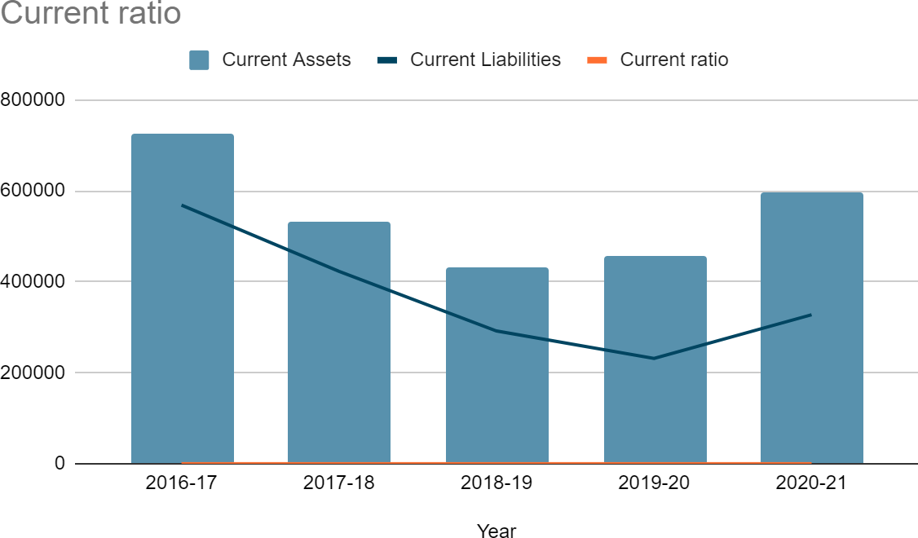

## Quick Ratio:

Quick ratio is also known as acid test ratio. It measures the ability of a company to pay its current liabilities when they come due with only quick assets. The acid test of finance shows how well a company can quickly Convert its assets into cash in order to pay off its current liabilities.

Quick Ratio = Liquid Assets/current liabilities

Liquid assets=Total current assets-Inventory-prepaid expense

|  |  |  |  |
| --- | --- | --- | --- |
| **Year** | **Liquid assets** | **Current Liabilities** | **Current ratio** |
| 2016-17 | 500039.07 | 568609.1 | 0.8794074347 |
| 2017-18 | 332013.52 | 423199.2 | 0.7845324849 |
| 2018-19 | 264496.85 | 291911.96 | 0.9060843208 |
| 2019-20 | 371745.77 | 231457.62 | 1.606107287 |
| 2020-21 | 489899.71 | 327700.89 | 1.494959962 |

**Interpretation:** If you observe the quick ratio of BDL, you can see it decreasing from 0.87 in 2016-17 to 0.78 in 2017-18. From then on, increasing trend is observed, presently it is at 1.61.

According to industry standards the quick ratio should be 1.05. It means the company's Quick ratio is above industry standards in 2020-21. So BDL is having a healthy Quick ratio as prescribed by Standards.

**Graphical Representation:**

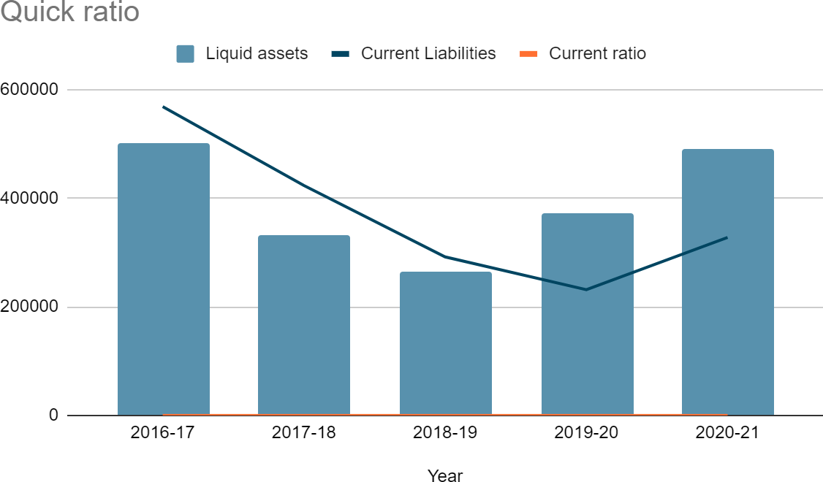

**Profitability Ratios Net profit ratio:**

Net profit ratio is a popular profitability ratio that shows relationship between net profit after tax and net sales. It is computed by dividing the net profit (after tax) by net sales.

Net profit ratio = Net profit/Net sales *100

|  |  |  |  |  |
| --- | --- | --- | --- | --- |
| **Year** | **Net Profit** | **Revenue** | **Net profit margin** | **Net profit margin in percentage** |
| 2016-17 | 52405.56 | 488661.64 | 0.1072430404 | 10.72% |
| 2017-18 | 52815.16 | 455759.75 | 0.1158837743 | 11.59% |
| 2018-19 | 42258.72 | 306934.97 | 0.1376797176 | 13.77% |
| 2019-20 | 53490.08 | 309519.79 | 0.1728163488 | 17.28% |
| 2020-21 | 25776.52 | 200837.31 | 0.1283452761 | 12.83% |

**Interpretation:** If you observe the net profit margin of BDL, you can see the profitability was decreasing from 2015-16 to 2017-18. Consequently, increase is observed from 2018-19 onwards. This implies that though BDL net profit ratio was decreasing initially, it started to increase from 2018-19 indicating BDL is trying to improve its profitability.

**Graphical Representation:**

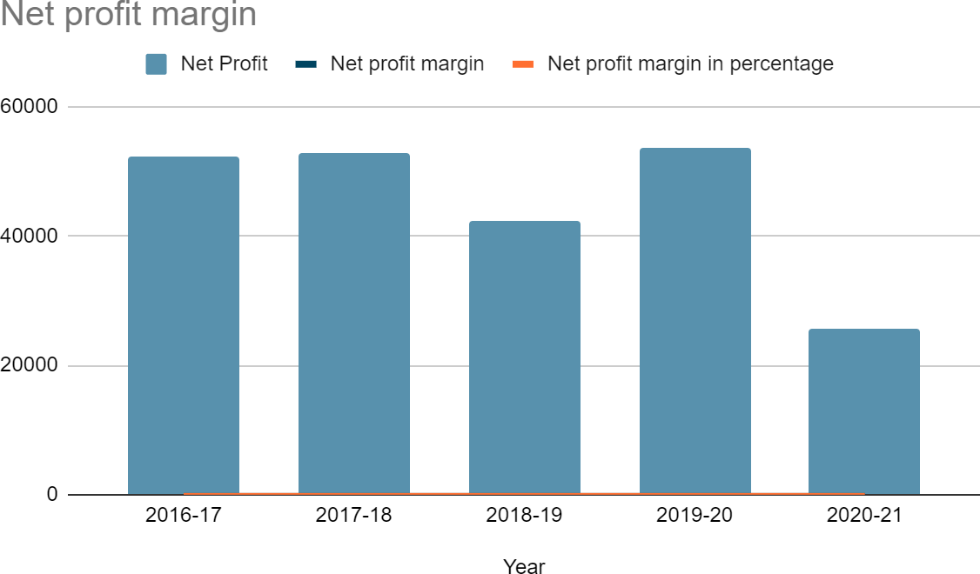

**Return on investment:**

ROI measures the gain or loss generated on an investment relative to the amount of money invested. ROI is usually expressed as a percentage and is typically used for personal financial decisions, to compare a company's profitability or to compare the efficiency of different investments.

Return on investment=net Income/Total assets *100

|  |  |  |  |
| --- | --- | --- | --- |
| **Year** | **Net income** | **Total assets** | **Return on investment** |
| 2016-17 | 52405.56 | 873969.37 | 5.99626964 |
| 2017-18 | 52815.16 | 659837.25 | 8.00427075 |
| 2018-19 | 42258.72 | 546841.88 | 7.727776812 |
| 2019-20 | 53490.08 | 568517.38 | 9.408697409 |
| 2020-21 | 24422.19 | 596175.61 | 4.096475869 |

**Interpretation:** If you observe the Return on Investment of BDL, you can see that it is increasing every year. It increased from 5.76% in 2015-16 to 9.40% in 2019-20. It is observed that company is trying to improve its ROI consistently to meet the industry average which is 15%. So it is advised for the company to choose the investments which gives more returns.

**Graphical Representation:**

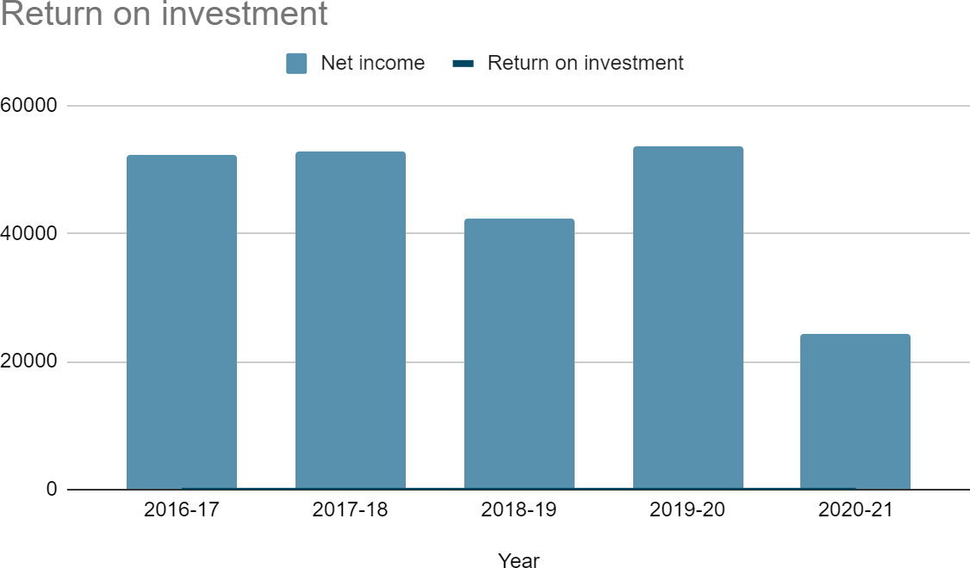

**Return on Net worth:**

Return on Net worth (RONW), also known as Return on Equity (ROE) is the calculation reveals how much profit company, generates to their shareholders from the Share Equity.

Return on net worth= Net income/shareholders equity

|  |  |  |  |
| --- | --- | --- | --- |
| **Year** | **Net income** | **Share holders equity** | **Return on net wort** |
| 2016-17 | 52405.56 | 219497.59 | 0.2387523253 |
| 2017-18 | 52815.16 | 195637.99 | 0.2699637223 |
| 2018-19 | 42258.72 | 226854.6 | 0.1862810805 |
| 2019-20 | 53490.08 | 260682.97 | 0.2051920768 |
| 2020-21 | 24422.19 | 18328.12 | 1.332498369 |

Interpretation: If you observe the Return on net worth of the company, you can see decrease and increase tendency. It was initially increased from 0.24 in 2016-17 to 0.27 in 2017-18 and again decreased to 0.19 in 2018- 19. Similarly, increased to 0.21 in 2019-20 and again recorded an increase to 1.33 in 2019-20. Considering decrease-increase tendency, inconsistency is observed. It is advised to the company to maintain consistency in Return on Networth.

**Graphical Representation:**

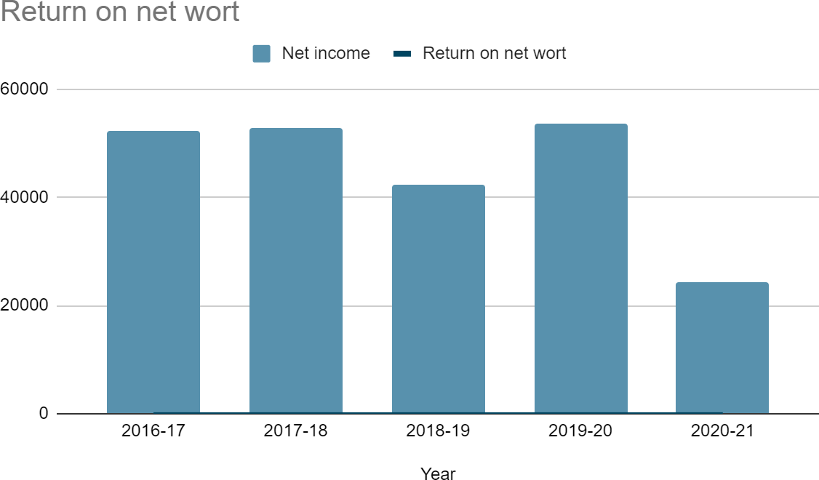

**Return on assets:**

The return on assets ratio, often called the return on total assets, is a profitability ratio that measures the net income produced by total assets during a period by comparing net income to the average total assets.

Return on assets = Net income/average total assets

|  |  |  |  |
| --- | --- | --- | --- |
| **Year** | **Net income** | **Average total assets** | **Return on assets** |
| 2016-17 | 52405.56 | 910969.03 | 0.05752726852 |
| 2017-18 | 52815.16 | 748923.78 | 0.07052140873 |
| 2018-19 | 42258.72 | 603339.56 | 0.07004135449 |
| 2019-20 | 53490.08 | 557679.63 | 0.09591542729 |
| 2020-21 | 24422.19 | 596175.61 | 0.04096475869 |

Interpretation: If you observe the return on assets Ratio of BDL, you see the decrease of ratio from 0.06 in 2016-17 to 0.04 in 2020-21. This indicates that the company has to improve in converting the money used to purchase assets into net income or profits. Decreasing trend indicates the company should try to effectively manage its assets to produce greater amounts of net income. As there is a negative trend in ROA, it also indicates the negative profitability of the company, it means the company should be making a reasonable amount of profit. But it is advised to the company to Increase its Return on assets.

Graphical Representation:

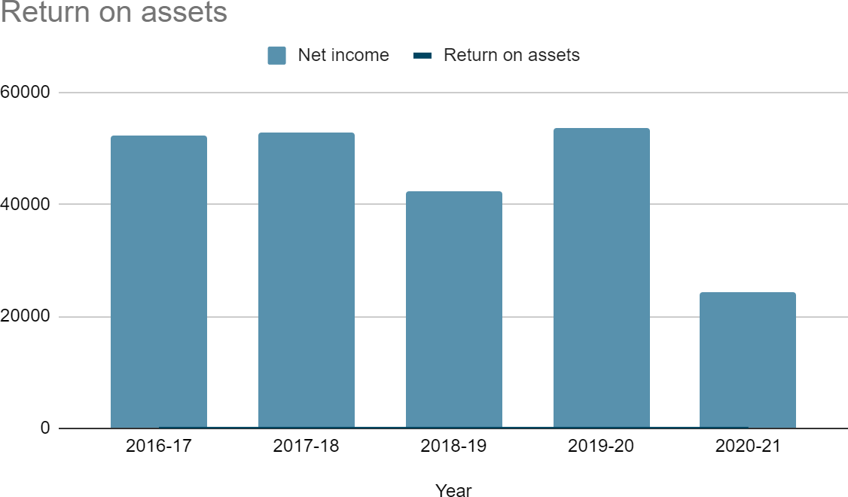

**Dividend Per share:**

Dividend per share (DPS) is the sum of declared dividends issued by a company for every ordinary share outstanding.

Dividend per share= Annual dividends/no of shares

|  |  |  |  |  |
| --- | --- | --- | --- | --- |
| **Year** | **Annual dividend (Rs in Lakhs)** | **No.of shares (in nos)** | **Face Value (In Rupees)** | **Dividend per share (In Rupees)** |
| 2016-17 | 15721.67 | 1221875 | 1000 | 1287 |
| 2017-18 | 15861.2 | 183281250 | 10 | 9 |
| 2018-19 | 12683.07 | 183281250 | 10 | 7 |
| 2019-20 | 16128.75 | 183281250 | 10 | 9 |
| 2020-21 | 17220.8 | 183281250 | 10 | 9 |

**Interpretation:**

Generally Dividend per share tells us how profitable, stable and financial health of a company is over a fiscal period. If you see the dividend per share of BDL, you can see the decrease of dividend per share in 2017-18 compared to 2016-17, which is due to the issue of Bonus shares resulting in an increased number of shares. Till this period its nominal value was 1000 per share. During 2017-18, share split happened and face value of the share became Rs. 10/- per share.. If you see the dividend per share of BDL from 2017-18, dividend per share is around Rs. 9/- per share for Rs.10/- face value share (except in 2018-19)

**Graphical representation:**

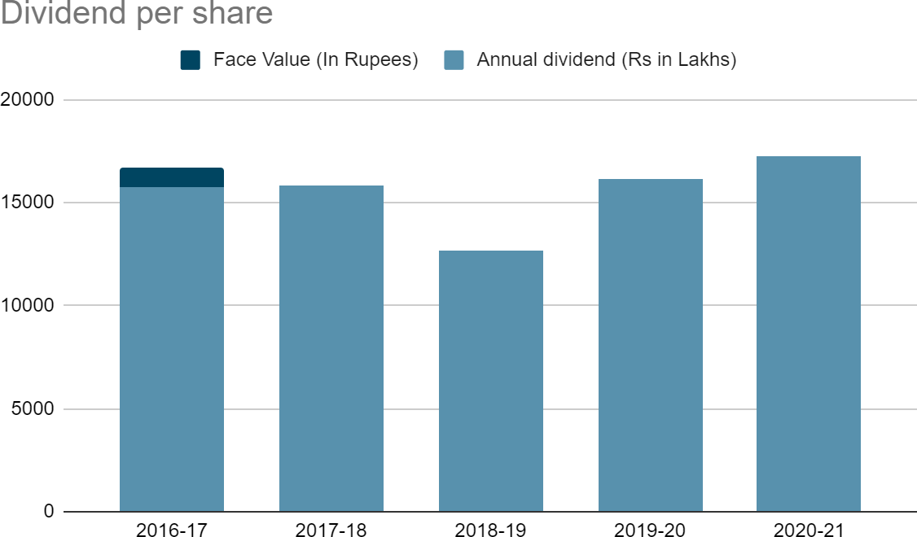

**Dividend payout ratio:**

The dividend payout ratio measures the percentage of net income that is distributed to shareholders in the form of dividends during the year.

Dividend payout ratio=Total dividends/net income

|  |  |  |  |
| --- | --- | --- | --- |
| **Year** | **Annual dividend** | **Net income** | **Dividend pay-out ratio** |
| 2016-17 | 15721.67 | 52405.56 | 30.00000382 |
| 2017-18 | 15861.2 | 52815.16 | 30.03152883 |
| 2018-19 | 12683.07 | 42258.72 | 30.01290621 |
| 2019-20 | 16128.75 | 53490.08 | 30.15278721 |
| 2020-21 | 7328.75 | 24422.19 | 30.00857008 |

**Interpretation:**

Basically dividend payout ratio tells us how a company is using its profits. If a company is paying low dividends, it means it is retaining its profits for future developments/ expansion which may further result in high dividends in future. In the case of BDL, BDL is consistently offering 30% as dividends. This means company is using 70 percent of profits for development and definitely there is a scope for development in future.

**Graphical Representation:**

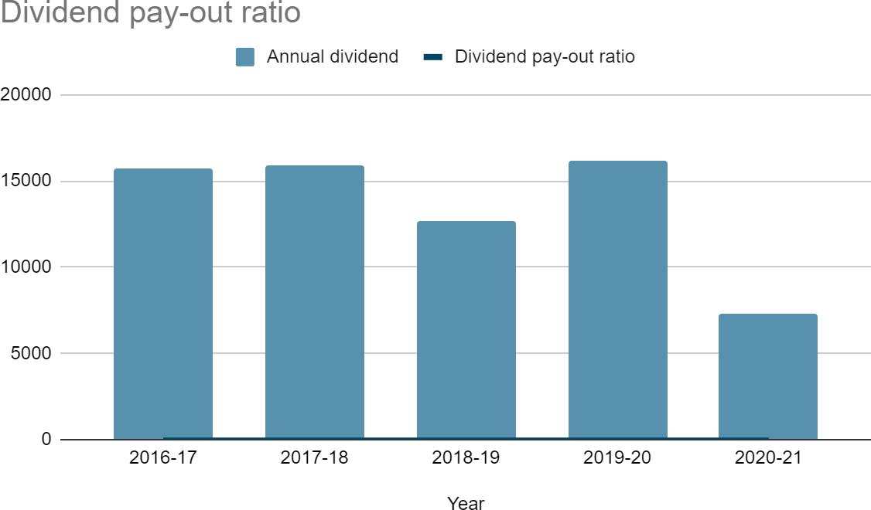

**Turnover Ratios Inventory Turnover Ratio:**

The inventory turnover ratio is an efficiency ratio that shows how effectively inventory is managed by comparing cost of goods sold with average inventory for a period. This measures how many times average inventory is turned" or sold during a period.

Inventory Turnover Ratio=cost of the goods sold/average inventory Where, Cost of goods sold=sales-profit

Average inventory = opening inventory + closing inventory/2

|  |  |  |  |  |
| --- | --- | --- | --- | --- |
| **Year** | **COGS** | **Average Inv** | **Inv turnover ratio** | **No of days need to sell** |
| 2016-17 | 436256.08 | 214883.09 | 2.030202004 | 180 |
| 2017-18 | 405944.19 | 208314.1 | 1.948712017 | 188 |
| 2018-19 | 264676.25 | 179519.92 | 1.474355882 | 248 |
| 2019-20 | 256029.71 | 126052.48 | 2.031135841 | 180 |
| 2020-21 | 264676.25 | 179519.92 | 1.474355882 | 180 |

**Interpretation:**

ITR tells us that how many times a company has sold and replaces its inventory. The present inventory turnover Ratio of BDL is 2.03 times which means the company is selling and replacing

inventory 2.03 times this year i.e, for every 180 days, they are selling and replacing their Inventory. Although ITR kept on increasing the company has not reached the mark of industry average which is 8 times a year. The company being in manufacture of defense equipment, they stock only to the extent of

**Graphical representation:**

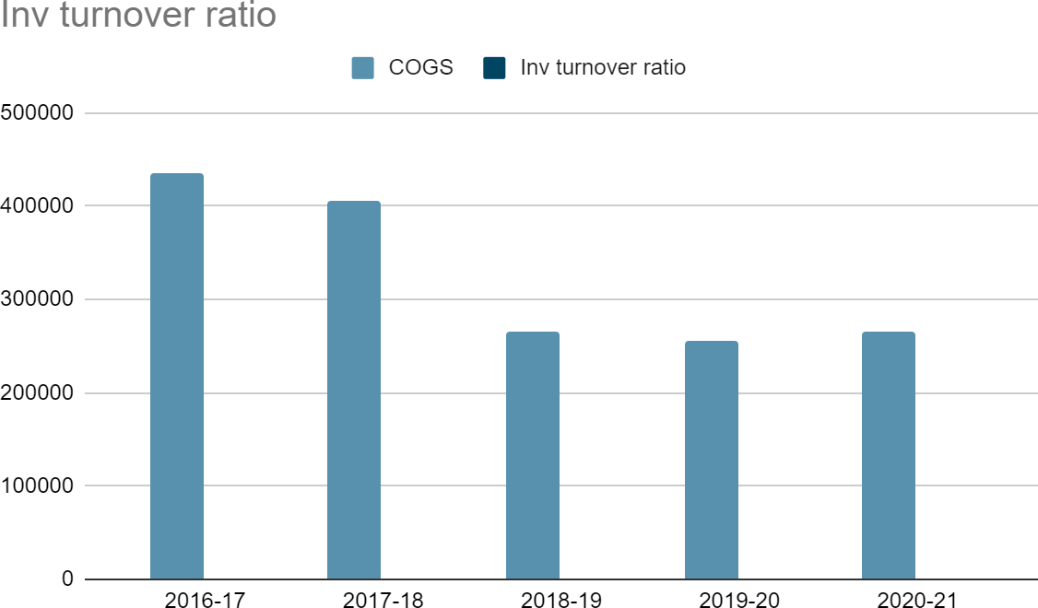

**Debtors Turnover Ratio:**

he accounts receivable turnover ratio, also known as the debtor's turnover ratio, is an efficiency ratio that measures how efficiently a company is using its assets. The accounts receivable turnover ratio measures the number of times over a given period that a company collects its average accounts receivable.

Debtors turnover ratio= net credit sales/average accounts receivable Average collection period= 365/debtors turnover ratio

|  |  |  |  |  |
| --- | --- | --- | --- | --- |
| **Year** | **Net credit sales** | **Average accounts receivable** | **debtors turnover ratio** | **Average collection period** |
| 2016-17 | 416357.64 | 29650.18 | 14.04233094 | 25.99283563 |
| 2017-18 | 488661.64 | 14736.38 | 33.16022252 | 11.00716377 |
| 2018-19 | 458759.95 | 34155.71 | 13.43142772 | 27.17507086 |
| 2019-20 | 306934.97 | 67880.56 | 4.521691777 | 80.72199919 |
| 2020-21 | 309519.79 | 43214.65 | 7.162381044 | 50.96070675 |

**Interpretation:**

If you observe the Debtors turnover ratio, it was 33 times a year in 2016- 17 and decreased to 7 times in 2019-20. Average collection period increased from 11 days to 51 days from FY 2016-17 to FY 2019-20 respectively. This means in 2016-17 for every 11 days the company is collecting the receivables whereas it was collecting receivables for every 51 days in 2019-20. Current

Debtors turnover ratio is 7 times a year. It implies that the receivables collection to be improved. Company should try to maintain industry average of 11 times a year.

**Graphical representation:**

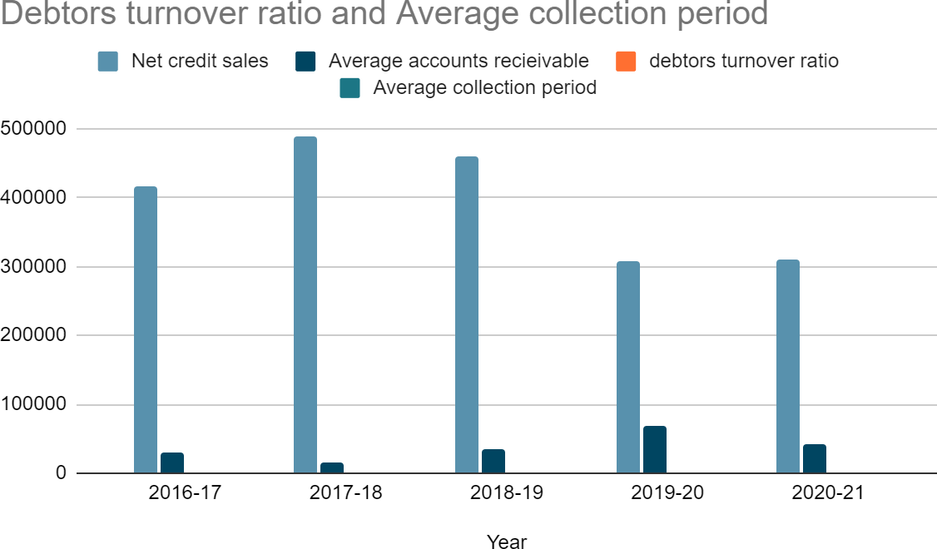

**Working capital turnover ratio:**

The working capital turnover ratio measures how well a company is utilizing its working capital to support a given level of sales. A high turnover ratio indicates that management is being extremely efficient in using a firm's short-term assets and liabilities to support sales and vice versa.

Working capital turnover ratio=net sales/average working capital

Where, average working capital=opening working capital + closing working capital/2

|  |  |  |  |
| --- | --- | --- | --- |
| **Year** | **Net sales** | **Average working capital** | **Working capital turnover ratio** |
| 2016-17 | 416357.64 | 145216.21 | 2.867156773 |
| 2017-18 | 488661.64 | 178334.41 | 2.740142186 |
| 2018-19 | 458759.95 | 132771.37 | 3.455262607 |
| 2019-20 | 306934.97 | 123803.15 | 2.479217774 |
| 2020-21 | 309519.79 | 182489.01 | 1.696100987 |

**Interpretation:**

If you observe the working capital turnover ratio of BDL it was 2.87 times in 2016-17, increased to 3.46 in 2018-19 and again decreased to 1.70 times in 2020-21. It indicates that company has to improve its utilization of working capital to support a given level of sales, though it was increasing in its intermediate years.

**Graphical representation:**

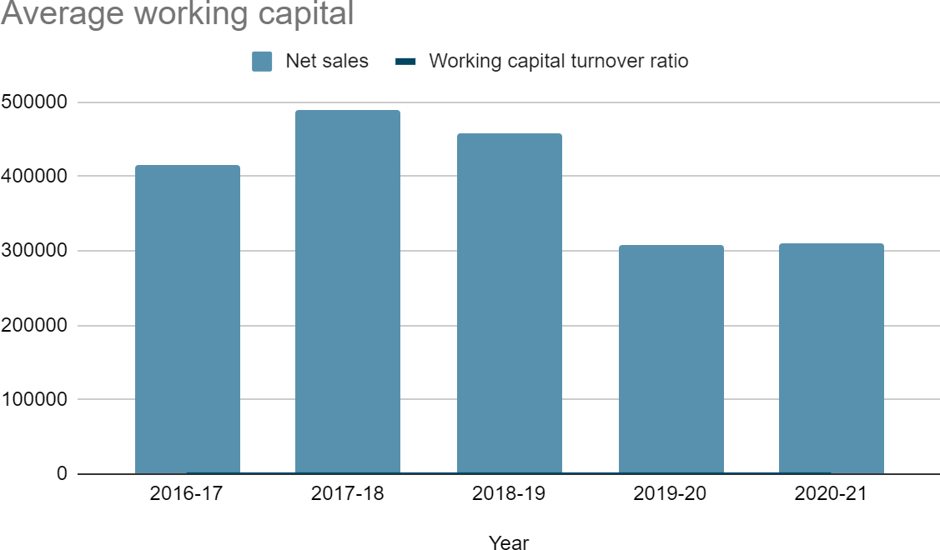

**Fixed Assets turnover ratio:**

The fixed asset turnover ratio is an efficiency ratio that measures a Company, return on their investment in property, plant, and equipment by comparing net sales with fixed assets. It calculates how efficiently a company is a making sale with its machines and equipment.

Fixed assets turnover ratio= net sales/average fixed assets.

|  |  |  |  |
| --- | --- | --- | --- |
| **Year** | **Net sales** | **Average fixed assets** | **Fixed assets turnover ratio** |
| 2016-17 | 416357.64 | 62280.94 | 6.685153435 |
| 2017-18 | 488661.64 | 80124.75 | 6.098760246 |
| 2018-19 | 458759.95 | 94561.05 | 4.851468443 |
| 2019-20 | 306934.97 | 100111.06 | 3.065944662 |
| 2020-21 | 309519.79 | 98921.16 | 3.128954311 |

**Interpretation:**

If you observe the fixed assets turnover ratio of BDL you see that in 2016 - 17 it was 6.69 times and gradually decreased to 3.06 in 2019-20 and again slightly raised to 3.13 times in 2020-21. It indicates that fixed assets are not being utilized efficiently. Ideally it is good to have a fixed assets ratio of 4 and above. So company should try to maintain industry standards to be healthy in this aspect.

**Graphical representation:**

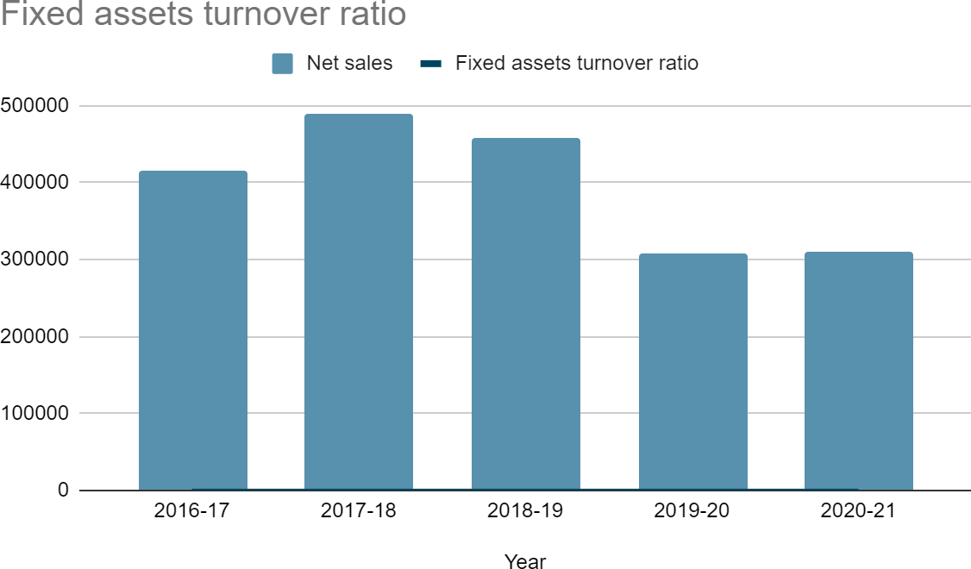

**Total assets turnover ratio:**

The asset turnover ratio is an efficiency ratio that measures a company's ability to generate sales from its assets by comparing net sales with average total assets. This ratio shows how efficiently a company can use its assets to generate sales.

Total assets turnover ratio=net sales/average total assets.

|  |  |  |  |
| --- | --- | --- | --- |
| **Year** | **Net sales** | **Average total assets** | **Total assets turnover ratio** |
| 2016-17 | 416357.64 | 910661.79 | 0.4572033707 |
| 2017-18 | 488661.64 | 901969.03 | 0.5417720828 |
| 2018-19 | 458759.95 | 748923.78 | 0.6125589309 |
| 2019-20 | 306934.97 | 603339.56 | 0.5087267442 |
| 2020-21 | 309519.79 | 557679.63 | 0.5550136196 |

**Interpretation:**

If you observe the total assets turnover ratio of BDL, it increased from 0.46 times in 2016-17 to

0.61 times in 2018-19 and again declined to 0.51 in 2019-20, further raised to 0.55 in 2020-21. This means BDL is generating only 0.55 rupee of sales for every rupee in its assets. This implies that the company has to improve in efficient use of assets to generate sales. The positive trend (slight raise in 2020-21) indicates company's efforts in improving assets turnover ratio.

**Graphical representation:**

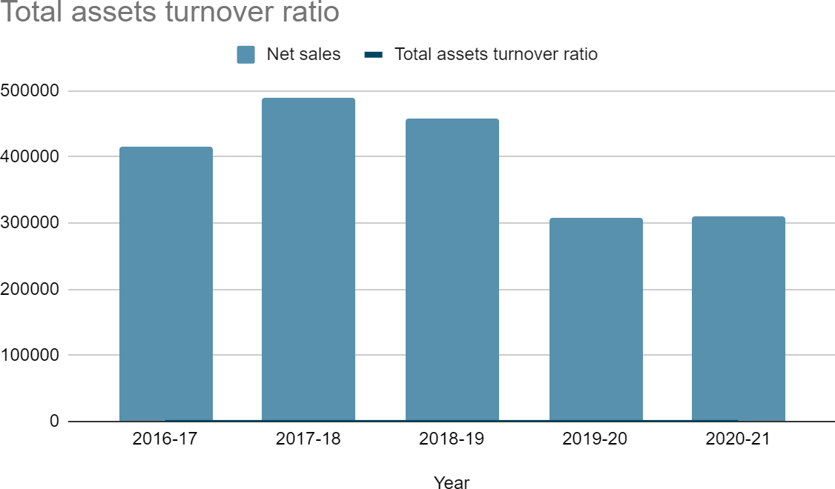

**Leverage ratios:**

**Debt Equity ratio:**

The debt to equity ratio compares a company's total debt to total equity. The debt to equity ratio shows the percentage of company financing that comes from creditors and investors. A lower debt to equity ratio usually implies a more financially stable business. Companies with a higher debt to equity ratio are considered risky to creditors and investors than companies with a lower ratio.

Debt equity Ratio = Total Liabilities/Total Equity

|  |  |  |  |
| --- | --- | --- | --- |
| **Year** | **Total Liabilities** | **Equity** | **Debt equity ratio** |
| 2016-17 | 811977.78 | 165244.68 | 4.91379075 |
| 2017-18 | 680471.78 | 219497.59 | 3.100133263 |
| 2018-19 | 464199.26 | 195637.99 | 2.372746009 |
| 2019-20 | 319987.28 | 226854.6 | 1.410539085 |
| 2020-21 | 307834.41 | 260682.97 | 1.180876564 |

**Interpretation:**

If you observe the debt equity ratio of BDL, it decreased from 4.91 in 2016-17 to 1.18 in

2020-21. It means the company is more financially stable and investors have more funding than creditors and the company is performing well. The company is also financially less risky. So the company is healthy in this aspect.

**Graphical representation:**

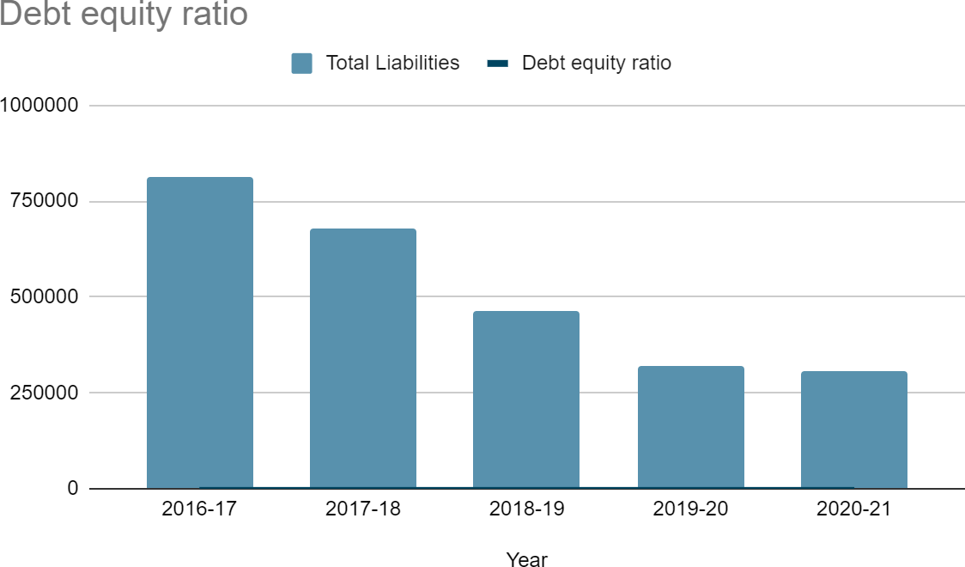

**Fixed assets to equity ratio:**

The fixed-asset-to-equity ratio provides a snapshot of how financially strong a company would be if its revenues, for whatever reason, dried up. Companies with a high ratio know that they at least have valuable fixed assets that they can turn into cash if needed.

Fixed assets to equity ratio= Total fixed assets/Equity

|  |  |  |  |
| --- | --- | --- | --- |
| **Year** | **Fixed assets** | **Equity** | **Fixed assets to equity** |
| 2016-17 | 70948.87 | 165244.68 | 0.4293564549 |
| 2017-18 | 89301.6 | 219497.59 | 0.4068454692 |
| 2018-19 | 99822.43 | 195637.99 | 0.5102405213 |
| 2019-20 | 100399.7 | 226854.6 | 0.4425729079 |
| 2020-21 | 97442.63 | 260682.97 | 0.3737974521 |

**Interpretation:**

If you observe the fixed assets to equity ratio it was 0.43 i.e., 43% in 2016-17 and it increased to

0.51 i.e, 51% in 2017-18. There is almost 8% increase compared to 2016-17. Again decreased to

0.37 in 2020-21. It implies that stockholders' have financed 37% of the fixed assets. The company is said to be healthy if it had maintained a ratio of 60% to 70%. So the company has to improve in this aspect.

**Graphical representation:**

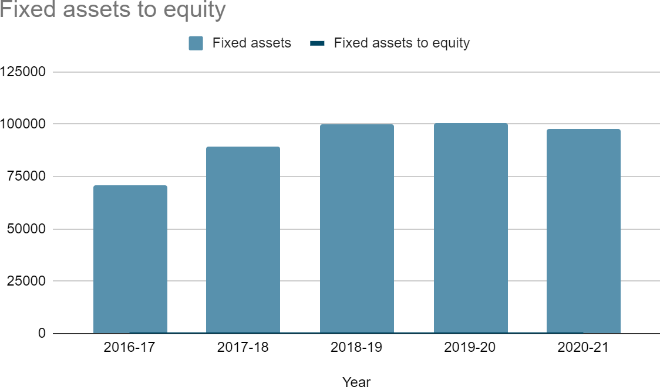

**Current assets to Equity ratio:**

Current assets to equity ratio, also known as current assets to proprietors fund ratio shows the stockholders' funds invested in current assets.

Current assets to equity ratio=Current assets/stockholders equity

|  |  |  |  |
| --- | --- | --- | --- |
| **Year** | **Current assets** | **Equity** | **Fixed assets to equity** |
| 2016-17 | 887731.69 | 165244.68 | 5.372225539 |
| 2017-18 | 568609.1 | 219497.59 | 2.590502702 |
| 2018-19 | 531767.42 | 195637.99 | 2.71811942 |
| 2019-20 | 430950.05 | 226854.6 | 1.899675166 |
| 2020-21 | 457397.54 | 260682.97 | 1.754612279 |

**Interpretation:**

If you observe the current assets to equity ratio you can see it was 5.37 in 2016-17 and decreased to 1.75 in 2020-21. It means stockholders have invested 5.37 times on current assets in 2016-17, invested 1.75 times in Current assets in the year 2020-21.

**Graphical representation:**

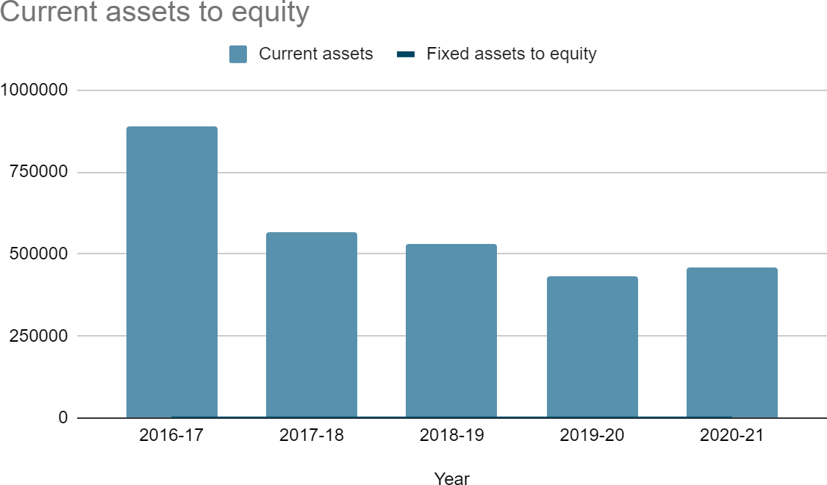

## CHAPTER - 5

FINDINGS, SUGGESTIONS

& CONCLUSIONS

**FINDINGS**

The current ratio of BDL is 1.98 The quick ratio of BDL is 1.61

The Absolute liquid ratio of BDL is 0.09

The inventory turnover ratio of BDL is 2.03 times

Debtors turnover ratio of BDL is 7.16 times, they collect Accounts receivable for every 50 days Working capital turnover ratio of BDL is 1.70 times

Fixed assets turnover ratio of BDL is 3.13 times Total assets turnover ratio of BDL is 0.55

Debt equity ratio of BDL is 1.18

Fixed assets to Equity ratio of BDL is 0.37 Current assets to Equity ratio of BDL is 1.75 Net profit ratio of BDL is 0.17 or 17%

Return on Investment of BDL is 9.40 Return on assets of BDL is 0.09 Return on net worth of BDL is 0.21

Dividend per share of BDL is Rs. 9 (Rs.10/- Face Value) Dividend payout ratio of BDL is 30%

**SUGGESTIONS**

1. The company has to maximize its profits by increasing revenues, taking cost reduction techniques and following economic measures.
2. BDL can increase its turnover by diversifying into manufacture of other defense products.
3. BDL has to improve on in-house research and development activity to deliver new innovative products to the armed forces.
4. Return on investment is fluctuating every year. The company has to make effort in increasing return on investments by reducing its administration, selling and other expenses.

**CONCLUSION**

Based on the study on ratio analysis, it is concluded that BHARAT DYNAMICS LIMITED is one of the well-organized and continuously improving organizations, which is going to have a great future. The liquidity position of the concem, ie., liquid assets like cash, debtors etc, have to be improved through growth in sales.

The long term financial position of the concern can be analyzed by studying the changes in fixed asset ratio, debt equity ratio, debt ratio. An increase in fixed assets should be compared to the increase in long term loans and capital.

It was a great experience in this company. According to my experience, it is well established organization with entire production is undertaken with highest quality standards

Overall what we can conclude is that the company's financial performance is good and satisfactory, they didn't stop but they increased their performance year by year. With the utmost growth we can see the future of the company is very bright.

**BIBLIOGRAPHY:**

Annual reports of BDL

Financial Management by Prasanna Chandra [www.myaccountingcourse.com](http://www.myaccountingcourse.com/) [www.accountingformanagement.org](http://www.accountingformanagement.org/)