“A Study on Employee Retention in X-YUG Technologies”

By

Name Of the Student: A. Durga Bhavani

Roll No.: 2021BM010017

Semester: IV

Name Of the Program: MBA

Name Of the Faculty Guide: Dr. Sandhya

Date Of Submission:



MALLA REDDY UNIVERSITY

Maisammaguda, Dulapally,

Hyderabad-500043, Telangana State

# Declaration

The Research Report entitled “A Study on Employee Retention in X-YUG Technologies” is a record of Bona fide work of A. Durga Bhavani (2021BM010017) submitted in partial fulfilment for the award of Master of Business Administration during the academic year 2021-22.

We also declare that this report is of our own effort and it has not been submitted to any other university for the award of any degree.

A.DurgaBhavani - (2021BM010017)

# Certificate

This is to certify that the Research Report entitled “A Study on Employee Retention in X-YUG Technologies” is being submitted by A. Durga Bhavani (2021BM010017), in partial fulfilment for the award of Master of Business Administration during the academic year 2021-22.

Signature of the Project Guide

ACKNOWLEDGMENT

I would like to place on record the deep sense of gratitude to the honourable Vice Chancellor Prof.V.S.K.Reddy Sir, Malla Reddy University for providing the necessary facilities to carry the concluded research work.

I express my gratitude to Dr.Anjaneyulu, Registrar & Dean, MBA and Dr.P.Venkateswara Rao, HOD, SOMC for providing me the ways and means by which I am able to complete this research work.

My sincere thanks to Dr. Sandhya, for outstanding support throughout the research for the successful completion of the work.

Last but not the least, I thank all Teaching and Non-Teaching Staff of our department and especially my classmates and my friends for their support in the completion of my research work.

A.Durga Bhavani - (2021BM010017 )

TABLE OF CONTENT

|  |  |  |
| --- | --- | --- |
| CH.NO | PARTICULARS | PAGE NO |
| CHAPTER - I | Introduction | 1 to 5 |
|  | Objectives Of the  Study | 5 |
|  | Need Of the Study | 6 |
|  | Focus Of the Study | 6 |
|  | Research  Methodology | 6 |
|  | Limitations Of the  Study | 7 |
| CHAPTER – II | Industry Profile | 8 to 9 |
|  | Company Profile | 10 to 11 |
| CHAPTER -III | Review Of Literature | 12 to 13 |
| CHAPTER -IV | Data Analysis & Interpretation | 14 to 20 |
| CHAPTER - V | Findings | 21 |
|  | Suggestions | 22 |
|  | Recommendation | 23 |
|  | Conclusion | 24 |
|  | Questionnaire | 25 |
|  | Bibliography | 26 |

ABSTRACT

Employee retention is the practice of encouraging employees to stay with the company as long as possible or until the project is completed. Employee retention is beneficial for both employers and employees. Employees are the company's most valuable asset. Employees who are unable to reach their full potential and are not heard and appreciated at work are more likely to leave due to stress and frustration. Employees feel a sense of accomplishment and belonging in a transparent environment, while a healthy work environment gives them a sense of belonging.

This study aims to show how important employee retention is in today's world and what could happen if companies are not aware of the problem and act quickly. if such an action were not taken, what would be the consequences and how it would affect society and the industry.

Employees encounter a variety of issues that present difficulties for HR, including: how to deal with problems and prevent employees from leaving the company

The aim of the research is to find out what is the cause of the problem and the need to meet the employee's expectations. This research also demonstrates retention tactics.

CHAPTER - 1

## INTRODUCTION

Human Resource Management

Human Resource Management (HRM) is a strategic and coherent approach to managing an organization's most valuable asset: the people who work in it and who individually and collectively contribute to the achievement of the company's goals. increase. The terms "human resources management" and "human resources" (HR) have largely replaced the term "human resource management" as a description of the process of guiding people within an organization. Human resource management is evolving rapidly. Human resource management is both an academic theory and a business practice that deals with theoretical and practical methods of human resource management. The human resources management (HRM) function includes a variety of activities, but key to it are the staffing needs that exist and the availability of independent contractors or staff to meet those needs. deciding to hire. Recruit and train the best people to ensure they are performing at their best. Address performance issues. We also ensure that our personnel and management practices comply with various regulations. Activities also include managing employee benefits and compensation, employee records, and approaches to personnel policies.

HRM is seen by practitioners in the field as a more innovative view of workplace management than the traditional approach. Its techniques force the managers of an enterprise to express their goals with specificity – so that they can be understood and undertaken by the workforce – and to provide the resources needed for them to successfully accomplish their assignments. As such, HRM techniques, when properly practiced, are expressive of the goals and operating practices of the enterprise overall. HRM is also seen by many to have a key role in risk reduction within organizations.

There is a long-standing argument about where HR-related functions should be organized into large organizations, e.g., "Should HR be in the organization development department or the other way around?" The HRM function and HRD profession have undergone tremendous change over the past 20 to 30 years. Many years ago, large organizations looked to the "Personnel Department" mostly to manage the paperwork around hiring and paying people. More recently, organizations have begun to consider the "HR Department" as playing a major role in staffing, training, and helping manage people so that the people and the organization are performing at maximum capability in a highly fulfilling manner.

Employee Retention

Employee retention refers to the process of encouraging employees to stick around the company for as long as possible or until the project is finished. Both the company and the employee gain from staff retention. Today's workers are unique. Not them, but others lack access to wonderful possibilities. They move on to the next job as soon as they become unsatisfied with their current employer or position. Employers have a duty to keep their finest workers on staff. They would have no good employees if they didn't. A competent employer should be able to draw in and keep personnel. Retention requires five key components

* Compensation
* Environment
* Growth
* Relationship
* Support

Employee retention would require a lot of efforts, energy, and resources but the results are worth it.

The importance of employee retention

Why is employee retention so important when companies put so much effort into it? Is the sole objective to reduce turnover costs? So the answer is undoubtedly no. The importance of employee retention is emphasized by the cost to the firm as well as the need to prevent talented individuals from being poached. The organization gains from the employee retention process in the following ways:

1. Turnover Costs: The cost of employee turnover adds hundreds of thousands of dollars to a company's costs. Although it is difficult to fully evaluate turnover costs (including recruitment costs, training costs, and lost productivity), industry experts often use a conservative estimate of 25% of an employee's average salary.

2. Loss of company knowledge: When an employee leaves, they leave behind important information about the company, its clients, ongoing projects and its past (and sometimes competitors). Often a lot of time and money has been invested in the employee with the hope of a future return. When the employee leaves, the investment is not returned.

3. Disruption of customer service: Customers and clients choose a business in part because of its employees. Relationships are created that foster ongoing support for the organization. When an employee leaves, the connections they have made with the business are severed, which could lead to a potential loss of customers.

4. Turnover causes more turnover: The impact of an employee's resignation is felt by the entire company. It is often necessary for co-workers to take time off. For the rest of the staff, unspoken criticism often gets worse.

5. Company Reputation: A low attrition rate helps the company maintain its reputation. Increased retention rates motivate potential employees to work for the company.

6. Better efficiency: When employees leave, it takes a long time to find and train successors and often goes unannounced, resulting in a direct loss to the company.

What does an employee do on vacation

Employees do not leave the company without a good reason. There are certain circumstances that make them leave the organization. The most common reasons are:

1. The work does not meet the expectations of the employees: The work may not meet the expectations of the applicant. Unexpected tasks lead to job dissatisfaction. Occupation and person do not match. Candidates may be a good fit for specific job positions that match their personality.

2. Lack of opportunities for growth: A candidate's work and career stagnate when there are no or few opportunities for learning and growth in the current job.

3. Lack of Gratitude: When their work is not appreciated by their bosses, employees are demotivated and lose interest in their work.

4. Lack of confidence and support from colleagues, superiors and management: Confidence is the most important factor one needs to remain employed. Uncooperative colleagues, supervisors and managers can create an unpleasant office environment and make work difficult.

5. Overwork stress and work-life balance: Work-life stress can lead to work-life imbalance, which ultimately leads to employee turnover.

6. Compensation: Better compensation packages offered by other companies can attract employees towards them.

7.New job offer: Attractive job offers which the employee thinks are good for him in terms of job responsibility, remuneration, growth and learning etc. can lead the employee to leave the organization

Employee retention tools

In the current scenario, the world has turned into a global village and the entire planet is reachable from anywhere. In this small world, even companies have access to people and vice versa. So theirs

work is easily available for everyone. In this situation, the biggest challenge for companies is to keep their employees, especially their knowledge banks, intact.

All businesses plan to increase their sales at any time. In all this effort to increase sales, they forget the losses from employee layoffs and the costs of hiring new employees (recruitment costs, training costs, lost productivity, etc.). Hiring a new employee typically costs around 35% or more of the employee's average salary. For example, suppose the average annual salary of employees is Rs 20,000 and the cost of hiring a new employee and other expenses is Rs 7,000. If he lays off 2 employees every month the cost will be Rs 14000 and if he uses the same for 12 months it will be about Rs 168000 which is a direct loss in turnover to the company. After all, there is always a risk of putting the right employee in the right position with the right attitude. When employees leave, a lot of time is lost in hiring and onboarding, which is a direct loss to the company and often goes unnoticed. After that, we cannot guarantee the same level of performance as a new employee (may or may not be better). We need time to evaluate his skills and the way he works.

The loss is even more severe if it is your knowledge base. This can even kill the process. And above all, layoffs often trigger a chain reaction with other employees that has a negative impact. For all these reasons and many more, you need to retain your employees. Retaining employees requires understanding what they need while letting them know what the company expects from them. Since it is a common human tendency to feel that all people are important and expect the same from the other party, managers should hold employees accountable for their respective tasks and facilitate the process to make them feel very important (while creating a backup for him). Care and importance are two things that every human being is obsessed with.

Employee retention strategies:

1. Employee Reward Program: You can recognize top employees monthly or quarterly (depending on your budget) and reward two or three top employees each month. The award can be in the form of gifts or money. These rewards will be taken into account when evaluating performance.

2. Career Development Program: Everyone is worried about their career. We may provide conditional support for certain courses that are beneficial from a business perspective. Conditional support means that the company will cover the costs only if it receives a certain percentage of the total costs. Also, access to these courses should be limited based on the number of tests and places. To be admitted to such a program, we may suggest you sign a commitment to the company, as you cannot leave the company for approximately two years after completing the course.

3. Bonus linked to performance: Employees are constantly learning about the interests of the company, which of course are based on the strategic planning of management and employee productivity. To get more work from your employees, you can offer bonuses. This allows employees to share the company's interests and work together

Primary sources: -

* Questionnaire

Secondary sources: -

* Websites
* HR Books.

Area of study: - The universe of the study is x-yug technologies Hyderabad.

Sample size: - 71 employees

LIMITATIONS OF THE STUDY

* Size of sample is 100 number of responded is 71.
* Since the filling of questionnaire need special attention so may be the employees are less interested in entertaining.
* The information was collected through the questionnaire is subject to willingness of the respondent to respond.

CHAPTER – 2

## INDUSTRY PROFILE

The Information Technology (IT) industry in India has played a key role in putting India on the global map. The IT industry in India is one of the most significant contributors to the growth of the Indian economy. The industry has played a significant role in transforming India's image from a slow-moving bureaucratic economy to a land of innovative entrepreneurs and a global player in providing world-class technology solutions and business services. Industry helped India transform from a rural and agricultural economy to a knowledge-based economy.

Information technology has made it possible to access information at gigabit speeds. It has had a huge impact on the lives of millions of people who are poor, marginalized and live in rural and remote topographies. The Internet has revolutionized the possibilities of e-government measures such as e-health, e-education, e-agriculture, etc. Nowadays, whether it is filing income tax returns or applying for passports online or electronic railway tickets , just a few mouse clicks. India's IT potential is on a constant march towards global competitiveness, improving defense capabilities and addressing energy and environmental challenges, among others.

Following the economic reforms of 1991-92, major fiscal incentives provided by the Government of India and individual state governments were introduced, such as liberalization of foreign trade, removal of customs duties on imports of information technology products, relaxation of controls on inward and outward investment and foreign exchange, establishment of Export Oriented Units (EOU ), Software Technology Parks (STPs) and Special Economic Zones (SEZs), has enabled India to flourish and gain a dominant position in the global IT scenario. In order to mitigate and promote the Indian IT industry, the Government of India has set up a National Task Force on IT and Software Development to examine the feasibility of strengthening the sector. Venture capital is a major source of finance for the software industry worldwide. Norms for venture capital fund operations have also been liberalized in line with international practice to boost the industry.

The software and services industry group consists of companies providing Internet services and companies providing software and IT services. Internet services include companies that provide online databases or interactive services such as search engines or social networks. IT services include companies that provide IT consulting or data processing services to other companies. So software consists of any kind of software that can be used for commercial use such as enterprise software and system software. Examples of companies that provide software and services include Google, eBay, Facebook, Accenture, PayPal, Adobe, Microsoft, and Electronic Arts (EA).

The Indian IT industry will move at a faster pace than ever before towards the new industrial transformation that is Industry 4.0 by keeping up with future technologies through digital transformation. With the emergence of new breakthrough technologies such as artificial intelligence, IoT, blockchain, machine learning, modern data science practices, cloud computing and big data and the introduction and implementation of micro services, developer operations and automation in most industries, the future of the IT industry in India is clear.

1. Most IT companies are virtually debt-free, resulting in excellent financial management.

2. Most of the IT companies have an excellent cash conversion ratio, resulting in high liquidity.

3. Most IT companies have a great return on invested capital.

4. Most IT companies have excellent operating margins, which means growth for companies.

5. Most IT companies have high ROI as well as profitability rate.

THE POWER OF THE IT INDUSTRY:

Strengths can be both external (related to the business environment) and internal to the IT industry (related to their internal processes and management).

1. The increase in the number of Internet and mobile phone users in recent years.

2. Growth in demand for hardware and software products in the Indian market after the outbreak of Covid.

3. Supportive government policy and recent initiatives such as the National Digital Health Mission.

4. Commitment to prevailing quality and cycle execution.

5. Strong brand and long-term connections with customers.

6. Ability to scale innovation and management

## COMPANY PROFILE

X-YUG is part of a diversified three decades old Aztar Group. Est. in 1990, which specializes in Print Media, Tech Application, Insurance Broking, Data Analytics, Ecommerce, Non-Tangible Asset Management, Property Underwriting, Corporate Law Advisory and Activations. It is classified as non-govt company and is registered at Registrar of Companies, Hyderabad. X-yug is growing in the IT industry with better experience in online web applications and designing software.

X-YUG is a project started by Amstar corporation with the purpose of providing complete digital solutions to small and medium enterprise. It is the world’s first and largest initiative in 360o digitalization.

X-YUG is new revolutionary I.T force to transform all range of business into digital bloom. refines business’s needs with combining of I.T innovations & adoptions. Technology-intensive company, provides a wide range of comprehensive suite of solutions comprising of infrastructure, custom software, web application, testing, enterprise architecture consulting. delivers state-of-the-art solutions in various areas including, but not limited to, integrated business solutions, system applications, product development, internet/intranet applications and communication & network management services. it was not only subjected to it sector it involves internet marketing.

X-YUG is also into Digital & Marketing services established digital marketing agency, recognized by major industry review sites and digital market leaders. committed to delivering results-driven B2B & B2C Marketing services that follow with needs and meet market demands.

As a branding firm deeply rooted in multiple industries, helped clients capture marketplace opportunities and establish sustained differentiation through creative, imaginative design, comprehensive brand strategy, and insightful market research is growing in the IT industry with better experience in online web applications and designing software.

Product design (or industrial design) is just a part of the new product development process. In addition to designing, offering prototyping, manufacturing, and marketing new products.

X-YUG has been constantly striving to reach every corner of the world. Through technological innovations and intricately crafted international marketing networks, with ambition to create a world wide web of customer groups, who in turn will make several other clusters of prospective customers across the globe, imbibing a cascading global sales array.

Company’s unique marketing plans are designed to be flexible & adaptive to the prevailing market conditions and give a window of opportunity to all our deserving customers to start up their own business enterprise thus help creating clusters of business hubs all through the Globe. This concept is very innovative and will be a trend setter creating a new benchmark. The philosophy behind x-yug. has been always to make its valuable customers, more self-empowering, more financially independent while sharpening their marketing skills to achieve distant goals.

Vision

To create digitally empowered businesses in concurrence with the digital India program, xyug aims to bring businesses all over India to the digital platforms.

Insight

We use research, analytics, and creativity to gain a clear and deep understanding of unmet needs and opportunities related to brands, customers or markets, to create value for businesses.

Strategy

Brands are living business assets. We build a strategic and creative foundation for the future by clearly defining their purpose, identity, and role. This creates identification, differentiation, loyal customers, and value for businesses.

Technology

Through strategic planning, technology platforms, and internal engagement, we bring a brand experience to market and strengthen internal marketing and brand management capabilities.

Services:

A Marketing Support Service would typically include some or all of the the following elements:

* Marketing & Market Research
* Corporate Identity / Branding development
* Marketing collateral & infrastructure development / re-development
* Marketing Support Hub - design, development, build, operate
* Stationery & Marketing Collateral management - design, print, logistics
* Website portfolio design and development
* Advertising Campaign media planning / buying, creative, delivery & management
* Integrated CRM solution development / re-development
* Creative design (online & offline)
* Digital Marketing services
* Social Media services
* Photography & video services
* Event support
* Press & Public Relations service
* Real time Campaign and Service performance & ROI reporting

## REVIEW OF LITERATURE

The literature clearly shows that there are six keys to retaining staff. They are recruitment, communication, training, job satisfaction, salary and benefits.

The quest to retain the best employees begins with recruitment. Attracting and retaining top talent aren't two different things, they're the same thing. Both need to build and maintain a positive reputation both internally and externally. Employers must be honest with their employees about their beliefs, expectations, culture, needs and opportunities within their organization. By representing the organization realistically, the department will attract people who are comfortable working in that culture (Marx, 1995). Denton (1992, p. 47) goes on to say, ``The better a new employee fits into the organization, the more likely they are to retain them. Working conditions, responsibilities, opportunities, and other details need to be open to reduce the chances Taylor and Cosenza (1997) suggest that companies should show potential employees the true picture of the organization. supports this notion, pointing out that is essential.

The literature clearly points out that if a department wants to increase employee retention, it must start with a robust recruitment process.

Communication: Carney (1998) believes that the key to employee retention is very simple. It's communication, communication, communication. Communication with employees should start early in the relationship. He believes that mining time for new recruits is likely to be less than two weeks for him. Employers need to involve their employees early on by letting them know how important their work is. Lynn (1997) goes on to say that an atmosphere of fairness and openness must be created early on by setting clear company guidelines. Taylor and Consenza (1997) point out the importance of communicating organizational values to employees in order to increase their levels of acceptance, participation, and motivation. Lynn (1997) emphasizes this by pointing out the need to share the organization's vision with employees and the importance they play in meeting their desired and perceived quality of work. It repeats the concept (Taylor & Consenza, 1997). There must be common goals and trust among employees. People want to feel that they are an important part of something bigger (Carney, 1998). As Denton (1992) points out, managers need to make sure their employees understand what they should do and why it matters. Lynn (1997) states that communication need not be one-way to be effective. Employers should listen to their employees.

You need to create an atmosphere where employees feel comfortable suggesting and trying out new ideas. Literature suggests that communication should begin early in the employeremployee relationship. Company values and culture must be clearly articulated to all employees and their importance within the organization continually emphasized.

Training: As already mentioned, it's important for employees to feel like a valued part of the organization. Training helps reinforce this message. Training your staff is one way to show them that you respect them and want them to grow. Departments invest in their employees by providing training (Marx, 1995) It benefits in part by creating a positive work environment and offering employees opportunities for advancement (Lynn, 1997). Lynn goes on to say that training helps build employee loyalty. Training helps keep staff active. For an increasing number of people, the opportunity to acquire new skills has become an important personal goal, both for the career opportunities that education offers and for the opportunity to do something else (Mendonsa, 1998). respect. This leads to increased loyalty and commitment.

Job Satisfaction: As already mentioned, it's important for employees to feel like a valued part of the organization. Training helps reinforce this message. Training your staff is one way to show them that you respect them and want them to grow. Departments invest in their employees by providing training (Marx, 1995) It benefits in part by creating a positive work environment and offering employees opportunities for advancement (Lynn, 1997). Lynn goes on to say that training helps build employee loyalty. Training helps keep staff active. For an increasing number of people, the opportunity to acquire new skills has become an important personal goal, both for the career opportunities that education offers and for the opportunity to do something else (Mendonsa, 1998). respect. This leads to increased loyalty and commitment.

It benefits in part by creating a positive work environment and offering employees opportunities for advancement (Lynn, 1997). Lynn goes on to say that training helps build employee loyalty. Training helps keep staff active. For an increasing number of people, the opportunity to acquire new skills has become an important personal goal, both for the career opportunities that education offers and for the opportunity to do something else (Mendonsa, 1998). respect. This leads to increased loyalty and commitment. While an organization must be competitive in terms of compensation and benefits, it is the relationship with the supervisor that is often a crucial factor in determining whether a person stays or goes (Mendonsa, 1998). Employees want more interaction with management, more self-satisfaction on the job, more responsibility and more control over decisions affecting them. They want their work to make a difference and want to be part of something that matters (Taylor, 1997). Departments should encourage innovation by soliciting the advice and input of their staff members, followed by responses to ideas, complaints or questions (Taylor, 1997). It is difficult to keep people on the job if they have no say in how to do it (Spragins, 1992). People need to be recognized for their accomplishments in the workplace. In most organizations the feeling of under-recognition is the most pervasive feeling in the workplace (Mendonsa, 1998). Provide a great deal of personal and team recognition (Carney, 1998). Recognize achievements with memos, mentions in staff meetings or articles in the newspapers (Lynn, 1997).

one of the proven methods of employee retention. Promoting from within shows that there is truly room for advancement and growth within the department. Employee involvement, recognition, importance of work, and career advancement opportunities are all important, when dealing with employee retention

## ANALYSIS AND INTERPRETATION

1.The job you are performing is satisfactory.

Interpretation:

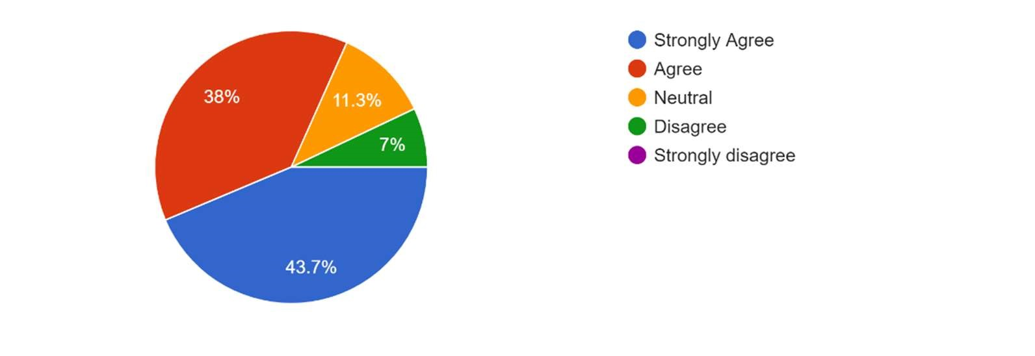

|  |  |  |  |  |
| --- | --- | --- | --- | --- |
| Strongly agree | Agree | Neutral | Disagree | Strongly disagree |
| 43.7 | 38 | 11.3 | 7 | - |

In the above given data around 44% of the surveyed employees strongly agree that the employees are satisfied with the job but 7% employees are not satisfied with the job.

1. Employee participation in management is encouraged here.

Interpretation:

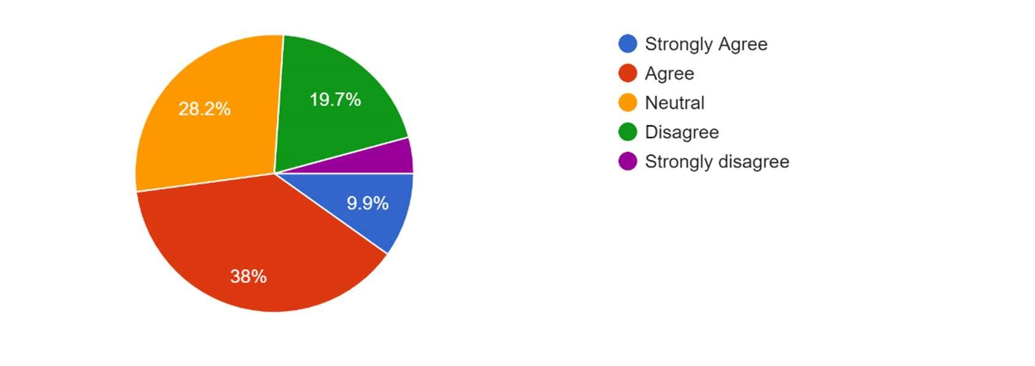

|  |  |  |  |  |
| --- | --- | --- | --- | --- |
| Strongly agree | Agree | Neutral | Disagree | Strongly disagree |
| 9.9 | 38 | 28.2 | 19.7 | 4.2 |

In the above given data around 38% of the surveyed employees agree that the management is encourages employees,28% employees are neutral but 19.7% are disagreed for the statement regarding encouragement of management.

1. Do you feel recognized as an individual.

|  |  |  |  |  |
| --- | --- | --- | --- | --- |
| Strongly agree | Agree | Neutral | Disagree | Strongly disagree |
| 4 | 49.3 | 22.5 | 19.7 | 4.5 |

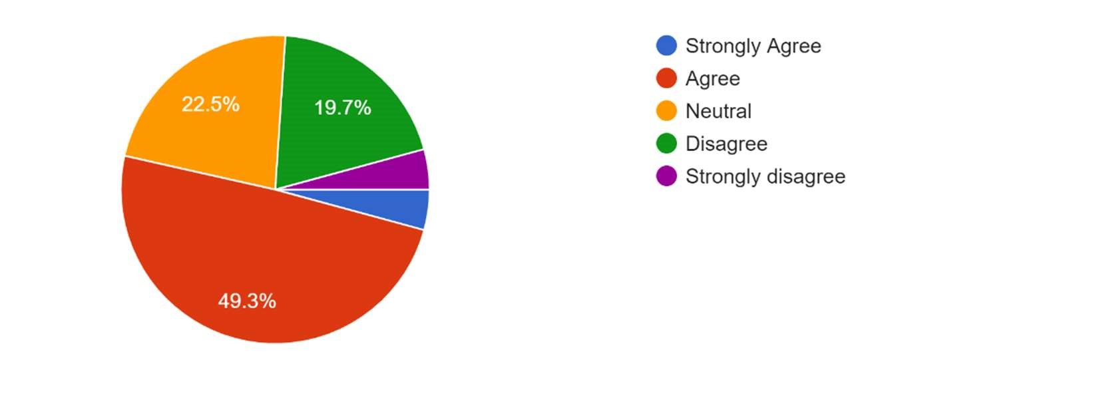Interpretation:

In the above given data around 50% of the surveyed employees agree that they are recognized but 20% employees are feeling they are not recognized.

1. Your management comes forward when you are facing with critical situation.

Interpretation:

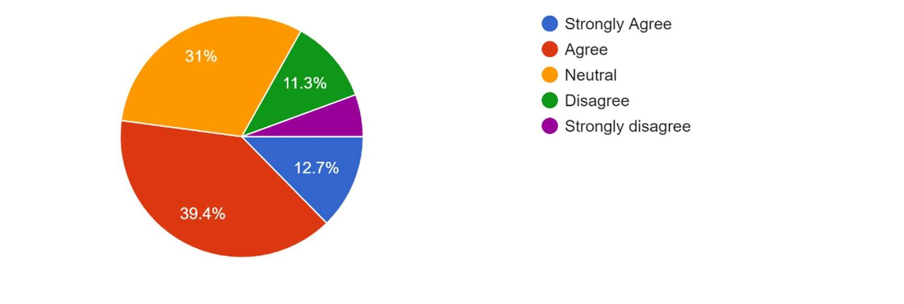

|  |  |  |  |  |
| --- | --- | --- | --- | --- |
| Strongly agree | Agree | Neutral | Disagree | Strongly disagree |
| 12.7 | 39.4 | 31 | 11.3 | 5.6 |

In the above given data around 40% of the surveyed employees agree that the management take care of the problems but 12% employees are not satisfied with the way management handle their problems.31% employee are neutral.

5.Employee work loads are distributed fairly.

Interpretation:

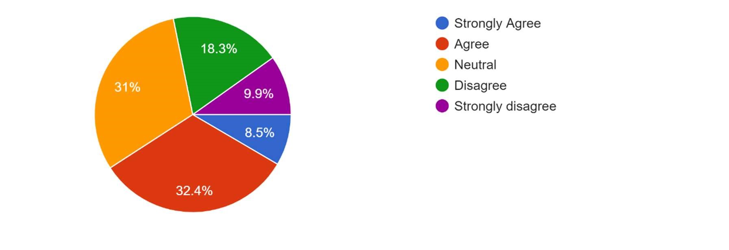

|  |  |  |  |  |
| --- | --- | --- | --- | --- |
| Strongly agree | Agree | Neutral | Disagree | Strongly disagree |
| 8.5 | 32.4 | 31 | 18.3 | 9.9 |

In the above given data around 32% of the surveyed employees agree that the management distribute work load equally, but 18% employees are feeling work not assigned equally.

6.Your organization conducts training programs often.

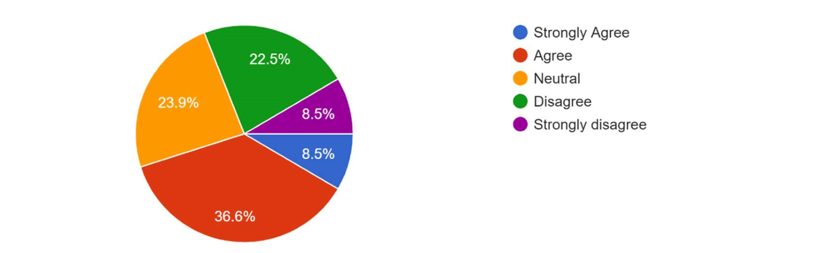

Interpretation:

Interpretation:

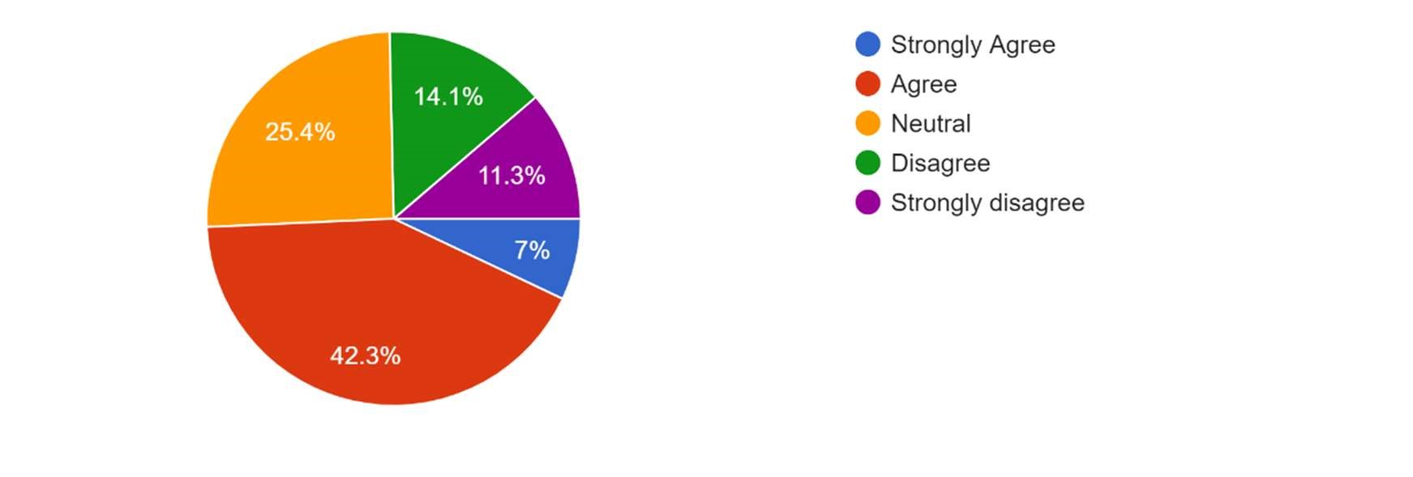

|  |  |  |  |  |
| --- | --- | --- | --- | --- |
| Strongly agree | Agree | Neutral | Disagree | Strongly disagree |
| 7 | 42.3 | 25.4 | 14.1 | 11.3 |

In the above given data around 42% of the surveyed employees agree that the management providing on time training for employees but 14% employees feels training was not often.

1. Do you agree that you are rewarded periodically for your performance.

|  |  |  |  |  |
| --- | --- | --- | --- | --- |
| Strongly agree | Agree | Neutral | Disagree | Strongly disagree |
| 8.5 | 36.6 | 23.9 | 22.5 | 8.5 |

In the above given data around 37% of the surveyed employees agree that the management rewarding employee regularly but 23% employees are feeling they are not rewarded reguraly.

1. Work-life balance is supported by this organization.

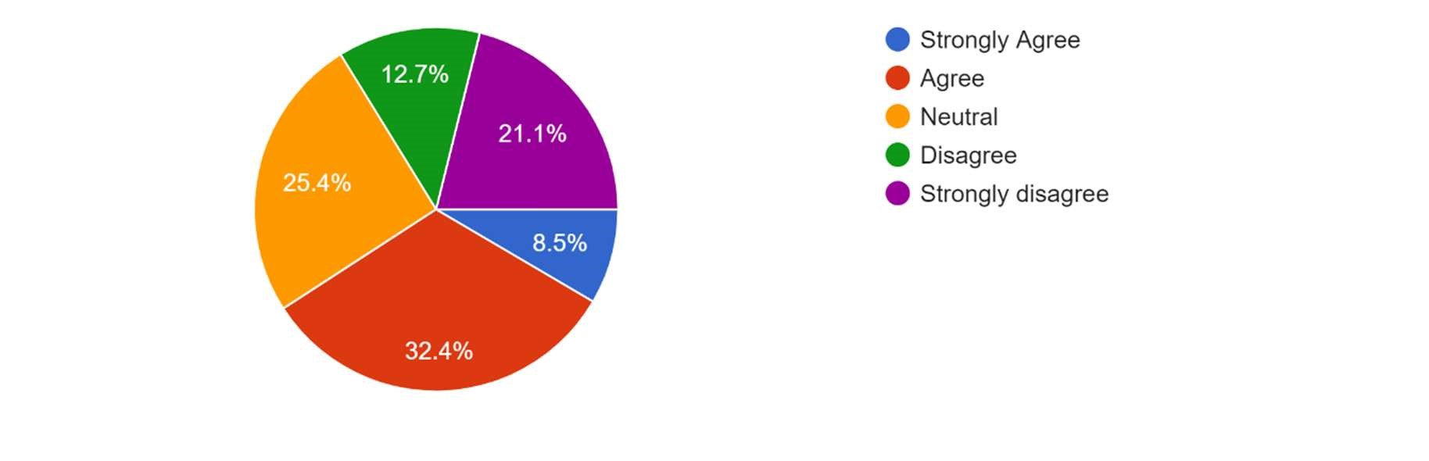

Interpretation:

|  |  |  |  |  |
| --- | --- | --- | --- | --- |
| Strongly agree | Agree | Neutral | Disagree | Strongly disagree |
| 8.5 | 32.4 | 25.4 | 12.7 | 21.1 |

In the above given data around 32% of the surveyed employees agree that the management balancing employees personal and work but 21% employees are strongly disagreed for the question.

1. You are satisfied with your existing pay structure.

Interpretation:

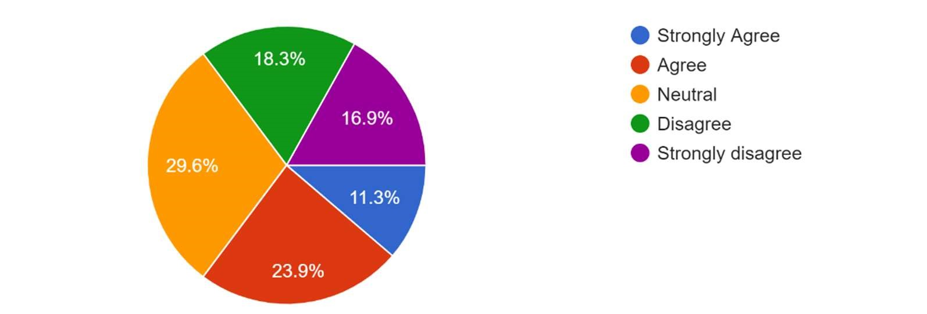

|  |  |  |  |  |
| --- | --- | --- | --- | --- |
| Strongly agree | Agree | Neutral | Disagree | Strongly disagree |
| 11.3 | 23.9 | 29.6 | 18.3 | 16.9 |

In the above given data around 30% of the surveyed employees are neutral about they pay structure but 18% employees are not satisfied with the pay structure.

1. There are no barriers of communication while you are communicating with your supervisor.

|  |  |  |  |  |
| --- | --- | --- | --- | --- |
| Strongly agree | Agree | Neutral | Disagree | Strongly disagree |
| 7 | 32.4 | 28.2 | 16.9 | 15.5 |

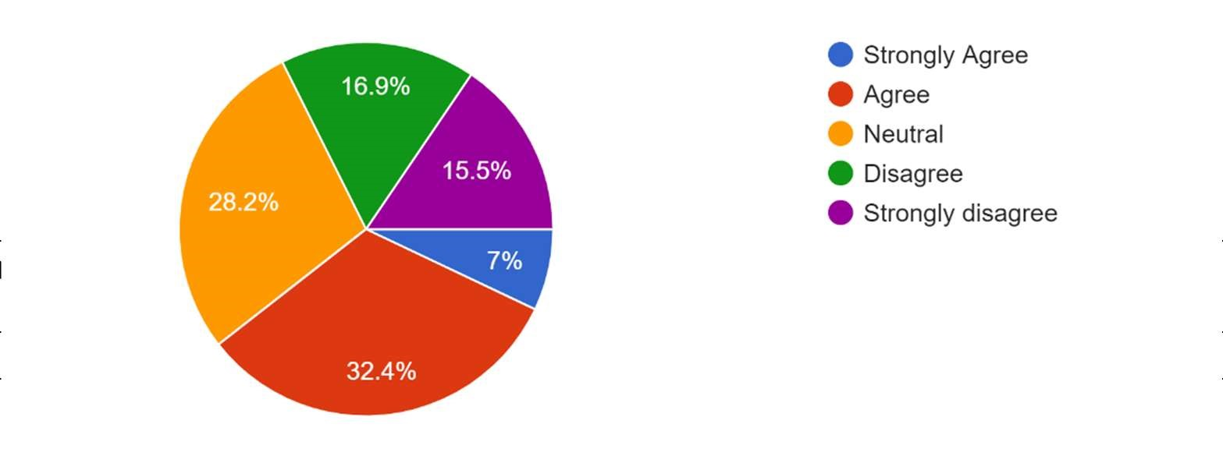Interpretation:

In the above given data around 32% of the surveyed employees agree that there are no barriers for communication but 17% employees are feeling there are some barriers.

1. Better infrastructure amenities are available in this organization to do your job well.

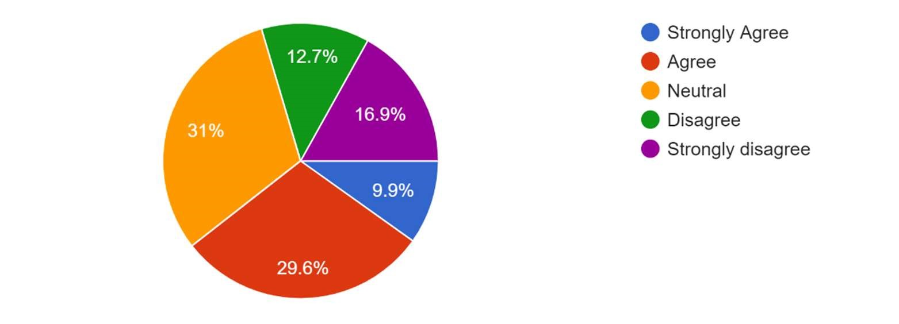

Interpretation:

|  |  |  |  |  |
| --- | --- | --- | --- | --- |
| Strongly agree | Agree | Neutral | Disagree | Strongly disagree |
| 9.9 | 29.6 | 31 | 12.7 | 16.9 |

In the above given data around 30% of the surveyed employees agree that the infrastructure is good but 17% employees are strongly disagree.

1. Employee retention helps the development of organization.

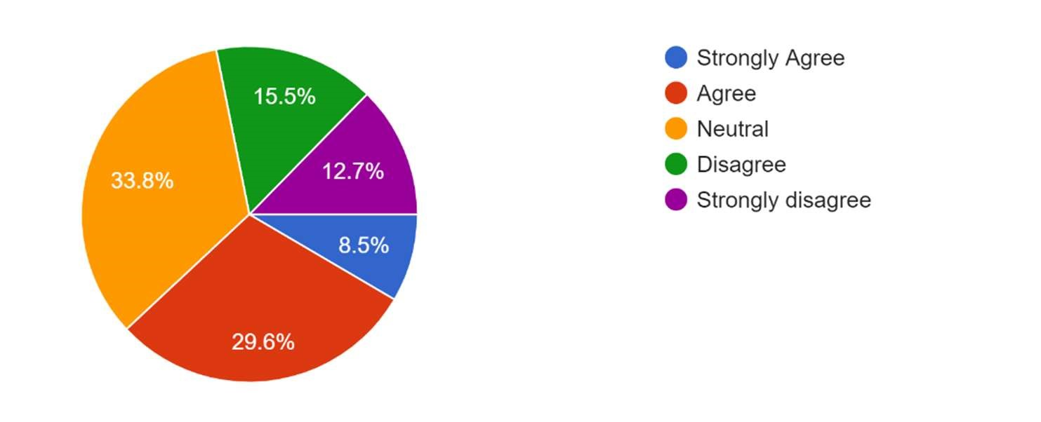Interpretation:

In the above given data around 34% of the surveyed employees neutral about

|  |  |  |  |  |
| --- | --- | --- | --- | --- |
| Strongly agree | Agree | Neutral | Disagree | Strongly disagree |
| 8.5 | 29.6 | 33.8 | 15.5 | 12.7 |

retention leads to organisation development but 15% employees are feeling retention is important for development.

1. Implementation of three R’s recognition, reward, respect increase employee retention.

Interpretation:

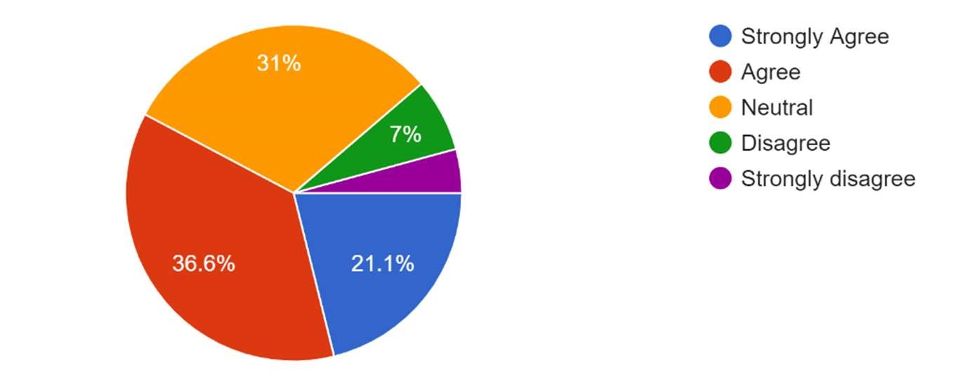

|  |  |  |  |  |
| --- | --- | --- | --- | --- |
| Strongly agree | Agree | Neutral | Disagree | Strongly disagree |
| 21.1 | 36.6 | 31 | 7 | 4.3 |

In the above given data around 37% of the surveyed employees agree that the 3R’s are important for organization development but 7% employees disagrees.

1. conducts performance evaluation for all field employees on a regular basis.

Interpretation:

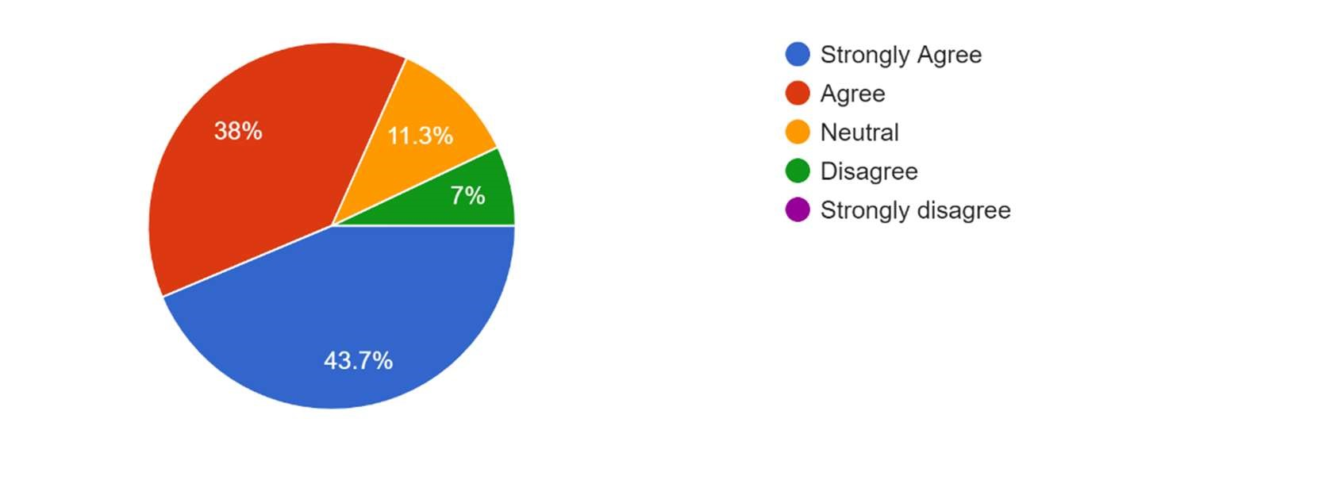

|  |  |  |  |  |
| --- | --- | --- | --- | --- |
| Strongly agree | Agree | Neutral | Disagree | Strongly disagree |
| 43.7 | 38 | 11.3 | 7 | - |

In the above given data around 44% of the surveyed employees strongly agree that the management performing evaluation regularly but 7% employees disagree.

## FINDINGS

* Most of the employees are satisfied with the job they are performing.
* Only 38% employees are felt that they are encouraged by the management. Rest are confused.
* 50% employees are recognized by the management.
* Only 40% employee feel that management helps in case of any problem occurred. Rest are not sure about the involvement of management.
* Most of the employees are felt that work has been distributing equally.
* 42% employee are agreed that training has been conducted timely. rest are confused.
* Very less number of employees feel that they are recognized which is very important for employee retention.
* 21% disagree that their work life is balanced with personal life.
* 30% are satisfied with pay structure. Rest are confused.
* Regarding the environment for work half of the employees feel good but the other half are confused
* 40% employee are agreed that 3R’s are important for retention in an organization. Rest are not sure.
* Most of the employees feel that there are barriers for communication with top management.

RECOMMENDATIONS

• Management must focus on the training program as it must be linked to career development.

• The right employee should be employed in the right position so that he feels motivated and can work more efficiently.

• Management should redefine the salary structure of its employees.

• The HR manager ensures that the work is distributed more fairly.

• Management should provide better infrastructure to its employees to perform their work well.

• Management should assist employees in balancing their work life.

## CONCLUSION

Retention is an important concept that has received considerable attention from academics, researchers and practicing HR managers. The organization has the potential to benefit from human resource programs. By implementing a few programs, it could become a solid company that will work from the employees' point of view. It includes programs such as (compensation, benefits, retirement, supervisor training and safety).

At its core, retention includes important elements such as need or content, search and choice strategies, goal-directed behavior, social comparison of reward reinforcement, and satisfaction with performance. The increasing attention paid to retention is justified for several reasons. Motivated employees come up with new ways of working. They are quality oriented. They are more productive. Any technology needs motivated employees to successfully adopt it. There are several approaches to preservation. Early theories are too simplistic in their approach to preservation. For example, proponents of scientific management believe that money is the motivating factor. The human relations movement assumes that social contacts will motivate workers. They need to have certain techniques to help them change employee behavior. One such technique is reward. Reward, especially money, is a motivator according to the needs and process theories of retention. However, for behavioral scientists, money is not important as a motivator. Whatever the arguments, it can be said that money can influence some people under certain circumstances. Job enrichment is a consequence of Herzberg's two-factor retention theory and is considered a powerful motivator. Enriched work brings additional responsibilities. This makes work interesting and rewarding. Expanding a task means adding several more task elements horizontally. The variety of tasks helps to motivate the job holder. Job rotation involves moving an existing employee from one job to another.

## QUESTIONNAIRE

1. The job you are performing is satisfactory.
2. Employee participation in management is encouraged here
3. Do you feel recognized as an individual.
4. Your management comes forward when you are facing with critical situation.
5. Employee work loads are distributed fairly.
6. Your organization conducts training programs often.
7. Do you agree that you are rewarded periodically for your performance.
8. Work-life balance is supported by this organization.
9. You are satisfied with your existing pay structure.
10. There are no barriers of communication while you are communicating with your supervisor.

1. Better infrastructure amenities are available in this organization to do your job well.
2. Employee retention helps the development of organization.
3. Implementation of three R’s recognition, reward, respect increase employee retention.
4. conducts performance evaluation for all field employees on a regular basis.

## BIBLIOGRAPHY

BOOKS

* Human Resource Management C.B.Memoria
* Human Resources Management – Ashwathappa
* Journals, Newspaper and Internet

https://www.academia.edu/43495660/A_study_of_Literature_Review_on_Employee_Retenti on https://www.semanticscholar.org/paper/Employee-Retention%3A-A-Review-of-Literature-

Das-Baruah/0fe1bdfebc4272a68a87cb80edfa08103090297e https://www.shrm.org/resourcesandtools/tools-andsamples/toolkits/pages/managingforemployeeretention.aspx