**Time Management as a Productivity Factor in Organizations. Case study: Papa São Gregório VII’s School**

**Joao Maria Funzi Chimpolo1*, Marisol Perez Campana2, Jacira Soraya Pedro Xaver Mucuahata3**

*1Department of Management, Faculty of Economics, Agostinho Neto University, Luanda-Angola*

*2Faculty of Industrial Engineering, University of Holguin, Cuba*

*3 Accounting and Management Course, Faculty of Social and Economic Sciences, Belas University, Belas, Angola*

*E-mail* : bobbyyely@yahoo.es/akempena@gmail.com*

**ABSTRACT**

The possibilities for carrying out work activities multiply with the different technological options and, consequently, demand more synergy from people when using the time to perform their tasks. Because, in addition to work, human beings usually have other aspects of life that require care, such as family, social commitments, physical activities, leisure, culture, education, health and personal and professional improvement, these occupations are part of this continuous period, called time, in which it is an element that lacks adequate management, as it is present in all human dimensions. regarding the methodology, two ways were used as for the means, the bibliographic and field research was used, as for the purposes it is classified as descriptive, seeing for the information presented by the company they are satisfactory in the implementation of time management, so that the company has greater productivity. At the end of this work we can conclude that time management is undoubtedly an element of total importance for the whole sphere of human and business life, we found some deficiencies in time management, and some employees are relaxed and this may not be beneficial for the company, ie Papa São Gregório VII’s School, facts that allowed us to make some recommendations for the company.

**Keywords:** Time management, Productivity, Swing, Performance, Papa São Gregorio VII.

**INTRODUCTION**

According to Andrade (2006), time management is a force of expression. Time management can be understood as a series of behaviors that involve its effective use to aid productivity. For Flores (2011) time management is a contribution to personal life planning. According to Fonseca (2016), time management is to use a system that helps to acquire control over the hours of the day, so that we can balance the functions we perform, satisfying our needs and fulfilling our responsibilities. For Hindle (2013) ensures that time is a precious resource and organizations are increasingly demanding with its management. Especially when there are interdependent activities, which is the case for most companies. It is necessary to define the activities, specifying in detail what will be carried out. From the definition of activities, their sequencing is determined and the duration of each one of them is estimated, considering the available resources. According to Fonseca (2016), time management is to use a system that helps to acquire control over the hours of the day, so that we can balance the functions we perform, satisfying our needs and fulfilling our responsibilities. According to Nicoletti, (2006), time management aims to ensure punctuality in completing activities, and is directly related to the end of the project and the resources spent. According to Silveira (2002), he states that activities in organizations are increasingly collaborative and the non-execution of a task, can compromise the result of the whole process. A detailed analysis in search of the concept of time management comes up against the inexistence of a diversity of concepts, as there are several particularities when a text pronounces itself in relation to “time”; in fact, the concept of time has been a challenge for peoples, thinkers, poets and artists. Observing the proportion and diversity in which time can be defined, we can mention the conception of time Chrono’s and Kairos, concepts derived from Greek mythology, as remembered by Inhuma, Santiago and Sigrist (2017). The first consists of chronological time, being quantitative and objective, that is, the time measured by the clock, by the days and routines, also called as the time of men. The second term is opposite to the first where time is qualitative and subjective, and represents lived experiences (Inhuma et al., 2017). It can be seen, therefore, that time management is related to the planning of a work routine, which aims to establish, maintain and improve the standards of quality, productivity and safety of the procedures and processes that will be performed. Routine and time management allow gains related to quality, operational reliability and increased competitiveness (Campos, 2015). Reis (2006) states that in the practice of time management, one should always reflect on the activities of the day, separating what can and cannot be done on another day. The use of time management strategy is a key factor for improving the quality of life, whether in the organizational environment or in the social environment. Drucker (1981) states that every activity requires time to be performed. Time is a singular, unique and irreplaceable element, as there is no other element that can replace it. As a result, time is a limiting factor, as the limits of the execution of a process are established by the scarcest, immutable, irreversible and perishable factor of time. Focusing on performing important activities and reducing waste or misuse of time represent common demands of people in the knowledge and information age and require an individual reassessment of the way in which time is spent. With this view, it can be mentioned that time management consists of placing planned actions in a temporal perspective, transforming them into tasks and commitments aimed at achieving the objectives and expected results.

There is a need to consider three main grounds for time management to obtain efficiency, effectiveness, as a firm decision to want to exercise effective control over time; prioritization of activities by importance; and exercise of discipline, perseverance, integrity and positive habits. (COVEY, 2007), based on this principle, the importance of being aware of where, and how, is being applied each hour of the day. To deal with this, Time Management emerges, which involves the creation of administrative and operational strategies, together with the review of the operational process and information flow, among other actions (Guerreiro 2013; Soutes, 2013). In general, it is a simple plan for the use and control of the main and most valuable resource present in any person's life: time. If, in personal life, knowing how to make the most of time is essential, in the organizational context it becomes an obligation, since there are always numerous results to deliver in a short space of time. Such pressure, if not well managed, ends up compromising the professional's quality of life, which directly affects their productivity, since the employee needs to be well to produce well. For Reggiani (2005), productivity is related to how well the resource is being used in its respective production, whether good or service, however, this is not the only factor capable of reflecting the performance of a company. Factors such as efficiency, quality, profitability, work environment and innovation are also evaluated for generating productivity. The organization's role is to make sure that it offers a conducive environment for the employee, in addition to perceiving and/or implementing so many other variables that can help in the development of its employees, motivating them. However, it is up to the professional to have organization and discipline in managing their demands, managing their time in the most effective and efficient way possible. For Morgan (2010), this control is the responsibility of each employee, and they must receive constant monitoring from the manager in the execution of the routine, so that they maximize their performance. The process of learning the importance of organizing time for the good performance of activities is contingent on the ability to remain open to changes taking place in the environment and to challenge operational assumptions. Time management has identified two major factors that define every type of activity. She divided the time by the criterion of urgency and by the criterion of importance, 7 the criterion of urgency is what should be done today, and the criterion of importance is analyzed according to its priority at a given moment. Barbosa (2012) recalls that an urgent task refers to something that must be done immediately and importance refers to something that needs special attention. Over time, this traditional time management gained new horizons and came to be classified as Matrix. Still, the concept of the time matrix has been widespread in recent decades and used by several time management theorists and courses. This matrix division of time must respond quickly to changes in demands, making better use of their times, analyzing the reduction of waiting times and promoting the best use of resources, based on the Eisenhower structure, the specialist in Time Management, Christian Barbosa created the Triad of Time. The same created activities subdivided as important, urgent and circumstantial. The same author ends with the observation that this type of methodology has the objective of increasing your time dedicated to important things in order to bring your triad to a standard close to the ideal, in this way we can evaluate that when we triage our time with the purpose to reduce the time of the service performed, we increase our free time. Assigning a certain activity to this category, it is possible to achieve desirable goals. According to Barbosa (2012) observes that “when you have your life based on the sphere of importance, you are walking the road that will take you to the point you want to get. Each important action that is performed gives the feeling of fulfilling a duty” To understand how to define important activities in the triad of time, according to the aforementioned author, it is necessary to know their own characteristics. Also, it lists what these characteristics are as important tasks have a deadline (hours, days, weeks, months, years, etc.) to be done. Otherwise, they would be urgent. These activities are personal, with importance to you and not always to others. They provide pleasure in being performed. They bring some kind of positive result in the short, medium or long term. It requires a little more attention, because if not carried out, they can cause a lot of problems. In this case, it is necessary to carry out the activities immediately.

According to Barbosa (2012) explains that of all the spheres of the Triad, the one that requires greater concern and attention is the circumstances. In this work, our definition of circumstances is any type of activity that you are compelled to do because of a situation, condition, environment, or another person – without your full will. For centuries, man has been trying to manage his time better in order to become more productive and make better use of this precious resource to accomplish everything he deems important. In the search for adequate solutions to this challenge, several scholars have been dedicating themselves to the research of Time Management, which resulted in some different lines of thought, but which in general present very similar basic principles: organization, control and prioritization. According to Covey (2014) “the essence of the best ideas in the area of ​​time management can be captured in a single sentence: organize and execute according to priority”. This phrase represents the evolution of three generations of time management theory, and the best way to accomplish this is subject to a wide variety of approaches and methods. Time management must be seen in a personal way, even if it generates positive elements for the company, time management is something personal, coming from the will of each employee, in this way even if it is inserted in a quality control of a certain organization, the action of managing time depends on the will of each employee, being a personal and non-transferable motivation. It is necessary for organizations to study the importance of quality control together with time management, considering that the administration of a company must be guided based on the search for total quality, whether in the production of personnel and in administrative processes, management time allows the use of tools that will bring personal and organizational satisfaction, its continuous pursuit must be a goal to be achieved by the organization that wants efficiency. Time management objectives For Junqueira (2014) time management makes the executive more effective, giving him more time to spend on important activities. Clegg (2012) concludes that “A good time management strategy is a vehicle for producing more and having a better life”. The most succinct objective of Time Management is undoubtedly the improvement of the quality of life, whether in the organizational environment or in the social environment.

When talking about time management and the importance of establishing the tasks that will be performed daily, we arrive at the concept of work routine. This is being studied by many researchers. There is a consensus that it is fundamental to explain the existing differences in performance, with regard to the development of innovative processes or services, between institutions (Knott & Mckelvewy, 2014; Becker, 2010). Establishing and managing the work routine is to form a set of daily actions and checks, carried out with the utmost care, dedication, priority and autonomy. It is to establish a sense of responsibility in people to fulfill the obligations conferred on them (Campos, 2015). Also according to the author, routine management is centered on the perfect definition of each person's authority and responsibility; in the standardization of work processes; monitoring the results of these processes and comparing them with the targets; in the corrective action of the process, from the deviations found in the results, when compared with the goals; a good working environment and the maximum use of people's mental potential; and, in the continuous search for perfection. It is verified, then, that managing the routine is, in itself, a process that can be applied to any type of department or sector of the organization that has the objective of full customer satisfaction through systematic control and continuous improvement of each microprocess on a daily and progressive basis (Galgano, 2009). For Marshall Júnior and Cierco (2006), routine management seeks the efficiency of organizational processes, through the standardization of work to avoid changes that may compromise the established quality. And Carvalho (2005) adds that this management is the responsibility of each employee and this must receive the constant monitoring of the manager in the execution of the routine, in order to maximize his performance. Uncertainty and the associated risk are factors that, not being under the control of the decision maker, influence decisions. In the day-to-day activities of companies, the Manager/Administrator needs to make distinct and different business decisions, which must be consistent with available resources, internal and external constraints and company objectives. Time management is a crucial task that is difficult to take into account when things are not planned in a timely manner, there are three decisions that managers must make Strategic decisions - They concern the decisions made, taking into account the company and its environment surrounding. They determine the goals and objectives related to strategies to be adopted, in the sense of developing and exploiting the current position in the market. Administrative Decisions are decisions related to the structuring, acquisition and development of available resources, in order to create possibilities to carry out strategic options and have the best possible performance results. Operational Decisions are decisions related to the implementation of the plans defined in the administrative decisions, in order to maximize the efficiency and profitability of the resource transformation processes. They require more attention from decision-making bodies. These three types of decision, although distinct, are interdependent and complementary and are taken in an environment of limited resources, which necessarily requires a good plan. Value and Importance of Time Management Time is valuable, that is, time passes (Cardoso, 2010), in this way, by understanding its value, it is possible to transform it into gain by doing what is important. Time management is essential in the life of organizations, given that the incorrect organization of time makes it impossible to achieve their productivity goals and, as a consequence, the desired results. For Augusto (2013), it is essential to have more time, amount of life, results and balance, since it is not a matter of self-help or belief, but a matter of methods applied in your routine that provide correct organization of the work. your time. The second Seneca (2006) is that “people are dominated by the passion to learn useless things”. Bringing this phrase to the present day, we have the internet as an example, where we look for content that often doesn't add anything at all, just a waste of time. Bliss (2011, apud Lima & Jesus, 2011), time is finite, scarce and very important. Time is life, and by wasting it, life is wasted. The time can be longer or shorter depending on the ability to manage it, in addition, once it is spent, it is not possible to recover it, for this reason there is the importance of saving it. When man measures time, he does so through the impression or perception he has of it (Cardoso, 2010).

Managing your time directly reduces stress levels. Fewer surprises with Time Management that story of being caught off guard by a tight deadline is not going to happen (or at least drastically reduce the chances). Of course, increasing productivity is one of the main goals of time management. When you are aware of what needs to be done it is much easier to manage your to-do tasks. This way it will be possible for each task to be executed at its right time. Being organized is directly linked with less rework and fewer mistakes. We know that we cannot create more time (believe me, 24 hours is more than enough for a day). However, we can all make the best use of the 8 hours we have in the work environment by making the correct use of this time. When you know exactly what needs to be done, less is spent on downtime. Instead of wondering what to do next, you can go ahead and start the next activity. By making good use of your time, you will be able and better prepared for more opportunities. • Improved reputation: In both professional and personal life you will always be that person everyone can trust. Nobody will question if, for example, you will show up to a meeting, if you will do what you promised or if you will respect the deadline with less effort: planning allows your life to become easier, more time on what really matters. Managing Time is allocating it to the most impactful tasks. With the correct Time Management, you will spend more hours on what is really important for your day. Planning and preparing for the day to come prevents us from creating our own problems, failing to manage time can result in friction in various spheres of life such as devaluation of Man and Organization, loss of authority, disturbance, penalty, higher costs, performance failures, inability to predict weather and less free time.

First of all, you have to understand that it all starts with organization. Therefore, the secret is to plan for a better organization of tasks and use your time efficiently in order to fulfill the activities that arise (in addition to those that are part of the routine). Planning is thought before action. It consists of organizing/planning time, making choices based on the time available. Planning is to establish goals and set objectives, determine the activities to be carried out, their sequence of execution and deadlines for compliance. Project the future and define clear and achievable goals; establish an organization of action in order to achieve the defined objectives; control the action developed, interpreting the deviations from the established; discipline the way of thinking and acting; monetize human resources; possibility of eliminating routine, erroneous or outdated work practices. For good time planning, the greatest effort should be reserved for the tasks that we consider priorities and those that are not should be eliminated or carried out in the shortest possible time. Below are some strategies that facilitate time management such as: delegate tasks, prioritize work, avoid procrastination, schedule tasks. Below is a list of some difficulties inherent to planning, such as: difficulty in thinking in terms of the future; difficulty accepting the need to change; difficulty working in a group; lack of preparation in terms of social and relational skills; little technical knowledge regarding planning; lack of time; lack of discipline; lack of motivation; poor communication; lack of habit regarding the systematization of work processes and existence of obsolete routines. According to Alvarães (2017), one of the major problems that people perceive in time management is not knowing how to differentiate these three elements that are totally different from each other.

**METHODOLOGY**

Papa São Gregório VII’ School, is an institution dedicated to teaching, bringing together primary and secondary education, it is an Angolan institution, legally represented by the company with its headquarters in the municipality of Belas in Lunada, the funds for the creation of this institution come from of the company Jewizia Lda, its staff is made up of 35 employees, including 10 administrative, 4 security guards, 4 cleaning assistants, 2 gardeners, 13 teachers and 1 director and sub-director. The legal basis for the existence and activity of teaching aprssas in the diary of the republic, Colégio Papa São Gregório VII has attended to the priority of teaching of this municipality. It is located in Bairro Befica, Rua nº 24 (Rual da Clinica Bil). The project was born from the need to meet the educational demand registered in the country's capital, taking the 1st steps with already qualified employees responding to the demand of this circumcision. The College is 3 Killomtros from via epresse, 30 meters from Clinca Bil. Papa São Gregorio VII’s School assumes itself as the organization responsible for contributing to one of the main variables of priorities in the state (Teaching). The main strategic objective of Papa São Gregorio VII’s School is to contribute to the reduction of the illiteracy rate. Other objectives of Papa São Gregorio VII’s School are to train quality professionals, concerned with the development of practical experience in a professional environment and the monitoring of technological advances, so that they can satisfactorily meet the needs of the market. Position itself as one of the educational reference institutions in the municipality of Bela. The Papa São Gregorio VII‘s School measures about 400 m in width and 400 m in length, thus having: Refectory; Meeting room; Human Resources Sector; General secretary; 2 Teachers' bathroom; Houses for students. Its mission is to contribute to the process of integral formation and of the evangelizers of the Students, so that they can act in society as ethical, solidary and participatory citizens. Position itself as one of the best Teaching Institutions in the municipality of Belas and at the provincial level. We respect the highest ethical standards. We strictly comply with our commitments and report regularly and transparently to state services. We put quality in everything we do. We give priority to the safety of our Students and all personnel connected to our Institution. We believe that man is the basis of sustainable development for a society.

***Type of study***

The type of study carried out in this work is a case study of the Papa São Gregorio VII’s School. For this study, a qualitative and quantitative approach was used, since a series of calculations were made using mathematical formulas and interpretation of the results obtained. As for the objectives, exploratory and descriptive research was used.

***Population and sample***

Population is a defined set of elements that have certain characteristics. In order to carry out this work as a population, we focused on the five departments that make up the College as a Sample, using only the Human Resources department.

***Inclusion criteria***

For this work, only data related to the performance evaluation of employees assigned to the organization under study in the period 2020 and 2021 were included.

***Exclusion criteria***

Data or information related to the period from 2019 onwards and from 2022 were not considered, because the information from 2020 and 2021 are sufficient to provide sustainability in this work.

***Methods to be used***

The method used for this work is the hypothetical-deductive one, because hypotheses were formulated from a problem, as a rule they are optional in the implementation of monographs, which is why they do not exist in this monograph.

***Procedures and instruments or techniques for data collection***

The data needed to carry out this study and which allowed us to make a deep analysis of the contribution of time management comes from information provided by the company. Thus, this research can be classified as documentary because documents published on various digital platforms were used. For a better understanding of the theme and the concepts related to the theme, a bibliographic research was carried out, namely in books and magazines on the Internet.

***Data processing***

For the present work, the data were processed through maps, using software such as excel and word.

**RESULTS AND DISCUSSION**

***Data analysis***

Bearing in mind the objective of this work, understanding how time management contributes to increasing organizational productivity. With data collection it was possible to confront compliance. Below are the results of the interview and possible conclusions.

Table 1. Distribution of respondents by Gender

|  |  |
| --- | --- |
| Gender | distribution of respondents |
| Male | 70% |
| Female | 30% |

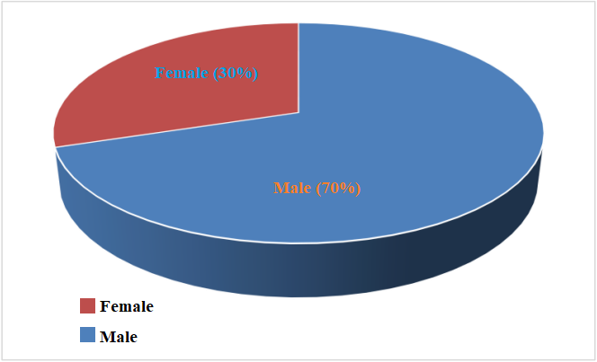

Figure 1. Distribution of respondents by gender

The table and graph above illustrate the index of our respondents by gender, with 60% of our respondents corresponding to the male gender and the remaining 30% to the female gender.

Table 2. Distribution by age

|  |  |  |
| --- | --- | --- |
| Age groups | Frequency | % |
| 18-30 | 3 | 52 |
| 31-40 | 4 | 17 |
| 41-50 | 2 | 12 |
| 51-60 | 6 | 12 |
| More than 60 years | 4 | 7 |
| Totals | 19 | 100 |

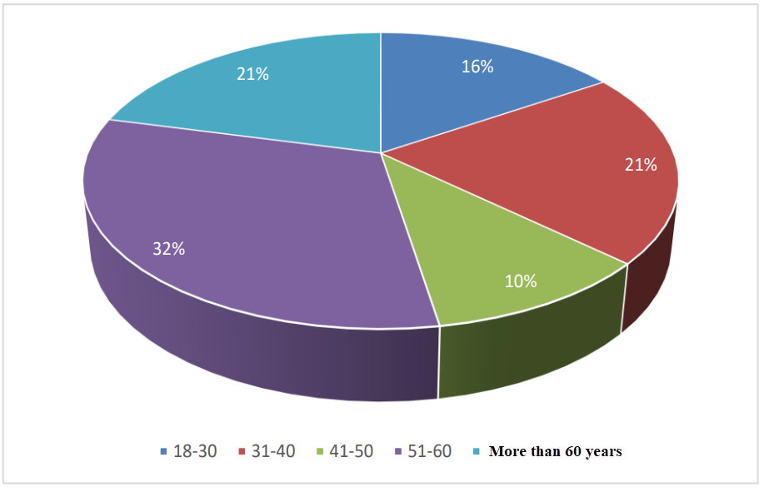

Figure 2. Distribution by age

The table and graph above illustrate the age index of our respondents, ranging from 18 to 60 years old.

Table 3. Performance evaluation.

|  |  |  |
| --- | --- | --- |
| Answers | Frequency | % |
| Monthly | 8 | 42 |
| Semi-annual | 7 | 37 |
| Annual | 4 | 21 |
| Total | 19 | 100 |

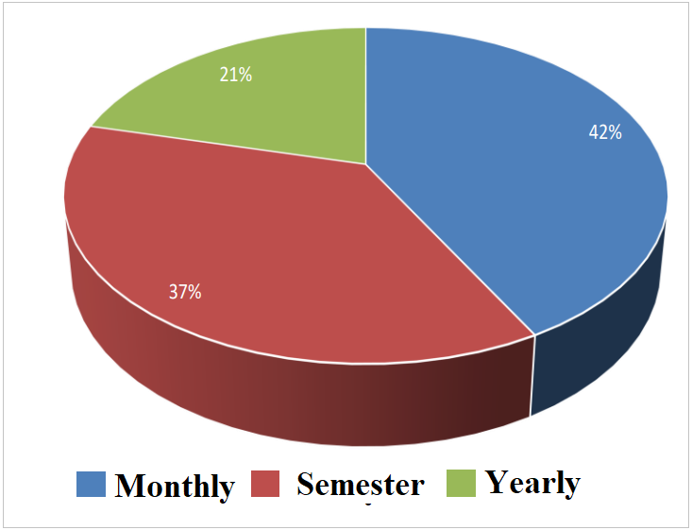

Figure 3. Performance Evaluation Mode

The table and the graph refer to the performance evaluation of the college's employees, with 42% saying that the performance evaluation has been carried out on a monthly basis, 37% say it is semi-annual and 21% annual. the percentage with the highest index in the performance evaluation modality.

Table 4. Time management is carried out in this Institution

|  |  |  |
| --- | --- | --- |
| Answers | Frequency | % |
| Yes | 10 | 53 |
| No | 7 | 37 |
| Perhaps | 2 | 10 |
| Total | 19 | 100 |

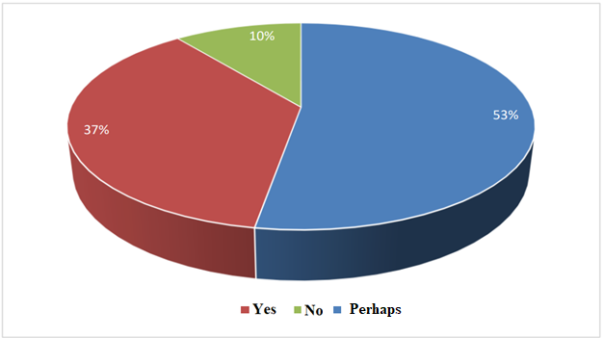

Figure 4. Time management is carried out in this Institution

The table and the graph answer the question of time management in the istitution, therefore, 53% say that time management has been done, 37 are of the opinion that it has not been done. 10% with the answer of doubt.

Table 5. Advantages in the good use of time

|  |  |  |
| --- | --- | --- |
| Answers | Frequency | % |
| Yes | 10 | 53 |
| No | 7 | 37 |
| Perhaps | 4 | 10 |
| Total | 21 | 100 |

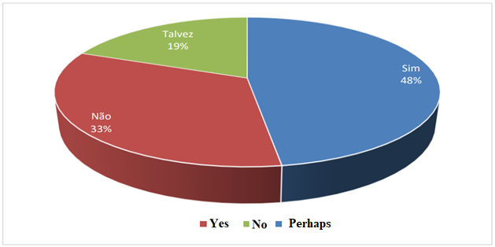

Figure 5. Advantages in the good use of time

The table and the graph refer to the advantages in the good use of time, and it is clear that 48% of respondents say yes, 33 say they have no advantages and 19% have a dubious statement.

Table 6. Responsible for the performance evaluation

|  |  |  |
| --- | --- | --- |
| Answers | Frequency | % |
| Head of Human Resources | 14 | 70 |
| Director | 3 | 19 |
| Deputy director | 2 | 10 |
| Total | 19 | 99 |

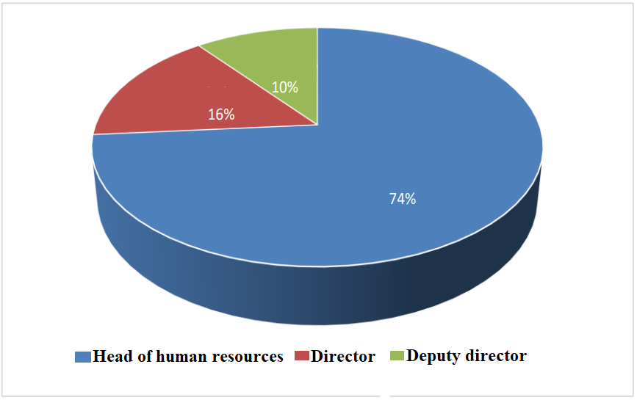

Figure 6. Responsible for the performance evaluation

The table and the graph clearly show who is responsible for carrying out the performance evaluation of the institution. 74 say they are the head of human resources and 16% the right and the remaining 10% say they are the sub-director.

Table 7. Identifying elements of good time management

|  |  |  |
| --- | --- | --- |
| Answers | Frequency | % |
| Performance evaluation | 14 | 24 |
| Compliance with the teaching programs of the teachers | 15 | 25 |
| Annual reports | 30 | 51 |
| Total | 59 | 100 |

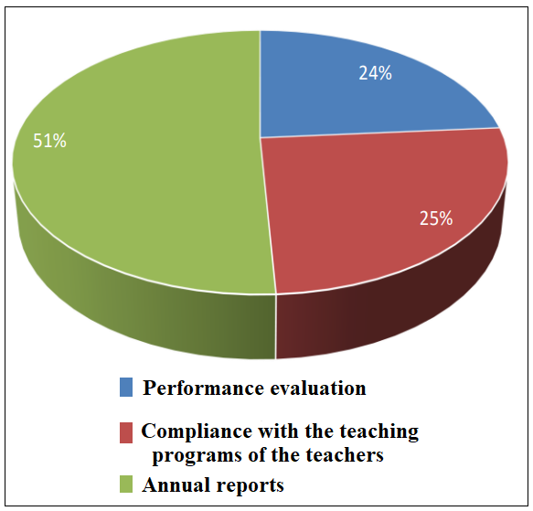

Figure 7. Identifying elements of good time management

The table and the graph show that 51% say that annual reports are the main elements to analyze good time management, 25% say that they do not comply with the teaching programs of teachers, and 24% say that performance evaluation is based on identifying element of good time management.

Table 8. Fulfillment of tasks assigned to employees

|  |  |  |
| --- | --- | --- |
| Answers | Frequency | % |
| Yes | 10 | 53 |
| No | 7 | 37 |
| Perhaps | 2 | 10 |
| Total | 19 | 100 |

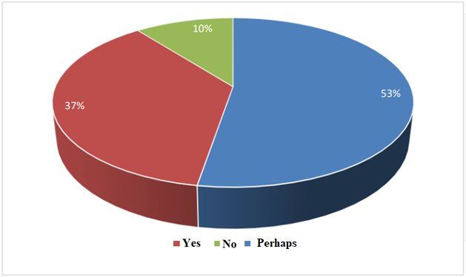

Figure 8. Fulfillment of tasks assigned to employees

The table and the graph answer the question of attribution and fulfillment of tasks entrusted to employees, with 53% of respondents saying that yes they are fulfilled, 37% say that tasks are not fulfilled and the remaining 10% with dubious answers about compliance of task assignments to employees.

Table 9 Impact of time management

|  |  |  |
| --- | --- | --- |
| Answers | Frequency | % |
| Positive | 15 | 79 |
| Negative | 4 | 21 |
| Total | 19 | 100 |

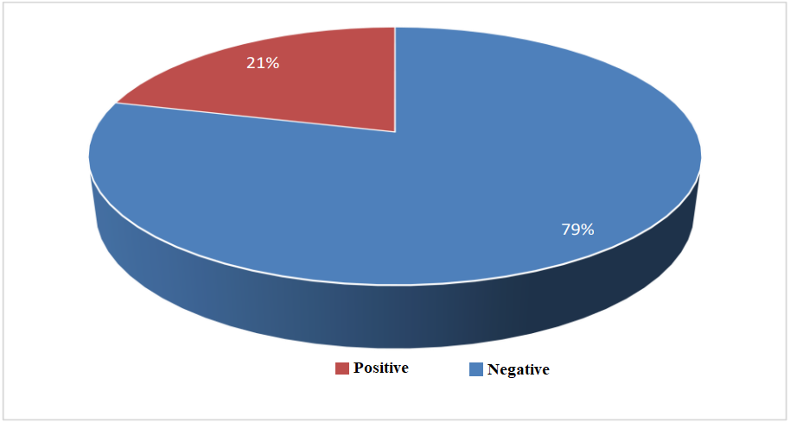

Figure 9. Impact of time management

The table and the graph answer the question of the impact of time management on the institution, with 79% of respondents saying that it brings positive results and 21% say that it leads to negative results.

Table 10. Impact of decisions

|  |  |  |
| --- | --- | --- |
| Answers | Frequency | % |
| Yes | 11 | 58 |
| No | 1 | 37 |
| Perhaps | 7 | 5 |
| Total | 19 | 100 |

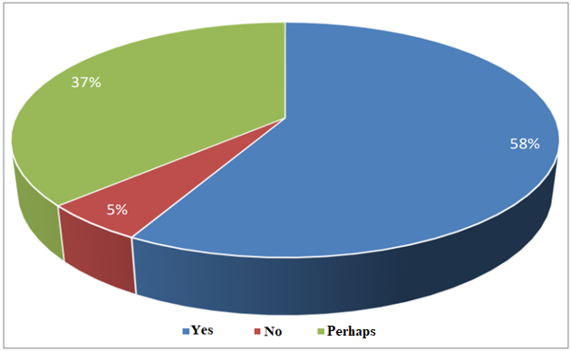

Figure 10. Impact of decisions

The table and graph answer the question of the impact of decisions made when employees waste their work time, 58% say it affects results, 37% with dubious answers and the remaining 10% say there are no major impacts.

Table 11. Decision making with production levels

|  |  |  |
| --- | --- | --- |
| Answers | Frequency | % |
| Yes | 8 | 42 |
| No | 2 | 11 |
| Perhaps | 9 | 47 |
| Total | 19 | 100 |

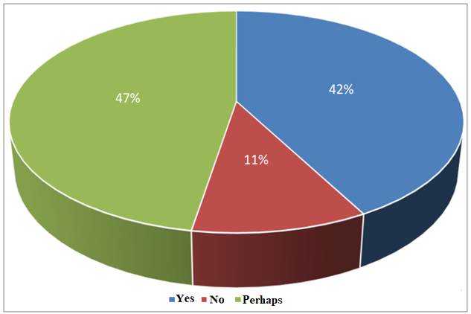

Figure 11. Decision making with production levels

The table and the graph respond to the decision-making process based on productivity, with 47% of those questioned saying with a dubious answer, 42% saying that decisions can be made depending on the level of productivity.

**CONCLUSIONS**

Starting from the general objective of this work, it appears that time management is undoubtedly an extremely important factor for the work process, that is, for managers as for all employees of different organizations. Many professionals are evaluated by the way they use their time:

•Some companies impose financial losses by not meeting deadlines, the efficient use of time within a company, at work and in professional activity is already considered a significant and relevant competence because, those who use their time effectively in their work demonstrate commitment to the company and focus on results and the ability to prioritize tasks and delegate.

Concluding this research, I can say that the objectives were achieved, to point out that Time Management has contributed to the improvement of the company's management.

**REFERENCES**

Andrade, F. Outlook as a Productivity Tool. São Paulo: Nobel, 2014.

Andrade, M. Time management in organizations. Economic Life, Editorial SA. Porto, 2006.

Bakker, W. Time management. Economic Life, Dom Quixote, 2016.

Barbosa, C. The time triad: The unique method to boost your productivity. Rio de Janeiro: Elsevier, 2008.

Cardoso, T. Impact of time management on women's daily lives. Porto, 2013.

Campos, R. The Origin of Timekeeping. Available in: www.infoescola.com/historia/a-origem-da-contagem-do-tempo/. Acesso em: 23 de março de 2019.

Chaves, E. Time management. Rio de Janeiro, Editorial SA. Porto.2017http://www.chaves.com.br/TEXTSELF/MISC/timemgt.htm

Chiavenato, I. Gestão de Pessoas: the new role of human resources in organizations. Rio de Janeiro: Campus, 2001.

Covey, S. The Seven Habits of Highly Effective People. Translation of Celso Nogueira São Paulo: Nova Cultural, 1989.

Clegg, B. Time Management: Practical Method. Rio de Janeiro: Quality Mark, 2012.

Drucker, P. O gerente eficaz. Rio de Janeiro 9. ed. Zahar, 1981. FONSECA, A.V. Organizational Consultant. Time management RHCoaching Consultation and Management Training. Available in:http://www.desenvolvimento.gov.br/arquivos/dwnl_1349372089.pdf. 2016>. Acesso em: 28 set. 2018.

Francisco, C. et al. Introduction to Scientific Research Methodology. Luanda-Angola: First Ed. Luanda: Bc Livtec, Lda., 2017.

Flores, A. Time management as a contribution to personal strategic planning (Master's Thesis, Federal University of Santa Maria, Santa Maria). Available in:[http://repositorio.ufsm.br/handle/1/4577. 35](http://repositorio.ufsm.br/handle/1/4577.%2035)

Galgano, M. Time management – Proposal and application of a methodology for time management in a bank branch. Journal of Fafibe On-Line, 8(1), 218–228. GUERREIRO, Roverson. Time-based management practices: Brasilian Journal, 2013.

Inhuma, S. Time management and motivation: intrinsic and extrinsic factors that influence the achievement of professional goals. On-Line Scientific Magazine Technology. Journal of Management – Humanism, Magazine, 29–44, 2017.

Lima, M. C. F.; Jesus, S. B. Time Management: A study on effective time management as a tool to increase productivity and work life balance. Journal of Management and Secretarial, 2, pp. 121-144, 2011.

Morgan, E. Management and quality Food production. Economic Life, Editorial SA. Porto, 2010.

Reggiani, M. Be More In Time Management and Productivity. São Paulo, 2011. SÊNECA. About the Brevity of Life. Porto Alegre: L&PM Pocket Plus, 2006.

Soutes, C. Management Principles. Lisbon: Editorial Presence, 2013.

Quinello, R., & Nicoletti, J. R. (2006). Facilities management. São Paulo: Novatec Edition. Available in: www.triadedotempo.com.br/interna_livro_livro.asp