Energy Saving Load Balancing Approach to Boost AOMDV Routing In MANET and Data Security

¹Priyanka Choudhary, ²Roshni Verma
¹M.Tech Scholar, ²Assistant Professor
^{1,2}Dept. of Information Technology (Cyber Security), VGI/VITM Indore

ABSTRACT

A new approach to Mobile ad-hoc Networks (MANETs) is also a Multipath of devices or nodes which will transmit through a wireless communication medium that was supported at a frequency with none mounted infrastructure or our centralized management. Our mere and foremost objective of such network infrastructure is to develop dependency of communication and institution intelligence. each mobile node is related to transmitter and receiver for wireless communication and knowledge exchange, small processor for computation purpose and process, flush memory for storage at the side of battery to produce energy to all or any connected devices. It uses connecting board to mound all such necessary elements along. the entire phenomena build them self-configurable nodes to deploy into any scenario any surroundings. they will be deployed into hostile and resistance surroundings for temporary purpose. thanks to a distinct nature of such network, it should become crucial a part of performance of actual system like military or emergency services. Security has become a primary concern so as to produce protected communication between mobile nodes during a hostile surroundings. not like the wire line networks, the distinctive characteristics of mobile unintended networks create variety of nontrivial

Challenges to security style, like open peer-to-peer spec, shared wireless medium, demanding resource constraints, and extremely dynamic topology. Mobile nodes could deploy into discretionary topology with none coming up with and random choice. Here, destination is also deployed for means from supply and might be out of vary from supply node. Routing protocol is employed to see route among mobile nodes. Consequently, a load balancer may be a mechanism or device provides distribution and traffic handling facility with dependability. It improves the performance by nearly implements the logic of distribution. They improve the performance of applications by decreasing the burden on servers related to managing and maintaining application and network sessions, likewise as by playacting application-specific tasks. Project works think about Energy Aware Load leveling Multipath Routing (EALBM) because the base work and explore some prospects of improvement.

Keywords: Cryptography, PK, round, secret variety,encryption time, secret writing time, speedup. Energy potency, Mobile Ad-hoc Networks, Network period, Routing protocol, Wireless device Networks security with committal to writing code.

- Introduction

Wireless communications and Wired communication are modernly the emerging areas in concert of the foremost active areas of technology build. The desired for additional wireless capability has grown up at a awfully speedy pace. historically radio information measure and transmitter power area unit the resources that are wont to increase the capability of wireless systems. Sadly, these 2 resources area unit restricted within the preparation of wireless networks. The set wo resources aren't growing at rates which will support increasing demands for wireless capability. On the opposite hand, another resource process power is growing at a awfully speedy rate. Moore's Law that talks regarding doubling of processorcapabilities in each twelve months hasbeen quite correct over the past fifteen years. Increase in processor capability is promising new technologies and developments to meet increasing demands. Wireless network technology advancements offer several advantages.
- Wireless networks area unit are straightforward and economical.
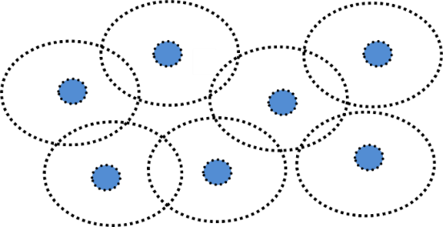
- The Mobility and easy convenience of accessing the network resources from any one location to another location.
D
G
A
E
C
F
B
- Scalability.
- In expensive, as wireless networks eliminate or reduce the wiring costs.
- Share the file very firmly and it is most reliable.
- Google verification, user code and
Password

MobileAd-HocNetwork
A mobile impromptu network (MANET) is also a cluster of devices or nodes that transmit across a wireless communication medium in the main supported frequency with none mounted Infrastructure or centralized management. Cooperation of nodes is incredibly necessary to forwardpackets on behalf of every fully completely different path once different destinations area unit out of their direct wireless transmission vary. There no centralized management or network infrastructure for a painter to be discovered, thus making its preparation quick and low-cost. The nodes facility to maneuver generously ensures a flexible and handy vibrant topology is another necessary feature of a painter. variety of the painter applications includes emergency disaster relief, military operations over a field of honor (vulnerable battleground (vulnerable infrastructure), and geographical area expeditions (transient networks), and community

Figure1.1 Multi-hopWirelessNetwork

RoutingProtocols

Figure1.2 Routing Protocols
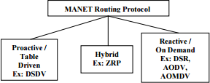
Information communication is a necessity necessary to follow in info Era that is going to be done by forwarding or rerouting information from one node to another node. Info forwarding task is finished with the help “Routing”. Routing could also be a tough task since there is no central organizer, like base station, or mounted routers in different wireless networks that manager outing decision. each node act as a router /base station to forward the information, so a special quite routing protocol is very important, There area unit a during which unit ample vary of routing protocols area unit developed for MANETs Routing protocols for Mobile impromptu u networks loosely classified into the next categories:

1.3 Load Balancing
In computing, load reconciliation distributes work hundreds across cluster computing

resources, like computers, a laptop cluster, network links, central process units, or disk drives. Load reconciliation aims to optimize resource use, maximize output, minimize latency, and avoid overload of any single resource, victimization multiple elements with load reconciliation rather than one element could increase dependableness and availability through the redundancy. Load reconciliation typically involves dedicated code or a hardware, like a multilayer switch or a site Name System server method. Load reconciliation is widely differs from a channel bonding there in load reconciliation divides traffic between network interfaces on a network socket(OSImodellayer4)basis, where as the channel bonding implies a division of traffic between physical interfaces at a lower level, either per packet (OSImodelLayer3)or on a data link (OSImodelLayer2) basis with a protocol like shortest path bridging.
A load balancer is a elementry device that behaves and acts as a reverse proxy and distributes network or application traffic through the number of servers. Load balancers are used severly to increase capacity (concurrent users) and robustness of several applications across the servers. They improve the overall performance of applications by decreasing the burden on

Servers related to managing and maintaining application and network sessions, moreover as by playacting application-specifictasks. Load balancers area unit usually sorted into 2 categories: Layer four and Layer seven. Layer 4load balancers bear upon knowledge found in network and transport layer protocols (IP, TCP,FTP,UDP).Layer7loadbalancersdistributerequestsbasedupondatafoundinapplicationlayer protocols like hypertext transfer protocol.
RREQ Packet Format
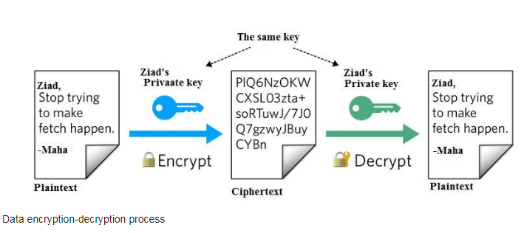
Figure 1.3 Data Encryption Decryption Process

  - HELLOpacket
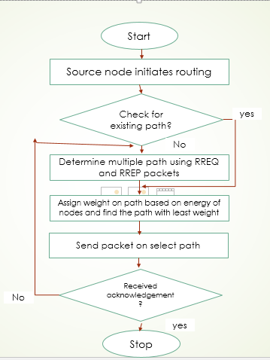
This is the implementation of Ping request

to find neighbors at a regular intervals. It is periodic packet forwarding may be done after millisecond.

  - Data transmission

A lot of research work has been undertaking in wireless telecommunication technologiesas well as low-price, low-power and multifunctional mobile nodes for conducting recent developments. Ad-hoc networks suffer with couple of limitation which may be consider as low processing, storage and battery life. Mobile nodes generally consider a limitation that they can’t be allow to transfer energy from one node to another node.
  - Problem Definition And Proposed Solution
Packet sniffing is the act of gathering, collecting, and monitoring the data pieces (packets) that travel through a computer network or the internet.
the internet or a local network is gathered for a wide range of purposes such as – monitoring the traffic & bandwidth, maintain the networks, analyse the data collected by the device, and so on.

Channel | Channel/Wireless
Propagation | Propagation/Two Ray Ground
Network Interface | Phy/ Wireless Phy
Platform | Ubuntu21.10/22.04
NS Version | Ns-allinone-3.35
MAC | Mac/802_11
Interface Queue | Queue/Droptail / Priqueue
Link Layer | LL
Antenna | Antenna/OmniAntenna
Interface Queue Length | 60
No. of Nodes | 10,20,30
Simulation area size | 760*650
Traffic Pattern | CBR Sessions
CBR Packet Size | 512bytes
Simulation Duration | 500seconds
Routing Protocol | AOMDV

Table no. 1.1 Parameters data for problem solution
The following metrics are used in this work for comparing the performance of AODV,AODV under attacks and Modified AODVroutingprotocols.

    - Throughput
    - Packet DeliveryRatio
    - End-to-EndDelay
    - NormalizedLoad

1.6 Now Analysis With Google Security Data Transition On Wireless File Shearing Securely With Code

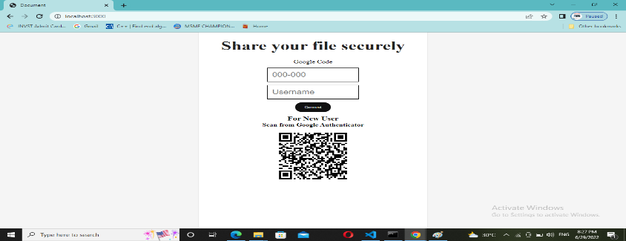
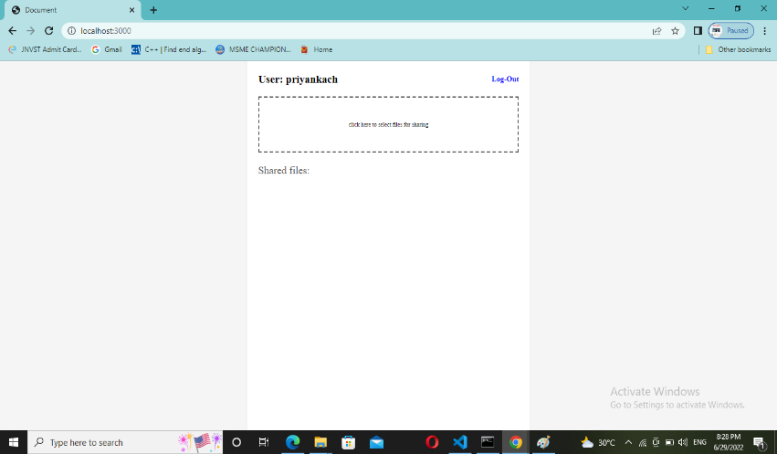

Table1.2 wireless file shearing securely Simulation Parameters

Channel | Channel/Wireless
NetworkInterface | Phy/WirelessPhy/ local network / google authentication
Platform | Open source / java script
Version | 1.5.1 google page
Language | HTML, CSS , JAVASCRIPT, NODE JS
InterfaceQueue | Queue/Droptail/Priqueue
No.ofNodes | Multiple
Simulationareasize | LAN
TrafficPattern | CBRSessions
Data PacketSize | 1MB
SimulationDuration WITH OTP | 1sec to 2sec

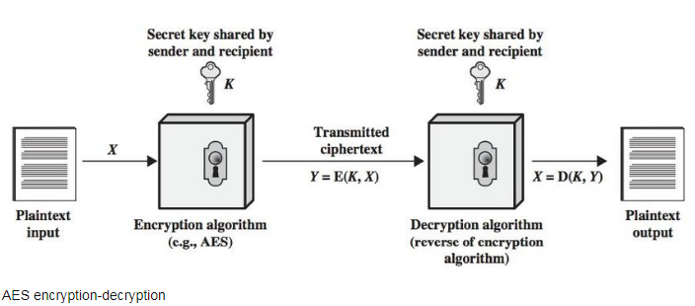

Figure 1.4 AES Encryption Decryption

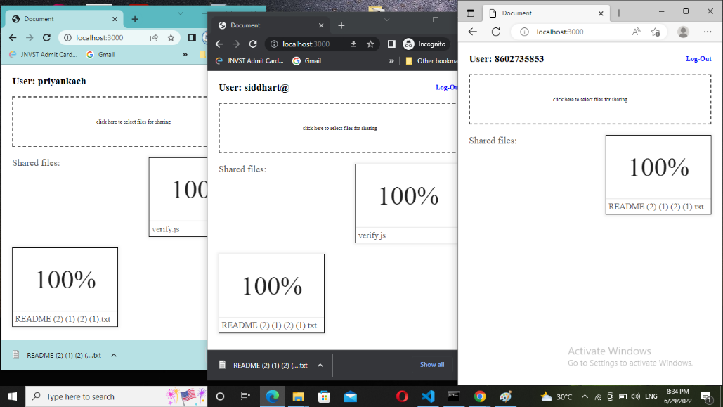

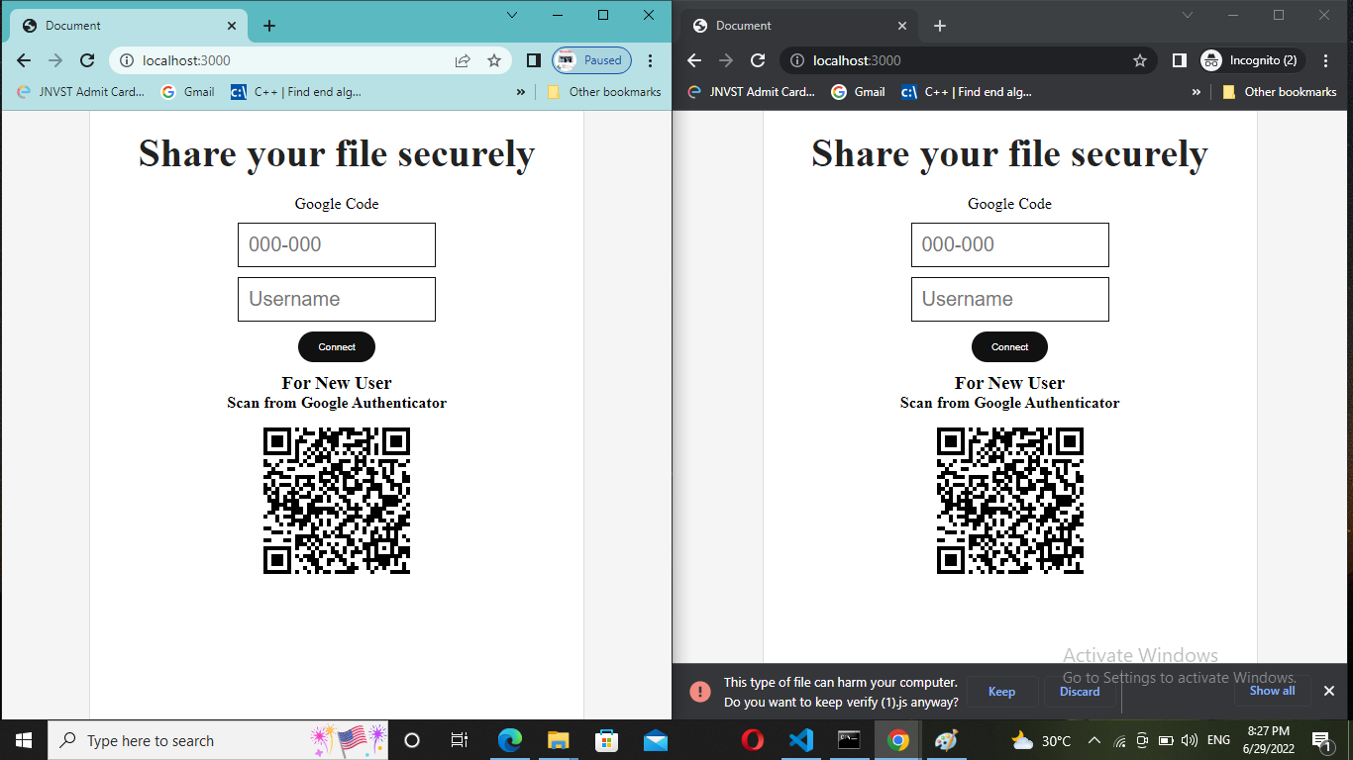

Figure 1.5 Data Encryption Decryption Process on data share file securely

1.6 Result and Conclusion

1.6.1 Throughput Analysis (bits/sec)
Through out is the rate of total data transmitted with Respect to total time period.In simple words it defines the rate of transmission per unit time. Here, better throughput has beenobserved for EALBM algorithm rather than traditional EALBM. A slight slaghas been happed with respect to enhancement into number of mobile nodes can be considered as negligible.

Packet delivery ratio (PDR) Analysis

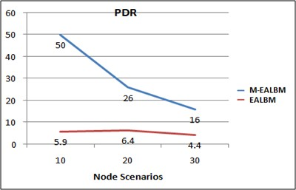

Normalized Load Analysis

Conclusion

Following conclusions were made from above performance analysis.

    - Throughput of proposed solution becomes high with 50 % than EALBM methodand 60% with AOMDV method. A slight slag has been happed with respect to

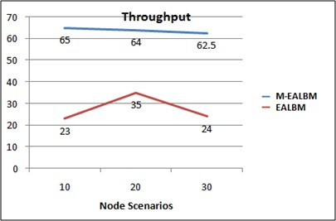
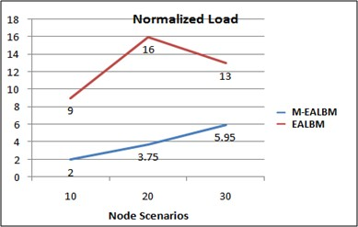
    - PDR of proposed solution become 4 times than EALBM technique and AOMDV.It also observes that an enhancement into mobile nodes rapidly degrade the packetreceiving. A poor performance has been observed into 30 node scenarios withrespectto 10 nodes but still betterthanEALBM.
    - It reduces End-to-End delay with high degradation with AOMDV method and basic improvement with EALBM technique.
    - A normalized load in propose becomes lower than 50% from EALBM method in proposed method. New protocol givesfour-timebetterperformancefor10nodes
    - Scenario and six times for 20 no de scenario. 30 Nodes give poor performance than10and 20 but two times better than tradition EALBM.
    - The complete work conclude that propose method perform better than not only AOMDV but EALBM method also.

Future work
Proposed solution can also be implementing with other networks such as sensor network, Wi-Max Proposed solution can also be evaluated on other simulator like Qualnet, OPNET too b serve the impact on other tools.
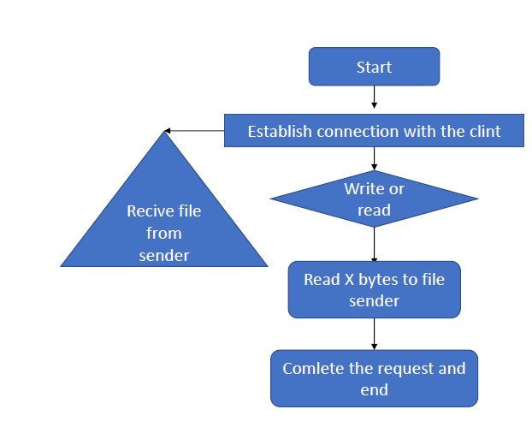
Figure 1.5 Flow chart securities of data shearing
- A scope of performance improvement is still awaited in preventive technique.
- Secure the packet from third-party.
- All data packet Reached right node

References

- Alotaibi, Naif D., and Elyas I. Assiri. "Enhancing MANET by Balanced and Energy Efficient Multipath Routing with Robust Transmission Mechanism with Using FF-AOMDV." Communications and Network 13.4 (2021): 131-142.

- Naseem, M., Ahamad, G., Sharma, S., &Abbasi, E. (2021). EE‐LB‐AOMDV: An efficient energy constraints‐based load‐balanced multipath routing protocol for MANETs. International Journal of Communication Systems, 34(16), e4946.

- Sarhan, Shahenda, and ShadiaSarhan. "Elephant herding optimization Ad Hoc on-demand multipath distance vector routing protocol for MANET." IEEE Access 9 (2021): 39489-39499.

- Rani, B. Sandhya, and K. Shyamala. "Energy efficient load balancing approach for multipath routing protocol in ad hoc networks." 2019 Second International Conference on Advanced Computational and Communication Paradigms (ICACCP). IEEE, 2019.

- Singh, Sunil Kumar, and Jay Prakash. "Energy efficiency and load balancing in MANET: a survey." 2020 6th International Conference on Advanced Computing and Communication Systems (ICACCS). IEEE, 2020.

- Li, Peng, Lu Guo, and Fang Wang. "A multipath routing protocol with load balancing and energy constraining based on AOMDV in ad hoc network." Mobile Networks and Applications (2019): 1-10.

- Yazdinejad, Abbas, Sara Kavei, and SomayehRazaghiKarizno. "Increasing the performance of reactive routing protocol using the load balancing and congestion control mechanism in MANET." Computer and Knowledge Engineering 2.1 (2019): 33-42. .

- Venkatachalapathy, K., and D. Sundaranarayana. "A Min-Max Scheduling Load Balanced Approach to Enhance Energy Efficiency and Performance of Mobile ADHOC Networks." International Journal of Computer Networks & Communications (IJCNC) Vol 11 (2019).

- Makwana, H., and Hitesh Patel. "Advancement in performance of wireless AdHoc network using AOMDV in MANET." International Journal for Innovative Research in Science & Technology 4.10 (2018): 16-20.

- Zaghal, Raid, Saeed Salah, and Mohammad Ismail. "An InfiniBand-based mechanism to enhance QoS in multipath routing protocols in MANETs." 2018 9th IFIP International Conference on New Technologies, Mobility and Security (NTMS). IEEE, 2018.

