**MODELING AND DYNAMIC ANALYSIS OF WIND TURBINE BLADE USING FINITE ELEMENT METHOD**

**K Sree Devi**

Assistant Professor, Department of Mechanical Engineering

**N Lakshman Y20MTMD916**

PG Scholar, Department of Mechanical Engineering University College of Engineering & Technology, Acharya Nagarjuna University, Guntur, A.P

**ABSTRACT**

Wind turbine blade is one of the important components requiring more attention at the design stage. These blades are made up of fibrous material and sometimes hollow composite web sectionsmay be employed in its construction. The main focus in its design is to achieve a desired strength to withstand various loads as per the power requirements. In view of this, modeling & dynamic analysis of blades is an essential requirement not only to avoid resonant vibrations but also to understand the stability of operation during various operating conditions. In this line, present workfocuses on dynamics of horizontal- axis wind turbine blade with NACA 63415 profiles subjected to aerodynamic, centrifugal and gravity loads. The basic geometrical parameters of the blade are designed by using blade element moment method & the blade is modeled as a ruled 3D surface. By computing element wise cross sectional details from 3D model, a 1D beam finite element modeling is developed and modal characteristics are obtained. These are further validated with 3D finite element model result. Then, the effects of the tip speed ratio and rotational speed on thenatural frequencies are studied. Further, finite element model have 10 elements with 6 degrees offreedom per node is used to obtain the dynamic response of the blade subjected to various loading conditions. The effect of aerodynamic, centrifugal and gravity parameters on the frequency response, edge-wise and flap-wise beating at the tip of blade are studied. The iterative programs developed in the work helps in testing the blade frequencies & response at any operating conditions. In order to estimate the stability during rotation, the frequency responses are obtained from response histories at the blade tip, by using Fast Fourier Transform algorithm. It is found thatthe centrifugal loads have profound effect on the frequency responses compared with other loads. The dynamics of long blade when rotating at varying wind conditions (aerodynamic loads) is influenced by gravity loads also.

# INTRODUCTION

Wind turbines can be classified into Horizontal Axis Wind Turbines (HAWT), and Vertical Axis Wind Turbines (VAWT). Horizontal type turbines have the blades rotating in a plane which is perpendicular to the axis of rotation. The HAWTs are most widely used type of wind turbines and come in varied sizes and shapes. The primary types of force acting on the blades of HAWT are the drag forces. The Horizontal type are commercially applicable type due to itsvaried sizes and storage capacities. In Vertical Axis Wind Turbine blades, the rotation axis coincides with the axis of generation of power. Advantages of Vertical Axis wind turbine is the placement of generator at the base of the turbine. But these type are nearer to ground whichmakes it difficult to capture the power at higher altitudes. While the HAWTs require yaw mechanism to orient themselves in the direction of wind, the VAWTs do not have such problem. But disadvantage with VAWTs is the low starting torque, lesser installation height and dynamic stability issues.

Any Horizontal axis wind turbine contains five major components: Rotor Blades, Rotor Hub, Nacelle, Yaw system and Tower. It is the shape of Blade which decides the tapping of wind energy and conversion into Kinetic energy of the blades. These blades have in general aerodynamic profiles and are constructed with materials having high strength to weight ratio. The tip speed ratio, number of blades and profile of the blades create huge difference in generation of wind power. The hub connects the rotor blades with the generator shaft. The nacelle houses a gearbox and generator to tap the power obtained at the shaft into electrical energy. A yaw mechanism is provided to the HAWT in order to orient itself to the wind direction. The sensitivity of the yaw mechanism plays important role in making the blade orient itself towards the wind and improving efficiency of the turbine. The Tower provides the necessary altitude for the blades to overcome the obstacles that might cause turbulence

1

# WIND TURBINE BLADES:

Horizontal axis wind turbine blades are subjected to various type of excitations. Wind turbineblades has an aerofoil cross section with taper & twist incorporated to generate more output energy. During the rotation, the blade is subjected to centrifugal forces, and other aerodynamiceffects as well as the gyroscopic coupling effect. Several earlier works studied these dynamic analysis problems of wind turbine blades. The modelling of the blade is carried out as a cantilever beam with unsymmetrical and variable cross section. Routine approach for study ofsuch blades is finite element modelling where the beam is discretized into several elements, each having a defined area and Moment of Inertia. In practice for a lengthy wind turbine bladeof unsymmetrical section, the element stiffness & mass matrices contain in total four Momentsof Inertia, Ixx, Iyy, Izz & Iyz.

Airfoils are common profiles for wind turbine blades. The blade contour must utilize the aerodynamic considerations while the material provides the stiffness and strength to the blade.

An airfoil is defined by a number of terms as shown in Figure 1.1. The leading edge is where the wind starts to hit the airfoil and trailing edge is where the air leaves the airfoil surface. Theupper surface and lower surface of airfoil have a mean camber line midway between the two lines. The chord line connects the leading edge and trailing edge and the distance is designatedby c. Camber is the maximum distance between the chord line and mean camber line. The angleof attack α is the angle at which the wind strikes the airfoil with relative wind velocity Vrel. Thethickness of the airfoil is distance between the upper & lower surface of the airfoil. The chord length, thickness and camber affect the aerodynamic performance of the airfoil.



Angle of attack

Mean chamber line

TTrailing

Vre

Leading

Chord There are three widely wind turbine profiles which are NACA, LS & LM profile standards. Out of these, NACA airfoils have been widely accepted even in commercial applications due to their high power coefficients and lesser drag profiles. NACA stands for “*National Advisory Committee for Aeronautics”.* In Horizontal axis wind turbines, the NACA profiles are used to generate the profile shape of the cross section of the blade by using a set of camber line equations to generate points on the upper and lower surface of the airfoil. The Shape of NACAairfoil is to be decoded from a series of digits which when substituted in the Equations gives the coordinates of the airfoil. There are different NACA series available for various aerospace, wind energy, rocketry applications out of which NACA 4 digit series and NACA 6 digit seriesprovide better performance when used for generation of wind power.

# LITERATURE REVIEW

In the area of wind turbine blade design and analysis several works are available in literature. These are summarized in this section.

Aerodynamic Design & Blade Optimization of Wind Turbine Blades:

Designing a blade by using well known Blade Element Momentum (BEM) Theory is afascination to many researchers who are interested to get better geometrical parameters to maximize the power output of the blades.

National Advisory Committee for Aeronautics (NACA) developed a series of standard airfoil shapes which are prominent in usage as the profiles of the blades. Using the airfoil profile, knowing the angle of attack of the wind and the proposed length of the blade, researchers such as Tenguria et al. [1] have used BEM theory to optimize the coefficient of power, lift and drag characteristics with various tip speed ratio, lift and drag coefficients. It is observed that at a power coefficient 0.46 and lift to drag coefficient is 124.47, the power absorption is maximum.

John McCosker [2], developed an optimized code for a discretized 9 element wind turbine blade having a length of 0.95 m. He obtained optimal speed ratio, angle of wind, the pitch angle and relative chord lengths for each element. After convergence, the power extracted from windis found to be 0.81 KW. The airfoil shape is varied from NACA 4412 to NACA 23012 wherethe angle of attack of the blade to get maximum glide ratio is found different for each

profile.

Cost reduction of generation of wind power is critical and it can be possible by suitable structural design changes and use of composite materials to lead greater profits. This is discussed by Anjali et al [3], in which they described an ant colony optimization method by varying the composite material of the blade and conducting stress analysis. Ultimately, he obtained the optimized values of chord length and blade twist angles and it is found that Kevlar 149 material has highest natural frequency and less deflection compared to others.

Thumthae and Chitsomboon [4] investigated an untwisted blade for obtaining optimal pitch to get maximum power for wind turbine using stead flow wind conditions. Research is also doneusing Genetic algorithms to obtain the optimization of chord and twist angle by Juan Mendez and Greiner [5], for a test turbine having 19m rotor diameter and 100 KW nominal power. Similar works have been done [6-9] where observations state that optimizing the blade shape parameters is mostly to maximize the output power generation of the blade.

Ingram [8] derived equations relating to the Blade Element Theory in order to find the axial force, Lift and drag characteristics, considering the tip loss correction to calculate the rotor performance. An iterative procedure is used to refine the obtained results.

Vasjaliya et al [9], evaluated multidisciplinary optimization process to minimize cost, weight and maximize power output by considering a fluid structure interaction and structural robustness to enhance performance of a QBlade / XFoil airfoil blade. In process of optimization, structure and design variables are taken as input parameters and a number of DOEs were created and solved.

Sedaghat et al. [10] used BEM Theory to get a generalized quadratic equation on angular induction factor with tip speed ratio, drag to lift coefficient. Then an optimal blade geometry is obtained which is used to calculate the power performance at variable speeds. BEM theory ensures quicker way to understand the off design power performance of blades moving at a constant speed.

Using 3D modelling softwares such as CATIA, Solidworks, the design of wind turbine blade can be seen much more realistically. These surface models can even be exported to analysis packages to conduct further research analysis by posing suitable conditions. Scott Larwood et al. [11] studied the design of a swept wind turbine blade. Parametric

study to determine sweep parameters using STAR7d scaled model showed that loads were most sensitive on the tip of sweep.

Finite Element Analysis & Modal Analysis of Wind Turbine Blades:

Today, the method of finding the modes of vibration of a structure has become widespread to assess the inherent properties of the structure. The significance of finding the solution for these single degree of freedom systems is such that they can be used to analyse the complex multiple degree of freedom systems as the latter can be decoupled into a system of Single degree of freedom systems. [12-16] discusses the experimental and numerical investigations done on performing Modal Analysis on complex wind turbine blades.

Gursel et al. [12] studied the vibration characteristics of rotor blades using approximation method such as Rayleigh to calculate the natural frequency of each blade. They have validated the results of vibration analysis by using Finite element analysis.

Larsen et al. [13] shown experiments on a LM 19m blade to investigate the mode shapes, dominating deflections, and explained the difference or error in measurement between the theoretically computed values and experimental results. It is observed that for non – dominating deflection direction, the measured and computed mode shapes are found to be in good agreement. A forced vibration damper is introduced in the experimental setup to check the damping characteristics of the blade.

Liu et al [14] studied modal and harmonic analysis of circumferential force is on a 5MW S809airfoil, wind turbine model to obtain the natural vibration characteristics to get first seven orders of natural frequencies along with harmonic responses in different phases.

Allikas et al. [15] validated a full scale single layer layup small horizontal axis wind turbine blade through experimental bending test and modal analysis. They have taken Glass fiber reinforced composite plastics to get the stiffness and strength analysis acted by 7848 N load. Adifference if 16.8% occurred during load Case 6, damaging the blade due to value of obtained stress being greater than yield strength of the skin element of blade.

Sami et al. [16] extracted fundamental flapwise and edgewise modal frequency of a 5KW GFRP wind turbine blade by using 3d shell elements. It is to understand better the dynamic behaviour that he

conducted experiments using electrodynamic shaker system to predict the resonant frequencies. He observed that flapwise frequencies are found to be in agreement to each other while % of error is more in case of edgewise frequency.

Fangfang song [17] worked on optimization of design of the blade, having NACA 63415 profile and then modelled the surface model of blade using Solidworks software. Then the finite element model is considered to find out the modal analysis of the blade. The excited frequeny from wind speed of 10m/s is calculated as 7.16 Hz which is found to be more than the fundamental frequency obtained from the modal analysis therefore no resonance will occur when the blades run at rated wind speed.

Dynamic Analysis:

Jie et al [18], used a 38m blade having rated power 1500KW and conducted structural stress and strain distribution analysis to understand the flapwise loads and vibration mode shapes. Shell 99 elements are used to discretize the blade using Finite Element Analysis to validate the result. The authors have conducted structural response characteristics [19] to study the aerodynamic characteristics using CFD simulation and then formulating dynamic characteristics of the blade. The BEM method predicted much higher aerodynamic loads than CFD method. A maximum error of 4.86% is observed between FE model and calculated frequencies.

Inoue et al. [20] studied the dynamic analysis of wind turbine blade by investigating its fundamental vibration behaviour. Effect of gravitational and wind load on super harmonic resonance was presented.

Lag wise dynamic characteristics of a wind turbine blade subjected to unsteady aerodynamic forces was studied by Li et al. [21]. A mathematical model [22] is developed for describing non-linear vibration of horizontal axis wind turbines which uses Kelvin Voigt Theory to compute the decouple a set of coupled equations of motion representing a wind turbine blade subjected to aerodynamic and gravitational loads. The expressions for static deformation, aeroelastic stability and dynamics of the blade are solved from the set of equations. The system consists of a rotating blade with out of plane bending having in plane bend and torsion. Factorssuch as coning angle, twist angle, eccentricity, mass centre, shear centre were included.

Li et al. [23] also conducted the dynamic response analysis for flap wise direction in case of super harmonic response. Amplitude modulation equations are used to derive frequency response. Effect of static displacement, perturbation frequency, dynamic displacements are studied and results are compared with numerical solution. It is found that dynamic displacements of flap wise are larger compared to axial displacements of the blade.

Hamdi et al. [24] independently presented forced vibration analysis of wind turbine blade rotating at a constant angular velocity by taking into consideration aerodynamic, centrifugal, gravity and gyroscopic loads. In this, both static and dynamic investigation studies have been discussed with and without gyroscopic loads is done. The excitation force vector containing harmonic components is incorporated in the equations of motion, and the differential equations are solved by using Newmark method. Dynamic responses along with FFT responses are obtained for blade for the first 25 seconds.

Karadag [25] studied effect of shear center on dynamic characteristics of the blade. Different methods such as Reissner, Potential and finite element methods are used to calculate the naturalfrequencies of the blade rotating at 0 rpm and 3500 rpm for the loads acting at the shear centres. The bending and torsional modes are observed and variation is found for finite element methodand Reissner method. It is seen that shear center affects the natural frequencies and modes of the rotating beams with complex geometry. Both thick beam and thin beam theories give resultsin close comparison. Torsional frequencies show greater change with increase of rotation than the bending frequencies.

Nymann et al. [26] described a formulation of 3D two node FE analysis in rotating frame of reference. The effect of Elastic, geometric and torsional bending are shown to play significant role in improving accuracy modelling of structures. Structural responses at middle of the bladeand blade tip is observed. The actuator forces seem to reduce material strains at all times.

Keerthana et al. [27] introduced a step wise procedure to develop the blade’s geometrical properties by using optimization techniques and taking input parameters as the tip speed ratio, wind speed and the aerofoil properties, the chord, twist distributions are calculated. Then a CFD analysis for obtaining the lift & drag coefficients (CL and CD) is done to calculate the liftand drag forces acting on the blade.

Yangfeng Wang [28] considered two cases of turbine blades having 1m and 5m in length and conducted damage detection technique by comparing the dynamic response analysis and modeshape curvature methods using composite multi-layer materials. The dynamic analysis method is used to understand the damage severity of wind turbine blades.

Chu and Clausen [29] used 5KW horizontal axis wind turbine blade 2.5m long to find out the dynamic response using LXRS telemetry system which uses 3 gauges to measure the response during operation. At small speeds, turbine operation is satisfactory, but yaw error is found to increase as speed increased to large extent. Zheng et al. [30] found dynamic response by considering flexible beam elements and obtained the response characteristics for a medium and high speed wind turbine.

# SCOPE OBJECTIVE OF THE PROJECT

Most of the literature dealt with investigation of various airfoils design, aerodynamic evaluation by simulation tools, and the analysis of complex composite web section blades usingvarious techniques including FE modeling, analytical approaches as well as experimental works. Very few works considered the power generation by blades of around 1m length for analysis. There is a requirement of developing a user interactive software that computes the blade data corresponding to flow conditions and generate the dynamic response using some finite element approach.

In the present work, research is carried out with inclusion of the following aspects: Performance of wind turbine blade models with NACA 63415 profile, airfoil blade section analysis with taper and twist, in stationary and rotating conditions, modal

# LOADS ACTING ON THE WIND TURBINE BLADE:

The wind turbine blade profiles are constructed by combining the concepts of 2-dimensional airfoil and Blade Element Momentum theory. The chord and twist distributions are obtained from BEM theory whereas as the profile can be constructed form the camber line equations shown in Appendix I. A lofted surface is modelled in a design software to obtain the 3- Dimensional realistic view of the model of blade. Blade Element Momentum Theory (BEM) discretizes the whole blade into a number of elements and couples the momentum theory withlocal forces acting on each blade element. The first method examines the momentum balance of a rotating turbine in a stream tube with wind passing over it. The second method determinesthe lift & drag forces. These two methods gives a series of equations to solve the blade element cross section as independent forces are assumed to be acting on each blade element. The model is based on Rankine Froude Momentum model which has the following assumptions: no aerodynamic interactions amongst blade elements, velocity in direction of length of blade is neglected, the forces are assumed to be dependent only on lift and drag coefficients.

# Aerodynamic Loads

These loads are based on the type of airfoil profile selected. These loads are applied due to flow of wind over the blade and are the primary loading which generates the power. The aerodynamic loads are of three types: Thrust Force dFt, Drag Force dFd and Pitching Moment dM.

*e*

# Centrifugal & Gravitational Loads

These types of loads depend on the angular Rotational speed of the blade Ω.

data & forced vibration analysis, using analytical and**Gyr Gyroscopic Load**

FE Modeling.

Initially, a dynamic model of the wind turbine blade is carried using Finite element modelling. The blade design parameters are found out by using the Blade Element Momentum theory which defines the geometry of the blade. A computer aided design model of the blade is developed in CATIA software with wind turbine blade having lengths of 1.02 m of NACA 63415 airfoil. The model is analysed in ANSYS and the frequency (modal) data is obtained. Further, dynamic analysis of the blades is carried out using beam finite elements and the nodal forces are applied including aerodynamic lift & drag forces, centrifugal forces and gravity loads.

The Gyroscopic loads causes a tilt moment to occur when the blade is rotating and simultaneously a yaw mechanism is installed for changing the blade’s orientation with respect to the wind direction. This combined effect will produce a resulting yaw moment and tilt moment. But in 3 bladed turbines, the yaw moment is neglected.

# INPUT PARAMETERS

|  |  |
| --- | --- |
| **Material** | **Glass Fiber Reinforced**  **Plastic** |
| Mass density of the blade | 1400 kg/m3 |
| Elastic Modulus of the blade | 6 GPa |
| Poisson’s Ratio | 0.18 |
| No. of Elements | 10 |
| No. of Elements at the root section | 1 |
| No. of Elements in the working region | 9 |
| Length of the blade | 1.02m |
| Radius of the hub | 0.06m |

**DESIGN PROCEDURE OF WIND TURBINE BLADE**

The values of coordinates of top and bottom surfaces of airfoil as stored in excel format are called in commercial solid model software CATIA V5. The macro after pasting the coordinatesprompts an option either to generate only points, or points & spline, or loft the splines. The inserted spline in the CATIA part file is either scaled to the required size or rotated to give the amount of twist to the wind turbine blade. After getting the two splines, the surface modelling feature is activated and a loft surface is formed by multi section solids option from CATIA toolbox. After getting the loft surfaces, upper and lower surfaces are joined so that we get a solid model ready for analysis as shown in Fig.3.3. The solid model obtained is saved in either

.para solid or .igs format and is exported to ANSYS for further analysis as seen in Fig. The first few natural frequencies of the system can be found out using ANSYS workbench which will serve as a base for transient and vibrational analysis of the system. In this analysis, the wind turbine blade is simplified to be a cantilever problem where the blade is fixed at the hub portion.

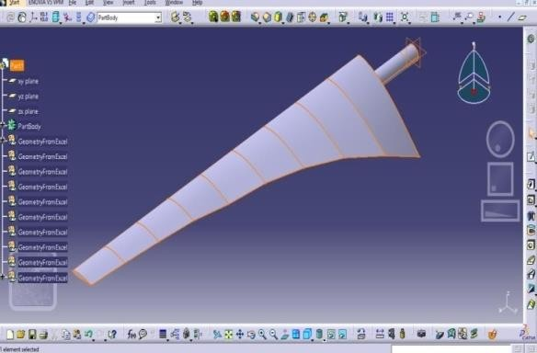

# Fig. Solid model of the twisted blade

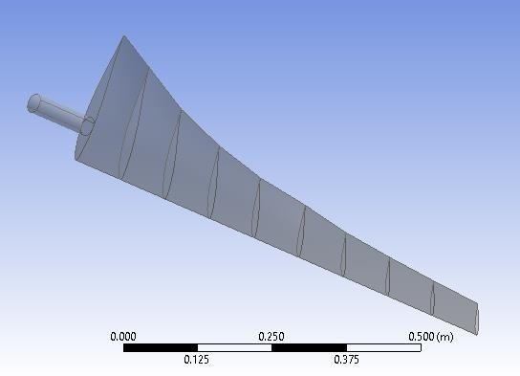

**Fig. Imported solid model**

The igs file is opened in ANSYS workbench for modal analysis. The modal analysis tool is invoked, the materials are given and the geometry is imported into the workbench. The total deformation and first five natural frequencies are obtained and their mode shapes are recorded.

# INTRODUCTION TO ANSYS

To evaluate a broad range of issues encountered in engineering mechanics, ANSYS is a large-scale multipurpose finite element programmed created and maintained by ANSYS Inc.

# Basic Steps in FEA

* DISCRETIZATION of the domain
* Application of Boundary conditions
* Assembling the system equations
* Solution for system equations
* Post processing the results.

# ANALYSIS PROCEDURE IN ANSYS:

Designed component in CATIA workbench after imported into ANSYS workbench now select the steady state thermal analysis.

1. ENGINEEERING MATERIALS (MATERIAL PROPERTIES).
2. CREATE OR IMPORT GEOMENTRY.
3. MODEL (APPLY MESHING).
4. SET UP (BOUNDARY CONDITIONS)
5. SOLUTION
6. RESULTS

# STATIC STRUCTURAL ANALYSIS

The static structural analysis determines the stresses, displacements, shear stress, and forces that are brought on by a load that has minimal damping and inertia effects. It is believed that the loads and the structure's response would remain stable over time and will only gradually change. The ANSYS WORKBENCH solver can be utilized to simulate a static structural load. The several types of loading that can be used in a static analysis include, as shown in the following figures, selecting static structural application, applying material properties in engineering data, selecting geometry import, and selecting model create. Apply boundary conditions in setup.

# MESHING

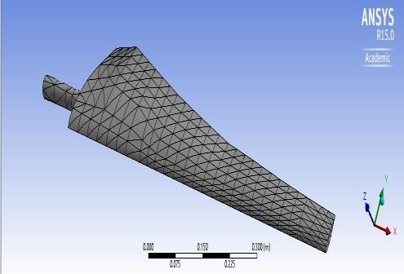

Mapped Mesh of the blade

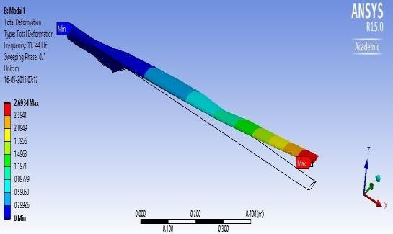

1st Flap wise Bending Mode shape

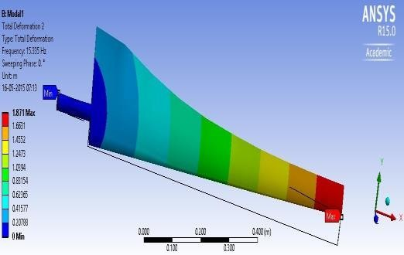

1st Edgewise Bending Mode shape

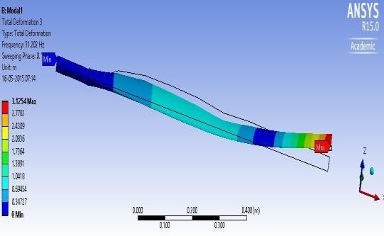

Combined Bending Mode shape

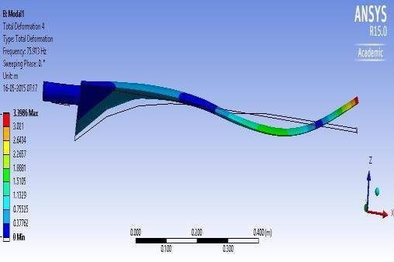2nd Flap wise Mode shape

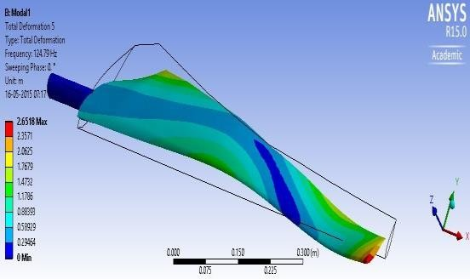

Torsional Mode shape

# MODAL ANALYSIS:

Using ANSYS 15.0 workbench, the modal analysis tool is invoked, the material properties aregiven, and the geometry is imported into the workbench. Above fig shows the mesh details for 3 D model using tetrahedral beam elements. The total deformation and first five natural frequencies are obtained and their mode shapes are recorded.

Aerodynamic and elastic forces occurring cause aero- elastic vibrations, and these vibrations arise around all three axes. First, the rotor blades generally vibrates across the plane in which rotor rotates in flap- wise direction (1st mode). Further, rotor blades vibrate in the plane edge wise. Further in mode shapes, the blades simultaneously vibrate along 2 directions (sway).

# Effect of Rotational Speed on Natural Frequencies

Constant speed Analysis is helpful to examine the effect of system parameters on the natural frequencies of undamped free vibrations of a tapered wind turbine blade rotating at various speeds from 0rpm to 50 rpm.

Graphs are plotted as shown in Figures 4.8 to

4.10 between the frequency of flap- wise

bending, Edge-wise bending and torsional bending modes with increase in the rotational speed of the blade.



Flapwise bending

1

12

11.476 11.461

11.1

10.3

1

9.22

8

6

0

1

2

3

4

5

Rotational speed

Variation of Flapwise Bending mode with respect to rotational speed



Torsional mode

14

3

142.

14

2

139.

14

137.

13

13

13

136.

136.

135.

0 1

2

Rotational

3

4

5

Variation of Torsional Bending mode with respect to rotational speed

λ

Variation of Edgewise Bending mode with respect to rotational speed



Edgewise bending

18

1~~5.~~

403

14.

13.8

12.5

11.9

11.7

16

14

12

10

1

2

3

4

5

Rotational speed



40

35

30

5

6

7

25

20

15

0 . 2 0 . 3 0 . 4 0 . 5 0 . 6 0 . 7 0 . 8 0 . 9 1 . 0

Distance from root, r (m)

Twist distribution variation for different

taper ratios

Frequency, (Hz)

Twist angle, φT (deg)

It is observed from the above figures, that the value of natural frequencies are more in torsional bending mode compared to the flap- wise bending mode and edge- wise bending mode. It is also seen that in the torsional mode, the trend of natural frequencies are seen to decrease until 20 rpm and then increase. This can be noted that optimal speed of the wind turbine operation must be more than 20 rpm in order to ensure safety of the component.

# Effect of tip speed ratio on the chord & Twist distributions of the blade

Graphs are plotted between the distances from the root to the chord length and twist distributions for different values of tip speed ratios.



3

5

2

6

3

2

7

15

10

0.12 0.22 0.32 0.42 0.52 0.62 0.72 0.82 0.92 1.02

Chord distribution variation for different taper ratios



160

140

120

100

80

5

60

6

40

7

20

0

1 1.5 2

2.5 3

Mode

3.5 4 4.5 5

Modal Variation for different taper ratios

Chord Length, c (cm)

Frequency, Hz

Frequency, Hz

From the figure, it is observed that whenever the tip speed ratio (λ) increases the chord length also increases. From the figure, it is observed that whenever the tip speed ratio (λ) is increases the twisting angle is decreasing. This corresponds to the fact that larger tip speed ratio blades must have lesser chord length to ensure that they rotate faster reducing the overall centrifugal forces ofthe blade.

# Effect of tip speed ratio on the modal characteristics of the blade

Graph is plotted between the first five natural frequencies and mode shapes for different tip speed ratios of 5, 6 and 7 from the results of modal analysis.

From the figure, it is observed that lower tip speed ratios have higher values of modal frequencies. Compared to λ=6 & 7, where the trend of modal frequencies are gradually increasing, the frequencies are found to be increasing at gradual mode until 4th natural frequency for λ=5 and then slope of the curve is observedto decrease.

# Dynamic response Analysis

Dynamic response of the blade subjected to aerodynamic, centrifugal, gravity and gyroscopic loads is computed by using Newmark time algorithm.

FFT response at Tip of blade

0 .05

0 .045

0 .04

0 .035

0 .03

0 .025

0 .02

0 .015

0 .01

0 .005

0

10 11 12 13 14 15

Frequency HZ

FFT spectrum of blade dynamic response It shows that the fundamental frequency f1=10.46 Hz and second frequency f2=12.7 Hz for rotational speed (Ω) of 50 rad/s. These frequencies are found to be slightly more than the free vibration frequency due to the additional centrifugal stiffening & geometric stiffening effect due to the rotational velocity of the blade.

The Edge-wise flexure angle response (β) and the f lap-wise Flexure Angleresponse (γ) are shown below.

node trajectory at end of blade

Flexure Angle Response, β

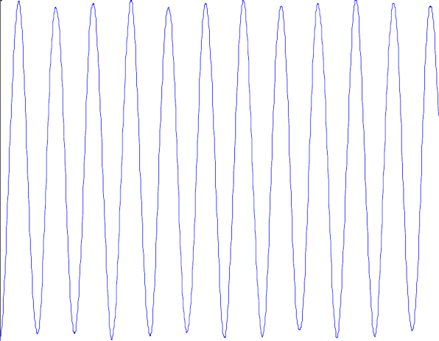

0.012 node trajectory at end of blade 0.01

0.008

0.006

0.004

0.002

0

0 0.1 0.2 0.3 0.4 0.5 0.6 0.7 0.8 0.9

Flexure Angle Response, β

Flap-wise beating at the blade end

It is observed that amplitudes of edge-wise beating is less (in range of 1*10 -4) but the frequency of vibration is more whereas in the flap-wise beating, the amplitudes are more (in order of 0.012) but frequency of vibration is less.

There is negligible difference with responses of considering all loads, and aerodynamic loads alone. But since aerodynamic load are profile dependent, and not time dependent, its effect on dynamic displacement response is null.

# CONCLUSION

High speed rotating wind turbine blade dynamic analysis has been conducted in this work. From the available literature, various forces acting on the blade are accounted and the tapered-twisted aerofoil profile of the blade was generated as a 3D model. By computing element wise cross sectional details from 3D model, a one dimensional finite element beam modeling was considered to discretize the blade from the hub center. Also, a method proposed in literature for the blade dimensions selection was adopted to get the optimum chord and twist angle when the blade tip speed ratio, airfoil type & length of the blade are specified as inputs. The entire work concentrates on the beam finite element modeling of the blade. The modal and transient analysis studies are conducted using

10 beam elements with 6 degrees of freedom per node. It was considered that the blade is fixed at the hub rigidly with five degrees of freedom constrained. The effect of rotational speed on variations of the natural frequencies with the system parameters are given and it is found that with increase in speed, torsional modes vary at larger extent compared to flap- wise and edge-wise modes. Three blade models

having tip speed ratios of λ=5, 6 and 7 are considered and the effect of tip speed ratio on the chord & twist distributions and on the modal characteristics are studied. The results show that at tip-speed ratio (λ=6), the torsional frequencies are more. Dynamic response by considering various loading conditions of blade displacement, and edge -wise, flap-wise beating responses are obtained and studied. Results are very interesting indicating the effects of aerodynamic load, centrifugal loads and gravity on the tip response. These results are helpful for the design of blades to avoid resonant conditions.

# REFERENCES

1. Nitin Tenguria, N.D. Mittal, Siraj Ahmed, “*Aerodynamic Design of a HAWT Blade for Indian Wind Condition”,* International Journal of Advances in Engineering, Science & Technology (IJAEST), Vol. 1 No.7, September – November 2011, pp 37-41.
2. John McCosker, *“Design and optimization of a small wind turbine”,* Rensselaer Polytechnic Institute, Hartford, Connecticut, December 2012, pp 1-56.
3. M. Anjali, C. Tara Sasanka, Ch. Deva Raj, K. Ravindra, “*Meta Heuristic Method for the Design Optimization of a Wind Turbine Blade”,* International Journal of Current Engineering and Technology, ISSN 2277 – 4106, Special Issue -3, April 2014, pp 175-179.
4. Chalothorn Thumthae, Tawit Chitsomboon, “*Optimal Pitch for untwisted blade horizontal axis wind turbine”,* 2nd Joint International Conference on “Sustainable energy and environment SEE, November 2006, pp 1-6.
5. Juan Mendez, David Greiner, “*Wind blade chord and twist angle optimization by usinggenetic algorithms”*, Intelligent systems & Numerical Applications in Engineering, Spain 2011, pp 4-19.
6. Wang Yongzhi, Li Feng, Zhang Xu, Zhang Weimin, ”*Composite Wind Turbine Blade aerodynamic and structural integrated design optimization based on RBF meta- model”,* China Academy of Aerospace Aerodynamics, May 2007, 830: 10-18.
7. K. Dykes, A. Platt, Y. Guo, et al. *“Effect of Tip speed constraints on the optimized design of a wind turbine”,* National renewable energy laboratory, NREL/TP-5000- 61726, October 2014, pp 1-77.
8. Grant Ingram, “*Wind Turbine Blade Analysis using the Blade Element Momentum Method, Version 1.1”,* October 18, 2011, pp 1-21.
9. Naishadh G. Vasjailiya, Sathya N. Gangadharan, “*Aero-structural design optimization of composite Wind Turbine Blade”,* 10th World Congress, 2013, pp

201-217.

1. Ahmad Sedaghat, M. El Haj Assad, Mohamed Gaith, “*Aerodynamics Performance of continuously variable speed horizontal axis wind turbine with optimal blades”,* EnergyVol 77, December 2014 752-769.
2. Scott Larwood, C.P. Van Dam, Daniel Schow, “*Design Studies of swept wind turbine blades”,* Renewable Energy 71 (2014) 563 – 571.
3. K. Turgut Gursel, Tufan Coban, Aydogan Ozdamar, “*Vibration Analysis of rotor blades of a farm wind power plant”,* Mathematical and Computational applications, Vol. 17, No. 2, 2012, pp. 164-175.
4. Gunner C. Larsen, Morten H. Hansen, Andreas Baumgart, Ingemar Carlen, “*Modal Analysis of Wind Turbine Blades”,* Risφ National Laboratory, Roskilde, Denmark February 2002, pp 1-72.
5. Chao Liu, Dongxiang Jiang and Jie Chen, “*Vibration Characteristics on a Wind Turbine Rotor using Modal and Harmonic Analysis of FEM”,* 978-1- 4244-8921-3/10 IEEE 2010, pp 1-5.
6. O Pabut, G Allikas, H Herranen, R Talalaev, K Vene, “*Model Validation and structural analysis of a small wind turbine blade”,* 8th International DAAAM Baltic Conference, Industrial Engineering, 19-21 April 2012, pp 1-10.
7. Saad Sami, Behzad Ahmed Zai, M. Amir Khan,”*Dynamic Analysis of a 5KW Wind Turbine Blade with experimental Validation”,* Journal of Space Technology, Vol. 4, No-1, July 2014, pp 82- 87.
8. Fangfang Song, Yihua Ni, Zhiqiag Tan, “*Optimization Design, Modelling and Dynamic Analysis for Composite Wind Turbine Blade”,* International Workshop of Automobile, Power and Energy Engineering, Procedia Engineering, 16 (2011) 369- 375.
9. Zhu Jie, Cai Xin, Pan Pan, “*Static and Dynamic Characteristics Study of Wind Turbine blades”,* Advanced Materials Research Vols 433-440 (2012) pp 438-443.
10. Xin Cai, Pan Pan, Jie Zhu, Rongrong Gu, “*The Analysis of the aerodynamic characterand structural response of Large Scale Wind Turbine Blades”,* 6, , Journal of Energy, 2013, pp 3134-3148.
11. T. Inoue, Y. Ishida and T. Kiyohara, “*Non Linear Vibraiton Analysis of wind turbine blade (occurrence of the super harmonic resonance in out of plane vibrations of the elastic blade”,* J. Vibration and acoustics, Trans. ASME, Vol. 134, pp. 0310091 -10, 2012.
12. L. Li, Y. Li, Q. Liu and H. Lv, “*Dynamic Characteristics of lag vibration of wind turbine blade*”, Acta Mechanica Solids Sinica, Vol. 26, pp. 592 – 602.
13. L. Li, Y. H. Li, Q. K. Liu, H. W. Lv, “*A Mathematical Model for Horizontal axis wind turbine blades”,* Applied mathematical Modelling 38 (2014) 2695- 2715.
14. L. Li, Y. H. Li, H. W. Lv, Q. K. Liu, “*Flapwise dynamic response of a wind turbine blade in super- harmonic response”,* Journal of Sound and Vibration 331 (2012) 4025-4044.
15. Hamdi H, Mrad C, Hamdi A, Nasri R, “*Dynamic response of a horizontal axis wind turbine blade under aerodynamic, gravity and gyroscopic effects”*, Applied Acoustics,July 2013, pp 1-11.
16. V. Karadag, “*Dynamic analysis of Practical Blades with Shear center effect”,* Journal of Sound and Vibration (1984) 92(4), 471-490.
17. Martin Nymann Svendsen, Steen Krenk, jan Hogsberg, “*Resonant Vibration control of rotating beams”,* Journal of Sound and Vibration 330 (2011) 1877-1890.
18. M. Keerthana, M. Sriramkrishnan, T. Velayutham, A. Abraham, S. Selvi Rajan, K. M. Parammasivam, “*Aerodynamic analysis of small Horizontal axis wind turbine using CFD”,* Journal of Wind and Engineering, Vol. 9, No.2, July 2012, pp. 14-28.
19. Yangfeng Wang, Ming Liang, Jiawei Xiang, “*Damage detection method for wind turbine blades based on dynamic analysis and mode shape difference curvature information”,* Mechanical Systems and signal processing 48 (2014) 351-367.
20. Mu Chu, Philip Clausen, “*The Dynamic Response of Small Horizontal Axis Wind Turbine Blade operating in Highly Turbulent Flow”,* Solar 2014, 52nd Annual conference of the Australian Solar Council, Melbourne, May 2014, 2323 1-17.
21. Yuqiao Zheng, Rongzhen Zhao, Hong Liu, “Dynamic response of flexible wind turbineblade”, Telkomnika, Vol 11, No. 12, December 2013, pp, 7052-7057.