**DESIGN OF A MICRO CONTROLLER BASED TRAFFIC LIGHT CONTROLLER SYSTEM FOR CONGESTION AND EMERGENCY SITUATION**

**Ezeugonna Franklyn Ifeanyi, Okoro Ugochukwu Samuel, Okere Promise**

Graduate, Electrical and Electronic Engineering, Federal University of Technology, Owerri, Imo Nigeria.

Graduate, Electrical and Electronic Engineering, Federal University of Technology, Owerri, Imo Nigeria

Graduate, Electrical and Electronic Engineering, Federal University of Technology, Owerri, Imo Nigeria

**ABSTRACT**

Traffic is a major challenge in many cities in the world today dictated by devices such as traffic lights. Traffic lights have become an integral part of human day-to-day life. Problems associated with such traffic light usage includes lateness of workers to work, fatigue of traffic warders and vehicle owners, accidents due to collisions, bribery and corruption by traffic warders, bad health conditions The basic fixed-time method for traffic light is not always effective which leads to traffic congestion during peak hours as well as threat to emergency situation. This work provides a simple model for the design of a Micro-controller-based traffic controller system during congestion and emergency situation. This was achieved by designing the said traffic light model on proteus as a model as well as writing the C program on Arduino IDE that is now compiled and uploaded to the Atmega 328 chip used. This schematic is now implemented to a real-life model traffic light controller system model. The components used here are the Atmega 238 micro-controller, arduino uno board, infra-red sensors, buzzer, blue, green and red leds for emergency and congestion situation. The designed traffic light controller was able to last for 9secs for the various conditions of emergency and congestion situation. For congestion situation, any obstruction to the sensors switches on the green light to the affected lane and the rest to red. During emergency situation, obstruction to the infra-red sensors switches on the buzzer, blue and red lights to the various three lane road.

**Keywords:** Arduino Uno, Control System, Embedded Systems, Infra-Red Detection, Micro controllers, Programming, Traffic Light,

1. **INTRODUCTION**

**1.1 General Overview**

Transportation has always been a crucial part of human activity as fast transportation systems and rapid transit systems are nerves of economic developments for any nation [1]. Traffic is a major challenge in many cities in the world today. In many instances traffic flow is dictated by devices such as traffic lights.

Traffic lights have become an integral part of human day-to-day life [2]. Traffic lights are the signaling devices that are placed on the intersection points and used to control the flow of traffic on the road. Normal traffic light systems operate on timing mechanisms that change the light after a given interval to control flows roads by displaying lights of a standard color (red, yellow/amber, and green). The traffic lights have given many benefits to all road users [3]. Besides reducing the number of accidents, it made the traffic flow go smoothly and reduce time wastage due to traffic jam.

For the purpose of this design, micro-controllers like the Arduino based type was chosen and sensors were used for implementation. A micro-controller is a general-purpose device, which integrates a number of the components of a microprocessor system on to a single chip [4]. It has inbuilt CPU, memory and peripherals to make it as a mini computer. The various types include Atmel chips, PIC chip, 8085, 8051 micro-controllers etc. Sensors were also used. These are devices calibrated to a known standard which measure a physical quantity and outputs its reading to an observer or external device. Its types include: Thermal Sensors like RTD, Thermocouple, Proximity sensors like infra-red sensors, pressure sensors, flow meter. Infra-red sensors were chosen for this work as it gives signal in obstruction of the specified range [5]. The coding, compiling and uploading of codes can be done by using Arduino IDE while design and simulation process can be implemented with proteus software. Traffic congestion may result due to heavy traffic at a junction. Traffic congestion has not been settled fully due to the limited traffic management techniques available. Real situations are generally continuously changing and the system has to adapt itself to change in the continuously changing circumstances [6].In this work, an attempt to provide some traffic management strategy which is self-changing in nature has been made. This is done so as to fit in to continuously changing real time traffic scenarios. In this design, time is assigned to traffic light of particular lane according to the traffic density on the road [2].

This project provides a solution to road traffic problems in large cities through the design and implementation of a micro-controller-based traffic controller system for congestion and emergency situation. This technique has been applied in developed countries like the U.S.A, China and Germany [7].

**1.2 Problem Statement**

Traffic congestion situation is seen as a major problem on road usage as it generally slows economic development of a region. This may lead to death during emergency. Also, there may be high petrol usage consumption as motorist spends more time on the road. Noise pollution from vehicles and drivers can be hazardous to human life. Lateness of workers to work is seen as a major setback to economic growth as a result of time wastage. Fatigue of traffic warders and vehicle owners is also a major problem to road transportation. Accidents due to collisions during congestion may be hazardous to both the victim and the owner. Bribery and corruption by traffic warders on road intersections is also a stigma to transportation system as it increases the rate of lawlessness on motorist.

**1.3 Objectives of Study**

The aim of this work is to design a micro-controller based traffic controller system for congestion and emergency situation.

**1.3.1 Specific Objectives**

The specific objectives are:

1. to design a micro-controller-based traffic controller system for congestion and emergency situation.
2. to use Arduino IDE to code, compile and upload the C program into the Atmega 328 micro controller.
3. to use Proteus to construct and simulate the circuit.

**1.4 Justification of Study**

It is indisputable that transportation has become an inevitable part of life. These impressive advantages that transportation has offered have been overshadowed by many hazards which uncontrolled transportation can cause.

1. Fundamentally, the use of this micro-controller-based traffic light controller device in the real world can control traffic flow, as well as reduce death threats during emergency cases as the vehicles get to these points. These devices can also reduce the rate of accidents on the road if obeyed by drivers. It enables pedestrian and motorist to get a fair share of the road usage especially when crossing the road. It is able to curtail congestion cases on roads due to delay of IR sensors showing congestion. Traffic Light controller system for emergency and congestion situation can so reduce the frequency of road congestions and emergency situations there by creating a good health environment as well as early and economical job functions.
   1. **Scope of Work**

This work covers a three way road system with emergency passage for a traffic light situation of red, blue and green light. Vehicle movement can be detected using infra-red sensors(IR Transceiver) and atmega 328 p chip.Traffic control in this report is just restricted to density based road traffic control using red and green leds and emergency situations using red and blue leds.A single emergency passage is also implemented which sounds a buzzer to alert the drivers of such situation as well as a blue and red LED indication to signify such situation when the buzzer may not be loud enough to do so. A 74HC 595 Shift Register was also used for this project to create more pins for the micro-controller used.

**LITERATURE OVERVIEW**

**2.1 History of Traffic Light Controller Systems**

Ever since Roman times, society has tried to control traffic. Even the fabled Roman road system created a conflict between pedestrian and equine travelers. However, a practical solution was not developed until the mid-nineteenth century, when J. P. Knight, a railway signaling engineer, created the first traffic signal, which was installed near Westminster Abbey in London, England in 1868. Unfortunately, the device exploded, killing a police officer, and its use was discontinued after being in operation for only a short time [8].

The modern traffic light was invented in America. New York had a three-color system in 1918 that was operated manually from a tower in the middle of the street. Other cities soon adopted the idea of having someone on the scene to control the lights. Garrett Morgan, inventor of the gas mask, also developed traffic signaling devices. Having witnessed an accident between a car and a carriage, Morgan felt compelled to devise a system to prevent such collisions at street intersections. In 1923 he patented an electric traffic light system using a pole with a cross section on which the words STOP and GO were illuminated.

These basic designs were soon improved. In 1926 the first automatic signals were installed in London; they depended on a timer to activate them. In the 1930s vehicle-activated lights were created in which cars rolled over half-buried rubber tubes. Air in the tubes was displaced by the weight of the car rolling over them, and the increased pressure operated an electric contact, activating the lights. But these tubes wore out quickly. A better idea was the inductive-loop device: a loop of wire was imbedded in the road itself and connected to a box controlling the lights; a current of electricity passed through the loop, and when the steel body of a car passed overhead, it produced a signal that activated the light.

Today, traffic is automatically routed onto limited access highways courtesy of a computer activated guidance system that determines traffic volume on the highway. Global positioning satellite systems (GPS) are installed in many cars. These systems connect with a satellite and inform drivers where they are and possible routes to their destination. Such systems will eventually enable a drive to determine the best route to a destination given prevailing traffic conditions [5].

**2.2 What actually is Traffic Light controller?**

Before talking about traffic light controller, an issue has to be addressed which is traffic and traffic congestion and emergency situation.

Transportation has always a crucial part of human civilization. As there is a huge increase in number of vehicles, managing the traffic becomes a smart task. Traffic congestion is seen as the overcrowding of a junction road. In the present day especially in Nigeria, the vehicle problem is increasing and Traffic congestion is a severe problem in many modern cities all over the world. To overcome the problem, we have come up with an exclusive idea for a dynamic and automatic traffic light control expert system. Traffic light optimization is a big problem. Even for single junction there is no optimal solution. The problem becomes even more complex with multiple junctions, as the state of one light is responsible for the flow of traffic of that road only. Another complication is that the flow of traffic density frequently changes, depending on the time of day, the day of the week, and the time new year [9].

Traffic light controller is an embedded hardware device capable of giving out road signal*s* for directing vehicular traffic by means of colored lights*,* typically red for stop, green for go, and yellow for proceed with caution.

Traffic-signal control systems coordinate individual traffic signals to achieve network-wide traffic operations objectives. These systems consist of intersection traffic signals, a communications network to tie them together, and a central computer or network of computers to manage the system. Coordination can be implemented through a number of techniques including time-base and hardwired interconnection methods. Coordination of traffic signals across agencies requires the development of data sharing and traffic signal control agreements. Therefore, a critical institutional component of Traffic Signal Control is the establishment of formal or informal arrangements to share traffic control information as well as actual control of traffic signal operation across jurisdictions. Signal coordination systems are installed to provide access. A traffic-signal system has no other purpose than to deliver favorable signal timings to motorists. The system provides features that improve the traffic engineer’s ability to achieve this goal. These are primarily access features. They provide access to the intersection signal controller for maintenance and operations. The completer and more convenient the access, the more efficient the operator will be and the more effective the system. In addition to control of traffic signals, modern systems also provide wide-ranging surveillance capabilities, including various kinds of traffic detection and video surveillance. They also provide more powerful traffic-control algorithms, including the potential for adaptive control and predictive surveillance [10].

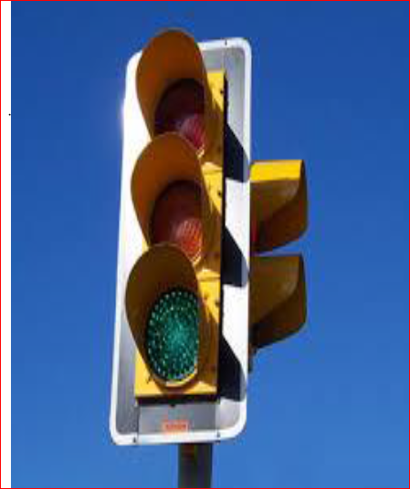

**Fig 2.1: A simple road traffic light controller [11]**

The typical sequences of colour phases used in typical lighting system include:

1. Illumination of the green light allows traffic to proceed in the direction.
2. Illumination of the orange light denoting for prepare to stop.
3. Illumination of the red signal prohibits any traffic from proceeding [11].

Traditionally, incandescent and halogen bulbs were used. Because of the low efficiency of light output and a single point of failure (filament burnout) municipalities are increasingly retrofitting traffic signals with LED arrays that consume less power, have increased light output, last significantly longer, and in the event of an individual LED failure, still operate albeit with a reduced light output. With the use of optics, the light pattern of an LED array can be comparable to the pattern of an incandescent or halogen bulb. The low energy consumption of LED lights can pose a driving risk in some areas during winter. Unlike incandescent and halogen bulbs, which generally get hot enough to melt away any snow that may settle on individual lights, LED displays – using only a fraction of the energy – remain too cool for this to happen.

**2.3 The Three Colors and Their Meanings**

There are three colors (or traffic lights):

1. **Red - personal for named recipients only**

In the context of a meeting, for example, RED information is limited to those present at the meeting. In most circumstances, RED information will be passed verbally or in person.

1. **Amber - limited distribution**

The recipient may share AMBER information with others within their organization, but only on a “need-to-know” basis. The originator may be expected to specify the intended limits of that sharing.

1. **Green - community wide**

Information in this category can be circulated widely within a particular community. However, the information may not be published or posted publicly on the Internet, nor released outside of the community [12].

Transportation has always a crucial part of human civilization. One of the principal challenges in traffic control is to accommodate the traffic in a safe and efficient way. The management of traffic to reduce or eliminate accidents, is the other critical reason for traffic control .In road traffic, intersections with traffic lights (i.e., green, amber, and red indications) will often add a separate lane with a lighted green arrow to allow left turns with no opposing traffic. This frequently results in longer non green periods at the intersection, causing an increased delay and a reduction in efficiency and mobility. Traffic control will always be burdened with seeking to satisfy the frequently conflicting goals of safety and mobility [13].

Several measures had been deployed to address the problem of road traffic congestion in large cities in Nigeria; namely among these are: the construction of flyovers and bypass roads, creating ring roads, posting of traffic wardens to trouble spots and construction of conventional traffic light based on counters. Traffic lights are essentially used at junctions or intersections.

**2.4.1 What are Intersections**?

An intersection is a road junction where two or more roads either meet or cross at grade (i.e. are at the same level). An intersection may be 3-way, a T-junction/T intersection or fork, 4-way – a crossroads, or 5-way or more. Itmay often be controlled by traffic lights, and may have a roundabout or an island.

**2.4.2 Types of Intersections**

These include**:**

i. **3-Way Intersection** - A junction between three road segments (arms), is a T junction (two arms form one road) or a Y junction. In this project work, a 3way intersection is considered.

ii. **4-Way Intersections:** This usually involves a crossing over of two streets or roads. In areas where there are blocks and in some other cases, the crossing streets or roads are perpendicular to each other. However, two roads may cross at a different angle. In a few cases, the junction of two road segments may be offset from each when reaching an intersection, even though both ends may be considered the same street[14].

The junction used in our project is a tee or three way intersections. At these junctions, Traffic wardens play a role at controlling traffic as a traditional method. Automatic traffic lights have been deployed and have been proven to be more efficient to an extent. .Emergency lanes are built in some countries on theses lanes which will be considered for the purpose of this work.

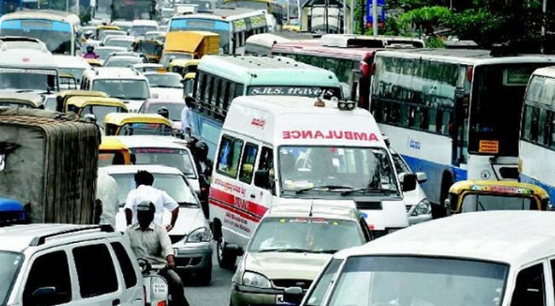

**Fig 2.4: Ambulance experiencing traffic in congested area [15]**

**2.5 Traffic Wardens**

Humans have been used as a means of controlling traffic for a very long time now. Fatigue is a big issue, as tired wardens may forget to watch their traffic, or may inadvertently turn their "Stop bats" to the "Slow" position. Traffic Wardens do engage in bribe collection and sometimes conflict which can be disadvantageous to their job functions.

This measure however, had failed to meet the target of freeing major 4-way intersections resulting in loss of human lives and waste of valuable man hour during the working days. The decision to install a traffic signal controller depends on the conditions at the intersection meeting one of a series of warranting conditions, as defined in the Manual on Uniform Traffic Control Devices. Briefly, the conditions generally thought to warrant traffic-signal operation follow.

1. **General Traffic Volumes**: When traffic volumes at most of the intersection approaches reach the point where other forms of control cannot efficiently assign right of way to the approaching motorists.
2. **Interruption of Continuous Traffic**: When traffic on a major street is so heavy that traffic on a lightly travelled side street has little opportunity to cross or enter the main-street traffic. This condition requires heavier traffic on the main street than the previous condition, but allows lighter traffic on the side street.
3. **Pedestrian Volumes**: When pedestrian traffic is heavy enough to justify the interruption of vehicular traffic.

iv**. School Crossings**: If judged necessary by the traffic engineer, a traffic signal may be used to facilitate the crossing of school children.

1. **Progressive Movement**: Sometimes a traffic signal will help keep platoons of cars tightly formed to enhance the coordinated flow along a street and encourage an appropriate speed.
2. **Accidents**: Traffic signals are sometimes effective in reducing accidents that result from the inability of motorists to safely assign their own right of way. These accidents typically involve right-angle collisions.

Once a traffic signal is installed, it may be operated one of two ways: pre-timed or actuated. In practice, the installation of isolated pre-timed intersections has become rare. Most signals in isolated circumstances control highly variable traffic, and therefore work better when actuated by traffic.

1. **Pre-timed Operation**

In this form of operation, the red, yellow, and green indications are timed at fixed intervals. Pretimed operation assumes that the traffic patterns can be predicted accurately based on time of day. As previously mentioned, this predictability can usually only be achieved by controlling the traffic entering the intersection with upstream signals, as in a system. In isolated locations, however, the traffic approaching the intersection arrives randomly, and is not usually predictable enough to make pre-timed operation a good choice. But pre-timed operation does not require traffic detectors at the intersection, and is therefore much cheaper to install. Consequently, pre-timed operation is usually used at isolated intersections only when funds do not allow actuated operation.

1. **Actuated Operation**

Intersections with this form of control consist of actuated traffic controllers and vehicle detectors placed in or on the roadways approaching the intersection. In actuated operation, the control algorithm is primarily concerned with when green intervals terminate [17].

For traffic congestions at various intersections, such smart applications can be carried out using either of IR detection and Arterial Video Surveillance. This work is based on IR Sensor based and micro-controlled controlled Traffic control systems for both congestions and emergency situations. The emergency situation here is interpreted by using a buzzer as an alarm system.

**2.6.1 The Infra Red Detection**

IR sensor is the combination of IR LED with Photo Diode. After this combination we are connecting the Darlington Pair Transistor. End of the IR sensor we have to connect a NOT gate for the inverting purpose means low input have corresponding low output. At last this entire connector is connected to any one external interrupt to generating the interruption of the main program. Infra-Red actually is normal light with a particular colour. We humans can't see thiscolour because its wave length of 950nm is below the visible spectrum. That's one of the reasons why IR is chosen for remote control purposes, we want to use it but we're not interested in seeing it. Another reason is because IR LEDs are quite easy to make, and therefore can be very cheap. This project work is majorly on this type as a prototype design shall be made. The idea is all about giving priorities to the completed sensor circuitry. This gives a signal when prototype vehicles fill the sensor path. The sensor gives a signal to the microcontroller which releases the green light on the traffic light controller system to the much densed lane that completes the sensor path [7].



**Fig 2.5:Traffic Light Control Module Using Sensor[7]**

**2.6.2 Arterial Video Surveillance**

Its usage can solve problems relating to the congestion phase solution as a camera here is employed. This is called Video surveillance systems (CCTV) are systems used to verify and monitor traffic and incidents. They are also used to determine the type of assistance required. Each system consists of various elements including camera units, a controller cabinet housing the control equipment, and the communication system that connects the camera to a control center. The primary objective of an arterial CCTV system is to provide surveillance of arterial sections, intersections, visual confirmation of incidents, and information on the types of assistance that will be required [17].

**2.7.1 Advantages of Traffic Light Controller System**

Traffic signals control vehicle and pedestrian traffic by assigning priorities to various traffic movements to influence traffic flow. Properly designed, located and maintained traffic signals have one or more of these advantages:

1. Provide for orderly movement of traffic.
2. Increase traffic-handling capacity of an intersection;
3. Reduce frequency and severity of certain types of crashes, especially right-angle collisions.
4. Provide for continuous movement of traffic at a definite speed along a given route.
5. .Interrupt heavy traffic at intervals to permit other vehicles or pedestrians to cross.

**2.7.2 Disadvantages of Traffic Light Controller System**

Traffic signals are not a solution for all traffic problems at intersections, and unwarranted signals can adversely affect the safety and efficiency of traffic by causing one or more of the following:

1. Excessive delay.
2. Increased traffic congestion, air pollution and gasoline consumption.
3. Disobedience of signals.
4. Increased use of less-adequate streets to avoid traffic signals.
5. Increased frequency of crashes, especially rear-end collisions.

**2.8.1 What is the purpose of a traffic signal?**

Traffic signals are designed to ensure an orderly flow of traffic, provide an opportunity for pedestrians or vehicles to cross an intersection and help reduce the number of conflicts between vehicles entering intersections from different directions.

**2.8.2 How do traffic signals work?**

Fixed-time signals follow a predetermined sequence of signal operation, always providing the same amount of time to each traffic movement, whether traffic is present or not. Actuated signals change the lights according to the amount of traffic in each direction. They use various types of sensors to detect vehicles, and adjust the length of the green time to allow as many vehicles as possible through the intersection before responding to the presence of vehicles on another approach.

**2.8.3 When should signals be considered?**

Traffic signals should be considered when they will alleviate more problems than they create. A warranted signal properly operated may provide for more orderly movement of traffic, and reduce the occurrence of certain types of collisions. However, traffic signals function by stopping traffic, and whenever a vehicle is stopped on the road, the potential for a crash is created. As a result, unwarranted signals can result in increased crashes, delays and congestion [16].

**2.8.4 Constituent of a Traffic Light System**

**i. A Display:** It is the basic [traffic signal display](http://www.edgefxkits.com/density-based-traffic-signal-system) which the vehicle driver or the commuter can see. It can be a conventional incandescent discharge lamps or an arrangement of LED.

**ii.A Detector unit:** It is the unit which detects the presence of vehicles and sends this information to the controller to be processed.

**Practically there are two types of Detectors:**

1. **Inductive Loop Detector:** It consists of a coil of wire embedded into a groove on the road surface which is sealed with a rubber.  It detects change in frequency. The inductor coil is connected with the detector which detects the change in resonant frequency of the coil loop and accordingly controls the triggering of the relay which is used to trigger the traffic signals. Basically, it works on the principle that when a car moves over the inductor coil, the inductance of the coil decreases. This decreased inductance causes the resonant or oscillation frequency to increase and the electronics unit accordingly sends electric pulses to the control unit to control the switching of traffic lights. However, a disadvantage of such system is the inductor loops are prone to electromagnetic interference, i.e. electromagnetic radiation from other devices can also affect the magnetic field and hence the inductance of the coil. They are also more prone to failure and require high installation cost and also cause disruption of traffic.

[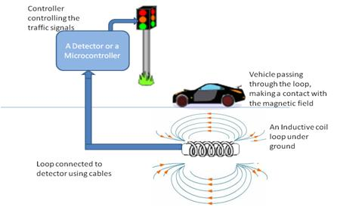](https://www.elprocus.com/wp-content/uploads/2013/09/Traffic-Signal-Control-using-Inductive-Loop-Detector.jpg)

**Fig 2.7:Traffic Signal Control using Inductive Loop Detector [18]**

**b. Sensors mounted on the Poles:**It can be a simple IRLED-Photodiode arrangement or a video detection unit which can detect the presence of vehicles. This works on the principle that when a car passes between the IR transmitter and IR receiver, the IR light is blocked and as the result the resistance of the photodiode increases. This change in resistance can be converted to electrical pulses, used to control the traffic lights.

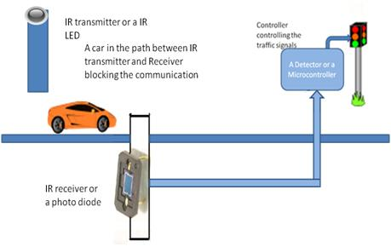

**Fig 2.8.0:Sensors mounted on the Poles[18**

1. **A controller unit:** It is the unit which receives the detector output which gives an indication of the presence of vehicles and thereby makes a calculation of the traffic density and accordingly controls the display unit. It can be a microprocessor-based computer or a simple microcontroller.

The work being smart is all about the use of sensors and programmable microcontrollers in the traffic control system. What are Sensors and Microcontroller?

**2.8.5 Sensors**

A sensor is a device calibrated to a known standard which measures a physical quantity and outputs its reading to an observer or external device. The type of sensor employed here is a proximity sensor which is based on sensing between the sensor and sensed distance. Sensors used in the Wireless Sensor Network for traffic signal systems are mainly of two types: Intrusive type and non-Intrusive type

**i) Intrusive types:** These sensors are kept under the road and sense the traffic waiting at the signal. This type of sensor has the same working principle as that of a metal detector.

**ii) Non-Intrusive types:** These sensors are fitted on the road. The installation of this type of sensor is easy as no cutting of road is needed to be done. Non-intrusive sensor includes acoustic sensors or video image processors to detect the presence of vehicles waiting at the traffic intersection. Although Intrusive sensors are very effective still non-intrusive sensors are preferred over Intrusive sensors as they are cost-effective, easy to install, immune to natural corrosion and degradation [18].

**2.8.6 Micro-controller**

Microcontroller is a general-purpose device, which integrates a number of the components of a microprocessor system on to a single chip. It has inbuilt CPU, memory and peripherals to make it as a mini computer.

Microcontroller ATMEG 328 is the brain of the project which initiates the traffic signal at a junction. The leds are automatically on and off by making the corresponding port pin of the micro controller high. A seven-segment display also connected to display the timing of each signal.

Microcontroller based traffic control system is an application specific project, which is used to control the traffic. An embedded system is developed which consists of a micro-controller, IR transmitter and receiver, LED’s. This project is implemented by placing IR transmitters, receivers and LEDs at the 3-way junction. Transmitters and receivers are placed at either side of the three paths, and 3 LED’s at each corner of the junction. When there is a traffic along the paths, value of R would be 00 which are the values of IR sensors and if there is no traffic the value is 11.

For instance, let the traffic at the path R1 be initially 11 i.e., there is no traffic when the traffic reaches the first sensor, the value of R would be 01, if it reaches second sensor, the value of R is 00, it is recognized that traffic is heavy and the led glows which indicates that vehicles can move forward, traffic is cleared, and the sensor values automatically changed to 11. The control goes to the next path when the values of sensors contain a greater number of zeroes. This entire embedded system is placed at that junction Microcontroller is interfaced with LED’s and IR sensors.

**2.9 Review of Related Literature**

The following table shows the previously worked on designed so far on this topic by various authors**.**

|  |  |  |  |  |  |
| --- | --- | --- | --- | --- | --- |
| **S/N** | **Author’s Name** | **Title of Paper** | **Problem solved** | **Components used** | **Deficiency of Work** |
| 1 | Osigwe Uchenna C et all, 2015[19]. | Design and Simulation of an Intelligent Traffic Light Control System | The new system eliminated some of the problems identified in the current traffic monitoring and control systems. | Fuzzy-Logic software was used | This wrok was limited to simulation alone without implementation. |
| 2 | Iskandar Bim Amnudin, 2014[20]. | Pre-emption Sequence of a Traffic Light Controller for Emergency Vehicles | The project was able to run the traffic lights in a normal sequence triggering a pre-emption sequence once the chip receives a trigger signal from the user before resuming it back into the normal traffic light sequence. | Arduino mega chip,leds(green, red and yellow), 4 channel RF modules, banana wires, etc | This designed was based on normal traffic light sequence and limited to four lane road only. |
| 3 | Mohammed Ehsan Satif 2016[3]. | Smart Traffic Controller based on Micro-Controller built a new traffic controller to optimization using the Arduino UNO microcontroller board | system contains switches to control the traffic light manually in cases of congestion. | Ultra sonic sensors, arduino uno micro-controller and board, leds, jam level displayer tools etc | This process is done manually and limited to only traffic jam checking. |
| 4 | Sochum Misra, 2012[21]. | Design of Traffic Light Controller using Timer Circuit | Basic level of safe unmanned traffic signaling with pedestrian crossing request was accomplished. | 555 timer IC, leds ( red,yellow and green), reistors, capacitors, decade counters etc | This process was done based on time count of five seconds for pedestrian crossing which may not be safe in cases of time delay of pedestrian.This was not smart rather manually done. |
| 5 | Ogwo Eme et all, 2015[22]. | Simulation of N-way Traffic Light using Arduino Environment | This system was able to handle road traffic control as well as assisting pedestrians to move by the automatic ON and OFF operation of the traffic light at the specified time and movement assignment to the busiest lane. | Arduino IDE , proteus, resistors, transistors, leds(red, yellow and green,) Arduino uno chip | The light changing speed was fast which was not efficient for the design due to shortage of programming code style. |

**Table 2.1: Review of Related Literature**

**METHODOLOGY**

**3.1 Project Approach**

This chapter explains in detail the methodology and components of this final year project report. Each part and component that has been selected has as its own purpose mostly focused on functionality and low cost. In this chapter also, the technical plan, analysis and also the specifications are being explained.

**3.2 The Proposed System**

The system design is a micro-controller-based traffic light controller system which uses IR sensors are used to measure the density of vehicles which are fixed within a given distance. This is done by:

1. A three way or T intersections is designed.
2. Buzzer and infra-red sensors are implemented on this intersection.
3. Sensor detection and switching of lights is implemented on this design for the congestion and emergency situation.
4. An emergency passage route is also designed on the three-way intersection.
5. Traffic light switching is done on green and red for congestion and blue and red for emergency.
6. Processing of entire system is done by the interfacing of the micro-controller (Atmega 328 chip) and the buzzer, sensor and leds.
7. Sensors for congestion situation are position in such a way that congestion does not occur on the three lanes at the same time.

Method and analysis which is performed in your research work should be written in this section. A simple strategy to follow is to use keywords from your title in first few sentences.

**2.1 Subheading**

Subheading should be Font Size- 10pt, Font Type- Times New Roman, justified.

**2.2 Subheading**

Subheading should be 10pt Times new Roman,

1. **MODELING AND ANALYSIS**

Fluid and Material which are used is presented in this section. Table and Fluid should be in prescribed format.

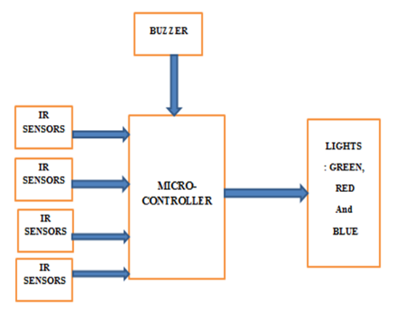

**Fig 3.1: Block Diagram of the Smart Traffic Light System**

**3.3 Operation of the Project**

The micro –controller (Atmega 328) which acts as the brain of the project is programmed to interact with the infra-red and LED display. Infra-red sensors represented by switches on the proteus software are connected to the ports of the microcontroller and traffic light leds are connected to port. If there is traffic on road, then that particular sensor output becomes logic 0 else logic 1. By receiving these IR sensor outputs, a program is written to control the traffic system. If you receive logic 0 from any of these sensors, the micro-controller gives a signal which urn on the green light to that particular path and give red signal to all other paths.IR receiver receives IR rays that are transmitted by IR transmitter. Normally IR receiver has high resistance in order of mega ohms, when it is receiving IR rays the resistance is very low. The operating voltage of IR receiver is also 2 to 3V. IR pair is placed in such a way that when we place an obstacle in front of this IR pair, IR receiver should be able to receive the IR rays. When power is supplied, the transmitted IR rays hit the object and reflect back to the IR receiver. Instead of normal big traffic lights, LEDs (RED, GREEN, BLUE) were used. In normal traffic system, the glowing of the LEDs was on time basis. If the traffic density is high on any particular path, then glows green LED of that particular path and glows the red LEDs for remaining paths. This occurs for all lanes down to nine (9) seconds count During the emergency condition, a special middle lane is constructed. When an obstruction inform of an emergency vehicle moves through the part up to where the infra-red sensors are used it gives a signal with the help of a micro –controller which triggers a buzzer to a nine seconds (9) timer count, the traffic light displays in form of LEDs are all on red and blue indication light. This emergency vehicle moves to another emergency lane within this period. The buzzer used gives a warning signal to all other motorists on the road to hold on for a while. A flow chart for this operation is given below:

**START**

**IR sensor, arduino uno and atmega chip,leds,buzzers, resistors**

**Micro-controller used is programmed to receive signal from the sensors to sound the buzzer and glow the leds.**

**IR sensors sense obstruction in the congestion lane road**.

**low**

**High**

**YES/NO**

**Signals the micro-controller to switch on the green and red leds for 9secs.**

**Switch to emergency condition when its signal gives a signal**

**High**

**low**

**YES/NO**

**Switch on buzzer, blue and reds and display 9secs on a seven segment display**

**STOP**

**2: Flow chart of operation of the micro-controller based traffic lighcontroler**

**MAJOR PARTS OF THIS SYSTEM INCLUDE:**

* 1. **Power Supply**

This shows the use of a 240v/12v transformer, IN4007 diodes( four diodes), 1000uF (25v rating or higher) connected together with an AC source before being regulated using LM7805 IC all formed a P.S.U to give a 4.95v output voltage to the main circuitry

**3.4.1 Resistors**

A resistor is a passive two-terminal electrical component that implements electrical resistance as a circuit element. In electrical circuits, resistors are used to reduce current flow, adjust signal levels to divide voltages, bias active elements and terminate transmission lines. Fig 3.2 illustrates a resistor symbol.

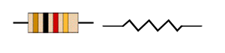

Figure 3.3.1 diagram and symbol of a resistor

Apart from the resistors that are in the embedded system module, an external fixed resistor was used to connect the output of the Arduino board to the sensor.

**3.4.2 74HC595 Shift Register**

The shift register operates in a fairly simple way, but can be modified to become very complicated but very useful. The basic concept is you have 8 output pins from the 74HC595.  For this example, let just say these are sent through a resistor to an LED.  So we have pins Q0 through Q7 as the output pins.  The rest can be considered control pins, their exact function is outlines in the table above.   
We can control the shift of the register with clock pulses.  As we raise the signal going to the clock pin to high, the clock is moved forward one step.  and when we pull it low and high again it shifts another.  Each time we shift the clock we switch the input to a different one of the eight registers.  We are essentially controlling the output of each of the eight pins one at a time, and as we move one clock signal forward, we switch to the next output pin to control.  We can use the Storage register clock pin to control the "Master on/off" switch.  Essentially how this is used is we can pull it low before we send our register values.  We then send all eight register values,whether they be high or low, and when we are done we pull the Storage register clock pin high.  What will happen is the value you send will be stored on each output pin, but not activated yet.

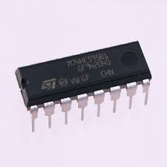

**Fig 3.3.2: 74HC595 Shift register**

**3.4.3 ATmega 328 P Micro-Controller**

The Atmel [8-bit](https://en.wikipedia.org/wiki/8-bit)[AVR](https://en.wikipedia.org/wiki/Atmel_AVR)[RISC](https://en.wikipedia.org/wiki/Reduced_instruction_set_computing)-based microcontroller combines 32 kB [ISP](https://en.wikipedia.org/wiki/In-system_programming) [flash](https://en.wikipedia.org/wiki/Flash_memory) memory with read-while-write capabilities, 1 kB [EEPROM](https://en.wikipedia.org/wiki/EEPROM), 2 kB [SRAM](https://en.wikipedia.org/wiki/Static_random-access_memory), 23 general purpose I/O lines, 32 general purpose working [registers](https://en.wikipedia.org/wiki/Processor_register), three flexible timer/[counters](https://en.wikipedia.org/wiki/Counter_%28digital%29) with compare modes, internal and external [interrupts](https://en.wikipedia.org/wiki/Interrupt), serial programmable [USART](https://en.wikipedia.org/wiki/USART), a byte-oriented 2-wire serial interface, [SPI](https://en.wikipedia.org/wiki/Serial_Peripheral_Interface_Bus) serial port, 6-channel 10-bit [A/D converter](https://en.wikipedia.org/wiki/A/D_converter) (8-channels in [TQFP](https://en.wikipedia.org/wiki/Quad_Flat_Package) and [QFN](https://en.wikipedia.org/wiki/Quad_Flat_No-leads_package)/[MLF](https://en.wikipedia.org/wiki/Quad-flat_no-leads_package#Variants) packages), programmable [watchdog timer](https://en.wikipedia.org/wiki/Watchdog_timer) with internal [oscillator](https://en.wikipedia.org/wiki/Electronic_oscillator), and five software selectable power saving modes. The device operates between 1.8-5.5 volts. The device achieves throughout approaching 1 [MIPS](https://en.wikipedia.org/wiki/Million_instructions_per_second#Million_instructions_per_second) per MHz.

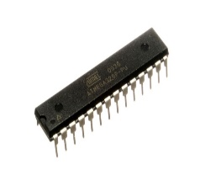

**Fig 3.3.3: ATmega 328 Chip**

* + 1. **IR Transceiver**

IR LED means Infrared Light Emitting Diode. The Infrared Light which is not visible to human eye works like normal LEDs but the material used in the core is very different; it emits infrared light when current passes through it. These IR LEDs are used to detect obstacles ahead. It emits IR lights which get reflected if any obstacle is present in the direction of emitted IR ray, the reflected IR ray caught by Photodiode calculates the reflected light strength. The higher the reflected IR ray strength the closer the obstacle and vice versa.

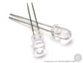

**Fig. 3.4: An IR LED**

On the other hand, a Photodiode is a light sensitive semiconductor diode which converts light energy into voltage or current based on the mode of operation. In general, Photodiodes are operated in reverse biased conditions. The clear photodiode can detect visible and IR rays to limit the photodiode to only detect IR rays. A black coating is applied to the photodiode and it allows the current pass through it when it is exposed to IR rays and vice versa. The amount of current passing through the photodiode is directly proportional to the amount of IR rays that falls on it.

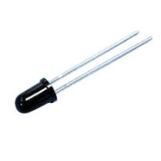

**Fig 3.5: A Photodiode**

In the circuit below, the photodiode is operated in reverse bias condition i.e., the long leg of the photodiode goes to the ground and the short leg is connected to the 5 Volts supply through 3k Ohms resistor.

**3.4.5 Proteus 8 Professional**

Proteus is a simulation software that provides a powerful working environment, where the user can design different electronic circuits with all the necessary components easily accessible from the simple (yet effective) interface like signal generators, power supply simple resistor and a different microcontroller or microprocessor.  
Virtual System Modeling (VSM) feature allows the real time design simulation. It is armed with the mixed-mode SPICE simulation.  Advanced Routing and Editing Software (ARES) is another powerful feature that permits one to route or edit the different components which are used for producing printed circuits.

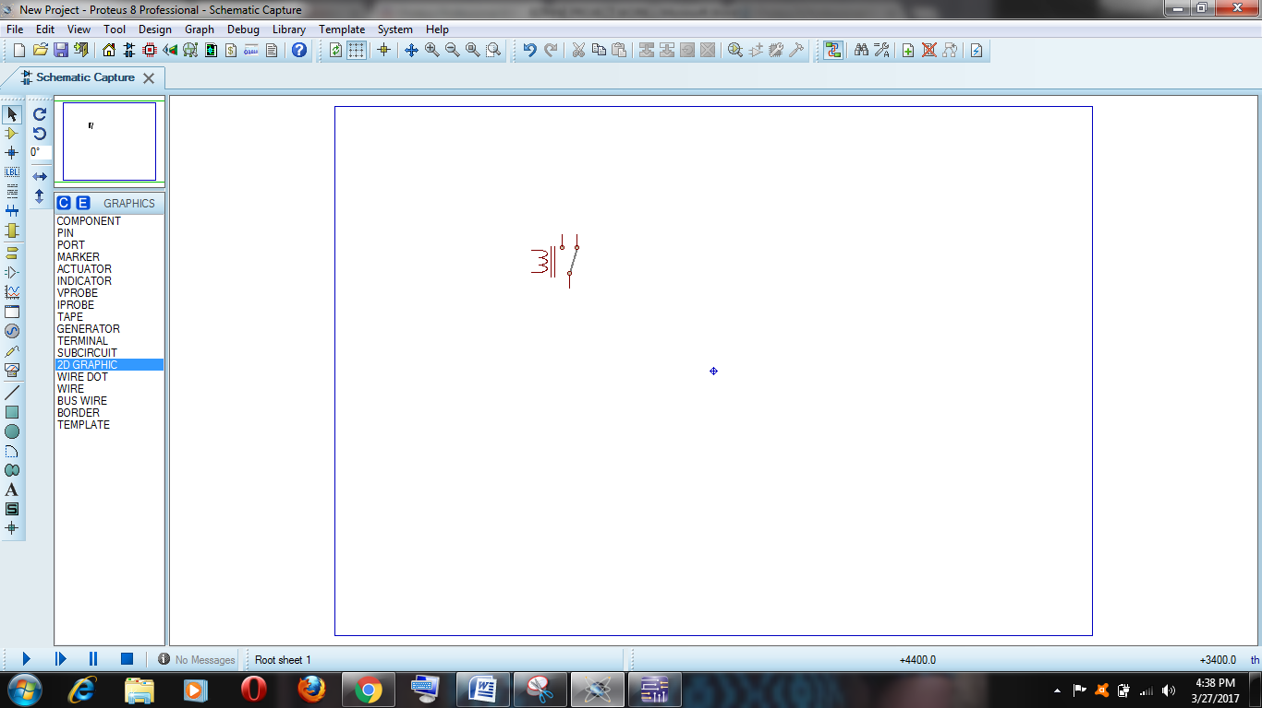

**Figure 3.6: Proteus 8 Professional Window**

**3.4.6 Arduino Uno**

Arduino Uno is an open-source platform used for building electronics projects. Arduino consists of both a physical programmable circuit board (often referred to as a microcontroller) that runs on your computer, used to upload computer code to the physical board.

Unlike most previous programmable circuit boards, the Arduino does not need a separate piece of hardware (called a programmer) in order to load new code onto the board but rather a simple USB cable. Coding can be done with c programming before uploading to the chip this development board..

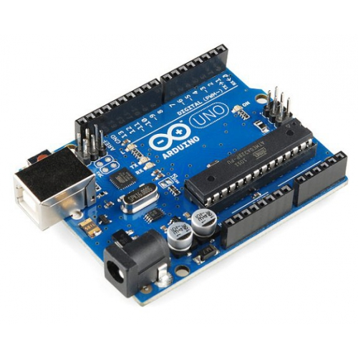

**Fig 3.7: Arduino Uno Board**

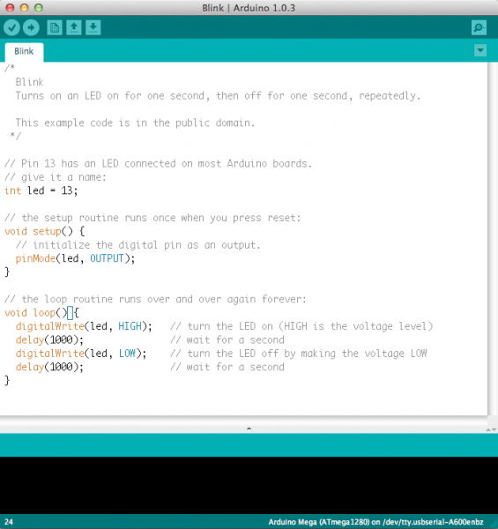**3.4.7 Arduino IDE**

It is an [open source](https://en.wikipedia.org/wiki/Open-source_software) [computer programming language](https://en.wikipedia.org/wiki/Programming_language) [integrated development environment](https://en.wikipedia.org/wiki/Integrated_development_environment) (IDE) built for the electronic arts, [new media art](https://en.wikipedia.org/wiki/New_media_art), and [visual design](https://en.wikipedia.org/wiki/Visual_design) communities with the purpose of teaching the fundamentals of [computer programming](https://en.wikipedia.org/wiki/Computer_programming) in a visual context, and to serve as the foundation for electronic [sketchbooks](https://en.wikipedia.org/wiki/Sketchbook). IDE uses a simplified version of C++, making it easier to learn to program. Finally, Arduino provides a standard form factor that breaks out the functions of the micro-controller into a more accessible package. The Uno is one of the more popular boards in the Arduino family and a great choice for beginners and Engineering students.

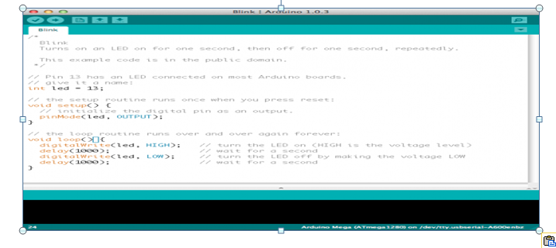

**Fig 3.8: A screenshot of the Arduino IDE.**

**3.5 Materials used for this Project**

**Table 3.0: Materials used for the design**

|  |  |
| --- | --- |
| Components used | Quantity |
| Arduino Uno | 1 |
| Atmega 328 | 1 |
| Shift Register(74HC595) | 4 |
| LED (green,red,blue) | 10 |
| Infra-Red Transceiver | 5 |
| jumper set male | 2 |
| Board | 1 |
| P.S.U(Diodes, transformers, capacitors) | 1 |
| Regulator (LM7805) | 3 |
| Resistor(1k) | 21 |
| Buzzer | 2 |
| Banana Wires | 2 |
| Casing | 1 |
| Marker | 1 |
| Vero board | 1 |
| Switch | 2 |
| Wax | 1 |

Soft wares used were:

1. Proteus: For designing the schematics of the circuitry and for carrying out the necessary simulation.
2. Arduino IDE: For programming the micro-controller and uploading the codes to the chip on Arduino Uno.
   * 1. **Implementation of the Schematic Diagram**

To achieve the micro-controller based traffic controller, materials such arduino uno board, atmega 328 chip, leds( red, blue and green), buzzer(small), jumper wire(male),infra-red transceiver were sourced. A well simulated circuit diagram using proteus for this purpose is shown below:

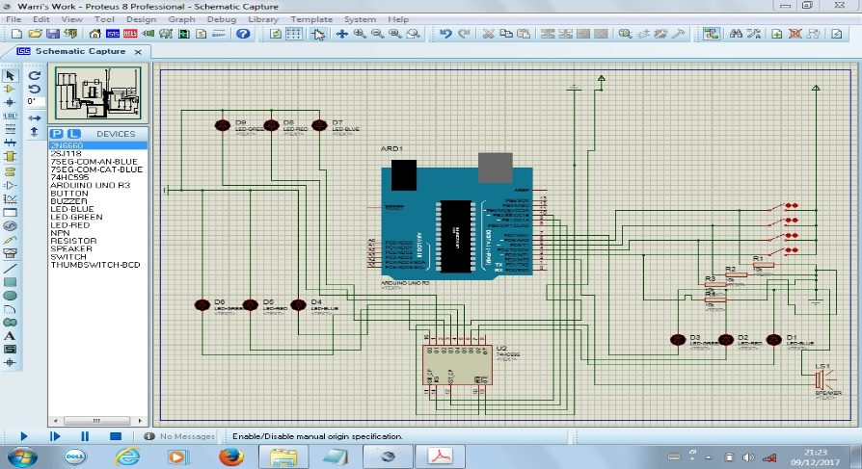

**Fig 3.9.1: Schematic diagram of the simulated circuitry**

On the Arduino IDE, a c program code was written to put the infra-red sensors on a high or low in cases of emergency switching lights and buzzer sounding. The blue and red lights were indicated on a 9secs display counter. The program also accesses the green and red leds from the infra- red sensor signals on any of the three way lanes. Proteus was used in designing the whole setup. The program is saved and inputted into the arduino uno board on the software and simulated afterwards. This worked effectively. The following processes were implemented to achieve this project:

1. Connect Pin 13 of the Atmega 328 micro-controller from the arduino uno board to pin 11 of the shift register (74HC595).
2. Connect Pin 12 to pin 12 of the first register (74HC595) for the work.
3. Connect pin 11 of the chip to the pin 14 of another register (74HC595).
4. Connect pin 10 to pin 11 of that same shift register.
5. Connect pin 9 to pin 12 of this shift register.
6. Connect pin 7 to D3 and then to a 1k resistor to get a desired current output the first considered shift register.
7. For the first lane congestion condition, connect pin 6 to IR sensor 1and then to a 1k resistor to get a desired current output.
8. For the second lane congestion, connect pin 5 to sensor 2 and then to a 1k resistor to get a desired current output.
9. For the third lane congestion, connect pin 4 to sensor 3 and then to a 1k resistor to get a desired current output.
10. For pin 3 emergency lane, connect pin 3 to sensor 4and then to a 1k resistor to get a desired current output.
11. Connect pin 2 to one terminal of the buzzer and then to a 1k resistor to get a desired current output while pin 1 is unused.
12. Pin 10 is connected to the ground for the emergency traffic light while pin 0 to pin 13 to the emergency lane shift register.
13. Connect 1k resistors to all sensors to get desired output sensitivity and connect them all to the ground.
14. Connect continuously all the leds (D1, D2, D3 together as well as to one terminal of the buzzer. Connect D2 to pin 6 of the second shift register of the congested lane. Connect D1 to pin 7.
15. Connect pin 13 of the second shift register to the ground Also connect pin 13 of the first register to the ground.
16. Connect pin 14 of the second register to pin 5 of the first register and pin 11 to pin 10. Pin 9 is left unused.
17. Connect pin 15 to D9. Pin 1 toD8, pin 2 to D7, pin 3 to D 6, pin 4 to D5, pin 5 to D4, Pin 6 to D2, pin 7 to D1 all connected from the second shift register. Connect along with this diode and 1k resistor to get a desired glowing output of the leds.
18. Connect D9, D8, D7 continuously and D6, D5, D4 continuously and to ground.

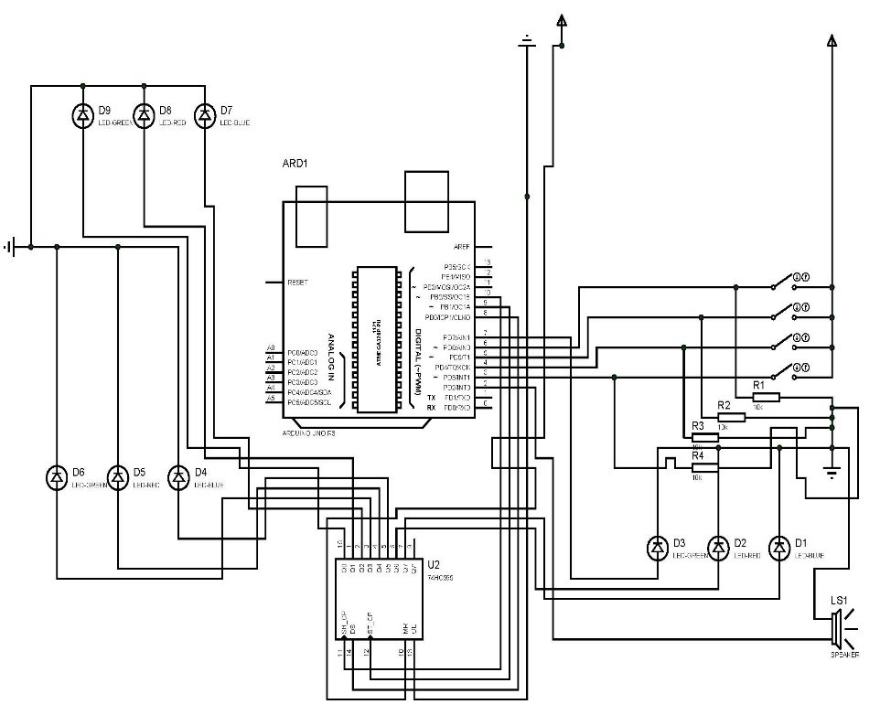

**Fig 3.9.2: Circuit diagram of the work**

**RESULT AND DISCUSSION**

**4.1 Introduction**

This Part explains the results of the project and the analysis throughout this project. It gives a detailed insight on the analysis and output of the project.

**4.2 System Testing**

i. After the construction and implementation phase, the system built has to be tested for Durability, Efficiency, and Effectiveness.

ii. All components were properly inserted into the breadboard from whence some tests were carried out at various stages.

1. To ensure proper functioning of components’ expected data, the components were tested using a digital multi meter (DMM).
2. Resistors were tested to ensure that they were within the tolerance value while faulty resistors were discarded.
3. The 78LS05 voltage regulator was also tested, the resulting output was 4.96v which is just a deviation of 0.04v from the expected result of 5.00v when connected to the P.S. U. made of 240 v AC.
4. The LEDs were tested to ensure that they were all working properly using the multi-meter to glow.
5. The overall system is tested via a simulation process on Proteus before transferring it on to the bread board. The system was first assembled using a breadboard.
6. The IR sensors are first tested by sending in a 5v source to it.It produces up tto 4.93v and when obstructed the voltage reduces to a 0.34v between the IR led and the photodiode. This shows that the IR sensor part was ok. The more the resistance the less the voltage with less current flowing.
7. The three way switch for the entire project is tested with the multimeter to know their polarity for the right connection to be known.

**4.3 Component Test**

Similar components like resistors were packed together. Other components includes LEDs, resistor, voltage regulator, -buzzer, etc

**Table 4.0: Component test values**

|  |  |  |  |
| --- | --- | --- | --- |
| Components Used | Quantity | Actual Value | **Reason for Usage** |
| Resistors | 100k, 1k, 47k, 50k,10k etc | 103k, 1.02k. 47.4k. 50.2k, 10.46k | This resistor when used because they were able to allow the small desired current to runthe various components |
| Jumper wires | continuous | continuous | This jumper wires enables easily connection on the vero board. |
| IR sensors | The infra red led and photo diode polarity were tested | This produced 3.94 v when high and 0.34 v when lowered by an obstruction | The program for the arduino was run with common anode seven segment display. |
| Header wires | continuous | Continuous | They were able to fit in into the arduino properly |
| Buzzer | sounded due to continuity | sounded due to continuity | This was chosen as it requires just 5v dc supply to power on gotten from the transformer. |
| P.S.U | 5.0v | 4.96v | The circuit was aimed at supplying 5v dc. |
| LEDS(red, green and blue ) | No light | Glowed to color light on continuity | They could accommodate 5v dc. |

**4.4**

**Result Presentation**

From a proper analysis of positive points and constraints of the system it is inferred that the system is working as per the objectives of the project The project has been designed to substantially enhance the performance by ensuring smooth mobility of emergency services (like ambulance, fire engines, etc. and vehicles in congested areas. The implementation of the algorithm is done in such a way that it not only paves way to emergency vehicles but it’s auto reinstatement of the older status of traffic light helps in smooth transition of traffic along the road. The system also reduces the workload of traffic personnel as it totally automates the whole prospect of traffic signaling which also greatly reduces the domain of error being an automated signaling system it eliminates the chances of human error which often results in road accidents and mishaps.

After soldering the various components on the vero board, continuity for all points is tested. Power supply at required voltage is supplied to the circuit to check for the workability of the design. The design was turned on and worked as schedule.

Results obtained were:

1. Blue and Red light turned on during the emergency situation.
2. Buzzer sounded for a 9secs timed sequence. This time applies to all lanes.
3. The Infra Red Sensor indicated their functionality during emergency situation when an obstruction cuts across it.
4. For congestion, the IR sensors gives a signal when an obstruction is seen across which changes the traffic light indicated on that lane road to green and others to red.
5. A timer is seen counting for nine (9) seconds on seven segment display.

**Table 4.1: Project work operation**

|  |  |  |
| --- | --- | --- |
| A | LOW | Priority operation |
| B | LOW | green and red |
| C | LOW | green and red |
| D(emergency) | LOW | blue and red |
| A,B | LOW | Counts for 9secs and switch between each lane at continuously on obstruction |
| ABC | LOW | Counts for 9secs and switch between each lane at continuously on obstruction |
| ABC and D | LOW | count for disturbed lane for 9secs delay the emergency condition for 2secs before switching. |

**5.1 Conclusion**

The Atmega328 microcontroller-based traffic control system works on traffic related problems such as traffic jam: emergency or forcibly passing etc can be solved. Traffic jam is the common phenomena in city area as it obstructs and wastes time of economic activities. Other reasons such as not obeying simple traffic rules, faulty traffic lights, wrong vehicle packing can also cause such jam. The problem of traffic jam for both congestion and emergency situations led to the reason for such micro-controller-based traffic light controller system which was hopefully achieved so far. By using this system configuration, it reduces the possibilities of traffic jams, caused by traffic lights by releasing vehicles for congested areas automatically and also giving a stand still signal for all vehicles within an intersection for emergency vehicle to pass through.IR sensors, buzzers, leds and Atmega 328 chip were the major components used in the design.

**5.2 Limitation**

1. The project was initially limited to power supply coverage.
2. In this project, tracing of wires was not an easy task.
3. Troubleshooting was also a great limitation due to the many wires.
4. The use of infra-red and its testing was a challenge.
5. Too many wiring was done on the project such as cutting and joining wiring process.

**5.3** **Recommendation**

1. For future works, the Traffic Light Controller design will include the use of more seven segments display on each lane as well as yellow light inclusion for normal condition.
2. A comprehensive and an exceptional Traffic Light Controller design can be made into an embedded circuit board to control the actual traffic flow in the city’s traffic intersections after solving cases of emergency and congestion situation.
3. More lane roads traffic controller can be implemented further with more complex algorithm to run a normal working prototype traffic light condition in all case scenarios such as more than one lane experiencing congestions at the same time, power supply problem etc.
4. For a more robust and massive outdoor usage, a Programmable Logic Controller is used rather than Atmega 328 micro-controller.
5. The number of digital pins for the Atmega 328 microcontroller used in this project was a major problem. For a better future project with much diversity, Arduino Mega and its various chips can be used.

Acknowledgment

In the world, no work has been completed smoothly where there is no guidance and help. The project work is the result of an effort of more than four-month duration during which I have been accompanied and supported by many people. It is a pleasure that we have now the opportunity to express our gratitude to all of them.

Firstly, I offer millions of thanks to almighty God who has given us strength to complete of this project successfully. At the very beginning, I would like to express our immense gratitude and delightful thanks to my H.O.D, Dr.D.O. Dike, Prof. Chukwudebe, Prof. Okafor, Dr. Nosiri, my course adviser, Dr. Kenedy, Dr. F.K Okpara and my supervisor Engr.A.O Akande of the Dept. of EEE, Federal University of Technology, Owerri for giving me an opportunity to work on this topic, in which I found interest compared convention course work. My respect is also due to my supervisor for his wisdom, guidance, supervision and faithful discussion with me throughout the work. He not only agrees to supervise the project wholeheartedly, but from the beginning of our study here, he supported me with incessant generosity.

I would also like to extend my warmest thanks to my parents, siblings, friends for their support all round towards achieving this project dream.

References

[1] R.N Dhole and A. Deshmikh.“Smart Traffic Light.” B.Tech Project. Shin Guru Singhji Institute ofEngineering and Technology,Nanded, India. 2015.

[2] B. Sruth, K. Dharmattaj and G.Madhu. “ Embedded System for Traffic Light Control.” B.Tech Project. TRR College of Engineering, In olev,Patancharu,Medak District,India.2014.

[3] M. EhsanSatif. “Smart Traffic Controller based on Micro-Controller.” ***The Iraqi Journal of Computer , Communication , Control and System Engineering***. Vol.16, pp. 38-44. Feb, 2016.

[4] O.Ramdas and G. Anil Vishwasrao.“ Image Processing Based Traffic Light Control.” ***International Journal of Science, Engineering and Technology Research***.Vol.3,pp.1010-1014. May,2016.

[5] M.R. Hafizula and Md. Sabry Ahmed. “Implementation of Automatic Traffic Light Controller.” B.Tech Project .Northern University Bangladesh. 2013.

[6] N. Ain Ibrahim. “ Intelligent RF Traffic Light Control for Ambulance.”B.Eng Project. UniversitiTeknikal, Melaka, Malaysia.2013.

[7] B.Vineetha.“ Design of FPGA Based Traffic Light Controller system.” M.TechThesis.Mina Institute of Engineering and Technology for women,, Nalgmos.2015.

[8] Wikipedia. “History of Traffic Light Controller. ”.Internet: <http://en.m,wikipedia.org/wiki/Trafficllight>. 13thNovember ,2017. [November 15,2017]

[9] A. Bin Hamad.“Development of a Traffic Light Control System using Programmable Logic Controller.”B.EngProject.Universiti Malaysia,Pallang,2016.

[10] B.R Swetha. , D. Trivasri, M. Karthiga and S. Padma. “ Density Based Traffic Control System using ArduinoUno***.International Journal of Industrial Engineering.***Vol.6,pp.5-7.2014.

[11] Wikipedia. “Traffic Light Controller. ”.Internet: <http://en.m,wikipedia.org/wiki/Trafficllight>. 10thNovember ,2017. [November 14,2017]

[12] K.Vidhya, and A. BazilaBamu. “Density Based Traffic Signal System.” ***International Journal of Innovative Research in Science ,Engineering and Technology***. Vol.3,pp.2218-2223.March,2014.

[13] B.Prashanth Kumar, B,Karthic, J.Bheemarag and M. Srinivas. “Micro-controller Based Traffic Light Controller.” B.Tech Project.Gokaraja Ranguraju Institute of Engineering and Technology,Bacchupally,Hajderrabad. 2015.

[14] Wikipedia. “Types of intersections. ”.Internet: <http://en.m,wikipedia.org/wiki/Trafficint>ersections. 13thNovember ,2017. [November 15,2017]

[15] Google. “Ambulance Traffic Situations.” Internet: https://www.indiatimes.com/news/india/7-year-old-loses-life-as-ambulance-remains-stuck-in-10km-long-noida-traffic-322120.html/. August 5,2013.[November 15,2017]

[16] Channels TV. “Traffic Warden.” Internet: <https://www.channelstv.com/2017/04/23/traffic-warden-promoted-inspector-rank-bayelsa/>. 12th April,2017 [November 5,2017].

[17] Wikipedia. “Arterial Video Surveillance ”.Internet://en.wikipedia.org/wiki/Traffic_light_control_and_coordination#/media/File:Khobarhires.JPG. 13thNovember, 2017 [November 15,2017]

[18] Google. “Constituents of Traffic Light Controller.” Internet:www.edgefxkits.com/densitybasedtrafficsignalsystem/. August 5,2016.[November 15,2017].

[19] C.O Uchenna, O. OnaolapoFrancisca and A. Onibere Emmanuel “Design and Simulation of an Intelligent Traffic Light Control System***.”. International Journal of Advances in Engineering and Technology.*** Vol.1,pp.47-57.June,2015.

[20] I. BimAmnudin. “ Pre-emption Sequence of a Traffic Light Controller for Emergency Vehicles.” M.A Thesis. UniversitiTeknologi, Malaysia. 2014.

[21] SochumMisra. “Design of Traffic Light Controller using Timer Circuit.”. ***Proceedings of National Students Paper and Circuit Design Contest***. Vol. 2,pp.1-3.February,2012.