**IMPACT OF PREFABRICATION TECHNOLOGY ON PROFITABILITY IN CONSTRUCTION INDUSTRY**

***Er. Amit Kumar****, Assistant Professor, Department of Civil Engineering, Aravali College of Engineering & Management, Faridabad, Haryana, India.*

**ABSTRACT**

The construction industry is growing exponentially day by day and it makes a remarkable contribution in escalating the pace of development of the nation. Refinements are adapted and analyzed at each and every stage of construction.  Prefabricated components are increasingly becoming an eminently improving technology to achieve cost effective and speedy construction in the construction industry. This increasing trend for prefabricated components has now turned into numerous applications as they can provide a much faster output for the ever increasing urban construction demand. In addition to this, adopting prefabrication technology also promoted mechanization in the construction industry and created new areas of employment. A house for residence is basic need for human being. In the present scenario in India, Conventional construction is not affordable for lower and middle income people of the society. As well as sustainability and environmental impact are the major issues that must be considered.

There are various prefabrication technologies that came into research in the few recent years. Many of them are fit from point of view of sustainability, environmental impact and waste reduction.One thing, that must be analysed for these technologies is affordability. Affordability may be defined in terms of cost of construction, cost of repair and maintenance etc.

This paper proposes a dynamic model for quantitively examining the profitability concern, when conventional construction technology is replaced with prefabrication technology ( EPS core panel technology). Research is made for short run of time as well as long run of time by performing comparative analysis and life-cycle cost analysis respectively. The study emphasizes the effect of prefabrication technology on the profitability and its effect in the construction work cycle.

**Keywords:** prefabrication, affordability, profitability, sustainability

**TABLE OF CONTENT**

**CONTENTS PAGE NO**

**Title Page…………………………………………………………………………………….…...(i)**

**Declration………………………………………………………………………………...……….(ii)**

**Certificate………………………………………………………………......…..............................(iii)**

**Abstract………………………………………………………………………………………........(iv)**

**Acknowledgement…………………………………………………………………....……...……(v)**

**List of tables………………………………………………………………………...………….....(viii)**

**List of Figures………………………………………..………………………...…………………(ix)**

**List of abbreviations and symbols…………………………………….…………………...…….(x)**

**CHAPTER-1 INTRODUCTION 1-11**

* 1. **Background………………………………………………………………….…..…..1-2**
  2. **Usage, installation and replacement applicability…………………………….......2-10**
     1. **Types of panels…………………………………………………………….....2**
     2. **Installation procedure………………………………………………….........3**
     3. **Connections used in EPS core panel system……………………………......4-7**
     4. **Tools required and machinery involved for installation………………......8**
     5. **Advantages of EPS core panel system……………………….………….......8**
     6. **Limitations and shortcomings of EPS core panel system….........................8**
     7. **Tests that are performed in EPS core panel system……..............................9-10**
     8. **Some current practices of EPS core panel technology in India...................10**
  3. **Objective of the study………………………………………………………….....…11**
  4. **Scope of the study………………………………………………………….…….….. 11**

**CHAPTER-2 LITERATURE REVIEWS AND INFERENCE 12-23**

**2.1 Literature Reviews…………………………………………………………................12-18**

**2.2 Inference of literature reviews………………………………………………...….....19-23**

**CHAPTER-3 RESEARCH METHODOLOGY 24-34**

**3.1 Research Flow Chart……………………………………………………….................24**

**3.2 Introduction to site………………………………………….…………………….......25-26**

**3.3 Data Collection……………………………………………………………...................27-34**

**3.3.1 Data regarding cost of building with conventional construction…………….27-29**

**3.3.2 Data regarding cost of building with EPS core panel system construction....29-33**

**3.3.3 Data regarding life-cycle cost analysis………………………………………....34**

**CHAPTER-4 ANALYSIS, RESULTS AND DISCUSSION 35-42**

**4.1 Comparative analysis (cost & time comparison)……………………………...........35-39**

**4.1.1 Cost comparison……………………………………………………………........36-38**

**4.1.2 Construction duration comparison……………………………………….........38-39**

**4.2 Energy saving with EPS core panel…………………………………………….........40-41**

**4.3 Life cycle cost analysis……………………………………………………………..…41-42**

**CHAPTER-5 CONCLUSION 43-44**

**REFERENCES 45-46**

**LIST OF TABLES**

1. **Table 3.1 Detail of Cost of 1 m^3 of RCC work (M20 grade)……………………...…..27**
2. **Table 3.2 Detail of Cost of 1 quintal of steel reinforcement……………………………28**
3. **Table 3.3 Detail of cost for 1 m^3 masonry work ……………………………………....28**
4. **Table 3.4 Detail of cost for 10 sq. met plastering…………………………………….....29**
5. **Table 3.5 Detail of cost of 200 mm thick EPS panel………………………………….....30**
6. **Table 3.6 Detail of cost of 230 mm thick EPS panel………………………………….....31-32**
7. **Table 3.7 Detail of cost of 130 mm thick EPS panel………………………………….....32-33**
8. **Table 3.8 Data collection for life-cycle cost analysis.........................................................34**
9. **Table 4.1 Cost estimation of conventional construction………………...........................36-37**
10. **Table 4.2 Cost estimation of construction with EPS core panel system…...………......37**
11. **Table 4.3 CDD and HDD calculations………………………..……………...…….…….40**

**LIST OF FIGURES**

**Figure 1.1 Cross-sectional view of EPS core panel ……………………………………....…........2**

**Figure 1.2 Images Showing Installation Procedure of assemblies in EPS core panel building..3**

**Figure 1.3 ImageShowing wall to floor connections while installing the panels ……………....4**

**Figure 1.4 Image showing wall to roof connections while installing the panels……….…….....5**

**Figure 1.5 Image showing wall to wall connections while installing the panels ………..….......6**

**Figure 1.6 Image Showing Doors and windows details in EPS core panel system ……..…......7**

**Figure 1.7 Summary of the tests that are performed on EPS core panels ………………….…9**

**Figure 1.8 Summary of the tests that are performed on shortcrete………………………...…..10**

**Figure 3.1 Image representing location of the reference building site……………………….....25**

**Figure 3.2 Photographs of site visit………………………………..…………………………........26**

**Figure 4.1 Image representing floor plan of the reference building ……………………….…...35**

**Figure 4.2 Histogram representing cost comparison………..……………………………….......38**

**Figure 4.3 Histogram representing Duration comparison…………………...…………............39**

**Figure 4.4 Histogram representing LCCA results…………………………………………....….42**

**LIST OF ABBREVIATIONS AND SYMBOLS**

₹ Rupees

IC Initial construction cost

R&MA Annually recurring Repair & Maintenance cost

R&MNA Non- annually recurring Repair & Maintenance cost

OC Operation cost

SV Salvage value

CDD Cooling degree day

HDD Heating degree day

**CHAPTER.1**

**INTRODUCTION**

**1.1 BACKGROUND**

Prefabrication may be defined as a method of construction in which different components of a building are assembled in a factory away from building site and then complete assembly or sub-assemblies are transported to the building site through different source of transportation where they are erected and fastened together using various types of bracings.

Profitability is the ability of a business to earn a profit. A profit is what is left of the revenue a business generates after it pays all expenses directly related to the generation of the revenue.

Following topic is about to analyse the impact of prefabrication on profitability. It is about to determine weither what will be the consequences related to profitability if we replace prefabrication method in place of conventional construction method.

Major objects of prefabrication method is to bring rapidity in the construction work as well as to improve efficiency,sustainability,to reduce environmental impact without compromising with quality.

**Need of prefabrication:-**

*To reduce environmental impact.

*waste reduction.

*To increase sustainability.

*To increase efficiency.

*To achieve faster construction methods.

*To reduce time and cost.

Following are the advantages of prefabrication from point of view of profitability.

*construction using prefabrication speed up the construction work and all of us know that time is money.Faster construction work has positive impact on the economy of the project.

*Construction activities are not affected by weather (excessive cold, heavy rain, snow etc.)

*Preciseness and greater quality assurance.

*There is less waste generation which means there are less material consumption results in positive impact on the economy of the project.

*Need of scaffolding,formwork,shuttering etc. is highly reduced

There are two main types of prefabrication technology.

1. Volumetric (modular) prefabrication
2. Panellised prefabrication

The prefabrication method that is to be used in the analysis is “Expanded Polystyrene Core Panel Method”. In this technique, a panel is used in which a polystyrene core is sandwiched between 3 mm dia GI mesh and shortcrete is applied on either side of the core covering the mesh.

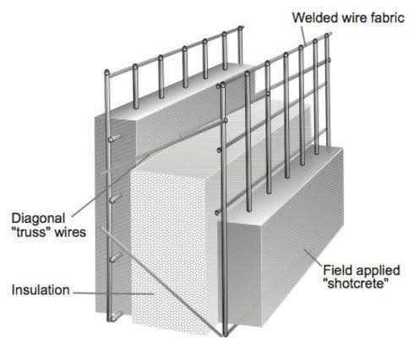

*Image Source: https://images.app.goo.gl/PKNyCcMXp6RZaMMYA*

**Figure 1.1** Cross-sectional view of EPS core panel

* Diagonal mesh is provided across the polystyrene core.
* Polystyrene foam is expanded before meshing with the application of heat and air till it reaches 90 % air content to acquire better insulation.
* In EPS core panel system,these panels are used as wall and slab without involvement of columns and beams.

**1.2 USAGE,INSTALLATION AND REPLACEMENT APPLICABILITY**

**1.2.1TYPES OF PANELS**

* Expanded polystyrene core panels are classified as Load Bearing panels and non-load bearing panels.
* Panels used for exterior walls and roof/slab are load bearing panels and panels used for partition walls are non-load bearing panels.
* These panels are available in width of 1200 mm and length of 3000 mm and total thickness varies between 80 mm to 230 mm.
* In this analysis,180 mm thick panel will be used as load bearing panel and 130 mm thick panel will be used as non-load bearing panel which are safe for upto 10 kn/mm^2 total set of loads for upto 4 storey buildings.

**1.2.2 INSTALLATION PROCEDURE**

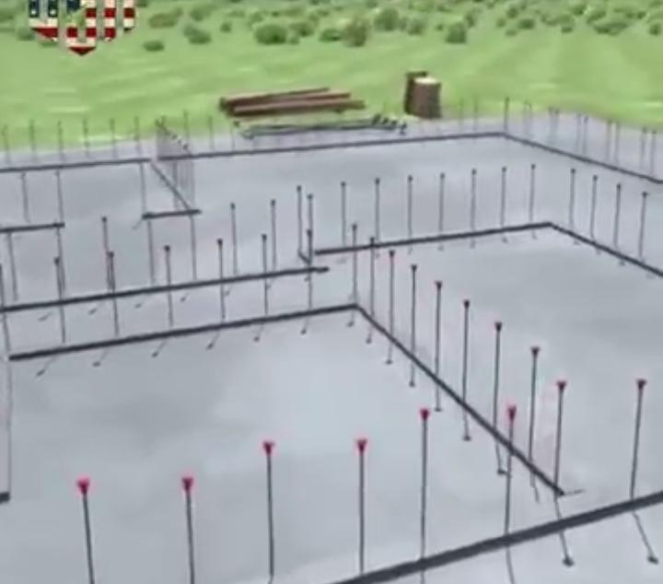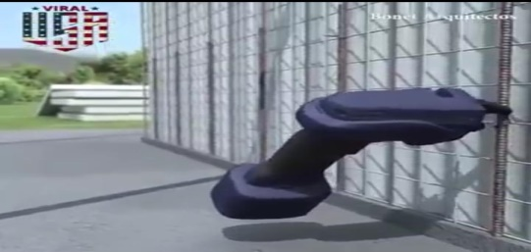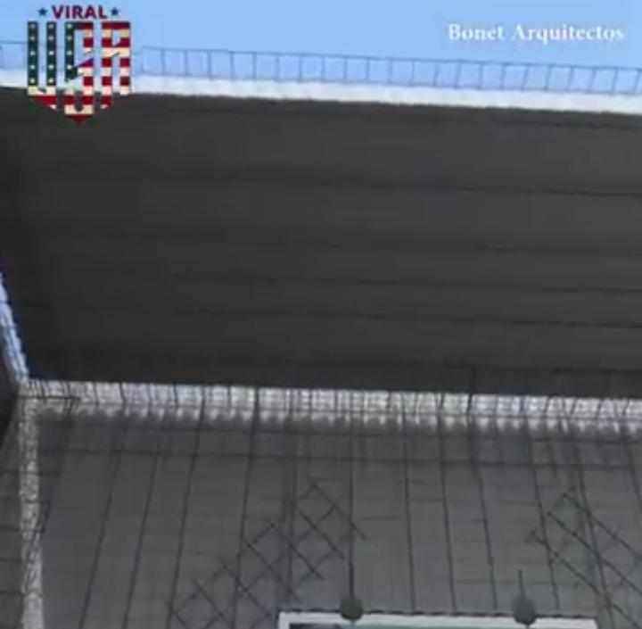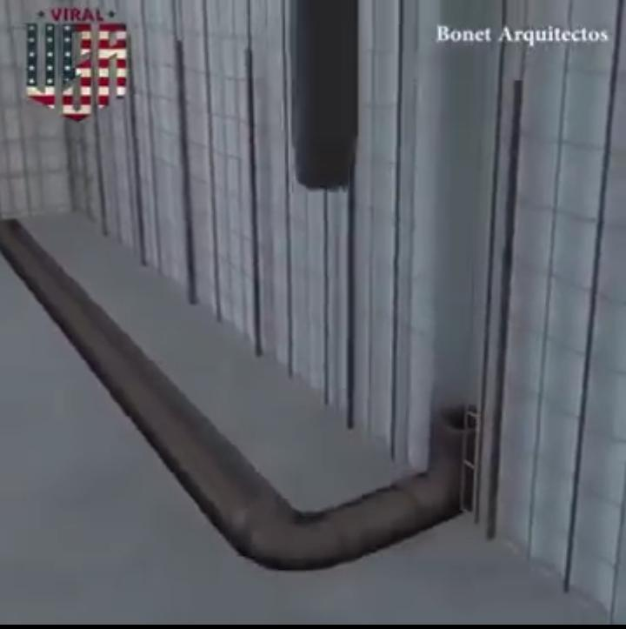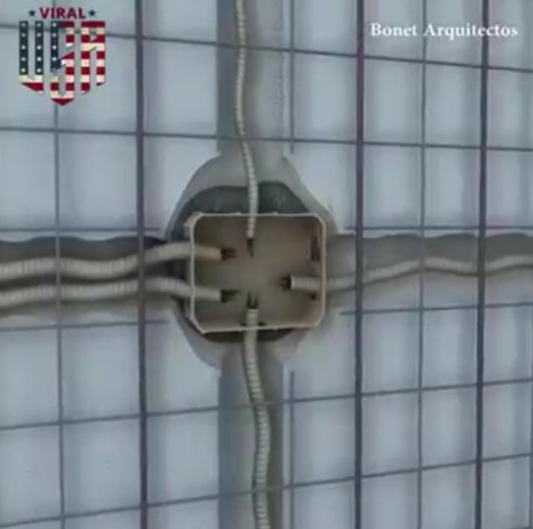 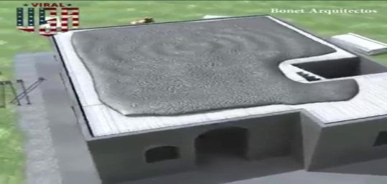

*Image Source:* *https://youtu.be/WFpl69-TFHY*

**Figure 1.2** ImagesShowingInstallation Procedure of assemblies in EPS core panel building

**1.2.3 CONNECTION USED IN EPS CORE PANEL SYSTEM INSTALLATION**

**WALL TO FLOOR CONNECTIONS**

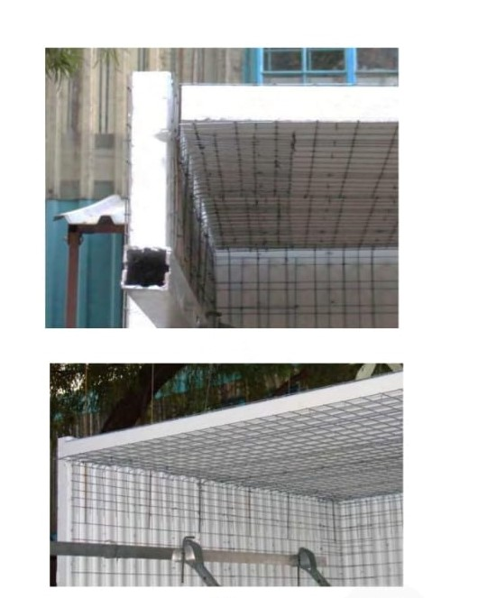 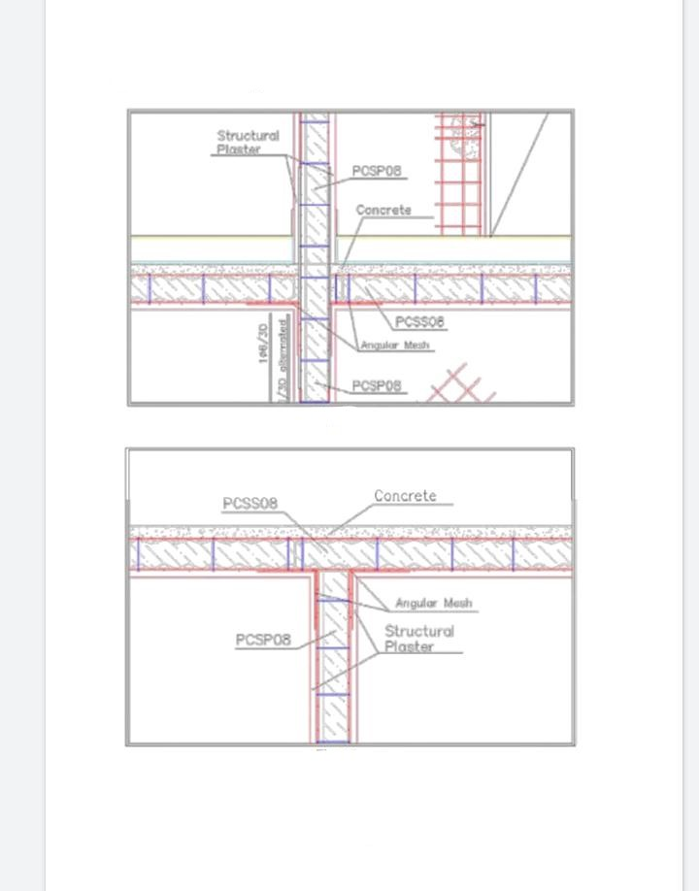

*Image Source:https://www.google.com/url?sa=t&source=web&rct=j&url=http://bmtpc.org/DataFiles/CMS/file/PDF_Files/34_PAC-EPS.pdf&ved=2ahUKEwjxj4mY09PrAhVKaCsKHcnoD14QFjABegQIDRAH&usg=AOvVaw3eosYM7asofFewcmePo0rf&cshid=1599365091244*

**Figure 1.3** Image showing wall to floor connections while installing the panels

**WALL TO ROOF CONNECTIONS**

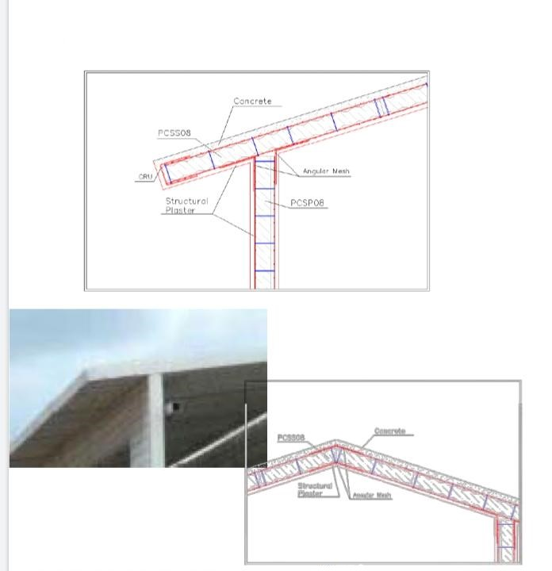

*Image Source:* *https://www.google.com/url?sa=t&source=web&rct=j&url=http://bmtpc.org/DataFiles/CMS/file/PDF_Files/34_PAC-EPS.pdf&ved=2ahUKEwjxj4mY09PrAhVKaCsKHcnoD14QFjABegQIDRAH&usg=AOvVaw3eosYM7asofFewcmePo0rf&cshid=1599365091244*

**Figure 1.4** Image showingwall to roof connections while installing the panels

**WALL TO WALL CONNECTIONS**

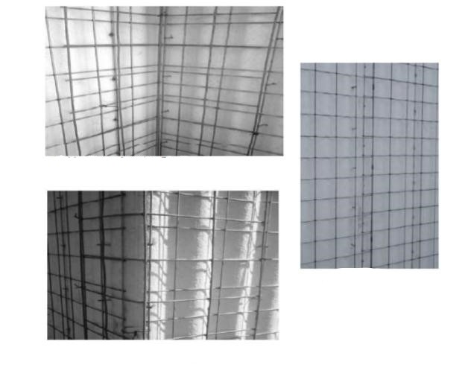

*Image Source: https://www.google.com/url?sa=t&source=web&rct=j&url=http://bmtpc.org/DataFiles/CMS/file/PDF_Files/34_PAC-EPS.pdf&ved=2ahUKEwjxj4mY09PrAhVKaCsKHcnoD14QFjABegQIDRAH&usg=AOvVaw3eosYM7asofFewcmePo0rf&cshid=1599365091244*

**Figure 1.5** Image showing wall to wall connections while installing the panels

**DOORS AND WINDOWS DETAILS**

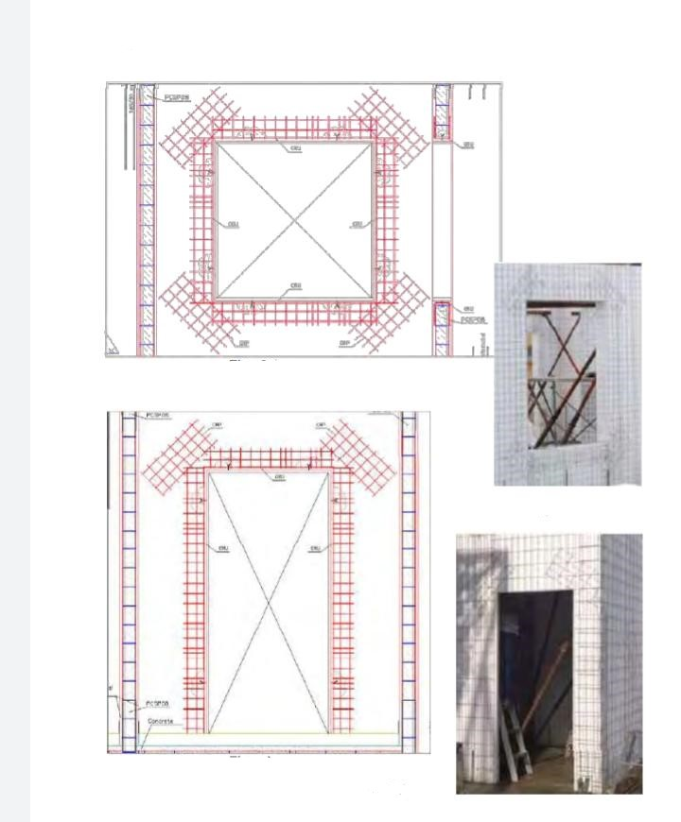

*SOURCE: https://www.google.com/url?sa=t&source=web&rct=j&url=http://bmtpc.org/DataFiles/CMS/file/PDF_Files/34_PAC-EPS.pdf&ved=2ahUKEwjxj4mY09PrAhVKaCsKHcnoD14QFjABegQIDRAH&usg=AOvVaw3eosYM7asofFewcmePo0rf&cshid=1599365091244*

**Figure 1.6** Image ShowingDoors and windows details in EPS core panel system

**1.2.4 TOOLS REQUIRED AND MACHINERY INVOLOVED IN INSTALLATION**

1.Parallel side timber of metal template to mark the position of the wall panel on the foundation and spacing.

2.Electric drill for drilling holes for the starter bar

3.Tape to measure dimension

4.Pliers for wire tying

5.Level and plumb lines

6.Wire cutter

7.Hand hold blow torch

8.Normal plaster tools

9.EPS cutting machine

10. Wire straightening machine

**1.2.5** **ADVANTAGES OF EPS CORE PANEL SYSTEM**

* EPS panels persue a very high degree of thermal and sound insulation,so it provides comfort to building occupants.
* It is considered as a cost effective construction technique.
* It is a prefabrication technique hence reduce site complexity.
* Handling and installation of EPS panels is easy.
* It is a rapid construction technique which ultimately affects on the profitability.
* EPS is virtually inert and does not absorb moisture and is durable and resistant to decay.
* Installation does not need heavy construction equipments.

**1.2.6 LIMITATIONS AND SHORTCOMINGS OF EPS CORE PANEL SYSTEM**

Even after number of advantages of EPS slabs, there are certain disadvantages too,such as

* 1. These panels are generally preferred for upto 4 storey buildings.
* 2. Improper scheduling may lead to deterioration of EPS panels (yellowing) which has a negative effect on the insulation property of the panels.
* 3. In the current practices, there is cracking at the joints of EPS-LB/NLB panels which can be avoided by providing chicken mesh as per structural requirements.
* 4.The EPS core panel system has some practical issues that can be avoided by suitable technological interventions.
* 5.Compressive strength of shortcrete shall not be less than 20 Mpa.
* 6.The steel reinforcement shall have a minimum allowable stress of 415 Mpa.

**1.2.7 TESTS THAT ARE PERFORMED IN EPS CORE PANEL SYSTEM**

**TESTS ON EPS CORE PANELs**

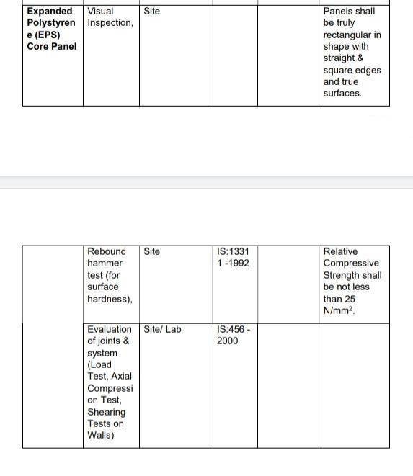

*Image Source:*

*https://www.google.com/url?sa=t&source=web&rct=j&url=https://www.bmtpc.org/DataFiles/CMS/file/PDF_Files/Manual_EPS.pdf&ved=2ahUKEwjxj4mY09PrAhVKaCsKHcnoD14QFjAFegQIARAB&usg=AOvVaw3dankANyZslp-jKcr4V8eI&cshid=1599365091244*

**Figure 1.7** Summary of the tests that are performed on EPS core panels

**TESTS ON SHORTCRETE**

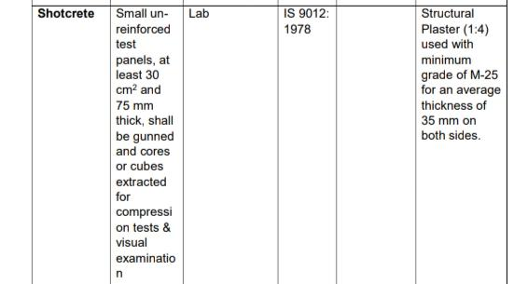

*Image Source:*

*https://www.google.com/url?sa=t&source=web&rct=j&url=https://www.bmtpc.org/DataFiles/CMS/file/PDF_Files/Manual_EPS.pdf&ved=2ahUKEwjxj4mY09PrAhVKaCsKHcnoD14QFjAFegQIARAB&usg=AOvVaw3dankANyZslp-jKcr4V8eI&cshid=1599365091244*

**Figure 1.8** Summary of the tests that are performed on shortcrete

**1.2.8 SOME CURRENT PRACTICES OF EPS CORE PANEL TECHNOLOGY IN INDIA**

* 1. EPS housing project at Chandrashekharpur, Bhubaneswar,Odisha
* 2. EPS housing project at Bihar Shariff, Bihar
* 3. EPS housing project at Aurangabad Jagir,FARIDABAD,Uttarpradesh

**1.3 OBJECTIVE OF THE STUDY**

●To determine the Cost and time estimate of a three storey building for both prefabrication technology (EPS core panel system) and traditional construction to identify profitable technology.

●To determine that which of the two technologies is more profitable in longer runs, For this purpose, Life cycle cost analysis is to be performed.

**1.4 SCOPE OF THE STUDY**

●Comparative analysis is performed only for construction of superstructure of a G+3 building as the construction upto plinth level will be identical with both the technology. Only the construction of structure and plastering work of a three storey building is included for the purpose of comparative analysis as plumbing, electrical, windows and door fitting and other finishing work will have nearly same cost and time of construction.

**CHAPTER 2**

**LITERATURE REVIEWS AND INFERENCE**

**2.1 LITERATURE REVIEWS**

N. Dineshkumar et al. (2015) conducted a comparative study on prefabrication construction with cast in-situ construction of residential buildings. The construction boom in India is developing at a fast rate of growth. It provides wide opportunity in India for a new entrant in prefab sector. At present precast concrete buildings are the advanced construction techniques available over worldwide. The prefab construction for individual double storey residential building cost is 13% more than the conventional construction. This is main drawback for prefab construction which is not economical to construct in this case. At the same time the prefab construction is easy to work and reduces the project duration, is reduced by 63 days when compared to the conventional.

1. **BUILDING AND ENVIRONMENT,VOLUME 42,ISSUE 10,OCTOBER 2007**-“***Towards adoption of prefabrication in construction”***

This paper provides a feasibility study report for a prefabrication project. Outcome of this report was that, with the use of prefabrication method, waste generation may be lowered upto a considerable extent. Environmental emission is also reduced and prefabrication method provides rapidity in the construction work.

1. **MEASURING THE IMPACT OF PREFABRICATION ON CONSTRUCTION WASTE REDUCTION:AN EMPERICAL STUDY IN SHENZHEN,CHINA,JULY 2014**

A comparative study was carried out between prefabrication and conventional construction technique.Finally,it was observed that adopting prefabrication technology reduces the waste in considerable amount and percentage of reusable waste is increased.

1. **NATIONAL CONFERENCE ON ALTERNATIVE AND INNOVATIVE MATERIALS AND TECHNIQUES-,SEP 2014- “*prefabrication and its adoption in India”***

Increasing population in India demands more houses.Cost and time are the major factors that affect the affordability of houses. In this paper, adoption of prefabrication technology over traditional construction technology is analysed for Indian scenario

1. **CURRENT TRENDS IN TECHNOLOGY AND SCIENCES,CTTS,VOLUME 3,ISSUE 2 ISSN-2279-0535,2014-“*Thermal behaviour and admissible compressive strength of expanded polystyrene wall panels of varying thickness”***

This paper presents the analysis of behaviour EPS panels against thermal effect and also the permissible axial load and compressive strength is analysed for varying thickness of EPS panels and graph representation of the above is also stated.

1. **INTERNATIONAL JOURNAL OF INNOTIVE SCIENCE,ENGINEERING AND TECHNOLOGY,VOLUME 2,ISSUE 4,APRIL 2015-*“Comparative study on prefabrication construction with cast in-situ construction of residential building”***

Comparison is carried out between prefabrication and conventional method. Comparison is done considering the three segment of a double storey building i.e.; sub-structure, super-structure and finishing work. Result shows that construction cost by prefabrication method is 13% more than conventional construction while comparing the time, prefabrication method takes 63 days less than conventional method.

1. **INTERNATIONAL CONFERENCE ON EARTHQUAKE ENGINEERING AND POST DISASTER RECONSTRUCTION PLANNING,APRIL 2016-“*Seismic Design of Expanded Polystyrene Core Panel Based Building Systems”***

In the above research paper, behaviour of EPS core panel building against seismic effect is analysed and comparative analysis with conventional building to withstand against earthquake is also analysed.

1. **COMPARATIVE ANALYSIS OF THE PRODUCTIVITY LEVELS ACHIEVED THROUGH THE USE OF PANELIZED PREFABRICATION TECHNOLOGY WITH THODE OF TRADITIONAL BUILDING SYSTEM,APRIL 2016**

Data were obtained from different construction sites of Newzealand and questionnaire survey was carried out with industry stake holders.

After the final analysis, it was found that with the use of panelised prefabrication technology, cost saving was 21 %, time saving was 47%, and average improvement in the productivity is 10 %, when compared with traditional construction technology.

1. **BULLETIN DE LA SOCIETE DES SCIENCE D LIEGE,,VOLUME 85,2016,PAGE.1229-1234,2016-*“Behavior of prefabricated structures in developed and developing countries”***

A comparative study about the behaviour of prefabricated structure in developed and developing countries were carried out and based on various data, positive and negative behaviour was categorised for different impacts in developed and developing countries.

1. **SSRG-INTERNATIONAL JOURNAL OF COMPUTER SCIENCE AND ENGINEERING,VOLUME 03,ISSUE 05,MAY 2016**-***“Study on prefabricated modular & steel structure”***

This paper presents a description about various prefabrication technologies that may be replaced with conventional construction that may results in time and money saving and are also sustainable. A brief description about modular construction is also stated.

1. **INTERNATIONAL JOURNAL OF ENGINEERING AND TECHNOLOGY,JUNE 2016-** **VOLUME 3,ISSUE 6,ISSN-2395-056*-“AkashLankeDesign,cost and time analysis of precast and RCC building”***

Cost and time analysis of a 12 storey building was carried out from both conventional and prefabrication method. Data were obtained from different sites an questionnaire survey and following results were obtained.

While using prefabrication method, there is considerable saving of cost and a lot of saving of time.

1. **INTERNATIONAL JOURNAL OF INNOVATIVE WORKS IN ENGINEERING,VOLUME 2,ISSUE 3,ISSN-25455-5797,JUNE 2016-“*Impact of prefabrication on profitability over traditional construction”***

According to this literature, prefabrication is profitable over conventional construction in terms of sustainability, waste reduction, environmental emission, healthy environment and rapidity in construction activities.

While talking about cost, cost estimation of a single storey building was carried out for both prefabrication method and conventional construction. It was found that 31 lakhs were saved while using prefabrication.

1. **INT. J. SCI. ENG 1 (2),44-50,2017-“*Prefabrication,SustainableTechique in buidingConstruction, Feb 2017”***

Impact of prefabrication technology on sustainability, environment, profitability, quality and ease of work is analysed and determined in this paper. The conclusion is that prefabrication technology provides high energy saving, as well as environmental friendly in terms of usage.

1. **INTERNATIONAL JOURNAL OF ADVANCE ENGINEERING AND RESEARCH, IJAERD,VOLUME 4,ISSUE 3,MARCH 2017*-“Comparative Study of prefabrication constructions with cast-in situ constructions”***

The aim of this paper is to analyse the drawbacks of conventional construction e.g. High cost, more time taken, complexity etc. and analyse that how prefabrication technology is efficient to overcome these drawbacks.

1. **INTERNATIONAL JOURNAL OF EMERGING TRENDS AND TECHNOLOGY IN COMPUTER SCIENCE,VOLUME 6,ISSUE 03(MAY-JUNE 2017)-*“Impact of prefabrication technology and equipment on the profitability using Primavera”***

Prefabrication is regarded as a sustainable and recyclable technique in terms of impact and environmental protection. In this paper, impact of prefabrication on profitability is determined using Primavera software.

1. **INTERNATIONAL JOURNAL OF ENGINEERING,SCIENCE AND MATHEMATICS,** **VOLUME 6,ISSUE 3 ,JULY 2017*-“Monika Shekhar GuptaStudy on Prefabrication Construction”***

Construction industries demands various new technologies in the present scenario due to high demand of new buildings. Industries are trying to achieve faster construction technology and prefabrication technology is a such technology which results in rapidity in the construction activities.

The main aim of this paper is to investigate the current utilization of prefabrication technology.

1. **Sustainability,2017,9,1512,Doi:10.3390/Su9091512,AUGUST 2017-“*Factors affecting the capital cost of prefabrication-A case study of China”***

Higher capital cost is one of the barriers to adopt prefabrication method. Total capital cost of prefabrication is the sum of production cost,transportation cost,installation cost and other cost deviations.

Various factors were determined which directly or indirectly affect the capital cost of a prefabrication project, which are as follows.

1.Specifications and standards for prefabrication building design.

2.Related experience of manager.

3.Related experience of designer.

4.Capacity of production line of precast components.

5.Co-ordination between designer and precast components manufacturer.

1. **INTERNATIONAL JOURNAL OF ENGINEERING AND TECHNOLOGY, VOLUME 04,ISSUE 08,AUGUST 2017**-“***Analyse Time-Cost required for conventional and prefabricated building components”***

Cost estimation was carried out per floor of a building and results were obtained that per floor cost using prefabrication method is Rs. 685,388 while using conventional method is Rs. 828,213.

The cost reduction using prefabrication method is 17.24 % when compared with conventional construction and the time saving is 26 %.

According to this literature, prefabrication is more profitable than conventional construction from point of view of both time and cost.

1. **RUAS-SAS TECH JOURNAL,VOLUME 18,ISSUE 1-NOVEMBER 2017*-“Impact of prefabrication technology on profitability in construction industry”***

Cost estimation of an eighteen storey building was carried out by using MS Project software for both precast construction and conventional construction and the time duration for both was also calculated.

Findings-Construction using prefabrication costs 32 % more than conventional construction while the time duration for prefabrication was lesser (1454 days) than conventional construction (1755 days).

1. **INTERNATIONAL JOURNAL OF COMPUTATIONAL ENGINEERING RESEARCH,** ISSN **2278-3652,VOLUME 8,NOVEMBER 2017*-“Study on trends & usage of Prefabrication and Modularization: Increasing productivity in the construction industry”***

Climate change is the major atmospheric problem in the present scenario. Construction industry also contribute in the CO2 emission. Cement sector is alone responsible for 5 % of global man made CO2 emission. Use of prefabrication technology may reduce this extent upto a acceptable limit.

1. **INTERNATIONAL JOURNAL OF ADVANCED RESEARCH IN MECHANICAL ENGINEERING & TECHNOLOGY,VOLUME 1,ISSUE 4,ISSN 2456-6446,DECEMBER 2017-*“General study of light gauge steel structures; A review”***

This paper presents the general information about light gauge steel construction. A study was carried out regarding parts and components used in light gauge steel construction. And adoption of light gauge steel construction is also discussed.

1. **AMERICAN JOURNAL OF ENGINEERING AND TECHNOLOGY MANAGEMENT,ISSN:2575-1441(ONLINE),2017-“*Use of Expanded Polystyrene Technology and material recycling for building construction in Kenya”***

This paper describes that use of conventional technologies e.g.; Burnt bricks, stone blocks, Reinforced cement concrete etc. have some disadvantages that persist since a very long span of time. Use of EPS technology is analysed in terms of counteraction and solution of disadvantages of conventional construction e.g. Thermal effect,acoustic effect,slow construction, economy etc.

1. **INTERNATIONAL JOURNAL OF SCIENTIFIC RESEARCH AND DOVELOPMENT,** **VOL.01,ISSUE.07,ISSN(ONLINE)-2321-0613,2017*-“Pre-cast technology: an initial step to sustainable development”***

This paper introduces a thorough knowledge about precast technology. It states various framing systems that are commonly used in precast technology and also stated the installation process and machinery used in precast technology.

1. **INTERNATIONAL JOURNAL OF CIVIL ENGINEERING AND TECHNOLOGY** **IJCET,VOLUME 09,ISSUE 05,ISSN-0976-6316(ONLINE),MAY 2018*-“Study on comparison between prefabricated and conventional structure”***

In this paper, comparison between prefabricated structure and conventional structure is carried out on the basis of time and cost. It was concluded that prefabrication technology has the advantages of low cost construction as well as rapidity in the construction work. The comparison was carried out for a multi-storey residential building.

1. **THE STUDY OF LIGHT GUAGE STEEL FOR HIGH-RISE BUILDINGS AND BUSINESS CENTERS, 2018**

Advancement in the technologies and increasing requirement of houses forces to adopt new technologies that are economical, environmental friendly. durable, sustainable and rapid in construction. Light gauge steel construction is one of such technique. This paper provides the advantages of light gauge steel framing technology over traditional construction in terms of economy, pace, sustainability and waste generation.

1. **INTERNATIONAL JOURNAL OF SCIENCE AND RESEARCH,ISSN;2319-7064,2018-*“Prefabrication Technology –A promising Alternative in Construction Industry”***

Use of prefabrication technology results in low waste generation because components are fabricated in ware-houses and then transported to the site. Prefabrication technology results in low cost and provides rapidity in the construction work and is highly sustainable.

1. **JOURNAL OF APPLIED POLYMER SCIENCE,VOLUME 136,ISSUE 20,JANAURY 2019-“*Application of expanded polystyrene (EPS) in buildings and construction : A review”***

Use of EPS panels among many other structural is panel is analysed and performance, behaviour and future scope of these panels is examined with the help of data collected from current practices of these panels.

1. **Sustainability,2019,11,207;Doi:10.3390/Su11010207*-“Environmental Cost-Benefit Analysis of prefabricated public housing in Beijing”***

Survey was carried out on public housing sites to collect data regarding environmental cost-benefit and cost benefit analysis was carried out in environment perspective. The aim of this paper is to identify the impact of prefabrication on environment in terms of cost-benefit analysis.

1. **INTERNATIONAL JOURNAL OF APPLIED SCIENCE AND TECHNOLOGY,** **VOLUME 4,ISSUE 3,ISSN-2455-2143,JULY 2019*-“To study impact of prefabrication on profitability over traditional construction: A review”***

Prefabrication method results in minimal environmental impact due to a very low CO2 emission, and is also better from point of view of sustainability.

Construction using prefabrication method provides rapidity in the construction activities reduces waste generation, reduces site complexity, improve efficiency of project.

Overall, prefabrication method has better profitability value when compared to conventional construction method.

**2.2 INFERENCE OF LITERATURE REVIEWS**

|  |  |  |  |
| --- | --- | --- | --- |
| **S.NO** | **TITLE** | **TOOL APPLIED** | **BENEFITS DERIVED** |
| **1.** | Towards adoption of prefabrication in construction | Hindrance Approach,  Alternative Approach | Outcome of this report was that, with the use of prefabrication method, waste generation may be lowered up to a considerable extent. |
| **2.** | Measuring the impact of prefabrication on construction waste reduction: An empirical study in Shenzhen, China | System Dynamics Model | It was observed that adopting prefabrication technology reduces the waste in considerable amount and percentage of reusable waste is increased. |
| **3.** | Prefabrication and its adoption in India | Fascinating case study | In this paper, adoptability of prefabrication technology over traditional construction technology is analysed for Indian scenario. |
| **4.** | Thermal behaviour and admissible compressive strength of expanded polystyrene wall panels of varying thickness | Aid of a computer program in Microsoft Excel developed according to ENISO 6946 | This paper presents the analysis of behaviour EPS panels against thermal effect and also the permissible axial load and compressive strength is analysed for varying thickness of EPS panels and graph representation of the above is also stated. |
| **5.** | Comparative study on prefabrication with cast in-situ construction of residential building | Comparative Analysis | Result shows that construction cost by prefabrication method is 13% more than conventional construction while comparing the time, prefabrication method takes 63 days less than conventional method. |
| **6.** | Seismic Design of Expanded Polystyrene Core Panel Based Building Systems | FEM model analysis | In the above research paper, behaviour of EPS core panel building against seismic effect is analysed and comparative analysis with conventional building to withstand against earthquake is also analysed. |
| **7.** | Comparative analysis of the productivity levels achieved through the use of panelised prefabrication technology with those of traditional building system | Two-phase mixed method | After the final analysis, it was found that with the use of panelised prefabrication technology, cost saving was 21 %, time saving was 47%, and average improvement in the productivity is 10 %, when compared with traditional construction technology. |
| **8.** | Behaviour of prefabricated structures in developed and developing countries | Descriptive statistics | This study is based on analysing the behaviour of prefabricated structure against time, cost, environmental impact, and health and waste reduction in both developed and developing countries distinctly. |
| **9.** | Study on prefabricated modular & steel structure | Comparative Analysis | This paper presents a description about various prefabrication technologies that may be replaced with conventional construction that may results in time and money saving and are also sustainable.  A brief description about modular construction is also stated. |
| **10.** | Design, cost and time analysis of precast and RCC building | Cost and duration comparison | Cost and time analysis of a 12 storey building was carried out from both conventional and prefabrication method. Data were obtained from different sites a questionnaire survey and following results were obtained.  While using prefabrication method, there is considerable saving of cost and a lot of saving of time |
| **11.** | Impact of prefabrication on profitability over traditional construction | Dynamic model, life cycle assessment | While talking about cost, cost estimation of a single storey building was carried out for both prefabrication method and conventional construction. It was found that 31 lakhs were saved while using prefabrication |
| **12.** | Prefabrication, Sustainable Technique in building Construction | Case study | Impact of prefabrication technology on sustainability, environment, profitability, quality and ease of work is analysed and determined in this paper. The conclusion is that prefabrication technology provides high energy saving, as well as environmental friendly in terms of usage. |
| **13.** | Comparative Study of prefabrication constructions with cast-in situ constructions | Comparative analysis | The aim of this paper is to analyse the drawbacks of conventional construction e.g. High cost, more time taken, complexity etc. and analyse that how prefabrication technology is efficient to overcome these drawbacks. |
| **14.** | Impact of prefabrication technology and equipment on the profitability using Primavera | Primavera | Prefabrication is regarded as a sustainable and recyclable technique in terms of impact and environmental protection. In this paper, impact of prefabrication on profitability is determined using Primavera software. |
| **15.** | Study on Prefabrication Construction | Integrative analysis | The main aim of this paper is to investigate the current utilization of prefabrication technology. |
| **16.** | Factors affecting the capital cost of prefabrication-A case study of China | Mean Analysis | In this paper, factors that affect the capital cost of the project are analysed and solution of these factors are also studied. |
| **17.** | Analyse Time-Cost required for conventional and prefabricated building components | Microsoft project | Cost estimation was carried out per floor of a building and results were obtained that per floor cost using prefabrication method is Rs. 685,388 while using conventional method is Rs. 828,213.  The cost reduction using prefabrication method is 17.24 % when compared with conventional construction and the time saving is 26 %.  According to this literature, prefabrication is more profitable than conventional construction from point of view of both time and cost. |
| **18.** | Impact of prefabrication technology on profitability in construction industry | Feasibility analysis,  Breakeven analysis | Findings-Construction using prefabrication costs 32 % more than conventional construction while the time duration for prefabrication was lesser (1454 days) than conventional construction (1755 days). |
| **19.** | Study on trends & usage of Prefabrication and Modularization: Increasing productivity in the construction industry | BIM model | Climate change is the major atmospheric problem in the present scenario. Construction industry also contributes in the CO2 emission. Cement sector is alone responsible for 5 % of global man made CO2 emission. Use of prefabrication technology may reduce this extent up to an acceptable limit. |
| **20.** | General study of light gauge steel structures; A review | Finite element linear and non-linear analysis | This paper presents the general information about light gauge steel construction. A study was carried out regarding parts and components used in light gauge steel construction. And adoption of light gauge steel construction is also discussed. |
| **21.** | Use of Expanded Polystyrene Technology and material recycling for building construction in Kenya | General study | Use of EPS technology is analysed in terms of counteraction and solution of disadvantages of conventional construction e.g. Thermal effect, acoustic effect, slow construction, economy etc. |
| **22.** | Pre-cast technology:an initial step to sustainable development | Sustainability analysis | This paper introduces a thorough knowledge about precast technology. It states various framing systems that are commonly used in precast technology and also stated the installation process and machinery used in precast technology. |
| **23.** | Study on comparison between prefabricated and conventional structure | Comparison graph, Network diagram technique | In this paper, comparison between prefabricated structure and conventional structure is carried out on the basis of time and cost. It was concluded that prefabrication technology has the advantages of low cost construction as well as rapidity in the construction work. The comparison was carried out for a multi-storey residential building. |
| **24.** | The study of light gauge steel for high-rise buildings and business centres | Case study | Advancement in the technologies and increasing requirement of houses forces to adopt new technologies that are economical, environmental friendly. Durable, sustainable and rapid in construction. Light gauge steel construction is one of such technique. This paper provides the advantages of light gauge steel framing technology over traditional construction in terms of economy, pace, sustainability and waste generation. |
| **25.** | Prefabrication Technology –A promising Alternative in Construction Industry | Feasibility study | Use of prefabrication technology results in low waste generation because components are fabricated in ware-houses and then transported to the site. Prefabrication technology results in low cost and provides rapidity in the construction work and is highly sustainable. |
| **26.** | Application of expanded polystyrene (EPS) in buildings and construction : A review | Applicability analysis | Use of EPS panels among many other structural is panel is analysed and performance, behaviour and future scope of these panels is examined with the help of data collected from current practices of these panels. |
| **27.** | Environmental Cost-Benefit Analysis of prefabricated public housing in Beijing | Cost-benefit analysis | Survey was carried out on public housing sites to collect data regarding environmental cost-benefit and cost benefit analysis was carried out in environment perspective. |
| **28.** | To study impact of prefabrication on profitability over traditional construction: A review | Quantity estimation and cost analysis | Prefabrication method results in minimal environmental impact due to a very low CO2 emission, and is also better from point of view of sustainability.  Construction using prefabrication method provides rapidity in the construction activities reduces waste generation, reduces site complexity, improve efficiency of project.  Overall, prefabrication method has better profitability value when compared to conventional construction method |

**CHAPTER 3**

**RESEARCH METHODOLOGY**

**3.1 METHODOLOGY FLOW CHART**

**3.2 INTRODUCTION TO SITE**

*CONVENTIONAL CONSTRUCTION SITE, BARHNI, SIDDHARTHNAGAR

*4 STOREY UNDER CONSTRUCTION BUILDING

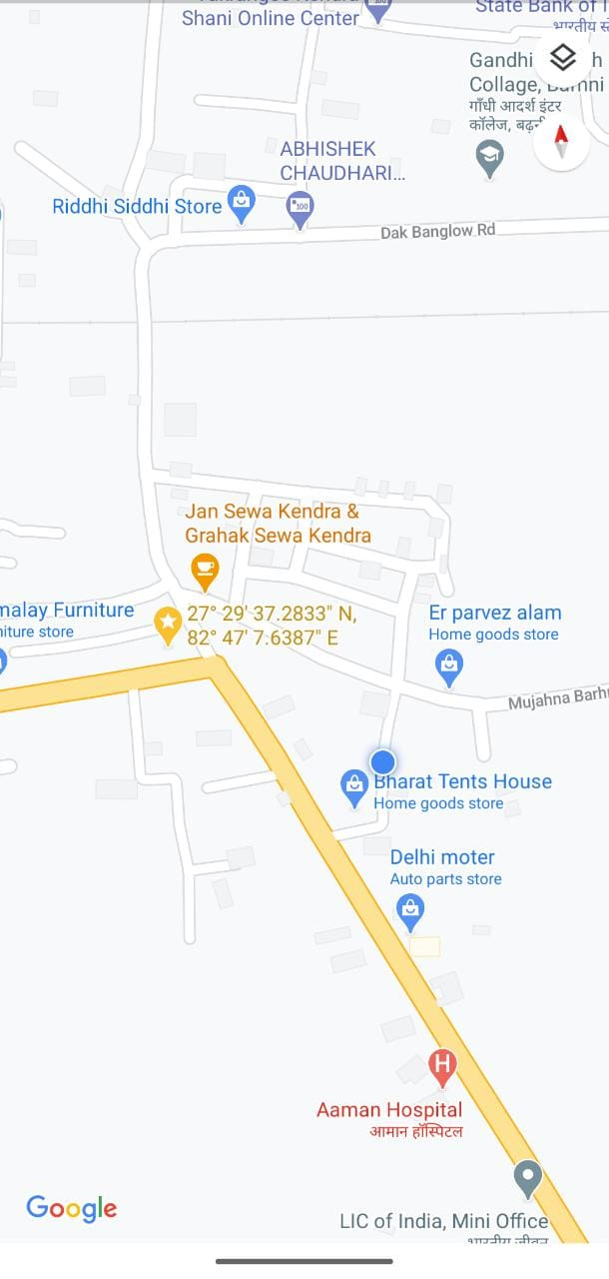

**Figure 3.1** Image representing location of the reference building site

*PHOTOGRAPHS OF SITE VSITED

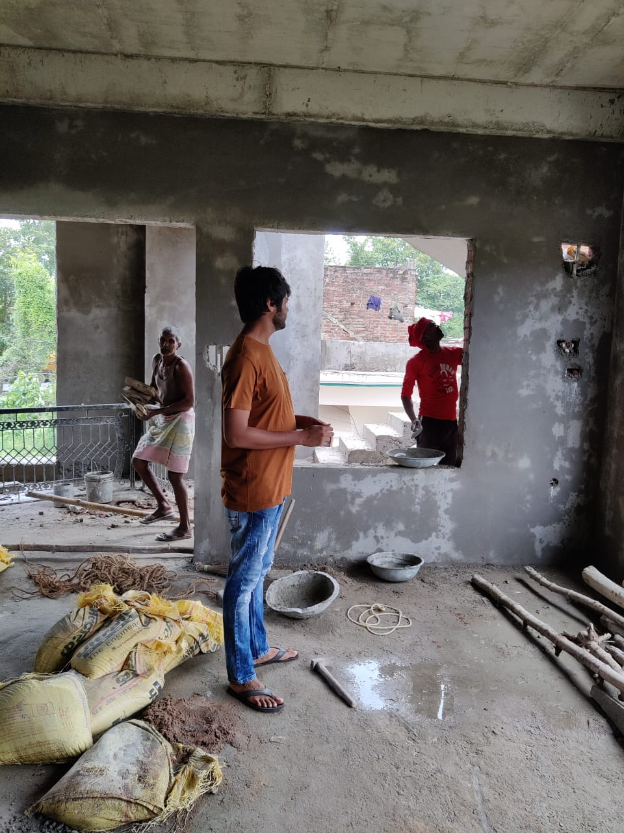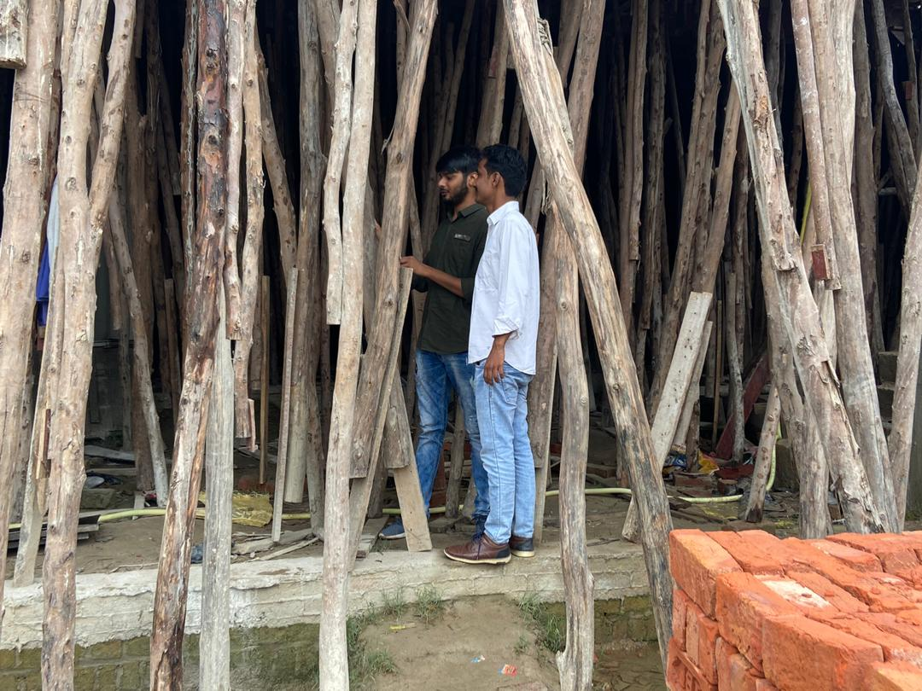

**Figure 3.2** Photographs of Site visit

**3.3 DATA COLLECTION**

**3.3.1 DATA REGARDING COST OF BUILDING WITH CONVENTIONAL CONSTRUCTION**

**Detail of Cost of 1 m^3 of RCC work (M20 grade) including transportation, execution and labour cost but excluding the cost of centering, shuttering and reinforcement**

**Table 3.1** Cost of unit quantity of RCC work

|  |  |  |  |  |  |
| --- | --- | --- | --- | --- | --- |
| **DESCRIPTION** | **UNIT** | **QUANTITY** | | **RATE** | **AMOUNT** |
| **1.MATERIAL** |  |  | |  |  |
| M20 grade concrete including the transportation cost up to site | M^3 | 1 | | 5700 ₹ | 5700 ₹ |
| GST | % | 18 | | @5700 ₹ | 1026 ₹ |
| TOTAL |  |  | |  | 6726 ₹ |
| **2.LABOUR** |  |  | |  |  |
| Mason | DAY | 0.24 | | 500 ₹ | 120 ₹ |
| Beldar | DAY | 2.75 | | 300₹ | 825 ₹ |
| Bhisti | DAY | 0.95 | | 350₹ | 332 ₹ |
| Coolie | DAY | 1.88 | 300 ₹ | | 564 ₹ |
| TOTAL |  |  |  | | 1841 ₹ |
| **COST OF 1 M^3 RCC WORK** |  |  |  | | **8567 ₹** |

*(Data Source:PRISM RMC INDIA LTD.)*

**Detail of Cost of 1 quintal of steel reinforcement for RCC work including straightening, cutting, bending, placing in position and binding all complete (above plinth level)**

**Table 3.2** Cost of unit quantity of reinforcement work

|  |  |  |  |  |  |  |
| --- | --- | --- | --- | --- | --- | --- |
| **DESCRIPTION** | **UNIT** | | | **QUANTITY** | **RATE** | **AMOUNT** |
| **1.MATERIAL** |  | | |  |  |  |
| Mild steel bar 1quintal adding 5% wastage  Total 1.05 q | Quintal | | | 1.05 q | 4700 ₹ | 4935 ₹ |
| Binding Wire |  | | |  |  | 50 ₹ |
| **2.LABOUR** |  | | |  |  |  |
| Blacksmith 1st Class | DAY | | | 1 | 700 ₹ | 700 ₹ |
| Beldar | DAY | | | 1 | 300 ₹ | 300 ₹ |
| **COST OF 1 q MS REINFORCEMENT WORK** | |  |  | |  | **5985₹** |

*Data Source:PWD SOR with updated rate of material and labour*

**Detail of cost for 1 m^3 masonry work including transportation and all labour cost**

**Table 3.3** Cost of unity quantity of masonry work

|  |  |  |  |  |
| --- | --- | --- | --- | --- |
| **DESCRIPTION** | **UNIT** | **QUANTITY** | **RATE** | **AMOUNT** |
| **1.MATERIAL** |  |  |  |  |
| Common burnt clay bricks of designation 7.5 (with transport) | No’s | 500 | 6300 ₹ | 3150 ₹ |
| Cement Mortar 1:4 (1 cement:4 coarse sand) | M^3 | 0.25 | 4500 ₹ | 1125 ₹ |
| **2.LABOUR** |  |  |  |  |
| Mason (Brick layer) 1st class | DAY | 0.47 | 535 ₹ | 250 ₹ |
| Mason (Brick layer) 2nd class | DAY | 0.47 | 500 ₹ | 235 ₹ |
| Coolie | DAY | 1.8 | 300 ₹ | 540 ₹ |
| Bhisti | DAY | 0.20 | 350 ₹ | 70 ₹ |
| TOTAL |  |  |  | 5370 ₹ |
| **COST OF 1 M^3 BRICK WORK (adding 1% water charge)** |  |  |  | 5370+1 %=**5423** ₹ |

*Data Source:PWD SOR with updated rate of material and labour*

**Detail of cost for 10 sq. met plastering work of 20 mm double coat with paste of 1:4 (1 cement:4 fine sand)**

**Table 3.4** Cost of unit quantity of plaster work

|  |  |  |  |  |  |  |
| --- | --- | --- | --- | --- | --- | --- |
| **DESCRIPTION** | **UNIT** | | **QUANTITY** | **RATE** | | **AMOUNT** |
| **1.MATERIAL** |  | |  |  | |  |
| Cement mortar 1:4 | M^3 | | 0.224 | 3528.85 ₹ | | 790.46 ₹ |
| **2.Labour** |  | |  |  | |  |
| Mason | DAY | | 0.94 | 500 ₹ | | 470 ₹ |
| Coolie | DAY | | 1.02 | 300 ₹ | | 306 ₹ |
| Bhisti | DAY | | 1.10 | 350 ₹ | | 385 ₹ |
| **3.Scaffolding and Sundries** | L.S. | | 12.61 | 2 ₹ | | 25.22 ₹ |
| TOTAL |  | |  |  | | 1976.60 ₹ |
| Add 1 % water charge |  | |  |  | | 19.76 ₹ |
| TOTAL |  | |  |  | | 1996.44 ₹ |
| Add GST (multiplying by factor 0.1405) |  | |  |  | | 280.49 ₹ |
| Total cost of 10 sq. met plaster work | |  |  | |  | 2276.93 ₹ |
| **TOTAL COST OF 1 SQ. METRE PLASTER WORK** | |  |  | |  | **227.69** ₹ |

*Data Source:PWD SOR with updated rate of material and labour*

**Cost of shuttering and centering including all rental, labour and transportation cost =** 300 ₹ per sq. met.

**3.3.2 DATA REGARDING COST OF BUILDIN WITH EPS CORE PANEL SYSTEM**

Providing and fixing in position, 200 mm thick factory made Expanded Polystyrene Core (EPS Core) wall panels consisting of EPS core sandwiched between two engineered sheets of welded wire fabric mesh duly finished with shortcrete materials on outer faces. The fabric mesh shall be made of 3 mm dia G.I. wire mesh with 50 mm pitch in both the directions and on both faces of the wall, kept at 120-135 mm gap and connected by the zigzag G.I. wire of 3 mm dia at alternate row by welding (at an angle ranging from 50-70 degree) . The EPS core shall consist of 100 mm thick EPS of density not less than 20 kg/ per cum. Both the outer faces of the panel shall be finished by applying the layer of 50 mm thick cement mortar 1:3 {1 cement: 3 coarse sand (not having more than 40% stone chips of size up to 6 mm)} À with the help of concreting /uniting equipment etc. at a pressure not less than 1 bar (100Kn/m2) and both surfaces finished with trowel. Fixing operations of wall panels shall be completed in all respect as per drawings and specifications and under the overall direction of the Engineer-in-charge.

**Table 3.5** Detail of cost of 1 sq. met of 200 mm thick EPS panel

|  |  |  |  |  |
| --- | --- | --- | --- | --- |
| **DESCRIPTION** | **UNIT** | **QUANTITY** | **RATE**₹ | **AMOUNT**₹ |
| **Details of cost for 1.20x3.00m= 3.60 sqm**  **MATERIAL**  Factory made EPS Core wall panel /roof panel sandwiched between two Engineered welded wire fabric mesh of 3 mm dia G.I. wire mesh, with 50 mm pitch in both the directions, kept at 120- 135 mm gap and interconnected by the zigzag G.I. wire of 3 mm dia at alternate row by welding.  3.60 sqm + 0.18 sqm (Add for wastage @5%)Total = 3.78 sqm | Sq.met | 3.78 | 1650.00 | 6237.00 |
| Add for L-shape,U-shape & straight lap mesh | L.S. | 208.00 | 2.00 | 416.00 |
| Cement mortar 1:3 (1cement:3 coarse sand) 2x1.20x3.00x0.05= 0.36 cum  Rate as per Item No.3.8 of SH: Mortar | Cum | 0.36 | 4664.55 | 1679.24 |
| 10 mm TMT bars (2 nos.75 mm long) Aluminium C-channels (100mmx 150mm long) For fixing wall with foundation | L.S. | 312.15 | 2.00 | 624.30 |
| **LABOUR**  For carrying out shotcreting, shoring, leveling, and finishing the surface with trowel | L.S. | 707.50 | 2.00 | 1415.00 |
| TOTAL |  |  |  | 10371.54**W** |
| Add 1 % water charges on “W” |  |  |  | 103.72 |
| TOTAL |  |  |  | 10475.25**X** |
| Add GST on “X” (multiplying by factor 0.1405 ) |  |  |  | 1471.77 |
| TOTAL |  |  |  | 11947.03 |
| Cost of 3.6 sq. met |  |  |  | 11947.03 |
| **COST OF 1 sq. met.** |  |  |  | **3318.62** ₹ |

*Data Source: PWD SOR*

Providing and fixing in position, 230mm thick factory made Expanded Polystyrene Core (EPS Core) roof/floor panels made of 3 mm dia G.I. wire mesh with 50 mm pitch in both the directions and on both faces of panel, kept at 120-135 mm gap and connected by the zigzag G.I. wire of 3 mm dia at alternate row by welding (at an angle ranging from 50-70 degree). The EPS core shall consist of 100 mm thick EPS of density not less than 20kg/ per cum. The bottom side of the panel shall be finished by applying a layer of 60-65 mm thick cement mortar 1: 3 {1 cement: 3 coarse sand (not having more than 40% stone chips of size upto 6 mm)} À with the help of shotcreting equipment etc. at a pressure of not less than 1 bar (100Kn/m2) and surface finished with trowel. The top face of the panel shall be provided and finished by applying 70- 75 mm thick layer of cement concrete 1:1.5: 3 (1 cement :1.5 coarse sand : 3 graded stone aggregate 20 mm nominal size). Fixing operations of roof/floor panels shall be completed in all respect as per drawings and specifications and under the overall direction of the Engineer-in-charge.

**Table 3.6** Detail of cost of 1 sq. met of 230 mm thick EPS panel

|  |  |  |  |  |
| --- | --- | --- | --- | --- |
| **DESCRIPTION** | **UNIT** | **QUANTITY** | **RATE** ₹ | **AMOUNT** ₹ |
| **Details of cost for 1.20x3.00m= 3.60 sq.m**  **MATERIAL**  Factory made EPS Core wall panel /roof panel sandwiched between two Engineered welded wire fabric mesh of 3 mm dia G.I. wire mesh, with 50 mm pitch in both the directions, kept at 120- 135 mm gap and interconnected by the zigzag G.I. wire of 3 mm dia at alternate row by welding.  3.60 sq.m + 0.18 sq.m (Add for wastage @5%)Total = 3.78 sq.m | Sq. Met | 3.78 | 1650.00 | 6237.00 |
| Add for L-shape,U-shape & straight lap mesh | L.S. | 202.32 | 2.00 | 404.64 |
| Cement mortar 1:3 (1cement:3 coarse sand)  60 mm thick on the bottom of roof slab =1x1.20x3.00x0.06=0.216 cum | cum | 0.216 | 4664.55 | 1007.54 |
| Mortar Cement Concrete 1:1.5:3  70 mm thick on the top of roof slab=1x1.2x3.00x0.70=0.252 cum | Cum | 0.252 | 9763.80 | 2460.48 **A** |
| **LABOUR**  For carrying out shotcreting, shoring, levelling, and finishing the surface with trowel | L.S. | 832.36 | 2.00 | 1664.72 |
| TOTAL |  |  |  | 11774.38 **W** |
| Add 1 % water charges on “W-A” |  |  |  | 93.14 |
| TOTAL |  |  |  | 11867.52 **X** |
| Add GST on “X-A” (multiplying by factor 0.1405 ) |  |  |  | 1321.69 |
| TOTAL |  |  |  | 13189.21 |
| Cost of 3.6 sq. met |  |  |  | 13189.21 |
| **COST OF 1 sq. met.** |  |  |  | **3663.66**₹ |
|  |  |  |  |  |

*Data Source:PWD SOR*

Providing and fixing in position, 130 mm thick factory made Expanded Polystyrene Core (EPS Core) wall panels consisting of EPS core sandwiched between two Engineered sheets of welded wire fabric mesh duly finished with shortcrete materials on outer faces. The fabric mesh shall be made of 3 mm dia zinc coated G.I. wire mesh with 50 mm pitch in both the directions and on both faces of the wall and connected by GI wire of 3mm dia at alternate row by welding. The EPS core shall consist of 60 mm thick EPS of density not less than 16 kg/ per cum. Both the outer faces of the panel shall be finished by applying the layer of 35 mm thick cement mortar 1:3 {1 cement: 3 coarse sand (not having more than 40% stone chips of size upto 6 mm)} with the help of shotcreting / guniting equipment etc. at a pressure not less than 1 bar (100KN/ m2) and both surfaces finished with trowel. Fixing operations of wall panels shall be completed in all respect as per drawings and specifications and under the overall direction of the Engineer-in-charge.

**Table 3.7** Detail of cost of 1 sq. met of 130 mm thick EPS panel

|  |  |  |  |  |
| --- | --- | --- | --- | --- |
| **DESCRIPTION** | **UNIT** | **QUANTITY** | **RATE** ₹ | **AMOUNT** ₹ |
| **Details of cost for 1.20x3.00m= 3.60 sq.m**  **MATERIAL**  Factory made EPS Core wall panel /roof panel sandwiched between two Engineered welded wire fabric mesh of 3 mm dia G.I. wire mesh, with 50 mm pitch in both the directions, interconnected by the zigzag G.I. wire of 3 mm dia at alternate row by welding.  3.60 sq.m + 0.18 sq.m (Add for wastage @5%)Total = 3.78 sq.m | Sq. Met | 3.78 | 600.00 | 2268.00 |
| Add for L-shape,U-shape & straight lap mesh | L.S. | 208.00 | 2.00 | 416.00 |
| Cement mortar 1:3 (1cement:3 coarse sand) 2x1.20x3.00x0.035= 0.052 cum  Rate as per Item No.3.8 of SH: Mortar | Cum | 0.252 | 4664.55 | 1175.47 |
| 10 mm TMT bars 8 nos. of 0.60 met long. Total length 4.8 met @0.617 kg/meter. Total weight 2.96 kg  Tag screw with washers for wire mesh fixing  For fixing wall with foundation | Kg  L.S.  L.S. | 2.96  78  312.15 | 83.50  2.00  2.00 | 247.16 **A**  156.00  624.30 |
| **LABOUR**  For carrying out shotcreting , shoring, levelling , and finishing the surface with trowel | L.S. | 707.50 | 2.00 | 1415.00 |
| TOTAL |  |  |  | 6301.93**W** |
| Add 1 % water charges on “W-A” |  |  |  | 60.55 |
| TOTAL |  |  |  | 6362.47 **X** |
| Add GST on “X-A” (multiplying by factor 0.1405 ) |  |  |  | 859.20 |
| TOTAL |  |  |  | 7221.68 |
| Cost of 3.6 sq. met |  |  |  | 7221.68 |
| **COST OF 1 sq. met.** |  |  |  | **2006.02**₹ |

*Data Source*:*PWD SOR*

**3.3.3 DATA REGARDING LIFE-CYCLE COST ANALYSIS:-**

Previous data obtained are for present construction cost when using conventional construction technique and light gauge steel construction technique. Following are the data for life-cycle cost analysis:-

**Table 3.8** LIFE CYCLE COMPONENT COST

|  |  |  |
| --- | --- | --- |
| **COMPONENTS OF LIFE-CYCLE COST** | **CONVENTIONAL CONSTRUCTION**₹ | **EPS CORE PANEL SYSTEM**₹ |
| INITIAL CONSTRUCTION COST | 4288553 ₹ | 4950227 ₹ |
| ANUALLY RECURRING REPAIR AND MAINTENANCE COST | 8500 ₹ | 8500 ₹ |
| NON-ANUALLY RECURRING REPAIR AND MAINTENANCE COST (after each 10 years) | 300000 ₹ | 250000 ₹ |
| OPERATION COST  (Energy cost and local taxes) | 313000 ₹ | 110000 ₹ |
| RESIDUAL VALUE (Resale value) | 1537386 ₹ | 1774587 ₹ |

*Data source:Discussion with users*

Rate of depreciation as per income tax act for residential building (for 2018-19 & 2018-20) = 5 %

**Salvage Value (SV) =P (1- i )y**

P = Original cost of asset , i = depreciation rate , y = number of years

Salvage vale of building with Conventional construction technology after 20 years study period

= 4288553 (1 – 0.05 )20 = 1537386 ₹

Salvage vale of building with EPS core panel technology after 20 years study period

= 4950227 (1 – 0.05 )20 =1774587 ₹

**CHAPTER 4**

**ANALYSIS,RESULTS AND DISCUSSION**

**4.1 COMPARATIVE ANALYSIS (COST & TIME COMPARISON)**

Comparative analysis is only being carried out for superstructure construction as the construction up to plinth level is same with both the technology i.e.; conventional and prefabrication

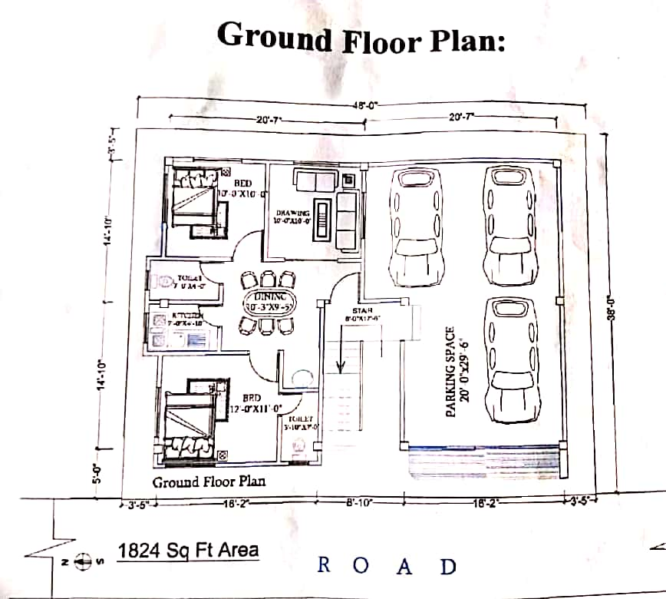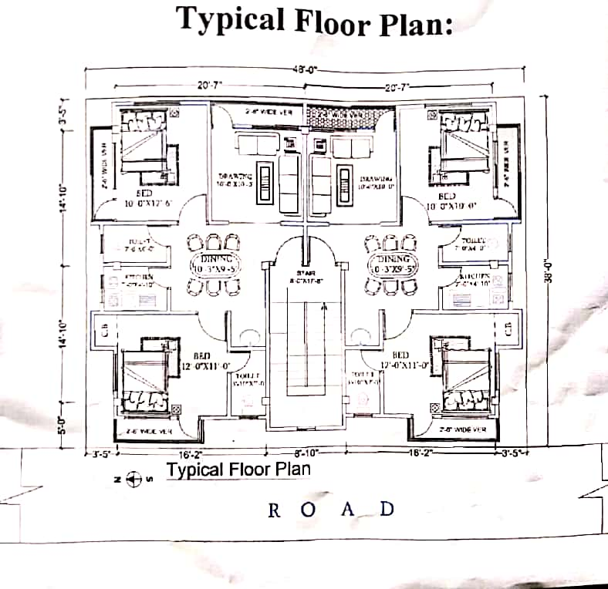

**Figure 4.1** Image representing floor plan of the reference building

**4.1.1 COST COMPARISON**

Cost of the building is calculated in the following Table if the building is constructed using conventional construction technology

**Table 4.1** Cost estimation of building with conventional construction

|  |  |  |  |  |  |
| --- | --- | --- | --- | --- | --- |
| **S.NO.** | **DESCRIPTION** | **UNIT** | **QUANTITY** | **RATE** ₹ | **AMOUNT** ₹ |
| **1.** | RCC work in COLUMN excluding the cost of centering,shuttering, and reinforcement (M20 grade) | Cum | 11.9476 | 8567.00  (including GST, transport and all type of labour charges) | 102355.08 |
| **2.** | RCC work in BEAM excluding the cost of centering, shuttering, and reinficement | Cum | 17.8656 | 8567.00 | 153054.59 |
| **3** | RCC work in SLAB excluding the cost of centering, shuttering, and reinforcement (M20 grade) | Cum | 81.850 | 8567.00 | 701208.95 |
| **4** | RCC work in LINTELS of doors and windows excluding the cost of centering,shuttering, and reinforcement (M20 grade) | Cum | 4.03 | 8567.00 | 34525.01 |
| **5** | Provision of reinforce-ment for all RCC work including the cost of straightning, cutting, bending, placing in position and binding all complete  1.COLUMN  2.BEAM  3.SLAB  4.LINTELS  TOTAL | QUINTAL | 23.447  28.048  64.252  3.163 | 5985.00 | 140330.30  167867.28  384548.22  18930.55  711676.35 |
| **6** | Shuttering work including rental,transport and labour charges for  1.COLUMN  2.BEAM  3.SLAB  4.LINTELS  TOTAL | Sq.met | 158.544  214.936  545.660  69.096 | 300.00 | 47567.20  64480.80  163698.00  20728.00  296474.80 |
| **7** | Masonry work including mortar, watercharge, and labour cost etc. using common burnt clay brick designation 7.5 and 1:4 cement mortar | Cum | 178.948  (deductions for doors and windows opening is made) | 5423.00 | 970435.00 |
| **8** | 20 mm thick plaster in two coats with 1:3 paste | Sq. Met | 3335.44 | 227.69 | 759446.33 |
|  | **TOTAL** |  |  |  | **3729176.11** |
|  | Add 10 % for material wastage |  |  |  | 372917.61 |
|  | Add 5 % for overhead charges |  |  |  | 186458.80 |
| **GRAND TOTAL 4288553 ₹** | | | | | |

Cost of the building is calculated in the following Table if the building is constructed using EPS core panel technology

**Table 4.2** Cost estimation of building with EPS core panel system:

|  |  |  |  |  |  |
| --- | --- | --- | --- | --- | --- |
| **S.NO** | **DESCRIPTION** | **UNIT** | **QUANTITY** | **RATE₹** | **AMOUNT₹** |
| **1** | 130 mm thick EPS panel work for non-load bearing wall construction including transportation and all type of labour charges | Sq. Met | 588.585 | 2006.02 | 1180713.29 |
| **2** | 200 mm thick EPS panel work for load bearing wall construction including transportation and all type of labour charges | Sq. Met | 533.475 | 3318.62 | 1770400.80 |
| **3** | 230 mm thick EPS panel work for slab construction including transportation and all type of labour charges | Sq. Met | 545.66 | 3663.66 | 1999112.72 |
| **GRAND TOTAL 4950227 ₹** | | | | | |

**Figure 4.2** Histogram representing Cost comparison

**OUTPUT FROM COST COMPARISON:**

From the above analysis, it is obtained that construction with EPS core panel technology is **15.42 %** costlier than that with conventional construction technology.

**4.1.2 CONSTRUCTION DURATION COMPARISON**

**CONVENTIONAL CONSTRUCTION:**

Time consumed in ground floor construction = 25 days

Time consumed in typical floor construction = 28 days

**Total time consumed for G+3 building construction=**25+3×28=**109 days**

**EPS CORE PANEL SYSTEM:**

Time consumed in ground floor construction = 9 days

Time consumed in typical floor construction = 11 days

**Total time consumed for G+3 building construction=**9+3×11=**42 days**

**Figure 4.3** Histogram representing duration comparison

**OUTPUT FROM DURATION COMPARISON:**

From the above analysis, it is obtained that conventional construction technology consumes duration **2.595 times more** than that of EPS core panel technology.

**4.2 ENERGY SAVING WITH EPS CORE PANEL**

Since EPS core panel buildings provide a very high degree of thermal insulation which reduces considerable amount of energy consumption which ultimately results in low operation cost of the building. The total saving of energy cost with EPS core panel system is analysed below.

CDD (cooling degree day) and HDD (heating degree day) concept is used in this analysis.

Monthly and annually CDD and HDD for Siddharthnagar is calculated and listed below.

**Table 4.3** CDD and HDD calculations

|  |  |  |  |
| --- | --- | --- | --- |
| **MONTH** | **Avg.Temperature (oF)** | **CDD (oF)**  (Avg Temp – 65 ) . number of days in month | **HDD (oF)**  (65 – Avg Temp) . number of days in month |
| JANUARY | 60.8 |  | 130.2 |
| FEBRUARY | 65.8 | 22.4 |  |
| MARCH | 75.9 | 337.9 |  |
| APRIL | 85.8 | 624 |  |
| MAY | 92.8 | 861 |  |
| JUNE | 92.5 | 825 |  |
| JULY | 86 | 651 |  |
| AUGUST | 84.4 | 601.4 |  |
| SEPTEMBER | 84 | 570 |  |
| OCTOBER | 79.2 | 440 |  |
| NOVEMBER | 69.6 | 138 |  |
| DECEMBER | 62.4 |  | 80.6 |
| **TOTAL** |  | 5070 oF = **2798.8 oC** | 210.8oF = **98.8 oC** |

Since the HDD is neglegible as compared to CDD,hence heating cost is not considered in the study.

Formula for the saving in energy expenditure for cooling the space of the building when conventional construction is replaced with EPS core panel system.

**S = (0.024 × Uw × CDD × CE ×P / Cop) × (Uo – Uw) - xCA** .…………………Equation 4.1

Where,

Uw = Overall heat transfer co-efficient for moderate temperature and 200 mm thick EPS core panel = 0.5 w/m2

Uo = Overall heat transfer co-efficient for moderate temperature and 200 mm thick masonry wall = 2.5 w/m2

Cop = Coefficient of performance of the cooling machine unit = 2

CE = Cost of electricity = 5.5 ₹ / Kwh

P = Life Cycle parameter = 20 years

x = insulation thickness = 200 mm

CA= Cost of insulation per unit volume = 16590 ₹

S = (0.024 ×0.5 × 2798.8 ×5.5 ×20 /2) × (2.5 – 0.5 ) – 0.2 ×16590

S = 3694.416 – 3318

**S = 376 ₹** per sq. met per year

Total saving in entire building with surface area 542.2 sq. met

**TOTAL SAVING = 376 × 542.2 = 203867 ₹**

**4.3 LIFE CYCLE COST ANALYSIS**

Followings are the component of Life Cycle Cost

1. Initial construction cost

2. Annually recurring repair and maintenance cost (painting, white-washing, minor repairs)

3. Non-annually recurring repair and maintenance cost “after each 10 years” (major repair of cracks, replastering, surface dressing etc.)

4. Operation cost (Energy cost and local taxes)

5. Salvage Value (After 30 years study period) **‘SV’**

**Life Cycle Cost (LCC) =IC + Present value of ‘R&MA’ + Present Value of ‘R&MNA’ + Present Value of ‘OC’ – Present Value of ‘SV’** ……….Equation 4.2

Present Value for future expenditure = Future value / (1+i) n

Present Value for equal uniform expenditure =

Annual value {(1+i) n-1 / i (1+i) n}

**Assumption for LCCA**

1.Discount rate (i) is 4.5 %

2.Study period is 20 years

**1.LCCA for conventional construction**

Life cycle cost = 4288553 + 85000 {(1+4.5%)20-1 / 4.5%(1+4.5%)20} +

300000 /(1+4.5%)10 + 300000 /(1+4.5%)20 +

313000{(1+4.5%)20-1 / 4.5%(1+4.5%)20} - 1537386 /(1+4.5%)20

LCC = 4288553 + 1105676 + 193178 + 124393 + 4071484 – 637466

**LCC = 9145818 ₹**

**2.LCCA for EPS core panel system**

Life cycle cost = 4950227 + 85000 {(1+4.5%)20-1 / 4.5%(1+4.5%)20} +

250000 /(1+4.5%)10 + 250000 /(1+4.5%)20 +

110000{(1+4.5%)20-1 / 4.5%(1+4.5%)20} - 1774587/(1+4.5%)20

LCC = 4950227 + 1105676 + 160982 + 103661 + 1430875 – 735820

**LCC = 7015601 ₹**

**Figure 4.4** Histogram representing LCCA results

**OUTPUT FROM LCCA :**

LCCA was carried out to determine the impact of prefabrication technology on profitability in long run of a construction project,it was obtained that LCC of EPS core panel technology is 23.29 % less than that of conventional construction.

**CHAPTER 5**

**CONCLUSION**

Study aims to identify the economical, preferable and profitable construction technology among conventional and prefabricated technology. Economy is not only about construction cost but the time elapsed in construction, operation and maintenance cost etc. also matters.

There are various prefabrication technologies that are used throughout the world. This paper aims to identify the impact on profitability if conventional construction system is replaced by EPS core panel system, a prefabrication technology, for a G+3 building.

An on-going G+3 building site was selected in Siddharthnagar for reference design. Cost estimation of the building was carried out using the data obtained from local suppliers, contractors and PWD schedule of rate. Further, cost estimation of the same building was carried out for EPS core panel system. Time elapsed in constructing the building was also calculated for both the technology.

A comparative analysis for cost and time was performed to determine whether which technology has lower initial construction cost and which technology is more rapid.

Initial construction cost with conventional construction technology was calculated as 4288553 ₹ and same with EPS core panel system was calculated as 4950227 ₹.Time taken in construction of entire building was 109 days with conventional construction and 42 days with EPS core panel system

After performing comparative analysis for cost and time, it was observed that EPS core panel technology (when using 130 mm for non-load bearing walls,200 mm for load bearing walls and 230 mm for slab) is 15.43 % costlier but 2.595 times faster than conventional construction technology.

Then, the question rose that a technology, that is economical in short run of time may be costlier in long run of time due to higher operation and maintenance cost and lower salvage value. To resolve the issue, life cycle cost analysis was performed for both the technology to identify the profitable technology in long run of time.

Data such as initial construction cost, annually recurring repair and maintenance cost, non-annually recurring repair and maintenance cost, operation cost and salvage value was collected for both the technology and their present vale were calculated and their present value were determined.

Life cycle cost analysis was performed for 20 year’s study period and assuming discount rate of 4.5 %.

Life cycle cost of the building with conventional construction technology was 8586481 rupees and LCC for EPS core panel technology was 7015601 rupees.

After comparing the life cycle cost of the building with both the technologies, it was observed that EPS core panel technology is 23.29 % cheaper than conventional construction technology.

An analysis was also performed to determine the saving in energy cost when conventional construction is replaced with EPS core panel system. CDD and HDD approach is used for this analysis. Annually 203867 ₹ saving in energy cost was calculated for the specified building

After completion of entire analysis, the conclusion of the analysis was found that EPS core panel technology is slightly costlier than conventional construction technology in terms of initial construction cost, but EPS core panel technology is more profitable than conventional construction technology in terms of long run of time. Also, EPS core panel technology is highly rapid in construction than conventional construction technology and energy cost of this technology is very low than conventional construction. Hence, apart from initial construction cost, EPS core panel technology is more profitable and preferable over conventional construction.

Prefabrication construction technology generates less waste on site because building elements are cast in the warehouse and then transported to the site for final erection and installation. Therefore, saving in time as well as money is achieved. It is remarkably seen that the cost of building constructed using prefab technology is significantly less and duration of construction is also much lesser as compared to traditional method. The prefab construction method helps in reducing the adverse impacts on the environment and offers an environmental friendly construction. Hence, prefab construction technique is much more efficient and sustainable. The better quality control may be achieved if this technology is adopted for repetitive type of works. From the study one may conclude that the prefab technology is economical than conventional cast in place method, but still there are certain aspects as mentioned earlier which may be taken into consideration while using this technology. The sustainability aspects viz. social, economic and environmental may promote prefab technology as a promising alternative in construction industry.

**REFERENCES**

1.Vivian W. Y. Tam, William C.Y. Ng; Towards adoption of prefabrication in construction; Building and environment, Volume 42,Issue 10(October 2007)

2.Zhengdo Li ,Measuring the impact of prefabrication on construction waste reduction: an empirical study in Shenzhen,China,(2014.07.013)

3.Rachit Sharma,Kshitiz Mudgal,Prefabrication and its adoption in India,National conference on alternative and innovative construction materials and techniques (sep 2014)

4.Anthony Nken Ede;Thermal behaviour and admissible compressive strength of expanded polystyrene wall panels of varying thickness; CTTS,Volume 3,Issue 2 ISSN-2279-0535 (2014)

5.N. Dineshkumar; Comparative study on prefabrication with cast in-situ construction of residential building; IJISET,Volume 2,Issue 4(April 2015)

6.Avirup Sarkar,Adil Ahmad; Seismic Design of Expanded Polystyrene Core Panel Based Building Systems,International Conference on Earthquake Engineering and Post Disaster Reconstruction Planning (April 2016)

7.Wajiha Mohsin Shahzad;Comparative analysis of the productivity levels achieved through the use of panelized prefabrication technology with those of traditional building system(April 2016)

8.Omid Raza Baghchesaraei,HosseinHosseiniLavasani,AlirezaBaghchesaraei; Behaviour of prefabricated structure in doveloped and doveloping countries; Bulletin de la societe des science d liege,,Volume 85,2016,page.1229-1234

9.Prajjwal Paudel, Study on prefabricated modular and steel structure, SSRG-IJCE,Volume 03,Issue 05 (May 2016)

10.Akash Lanke; Design, cost and time analysis of precast and RCC building; IRJET,Volume 3,Issue 6,ISSN-2395-056(June 2016)

11.Evanjaline Libie; Impact of prefabrication on profitability over traditional construction; IJIWET,Volume 2,Issue 3,ISSN-25455-5797(June 2016)

12.Abhishek K. Tawre, Prefabrication,sustainable technique in building construction,Resincap Int. J. Sci. Eng. 1 (2),44-50,2017

13. Anant Bhosale, Sushma Kulkarni, comparative study of prefabrication construction with cast-in situ construction,IJAERD,Volume 4,Issue 3 (March 2017)

14.T.Subramani,M. Muhammad Ansar,S.Priyanka; Impact of prefabrication technology and equipment on profitability using Primavera,IJETTCS,Volume 6,Issue 03(May-June 2017)

15.MonikaShekhar Gupta; Study on prefabrication construction; IJESM,Volume 6,Issue 3 (July 2017)

16.Hong Xue,ShouzianZhang,YikunSu,Zhezhou Wu; Factors affecting the capital cost of prefabrication-A case study of China;[www.mdpi.com/journal/sustainability](http://www.mdpi.com/journal/sustainability) sustainability,2017,9,1512,doi:10.3390/su9091512

17.Lakhi M. Chavan,Prof. D.B. Desai; Analyse time-cost required for conventional and prefabricated building components; IRJET,Volume 04,Issue 08(August 2017)

18.Chetan Kumar B.,AkshayaKumarV.H.,Harshad R. Parate; Impact of prefabrication technology on profitability in construction industry;RUAS-SAS Tech Journal,Volume 18,Issue 1 (November 2017)

19.Hamza Khan,Kkartikh Jain, , Study on trends & usage of Prefabrication and Modularization:Increasing productivity in te construction industry,IJCER,ISSN 2278-3652,Volume 8,(November 2017)

20.S. Vigneshkannan, A general study of light guage steel structures;A Review, IJARMET,Volume 1,Issue 4,ISSN 2456-6446,December 2017

21.Hannah Nyambara Ngugi,Use of Expanded Polystyrene Technology and material recycling for building construction in Kenya, AJETM,ISSN:2575-1441(online) (2017)

22. Mrs. Neetu B. Yadav, Pre-cast technology: an initial step to sustainable development, IJSRD, Vol.01, Issue.07, ISSN (online)-2321-0613 (2017)

23.V. Karthikeyan, Study on comparison between prefabricated and conventional structure,IJCET,Volume 09,Issue 05,ISSN-0976-6316(online) (May,2018)

24. Alhalbi Zinah Shuman, The study of light gauge steel for high-rise buildings and business centres, 2018

25.Shubham D. Auti, Prefabrication Technology-A promising Alternative in Construction Industry,IJSR,ISSN;2319-7064,2018

26. Nor Hafizah Ramli Sulong; Application of expanded polystyrene (EPS) in buildings and construction : A review, Journal of Applied Polymer Science,Volume 136,Issue 20 (Janaury 2020)

27.KaichengShen, Environmental Cost-benefit Analysis of prefabricated Public housing in Beijing,sustainability,2019,11,207;doi:10.3390/su11010207

28.Nitesh J. Ramchandani; To study impact of prefabrication on profitability over traditional construction;A review; IJAST,Volume 4,Issue 3,ISSN-2455-2143(July 2019)