Railway Traveller’s – Online FIR Registration

Dr.Anita Harsoor Department of Computer Science PDA College Of Engineering,

Gulbarga,Karnataka,India

# Abstract

While travelling in the train in the event of any incident the procedure of FIR becomes hectic for a passenger because there is no facility for a passenger to file FIR instantly. The passenger needs to visit railway police to file FIR. Railway department has provided a helpline number 182 for lodging FIR. Though it's not much helpful. We want to develop a system from which passenger travelling in a train can now file a FIR through his mobile in just a few steps and it's guaranteed that his/her all details will be valid. Passenger won't need to visit Railway Police station to file a FIR. The basic aim of this project is to provide hassle-free service to passengers travelling in a train the FIR registration will be attended by police satation in arriving next

# Introduction

A First information report is a document prepared by police organization. Online FIR is to develop an online crime reporting and management system which is easily accessible to the public, the police department and the administrative department. An EIR is an important document because it set the process of criminal justice in motion it is only after the FIR is registered in the police station that the police take up investigation of the case. The person giving information or making a complaint as a right to demand that the information is recorded by the police be read to him or her. Once the Justify information has been recorded by the police it must be signed by the person giving the information.

Vinayak Reddy, Shaik Majeed Ali, Shrishail Department of Computer Science

PDA College Of Engineering, Gulbarga,Karnataka,India

**Block Diagram**

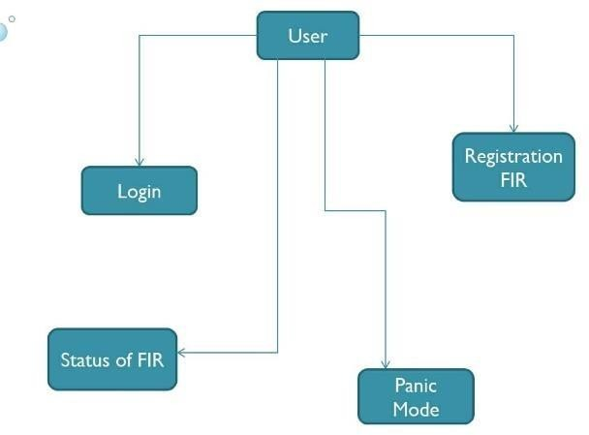

Fig 1: Block Diagram of Users Interface

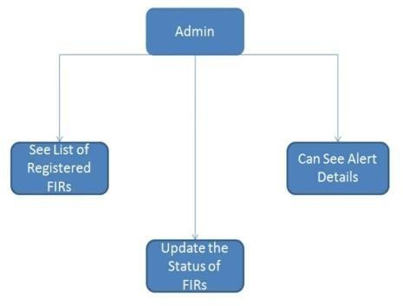

Fig 2: Block Diagram of Admin Interface

1. **Related Work**

As mentioned earlier, the 'Passenger Security- Online FIR Registration is the first of its kind. There are no exact technical papers published on this topic. However there were few technical papers related to this topic which gave us some ideas.

1. E-Cops Project Report was published by Ramesh Gavva and Prasarla Shanthan.

This technical paper was similar to an employee database. The only difference was that it contained all the information related to the police officers. There were various departments like traffic. narcotics and anti-trafficking and all the officers and their names and all the necessary details were there in the database (October 4, 2011).

1. Crime reporting and crime updates Was Published by Mohammad Shahnawaz.

Developed an application that applies to all police stations across the country and specifically looks in to the object of crime record management It give FIR number to the user which was not in previous papers. (2014).

1. Criminal report and management system was Bhowmick. Published by Sourav.

This paper developed a web based application that provides managing the data and various information about the criminals and their cases. Not only this but also provides the status updates. This paper proposes to simplify and speed up the process of FIR registration and tracking (2013).

1. Crime Reporting Interface Design Using Mobile Technology is Published by Srinidhi Eragam Reddy, Ramya Sahithi Amathi.

It aims to create a crime database to keep computer controlled logs of all FIR toward crime. The system is a desktop software that officers from around the department can access. This method can be used to manage the records of numerous activities in the police department's criminal log that are related to first knowledge files (2015).

1. A Scalable Online Crime Reporting System is Published by R.G.Jimoh K.T.Ojalari, and O.A.Enikuomchin.

A crime reporting system proto type was developed using four distinct forms of reports a complaint or alert reporting form, a crime incident report form, a join case summary report, and an arrest summary report A data collection module, a report monitoring and control module, and a data consumption module are the three major modules that make up the framework (2014).

# 3. Existing System

In current system, most of the operations are done manually like people are going to police station to register their complaints. Slow registration of fir takes time consuming. In existence system data is maintain in the form of records, it is the chance to loss of information. The storing of crime data in the form of record which is time consuming process. Existing system for the following drawbacks:

1.To maintain a complaint book. 2.More time for processing.

1. Manual work is needed.
2. Everytime went to police station to register a complaint.

If the complaint is against any reputed person then we face some violence. If there is no nearby police station then it is time consuming and loss of energy.

# Proposed System

Many problems are faced by the people to launch FIR manually. Much time and money is required. Hesitation, as some people think that going to police station will effect their reputation. The problem is here to create a robust "Android Application for Passenger Security" which will help passengers travelling in train to file FIR online through mobile app if any incident is happened. FIR registered by passenger will directly visible to GRP person. GRP will have to help that passenger in that case. By this

interface, it'll be helpful for passengers and Government Railway Police to communicate with each other.

Anti-Fraud support:

Passenger needs to be

This Android application is user friendly, so users can asily use this system. This proposed system has the features which overcomes the problems present in existing system.

System Design:

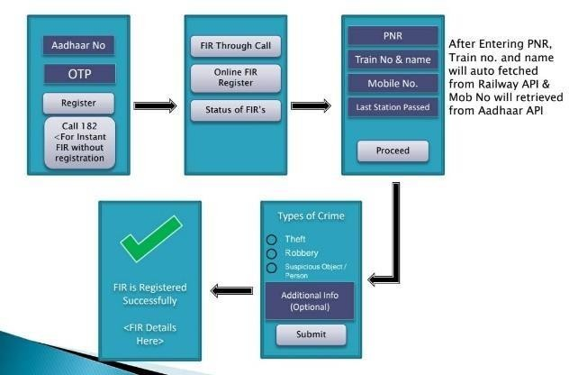

Features:

User Friendly UI:

This application is easy to use for passengers. It's not hectic for users. Also, all actions can be performed quickly so that they can report about their situation.

Time saving:

Rather than the process of filing the FIR form by visiting Railway Police Station, this app saves time of passenger as well a police.

Real-time Updates:

authenticated using Aadhaar. It means user will be

always authenticated and it's guaranteed than filed FIRS won't be fraud. This will help police to rectify genuine cases. Also, it saves time.

# Methodology

Passenger: Native android app is built for passenger. Passenger needs to authenticate first and then he/she can File FIR, See the status of FIR and report danger situation to Government Railway Police.

Gathering data: Passenger need to share all the data which has been asked in the FIR registration form. with that data GRP will take action.

GRP (Government Railway Police): This is dashboard for GRP. GRP can see list of registered FIRS, can take action on FIRS, can see Alert details.

Use Case diagram is shown figure 3. which shows the complete method of this Android Application working.

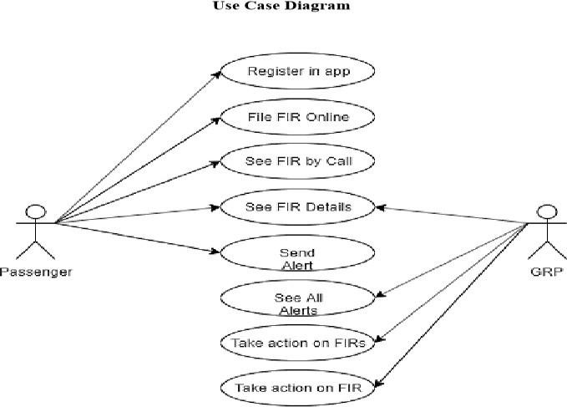

Fig 3: Use Case Diagram of Passenger security.

## Framework of the proposed work in project Phase

Android Studio IDE:

It provides accurate real-time updates of user location. Change in location will immediately reported to GRP.

Android Studio is the official integrated development environment (IDE) for

Google's Android operating system, built on JetBrains IntelliJ IDEA software and designed specifically for Android development.

Visual Studio Code:

At its heart, Visual Studio Code features a lightning fast source code editor, perfect for day-to-day use. With support for hundreds of languages, VS Code helps you be instantly productive with syntax highlighting, bracket- matching, auto indentation, boxselection, snippets, and more.

PHP:

PHP is typically used as a server-side language (as opposed to a language like JavaScript that's generally executed on the client-side).

MySQL:

MySQL is the world's most popular open source database. With its proven performance, reliability and ease-of-use. MySQL has become the leading database choice for webbased applications, used by high profile web properties including Facebook, Twitter, YouTube, Yahoo! and many more.

Firebase:

Firebase Storage provides secure file uploads and downloads for Firebase apps, regardless of network quality.

Java Platform:

The Java platform is a suite of programs that facilitate developing and running programs written in the Java programming language.

# Conclusion

The development of android application result in providing quick and emergency services to passengers. This application implementation will reduce the time of passengers as well as load of Government Railway Police or Railway Police Force.

# Reference

1. Online FIR Registration and Sos System-IJECS Author: Anindita khade, Sanket yerigeri Year:2016
2. Online Criminal Record Management SystemIJESC

Author: Prathiba Misra, Ghousiya Bee Year:2019

1. E-police System-FIR Registration and Tracking System-IRJET

Author: Archana Iyer , Sagar Gathoo Year:2016 4 .Crime Management System-ISSN

Author: Swathi Sharma, Ramya Naik Year:2018 5.Online Complaint Management System-IJISET Author: Osman Nasr,Enayar Alkhider Year:2015