**An Innovative Solution towards Present Day Energy Need of Sugar Industries**

**A Case Study**

1. **Introduction:** The search for renewable and clean energies is one of the main battles of our generation. Using waste to produce electricity can be a major source of energy in the future. Innovative technologies have recently emerged, encouraged by the new global interest in renewable energies, with very low CO2 emissions, making waste-to-energy a clean source of energy.

Sugarcane is generally regarded as one of the most significant and efficient sources of biomass for bio‐fuel (ethanol) production. Sugarcane offers production alternatives to food, such as feed, fiber and energy, particularly co‐generation of electricity and ethanol. Strong linkages between world sugar and oil prices have emerged in recent years, driven in part by the relationships between sugar as the primary ethanol feedstock in Brazil, the dominant producer and exporter of both sugar and ethanol in the world. Given expectations of rising oil prices, the significant potential for expansion of global sugarcane production as ethanol feedstock has resulted in a heightened global focus on sugar and ethanol as internationally traded commodities.

In sugar Industry About 50% of the bagasse will be saved in sugarcane crushing creates bagas and juice and by the use of that it is easily convertible to paper industry and cardboard industry, also it is possible to generate electrical power by the use of the same. This invention relates to a process for treatment of sugar factory and distillery effluents. In this process substantial quantity of biogas and fertilizer produced which is very useful for sugar factory and agriculture area surrounding it. In Maharashtra, about hundred distilleries and sugar cane industry combinable operated round the year. This project gives some main benefits to the sugar industries and distillery.

The requirement of input in this project is waste materials of sugar factory so that pollution around the sugar industry is reduced to about 90%. Sugar industry can satisfy their own energy (fuel, electricity) requirement. Each sugar industry will be able to save half quantity of bagasse. (Pulp produced after squeezing sugarcane) which having high market value as it can be used as the raw material for paper industry. Each sugar industry will be able to satisfy fertilizer requirement within the area by means of outcome of the plant i.e. Slurry/sludge. Also this organic fertilizer ultimately results in saving of chemical fertilizer which improves soil quality.

1. **Sugar Process Description And Steam Demand Reduction**

The sugar production from sugar cane is done basically by several steps shown in Figure 1:

1. Extraction of the raw juice and separation of the bagasse.
2. Clarification of the raw juice with juice heating and addition of chemical reactants.
3. Evaporation of the water content in the clarified juice for its concentration.
4. Treatment of the syrup produced in the evaporation.
5. Boiling, Crystallization and Centrifugation where the crystal sugar and the molasses are obtained.
6. Drying of the crystal sugar

  
 Fig 1:

1. **Our Process:**



Fig 2:

This process takes only 50% of bagas for treatment of Sugar factory waste water, Spent Wash and Distillery Sludge and Press Mud which is used to fulfill energy requirement. By mixing bagas in the effluents the organic loading is increased upto70% to75% get sufficient amount of bio-gas. This process is mainly based on the principle of anaerobic digestion in mesophellic range (300 c to 400 c) the problems normally arising in conventional digestion process are solved by designing this system in such a way that no extra energy is required and will get high percentage of methane (55% to 80%) in the final bio- gas mixture.

* 1. **Steaming:**

The above mixture is taken for steaming (like pressure cooker or using boiler steam) by steaming above organic matter the hard lignin bonds becomes weak they can be digested easily by anaerobic bacteria which produces methane CH4 and Carbon dioxide CO2. It reduces time of digestion.

The above process by Steaming reduced digestion time up to three to four weeks.

**3.2 Mixing and Maintaining PH:**

The factory and distillery effluents are mixed in following proportion with starter:

1. 1m3 of spent wash along with distillery sludge.
2. 0.5 to 0.7 metric tons of bagas.
3. 1 to 1.5 m3 of factory waste water.
4. 0.1 to 1.2 metric tonne of press mud
5. Starter (Initial or regular 0.5 to 0.8 m3 )

This elevates the pH of mixture (4.50 to 5.50) after the spent wash is having pH 4.5 to 5.5 to this press mud, factory water is added it will adjust the proper organic loading (about 15 to 22 % due to this pH value of the mixture is increased to 6.This press – mud and factory waste water is added to the mixture. The press mud and waste water will adjust the proper organic loading (about 15 to 22%) due to this the pH value of the mixture is pushed well about 6.00 After this starter is added so that pH reaches the value of greater than 6.50. At this pH value the digestion of mixture is possible.

When mixing process is completed bacterial culture is added to this mixture to start the anaerobic digestion. This culture is called starter.

Following are the main problems which are coming usually in conventional or the different methods of digestion are eliminated in this process.

* + 1. **Temperature:**

As an anaerobic fermentation is slightly exothermic, it maintains whole process in mesophellic temperature range (30 ℃ to 40℃).

* + 1. **Breaking of Scum:**

Initially, feed is not separate as slurry sludge and scum in digestion D-1 and D-2. As acid formation continues complex organic matters are breaking into simpler acids. Also gas bubbles form at bottom of digester which comes at top slowly the bubbles dimension increases it also agitates the mixture. As the height of digester up to 10m.

* + 1. **Agitation:**-

**a.** The mixture is shifted upwards & downwards inside the digester batteries in fig. 3 with the speed of 10 cm/hr (2.5m/day)

**b.** The gas bubbles formed at the bottom of digester comes up with the increase in dimension.

* + 1. **Collection of Bio-Gas:**

The gas produced in the digester batteries comes after repetitive blowing in the digester D-3 & D-4 (Fig.3). The outlet of D-3 & D-4 is connected to the main gas pipeline as shown in fig.3. Due to self gas pressure in digester D-3 & D-4, it flows towards the boiler.

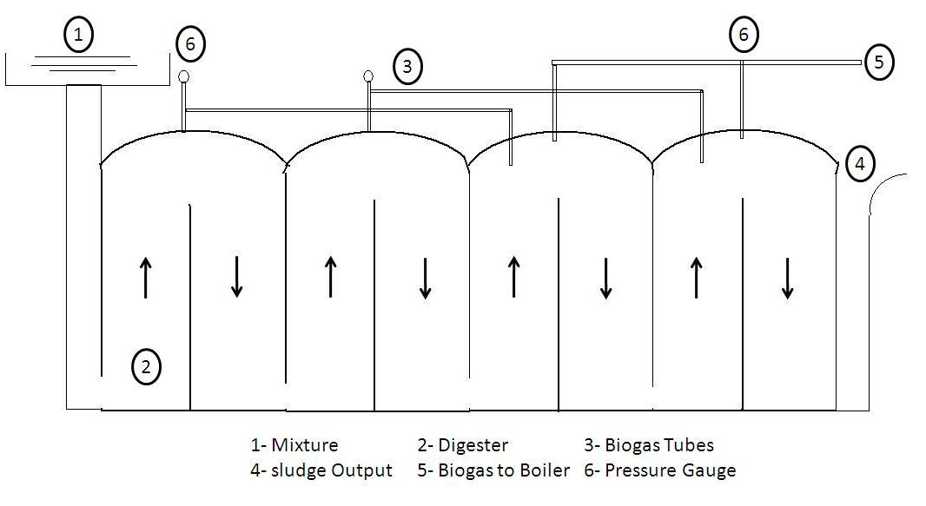

Fig 3:

1. **Highlights of the System:**

1. Due to design of digesters battery & mixing chamber the effluents travel forward using gravity & pressure created by generating bio-gas. Hence no pumps etc. Are required to operate the system. Only power required is at mixing stage which is less than 1% of the total energy generated.

2.This process treats the sugar factory & distillery effluents (i.e. spent wash, factory waste water, press mud etc.) Completely. Hence, pollution caused by these effluents in the surrounding areas is stopped 90%. The problems arising due to seepage of these effluents in nearby water stream & ground are 90% stopped.

**4.1 Case Study:**

1. The press mud is obtained from the sugarcane about to 3.00 to 3.50 % per day of crushing capacity of this industry.
2. Also the molasses is obtain about 0.35 to 0.45 % per day of Crushing capacity of sugar industry
3. And bagas is most important things in our process, which is obtain about 8.00 to 10.00 % per day of crushing capacity of sugar industry.

**4.2 Various Output of sugar industry is given in following chart:**

|  |  |  |  |  |  |
| --- | --- | --- | --- | --- | --- |
| **Sr. No.** | **Name of Sugar Factory** | **Crushing Capacity (Tonne)** | **Press Mud (Avg 3.33%)** | **Molasses (Avg 0.33%)** | **Bagas (Avg 9%)** |
| 1 | Niphad Co-op Sugar factory Ltd. Bhausaheb Nagar, Pimpalas | 3500 | 116.55 | 11.55 | 315 |
| 2 | Vasantdada Patil Co-op Sugar factory Ltd. Vithewadi | 2500 | 83.25 | 8.25 | 225 |
| 3 | Ravalgaon Co-op Sugar factory Ltd. Ravalgaon | 2000 | 66.6 | 6.6 | 180 |
| 4 | Girana Co-op Sugar factory Ltd. Bhausaheb Nagar, Dabhadee | 1500 | 49.95 | 4.95 | 135 |
| 5 | Kadwa Co-op Sugar factory Ltd. Rajaram Nagar, MatereWadi | 1250 | 41.625 | 4.125 | 112.5 |

**4.3 Following data gives some output parameters of the above specified sugar factory.**

Fig 4:

**4.4 The following data is given for 1200 Tons/ Day Sugarcane Crushing & 1500 Lit/Day Alcohol Distilling:**

|  |  |  |  |  |
| --- | --- | --- | --- | --- |
| **Sr. No.** | **Name of Effluent** | **Quantity Used per Day** | **Dry Solid %** | **Total Dry solid. Tones/day** |
| 1 | Spent Wash | 225000 liters (225)-m3 | 1.5% | 3.37 |
| 2 | Factory Waste Water | 400 m3 | 0.75% | 3 |
| 3 | Press Mud | 33 tones | 70% | 23 tones |
| 4 | Ba-gas | 120 tones | 12% | 75 tones for our System  75 tones for Paper Industry |
|  |  |  | Total | 104.37 tones ( Apx) |

1. **Calculations:-**
2. Total Volatile solids 50 % of Total dry Solids so 49 Tones of total volatile solids
3. Total organic volatile solids of 1 kg produced 0.70 m3 biogas.

49*103*0.70= 34.03 * 103 m3/day. (Approx)

1. Total Methane produce is= 64% of total biogas

= 34.03*103*0.64 = 21.77*103 m3/day

1. Methane recovery/ hr

(21.77/24)*103=0.9074*103 m3/hr

1. Energy Equivalent

1 m3 (CH4) = 10000 kcal of energy

0.9074*103*104 = 0.9074*107 k cal of energy

G. Total efficiency of furnace and boiler using bio-gas (CH4) is 50% k cal of energy

(0.9074*0.5)*107 = 0.4537*107 kcal

H. Energy Produced per Day in Watts

(0.4537*10000/860)*103 =5.27*103kwhr

3 MW this is the requirement of the energy by 1200 tons sugar cane crushing plus 15000 liters alcohol producing industry.

**Conclusion:**

1. By producing biogas (Methane) we will get 1.5 times more energy than burning bagas in conventional type furnace and boilers.
2. We will get sufficient energy to light nearby village or colony of sugar industry.
3. We can refill propane gas cylinder with biogas which can be used for cooking purpose.
4. We can give the biogas supply to nearby commercial buildings, restaurant,canteen etc.
5. We can supply sufficient organic fertilizer to nearby farms of sugar industry.
6. Pollution decreases by about 90% (air, water, ground pollution).

|  |  |
| --- | --- |
| E:\My Self\photo sign\NATHPHOTO1.jpg | **Mr. Navnath M. Ghogare** is working as a Lecturer in K K Wagh Polytechnic, Nasik, Maharashtra,India. His areas of interest are Electrical Power System , Renewable energy , Energy Conservation.  **Email- engg.navnath@gmail.com** |
| **C:\Users\91942\Downloads\S.B.Pund madam.jpg** | **Ms.Shradha B. Pund**  is working as a Lecturer in K K Wagh Polytechnic, Nasik, Maharashtra,India. Her areas of interest are Electrical Power System , Renewable Energy , Energy Conservation.  **Email- shradhapund18@gmail.com** |

