**Full stack Web Application using MERN**

Nandan kishor1, Prof. Manoj Tyagi2

*Email: nandankishornacson@gmail.com*

*1  Master in Technology, Department of Computer Science and Engineering, Technocrats Institute of Technology, RGPV, Bhopal, India*

*2 Assistant Professor , Department of Computer Science and Engineering, Technocrats Institute of Technology, RGPV, Bhopal, India*

**Abstract**

*Website is collection of webpages and all link together in Homepage tagged with each other. It is composed of text, audio, video, animation etc. are components of website which we search through browser by connected to Internet. The web development goes through web content development, client-side/server-side scripting and network security configuration. We used MERN stack technology to build our project. MERN stands for MongoDB, ExpressJs, ReactJs and NodeJs. ReactJs is used for making interactive dynamic client side application in html. React help us to create interfaces single page web application through which we connect to data and backend server , and render them as html. Express is server side JavaScript framework run inside NodeJs. NodeJs is neither programming language nor framework it's API backend server, API stands for Application program Interface. MongoDB used for database storage. MongoDB is non-structure database query language uses for database administration in MERN it's uses JSON file and talk to React.js front end through server. We use MERN stack to build our Online restaurant web application using MERN. In this project we used both frontend and backend technology and MERN 3-tier architecture to build our project.*

**Keywords :** *MERN, MongoDB, Express JS, React JS, Node JS, API, Bootstrap, CSS, JS, HTML5*

**1. Introduction**

Websites used for one who searching different kind of information and one who sharing uploading related information. Full Stack Development which comes real-life project experience back-end and front-end web technologies. We used MERN stack ReactJS, NodeJS, ExpressJS, and MongoDB.

Web development means creating website using HTML, CSS and JavaScript. The web development process involves web design, web content development, client-side/server-side scripting and network security configuration. Website is collection of publicly accessible Interline webpages that share a single domain name. HTML is client side scripting language used to design static web pages. CSS is used to style web pages like color, background, size etc. JavaScript is light weight and dynamic web programming scripting language . It is used to make client side dynamic pages. It is open source cross platform language. Web server is computer that store web pages , sites, app when client want to access these web pages its serve them. A web application is software application that run on a remote server . In most case web , web browser are used to assess web application. In MERN stack development ReactJS used as frontend for html, CSS , JavaScript and bootstrap. ExpressJS as Web API framework under NodeJs as Web server backend and MongoDB as Database Management. We used MERN stack to build our Web application Online restaurant application. Where their you can choose different food items from cruisine. Choose location by nearby restaurant and menu available their. Clients can Make payment online by various payment option.

MERN technology used to make single page Application . This is a Single Page Website where there are no multiple html pages instead of it , we have several components which gets active when they are called or used. MERN uses only JavaScript. Here for payment we have use the RazorPay Payment Gateway to accept the payments from the user and access their order.

Homepage divided into many section for better Application interface and clients have wonderful experience by visiting to our website.

**2. Main Components of basic Website**

Collection of linked web pages on web server on single domain is called website it's is called when URL access in browser through internet. Web pages can categories into two types dynamic web page and static web page. Static web page only contain static information means user can read only but can't do any modifications. In Dynamic web page it is possible to change a portion of web page or write into it without changing or loading entire web pages.

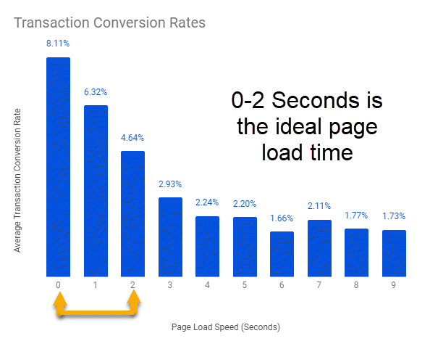

**2.1 HTML** - It's stands for hyper text markup language, created by Tim Berners lee in 1991 and published in 1995. HTML 5 introduced in 2014. HTML is client side scripting language used to design a webpage. HTML can be script in note pad or any text editor with extension .html or .htm or can also use IDE like visual Studio for best experience. HTML is use to create a website and become web designer. HTML use to structure web page.

**2.2 CSS -** It's stands for cascading style sheet it is used to style web page color, size, background etc. It can be define in three level of style sheet. Inline CSS, Internal or Embedded CSS, External CSS.

Inline CSS - CSS property in the body section attached with the element is known as Inline CSS.

Internal or embedded CSS - CSS rule set should be within HTML file in the head sectionsection or after the </HTML> tag.

External CSS - When you wanted to change in multiple pages using <link> tag on every page it is in head section and save that file in CSS extension external in CSS file.

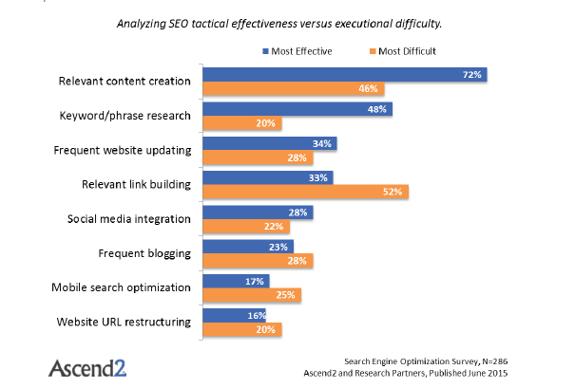

**2.3 JavaScript** – JavaScript is object oriented scripting language it is light weight program language used in web development. It create by Brendan Eich in 1995 emplemented by Netscape. It is functional logical part of web development.

JavaScript is scripting language if the web . JavaScript used millions of webpages to add functionality, validate form, detect browser and much more.

JavaScript act as both backend and frontend.

JS makes webpage dynamic and functional.

**3. Frontend and Backend technology**

In full stack web development we need both frontend end backend. Frontend is clients side scripting language and backend is server side scripting language. ReactJS is frontend and ExpressJS , NodeJS backend server side language MongoDB is backend database administration.

**3.1 Frontend**

Frontend development is client side development browser or application through which user can interact directly. It is use creating web user interface frontend mostly deals with HTML, CSS and JavaScript.

Responsive design - Bootstrap is free and frontend development (html and CSS) framework for faster and easier web development. Bootstrap is being famous for developing with the components that have the ability to follow the property of responsive design. Responsive design is about to use CSS and HTML resize, hide, shrink, enlarge or to move the content to look good on any screen. Responsive design is used to allow your page to work for computer, mobile or tablet.

Webpage creation - The web page is document commonly written with HTML that is accessible through internet or other network using internet browser. The web page accessible by entering URL address.

User friendly web design - Beside the basic elements of web design that makes site beautiful and visual compelling , the website must always consider to end user . User friendly can be archived by paying attention to the following factors.

Navigation - Site architecture, menus and other navigation tools in web design filter, search and option available.

Multimedia - Relevant video, audio, text, animation and graphics this make web page attractive and allow user to encourage visitor's to spend more and more time.

Compatibility - Design a website that equally well perform and supported different browser, operating system or machine.

Technology - Advancement of technology give designer freedom to add movement and innovation , allowing for web design which is always fresh dynamic and professional.

Frontend framework - Frontend framework like Angular, React , JQuery, backbone, Vue use to develop web application using framework and library.

Frontend is for UI user Interface client side wheareas Backend for logic, database server side.

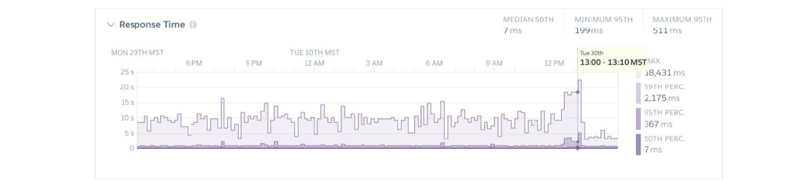

**3.2 Backend**

Backend is server side language backend is data access layer , the backend of application is responsible for things like calculation, business logic, database interaction, and performance. Backend code run on server this means backend developer not only understand program languages and database but also having knowledge of server architecture as well .

If application is slow, crash often, or constantly through error at user it's likely because of backend problems. There's lot of tools and framework used in backend development. Example - NodeJs, MongoDB, ExpressJS all comes under backend development. Backend deals with server as well as database.

All popular program language java, c/cpp, php, python, perl, c# comes under backend functional functional service of program.

API - API stands for Application Programming Interface It is an agreement or a protocol between two or more pieces of software and they can communicate and consume services and passing data between both of them. Most of backend programming language support API. Through framework you can build your custom API for others. API is underlying infrastructure of the web .

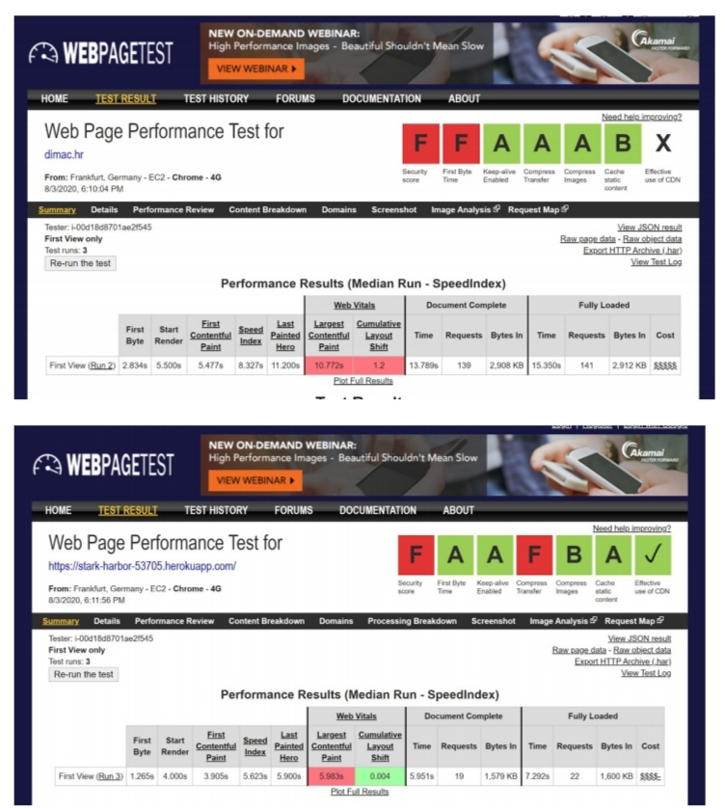

**3.3 Data and Database**

The most important part of backend is to store data . So database is critical part of backend development . Example - Oracle, MongoDB, MySql, Sql server, postgreSql.

The database is collection of organized data , information and records. The database is information that a person needs in his personal, business and social . The power and purpose of information is not only in collecting and finding them but more importantly using them.

DBMS is used to manage a database whereas , SQl is query language used by DBMS . It use to create, delete, shorting, update, modify, selectselect operations.

MongoDB - It is scalable high performance open source , document oriented database. MongoDB is non-relational database management system , schema less and contain document. It's architecture build on collection and database. This database use a document storage format called BSON which is binary style of JSON document.

We use MongoDB as data administration in our project.

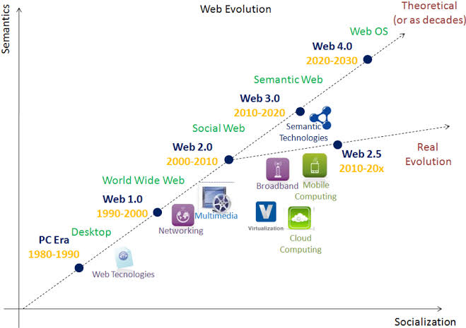

**4. Architecture of MERN Stack**

We choose loosely couple Architecture

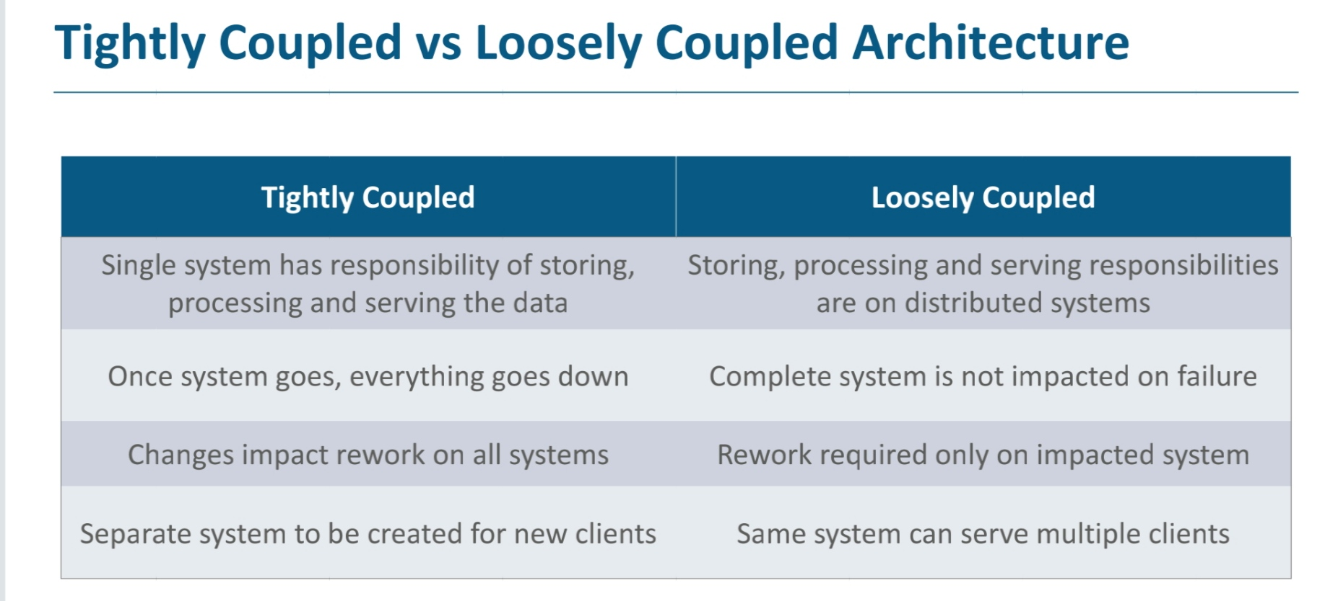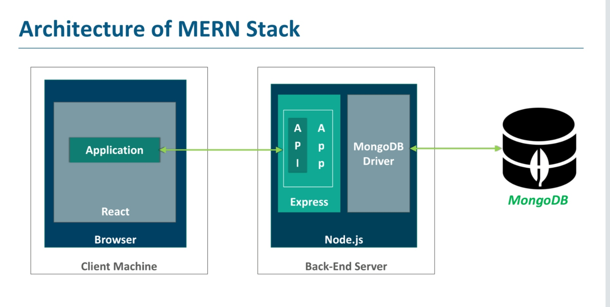

The MERN architecture allow us to easily construct 3-tier architecture ( frontend , backend and database) entirely using JavaScript and JSON. Web part as ReactJS, Server part as ExpressJS and NodeJs and database as MongoDB.

MongoDB is NoSql database use high volume of data storage. Open source document oriented database . It store data in JSON format. MongoDB use BSON to query database.

NodeJs is JavaScript run-time environment built on chrome's V8. Nodejs allow to run JavaScript on server. NodeJs runs single thread non-blocking , asynchronous programming which is very memory efficient . NodeJs use backend services such as API.

ExpressJS is flexible NodeJs framework that provide robust set of features for web and mobile application. Its provide easy routing of request based on HTTP method and URLs. Its allow to set middlewares to response to HTTP request. Allows dynamic render of html based passing argument to templates.

ReactJS is JavaScript library for building user interface for web and mobile application. React is used to build single page web application. React allow to create reusable UI components. React-router to handle front end routing.

**5. Requirements of Project**

Following Requirements -

- Visual Studio code editor

- NodeJS

- ReactJs

- postman

- MongoDB

- ExpressJS

- npm installation

**6. Design and methodology**

You can easily create and share website designs with Adobe XD. MS paint can also used to design on paper before start coding. As you see in figure left corner their is logo. Right side button at head section division. Body Section Headline and left side filter division and right side card division and bottom their is pagination division. Whole homepage divided into many section division.

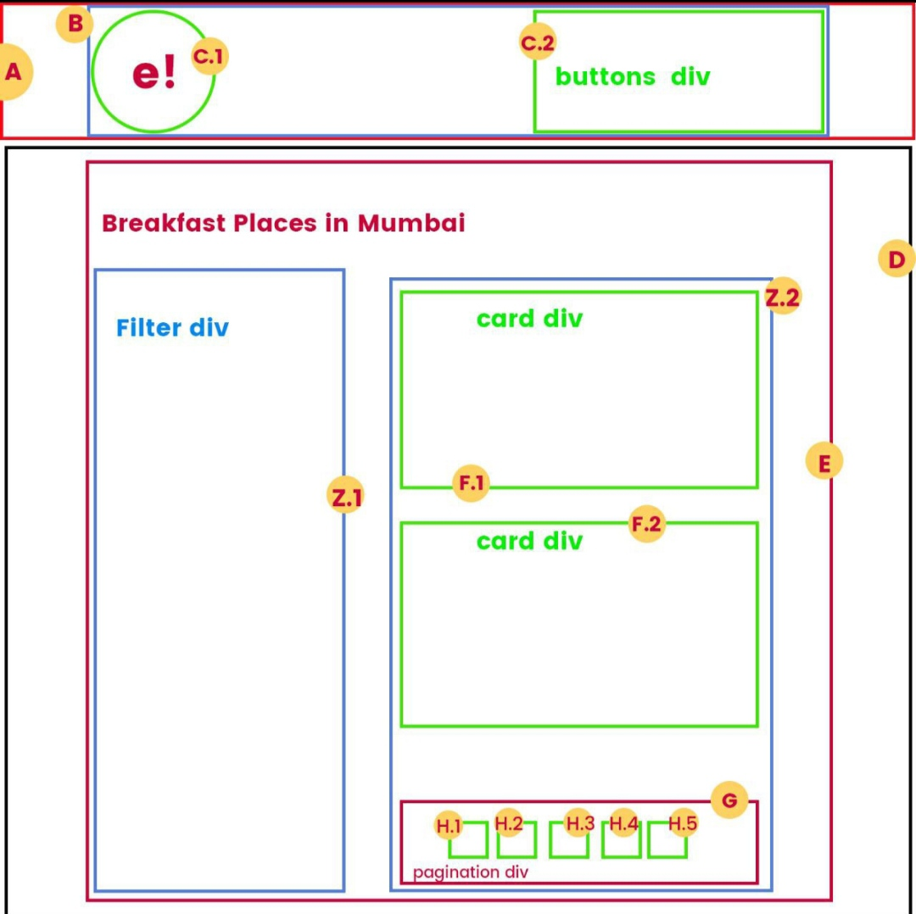

**6.1 Responsive Web design**

RWD is about creating web page than can response according to user's screen size.

RWD uses HTML and CSS.

It

RWD automatically adjusted different screen size and view port.

View port is user visual area of webpages varies as per device.

View port for smaller will be smaller (mobile) than the view port of large screen (computer)

We use Bootstrap for making website responsive in nature.

Bootstrap makes development faster and easier.

Includes Html and CSS design templates for form, table, typography, button etc.

Bootstrap is powerfull CSS framework for developing responsive design of website and web app.

**6.2 Advantage of JavaScript**

It's very fast because any code can run immediately instead of contact the server.

JavaScript having no compilation steps. Instead Interpreter on browser reads JavaScript code.

It's provide dynamic functionality without having server to react shows another page.

JavaScript allows flexibility to place code any where in HTML Document.

**7. MERN Stack part and their Execution**

**7.1 NodeJs**

Node.js is backend. Backend runs on the server and has no direct interaction with user.

Creates a connection between web and database. Main purpose of backend to listen request send by the front end application process request and response back with appropriate content.

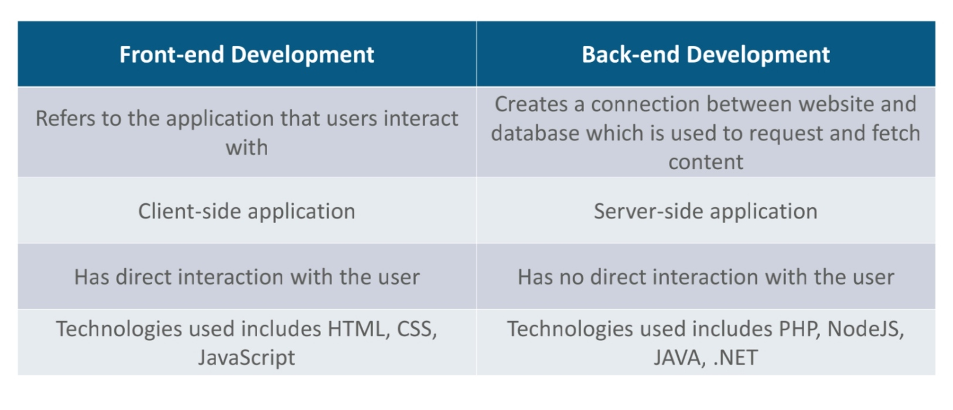

NodeJs is powerful JavaScript runtime environment developed on chrome's VS engine

NodeJs is run time environment contain everything that needed to execute JavaScript code.

Its compile JavaScript code code directly into native machine code.

It enable the developer to run JavaScript code directly into computer instead in a browser.

Module - It's functionality which organise in a single or multiple JavaScript file, and can be reused throughout NodeJS application.

Types of Modules

Care modules - These are inbuilt and can be used without any installation

Node Package Manager - These include group of modules or packages developed by other developer can be used in your application by installation.

User Define Modules - These are modules created by you, which you want to reuse in rest of your application.

**7.2 MongoDB**

It is open source database management system (DBMS) that uses document oriented database modelmodel which support various forms of data.

It's hold the set of collection and store the data as document.

MongoDB support BSON data (Binary JSON) data structure and complex query language.

Bason Document storage is Binary representation of JSON like document. It gives high speed to store mesh data.

MongoDB contain powerful tool called MongoDB shell, which provides built in support for administering MongoDB instance and manipulate data using MongoDB query language.

On installation MongoDB you get two parameters MongoDB shell and server.

CRUD operation in MongoDB

Create , Read , Update and Delete operation used to manage data/document within database.

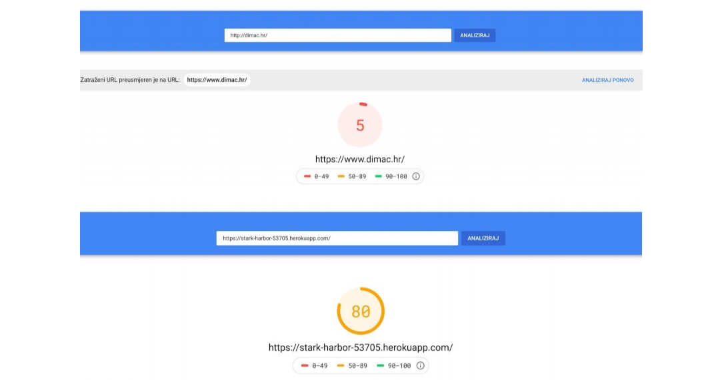

MongoDB compass is IDE for MongoDB provides GUI and easily analysis and perform queries.

**7.3 ReactJS**

React.js is JavaScript library for building user interface.

React is used in building of single page web application or mobile application , as it is optimal to fetching rapidly changing data needed to be recorded.

Features of react

React components provide many inbuilt component liberary for faster execution

Element like JSX, Components, Props, State and virtual DOM, let react create application faster with small code size , easy development and rich user interface.

Top cooperation such as Facebook, New York Times, Yahoo! Mail, Netflix, Instagram and much more use it to solve their user interface related issues.

It provide efficient DOM manipulation functionality, which improve speed and faster execution.

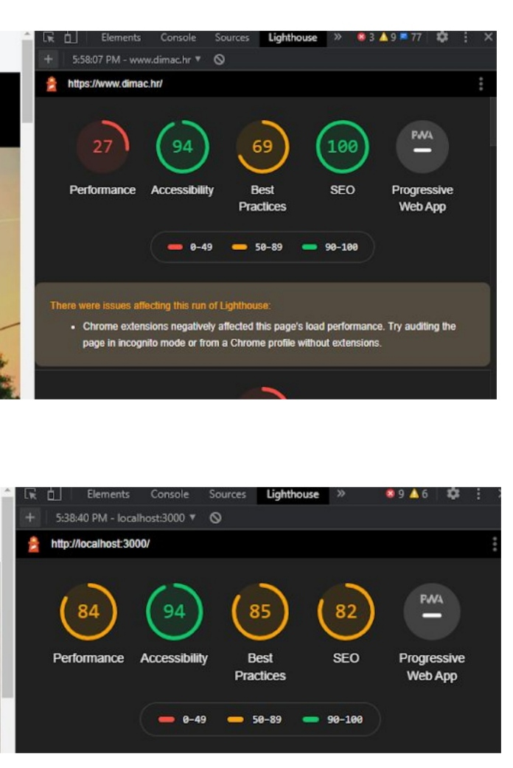

**7.4 ExpressJS**

Express is minimal and flexible NodeJS web application framework that provide a robust set of features for web and mobile application. Express is used to create server side of web application.

Express uses middlewares function, The function of middlewares function that have to the request object (req) and response object (res) to the following function of the intermediate processing in the cycle "request-response" Application.

Feature of Express

- Fast server side development

- Middlewares

- Routing

- template

- debugging

- time efficient

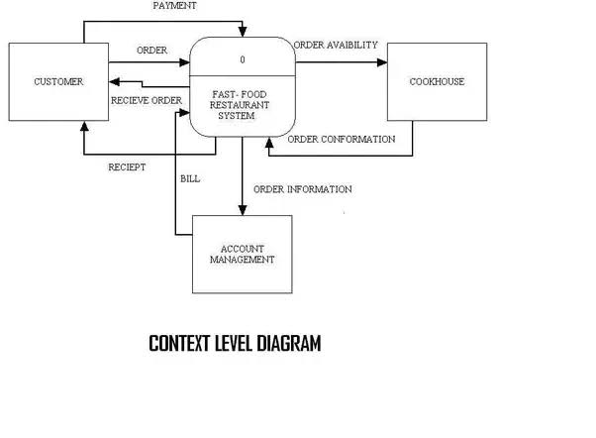

**8. Website building using MERN technology**

We have made Online Restaurant for food delivering from various best restaurant from different cities and state. User can find restaurant and cuisine and place a order. The section also provide quick search and online payment through Razor pay choosing banking option available. User can create their account and log in through ID provided.

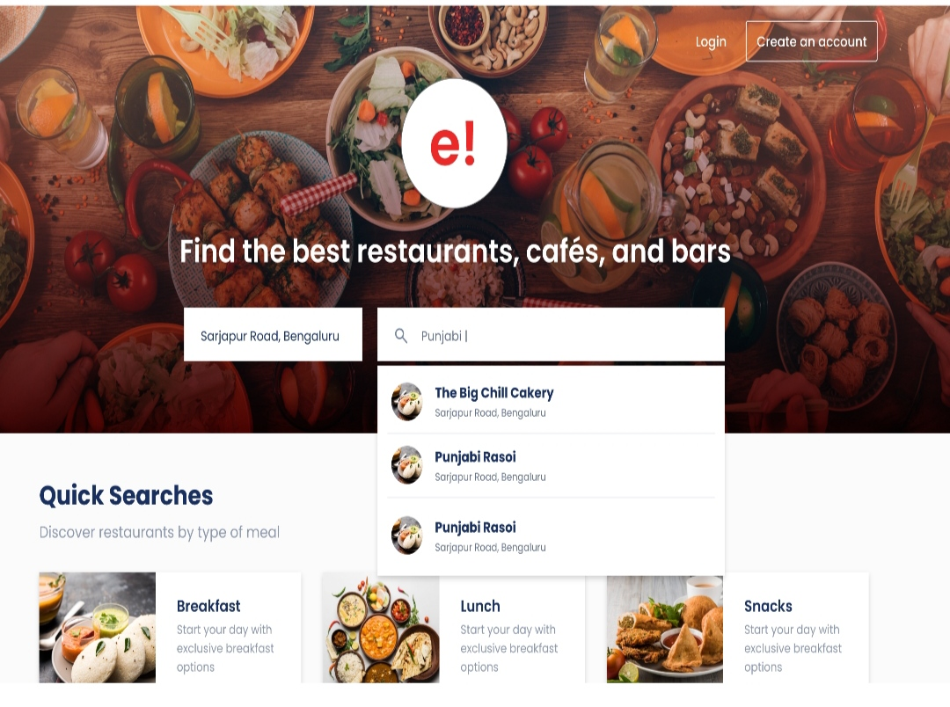

HTML, CSS, JavaScript is used for making website. Bootstrap framework is used to make website responsive.

This is single page web application that's why we used ReactJS. NodeJS is used as sever API using ExpressJS framework and database connectivity through MongoDB.

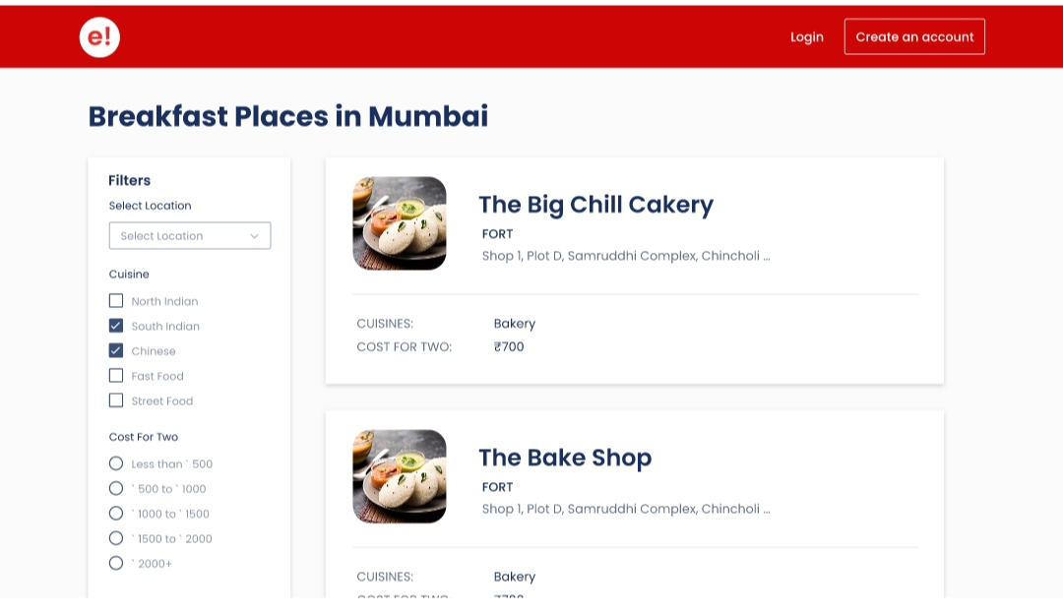

We have also used Filter for finding nearby location and cuisine types of food available and cost efficiency range. We divided whole page into division section for various options and categories. With Great GUI desktop view we built our website.

**9. Discussion**

This project build using MERN stack where we started build app with HTML, CSS, JavaScript, Bootstrap for web app development. We use backend Express.js, Node.js and MongoDB. Express for Node.js web framework. Node.js as JavaScript web server and MongoDB as document database. Build frontend using ReactJS client side JavaScript framework. Using these technology we made single page web application using ReactJS. We style the web page by great visual background wallpaper and font style. Add border around element and position them properly. A user generally looks user nearby for reason fastest delivery that's why we given option to select restaurant nearby and place order. A option should provided to choose desired location that allow user to search for restaurant in particular area. We provided user with quick search option like breakfast, lunch etc. Moreover, user who visit website will fully satisfied with outlook and option available for customer service and re-visit and share our app with others.

**10. Conclusion**

A paper show details analysis to how to make MERN full stack web products. We have discussed different technology, framework, library using to MERN stack application. Web application online restaurant design using these technologies. MERN stack development used 3-tier architecture Frontend development ReactJS using HTML, JavaScript, CSS and Bootstrap. Backend development using ExpressJS web framework and NodeJs web server. Database management used using MongoDB. Three layers of MERN stack as Web or Frontend level, second center or server level and Database as Backend level. MERN stack is very famous over other stack technology used for designing and creating website. The website contains online restaurant order food items from available restaurant nearby by cuisine items customer looking for delicious dinner or breakfast. Our web application contains all necessary section help customer to choose from such location, Cuisine, Price range. Customer can Sign up for LogIn to our website. Our website simplified by provide images, graphics and font style to beautifying website and customer overall experience and enhanced web page speed and content provided.

**11. References**

[1] Pro MERN Stack, Vasan Subramanian Bangalore, Karnataka, India. ISBN-13 (pbk): 978-1-4842-4390-9.

[2] Hausman, A. V., &Siekpe, J. S. . The effect of web interface features on consumer online purchase intentions. Journal of Business Research, 62, 5-13.

[3] Ethier, J., Hadaya, P., Talbot, J., &Cadieux, J. . Interface design and emotions experienced on B2C Web sites: Empirical testing of a research model.

Computers in Human Behavior, 24, p.2771-p.2791.

[4] Darley, W. K., Blankson, C., &Luethge, D. J. Toward an Integrated framework for online consumer behavior and decision-making process: A review. Psychology & Marketing, 27, 94-116

[5] https://docs.mongodb.com

[6] http://expressjs.com/en/api.html

[7] https://reactjs.org/docs/getting-started.html

[8] https://nodejs.org/en/docs/

[9].https://web.dev/progressive-webapps/#i18n.paths.progressive_web_apps.topics.introd

**Appendices**

**Appendix I. Homepage Website HTML, CSS, JavaScript code**

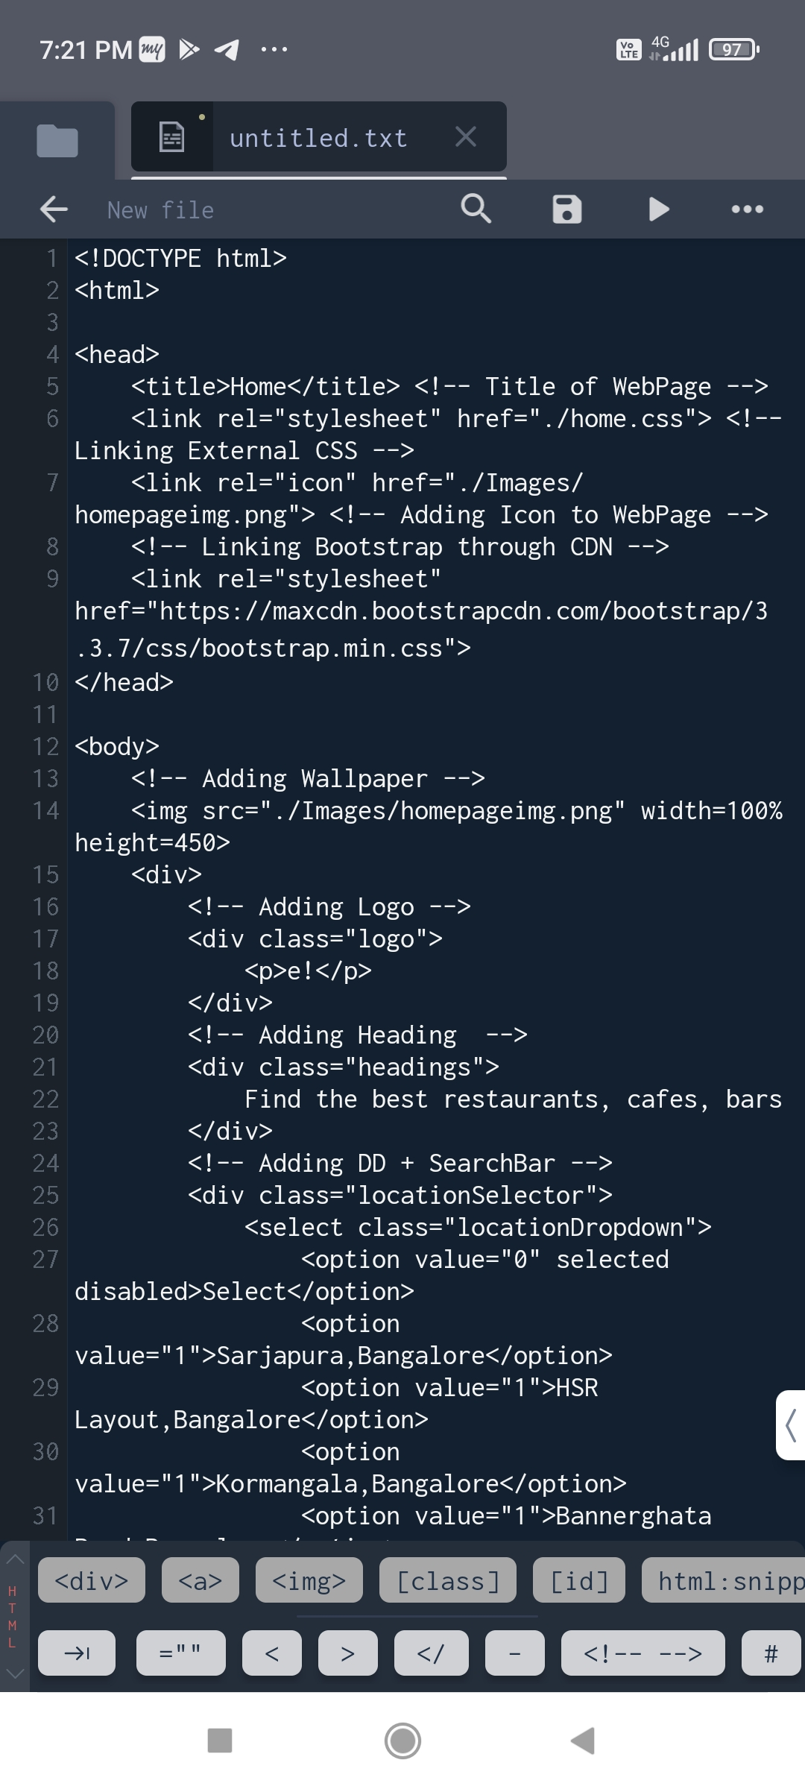

**II. Application js Website code**

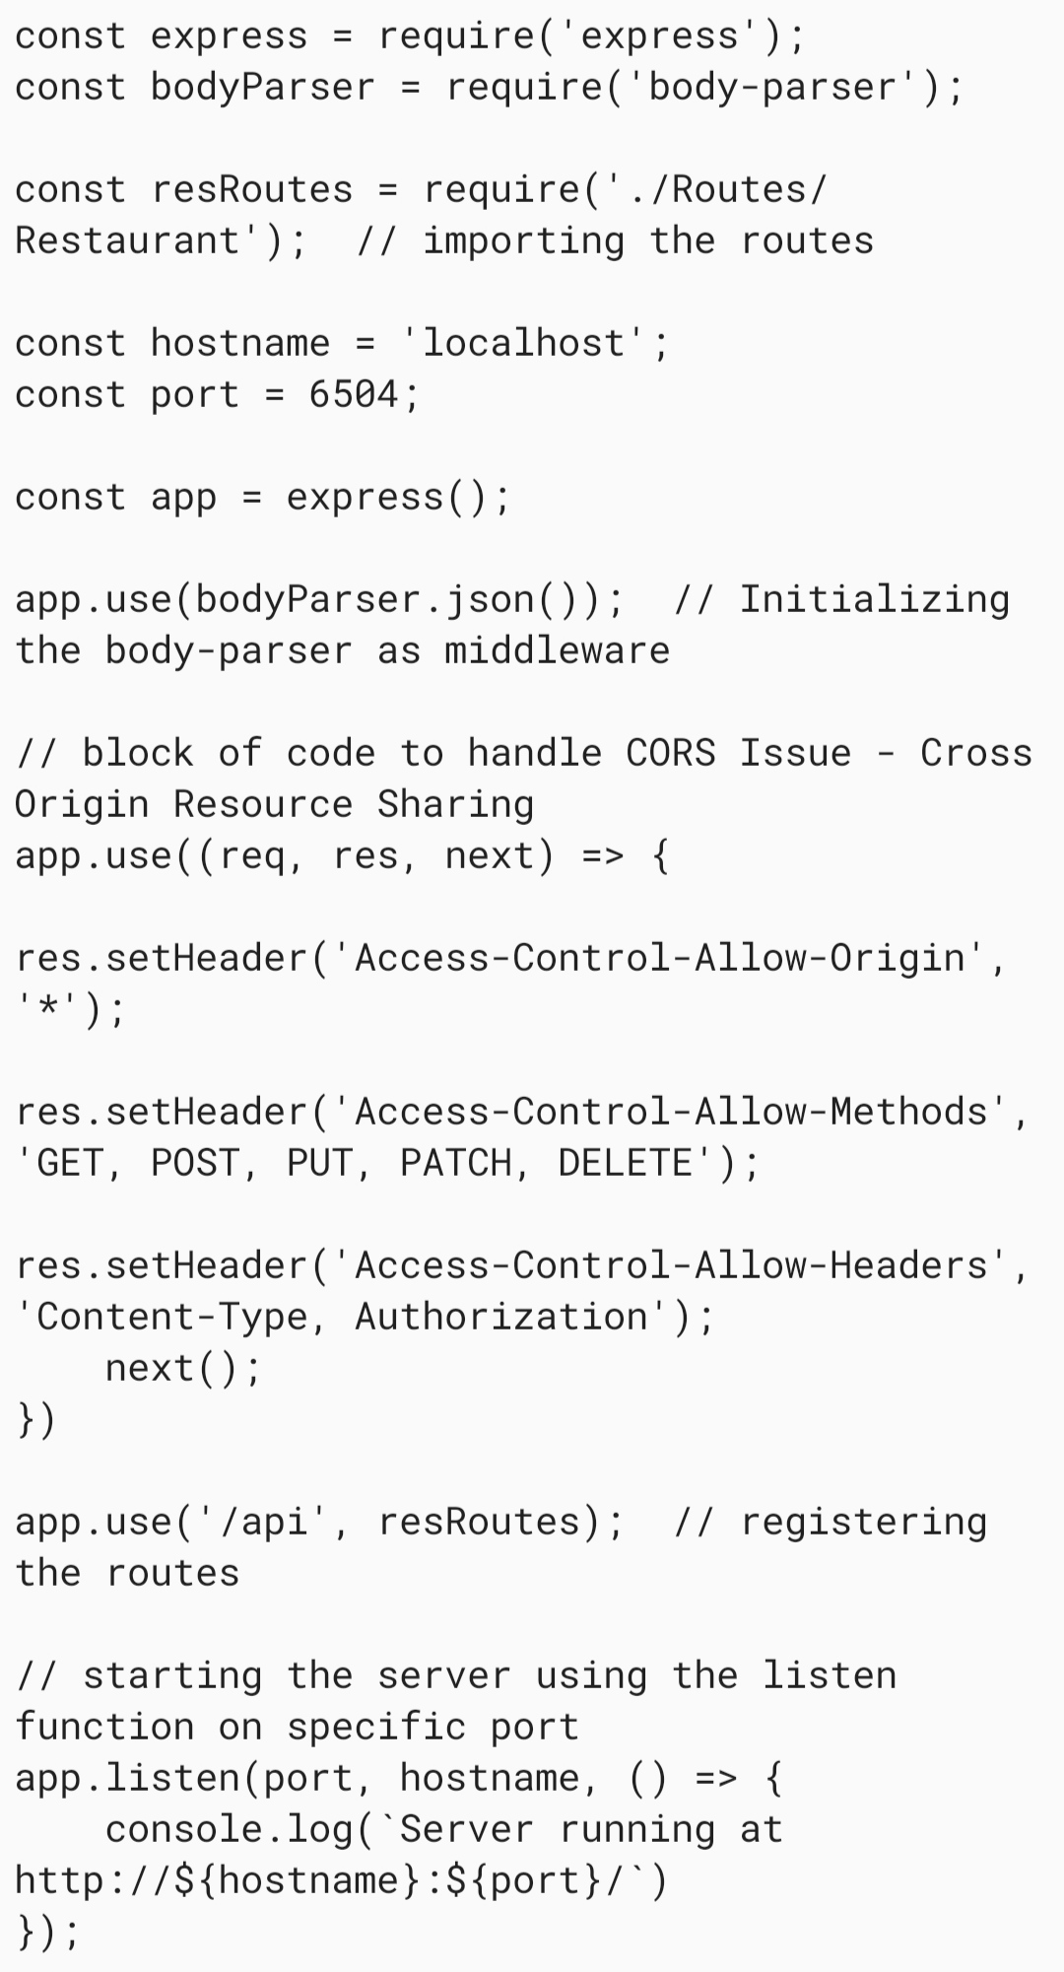

III. Homepage Websites View

