**‘‘A STUDY ON OPEN AND DISTANCE LEARNING (ODL) WITH SPECIAL REFERENCE TO BENGALI MEDIUM HIGHER EDUCATION INSTITUTION S HAILAKANDI DISTRICT OF ASSAM’’**

**Monsurul Islam, Research Scholar, Sunrise University Alwar**

**CONTENTS**

1. Introduction
2. Profile of the study area
3. Educational status
4. History of higher education in Hailakandi
5. Need of the study
6. Objectives of the study
7. Methodology and data source
8. Analysis of the study
9. Results and Discussion

10. Conclusion

11. References

**INTRODUCTION**

Education is the acquisition of knowledge or skills obtained or developed by learning process. Education plays a very important role for the development of Human Resource. It enhances, enriches and improves all the aspects of human resources. Higher Education provides people with an opportunity to reflect on the critical social, economic, cultural, moral and spiritual issues facing humanity. Development of such skills is required by one and all of the members of the present society belonging to all walks of life to shoulder their responsibilities properly. Higher education is accepted as a vehicle for sustainable development and realized as a powerful tool to build a knowledge society. Higher education plays key role in this regard. With the increasing demand of higher education and the challenges faced by individuals to acquire knowledge through such education, Government of India has taken many steps to improve the education system of India.

Open and Distance Learning (ODL) provides a viable alternative mode with the objective to take education to the door steps of the learner, enhancing social equity, and creating flexibility for lifelong learning. The terms open learning and distance education present approaches that focus on opening access to education and training provision, freeing learners from the constraints of time and place, and offering flexible learning opportunities to individuals and groups of learners. Open and distance learning is one of the most rapidly growing fields of education, and its potential impact on all education delivery systems has been greatly accentuated through the development of Internet-based information technologies, and in particular the World Wide Web. ODL system is being adopted throughout the world as an important tool to ensure access, equity and quality in the realm of higher education. In a developing country like India where there is a need of providing training to large number of students with limited recourses, in such a situation ODL system could play important and viable role in improving overall skills of people.

In this report we attempt to study the current scenario of ODL education with special reference to higher education in Hailakandi District of Assam. This report on higher education in Hailakandi is based on Open and Distance Learning. The studies covered number of issues. It included estimation of enrolment rate in higher education in Hailakandi through Open and Distance Learning. It also included the estimation of enrolment rate of individuals in various courses and quality of higher education in Hailakandi.

**Profile of the study area:**

**Assam** is a state in north-eastern India, situated south of the eastern Himalayas along the Brahmaputra and Barak River valleys. Assam covers an area of 78,438 km2 (30,285 sq. mi). The state is bordered by Bhutan and Arunachal Pradesh to the north; Nagaland and Manipur to the east; Meghalaya, Tripura, Mizoram and Bangladesh to the south; and West Bengal to the west via the Siliguri Corridor, a 22 kilometres (14 mi) strip of land that connects the state to the rest of India. The total population of Assam was 26.66 million with 4.91 million households in 2001. Assam's population was estimated at 28.67 million in 2006 and at 30.57 million in 2011 and is expected to reach 34.18 million by 2021 and 35.60 million by 2026.

As per the 2011 census, the total population of Assam was 31,169,272 having male population 15,954,927 and female 15,214,345(954 females per 1000males). The total population of the state has increased from 26,638,407 to 31,169,272 in the last ten years with a growth rate of 16.93%.

**Hailakandi** is the district headquarters of Hailakandi district in the Indian state of Assam. Hailakandi is located at **24.68°N 92.57°E**. The district coved total area 1,327 km2 (512 sq. mi) having population 6,59,260 with density 497/km2 (1,290/sq. mi). As per the 2011 census, the total population of Hailakandi was 6,59,260 having male population 3,37,890 and female 3,21,406.

**Educational status**

Education is the basic requirement for human development. With education, employment opportunities are broadened and income levels are increased. The development of an individual and the progress of a nation depend on education. The present study tried to understand the differentials and factors associated with school dropouts in a village. It was observed that the dropout was high among the children belonging to poor family background; Parental characteristics also play a significant role in determining school education. The dropouts among the children belonging to illiterate parents were four times higher than that of the literate parents. It was also observed that if parents were not working, the possibility of dropout among their children was relatively high. The study suggests that unless and until there is considerable improvement in the socio-economic status of households and change in the social attitudes of parents, achieving the goal of universalisation of school education will remain a major challenge for the village and for India too.

It is also the principal instrument in awakening the child to cultural values and thus is the strongest force in the development and growth of a child in preparing him/her to be a responsible, intelligent, and capable citizen. Education is also equally important to improve the women’s status and autonomy. It contributes to an increase in confidence and decision-making power within the household. In India, although the percentage of literacy is rising, what is alarming is that the number of illiterate children in the age group of 6 to 14 years is also increasing.

In 1990 at the World Conference on Education for All, governments agreed to a broad range of education goals including that of attainment of Universal Primary Education (UPE) by the year 2000. Sadly, the millennium year had come and gone, but the UPE goal is still a distant dream, more so in developing countries like India. The millennium development goals as drawn up by the United Nations now directs nations to ensure that all boys and girls complete a full course in primary education by the year 2015. While the government has been making concerted efforts aimed at expanding the reach of education, the phenomenon of school dropouts remains a blot on the progress of education in India. What is cause for particular concern is the enormity of the problem in most states of India and at all stages of school education where unacceptably high dropout rates have been reported. The dropouts represent a significant human cost to children and the nation since they will most likely be permanently illiterate. Illiteracy, poverty, inadequate earnings and poor living conditions of parents force them not only to withdraw their wards from schools but also put them in various types of jobs for contribution to the family income. According to the United Nations Educational, Scientific and Cultural Organization (UNESCO), India has the lowest public expenditure on higher education per student in the world. India spends just 3.5 percent of its gross domestic product on education, way below China's 8 percent; the public expenditure on education has actually declined from around 3.23 percent of GDP in 2000-01 to 2.88 percent in recent times. As a proportion of total government expenditure, it has declined from around 11.1 percent in 2000-01 to around 9.98 in recent years.

School education in Assam   is imparted through a number of pre-primary, primary, middle, high and higher secondary schools. The Government of Assam has implemented free and compulsory education for students up to the age of 14. Schools in Assam are either state run or under the management of private organizations.

In 2011, the literacy rate in the state was 73.18%. The male literacy rate was 78.81% and the female literacy rate was 67.27%. In 2001, the census had recorded literacy in Assam at 63.3% with male literacy at 71.3% and female at 54.6%. The literacy rate of Assam is slightly below the national average of 74.04%. According to the census report, 2011, the literacy rate in the district Hailakandi was 74.33%. The male literacy rate was 80.74% and the female literacy rate was 67.60%.

**History of Higher Education in Hailakandi**

Hailakandi was declared as the 24th district of assam in 1989 by a government of assam notification no. AAA.98/89/Pt/I Dt. 29/09/1989, Hailakandi is one of the aspirational districts in the barak valley region of Assam. According to some historians the district got its name from the ‘Kuki’ word ‘halam’ means a small state and the word ‘Kundia’ meaning a plot of land for temporary ploughing. It is also believed that the name of the district is sali paddy is grown abundantly as a staple food crop and from ‘Sailkandi’ the district came to be known as Hailakandi.

In Assam there are two organizations namely Directorate of Elementary Education and the Directorate of Higher Education under the Department of Education, Govt. of Assam. The Directorate of Elementary Education and Directorate of Higher Education have their Head Quarter at Kahilipara, Guwahati – 19. The Directorate of Elementary Education is responsible for administration control, development and expansion, inspection, supervision, monitoring and evaluation of elementary education in Assam. The Directorate of Higher Education caters to the universities, government colleges, non-govt. colleges, ad-hoc colleges, affiliated colleges, ad-hoc law colleges, Asom Publication Board, ABILAC, Literary & Voluntary Organisations, Sanskrit And Pali Prakrit Tols, Asom Sanskrit Board, State Selection Board, Asom Etc.

**List of institutions in Hailakandi providing Higher Education:**

1) [**Moinul Hoque Choudhury Memorial MHCM Science College, Algapur**](https://www.indcareer.com/assam/hailakandi/moinul-hoque-choudhury-memorial-mhcm-science-college-algapur)**:**Courses: Bachelor of Science (BSc)

2) [**AL Choudhury College, Hailakandi**](https://www.indcareer.com/assam/hailakandi/al-choudhary-college-hailakandi): Courses: Bachelor of Arts (BA), Bachelor of Science (BSc)

**3)** [**Dr Shashi Bhushan Institute of Education**](https://www.indcareer.com/assam/hailakandi/dr-shashi-bhushan-institute-education): Courses: Bachelor of Education (B.Ed)

4) [**AL Choudhury College, Kalibari Bazzar**](https://www.indcareer.com/assam/hailakandi/al-choudhury-college-kalibari-bazzar): Courses: Bachelor of Arts (BA), Bachelor of Commerce (BCom)

**5)** [**Srikishan Sarda (SS) College, Hailakandi**](https://www.indcareer.com/assam/hailakandi/srikishan-sarda-ss-college-hailakandi)**:**Bachelor of Arts (BA), Bachelor of Science (BSc)

**6)** [**SC Dey College, Hailakandi**](https://www.indcareer.com/assam/hailakandi/sc-dey-college-hailakandi): Courses: Bachelor of Arts (BA), Bachelor of Science (BSc), Bachelor of Commerce (BCom)

7) [**Lala Rural College, Lala**](https://www.indcareer.com/assam/hailakandi/lala-rural-college-lala): Courses: Bachelor of Arts (BA), Bachelor of Commerce (BCom)

**8)** [**Hailakandi Womens College, Hailakandi**](https://www.indcareer.com/assam/hailakandi/hailakandi-womens-college-hailakandi)**:** Courses: Bachelor of Arts (BA), Bachelor of Science (BSc

**9)** [**Hailakandi B.Ed College, Nazarul**](https://www.indcareer.com/assam/hailakandi/hailakandi-bed-college-nazarul)**: Courses: Bachelor of Education (B.Ed)**

**10) S.K Roy College, Katlicherra**

**About Dr. Shashi Bhushan Institute of Education:**

Dr. Shashi Bhushan Institute of Education which was initially known as Hailakandi B.Ed. College. Prof. J.B. Bhattacharjee, 1st Vice-Chancellor of Assam University, Silchar inaugurated the college on 15th July/1996 in presence of by Sri Sahidul Alom Choudhury, the then P. & R.D. Minister, Govt. of Assam. Itis the study centre of IGNOU.  
**About SriKishan Sarda College, Hailakandi:**  
Srikishan Sarda College, Hailakandi, was established on 18th September 1950. It is one of the premier institutions of higher education and providing quality education to the students of the district of Hailakandi and also the students from surrounding districts and neighbouring states as well. The college is situated at a very convenient place of Hailakandi with all sorts of transport facilities. A study center of the Distance and Open Learning of Krishna Kanta Handique State Open University has been opened from the session 2018-19 and both UG and PG correspondence courses are being offered by the college under this university.

**Need of the study**

In India, education is as yet a fantasy for some. Despite the fact that we are living in the 21st century there are loads of obstructions in the conventional education framework. So, Open and Distance Learning (ODL) system of education had grown tremendously around the world. It was started also in India in the form of correspondence course or distance education, In order to meet challenges of access and equity to higher education for large segments of the population, and in particular, the disadvantaged groups such as those living in remote and rural areas including working people, housewives and other adults who wish to upgrade or acquire knowledge through studies in various fields, academic institutions and government sector were looking for an alternative system of education that can provide access to learning of information as well as a degree for recognition like traditional system of education. For fulfilling these limitations, Indian Higher education needs a serious make over.

Therefore, viewing this situation it indicate that research should be done on open and distance learning (ODL) and this study is an attempt to explore the status of ODL system in a district like Hailakandi (ASSAM).

**Objectives of the study**

The following objectives have been considered for the study:

1. To study the present status of open and distance education in Hailakandi district.

2. To study the status of the courses for higher education available in the different study centres of Hailakandi.

3. To study the percentage of enrolment of students in different courses.

4. To study the challenges faced by the institutions in providing Open and Distance Learning in Higher Education.

5. To study the benefits of Open and Distance Learning in Higher Education.

**Methodology and Data Source**

We have selected some of the open and distance (ODL) study centres of higher education in Hailakandi. These are Dr. Shashi Bhushan Institute of Education IGNOU study centre, Sri Kishan Sarda college KKHSOU study centre, ALC college KKHSOU study centre. We have visited the centres and collected the primary data through questionnaires. We have also collected the data by analysing the institutional documents they provided us.

**Analysis of the study**

**The data collected from Dr Shashi Bhushan Institute of Education, an IGNOU study centre are tabulated as follows:**

The programs available are: Bachelor of arts (B.A.) Bachelor of Preparatory Program (BPP), Master of Arts in English (MEG), Master of Arts in History (MAH), Master of Arts in Economics (MEC), Master of Arts in Political Science (MPS), Diploma in Nutrition and Health Education (DNHE), Diploma in HIV and Family Education (DAFE).

Table1: Total number of students in different courses in the year 2016

|  |  |
| --- | --- |
| Name of the courses/programs | Total number of students enrolled |
| B.A. | 48 |
| MPS | 47 |
| MAH | 1 |
| Total | 96 |

Table2: Total number of students in different courses in the year 2017

|  |  |
| --- | --- |
| Name of the courses/programs | Total number of students enrolled |
| B.A. | 537 |
| BPP | 8 |
| MAH | 11 |
| MEC | 13 |
| MEG | 52 |
| MPS | 110 |
| PGDRD | 6 |
| Total | 737 |

Table 3: Total number of students in different courses in the year 2018

|  |  |
| --- | --- |
| Name of the courses/programs | Total number of students enrolled |
| B.A. | 195 |
| BPP | 2 |
| MAH | 4 |
| MEG | 28 |
| MEC | 3 |
| MPS | 24 |
| PGDRD | 1 |
| Total | 247 |

Table 4: Total number of students in different courses in the year 2019

|  |  |
| --- | --- |
| Name of the courses/programs | Total number of students enrolled |
| B.A. | 17 |
| DNHE | 1 |
| MAH | 4 |
| MEG | 2 |
| MEC | 4 |
| MPS | 12 |
| PGDRD | 2 |
| DAFE | 43 |
| Total | 85 |

**The data collected from Sri Kishan Sarda College are tabulated below:**

The programs available are: Bachelor of arts (B.A.), Master of Arts (M.A.), Bachelor of Computer Application (B.C.A.), Master of Commerce (M.Com.)

Table1: Total number of students enrolled in the year 2016

|  |  |
| --- | --- |
| Name of the courses/programs | Total number of students enrolled |
| B.A. | 29 |
| M.A. | 9 |
| Total | 38 |

Table2: Total number of students enrolled in the year 2017

|  |  |
| --- | --- |
| Name of the courses/programs | Total number of students enrolled |
| B.A. | 16 |
| M.A. | 2 |
| Total | 18 |

Table3: Total number of students enrolled in the year 2018

|  |  |
| --- | --- |
| Name of the courses/programs | Total number of students enrolled |
| B.A. | 1 |
| M.A. | 1 |
| Total | 2 |

Table4: Total number of students enrolled in the year 2019

|  |  |
| --- | --- |
| Name of the courses/programs | Total number of students enrolled |
| B.A. | 5 |
| M.A. | 2 |
| Total | 7 |

Table5: Total number of students enrolled in the year 2020

|  |  |
| --- | --- |
| Name of the courses/programs | Total number of students enrolled |
| B.A. | 3 |
| B.C.A. | 1 |
| M.A. | 7 |
| M.Com. | 1 |
| Total | 12 |

Table 6: Pass percentage in the last Five Years (2016-20)

|  |  |
| --- | --- |
| Name of the course | Pass Percentage (%) |
| B.A. | 40 |
| M.A. | 50 |

**Results and discussion**

With changing, time the scope of distance education has expanded in the Indian education system. By offering education outside the conventional classroom pattern, distance education attracts a wider range of students every passing year. The reason is that due to paucity of time it sometimes becomes difficult for some learners to pursue academics. Distance education courses offer a solution to such problems, allowing learners to pursue higher education from comforts of our homes and offices. Distance learning courses are self-explanatory and interactive. The study material is designed in such a way that all one needs to do is to devote only a part of one’s spare time to studying the self-learning material and complete the course.

The Indira Gandhi National Open University Act was passed in 1985 for distance mode in higher education. IGNOU and state open universities are autonomous institutions. IGNOU has established 16 Regional Centres and 222 study centres in all states and Union Territories in the country.

In Hailakandi District of Assam, there is only one study centre of IGNOU i.e., Dr. Shashi Bhushan Institute of Education and 3 study Centres of KKHSOU such as Sri Krishna Sarda Collge, ALC College and S.K.Roy College Katlicherra.

It has been observed that the centre of IGNOU that is Dr. Shashi Bhushan Institute of Education has students enrolled in the courses B.A, MPS, MAH in 2016. In the next year 2017 more students took other courses including BPP, MEC, MEG and PGDRD. The enrolment of students in the year 2016 was 50% which increased to 73% by 2017. In the year 2018 the percentage of enrolled students in B.A decreases from 73% to 63.68% as compared to 2017. The number of enrolled students in different courses increased from 2017 to 2018 and decreased from 2018 to 2019.

In Sri Kishan Sarda College, the study centre for KKHSOU it is seen that students are able to opt for B.A, M.A, B.C.A., M.Com. programs in distance mode. In the year 2019, enrolment in B.A increases from 50% to 71% and in M.A deceases from 50% to 29% as compared to 2018. In 2020 students got enrolled in other courses like B.C.A and M.Com. It is seen that the pass percentage of students from 2016 to 2020 in B.A and M.A are 40% and 50% respectively.

It is observed that the number of enrolled students in IGNOU first increases from 2016 to 2017 and then decreases from 2017 to 2018 in Hailakandi district. This may be due to the unavailability of proper self-learning materials and it was observed that the courses offered through distance mode have less significant value as compared to formal education in Hailakandi district.

Distance education does not provide opportunities for science students as most of the open universities have made their courses based on humanities and commerce departments. So, science students are deprived from availing education through distance mode. It is also observed that the students who completed distance education course have been denied employment in some areas. This has made distance education an unreliable mode of education and has raised several questions about it.

**Conclusion**

From the study it can be said that ODL provides opportunity of education to a large section of people in the society irrespective of any barrier. In a district like Hailakandi where there are Higher Education study centres for institutions like IGNOU, KKHSOU more students can opt for ODL education, which can play a significant role in transforming and empowering the adults in Hailakandi. Thus, we may say ODL can facilitate as well as strengthen the system of higher education because it provide quality education for people at cheaper cost. However the vision of an open university or an ODL institution should be focussed on the needs of the locality as well as fulfilling these needs.

**Photo Gallery**

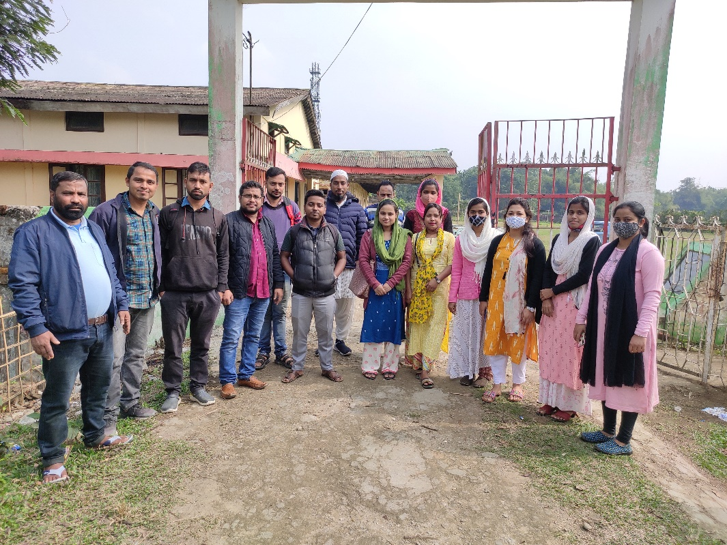

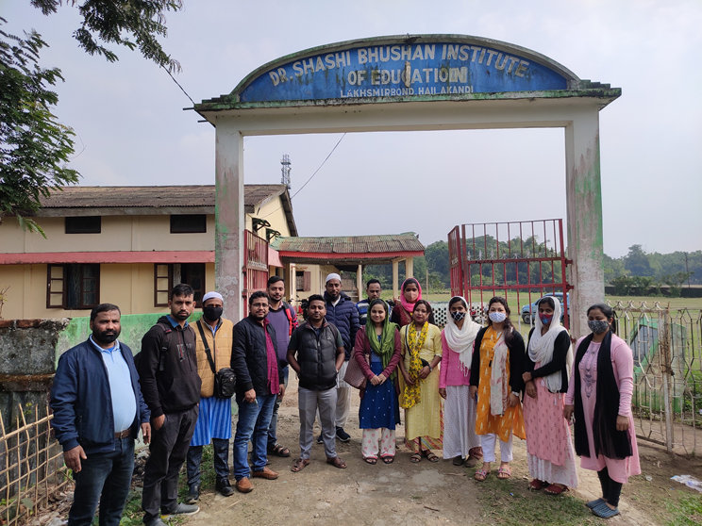

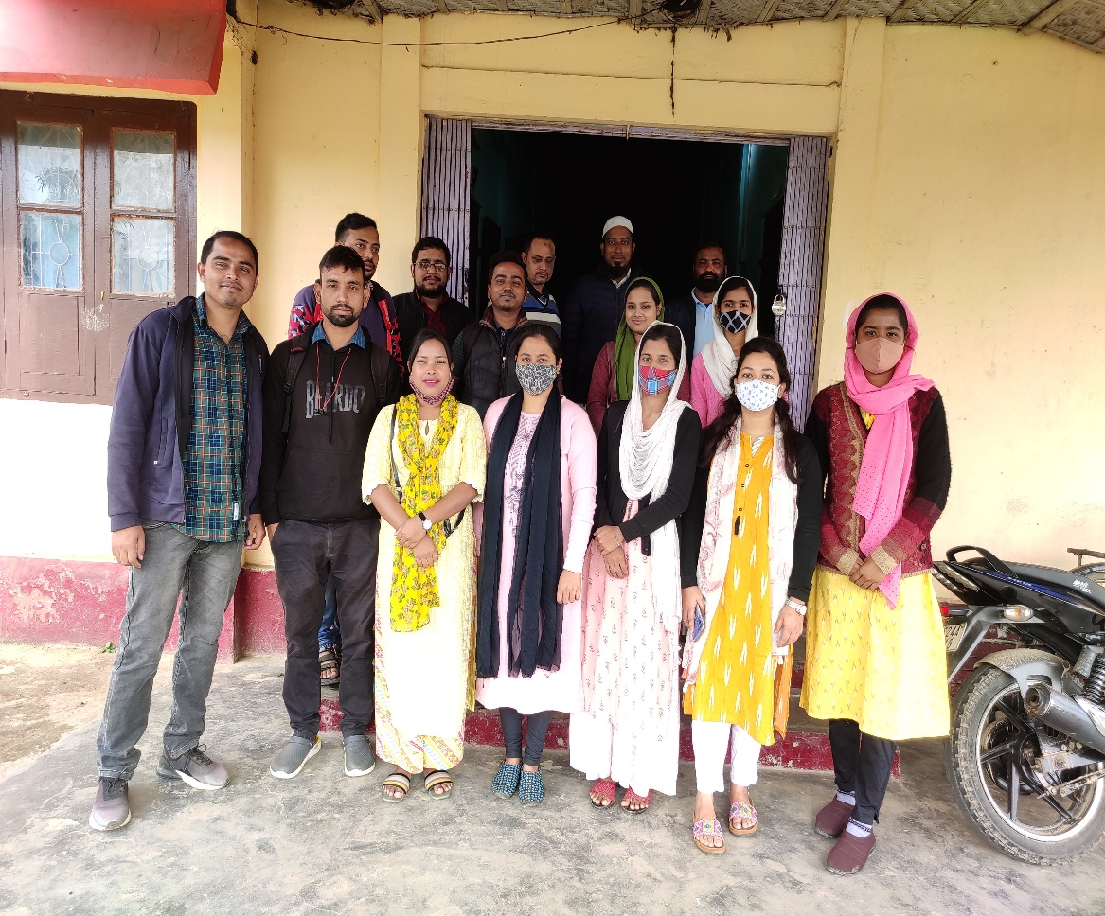

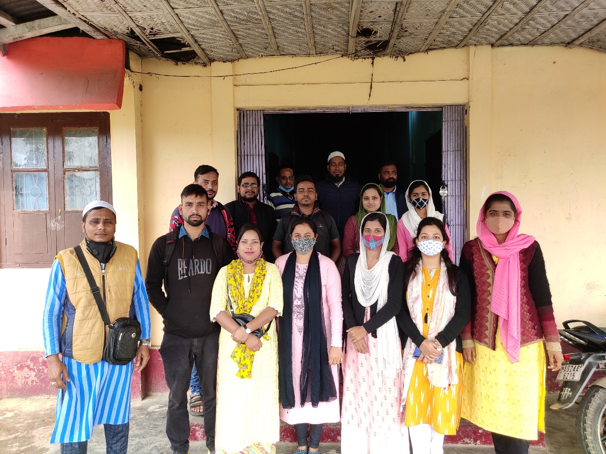

**References**

1. <http://hailakandi.gov.in/>
2. <http://www.hailakandi.nic.in/>
3. <http://scert.assam.gov.in/>
4. <https://diethailakandi.in/>
5. <https://www.sbiehailakandi.co.in/>
6. <http://www.ignou.ac.in/ignou/aboutignou/studycentre/centre>
7. <http://www.kkhsou.in/web_new/>