**IMPROVING HIGHWAY DESIGN EFFICIENCY AND PLANNING USING BIM AND GIS**

**First Author: Unnikrishnan .S**

1Designation:M.E Student, Department: Civil Engineering ,Sivaji College of Engineering, Tamil Nadu, India

**ABSTRACT**

Highway infrastructure plays an important role in a nation’s security, economy, and well-being, since safe, efficient, and reliable mobility of citizens and goods facilitate social and economic development. The main task in highway planning is to select an optimal alignment. This process is cumbersome, since it requires a comprehensive assessment of multiple factors, such as cost and environmental impact. The project helped to improve the efficiency of the geotechnical and infrastructural planning and design process. The project helped to close the gap in information flow between highway design and geotechnical analysis and it also provides the highway model. According to field survey and GoK, new alignment for Punalur – Thodupuzha State Highway (SH8) were optimized with the help of BIM and GIS software.The width of the road was increased from 5m to 14m. and the total length of the road were decreased from 2911.23m to 2766.23m. With the help of the InfraWork software the earthwork quantities also were calculated. Finally commuting trough SH8 become smooth. Dangerous curves are avoided, overall length gas been minimized. A constant elevation for the road has been maintained. Time taken for the project work was really less when comparing to the conventional alignment process

**Keywords:** GIS,BIM, Highway alignment optimization, Infra work software, environmental impact

1. **INTRODUCTION**

Highway infrastructure plays an important role in a nation’s security, economy, and well-being, since safe, efficient, and reliable mobility of citizens and goods facilitate social and economic development. The main task in highway planning is to select an optimal alignment. This process is cumbersome, since it requires a comprehensive assessment of multiple factors, such as cost and environmental impact. Once highway alignment has been settled, other critical aspects and related costs, such as construction costs and user costs, are largely determined. In reality, the planning of highway alignment is subject to several code and external restrictions, and efforts should be made to identify optimal alternatives. To solve this problem, this study proposes an Integrated Building Information Modeling (BIM) and Geographic Information System (GIS) model to facilitate the highway planning process by allowing data exchange between BIM and GIS tools.

1. **METHODOLOGY**

Highway optimization is done for the alignment scheduling using data collection, field survey and questionnaires and an optimal right of way is designed to avoid cuts and fills to the maximum. Highway alignment has been settled, other critical aspects and related costs, such as construction costs and user costs, are largely determined thereby reducing the cost using Infra work and ArcGIS

#### 2.1Preparation of Highway Alignment Optimization

For the project work, we took a 3km road updating has been studied on every aspects. The following are the conditions while constructing. Before doing the mapping procedure, all the data collection and field surveys are done. On this stages nature of the property is detailly monitored. The mapping is done on way which does not affect the real time delays during the construction of the SH8.

* + - 1. Quality of transportation/computing
      2. Cost effectiveness
      3. Reduce distance
      4. Traffic performance and its control
      5. Ecological balance
      6. Wild life cleanness

1. **MODELING AND ANALYSIS**

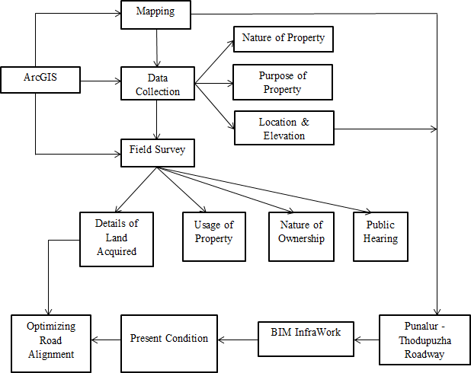

**Figure 1:** Pycnometer Test Procedure.

1. **RESULTS AND DISCUSSION**

According to field survey and GoK, new alignment for Punalur – Thodupuzha State Highway (SH8) were optimized with the help of BIM and GIS software. The profile view of the alignment will helps to identify the elevation of the road. The figure 4.2 shows the alignment difference between present and newly constructing road. From the figure, the green color line shows the present condition of the road alignment and the blue color shows the optimized alignment.

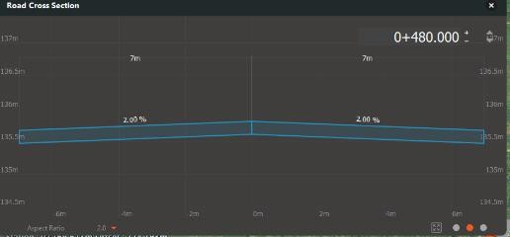

|  |  |  |  |
| --- | --- | --- | --- |
| SL. NO. | DIMENSION | BEFORE | AFTER |
| 1 | Width | 5m | 14m |
| 2 | Curve length | 1085m | 940m |
| 3 | Total length | 2911.23m | 2766.23m |
| 145m reduction occurs in the length | | | |

1. **CONCLUSION**

State Highway 8, Punalur to Thodupuzha running a span of 120km has been undergone modification. The old road has been realigned with expansion in width, avoiding heavy curves and sustaining ecological balance. The quantity for earthwork are availed by using the cut and fill method. Software’s used to modify the alignment are BIM InfraWork and GIS. This helps to easily alter the alignment. Finally commuting trough SH8 become smooth. Dangerous curves are avoided, overall length gas been minimized.

1. **REFERENCES**
2. **Ali. M. Mohamed** (2017) Method for clustering unlabeled BIM objects using entropy and TF-IDF with RDF encoding. *Adv. Eng. Inform*., 33,154–163.
3. **Alreshidi E, Mourshed M** and **Rezgui Y** (2017) Factors for effective BIM governance. *J. Build. Eng*. 10, 89–101.
4. **Andoh A,** and **Cai H** (2012) A Framework of RFID and GPS for Tracking Construction Site Dynamics. *In Proceedings of the ASCE International Conference on Construction Research Congress, West Lafayette, in USA*, 21– 23 May; pp.818–827.
5. **Anumba C, Dainty A** and **Ison S** (2008) Sergeant, the Utilization of GIS in the Construction Labour Market Planning Process; *Emerald Group Publishing Limited: Bingley,UK.*
6. **Bansal V.K**. (2011) Application of geographic information systems in construction safety planning. *Int. J. Proj. Manag., 29,66–77.*
7. **Bansal V.K.** and **Pal M**. (2011) Construction projects scheduling using GIS tools. *Int. J. Constr. Manag., 11,1–18.*
8. **Bansal V.K**.(2011) Use of GIS and topology in the identification and resolution of space conflicts. *J. Comput. Civ. Eng., 25,159–171.*
9. **Barazzetti F.** and **Banfi F.** (2017) BIM and GIS: When parametric modeling meets geospatial data. ISPRS Ann. *Photogram. Remote. Sens. Spat. Inf. Sci., 4, 1–8.*
10. **Chapra S.C.** and **Canale R.P**. (2006) Numerical Methods forEngineers;
    1. *McGraw-Hill: New York, NY, USA*.
11. **Cheng C.P.** and **Deng Y**. (2016) Analytical review and evaluation of civil information modeling. *Autom. Constr., 67,31–47*.