TITLE----‘STATUS OF OPEN & DISTANCE LEARNING(ODL) WITH SPECIAL REFERENCE TO BENGALI MEDIUM SECONDARY EDUCATION INSTITUTIONS IN HAILAKANDI DISTRICT OF ASSAM’

MONSURUL ISLAM, RESEARCH SCHOLAR ,SUNRISE UNIVERSITY,ALWAR

History of Secondary Education in Hailakandi

Hailakandi was declared as the 24th district of assam in 1989 by a government of assam notification no. AAA.98/89/Pt/I Dt. 29/09/1989, Hailakandi is one of the aspirational districts in the barak valley region of Assam. According to some historians the district got its name from the ‘Kuki’ word ‘halam’ means a small state and the word ‘Kundia’ meaning a plot of land for temporary ploughing. It is also believed that the name of the district is sali paddy is grown abundantly as a staple food crop and from ‘Sailkandi’ the district came to be known as Hailakandi.
In Assam there are two organizations namely Directorate of Elementary Education and the Directorate of Higher Education under the Department of Education, Govt. of Assam. The Directorate of Elementary Education and Directorate of Higher Education have their Head Quarter at Kahilipara, Guwahati – 19. The Directorate of Elementary Education is responsible for administration control, development and expansion, inspection, supervision, monitoring and evaluation of elementary education in Assam. The Directorate of Higher Education caters to the universities, government colleges, non-govt. colleges, ad-hoc colleges, affiliated colleges, ad-hoc law colleges, Asom Publication Board, ABILAC, Literary & Voluntary Organisations, Sanskrit And Pali Prakrit Tols, Asom Sanskrit Board, State Selection Board, Asom Etc.

CONTENTS
Chapter-1  - Introduction | Page No.
- Overview  - Needs of the study  - Objective | 1-2  3  4
Chapter-2  - About the study | 5-7
- Study area  - Geography | 5  6
Chapter-3  - Methodology | 7-13
- Sampling  - Tools and Procedure  - Data Analysis | 7  8-9  10-13
Chapter-4  - Findings and interpretation | 14-15
Chapter-5  5.Conclusion and Recommendation | 16
5.1. Bibliography  5.2. Photogallary | 17  18

CHAPTER-1
(Introduction)
  - Overview
Education is the most potent factor for the development of Human Resource. It increases, enriches and improves all the aspects of human resources. The institutions of today are expected to impart quality education to develop competent and capable individuals who can sustain in the competitive dynamic environment of tomorrow. Secondary education is accepted as base for sustainable development and realized as a powerful tool to build a knowledge society. It is the strongest instrument to make the mankind productive, progressive and powerful. The Indian Education system, which includes Technical Education, is one of the largest of the world, just after the United States and China. Secondary Education is the most powerful tool to build a knowledge-based society for the future. Secondary Education provides people with an minimum opportunity to reflect on the critical social, economic, cultural, moral and spiritual issues facing humanity. It contributes to national development through dissemination of specialized knowledge and skills. Being at the apex of the educational pyramid, it plays a key role in producing quality manpower for the country. The role of higher education in the development of human resources for national development can never be disputed. Secondary education can create the platform for high level professionals, technical and managerial personnel generate new knowledge through research and impart such knowledge leading to development of human resources.
Movement of our economy from industrial to service and then to knowledge one and the recent international developments like opening up of markets for global players, market orientated of economies, increased competition between nations require that developing countries develop their human resources infusing in them qualities like innovation, productivity, collaboration, teamwork, reflection, adjustment to change, multiplicity of reactions and readiness to face the challenges of a globally competitive market oriented and knowledge society. Development of such skills is required by one and all of the members of the present society belonging to all walks of life to shoulder their responsibilities properly. Higher education plays key role in this regard.
P-1

Open and Distance Learning (ODL) provides a viable alternative mode with the objective to take education to the door steps of the learner, enhancing social equity, and creating flexibility for lifelong learning (Koul, 2000). Education through distance mode indicates universalization and democratisation of higher education with an aim to provide cost- effective and relevant education to large sections of our population including those living in remote and far-flung areas. ODL has come into the educational scene as one of the most potent strategies to fulfil the demands of the mass education as well as individualizing it.

P-2
  - Needs of the study:
In a huge country like India where the fruits of development are not equally distributed, the importance of ODL system is tremendous. ODL system is being adopted throughout the world as an important tool to ensure access, equity and quality in the realm of higher education. Especially in developing countries where there is a need of providing training to large number of workers with limited recourses, in such a situation ODL system could play important and viable role in improving overall skills of workers. Therefore, this work is an attempt to explore the potentialities of ODL system in a district like Hailakandi.

P-3
  - Objectives of the Study:

The major objectives of the study are
- To study the present status and growth of open and distance education in Hailakandi district of Assam.
- To study the potentialities of open and distance education in encouraging secondary education.
- To study the percentage of enrolment of students in different courses.
- To study the challenges faced by the institutions in providing Open and Distance Learning in Secondary level.

P-4
CHAPTER:2
(About the Study)

2.1. Study Area:
Hailakandi is one of the 33 districts of Assam state in North East. It makes up to the Bakar Valley alongside Cachar and Karimganj. It was constituted as a civil division on 01/06/1989. Subsequently, it was upgraded to a district in 1989, when it was split from Cachar district.
According to some scholars, the name “Hailakandi” has been derived from the Sylheti word “Hailakandi”. Hailakandi is intricately linked to Abdul Matlib Mazumder (1890-1980), Late Nagendra Nath Choudhury, Late (Capt.) Manmatha Choudhury who lead the freedom movement in the erstwhile division

P-5
2.2. Geography:
Hailakandi District occupies an area of 1327 SQ. KM. comparatively equivalent to Iran’s Qeshm Island. Out of this more than 50% is reserved forest. There are total of two reserve forests in Hailakandi Districts viz. inner line reserved forest and Katakhal reserve forest. The district has got interstate border Mizoram on its south having a length of 76 KM. besides inter district border on other sides with Karimganj district and Cachar district. There are total of 62 nos. of Gaon Panchayat under these 5 blocks.

P-6
CHAPTER 3: METHODOLOGY

3.1. Sample of the study:
The pioneer study center of Open and Distance learning institution have been selected for conducting this work. The institution are Lakshirband H.S.School, Gyanjyoti, H.S. School, Algapur Public H.S. School.

3.2. Tools and procedure of study:
The present study uses both primary and secondary data. Primary data have been collected from the sample study center through questionnaires and interviews. On the other hand, secondary sources like books, journals, magazines and e-resources have also used for this study.

3.3. Data analysis:
After collection of primary and secondary data from the sampled study center, some tables are being developed in statistical manner. Among them table 1 represent the overall educational status of open and distance education of the district.

P-7
Table: 1 The different study center of open and distance education for secondary level in the district
SOS study center:
Sl. No. | Name of the institution
1. | AL Choudhury Jr. College
2. | Hailakandi Womens College
3. | Public HS School, Hailakandi
4. | Gopal Gobinda Jr. College

NIOS study center
Sl. No. | Name of the institution
1. | Kendriya Vidhyalay, Panchgram
2. | Jawahar Navodaya vidhyalaya, Monacherra
3. | Lakshirband H.S. School, Lakshirband
4. | Kanchanpur Medha Vikash Vidhyalaya
5. | Gyanjyoti H.S. School, Aenakhal

P-8
Table:2 Total intake capacity in the different institution
Sl. No. | Name of the institution | Intake capacity
SOS STUDY CENTER
1. | AL Choudhury Jr. College | 150
2. | Hailakandi Womens College | 150
3. | Public H.S School, Hailakandi | 150
4. | Gopal Gobinda Jr. College | 150
NIOS STUDY CENTER
5. | Kendriya Vidhyalay, Panchgram | 300
6. | Jawahar Navodaya vidhyalaya, Monacherra | 300
7. | Lakshirband H.S. School, Lakshirband | 150
8. | Kanchanpur Medha Vikash Vidhyalaya | 150
9. | Gyanjyoti H.S. School, Aenakhal | 150

P-9
Chart:1 Analysis of data of sampled study center:
- Gyan Jyoti H.S. School:
Status of enrollment in last three years:

P-10
Chart:2 Stream wise enrollment status in the year 2022:

Chart:3 Pass percentage in last two years (Class 10 and 12):

P-11
- Kanchanpur Medha Vikash Vidhyalaya:
Chart-4: Stream wise enrollment status in last three years.

Chart 5: Pass percentage in last three years:

P-12
SOS Study Center

- Hailakandi Womens College
Chart-6: Pass percentage in last three years

P-13
CHAPTER -4
(FINDINGS AND INTERPRETATION)

- Growth of Open and Distance Education in Assam

Barak valley region of Assam comprise of three districts i.e. Cachar, Karimganj and Hailakandi. The communication particularly surface transport is a great problem for the entire valley. Various problems come underway of improving transport facility in the region. Even during the era of technological climaxity, there are many places in the southern Assam which are yet not reached by road ways. So, it is difficult for students of these areas to join institutions for higher education as a regular student for lack of communication and economic hardship. In recent times, the necessity of secondary education has been increasing nationwide. This is the need of the hour in Barak Valley region too. Despite of being affected by problems like militancy, high rate of infiltration, flood, political unrest, lack of any industrial development, lack of proper transport, etc. these has been progressive demands for higher education in this region. Most of the educational institutions face daunting admission demand for knowledge acquisition. But due to various constraints education institutions following the conventional pattern of education are unable to cope up with the increasing demand.

It has been found that admission to commerce stream is not promising as compared to the other streams at senior secondary levels.

P-14
- Potentialities of different study in the district:
The following student support services are provided by IGNOU Regional Centre Guwahati for empowering students:
- Distribution of study materials to the students that provided by the Regional Centre.
- Subject-specific academic counselling is provided by part-time academic counsellors.
- Library facilities
- Information services related to rules, regulations, proceedings, schedules, etc. of the board through SMS.
- Miscellaneous help required by the students.

- Pass percentage: It has been found from the study that pass percentage is gradually increasing. It has been found that admission to commerce stream is not promising as compared to the other streams at senior secondary levels.

P-15
CHAPTER-5

5.1. CONCLUSION AND RECOMMENDATION

Open and Distance Learning system is an emerging field in secondary education, particularly in Assam. It is definitely going to play a bigger role in the times to come. In Hailakandi also the demand of ODL system is raising gradually. Despite the promises and significance of distance learning, there are lots of problems faced by learners that need to be resolved. However, if these are sorted out, then, certainly this system will emerge as one of the effective modes of propagating secondary education in Assam as well as in Hailakandi.

P-16
5.2. BIBLIOGRAPHY

Primary sources:
- Interviews with different center coordinator.
- Visiting different institution.
Secondary sources:
- Ansari, M. M. (2002). Best Practices in Open and Distance Learning Systems in India: An Assessment. Indian Journal of Open Learning, 11(2), 219-228.
- D.Joyanta (2018). Open and distance learning in Assam-An emerging trend and reality in the field of higher education: International Journal of Research in Social Sciences 8(7) ISSN: 2249-2496.
- Maxwell, L. (1995). Integrating Open Learning and Distance Education, Educational Technology, November-December, 43-48.

- Pandit, P.V. (2006). Expanding the scope of Open Distance Learning (ODL) for Learning for Development in India. University News, 46 (14).

P-17
P-18
5.3. PHOTOGALLARY

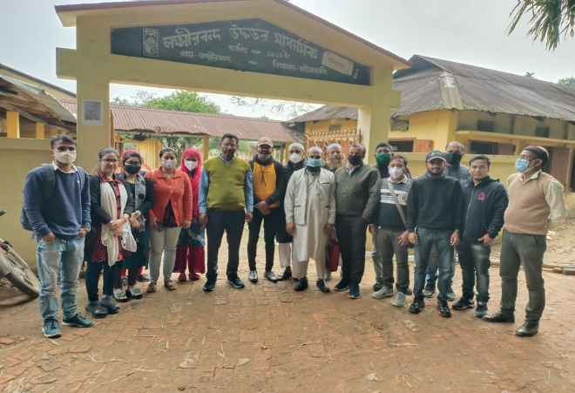 | 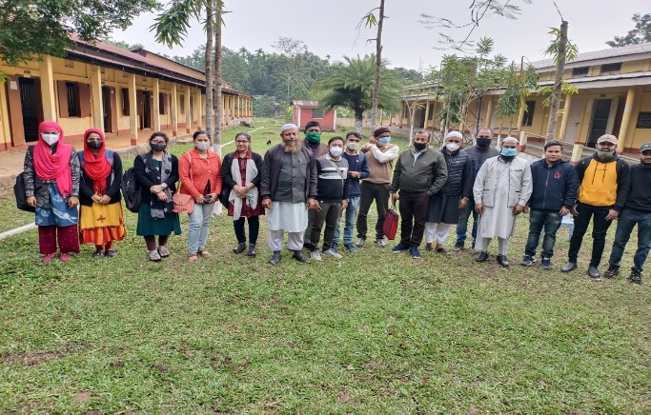
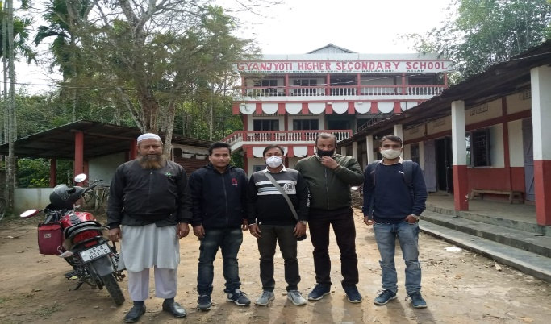 | 