# SEMINAR REPORT ON

**LEAN MANUFACTURING**

# BY

**Mr. ABHIJIT BHIMRAO DAHAGAONKAR**

# EXAMINATION NO. T190211218

**GUIDE**

**Mr. M. P. BAUSKAR**

Department of Mechanical Engineering

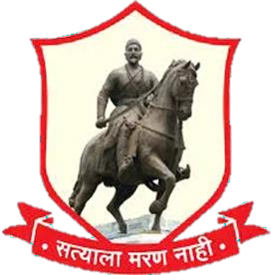

All India Shri Shivaji Memorial Society’s College of Engineering, Pune-01.

[2021-22]

c

SEMINAR REPORT ON

## LEAN MANUFACTURING

By

## Mr. ABHIJIT BHIMRAO DAHAGAONKAR

Exam Seat No: T190211218

Guide

Mr. M. P. BAUSKAR

Department of Mechanical Engineering

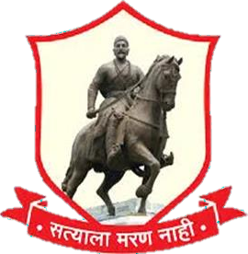

All India Shri Shivaji Memorial Society’s College of Engineering.

Pune-411001 [2021-22]



Department of Mechanical Engineering

*C E R T I F I C A T E*

This is to certify that***,* MR. ABHIJIT BHIMRAO DAHAGAONKAR** has successfully completed the Technical Paper Presentation entitled **“LEAN MANUFACTURING”** under my supervision, in the partial fulfilment of Bachelor of Engineering - Mechanical Engineering of Savitribai Phule Pune University.

M.P. Bauskar Dr. C.S. Choudhari

Guide Co-Ordinator, Mechanical Sandwich External Examiner

Date : Place: Pune

Dr. B.D. Bachchhav Head

Department of Mechanical Engineering

# LEAN MANUFACTURING



### 1. ABSTRACT

In the present business scenario, the competitiveness of manufacturing companies is determined by their ability to meet and respond as swiftly as possible to the changing environment scenario and to produce and supply high- quality products at a lower cost as per the demand of the customer. All the manufacturing companies are striving too hard to achieve their aims, objectives, and their capabilities through proper planning and skilfulness, through the application of automation and innovative concepts, e.g. lean manufacturing, just-in-time (JIT), and total quality management (TQM). Among these innovative concepts, lean manufacturing is recognized by the manufacturing companies as a major driver to achieving world-class capabilities. Many large and medium-sized manufacturing companies have adopted lean manufacturing concepts, and experienced reduction in manufacturing lead time and material handling cost, and improvement in quality with other benefits. It is generally agreed that for a lean manufacturing program to be effective, it should include a set of tools and techniques or provisions to ensure management obligation, employee association, identification of wastes, development of controls for wastes, and training and education for employees.

These tools and techniques are said to be typical of any comprehensive lean manufacturing implementation program. The implementation of lean manufacturing reduced the waste in the industry and enhances the profit and production. According to research conducted by the Lean Enterprise Research Centre (LERC), fully 60% of production activities in a typical manufacturing operation are waste – they add no value at all for the customer.

The good news is that just about every company has a tremendous opportunity to improve by eliminating waste, using lean manufacturing techniques and other manufacturing best practices. The techniques of lean manufacturing enable you to deliver higher quality products at significantly lower costs. Now that is something to get excited about!

It can be difficult to find reliable and well-written information about improvement techniques for manufacturing. So, our goal is to provide you with the absolute best source of easy-to-understand information for helping you improve the efficiency, effectiveness, and profitability of your manufacturing operations.

With that in mind, we have designed each lean production topic on this site to be self-contained and to stand on its own.



### ACKNOWLEGEMENT

The satisfaction that accompanies the successful completion of this review would be incomplete without the mention of the people who made it possible, without their constant guidance and encouragement would have made the efforts go in vain. I consider myself privileged to express gratitude and respect towards all those who guided me through the completion of this Technical Paper Presentation.

I convey thanks to my guide Prof. M. P. Bauskar of Mechanical Engineering Department for providing encouragement, constant support and guidance which was of great help to complete this successfully. Last but not the least I appreciate the opportunity given to me by our head of department Dr. B.

D. Bachchhav and our principal Dr. D. S. Bormane as well as all teaching and non-teaching staff of Mechanical department who were directly or indirectly involved with my presentation.

ABHIJIT BHIMRAO DAHAGAONKAR

TE Mechanical (S/W)



### LIST OF TABLES

|  |  |  |
| --- | --- | --- |
| **Sr.No.** | **Table Description** | **Page No.** |
| 1 | Price vs Process | 8 |
| 2 | Lean Management in BCIN | 17 |

**CONTENTS**

|  |  |  |
| --- | --- | --- |
| **Sr.**  **No.** | **Title** | **Page No.** |
| 1 | Introduction | 4 |
| 2 | Literature review | 7 |
| 3 | Lean Manufacturing | 10 |
| 3.1 | Role of Lean Manufacturing for organization | 10 |
| 3.2 | Tools for Lean Manufacturing | 13 |
| 3.3 | Six-Sigma | 15 |
| 3.4 | Principles of Lean Manufacturing | 16 |
| 4 | Issues and challenges in manufacturing process | 17 |
| 4.1 | Approaches adopted for implementation of lean manufacturing | 18 |
| 4.2 | Lean Management at Burckhardt Compression | 19 |
| 5 | Conclusion | 21 |
| 6 | References | 22 |



1. **INTRODUCTION**

Manufacturing has been recognized as the main engine for the growth of the economy. The ever-changing globalized environment has been posing challenges of competitiveness and survival to all the constituents of the economy. Manufacturers in the Indian industry have always faced heightened challenges such as rising customer demand for better and improved products, erratic demand, and competition in markets. There is no disbelief that the manufacturers are always embracing changes and improvements in their key activities or processes to cope with the ever-growing challenges. To be more efficient is the only way to stay and earn profit in a global market. Industries are giving a lot of attention to Lean manufacturing. Several industries in India are struggling to be world-class. The principal adoption of lean

manufacturing is still found to be complex. Lean Manufacturing is a set of techniques, which have developed gradually over a long period and are based on various minor to breakthroughs that help in reducing cost and hence increase productivity.

Lean is a philosophy of manufacturing that incorporates a collection of principles, tools and techniques into the business processes to optimize time, productivity, HR, and assets, while improving the quality level of products and

Services to their customer. Lean manufacturing, also called lean production, was originally created in Toyota after the Second World War in the reconstruction period [[1](https://www.intechopen.com/chapters/70020#B1)]. It is based on the idea of eliminating any waste in the industry, i.e., any activity or task that does not add value and requires resources [[2](https://www.intechopen.com/chapters/70020#B2)]. It is considered in any level of the industry, e.g., design, manufacturing, distribution, and customer service. The main wastes are as follows:

* Overproduction against plan
* Waiting time of operators and machines
* Unnecessary transportation
* Waste in the process itself
* Excess stock of material and components
* Non-value-adding motion
* Defects in quality

The wastes eliminated should improve the improvement of the quality and the reduction of the cost and time in the manufacturing. The main tools are the following:

* *Five S.* seiri (sort), seiton (set in order), seisō (shine), seiketsu (standardize), and shitsuke (sustain).



* Multiprocess handling. The manufacturing is preformed sequentially for multiple processes, contributing to the flow of materials.
* *Value stream mapping*. The tool compares the current state and future state of the events that depend on the product in order to reduce wastes. It is focused on the areas that incorporate value to the product.
* *Kanban* (pull systems). The lead time and cycle time are measured in several areas of the production in order to detect any problem and avoid it, e.g., to establish an upper limit to work in process inventory to avoid overcapacity.
* Mixed model processing.
* *Total productive maintenance*. The production system is considered as a whole, and the maintenance is focused on that. It leads the integrity of the maintainability, safety, quality to the assets, and human resources that add value to the production system.
* Elimination of time batching.
* *Control charts.* For checking mura (unevenness).
* *Rank order clustering. It is* employed in production flow analysis, considering the classification of machines and the technological cycle information control and generating a binary product-machine matrix.
* Single-minute digit exchange of die (SMED). The idea is that the changeovers and startups will be done in a “single-minute digit,” usually 10 minutes. A similar concept is one-touch exchange of die (OTED), where the “single-minute digit” should be less than 100 seconds.
* Redesigning working cells.
* Single point *scheduling.*
* *Poka-yoke* (error-proofing). It is considered as the tool that leads to the operator to avoid (*yokeru*) mistakes (*poka*). It leads to reduce or eliminate the product defects.



### LITERATURE REVIEW

The objective of this article is to understand the concept of lean manufacturing, its philosophy, various tools and techniques, lean implementation benefits and barrier towards lean implementation. *Main concepts:* Lean manufacturing by now is a widely discussed and applied manufacturing philosophy, in a variety of industries across the globe. The fundamental concept of lean manufacturing is to provide a quality product while also ensuring that the product does not cost too much to the customer. Most organizations today are going through a stage where there is a necessity to respond the rapidly changing customer needs. To sustain their place in the market, many organizations have started following the lean manufacturing concept. *Methodology of the research:* This article presents a review of the literature and attempts to identify the important and useful contributions to this subject. *Results:* Lean manufacturing utilizes a wide range of tools and techniques; the choice of tools is situation specific. Many factors contribute to lean success; not only is it mandatory to implement most of the lean tools, but an organization's culture needs transforming too.

Companies following lean manufacturing have better flexibility and a good market share. Moreover, lean manufacturing produces an operational and cultural environment that is highly conducive to waste minimization. To identify through a systematic literature review, the main Lean Manufacturing practices, critical success factors and barriers within small manufacturing companies’ context. This paper is a systematic literature review based on the proposed approach denoted as ProKnow-C to identify the correlated bibliographic portfolio. Our findings indicate that the consolidation of specific CSF related to the context of small manufacturing companies reinforces the body of knowledge, reinforcing the establishment of a broader perspective of LM implementation in these companies. Further, the capability of disseminating the continuous improvement mindset across all employees is a significant challenge for these companies, since their leaders are poorly trained in accordance with the underlying LM principles.

The recent growth of small companies and their relevance to socioeconomic development has raised the importance of improving their management processes. Particularly for LM implementation, few studies have specifically approached this context whose challenges may be differentiated, highlighting the need for a better comprehension of proper practices, barriers, and CSF. This outlines the development of environmental operations management, and discusses the integration of environmental and operations management in terms of both practice and recent research.

### LEAN MANUFACTURING

Lean manufacturing is defined as to produce same and more than the mass production using less effort, lesser space, without any new inventory, better quality and lesser defects. There are different objectives and essentials for implementation of lean manufacturing which are discussed as below:

* 1. Highest satisfaction of customers’ needs
  2. Total elimination of waste
  3. Use of less effort with same production rate

#### ESSENTIALS OF LEAN MANUFACTURING

Lean manufacturing uses a process layout in which the manufacturing cells are arranged in parallel. In every cell there should be no storage of materials, rather there is single piece of flow. Lean manufacturing aims at minimizing waste

of following type:-

* Correction and repair of any damaged tool etc.
* Use of any waste motion for transportation purposes
* Over production or producing more then needed
* Wasted effort to transport any kind of goods
* Maintaining excess inventory of raw material and finished products.

### ROLE OF LEAN MANUFACTURING FOR ORGANIZATION

Lean manufacturing techniques are beneficial to increase the profitability by reducing the production cost. Industrial major objective is profit which should be maximized. To understand the relation between cost, profit and sale we will In the above diagram the sale prize and production cost with profit is presented and lean manufacturing process flow.briefly study the following with respect to traditional process flow

In the process I and process II the traditional manufacturing techniques are usedand in the process ID the lean manufacturing approach is used. Let, we discuss the profit and satisfactions of customers and industry organizers.



#### Process 1 :

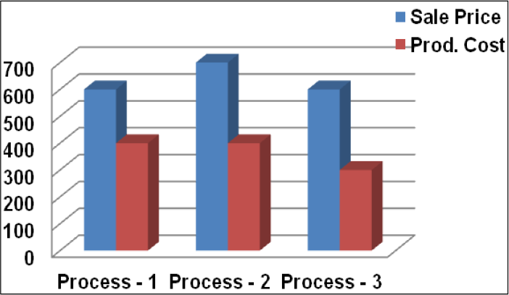

**Figure 1: Price Vs. Process**

Profit = Sale Prize - Production Cost Profit = 600 – 400 = 200

Customers satisfied but industry organizers will not.

#### Process 2 :

Profit = Sale Prize - Production Cost Profit = 700 – 400 = 300

Industry organizers satisfied but Customers will not.

#### Process 3 :

Profit = Sale Prize - Production Cost Profit = 600 - 300 = 300

Both customers and industry organizers satisfied. When you implement and follow a lean path you should see direct cost savings by driving out the waste. Lean manufacturing is customers focused. Satisfying customer demand is considered to be the key to success in your business. Lean allows your manufacturing deeds to become more closely aligned with other company goals and activities.



#### LEAN MANUFACTURING TECHNIQUES

Lean manufacturing as discussed above is not easy to achieve. It requires all round improvements in almost every aspect of function of an organization. There are the number of techniques and parameters which help to maintain the lean manufacturing system for an organization. Few are listed below:

* + - Value Mapping
    - · Single Minute Exchange of Dies
    - · Single Piece Flow
    - · Inventory Control via Card System
    - · Concept (Separate, Self-discipline, Simplify, Standardize, Sustain)
    - · Total Productive Maintenance
    - · Visual Management
    - · Production Line Optimization

It is interesting to note that the “wastes” typically targeted by environmental management agencies, such as no product geo-output and raw material wastes, are not explicitly included in the list of manufacturing wastes that lean practitioners routinely target.

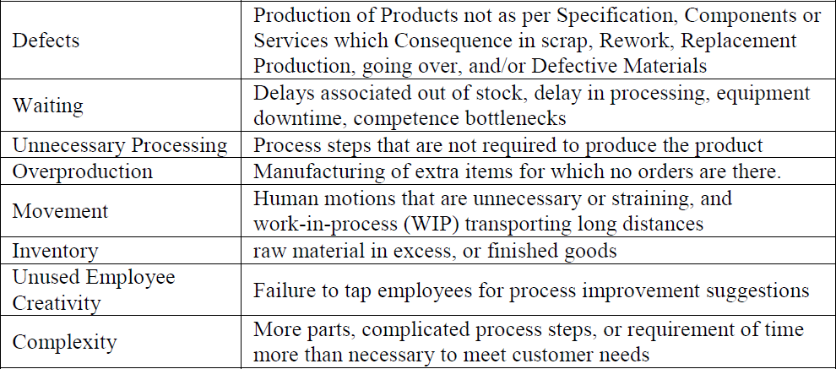

**Figure 2: Eight Types of Waste Targeted by Lean Methods**



#### DESCRIBED BELOW ARE EIGHT CORE LEAN METHODS

* + - Cellular Manufacturing / One-piece Flow Production Systems
    - 5S
    - Just-in-time Production
    - Total Productive Maintenance (TPM)
    - Kaizen
    - Kanban
    - Six Sigma
    - Pre-Production Planning (3P)

### TOOLS FOR LEAN MANUFACTURING

* + - · **Cellular Manufacturing (CM):** Cellular manufacturing is a concept that increases the mix of products with the minimum wastage possible. A cell is made up of equipment and workstations and is arranged in an order, to maintain a smooth flow of resources and components through the process.
    - **Continuous Improvements (5S):** One of the most effective tools of continuous improvement is 5S, which is the starting point for an effective lean company. 5S is a first, modular step towards serious waste diminution. 5S is made up of five Japanese words Seiri (Sort), Seiton (Straighten), Seiso (Sweep and Clean), Seiketsu (Systemize), and Shitsuke (Standardize).
    - **Seiri**: Deals with moving those items that are not currently being used on a continuous basis (e.g., items which won’t be used for the next month or so) away from those that are.
    - **Seiton**: Has to do with having the right items in the right area. Items that do not belong to a given area must not be in that area.
    - **Seiso**: Deals with cleaning and sweeping the work place methodically. The workplace should look neat and clean and ready to use for the next shift.
    - **Seiketsu**: Is to maintain a high standard of housekeeping and workplace arrangement.
    - **Shitsuke**: Is accountability of management to train people to follow housekeeping rules. And at times the sixth S for Safety is added though

5S purists say that an effective implementation of 5 S will eventually result in safety.

* + - **Just - in-Time**: Closely associated with lean manufacturing is the principle of just-in-time, since it is a management idea that attempts to eliminate sources of manufacturing waste by producing the right part in the right place at the right time. It broadly consists of three elements:

1. JIT production,
2. JIT distribution, and
3. JIT purchasing.

* **Kaizen:** Kaizen, a Japanese term that basically translates to 'continuous improvement' or 'change to grow to be good', this is a management concept originated by the Japanese in order to continuously effect incremental changes for the better, involving each and every one within the organization from managers to workers. The aim of Kaizen is to give more and more production value with less and less wastes (superior efficiency), to attain better working environment, and develop a stable processes by standardization.

#### TOTAL PRODUCTIVE MAINTENANCE (TPM)

Total Productive Maintenance (TPM) is an initiative for optimizing the effectiveness of manufacturing equipment. A team-based productive maintenance which involves every level functioning in the organization, right from the top executives to the worker on the shop floor. The goal of TPM is "profitable PM." It not only requires to prevent breakdowns and defects, but also to be carried out in such always that they are economical and efficient. Toattain this goal following

five techniques are to be mastered:

#### PREVENTIVE MAINTENANCE

* + - It is a daily maintenance (cleaning, inspection, oiling and re-tightening), design to retain the good working condition of equipment and prevent failure.
    - Periodic Maintenance (Time Based Maintenance - TBM) - Time based maintenance consists of inspections at regular intervals, cleaning and servicing equipment and replacing parts to prevent sudden failure and process problems.
    - Predictive Maintenance - This is a method in which the service life of important part is predicted based on inspection or identification, in order to use the parts to the limit of their service life
    - Corrective Maintenance - It improves equipment and its components so

that preventive maintenance can be carried out reliably

* **Maintenance Prevention -** It indicates the design of new equipment.

#### KANBAN PUSH/PULL SYSTEM

It is a scheduling system for lean and JIT production. The concept of pull in lean production means to respond to the pull, or demand, of the customer. Kanban is a Japanese word that means "instruction card"

### SIX-SIGMA

Six-Sigma is a strict, disciplined, data-driven methodology that was developed to enhance product quality and company profitability by improving manufacturing and business processes. Statistical analysis is used by Six Sigma for quantitatively measure how a process is performing. These processes can involve business practices, manufacturing, products, or service.

#### Six-Sigma Implementation

Two Six Sigma sub-methodologies were developed for this purpose:

1. DMAIC (Define, Measure, Analyse, Improve, Control) and
2. DMADV (Define, Measure, Analyse, Design, Verify).

#### Pre-Production Planning (3P)

Pre-production is the process of planning the recording. It's to make sure that no time and money is wasted at all Pre-production takes the form of meeting to discuss the project.

#### Production Smoothing

In a lean manufacturing system it is important to move to a higher degree of process control in order to strive to reduce waste. Heijunka, the Japanese word for production smoothing, it is where the manufacturer try to keep the production level as constant as possible from day to day.

#### Standardization of Work

A very important principle of waste elimination is the standardization of worker actions standardized work basically ensures that each job is organized and is carried out in the most effective manner. A tool that is used to standardize work is what called “takt” time is. Takt (German for rhythm or beat) time refers to how often a part should be produced in a product family based on the actual

customer demand. Takt time is calculated based on the following formula [Feld, (2000)]

#### Total Productive Maintenance

Machine breakdown is one of the most important issues that concern the people on the shop floor. The consistency of the equipment on the shop floor is very important since if one machine breaks down the entire production line could go down. An important tool that is necessary to account for sudden machine breakdowns is total productive maintenance. In more or less any lean environment setting a total productive maintenance program is very important.

### PRINCIPLES OF LEAN MANUFACTURING

* Identify Value
* Map the Value Stream
* Create the Flow
* Establish Pull
* Seek the Perfection

Today the lean concepts have reached many other industries which include healthcare, service providers and even armed services. The multiplicity of organizations that are practicing lean concepts in them goes to show the universal applicability of lean concepts or lean thinking. Lean technologies might be unique to the implementation but the lean thinking is universal. In any organization, Lean manufacturing can be implemented in R and D, production, planning, engineering / maintenance, sales, marketing, store etc.



### ISSUES AND CHALLENGES IN MANUFACURING PROCESS

It is well known fact that by application of LMS any organization can reap the benefits of the existing resources. Many companies who put into practice Lean do not adequately take advantage of the improvements. Extremely successful companies will discover how to market these new benefits and turn them into increased market share.

In this age of modern technology & globalization some employees are not aware about a system that can be handy for there professional growth and betterment of working environment. With the application of LMS there is unseen danger of rejecting or overruling of certain existing technique & tools in an organization. The success of LMS highly depends upon various factors but the key factor is perception of employees and working of the management. Despite the fact that LMS is not a very old technique to strengthen the quality & production in any organization, nevertheless it requires an in-depth understanding, knowledge and skills to apply it successfully in a given frame work. Training generally provides employees with an golden opportunity to hone their latent skills and enable them to become aware about the latest trends & technologies. Since LMS is a new phenomenon so employees require undergoing training seriously. But some times organization thinks that training is an extra financial burden that may reduce their share of profit & of no use for their employees.

LMS is considered as a very useful technique in the modern day setting of organization. it is very beneficial in reducing the cost and waste management. The success of LMS a great deal depends upon planning and implementation of plans & policies. Total quality management have been termed as the need of the hour organization like to have total quality in their management system. 6 Sigma also meant to improve the quality & production without increasing the cost of production. LMS can be very beneficial in implementing TQM & 6 Sigma.

Employees like to see their career graph moving. They always seek and like to be in constant touch with the latest technologies. They can contribute to a great deal to their working organization, if they get proper training & guidance along with healthy working environment. Many organizations consider training as a very important aspect for employee’s growth. By providing regular and rigorous training to the employees organisation can easily meet the objectives of LMS. Training programmes need be planed as per the requirement of employees and the organization.



### APPROACHES ADOPTED FOR IMPLEMENTATION OF LEAN MANUFACTURING

A successful implementation of any particular management practice frequently depends upon organizational characteristics, and not all organization can or should implement the same set of practice.

* Unionization

It is generally supposed that because implementation of manufacturing practices requires negotiating changes in work organization, unionized facilities will resist adopting lean practices and lag behind non-unionized facilities.

* Age of Plant

Plant age may imply either a tendency toward resistance to change or a li ability of newness. The “resistance to change” view is supported by the organizational sociology literature which suggests that the age of an establishment should inversely influence the rate of adoption of innovations, because organizational forms tends to be “Frozen” at birth.

* Size of Plant

Large manufacturers are more likely to implement lean practices than small manufacturers [Shah & Ward, (2003)].



### LEAN MANAGEMENT AT BURCKHARDT COMPRESSION

To keep doing a good job, we need to always get better. PULL@BCAG is not some secret code, it stands for team-based process quality and as such represents a work philosophy. Focus on shorter lead times.

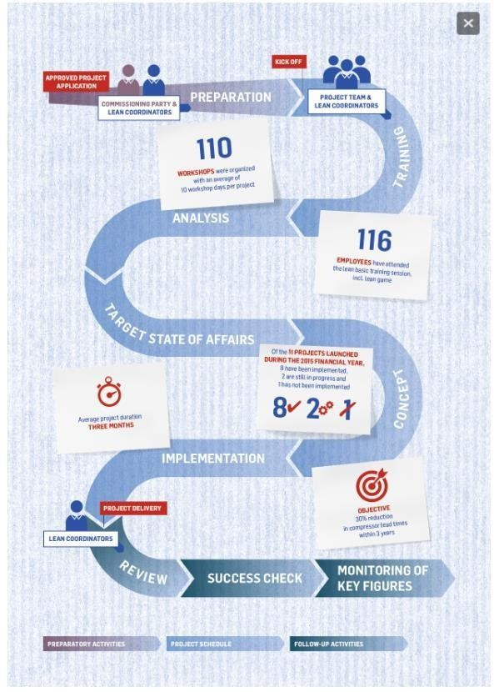

**Figure 3: Lean Management in BCIN**



The program was launched in 2009 and is now a fixed part of our Design & Manufacturing unit.

Supervisors and employees receive some basic training in lean and change management but most of the program activities revolve around project teams and their workshops. These interdepartmental teams work on creating specific solutions together with lean coordinators and then implement these solutions in their everyday work. The main objective is to constantly reduce lead times through sustained business improvements. Each project is described in detail and project outcomes are measured against clearly defined criteria.

#### Workspace optimization

One example of the many benefits this program has provided is workspace optimization. Instead of keeping certain tools at a central warehouse, for example, many workspaces are now individually equipped with the tools that are needed to get the job done. No more time is lost walking back and forth for tools, employee satisfaction has increased and efficiency has improved. Together with a new planning concept, a significant reduction in lead times has been achieved.

#### One-piece flow

Furthermore, a one-piece flow or continuous connected workflow method consisting of five steps was introduced for certain stages of the manufacturing process. Groups of employees work on one compressor at a set pace as it passes through various production stages and they have a certain degree of autonomy in how they organize their work. This change also led to a reduction in calculated standard times and therefore reduced lead times while increasing output.

#### Shopfloor Management

The introduction of the Shopfloor Management and Ship It tools improved transparency at various points of the order processing flow. Planning details, work in progress, and interfaces are posted on information boards and status reports are reviewed daily. Traffic light labels provide an immediate overview of delivery schedule adherence, lead times and efficiency. This serves as a coordination tool during shift changes or in brief work group meetings, and the given KPIs are used to target further improvement potential.

#### PULL@BCAG

The common objective of every project is to reduce lead times, improve efficiency and ensure delivery schedule adherence while maintainingif not improving overall quality. This concurrently promotes a greater sense of cohesion in the workforce.



### CONCLUSIONS AND FUTURE SCOPE

Waste minimization and improving efficiency have been identified as key objectives of lean manufacturing system implementation, it also reduces machine downtime, wastages & non value adding activities make increased productivity possible. The upper management must stay engaged and constantly challenge employees to improve and develop higher value adding work as a team for the successful implementation of lean. Thus as long as discipline is to be maintained, the lean tools continue to work and expose new opportunities for improvement. It has to be understood that unless and until the concepts of lean manufacturing are embraced and implemented, the company is not moving forward. In today’s world, Lean is no longer constricted to the manufacturing and automotive industries. Lean experience can be taken and applied to hospitals, school districts as well as media companies. Not only these but craft brewers and even copywriters look for people with Lean manufacturing management experience in order to streamline their businesses. The ultimate goal is to end-to-end digitizate the supply chain and production process. Despite the size, every company wants to reduce waste and maximize the customer value. Hence, there are numerous opportunities of Lean manufacturing in the business world. Lean managers are in a way problem solvers who not only help in identifying the different types of wastes and defects in the manufacturing process but also take the remedial steps to eliminate them and continually strive to enhance productivity and output of their operations. Thus, they are highly-demanded by businesses to enhance their productivity.



### REFERENCES

1. Gurumurthy, A. and Kodali, R-“A multi criteria decision making model for justification of lean manufacturing systems”, International Journal of Management Science and Engineering Management, Vol. 3, No. 2, pp. 54 -62.
2. Gundeep Singh, Dr. R.M. Belokar- “Lean Manufacturing Implementation in the Assembly shop of Tractor Manufacturing Company”, International Journal of Innovative Technology and Exploring Engineering, Volume-1, Issue-2, July 2012, pp 71 – 74.
3. Hariom Sharma- “Study of Lean Manufacturing Philosophy In Gear Manufacturing Company”, International Journal of Research in Engineering & Applied Sciences Volume 3, Issue 1 (January 2013).
4. Karlsson, C. and Åhlström, P., (1996), “Assessing Changes Towards Lean Production”, International Journal of Operations & Production Management 16, pp 24-41.
5. M.Yogesh, Dr.G.Chandramohan-“Lean Manufacturing in Small And Medium Enterprises”, International Journal of Mechanical Engineering and Technology (IJMET), Volume 4, Issue 6, November - December (2013), pp. 64-68.
6. Priti B. Khadse, Avinash D.Sarode, Renu Wasu –“Lean Manufacturing in Indian Industries A Review” - International Journal of Latest Trends in Engineering and Technology, Vol. 3 Issue 1 September 2013 PP 175 – 181.
7. Rajesh Kumar Metha, D. Metha, Naveen K. Metha, - “Lean Manufacturing Practices: Problems and Prospects” - FACULTY Of ENGINEERING ‐ HUNEDOARA, ROMANIA Tome X (Year 2012). Fascicule 3.P 119 - 124.
8. Wong, Yu., Wong, Kuan., & Ali, Anwar. “A Study on Lean Manufacturing Implementation in the Malaysian Electrical and Electronics Industry.” European J