**Brief study on the behaviour of brahmaputra valley**

**soil based on its mineralogical composition**

**binita Devi1, Bhaskar Jyoti Das2**

1Alumnus, Department of Civil Engineering, Assam Engineering College, Guwahati, Assam, India

2Associate Professor, Department of Civil Engineering, Assam Engineering College, Guwahati, Assam, India

**ABSTRACT**

Deposition of sediments in the river bed and banks of Brahmaputra river has always been a concern which leads to the reduction in the discharging capacity of the river. Excavating the sediments and using them for for construction purpose after proper stabilization (whenever needed) will be both economical as well as efficient and this will in turn increase the discharging capacity of the river that will contribute to some extent towards preventing flood. In order to use the sediments,its properties must be known and hence this study was carried out to gather a brief idea about its mineralogical composition and its impact on sediment behaviour.To obtain the mineralogical data, wet sieve analysis, sedimentation analysis and X-Ray Diffraction (powder), were carried out. Brahmaputra soil was collected from Hatisila stretch of Guwahati situated on the Chandrapur-Narengi road on the bank of the Brahmaputra river bearing latitude 26◦21’North and longitude 91◦ 87’East in the Kamrup district of Assam.The collected sample was non-plastic with little clay content.The data obtained from XRD analysis was useful in finding utility in the adaption of the sediments with or without stabilization in the field of civil engineering.

**Key words:** Sediments, Stabilization, Mineralogical, XRD Analysis, Discharging

**1.INTRODUCTION**

The mighty Brahmaputra river has been coined as the ‘Life Line’ of Assam, its people and culture. It is the second longest river in India.The river basin extends over an area of 5,80,000 sq km and in the state of Assam ,the river constitutes an area of 70,634 sq km. It leads Assam to sustain its World Heritage sites and biological hotspots.Despite being the Life Line, the river also act as a threat to the northeast region causing river erosion and devastating flood every year during monsoon and affecting several lives and displacing their habitats. To tackle the situation of flood and erosion in Assam, several preventive measures are being taken to control the causes of the hazard creating havoc in the region and one such cause is more or less the deposition of huge amount of sediments in the river bed and banks which leads to the reduction in the discharging capacity of the river. The total average annual rate of deposition of sediments in the Majuli island alone was estimated to be 1.87km2/yr from a period of 1966 to 2008. Keeping the above in mind, it becomes important to look for possible utility of the deposited sediments which will add to one of the preventive measure of flood management to a certain extent.However, unstable soils can create significant problems when used in the field of construction.Therefore, it is necessary to study the behaviour of sediments based on its mineralogical composition so as to ensure its utility and decide for the sediments which require suitable improvement to be used for various construction purposes.

**2. METHODOLOGY**

To study the mineralogical composition of the collected soil sample,the particle size distribution was carried out using wet sieve analysis, since the sediments were fine grained. For further classification of sediments,hydrometer analysis or sedimentation analysis was performed which is based on Stoke’s law to determine the percentage of silt and clay in the sediment.After proper classification of the sample, mineralogical composition was obtained using X-Ray Diffraction (powder) analysis which revealed a graphical representation of the minerals present in the sediment that are responsible for its behavioural changes and hence gives an idea about the suitability of sediments for various construction purposes.

**3. MATERIALS USED**

The sediments whose mineralogical composition was studied was sourced from Hatisila, Panikhaiti, Guwahati. The sample was extracted from siltation valley from a depth of below 2 feet which revealed high silt content and very less amount of sand and clay content. The soil sample collected was grey in colour having pungent odour. 75 micron IS sieve was used for wet sieving. Sodium hexametaphosphate and sodium carbonate were used as dispersing agent in carrying out sedimentation analysis. XRD analysis was performed in the Sophisticated Analytical Instrument Facility (SAIF), which is sponsored by Department of Science & Technology, Govt of India under the supervision of the concerned authorities of the Geology Department and Department of Instrumentation & USIC of Gauhati University.

**4. RESULTS AND DISCUSSIONS**

**4.1 Wet sieve analysis**

The sediment collected contains fines = 98.3%.

The result obtained revealed that the soil is fine grained soil and the particle size is such that it cannot be classified only by wet sieving. Further identification of soil sample was necessary to know the accurate particle size distribution of the sample i.e., to find the exact percentage of silt and clay in the sample. This was done by conducting sedimentation analysis or hydrometer analysis.

**4.2 Sedimentation analysis**

**Table 1 -** Hydrometer Analysis of Soil

|  |  |  |  |  |  |  |  |  |  |  |  |  |  |  |  |
| --- | --- | --- | --- | --- | --- | --- | --- | --- | --- | --- | --- | --- | --- | --- | --- |
| Time  Elapsed t(min) | Hydrometer  Reading(Distilled  Water) | | T (°C) | h (cm) | Hydrometer  Reading(Suspension) | | (h/t).5 | M | RC1 | η | D (mm) | C | RC2 | % finer  w.r.t.  Wd | %finer  w.r.t.  Total  Mass |
|
| Lower | Upper | Lower | Upper |
| 0.5 | 30 | 29 | 22 | 8.6 | x | 37 | 4.15 | 0.01194 | 38 | 8.602 | 0.0496 | 0.029 | 37.029 | 74.058 | 72.789 |
| 1 | 30 | 29 | 22 | 8.8 | x | 35 | 2.97 | 0.01194 | 36 | 8.602 | 0.0355 | 0.029 | 35.029 | 70.058 | 68.867 |
| 2 | 29 | 28 | 22 | 9.1 | x | 34 | 2.13 | 0.01194 | 35 | 8.602 | 0.0254 | 0.028 | 34.028 | 68.056 | 66.899 |
| 4 | 29 | 28 | 22 | 9.5 | x | 32 | 1.54 | 0.01194 | 33 | 8.602 | 0.0184 | 0.027 | 32.027 | 64.054 | 62.965 |
| 8 | 28 | 27 | 22 | 10.1 | x | 30 | 1.12 | 0.01194 | 31 | 8.602 | 0.0134 | 0.027 | 30.027 | 60.054 | 59.033 |
| 15 | 28 | 27 | 22 | 10.5 | x | 28 | 0.84 | 0.01194 | 29 | 8.602 | 0.0101 | 0.027 | 28.027 | 56.054 | 55.101 |
| 30 | 28 | 27 | 22 | 10.9 | x | 27 | 0.60 | 0.01194 | 28 | 8.602 | 0.0072 | 0.027 | 27.027 | 54.054 | 53.135 |
| 60 | 26.5 | 25.5 | 22 | 11.1 | x | 25.5 | 0.43 | 0.01194 | 26.5 | 8.602 | 0.0051 | 0.026 | 25.526 | 51.052 | 50.184 |
| 120 | 26.5 | 25.5 | 22 | 11.4 | x | 24.5 | 0.31 | 0.01194 | 25.5 | 8.602 | 0.0037 | 0.026 | 24.526 | 49.052 | 48.218 |
| 240 | 27 | 26 | 22 | 11.7 | x | 24 | 0.22 | 0.01194 | 25 | 8.602 | 0.0026 | 0.026 | 24.026 | 48.052 | 47.235 |
| 480 | 27 | 26 | 21.6 | 12.0 | x | 23 | 0.16 | 0.01199 | 24 | 8.672 | 0.0019 | 0.026 | 23.026 | 46.052 | 45.269 |
| 1440 | 27 | 26 | 21 | 12.0 | x | 22.5 | 0.09 | 0.01206 | 23.5 | 8.776 | 0.0011 | 0.026 | 22.526 | 45.052 | 44.286 |

**Figure 1-** Particle Size Distribution Curve of Soil by Hydrometer Analysis

Percentage of silt obtained was 85.24%, percentage of clay obtained was 13.06% and percentage of sand was obtained as 1.7%. Determination of clay and silt percentage was further checked and confirmed by using Stoke’s law in order to compare the value obtained with those obtained from the hydrometer analysis graph which was nearly similar and thus the above values were confirmed. This attempt was made for achieving higher accuracy of the work and preventing accumulation of error if any.

**4.3 X-Ray Diffraction analysis**

**Table 2** – Soil mineralogy as per X-Ray Diffraction

|  |  |  |  |  |
| --- | --- | --- | --- | --- |
| **Name of mineral** | **Name of compound** | **Reference code** | **Chemical formula** | **Crystal system** |
| Quartz | Silicon Oxide | 04-016-2085 | SiO2 | Hexagonal |
| Zeolite | Potassium Calcium Aluminium Silicon Oxide | 04-009-7473 | K7Ca8Al23Si25O96 | Cubic |
| Ajoite | Potassium Sodium Copper Aluminium Silicate Hydroxide Hydrate | 01-072-6848 | K2NaCu20Al3Si29O76(OH)16(H2O)8 | Anorthic |
| Potassium Benzenesulphonate | Potassium  Benzenesulphonate | 00-046-1950 | C6H5KO3S | Orthorhombic |
| Muscovite | Potassium Aluminium Silicate Hydroxide | 00-058-2036 | KAl2(Si,Al)4O10(OH)2 | Monoclinic |
| 1,8-dihydroxy-10H-anthracen-9-one | Anthralin | 00-036-1531 | C14H10O3 | Unknown |
| Potassium Chromium Oxide | Potassium Chromium Oxide | 00-034-0756 | K2Cr2O7 | Monoclinic |
| Magnesium Aluminium Silicate | Magnesium Aluminium Silicate | 00-014-0346 | MgO.Al2O3.SiO2 | Unknown |

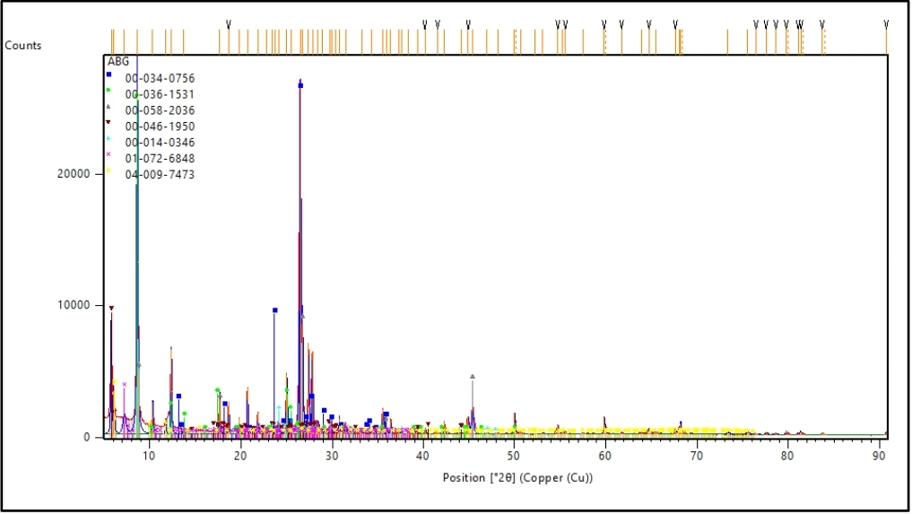

**Figure 2-** Peak pattern showing the composition of various minerals present in the soil sample with respect to their reference code (soil mineral composition)

**4.3.1 Impacts of minerals on soil properties**

Out of all the minerals obtained from X-Ray Diffraction, Quartz, Zeolite and Muscovite are dominant and have major impacts on the properties of soil from the point of view of civil engineering. Whereas, Magnesium Aluminium Silicate, Potassium Benzenesulphonate and Ajoite have minor impacts on soil engineering properties which can be ignored if present in smaller quantity. Potassium Chromium Oxide and Anthralin are important from the point of view of crop production and Agronomy and does not have major impact on soil properties from engineering point of view.

**4.3.1.1 QUARTZ** – Its compound name is Silicon Oxide bearing chemical formula SiO2 .This mineral is very compact and known for its hardness since 16th century possessing a hardness of 7 on Mohr’s Hardness Scale. Formation of quartz has been explained below by a schematic diagram (Bowen’s Reaction Series)

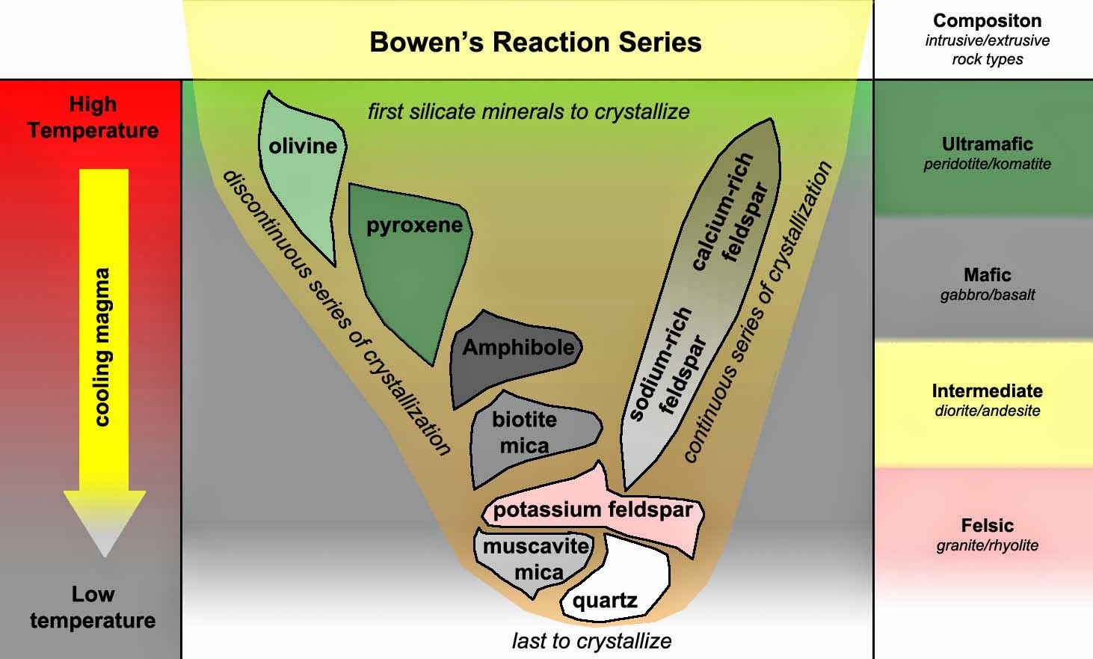

**Figure 3** – Formation of Quartz and Muscovite (Bowen’s Reaction Series)

It clearly shows that quartz is crystallized in the bottom with other two minerals at earth’s surface temperature and pressure where they are closer to their normal fields of stability. At surface temperature, quartz is completely stable and hence is the most resistant mineral on the earth’s atmosphere which reveals its suitability from the point of view of civil engineering.

**4.3.1.2 MUSCOVITE** –It is the next stable mineral obtained from Bowen’s Reaction Series. It is a hydrated phyllosilicate mineral of aluminium and potassium bearing chemical formula KAl2(Si,Al)4O10(OH)2 and possessing a hardness of 2 to 2.5 which is equivalent to the hardness of a finger nail according to Mohrs Hardness Scale. This mineral exhibits a sheet structure where the sheets are elastic and bonded very weakly parallel to each other and thus possesses slippage and swelling along its plane. It is resistant when present in optimum quantity but greater quantity of this mineral in soil is not suitable from engineering point of view as this decreases the maximum compacted density, compressive and shear strength, bearing capacity and CBR of soil.

**4.3.1.3** **ZEOLITE –** It is a resistant mineral bearing chemical formula K7Ca8Al23Si25O96 and possessing a hardness of 3 to 5 according to Mohs Scale of Hardness. Zeolites in soil improves soil composition, physical as well as chemical properties of soil and minimizes environmental pollution by offering environment friendly puzzolana substitute due to which soil possesses durability, strength, increased total porosity, reduced bulk density, weather resistance and also resistant to high temperature. Zeolites are described as the natural saviour of soil to maintain its quality due to its higher specific surface area, internal void structure and higher moisture holding capacity and thus this mineral is reliable from engineering point of view. Sediment collected contains zeolite in abundance.

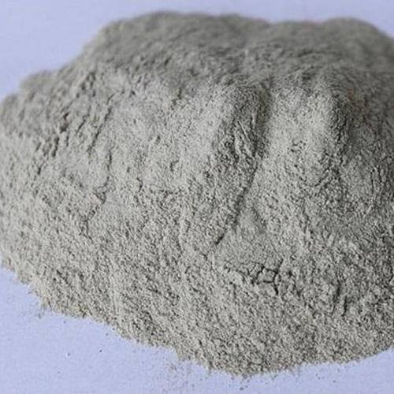

**Figure 4** – Zeolite

**4.3.1.4** **MAGNESIUM ALUMINIUM SILICATE –** It bears the chemical formula MgO.Al2O3.SiO2. Presence ofthis mineral in the sediment provides it with high compressive strength and thermal stability (resistant to temperature).

**4.3.1.5** **POTASSIUM BENZENESULPHONATE –** It bears the chemical formula C6H5KO3S. When the content of this mineral in the sediment exceeds optimum content, it affects the physico-chemical and biological properties of soil including the stability of soil aggregates.

**4.3.1.6 AJOITE –** This is a compact and resistant mineral of hydrated sodium potassium copper aluminium silicate hydroxide bearing chemical formula K2NaCu20Al3Si29O76(OH)16(H2O)8. Despite being a resistant mineral, the mineral possesses swelling property when its composition is more in the soil.

**4.3.1.7 POTASSIUM CHROMIUM OXIDE** – It bears chemical formula K2Cr2O7. Presence of this mineral in soil provides thermal stability and improves the water retention capacity of soil. This mineral is mainly important from the point of view of agronomy and crop production.

**4.3.1.8 ANTHRALIN -** It bears chemical formula C14H10O3. Presence of this mineral in soil have negligible impact on the soil properties from the point of view of civil engineering.

**5. CONCLUSION**

The prime objective of the study was to gather a brief knowledge on the mineralogical composition of the deposited sediments of a particular location which have a major imoact on the behaviour of sediments and ensures its stability and adaptability in the field of civil engineering. The soil sample taken for the study was found to be silty and revealed the composition of 85.2% silt, 14.5% clay and 0.29% sand .XRD analysis that was performed gave a graphical representation of the minerals present in the sediments and it also revealed the presence of dominant minerals which are responsible and have major impacts on soil properties. Also, the minerals present in abundance are well described and their effects on the sediment properties were studied. On the basis of the study, the adaptability of sediments for light construction such as subgrade material in construction of rural roads with low traffic laod, subgrade material in village roads can be ensured. Also it calls for improvement of sediments using different methods of stabilization to ensure durability to be used for other purposes in the field of civil engineering.

**ACKNOWLEDGEMENT**

I would like to express my deepest gratitude and sincere thanks to my respected guide Mr Bhaskar Jyoti Das, Associate Professor, Department of Civil Engineering, Assam Engineering College for his constant guidance, constructive suggestions, kind support and full cooperation throughout the study. I am grateful to respected Sasanka Borah Sir, Assistant Professor, Department of Civil Engineering, Assam Engineering College for helping me gather enough knowledge on using the digital equipments and respected Dr Anindita Bhattacharjee Ma’am for her kind support and suggestions throughout performing the XRD analysis. I am thankful to the concerned authorities of the Geology Department and Department of Instrumentation & USIC of Gauhati University for granting me the permission and supervising me to perform XRD analysis. Also I am thankful to laboratory staff and bearers of Civil Engineering Department, Assam Engineering College for cooperating whenever necessary. Lastly, I am indebted a lot to my parents for their whole hearted moral support and constant encouragement throughout the entire journey.

**REFERENCES**

[1] Alam Singh and G. R. Chowdhary, (2014), 2nd edition, Volume 2, “Geotechnical Testing and Instrumentation”, CBS

Publishers and Distributors Pvt. Ltd. ,ISBN – 13.

[2] Alam Singh, fourth edition, Volume – 1, “Soil Engineering in Theory and Practice”, CBS Publishers & Distributors Pvt.

Ltd. New Delhi.

[3] Dipak Sarkar and Abhijit Haldar (2010), 2nd edition “Physical and Chemical Methods in Soil Analysis”, New Age

International Publishers.

[4] Dr. B. C. Punmia, Er. Ashok K. Jain and Dr. Arun K. Jain. (2005), 16th edition, “Soil Mechanics and Foundations”, Laxmi

Publications, New Delhi.

[5] Dr. Satyendra Mittal, (2013), 1st edition, “An Introduction to Ground Improvement Engineering”, Medtech Publishers,

Scientific International Pvt. Ltd.

[6] Ganpat Louhar et al. (2020), “Zeolites : A potential source of soil amendments to improve soil properties”, Chemical

Science Review and Letters, DOI: 10.37273/chesci.CS205108196, ISSN 2278-6783.

[7] Gopal Ranjan and A S R Rao. (2000), revised 2nd edition, “Basic and Applied Soil Mechanics”, New Age International

Publishers, New Delhi.

[8] IS: 1498 – 1970; Indian Standard Classification and Identification of Soils for General Engineering Purposes; UDC

624.131.2.

[9] IS: 2720 (Part 4) – 1985; Indian Standard Method of Test for Soils; Grain Size Analysis; UDC 624.131.431.6.

[10] Jakkula VS, Wani SP (2018), “Zeolites : Potential soil amendments for improving nutrient and water use efficiency and

agriculture productivity”, Scientific Reviews and Chemical Communications, Volume 8, ISSN : 2277-2669.

[11] Nagesh P.C. and M.T. Maruthesha Reddy (2018), “Textbook of Geology for Engineers”, Medtech Publishers, Scientific

International Pvt. Ltd.

[12] R. K. Rajput (2000), revised 3rd edition, “Engineering Materials”, ISBN : 81-219-1960-6, S.Chand Publications.

[13] Satyendra Mittal and J.P. Shukla, 2014 edition, “Soil Testing for Engineers”, Khanna Publishers, New Delhi.

[14] Shamsher Prakash and Purushottam Kumar Jain, (2002), fourth edition, ISBN 81-85240-70-1, “Engineering Soil Testing”,

Published by Nem Chand & Bros, Roorkee Press, Roorkee.