**SMART COVID SCREENING AND ATTENDANCE SYSTEM**

**B. Jenefa1, S. Nabila2**

1Assistant Professor, Computer Science and Engineering, Rajas Institute of Technology, Nagercoil, Tamilnadu, India

2Pursuing Final Year ME, Computer Science and Engineering, Rajas Institute of Technology, Nagercoil, Tamilnadu, India

**ABSTRACT**

Due to the breakdown of COVID-19 pandemic also known as Serious Acute Respiratory Syndrome Corona virus-2 is an infectious disease that is released from an infected sick person. This spreads quickly through close contact with anyone infected. Institutions suffer a great deal from practically closed globally if the current situation is not going to change. Finger print dates are stored in the database at the registration process. Deep Learning has proven its effectiveness in recognition and classification through image processing. The research study uses deep learning techniques in distinguishing facial recognition and recognize if the person has follows the covid rules, the body temperature. The system develops a real-time monitoring and recognition the person wearing mask, temperature and finger print attendance system.

**Keywords:** Finger Print, Mask detection, Temperature

1. **INTRODUCTION**

Attendance plays more important role in student’s academic performance. Almost all the universities and educational institutions pose strict rule based on attendance. Student has to maintain said percentage of attendance to take end exam. Calling individual student’s name and marking his/her presence is common. The problem with this method is it takes time to call each and every student. Another problem is authentication, where a student can answer for his friend’s roll call.

1. **METHODOLOGY**

In this project we are using machine learning used to analyzing the face and also recognize the person following covid guidelines It read the camera data and analysis the data and find the personal is wearing mask NodeMCU micro controller is used for connecting the system to cloud and also used to detect the temperature After getting the signal that the person follows the covid guidelines the finger print sensor is activated and attendance is registered in google sheet. Contactless attendance marking and thermal screening system is designed using the concepts of IoT, Machine Learning and Artificial Intelligence. The entire system is divided into four major modules: Object’s proximity module, face recognition module accordingly, whenever student comes to attend class, he has gone with automatic attendance marking system. The temperature sensor module finds the distance of the student from the device. If it is within the specified range then image will be captured and compared with stored information. Once the student’s face is recognized temperature will be read using thermal sensor and student’s details like identity, timestamp and temperature will be recorded. It will continue to scan next student. In case some unknown person tries to enter into the class.

**2.1 Algorithm used and its performance**

Haar Cascade classifiers are an effective way for face detection. This method was proposed by Paul Viola and Michael Jones in their paper Rapid Object Detection using a Boosted Cascade of Simple Features Haar Cascade is a machine learning-based approach where a lot of positive and negative images are used to train the classifier. As the overall detection ratios of such a cascade are multiplicative, the accuracy stays close to 100%, while the number of FP is reduced greatly. By using the combination of both our face and our regionalized eyes detector we were able to fully automatically detect eyes in 94% of images still keeping the value losses of 13% By applying minimum neighbors’ constraint solely to the eyes detector the accuracy of 88% was achieved.

**2.2 Face Detection**

In computer vision, one essential problem we are trying to figure out is to automatically detect objects in an image without human intervention. Face detection can be thought of as such a problem where we detect human faces in an image. There may be slight differences in the faces of humans but overall, it is safe to say that there are certain features that are associated with all the human faces. There are various face detection algorithms but Viola-Jones Algorithm is one of the oldest methods that is also used today and we will use the same later in the article. You can go through the Viola-Jones Algorithm after completing this article as I’ll link it at the end of this article.

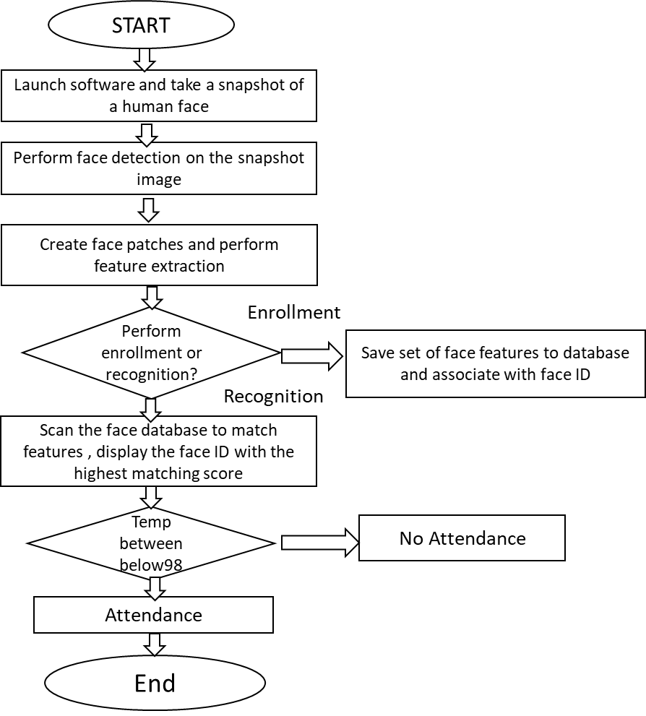

**Figure 1:** Face Detection Architecture Diagram

1. **MODELING AND ANALYSIS**

We are using computer and machine learning to analyzing the face and also recognize the person following covid guidelines. Computer is used read the camera data and analysis the data and find the facial detection. Arduino controller is used to get the data from the computer and send signal to the NodeMCU micro controller is used for connecting the system to cloud and also used to detect the temperature. Using google sheet database the data are stored in the cloud.

**3.1 System Architecture**

**Figure 2: System Architecture**

* 1. **Power Supply**

There are many types of power supply. Most are designed to convert the Voltage AC Mains electricity to a suitable low voltage supply for electronic Circuits and other Devices. A power supply can by broken down into a series of blocks, each of which performs a particular function. Here the AC supply main is given to the step-down transformer. The transformer having the different voltages. The output from the transformer is given to the rectifier circuit. In this rectifier circuit the AC voltage is converted to DC voltages. The rectified DC voltage is given to the regulator circuit. The output of the regulator is depends upon the regulator IC chosen in the circuit.

* 1. **Temperature Sensor**

A temperature sensor is a device used to measure temperature. This can be air temperature, liquid temperature or the temperature of solid matter. There are different types of temperature sensors available and they each use different technologies and principles to take the temperature measurement. Temperature sensors are used to measure temperature in many different applications and industries. They are all around us; present in both everyday life and more industrial settings. A temperature sensor is an electronic device that measures the temperature of its environment and converts the input data into electronic data to record, monitor, or signal temperature changes. There are many different types of temperature sensors. Some temperature sensors require direct contact with the physical object that is being monitored (contact temperature sensors), while others indirectly measure the temperature of an object. Among the contact temperature sensors are thermocouples and thermistors.

* 1. **Buzzer**

Buzzer is a kind of voice device that converts audio model into sound signal. It is mainly used to prompt or alarm. According to different design and application, it can produce music sound, flute sound, buzzer, alarm sound, electric bell and other different sounds. Typical applications include siren, alarm device, fire alarm, air defense alarm, burglar alarm, timer, etc. It is widely used in household appliances, alarm system, automatic production line, low-voltage electrical equipment, electronic toys, game machines and other products and industries. An audio signaling device like a beeper or buzzer may be electromechanical or piezoelectric or mechanical type. The main function of this is to convert the signal from audio to sound. Generally, it is powered through DC voltage and used in timers, alarm devices, printers, alarms, computers, etc. Based on the various designs, it can generate different sounds like alarm, music, bell & siren.

* 1. **Liquid-Crystal Display**

A liquid-crystal display (LCD) is a flat-panel display or other electronically modulated optical device that uses the light-modulating properties of liquid crystals. Liquid crystals do not emit light directly, instead using a backlight or reflector to produce images in color or monochrome. LCDs are available to display arbitrary images (as in a general-purpose computer display) or fixed images with low information content, which can be displayed or hidden, such as present words, digits, and 7-segment displays, as in a digital clock. They use the same basic technology, except that arbitrary image are made up of a large number of small pixels, while other displays have larger elements. LCDs are used in a wide range of applications including LCD televisions, computer monitors, instrument panels, aircraft cockpit displays, and indoor and outdoor signage. Small LCD screens are common in portable consumer devices such as digital cameras, watches, calculators, and mobile telephones, including smartphones. LCD screens are also used on consumer electronics products such as DVD players, video game devices and clocks. LCD screens have replaced heavy, bulky cathode ray tube (CRT) displays in nearly all applications. LCD screens are available in a wider range of screen sizes than CRT and plasma display, with LCD screens available in sizes ranging from tiny digital watches to huge, big-screen television sets.

1. **RESULTS AND DISCUSSION**

**4.1 Face Recognition**

Many face recognition methods have been reported in the literature. Also, many face databases and face recognition methodologies are available to test them. Unfortunately, most authors test their methods using restricted databases, or random subsets of them. This does not facilitate the comparison of the methods. In this paper we propose an evaluation methodology that utilizes three publicly available databases and an evaluation protocol that offers numerous splits of the images between training and testing images. We also evaluate many different face recognition methods using our methodology, offering a comparison between them.

**4.2 IMUTILS**

A series of convenience functions to make basic image processing functions such as translation, rotation, resizing, skeletonization, displaying Matplotlib images, sorting contours, detecting edges, and much easier with OpenCV.

**4.3 Pickle**

Pickle is a project to integrate [continuous testing](https://en.wikipedia.org/wiki/continuous_testing) into an environment for [continuous integration](https://en.wikipedia.org/wiki/continuous_integration), like [Wikipedia](https://meta.wikimedia.org/wiki/Wikipedia) which use [Lua-scripts](https://en.wikipedia.org/wiki/Lua_(programming_language)). Within Wikipedia Lua is used to implement advanced templates, and the same solution is used on a lot of other websites and projects. Continuous integration is a core element of [continuous deployment](https://en.wikipedia.org/wiki/continuous_deployment), which is very important for sites that must be up and running 24×7. Pickle use spec-style testing, which can be described as a variant of [unit testing](https://en.wikipedia.org/wiki/Unit_testing), or how to make the thing right. Later on, Pickle might be extended with step-style testing, or how to build the right thing. What to build, and how to build it, is not the only important thing.

**4.4 Time**

Software testing is performed to detect and help correct errors in computer software. Testing involves ensuring not only that the software is error-free but that it provides the required functionality to the user. Static and conventional methods of testing can detect bugs, but such techniques may not ensure correct results in real time software systems. Time software systems have strict timing constraints and have a deterministic behavior. These systems have to schedule their tasks such that the timing constraints imposed on them are met. Conventional static way of analysis is not adequate to deal with such timing constraints, hence additional real-time testing is important.

**4.5 OpenCV**

OpenCV-Python is a library of Python bindings designed to solve computer vision problems.cv2.imread() method loads an image from the specified file. If the image cannot be read (because of missing file, improper permissions, unsupported or invalid format) then this method returns an empty matrix. OpenCV is the huge open-source library for the computer vision, machine learning, and image processing and now it plays a major role in real-time operation which is very important in today’s systems. By using it, one can process images and videos to identify objects, faces, or even handwriting of a human. When it integrated with various libraries, such as NumPy, python is capable of processing the OpenCV array structure for analysis. To identify image pattern and its various features we use vector space and perform mathematical operations on these features.

1. **CONCLUSION**

There are many loopholes in the process of taking attendance using the old method which caused many troubles to most of the institutions. Therefore, the facial recognition feature embedded in the attendance monitoring system can not only ensure attendance to be taken accurately and also eliminated the flaws in the previous system. In covid times the temperature monitoring also an important guideline to reduce the covid spread the project make sure both the temperature and facial recognition for effective attendance management.

1. **REFERENCES**

[1] United Nations, “Goal 3 | Department of Economic and Social Affairs,” Accessed on July 10, 2020. [Online]

[2] World Health Organization, “WHO | Sustainable Development Goal 3: Health,” Accessed on July 10, 2020. [Online]

[3] J.H. Hardie, and N.S. Landale, “Profiles of Risk: Maternal Health, Socioeconomic Status, and Child Health”, Journal of marriage and the family vol. 75,3 (2013): 651-666. doi:10.1111/jomf.12021

[4] World Health Organization, “Every Newborn: an action plan to end preventable deaths,” WHO, 2014.

[5] H. Rashid, M.Kagami, F. Ferdous, E. Ma, T. Terao, T. Hayashi, Y. Wagatsuma, "Temperature during pregnancy influences the fetal growth and birth size" Trop. Med. Health 45, 1 (2017). https://doi.org/10.1186/s41182-016-0041-6

[6] G. Tadele and A. Wasie, “Correlates of maternal mortality in developing countries: an ecological study in 82 countries,” Maternal health, neonatology and perinatology vol. 3 19. 7 Nov. 2017, doi:10.1186/s40748-017-0059-8

[7] Dynamed. “COVID-19 and Pregnant Patients,” Accessed on July 10, 2020. [Online]. Available: https://www.dynamed.com/condition/covid-19- and-pregnantpatients

[8] Health Resources & Services Administration, “Medically Underserved Areas and Populations (MUA/Ps)”, May 2020. Accessed on July 10, 2020. [Online]

[9] D. Goodridge and D. Marciniuk, “Rural and remote care: Overcoming the challenges of distance,” Chronic respiratory disease vol. 13,2 (2016): 192-203.doi:10.1177/1479972316633414

[10] Vinoth Kumar, Akash Ravishankar, A.Karan, K.Vishal and J.Aanandha Praseeth Kumar, “A smart public transportation system for reliable and hassle free conveyance in sustainable smart cities” International Conference on Computer Communication and Informatics, June 2020 [4] S. Vigneshwaran, K. Raghul; B. Nivas; V.M. Kishore, “Design of Bus Tracking and Fuel Monitoring System”, 6th International Conference on Advanced Computing and Communication Systems , April 2020.