**MULTI MODAL MEDICAL IMAGE FUSION USING NON-SUB SAMPLED ROTATED COMPLEX WAVELET TRANSFORM**

Syed Munawwar1, S. Sree Navya 2, P. Basanthi 3, P. Supriya4, B. Lakshmi Sahithi5

Department of ECE1,2,3,4,5, Santhiram Engineering College, Nandyal, AP, India

***Abstract*—** The multimodal medical image fusion technique is a current research issue in the fields of medical imaging and radiation medicine, and it is generally known in the medical and engineering fields. A multimodality medical image fusion technique is extremely important in biomedical research and disease analysis. The process of combining relevant information from two or more images into a single image is known as image fusion. In this project, we use images from Computed Tomography (CT) and Magnetic Resonance Imaging (MRI) of the same patient to better visualise tumours using feature based Fusion of CT and MRI. This paper presents a unique approach to Multimodality Medical Image Fusion (MMIF), a technique for combining CT and MRI data from the same patient into a new slice using a Non-sub sampled Rotated Complex Wavelet Transform (NSRCxWT) and Discrete Wavelet Transform (DWT). The forward NSRCxWT and DWT are applied separately to CT and MRI images to extract complementary and edge related features. Using Average and Maximum value selection fusion rules, these features are then combined to form a composite spectral plane. The inverse transformation is then applied, resulting in a new, visually enhanced, and enriched fused image. The objective and subjective evaluation metrics are used to evaluate the quality of these fused images.

***Index Terms*—**Medical images**,** Non-sub sampled Rotated Complex Wavelet Transform (NSRCxWT)**,** Discrete Wavelet Transform (DWT),CT, MRI, image fusion.

**I. INTRODUCTION**

Image fusion is the combination of two or more different images to form a new image using different techniques [1]. It is Extracting information from multi-source images. It improves the spatial resolution for the original multi-spectral image and preserves the spectral information. Image fusion can be done in three levels: Pixel level fusion, Feature level fusion and Decision level fusion. Pixel-level fusion having a large portion of the remarkable data is protected in the merged image. Feature-level fusion performs on feature-by-feature origin, such as edges, textures. Decision-level fusion refers to make a final merged decision. The image fusion decrease quantity of information and hold vital data. It make new output image that is more appropriate for the reasons for human/machine recognition or for further processing tasks. Image fusion is a sub-field of image processing in which more than one image are fused to create an image where all the objects are in focus. Image fusion is most significant importance due to its application in medical science, forensic and defense departments. Image fusion process is performed in multi-sensor and multi-focus images of the same scene [4]. Multi-sensor images of the same are captured by different sensors where multi-focus images are captured by the same sensor. In multi-focus images, the objects in the scene which are closer to the camera are in focus and the farther objects get blurred. Multi-sensor images of the same scene are captured by different sensors where as multi-focus images are captured by the same sensor. In multi-focus images the objects which is present are closer to the camera and farther objects are get blurred. In opposite direction when the farther objects are focused then closer objects get blurred in the image. To achieve an image where all the objects are in focus, the process of image fusion is performed either in spatial domain or transformed domain. Spatial domain includes the techniques which directly incorporate the pixel values. In transformed domain includes the images are first transformed into multiple levels of resolutions. An image frequently contains physically relevant features at many different scales or resolutions. Multi-scale or multi-resolution approaches provide a means to exploit this fact. After applying certain operations on the transformed images, the fused image is created by applying inverse transform. Computed Tomography (CT) image can display accurate bone structures. Magnetic Resonance Imaging (MRI) image can reveal normal and pathological soft tissues. The fusion of CT and MRI images can integrate complementary information to minimize redundancy and improve diagnostic accuracy. Combined PET/MRI imaging can extract both functional information and structural information for clinical diagnosis and treatment [3].

**II. REVIEW OF EXISTING FUSION TECHNIQUES**

Image fusion integrates appropriate information from various modalities of input images into a fused distinct image of the same prospect that contains vital information features of the unique image where a human can use it more conveniently [3]. In many medical applications, image fusion is used as the most significant tool for the interpretation of the quality of images and to verify whether the data acquired through this is either functional or having high spatial resolution. Typically, MRI image shows structural information of the brain without any functional data, where as PET image describes functional information of the brain but with less spatial resolution. Therefore, image fusion is conceded to improve functional image’s spatial resolution through which original functional characteristics is preserved [4] with no spatial distortion.

Wavelet based fusion scheme satisfies the requirement quite well due to the advantages of wavelet analysis. A technique for fusing CT- MRI image using wavelet and spatial frequency method is proposed which eliminate the influence of image imbalance[5]. This method reduced blur effect, improved the clarity which is useful for clinical diagnosis. The result analysis indicated that this method is comparatively better than the conventional algorithm based on PCA in terms of good visual & quantitative fusion results. It is necessary to preserve the prominent features in source images and should not initiate for any artifacts which would distract the human observer.

In image fusion has become a common term used in medical diagnostics and treatment. The term is used when multiple images are registered and overlaid or merged to provide additional information. Fused images may be created from multiple images from the same imaging modality or by combining information from multiple modalities such as magnetic resonance image (MRI), computed tomography (CT), positron emission tomography (PET) and single photon emission computed tomography (SPECT). In radiology and radiation oncology, these images serve different purposes. For example, CT images are used more often to ascertain difference in tissue density while MRI images are typically used to diagnose brain tumors.

**III. FUSION ALGORITHM**

The multi resolution algorithm has been widely used in the field of image fusion. The wavelet transformation-based fusion algorithm will provide better fusion performance, and the loss of the origin edge of information is caused by the filter function by high pass and low pass in the wavelet decomposition or reconstruction. In addition, the operation of traditional wavelet transform takes a long time and needs large memory capacity and this is not suitable for a real-time systems. To obtain the better effective image in the fusion image information we use NSRCxWT. The multi sensor image fusion algorithm based on wavelet and multi wavelet is proposed after considering the image fusion quality and speed. The simulation and experimental results gives the merged image using the fusion method is suitable for the human vision features. In comparison with the original image the entropy, mean, standard deviation, MSE, PSNR values gives more clarity image.

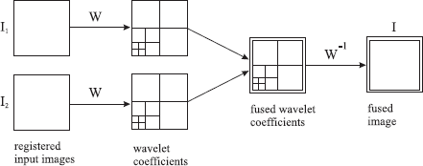

Fig.1**:** Fusion of the wavelet transforms of two images

**IV. METHODOLOGY**

The system architecture of the proposed method is shown in Fig.1.

Here, MRI and CT images are taken as its input for preprocessing and fusion. PET image is firstly decomposed into its Intensity Hue Saturation (IHS) transform and thus the information of high activity region is differentiated from the low activity region of PET image by making use of “hue angle” obtained from the IHS transform. After preprocessing, the quality of the input PET image is enhanced by Gaussian filters. The enhanced image is then fused based on Discrete Wavelet Transform (DWT) for brain regions with different activity levels[7].Then we combine low frequency coefficients of MRI and PET images and perform the inverse DWT to obtain the fused result for the fused low frequency output. Similarly by combining high frequency coefficients of PET and MRI images into a complete set of wavelet coefficients and performing the inverse DWT, we can obtain the fused result for the high activity region.

**V. PROPOSED TECHNIQUE**

Multimodality Medical Image Fusion (MMIF) involves [2] basic three steps-image modalities, image registration followed by feature based fusion, and the performance evaluation as shown in Fig.2.

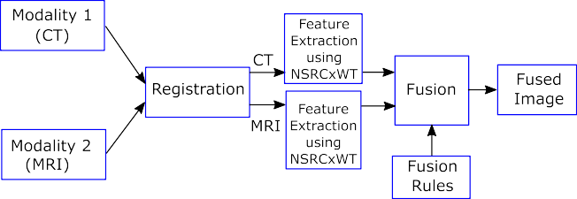

Fig.2: Block Schematic of Multimodality Medical image fusion using NSRCxWT method.

Two or more modality images are used as the source images. These source images are co-registered using registration algorithm. The medical image registration is a trivial problem due to non-similarity of the representations in CT and MRI. The acquisition process and devices are different, so the source images vary in orientation, structural presentations, and spatial resolution.

Fig.2: Block Schematic of Multimodality Medical image fusion. However, these images complement each other regarding anatomical structures. In this method, CT and MRI images are observed by overlapping on each other in all three views ( sagittal ,axial and coronal) and simple geometric transformation techniques which include scaling, rotation, panning, shifting, etc. are applied to bring them into voxel alignment. The effectiveness of fusion algorithms is very much dependent on the precise image registration. In the feature based fusion, the feature extraction technique is used to separate the salient information from input images, and these features are combined to create a new image. The visual quality and its appropriateness for diagnosis or stage evaluation are measured using the subjective and the objective evaluation criteria. The next few subsections deal with the principle and design of proposed Non-Sub sampled Rotated Complex Wavelet Transform.

Fig.2 Non-Sub Sampled Rotated Complex Wavelet Transform (NSRCxWT) Non-Sub sampled rotated complex wavelet transform (NSRCxWT) is a modified version of rotated complex wavelet filters (RCWF) [9, 10]**.**

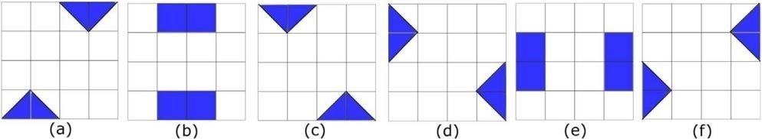

Fig.3: Fourier spectrum of 2D NSRCxWT filter kernels presenting orientations in (a) −30○, (b) 0○, (c) 30○, (d) 60○, (e) 90○, (f) −60○

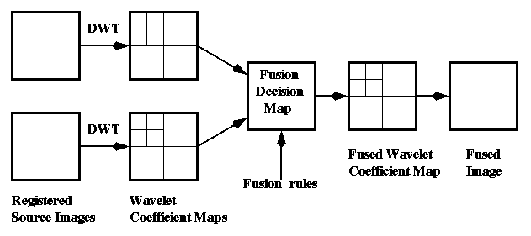

Fig.4:Block Schematic of Multimodality Medical image fusion using DWT method.

In this technique the image is segmented into bands using wavelet transform, the segmented image is then fused into sub bands using curvelet transform which breaks the bands into overlapping tiles and efficiently converting the curves in images using straight lines. These tiles are integrated together using inverse wavelet transform to produce a highly informative fused image.

**As proposed MMIF system combines the features** of CT and MRI images and creates new single images, redundancy of the feature coefficients is not an issue. Therefore, 2D down sampling in analysis and 2D up sampling in synthesis are eliminated to obtain non-sub sampled filtering. However, NSRCxWT and DWT also provides other benefits like shift invariance, multiscale decomposition, and multidirectionality. As source modalities (CT and MRI) are abundant in the edge content, it supports in the efficient feature extraction with the help of oriented 2D filters.

NSRCxWT along with DTCWT provides feature extraction in twelve directions. NSRCxWT filter coefficients also exhibit the same orthogonality property of DWT and DTCWT. It consists of wavelet functions in tree ‘a’ (real part) and tree ‘b’ (imaginary part) which are Hilbert pair of each other. This property helps in the design of directional, non separable 2D wavelet filter coefficients using two separable standard wavelet coefficients. The scaling function ϕ(m) and wavelet function ψ(m) for one tree and ϕ(n), ψ(n) for another tree are used to design DTCWT kernels which are highly oriented. These filter coefficients Multimodal Medical Image Fusion Using NSRCxWT Dept. of ECE Page 30 are determined using Eq. (10).

**VI. DISCUSSION OF RESULTS**

The MATLAB software was used to implement in this paper, "Multi Modal Medical Image Fusion Using Non-Sub Sampled Rotated Complex Wavelet Transform ". It has been successfully tested with fused images.

**DISCUSSION**

Performance evaluation of image fusion can be divided into subjective evaluation and objective evaluation. Objective evaluation is determined according to statistical parameters like mean, standard deviation. The subjective evaluations are concluded according to visual effects and some parameters are the entropy, image definition etc. Here some standard performances like entropy, mean, standard deviation, Fusion Factor, Fusion Symmetry, IQI and SSIM are determined.

**RESULTS**

One identical image is taken, one CT image, and one MRI image. Whenever integrating these two images by using Non sub sampled Rotated Complex Wavelet Transform and it is observed for performances of fused image. By using another four methods i.e., PCA, DWT, Stationary Wavelet Transform and Dual Tree Complex Wavelet Transform, we performed medical image fusion and observed performances. By using MATLAB the parameters like entropy, mean, standard deviation, Fusion factor, Fusion Symmetry, IQI and SSIM for five methods are found.

* + 1. **Image Fusion by NSRCxWT**

The better enriched and fused image done by NSRCxWT method is given in Fig 5. This is better quality image compared to remaining.

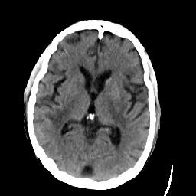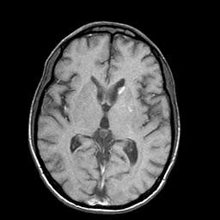

**Fig 5:** Input CT and MRI Image

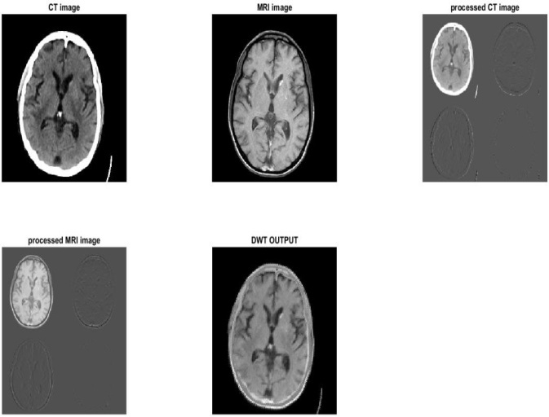

**Fig 6:** Image Fusion by DWT method

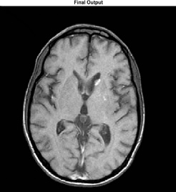

**Fig 7:** Image Fusion by NSRCxWT method

**CONCLUSION & FUTURE SCOPE**

Multimodality medical image fusion is an effective process useful in diagnosis, analysis of stages of the disease, and treatment review in neuro cysticercosis. The experimental results exhibit the effectiveness of the proposed fusion algorithm as per the subjective and the objective evaluation metrics when compared with existing wavelet based fusion algorithms. The subjective quality of the fused images using NSRCxWT is much better than that of the source modalities as well as the fused images using other wavelet based techniques. The fused images using NSRCxWT show the best of the significant structural content from CT and MRI with the least distortion. The visualization of the lesions for their number, location, and stage of disease are better seen in the fused images than that of the source modalities. The proposed technique also provides superior performance metrics over the state of the art wavelet based multimodality medical image fusion algorithms.

The future work will focus on the following areas: firstly, the experimentation on larger study sets can be performed to measure the robustness of the proposed algorithm and its effectiveness for diagnosis and analysis.

**REFERENCES**

[1] S.S. Chavan, S.N. Talbar, Multimodality image fusion in frequency domain for radiation therapy, in: IEEE International Conference on Medical Imaging, m- Health and Emerging Communication Systems (MedCom), Noida, UP., India, IEEE, 2014, pp. 174–178.

[2] S.S. Chavan, S.N. Talbar, Multimodality medical image fusion using M-band wavelet and Daubechies complex wavelet transform for radiation therapy, IGI Global: Int. J. Rough Sets Data Anal. (IJRSDA) under Special Issue on Medical Image Mining for Computer Aided Diagnosis 2 (2015) 1–23.

[3] M. Kokare, P.K. Biswas, B.N. Chatterji, Texture image retrieval using new rotated complex wavelet filters, IEEE Trans. Syst. Man Cybern.-Part-B:cybernetics 35 (2005) 1168–1178.

[4] Syed Munawwar, K.Sampath Kumar-Basic Intensity Transformations in image processing using MATLAB, JETIR,Jan-2019,Volume 6, Issue 1, ISSN (Online) : 2359 – 5162.

[5] Y. Yang, D.S. Park, S. Huang, N. Rao, Medical image fusion via an effective wavelet- based approach, EURASIP J. Adv. Signal Process. 2010 (2010) 13 Article ID 579341.

[6] S. Rajkumar, S. Kavitha, Redundancy discrete wavelet transform and contourlet transform for multimodality medical image fusion with quantitative analysis, in: Third International Conference on Emerging Trends in Engineering and Technology, Goa, India, IEEE Computer Society, 2010, pp. 134–139.

[7] S.S. Chavan, A. Pawar, S.N. Talbar, Multimodality medical image fusion using rotated wavelet transform, in: International Conference on Communication and Signal Processing (ICCASP), Lonere, Maharashtra, India, 2016, accepted.

[8] A. Eskicioglu, P.S. Fisher, Image quality measures and their performance, IEEETrans. Commun. 43 (12) (1995) 2959–2965. Multimodal Medical Image Fusion Using NSRCxWT

[9] M. Kokare, P.K. Biswas, B.N. Chatterji, Rotation-invariant texture image retrieval using rotated complex wavelet filters, IEEE Trans. Syst. Man Cybern. Part- B:cybernetics 36 (2006) 1273–1282.

[10**]** Syed Munawwar -Fusion of MRI and PET Images using DWT,IJEIR Sept-2017,Volume 6, Issue 5, ISSN (Online) : 2277 – 5668.

[11] Bhavana V., Krishnappa H.K., Multi-modality medical image fusion using discrete wavelet transform, in: Fourth International Conference on Eco-friendly Computing and Communication Systems, ICECCS-2015, Kururkshetra, Haryana, India, vol. 70, Elsevier, 2015, pp. 625–631.