**A STUDY OF SUSTAINABLE DEVELOPMENT WORK TO ASSURE WATER MANAGEMENT IN KERWAJAT**

**Kamlesh Kurmi1, Vikram Singh Kurmi2, Mithun Dabur3**

1Research Scholar, Departmet of Agricultural Engineering, Swami Vivekanand University, Sagar, MP, India

2Assistant Professor, Department of Agricultural Engineering, Swami Vivekanand University, Sagar, MP, India

3Head of Department, Swami Vivekanand University, Sagar, MP, India

**ABSTRACT**

The goal of the proposed project is to promote integrated water management practices through awareness, trainings, rainwater harvesting, groundwater recharge, water use efficiency and sanitation in five villages of Alwar district so that farmers income increase sustainably. The project will reach out to total 1,045 families and 6345 population through Sustainable Water Management and livelihoods This project has been multidisciplinary and the goal has been management of water and crop in the project villages. The emphasis has been that it should not only be conservation oriented but also should be production oriented. The purpose of the preparing this study was to understand and document the insights, needs aspirations and perspectives from the community on different development issues, particularly on WASH, land and water resources, women and children, livelihoods, and institutions affecting their lives.

**Keywords:** Sustainable, Livelihood, Harvesting, Precipitation and Deviation.

1. **INTRODUCTION**

In India and more particularly in the state of Rajasthan, 75% of the population lives in rural area. Most of them depend on natural resources like land, water, vegetation, and animals for their livelihood. Further, majority of the families in rural areas face the problem of poor access to basic needs like clean drinking water (CDW) and sanitation which makes them vulnerable and marginalized on account of various water-borne diseases. Women and children are the worse affected demographic group due to poor access to WASH facilities and practices which acts as a leading cause for child malnutrition, illness, and deaths in the country, more so in rural regions like Kerwajat Cluster (proposed project area). As a result, these factors culminate into poor human development outcomes like; poor participation in education, increase in family’s health care expenditure, loss of workdays, and thereby impels them into a vicious poverty .In rural areas, the primary source of livelihood for most families are agriculture and animal husbandry dependent highly on natural resources like land and water. Many of these livelihood practices particularly related to water resources are poorly managed, as a result they become highly vulnerable to climate induced weather or ecological variations. Likewise, in regions with plain alluvial terrains, natural resources like water and land are exploited and degrading and their productive capacity is reducing year by year. This results in increased input to support livelihood practices. Hence, circular approach and efficient management of natural resources through resource efficiency can enhance production the availability of water and productivity of soil, which will result in higher farm productivity and ensure sustenance for rural communities. The proposed project area, Kerwajat cluster at Ramgarh and Umarain block in Alwar district, Rajasthan is located in the eastern plain alluvial regions. It receives a moderate rainfall of 722mm annually, but is one of the highly groundwater dependent region in Rajasthan. This is because the terrain is a plain alluvial region, water percolation is good, soil is loamy and black cotton, water-logging is also commonly found in black soil regions. In region as such this, approach on efficient water utilization, water-saving, application of sustainable integrated farming system can aid water security and substantially reduce women’s drudgery in particular, ease living cost for families while conserving the local ecological system.

**2.METHODOLOGY**

The methodology adopted for the present study including the selection of the study area, sampling procedure, selection of the respondents, collection of data and various analysis used were discussed.

**2.1 Selection of the study area**

Kerwajat Cluster is situated in the central part of the district of Alwar and located 20-25 km from the district headquarter. The project area lies within the latitude of 27026’30” N to 27030’11” N and 76038’20” E to 73043’35” E longitude. The proposed project covers 5 villages which are part of 2 Gram Panchayats of Ramgarh and Umarain block. The villages are located in one cluster.

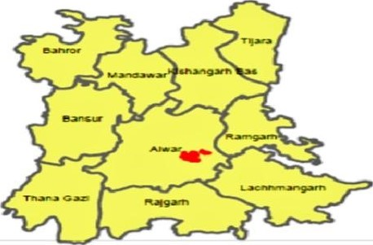

**2.2 Selection of respondents**

In selection of respondents from the households, households form a focal point of data collection and as such are a major source of socio-demographic data. Household surveys provide a cheaper alternative to full knowledge for timely data and are more relevant in understanding of the social and demographic issues. The baseline survey conducted of every HHs who is living inside villages.

**2.3 Data Collection**

The baseline and need assessment were mandated to collect data on some of the following indicator which was collected through primary and secondary data. The data was collected from individual HHs, government organization, social sites etc.

**Table 1.** Present and Project Population in proposed villages

|  |  |  |
| --- | --- | --- |
| Village Name | Families | Total population |
| Doomera | 280 | 1481 |
| Kakrali Jat | 111 | 664 |
| Kerwa Jat | 491 | 3069 |
| Nagla Charan | 80 | 606 |
| Nagli Rajawat | 83 | 525 |
| Total | 1045 | 6345 |

**3.MODELING AND ANALYSIS**

Mentioned points were analyzed in the following flow chart and then development work was done.

Institution Building around sustainable water management => Women as change agent for behavior change in WASH=>Optimizing land and water productivity=> Community managed system for SWM=>Technology for efficient water management=>Knowledge Management on SIFS=> Convergence for Groundwater recharge.

**4.RESULTS AND DISCUSSION**

This project has been multidisciplinary and the goal has been management of water and crop in the project villages.

**Table 2 .** Activity-Output table

|  |  |  |
| --- | --- | --- |
| **SN.** | **Activity** | **Output** |
| 1 | Awareness Training (Orientation and Formation of CBOs like VILLAGE LEVEL COMMUNITY INSTITUTIONS/GROUPS, Farmer's club, Women SHGs) | Community in project villages are organized and provided with relevant capacity building opportunities in the form of 10 CBOs (5 VILLAGE LEVEL COMMUNITY INSTITUTIONS/GROUPS and 5 SHGs) |
| 2 | Facilitate the theme of ICT based extension events like mobile bulk messaging | Nearly 1000 youth men and women are able to access knowledge on SWM related solutions |
| 3 | Pond  Deepening/Renovation | Project cluster have additional water harvesting to the tune of 10000Cum in terms of 3  ponds |
| 4 | Construction of Roof Rain Water Harvesting Structure (RRWHS) for drinking/domestic purpose (15000 liter capacity) | 400 household level RRWHS with storage capacity of 600 Ha-m and water harvesting potential of 1200 Ha-m (considering at least two cycle of water harvesting |
| 5 | Farm ponds (Size - 23meter x 17meter x 3 meter) - 1200 Cum Capacity | 10 number of Farm-ponds with 1.2 ha-m harvesting capacity |
| 6  7  8 | Roof Water harvesting for Hand-pump/bore/Open-well Recharge  Farm Bund (500 Cum/Farmer)  Promotion of mini sprinkler irrigation system | 50 number of recharge measures established at project villages  at least 50-acre land of 50 farmers protected against fast runoff  100-acre agriculture land of 100 families adopted water-efficient technology of mini-sprinklers |

The section presents major finding of the baseline survey and need assessment. The first part

discusses the general finding using qualitative data. This is followed by a presentation and

discussion on quantitative data collected through HHs and village level data.

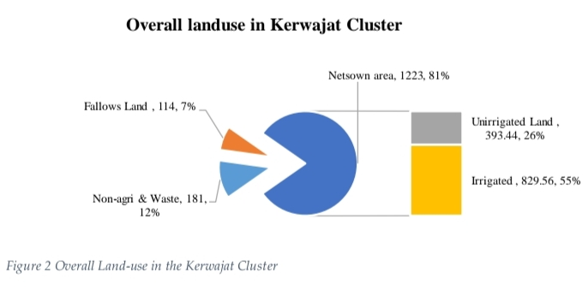

**5.CONCLUSION**

This section summarizes the problems faced by people of the project area that are determined through community consultations and baseline information. It provides the rationale behind taking up this project and specific interventions indicated in the same chapter. The project villages have many common problems regarding water management where negligible use of available resources in the cluster/watershed area for optimizing productivity with minimum hazards.

a) In the project villages water harvesting structures namely Nadi, Pond, anicut, Talai are very few. Except for Doomera, Kerwajat they do not have much water. Community also reflected that though these structures are deepened regularly under MNREGA, but they do not receive runoff to their present capacities because of lack of proper inflow to these structures.

b) In almost all villages no families use open wells and Hand pumps for drinking and cooking need. All villages are linked to GLR based and moderate depth tube-well based supply systems but mostly these supplies are defunct and non-operational.

c) Almost 90% of the Hand pumps are abandoned due to lowering of water-table, where ever deep bore wells are there they are fitted with electric motor or solar-pump operated, they have broken platforms. The community has reflected nearly all HP do not provide water now due to the limited depth and installed depth of pipes and cylinder assembly etc. Though, year-by-year depth of tube-wells, power of submersibles pumps, pumping hours, and cost of extractions is increasing but even than community considers that availability of water for drinking and irrigation is good, as they are able to get water from tube-wells (own, relatives or neighbors).

d) The farmers in the area mostly follow mono-cropping practices with Bajra & Cotton (Kharif) and Mustard & Wheat (Rabi), some farmers whose lands are in the waterlogging situation at Doomera and Nangali Rajawat do cultivate paddy (32 families cultivating 18 Hectare with average production of 31.7 Quintals/ha). This practice increases the vulnerability of farmers due to the chance of crop damage during an infestation of pests or weather extremities. Some people reflected that earlier this area used to produce multiple crops but now people do not grow not even for own consumption. All the main points of the research work are written in this section. Ensure that abstract and conclusion should not same. Graph and tables should not use in conclusion.

e) Irrigation in the area is mainly done by ground water i.e. dug-cum-bore wells and tube wells. Most of the irrigation is undertaken through open and unlined channels, no use of efficient irrigation technologies like drip or sprinkler, and following of inept agriculture practices. Ground water draft is very high in the project villages, as the stage of groundwater use has reached 161.5%, which is very high . The key reason for this is due to indiscriminate extraction and cultivation of high-water crops in recent years. With some interventions to increase access to irrigation, production of monsoon and winter crops can be augmented; and saving of water through enhancing irrigation efficiency can help farmers to reduce over-exploitation of groundwater.

f) Most farmers procure certified seed from the market and do not follow seed production, selection methodologies, resulting in poor production, thus promotion of improved seed selection, production, storage and concept of seed bank can be included.

**6.REFERENCES**

1. NITI Aayog 2019, Composite Water Management Index. National Institute for Transforming India.
2. Dhawan, Vibha 2017, "Water and Agriculture in India". Federal Ministry of Food and Agriculture.
3. CGWB, 2017, Aquifer Mapping and Groundwater Management District Alwar, Rajasthan, Ministry of Water Resources, River Development & Ganga Rejuvanation Government of India, Western Region, Jaipur.
4. Khadka, Navin Singh (6 August 2019). "Global report warns of Indian water crisis". BBC News. Retrieved 3 April 2020.
5. Directorate of Economics and Statistics, Government of Rajasthan.