**COMPACT CITIES(The way of the future)**

**Ar. Krishna Garg1**

1 PG Student, MUP, MITS University, Gwalior, Madhya Pradesh India

**ABSTRACT**

The human population is constantly increasing, resulting in a huge demand for various resources, and also expanding infrastructure and transportation connectivity. With the demand for people and things to commute between different facilities and activity locations, cities are now becoming denser. Public transportation must be promoted as component of a well-designed city. One approach for addressing this problem is to promote the Compact City concept. However, what qualities or benefits a compact city could provide remain unclear or confusing. As an outcome, the study's primary aim is to conduct an in-depth research of the compact city concept utilizing literature from various contexts around the world, with a few objectives,

1.To better understand the compact city concept and the implications of the today’s urban context.

2. To have a better understanding of the possible results, especially in terms of Green Growth.

3. To create indicators to track the progress of compact cities

**Keywords:** Integrated city,dense

1. **INTRODUCTION**

A compact city is one of the most discussed ideas in modern urban policy. It is a spatial form characterized by "compactness”. Although there are several definitions, this study looks at key features of a compact city such as:

i) dense and proximate development patterns;

ii) urban areas connected by public transport systems, and

iii) access to local resources and services (these aspects will be discussed in more detail later). Integrated city policies are also understood as a broader approach to integrated urbanization by influencing the way urban space is used.

The purpose of compact city policies is to address integrated city policy objectives, or urban sustainability goals (economic well-being, environmental quality, social equity, etc.). Compact city policies are expected to play a role in meeting these objectives because, by influencing urban use, they can significantly improve the city's environmental, social and economic performance. For example, an integrated city form with an efficient transportation system can reduce travel distances to cities, and this reduces the cost of transporting goods and services and the use of fuel (fuel). In built-up areas, a compact city facilitates local energy production technologies (including heat and energy, regional cooling, etc.). On the outskirts of cities, a compact city seems to be better able to save the world's agricultural resources, recreation and water and energy supply. This is the reason why policymakers are pursuing a compact city.

However, it is widely acknowledged that this concept creates a debate. Indeed, the popularity of this term increases the complexity. Although the word is widely known, there is no general understanding of what it means; people discuss it with different meanings in mind. Second, there is a great deal of debate about whether compact city policies actually lead to stronger, positive impacts on city sustainability goals. Even when there is evidence of this, many argue that the major negative influences are positive. For example, policies that promote over use of built-up areas can lead to increased traffic congestion, air pollution, urban sprawl, loss of open green space and lack of affordable housing. Third, there is the issue of how best to design and implement compact city policies. Since these are often designed for existing cities, each with its own specific context, the area needs to adapt its compact city strategies to suit its specific circumstances. In other words, no single metropolitan model works for all cities. Moreover, it takes a long time for compact city policies to achieve results, and these policies often raise conflicts of interest and create strong opposition from various interest groups. Implementation challenges include governance planning, citizen engagement, funding and monitoring / evaluation.

The main objectives of the research are:

1. To better understand the concept of a cohesive city and the impacts of modern urban conditions.

2. To better understand the potential consequences, especially with regard to Green Growth.

3. Developing monitoring indicators for integrated cities.

1. **METHODOLOGY**

The study is carried out by combination of the analysis of papers, articles and books by the different authers..

1. **LITERATURE**

Definition of compact city-

“Attempts to increase built area and residential population densities; to intensify urban economies, social and cultural activities and to manipulate urban size, form and structure and settlement systems in pursuit of the environmental, social and global sustainability benefits derives from the concentration of the urban function” – by Rod burgess

Key characteristics of a compact city

An extensive literature deals with the definition of a compact city. Although cities differ and different cities take different compact city forms, this study considers that the key characteristics of a compact city are:

•Dense and proximate development patterns- Density involves how intensively urban land is utilised, and proximity particularly concerns the location of urban agglomerations in a metropolitan area. In a compact city, urban land is intensively utilized, urban agglomerations are contiguous or close together and the border between urban and rural land use at the urban fringe is clear. However, public spaces including squares, streets and parks are also essential elements. Density and proximity are two major physical (or morphological) elements of the compact city. Simple morphological models can help clarify these two characteristics.

•Urban areas linked by public transport systems- These indicate how effectively urban land is utilised. Public transport systems facilitate mobility in urban areas and enable urban areas to function effectively

•Accessibility to local services and jobs- This concerns how easily residents can reach local services such as a grocery stores, restaurants and clinics as well as neighborhood jobs. In a compact city, land use is mixed and most residents have access to these services either on foot or using public transport

**Spatial characteristics**: The spatial characteristics of the compact city are:

* Mixed land use
* Diversity of life
* Social Interaction
* Feeling of safety in number- Eyes on the street

**Compact urban form** can be a major means of guiding urban development to sustainability, especially in reducing the negative effects of the present dispersed pattern of development in western cities. ( Jenks et al., 1996)

The promotion of compact development could help:

* Protect the loss of prime agriculture land,
* Reduction in environmental footprint due to increased density
* Reduced development costs,
* Reduce pollution
* Save energy and thereby, promoted more sustainable urban development

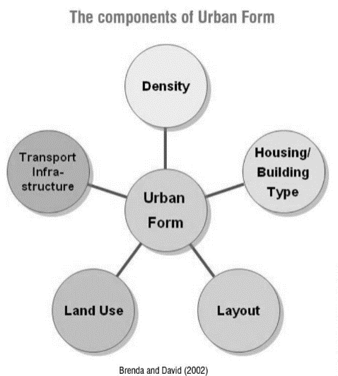Urban form is the “general pattern of building height and development intensity and the structural elements” that define the city physically, such as natural features, transportation corridors, open space, public facilities, as well as activity center and focal elements.

Figure 1 COMPONENT OF URBAN FORM

**Component of urban form**

1. Density

Population

Housing

Built-up Area

Density of public- transport

2) Land use

•Mix use of activities

•Location of development

•Employment

3) Layout

Brenda and David (2002)

• Proximity to services

• Share of urban land

• Open spaces

4) Housing

* Type of housing
* Mixed use buildings
* Verticality
* FAR

5) Transport infrastructure

* length of transport lines
* Access to services

**MISCONCEPTION?**

There are various misconceptions which are associated with the compact city policies are explained below:

1) Compact urban development as a component of the compact city-

“Compact city” and “Compact urban development” are distinct concepts in terms of the scale: Compact city is a policy approach to urban development and urban form at a metropolitan scale, while compact urban development typically refers to a development project at a neighbourhood scale. While compact urban development can create “compactness” in a specific neighbourhood, it is not sufficient to create a compact city, among other things because the location of such development in a metropolitan region matters for compact city outcomes.

2) The size of a compact city

People may associate the term “compact city with a “small” city in terms of population or geographical space. However, this study considers that “large” metropolitan area can also be “compact” if they have dense and proximate development.

3) A polycentric Urban Structure in a compact city-

The term “compact city” tends to be associated with a monocentric structure and has often been discussed as the contrary of urban sprawl or decentralization (Breheny,1995; Gordon and Richardson, 1997; Bertaud and Malpezzi,1998). However, it has been increasingly noted that many metropolitan areas in fact polycentric urban structures

The compact city on the metropolitan scale does not presume a specific urban form, whether monocentric or polycentric. A polycentric metropolitan area can be a compact city if they have dense and proximate development.

Polycentric urban form

Since the 1980s, the reconfiguration of metropolitan areas' physical urban form has been increasingly debated among both theorists and practitioners. The monocentric model, in which central city locations are considered the sole functional focal point for all types of social and economic activity, is no longer seen as the norm in the evolving spatial patterns of urban Europe.This is also the case in North America, Australia and increasingly in Asia. Central city locations are becoming components of a wider spatial functional entity that comprises headquarters complexes, back offices, airport cities, logistics management, different kinds of housing areas and entertainment facilities. Therefore, cities (or even clusters of proximate cities) seem to be integrating more and more with their hinterlands to form multi-centred functional city regions or metropolitan areas.

Changes in metropolitan areas are not taking place just in “inner cities” but also in their “hinterlands”. There is increasing evidence that a new phase of development in terms of the "urban periphery” is emerging that is not characterised simply by growth in terms of population and the extension of the urban fabric. It also involves a wider array of economic functions and

qualified jobs. The “new spaces of growth poles” take a broad variety of spatial forms and functional specialisations to create, in line with infrastructure networks, “new intermediate zones” with new centralities and peripheries. Such decentralisation processes may even lead to a

hollowing out of the traditional city (Knapp and Schmitt, 2003).

It can therefore be argued that almost all metropolitan areas, even so-called monocentric ones can also - albeit to different degrees – be considered polycentric urban configurations because of the morphological and functional differentiations taking place in and between neighbouring cities and towns within metropolitan areas. The role of cities is embedded in a

spatially wider polycentric organisation of socio-economic activities.

This is not without consequences for spatial planning in metropolitan areas as it entails

many challenges and calls for new trade-offs and tailor-made solutions. These challenges and the resulting experience in dealing with such issues can be linked to the notion of “intra-metropolitan polycentricism” (i.e. polycentricism within metropolitan areas).

Source: METREX (2010), "Intra-metropolitan polycentricity in practice: reflections, challenges and Conclusions from 12 European metropolitan areas”, Nordregio, Glasgow, United Kingdom.

4) Building forms and open space in a compact city

Many people associate the notion of compact city with high-rise buildings in large metropolitan areas. However, there are development options other than high-rise buildings. In fact, while a compact city aims at high-density built-up areas, several studies show that high-rise building developments are not necessarily denser. A study in Toronto showed that low- to medium-rise buildings can achieve relatively high densities. The findings identified net densities of 120-230 dwelling units per hectare in areas of

buildings of only up to five stories (Churchman, 1999). Another investigation of different geometrical forms of building in Paris and Hong Kong, China has indicated that high-rise building developments are not denser than low-rise developments. The study showed that a Parisian "Haussmanian” district of 6-7 stories is denser than a 20-story building

neighbourhood in Hong Kong, China on the same land size. In this case

density is compared by using the floor area ratio (FAR), which is a ratio of floor area to land area. The density in Paris (FAR = 5.75) is in fact higher than that in Hong Kong, China (FAR = 4.32). This shows that compactness can be achieved using different types of buildings and that density need not mean high-rise buildings. It is important for cities aiming to create a compact city to have a certain degree of flexibility in the choice of urban form and shape of buildings. This point is of great importance for the acceptability and the feasibility of creating a compact city.

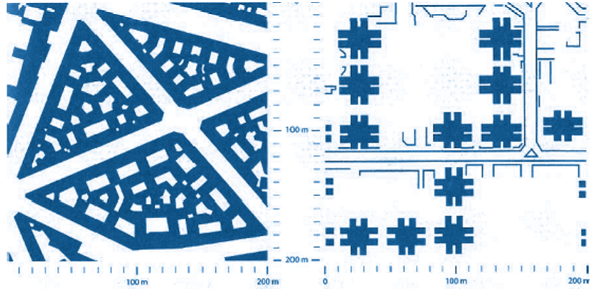

Figure 2BUILDING FORMS IN PARIS AND HONG KONG, CHINA

Source: Jacquet, P., R.K. Pachauri and L. Tubiana (2010), Regards sur la terre 2010. L’annuel du development durable: Villes : changer de trajectoire, SciencesPo, Paris

**The history and evolution of the compact city concept**

It is important to understand the original concept and how it has evolved over time, as this provides valuable background for discussing compact city policies in today's urban contexts.

**The origin of cities and the compact city**

The origin of the compact city can be found in the medieval fortress city or even in ancient cities. Such cities were "compact" in size, but the rationale was very different from that of the modern compact city. Early urban residents constructed walls around the city for protection, and within the walls they gave careful consideration to how to allocate the available space to residential areas, public squares and roads, etc. (this was in fact the start of city planning). It could be said, in fact, that the compact city concept arose with the origin of cities. In more recent times, city walls lost their usefulness owing to the development of military technologies. With the development of railways and automobiles they also became a barrier to traffic. In Europe in the 18th and 19" centuries, the massive influxes of people to cities during the Industrial Revolution also meant that the capacity of the enclosed walled areas was exceeded, and as a result, the city walls were gradually removed. Thus, the ancient compact city came to an end.

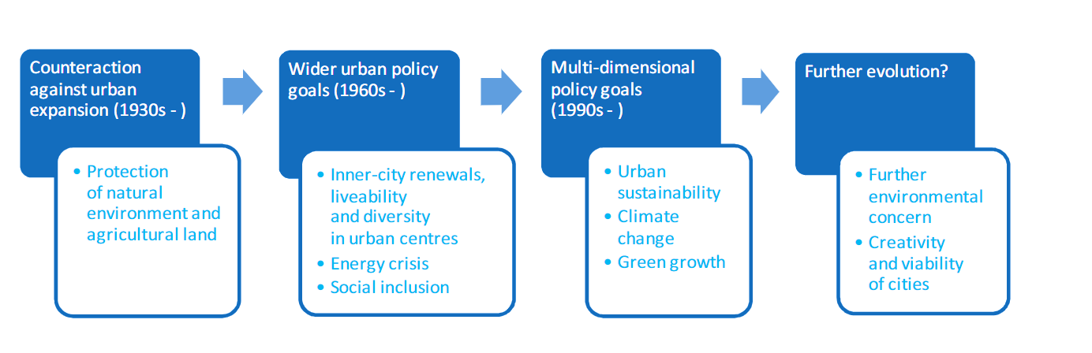

*Figure 3 EVOLUTION OF COMPACT CITY POLICIES*

**Compact city policies can achieve integrated urban sustainability goals**

They can generate synergistic impacts

*Table 1 How Compact city policies can achieve integrated urban sustainability goals*

|  |  |  |  |
| --- | --- | --- | --- |
| **How compact city policies can contribute to urban sustainability [excerpt]** | | | |
| Compact city  characteristics | Environmental  benefits | Social benefits | Economic benefits |
| Shorter intra-  urban distances | Fewer CO2 emissions,  Less pollution from automobiles | Higher mobility of low-  income households, due to lower travel costs | Higher productivity due to shorter  travel time for workers |
| Better access to  diversity of local  services and jobs | - | Higher quality of life due  to access to local services (shops, hospitals, etc.) | Skilled labour force attracted by  high quality of life  Greater productivity due to more diversity, vitality, innovation and creativity |
| More efficient  public service delivery | - | – Public service level for  social welfare maintained by improved efficiency | – Lower infrastructure investments and cost of maintenance |

**INDICATORS OF COMPACT CITY**

*Table 2 Indicator of Compact city*

|  |  |  |
| --- | --- | --- |
| **Category** | | **Indicator** |
| Indicators related to compactness | Dense and proximate development patterns | 1. Population and urban land growth |
| 2. Population density on urban land |
|  |  | 3. Retrofitting existing urban land |
|  |  | 4. Intensive use of buildings |
|  |  | 5. Housing form |
|  |  | 6. Trip distance |
|  |  | 7. Urban land cover |
|  | Urban areas linked by  public transport systems | 8. Trips using public transport |
| 9. Proximity to public transport |
|  | Accessibility to local services and jobs | 10. Matching jobs and homes |
| 11. Matching local services and homes |
|  |  | 12. Proximity to local services |
|  |  | 13. Trips on foot and by bicycle |
| Indicators related to the impact of  compact city  policies | Environmental | 14. Public space and green areas |
|  | 15. Transport energy use |
|  | 16. Residential energy use |
| Social | 17. Affordability |
|  | Economic | 18. Public service |

1. **CONCLUSION**

This study has shown that the concept of a compact city is attracting new attention as a form of policy among modern urban policy makers. Following this new focus are five urban norms, from environmental and social to economic, as described above, that drive policymakers to seek appropriate solutions. It is increasingly recognized that integrated city policies can play an important role in today's urban contexts. The description provided, despite its complexity, emphasizes that integrated city policies provide a comprehensive policy approach that addresses the goals of urban sustainability by contributing to the use of urban space.

The concept of a compact city has shifted from a simple urban inclusion policy to the protection of the natural environment and agricultural land to a multi-purpose policy that includes sustainability. Yet integrated city policies are often seen as the most protective of the environment by restricting and controlling economic growth.

Instead, the study recognizes that a compact city can make a positive contribution to economic growth. In other words, it is important to see the concept of a compact city from a green growth perspective and clearly integrate economic growth as the goal of a compact city policy. This can provide rich information on designing and implementing integrated city policies

1. **REFERENCES**
2. Angel, S., S.C. Sheppard and D.L. Civco (2005), “The dynamics of global urban expansion”, World Bank Transport and Urban Development Department, Washington, D.C.
3. Angel, S., J. Parent, D.L. Civco and A.M. Blei (2010), Atlas of Urban Expansion, Lincoln Institute of Land Policy, Cambridge, MA, www.lincolninst.edu/subcenters/atlas- urban-expansion, accessed 10 April 2012.
4. Angel, S., J. Parent, D.L. Civco and A.M. Blei (2011), “Making room for a planet of cities”, Policy Focus Report, Lincoln Institute of Land Policy, Cambridge, MA.
5. Bertaud, A. and S. Malpezzi (1998), “The spatial distribution of population in 35 world cities: the role for markets, planning and topography”, Working Paper, World Bank and Centre for Urban Land Economics Research, University of Wisconsin.
6. Blochlinger, H. and C. Vammale (2010), "Sub-central governments and the economiccrisis: impact and policy responses,” OECD Economic Department Working Papers,No. 752, OECD Publishing, Paris, http://dx.doi.org/10.1787/5kml6xq5bgwc-en.
7. Breheny, M. (1995), “The compact city and transport energy consumption”, Transactions of the Institute of British Geographers, New Series, 20(1): 81-101, Royal Geographical Society, London.
8. Burton, E. (2002), “Measuring urban compactness in UK towns and cities”, Environment and Planning B: Planning and Design 2002, 29(1): 219-250.
9. Churchman, A. (1999), “Disentangling the concept of density”, Journal of Planning Literature, 13(4): 389-411, Sage, London.
10. Commission of the European Communities (1990), “Green paper on the urban environment”, COM(90)218 final, Brussels, 27 June.
11. Cortright, J. (2008), “Driven to the brink: how the gas price spike popped the housing bubble and devalued the suburbs”, White Paper, CEO for Cities, www.ceosforcities.org/files/Driven%20to%20the%20Brink%20FINAL.pdf,
12. Dantzig, G.B. and T.L. Saaty (1973), Compact City: A Plan for a Livable Urban Environment, W.H. Freeman & Co., San Francisco, CA.
13. Dempsey, N. (2010), “Revisiting the compact city”, Built Environment, 36(1): 5-8, Aleyondrine Press von
14. Florida, R. (2010), The Great Reset, How the Post-crash Economy Will Change the Way We Will Live and Work, Harper Collins Publishers, New York, NY.
15. Fouchier, V. (2004), “Urban sprawl, density and mobility in the case of Paris Region”,French National Territorial Planning Agency, Paris.
16. Fulford, C. (1996), “The compact city and the market”, in Jenks, M., E. Burton andK. Williams (eds.) (1996), The Compact City: A Sustainable Urban Form?,E & FN Spon, Oxford.
17. Goldewijk, K., A. Beusen and P. Janssen (2010), “Long-term dynamic modeling of global population and built-up area in a spatially explicit way: HYDE 3.1", The Holocene, 20(4): 565-573, SAGE, Thousand Oaks.
18. Gordon, P. and H.W. Richardson (1997), “Are compact cities a desirable planning goal?” ,Journal of the American Planning Association, 63(1): 95-106, Taylor & Francis Group, Oxford.
19. Greenberg, M., K. Lowrie, H. Mayer, K.T. Miller and L. Solitare (2001), “Brownfield redevelopment as a smart growth option in the United States”, The Environmentalist,21(2): 129-143, Kluwer Academic Publishers, Norwell.
20. IPCC (Intergovernmental Panel on Climate Change) (2007), Climate Change 2007:Synthesis Report, IPCC, www.ipcc.ch/pdf/assessment-report/ar4/syr/ar4_syr.pdf,,
21. Jacobs, J. (1962), The Death and Life of Great American Cities, Cape, London.
22. Jacquet, P., R.K. Pachauri and L. Tubiana (2010), Regards sur la terre 2010. L'annuel du développement durable : villes : changer de trajectoire, SciencesPo, Paris.
23. Kim, B.H.S. (2010), “Critical review and evaluation of greenbelt policy in Korea”, paper presented to the Korea Planners' Association - OECD Joint Workshop, Seoul,14 April