**ANALYSING TRANSIT-ORIENTED**

**DEVELOPMENT IN AHMEDABAD, INDIA**

**Ar.Chandresh Sahu1**

1PG Student, MUP, MITS Gwalior, Madhya Pradesh , India

**ABSTRACT**

The global percentage of urban population has been steadily increasing in the twentieth century. According to the World Bank, more than 60% of the world population will be living in urban areas in the year 2030. India will not be an exception to this growth. In India, the problem of urbanization is aggravated by the concentration of economic opportunity in few cities. This creates the problem of extreme concentration and thus the creation of very large cities. By 2025, 22% of the urban population will be living in 9 cities. Such large concentrations create pressure on facilities such as transportation, housing, and other products required by the population. As such, there is a need for good planning and policy framework for the cities to grow sustainably.

Urbanization is an integral part of economic development. Rapid economic growth and urbanization in India have led to formation of slums, deterioration in environment, congestion etc. A sustainable strategy is required to maintain the economic growth and alleviate the problems arising due to the growth. Sustainable development can be defined as “any social and economic development that does not harm the environment”. Transit-oriented development (TOD) which concentrates development near and around transit systems to promote transit ridership is one such sustainable development strategy.

**Keywords:** Urban population, Urbanization, Deterioration, Congestion, Transit-oriented.

1. **INTRODUCTION**

There are many ways in which TOD promotes sustainable development. First and foremost, as already mentioned in the previous paragraph, it reduces auto usage by providing a transportation alternative. Secondly, land use planning and urban design improve the accessibility for non-motorized traffic and help promote alternatives to the auto; reduction in automobile use reduces obesity and other negative health effects as well. Concentrating jobs and other activities around transit improves the accessibility of the economically weaker section, i.e., the poor, as well as the disabled etc. Thirdly, concentration of activities along with urban design and land use planning also helps in reducing air pollution. Concentration of activities and land use planning help in creating a good distribution of activities within a neighbourhood; but in order to be successful, the area must be approachable and attractive to users (different people have different standards to use the same space). A balance is needed between achieving the most efficient system and recognizing community goals. Urban design is the key mechanism in achieving this balance. The city of Ahmedabad is the largest city in the state of Gujarat and the seventh largest in India. It is the commercial heart of the state, contributing nearly 60% of the total productivity of the state. Increasing populations in the city has resulted in transportation and environmental problems. In order to alleviate some of these problems, the city has recently invested in a bus rapid transit system, Ahmedabad bus rapid transit system (ART); the investment is expected to boost transit ridership. Since Ahmedabad is already a dense city, it could be possible that with this transit investment, a TOD type of development is already achieved. This study first investigates the existing development in Ahmadabad to determine if transit-oriented development (TOD) exists in some form. Secondly, what policy and planning measures can help improve the degree of TOD-ness in Ahmedabad?

1. **PROBLEM STATEMENT**

The city of Ahmedabad is the seventh largest city in India and the largest in the state of Gujarat. The city is spread over 440 sq. km and accommodates over 5 million people which is expected to grow to 11 million by 2035. The city also has registered vehicle strength of 1.4 million, which is growing at the rate of 8-10% per year. This rapid growth in automobiles has resulted in congestion, and air pollution. In order to solve these problems, the city has recently invested in a bus rapid transit system. The city has also become a centre of opportunities, with more and more people from regional areas moving into the city looking for jobs. These people often lack the skill to get a good steady job and cannot 3 afford to live within the inner city, instead choosing to live around the periphery of the city (as the cost of living in the inner city is usually very high) where the transit services are poor. Since transit is the main mode of travel for the urban poor, their mobility and accessibility are limited. Thus, there is a need for inclusive planning to improve the socio-economic status of all citizens. Transit investment can help to increase the access to opportunities, and in conjunction with good land use planning and policies can achieve sustainable urban development. The city of Ahmedabad has recently invested in a bus rapid transit system. But this investment alone is not sufficient. Around the world, integrating land use and transport planning has been recognized as the way to achieve sustainable development. If transit has to be the driver in urban development, transit ridership needs to increase. Many factors such as zoning policies, land use distribution, transport policies etc. play a role in increasing ridership. The current study assesses the sufficiency of transit investment and other factors influencing transit ridership for achieving sustainable urban development in Ahmedabad.

1. **LAND USE AND TRANSPORT POLICIES IN AHMEDABAD**

The rapid economic growth happening in India is mainly through the service and industrial sectors. Both of these sectors operate mainly in urban areas, and as such the state of these areas is crucial. Transportation is a crucial link for sustaining the growth and also for a smooth-running urban region. To improve the transportation links and alleviate some of the problems, the central government has launched a new National Urban Transport Policy (NUTP). Some of the objectives of this policy include: An integrated approach to land use and transportation planning Encouraging an equitable distribution of road space; concentrating on people rather than vehicles Improving access to business and production sites Encouraging greater use of public transport and non-motorized traffic Reduction in air pollution by changing travel patterns, improved technology, stricter norms etc.

These are only a few of the objectives. The whole list is presented in the document by the Ministry of Urban development. Using this policy as a framework, state governments can manage their 4 urban regions. In Gujarat, the state government has developed an urban transport policy, focusing on economic growth, environmental improvements and social equity; in other words, a plan for sustainable development. The objectives of the Gujarat urban transport policy include:

* To address issues relating to the planning, design, construction, operation, maintenance, management and development of all forms of urban transportation in an economically efficient, equitable and sustainable manner.
* To ensure provision of an adequate quantity and quality of urban transportation services.
* To accelerate the development of urban transportation infrastructure with appropriate legal, regulatory, institutional and financial measures.
* To make institutional changes necessary to consolidate publicly- owned urban transportation facilities in major urban areas and to improve service delivery.
* To develop the legal and regulatory framework to allow consolidation and to improve the prospects for private sector participation.
* To establish priorities for urban transport, from highest priority to lowest priority, as follows:

1. Mass transport.
2. Non-motorised transport such as bicycles and pedestrians.
3. Intermediate public transport such as auto-rickshaws and taxis.
4. Personalised motor transport such as motorcycles and cars.

The Gujarat state government has developed the local policies using the NUTP as a framework. For example; with respect to space management on roads priority is being given to public transport, consolidation with respect to land use to improve service delivery etc.

The Gujarat state government has developed the local policies using the NUTP as a framework. For example; with respect to space management on roads priority is being given to public transport, consolidation with respect to land use to improve service delivery etc. Since the current project deals with land use as well as transport, an insight into land use policies is essential as well. Gujarat unlike most other states in India has a unique way of dealing with urban development and land management. Land acquisition act of 1894, transfer of development rights, joint sector method of allowing license to private developers to construct dwelling units, master plan (development plan) is some of the land development schemes in practice. Gujarat uses the Development plan and Town planning scheme mechanism. According to the Land acquisition act, the Government of India can acquire land from any individual for public purposes. The main disadvantages of this method are that it takes an inordinately long time for acquiring land and the fact that the compensation paid to the land owner is not up to market standards. The other issue is with respect to disparity between the people who own the land being acquired and the people whose land adjoins the acquired land. This latter group of people enjoy the benefits of increased property value as well as the market value of the land, whereas the former enjoys neither. The Gujarat town planning and urban development act (GTPUDA), 1976 provides for a mechanism to 5 address these issues using a development plan-town planning scheme (DP-TPS) method. The relationship between the development plan (master plan) and the town planning scheme.

1. **RESEARCH OBJECTIVE**

The overall objective of the study is to assess the potential of the current BRT investment in Ahmedabad for achieving sustainable urban development goals. TOD is investigated as a potential strategy for achieving such sustainable urban development.

Objective 1

To define sustainable urban development and TOD and investigate the potential of TOD for achieving sustainable urban development.

Research questions

* What is sustainable urban development (SUD)? What are the goals of SUD?
* What is TOD? What are the goals of TOD?
* Do the goals of TOD align with the goals of sustainable urban development?

Objective 2

To determine whether the current urban form and transport development on and around the BRT corridor in Ahmedabad can be characterized as a TOD type of development.

Research questions

* What are the different types of transit development?
* How can a case be differentiated between TOD and non-TOD type of development?

Objective 3

To examines the TOD implementation process in terms of pace of implementation (likely implications on urban form).

Research questions

* Which criteria from the evaluation framework can be selected for improvement in the current case?

Objective 4

To investigate the policy and planning barriers that needs to be overcome in order to implement the changes

Research questions

* How can these barriers be overcome, in order to implement the changes identified in the previous step?

1. **BACKGROUND LITERATURE**

Definition of TOD

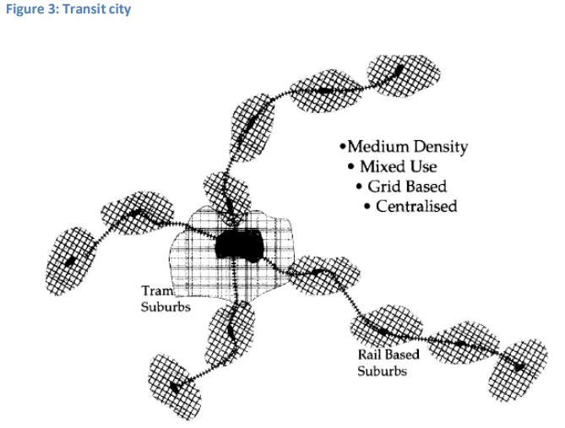Transportation planning plays a key role in urban development. Overdependence on automobile can cause sprawl, longer travel distances, congestion etc. Urban development strategies such as Urban development philosophies: new urbanism, traditional neighbourhood planning, and transit oriented development (TOD) offer an alternative to the use of private automobile. They share three common objectives – (1) reduce the number of motorized trips; (2) increase the share of trips that are nonmotorized; and (3) of the motorized trips that are produced, reduce travel distances and increase vehicle occupancy levels. Focusing on the built environment by changing density, diversity and design can help achieve these objectives.

SOURCE 6

Figure shows a transit city, which incorporates high density, mixed-use development around transit stations. Curitiba in Brazil, Bogota in Colombia, and Arlington County in the USA are some examples of such cities. In such transit cities (or transit-oriented cities) urban landscape is used to leverage transit services. Some of the definitions of TOD include:

* High-density mixed-use development around transit stations
* High residential or mixed-use development around transit corridors
* High density development within walking distance of transit stations

All of these definitions include the 3D’s (Density, Diversity and Design) of Cervero and Kockelman; diversity in the form of mixed use development, density in form of residence and jobs, and design in the form of good street connectivity for pedestrians.

**The role of density, diversity and design**

Density is the most important land-use predictor of ridership rates. In this case, density refers to population or employment density. Kockelman also found a direct relation between density and transit mode choice. Other studies have found a direct relation between congestion and density, and an inverse relation between density and auto use. The distance between activity locations also plays an important role in mode choice. Hence, activity density, defined as the number of local desirable non-work activity locations is an important consideration.

Urban design helps in increasing accessibility to transit services and hence, helps in increased transit use. In these definitions, urban design focuses mainly on increasing walking accessibility. This means that development borders will be small (e.g. 400m around stations). Transit use can also be leveraged by designing for good modal connections, such as between regional transit and rapid transit, bike and transit, etc.

A rich mix of choice is a defining feature in the best neighbourhoods [27]. Different activities within walking distances can help people complete many activities in one trip (i.e. trip chaining). Similarly, housing options can help people from different social levels live in the same communities and not move to poor accessible regions (which are more affordable). Hence, TOD needs to provide affordable housing for the economically weaker sections and other people who might depend on transit for mobility as well.

**TOD and sustainable urban development**

Table shows some of the strategies for achieving sustainable development. The strategies range from land use to transportation, housing etc. Overlaps also exist between the different classes of strategies. Transit oriented development as defined in the previous sections helps achieve each of these objectives. For example, high density development promotes job creation and community development; pedestrian accessibility and transit development improves transportation link; affordable housing and zoning policies improve social equity and housing and urban design. Thus TOD is a viable strategy to achieve sustainable development. The whole concept of sustainable development and TOD is linked in Figure. The figure shows the core strategies of TOD (i.e. the 3 D’s Density, Diversity and Design) and how they are linked to the three dimensions of sustainability.

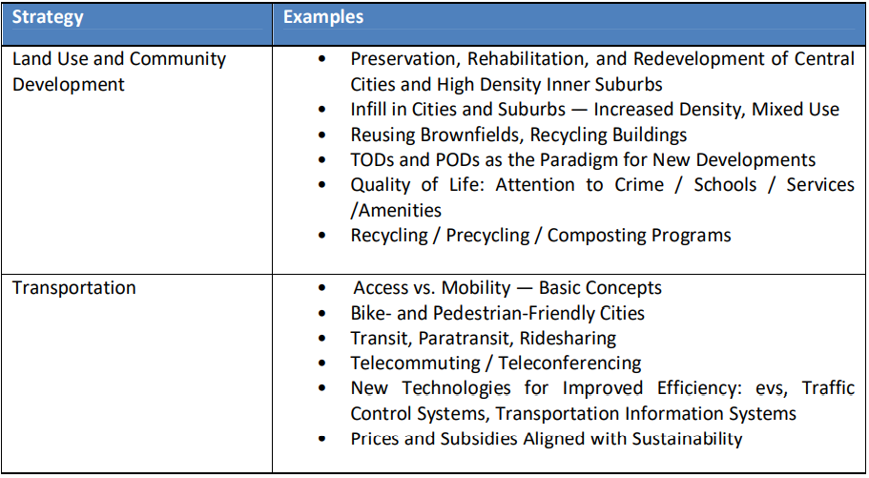

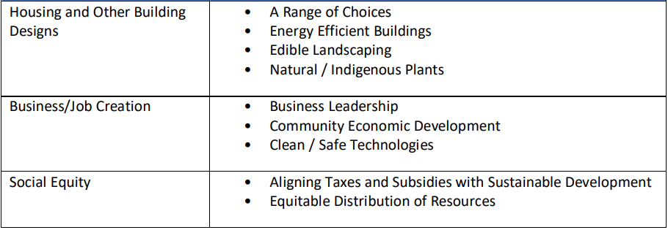

SOURCE 7

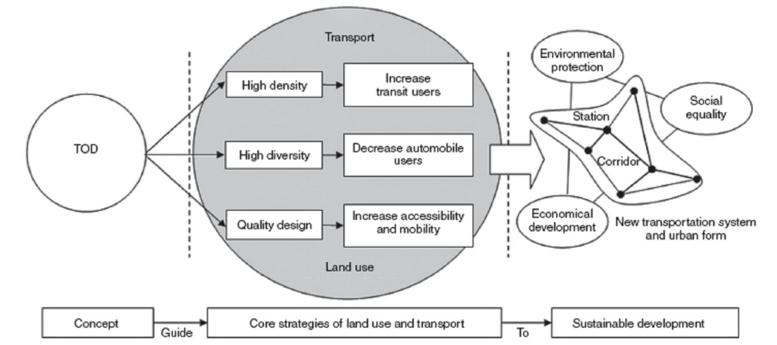

SOURCE 8

**What is TOD and what is not?**

Another form of development that is close to TOD is transit adjacent development (TAD). Cervero et al. define TAD as development that is close to transit services, but does not use the proximity to promote transit ridership. Even though both forms of development have the same principles, TOD is considered a better option; TOD increases transit ridership by using land use planning to leverage transit use, whereas TAD just focuses development near transit. As G.B. Arrington of PB PlaceMaking says, “Within the family of TOD, you might say there are two ‘brothers’ – TOD and his ‘evil brother’ TAD”.

**Evaluation of TOD**

An evaluation framework for TOD is not only essential for assessment of existing sites but also for future planning measures. According to Dittmar and Ohland [27], TOD projects have five main goals:

Location efficiency – key factors defining location efficiency include density, accessibility to transit services, pedestrian friendliness.

• Value capture – frequent high quality transit, good connections between modes,

• Rich mix of choices – different land use types: commercial, retail, residential etc., range of housing options

• Place making – pedestrian friendliness, safety, street connectivity, zoning policies

• Resolution of tension between node and place – developing a transit node (transit station) as an activity centre; design for pedestrian friendliness, mix of uses to promote trip chaining etc.

1. **CONCLUSIONS**

There have been many instances of using transit investment as a driver in urban development. One such strategy is transit oriented development (TOD). TOD is the name used for cases where transit investment and land use planning have been integrated to promote transit ridership. The only goal of TOD is not transit ridership; reduction in vehicle miles travelled (by promoting walking, biking and transit), improve accessibility (more activities close to transit) etc are also possible by TOD investment. Whereas there are many definitions of TOD, the essence is the same integration of transit and land use planning. In literature methods such as a land use design problem, it is measured using regression analysis, using a “TOD index” etc. has been used to measure the success of TOD. The objective of the current research is not to measure the success of TOD but to evaluate the urban development around the BRT in Ahmedabad. Hence, multi criteria decision analysis is used as the research method. MCDA is multi-disciplinary, is amenable to quantitative as well as qualitative indicators. Also, by the process of sensitivity analysis, biases can be removed.

1. **REFERENCES**
2. Newman, P. and J. Kenworthy, Sustainability and Cities: Overcoming automobile dependence. 1999: Island Press.
3. Samimi, A., A. Mohammadian, and S. Madanizadeh, Effects of transportation and built environment on general health and obesity. Transportation Research Part D: Transport and Environment, 2009. 14(1): p. 67-71.
4. Jacobson, J. and A. Forsyth, Seven American TODs: Good Practices for Urban Design in Transit-Oriented Development Projects. 2008. 2008.
5. CEPT, Detailed Project Report Phase-1. 2005, Centre for Environmental Planning & Technology University.
6. Transport, M.o.U. National urban transport policy.
7. Deakin, E., Sustainable Development and Sustainable Transportation: Strategies for Economic Prosperity, Environmental Quality, and Equity. 2001.
8. Newman, P.W.G. and J.R. Kenworthy, The land use-transport connection: An overview. Land Use Policy, 1996. 13(1): p. 1-22.
9. Li, C.N. and T.Y. Lai, Why should cities change from DOT to TOD. Proceedings of the Institution of Civil Engineers: Transport, 2009. 162(2): p. 71-78.
10. Cervero, R., et al., TCRP Report 102: Transit-Oriented Development in the United States: Experiences, Challenges, and Prospects. 2004, Washington: TRB.
11. Lefaver, S., Public Land with Private Partnerships for Transit Based Development. 1997, California Department of Transportation: California. p. 339.
12. Porter, D.R., Transit-Focused Development: A Progress Report. Journal of the American Planning Association, 1998. 64(4): p. 475-488.