Integrated Urban Regeneration

***- SOLUTION FOR CITIES REVITALIZE***

**Ar.Amrita kaur1**

1PG Student, MUP, MITS University, Gwalior, Madhya pradesh , India

**ABSTRACT**

Urban regeneration has been accompanying urban development since the earliest human settlement, and was emphasized after the World War Two. Several decades’ experience and billions of dollars forced the decision makers to realize the importance of urban image, quality of life, and urban environment, which were recognized as prerequisites and catalysts

for the economic development of cities. In this circumstance squares have been involved in urban regeneration projects to create symbol of the city and to provide space for residents, and have been proved to be effective for urban regeneration by many western countries. Dalian, a coastal city in Northeast China presented to be a successful case in the country in

involving the construction of squares in regenerating central city to transform the city from a heavy industrial city to a garden city. In the circumstance of urban beautification movement in China, which began in 1990s and was partly symbolized by the construction of fancy, large, but under-used squares, a study on the success of Dalian is indeed needed.

This study shed light on the major concerns of Dalian government to create squares in central city, the land use issues of squares, the usage on the squares, and the perception of squares by users. Through the application of key-informant interview, questionnaire survey, and onsite observation, the paper concluded that the construction of squares was part of the

urban regeneration policies in Dalian, the major concern was to provide local residents with public open space to enjoy public life, and to improve urban environment. The construction of squares was carefully and systematically planned, the location of squares was pertinent to the land use pattern nearby and to the function of each of the three districts in central city, the

squares are fully utilized, and are appreciated by both local residents and tourists. The squares were considered as catalyst in urban environment improvement, urban image enhancement, and tourism and economic development from the perspective of government officials, local residents, and tourists. Implication was provided for other cities in China based on the major findings and reviewed literature, future research opportunities were also suggested.

**Keywords:** Urban regeneration , Urban environment , local residents , Economic development .

1. **INTRODUCTION**

The problem that society has been going through for several years has greatly affected the construction industry once and for all housing market, stopping investment in public infrastructure and increasing unemployment. To overcome this research, legislative proposals, policy formulation, leading to the transformation and revitalization of urban areas, conserving the environment and geography and stopping the loss of causes for other purposes. Europe Union, a sustainable development policy based on all policies and strategies.

Thus, common agricultural policy, integration policy, community research and development policy, transport and energy and communications policy, environmental policy and housing policy also, based on with the goal of sustainable development.

The most important interventions, in recent decades, targeted at urban areas, are considered urban areas a process that focuses on solving important city problems, which will benefit both the current population, as well as the future population, to achieve the quality standards of disadvantaged communities. And aimed at solving urban problems as well to achieve long-term development in the economic, physical, social and environmental sectors in the area in which it is supposed to be changed. The most important principles of urban renewal are: - the need to establish a clear and measurable one the objectives of the urban renewal process and their sustainable development objectives; -

adequate analysis of environmental conditions; -

the need for efficient use of natural, economic and human resources - participation and collaboration between stakeholders, which leads to the improvement of the physical structure of buildings, social structure, economic base and environmental conditions (Roberts and Sykes, 2000).Urban renewal is an opportunity to solve problems such as: lack of residential ownership,a complete lack of public spaces and high urban density, making it impossible to widen roads, green spaces. creating, planting trees along roadsides etc. ..The name of the city renovation is similar to that of the city renovation or renovation of the city. Either way, the word is based, therefore, on the action verb goals, aimed at developing sustainable cities.

Urban regeneration involves the regeneration of oppressed urban areas, through actions such as: - regeneration historical sites development of living conditions in residential districts; - development of public spaces: squares, parks, urban furniture etc; - modernization of urban infrastructure: water, gas, electricity, transport networks infrastructure. A project of this difficulty, such as that of a sustainable urban renewal can only be achieved through partnerships between institutions, universities, urban people, environmental organizations and builders. City renewal actions are social, economic and technical based.

For public reasons, there are:

quality of life improvement;

renovation of buildings and houses according to our needs;

to improve the image of a residential area or region;

1. **METHODOLOGY**

Interview is one of the 4 fundamental sorts of information series in qualitative look at, which includes unstructured

and normally open-ended questions which are few in variety and supposed to elicit perspectives and reviews from the participants (Creswell, 2003). Since interview can assist the researcher to get historic records (Creswell, 2003), ten interviews had been performed inside and outside Dalian on

this look at with a purpose to recognize the primary motives for and issues of neighborhood authorities in developing squares, and to advantage extra records that couldn't be observed simply with inside the literature. The interviews performed on this studies had been of types: casual interviews with neighborhood citizens and key-informant interviews with authorities officers and a few specialists. No formal query listing became organized for the casual interviews, even as the query listing for key informant became designed with the help of the and researcher's manager and the course of the Office of Research Ethics on the University of Waterloo.ere p lore July n of amongst exclusive the Land Administration Bureau, 3) inquiries to officers with inside the Urban Planning Bureau, 4) inquiries to officers with inside the Tourism Administration Bureau, 5) specialists and scholars,and 6) excursion auides. However, at some point of The formal interview questions had been firstly designed with exclusive emphases respondent groups. Since the interview became performed orally, there has been no records letter. The query listing accordingly may be divided into six parts: 1) fashionable inquiries to all of the interview method, the researcher discovered that maximum of the interviewees spoke back the questions in a complete manner and that they constantly spoke back numerous questions simultaneously. For this reason, the researcher made a few change of the query listing

1. **MODELING AND ANALYSIS**

Fluid and Material For the first time in its industrial history, Bilbao was able to begin a comprehensive reform of its ailing economy and a substantial clean up of its filthy water systems, including:

1. A properly functioning sewage treatment system

2. High-tech business parks that are brand new;

3. Substantial urban renewal

4. Through the vast and open-minded SME, retraining and reskilling

The Abandoibarra region, where the Guggenheim Museum is built in the reclaimed docks, was the most prominent, best known, and most renowned new development, garnering almost a million people every year since it opened in 1997.

In 2013, it hosted 744 events that were 92 percent full, with about 500,00 people attending big conferences, local seminars and workshops, concerts and shows.

The concept of urban regeneration is a rejuvenation option for large cities, while it is a saving answer for Bucharest.

The urban redevelopment effort in our capital began in 2009, when the thermal repair phase of the

blocks began, it was continued to renovate building facades, enhancing the appearance of the urban area throughthe management of green spaces, parking spaces, and building access routes, among

other things, all of which contribute to enhanced productivity.

people's quality of life This was a first for Romania, and it represented the most difficult urban reconstruction.

The goal of this urban regeneration project was to rejuvenate the north of the capital's periphery residential districts (housing estates). The project was funded by European monies as well as funds from the local government.

The Regional Operational Programme, Priority 1 - Supporting the Sustainable Development of Cities, funds Integrated Urban Development Plans. Cities' development - urban growth poles

They have as their goal the regeneration of metropolitan areas, with the following goals: "it is increasing the quality of life in cities and creating new jobs through the rehabilitation of urban infrastructure

by strengthening commercial support structures and entrepreneurship, as well as urban services, including social services "( )Municipality of District 1 (2012).

The Municipality of District 1, 80 blocks, free of charge, were restored in 2009, taking into account the situation at the time. rehabilitation of a park and a theatre, as well as some schools and institutions in the capital's district 1 (Building

The Municipality of District 2 of the City of New York (Stock, 2010).

**Programs for Social Change-**

Between 1994 and 1999, Baracaldo, the largest working-class suburb, received urban assistance for the rehabilitation of circumstances in its worst districts.

The City of Bilbao launched two of the most dramatic social initiatives, both of which were established particularly to address social issues arising from the urban crisis and structural transformation.

Both the Basque government and the City Council's social housing programmes contribute to meeting housing needs: Local government public housing in the Basque Country is known as "protected housing."

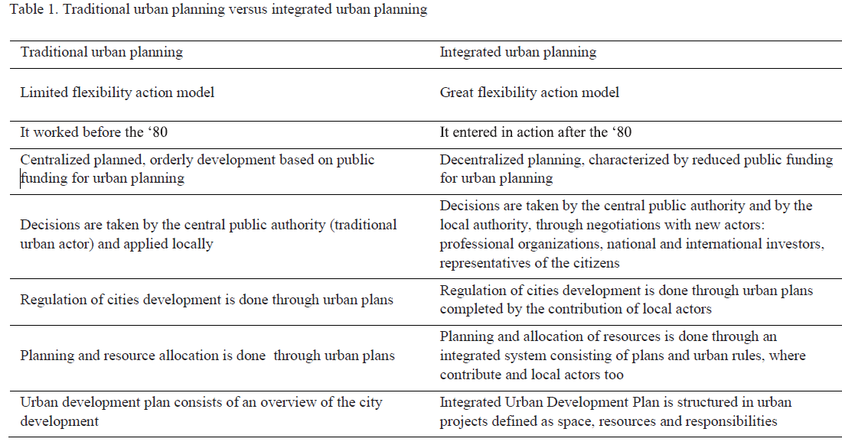

Source: Ministry of Public Works Development and Housing 2007

As a result, an integrated urban regeneration project combines economic, social, and political programmes developed by established urban actors such as government and newcomers.

This type of project allows for more flexibility in the urban development process by encouraging discourse among all parties involved in order to connect various areas of urban development.

This type of project is also built on a shared strategic goal for development and the allocation of responsibility among urban players, which is achieved through discussions.

A city project is a method of city administration (Ministry of Development, Public Works and Housing, 2007).

Integrated programmes are made up of a collection of instruments and urban procedures that aim to reformulate certain areas of the city, overcoming prior system rigidity and planning flaws.

Interventions at the municipal level aiming at urban revitalization, focusing on network infrastructure, environmental quality, and the impact of the economic and social components, as well as the territorial component.

Sustainable and comprehensive urban restoration must start with a multidisciplinary diagnosis that allows for a better understanding of the region that is being rehabilitated. This entails more than a working knowledge of structures, infrastructure, and public areas in order to engage various actors and people. In a nutshell, the purpose of revitalization is to

Stopping the deterioration of urban and social tissue and increasing social cohesiveness are the goals of degraded areas. promoting economic development, and, as a result, increasing the quality of life for citizens. (Rubio)

2011 (Del Val).

The Romanian capital need a greater emphasis on their identity and cultural character, as well as an improvement in the quality of life. a better quality of life and public services, improved accessibility, and the creation of a functional metropolitan region In this respect,

The finest example is Copenhagen, a city smaller than Bucharest that has had a functioning metropolitan region since the 1960s. The concept of urban regeneration is a way for revitalising large cities, whereas Bucharest is a case in point

.is a cost-effective alternative. The urban regeneration process in our capital began in 2009, when the thermal rehabilitation of blocks began. It has since been continued to modernise building facades, improving the appearance of the urban area through the management of green spaces, parking spaces, building access routes, and other elements that contribute to improved people's quality of life. This was a first for Romania, as it was the city's most sophisticated urban rehabilitation scheme.  (2011, Municipality of District 1)

In terms of urban regeneration, there have been several notable accomplishments.

Each district of the capital has been recorded. Since 2009, the Municipality of the First District has proposed, through the execution of "Strategy 2012 District 1," to fundamentally transform the face of Bucharest. This is a complicated urban regeneration project that attempted to rehabilitate the north of the city's periphery residential districts (housing estates). capital. The project was funded by European monies as well as funds from the local government. Integrated

The Regional Operational Programme, Priority 1 - Supporting the Sustainable Development of Cities, funds Urban Development Plans.Cities' development - urban growth poles They have as their goal the regeneration of metropolitan areas, with the following goals: "it is increasing the quality of life in cities and creating new jobs through the rehabilitation of urban infrastructure by strengthening commercial support structures and entrepreneurship, as well as urban services, including social services "( ) Municipality of District 1 (2012).

In 2009, the Municipality of District 1 rehabilitated 80 blocks for free, taking into account the rehabilitation of a park, a theatre, and several schools and institutions in the capital's district 1 (Building Stock, 2010). The Municipality of District 2 of the capital designed the district's urban regeneration plan, which includes a building structure that comprises of collective housing estates that were in a condition of severe degeneration, with low quality public spaces, green spaces, and parking spaces. Actions such as education network modernization, road rehabilitation, municipal water and sewerage extension, rehabilitation of recreational areas, sports facilities, churches and culture centres, the development of complex networks, shops, markets, and business centres were also included in the Plan.

The Municipality is exploring a number of initiatives for 2013, some of which have already begun in the Municipality of the Capital, such as:- The BerzeiBuzesti zone, for example, is one of the most important projects in the city in the last 20 years, with the goal of restoring historic value in the area between Victoria and the underground tunnel South Square, with work set to begin on March 1, 2013.

and the underground route Pantelimon Road - Chisinau Boulevard;- substantial alterations in the capital's heart, where Unirii Boulevard will be converted into a pedestrian area between Unirii Square and Constitutiei Square. The area around the wells will be pedestrianised, and cars will be allowed to drive along the edge of the road.

boulevard. This project is a component of the Municipality's 2011 Integrated Urban Development Plan;-

Significant alterations will be made to the city's two largest lakes, Floreasca and Tei, which will be outfitted to allow for boating. Tours of these lakes can be arranged. Ship ports, landing areas, and two amphitheatres are all part of the development plan.- building of new multipurpose halls in the city, with floating sceneries and the construction of a multipurpose hall; - construction of new multipurpose halls in the city, with floating scenes and the construction of a multipurpose hall

Lia Manoliu complex; - renovation of many of the capital's boulevards and streets. A first-rate rehabilitation project

will be the one on Liviu Rebreanu Boulevard, where it will be installed.

Bucharest's first "green" tram will be installed.

The result will be a modern boulevard with restored walkways, repaired roads, and well-equipped facilities.

with Bucharest's first "green-track"

Increased turf on the surface between the tram rails;- installation of new routes on large boulevards:

Dorobanti Boulevard, Carol Boulevard, Victoriei Boulevard, Barbu Vacarescu Boulevard

Grivitei Road, Sfintii Voievozi Road, Aurel Vlaicu Streat, Grivitei Road (Ionita, 2013).

In recent decades, the great cities of Europe and the United States of America have created comprehensive urban regeneration projects that have contributed to enhancing inhabitants' quality of life.modernization of public spaces and services, and to increase of incomes. The success of these cities, can be an example for Bucharest too.Public authorities are those which have to plan the urban development, governing the territory at different levels: national, regional and municipal.

In other countries, urban renewal is taking place. Before the development of policies at the EU level, certain nations had urban regeneration programmes in place. This is the case in France, the United Kingdom, and even Spain. Other countries, such as Greece and Portugal, have developed a new urban development thinking and approach model. Urban redevelopment initiatives have been launched in Dublin, Ireland's capital, mostly as a result of poor building design and management, as well as poor noise insulation, heat, and hydro. The following achievements were gained as a result of urban rehabilitation:

Physical and socioeconomic regeneration of metropolitan regions; construction of important roadways; development of new job-generating functions; rehabilitation of urban infrastructure; arrangement of parks and other green places; construction of cultural and recreational facilities Another example is the Polish city of Dortmund, which has issues such as inadequate home maintenance, a lack of green spaces and recreational facilities, and so on. The following goals were achieved through urban regeneration: improving the aesthetic appearance of building facades; improving the road network and auto and pedestrian traffic; improving the quality of parks and sports fields; and, last but not least, transitioning to an integrated approach to urban regeneration.

The Ministry of Housing, the Local Council, and the Municipality of Madrid all contributed to the transformation of the cities by allocating large sums of money, the majority of which were used to improve housing conditions, accessibility, and sustainability, followed by infrastructure and public space modernization.

The rehabilitation works, on the other hand, were carried out in two directions: improving the appearance of public space through a comprehensive regeneration of the area, networks, and urban furniture, and giving public aids for the rehabilitation of buildings and residences.

In Madrid in 2011, with the cooperation of the Ministry of Housing, the Local Council, and the Municipality of Madrid, and managed by EMVS (Empresa Municipal de la Vivienda) ie Municipal Housing Company, the following is an example of public investment in rehabilitation:

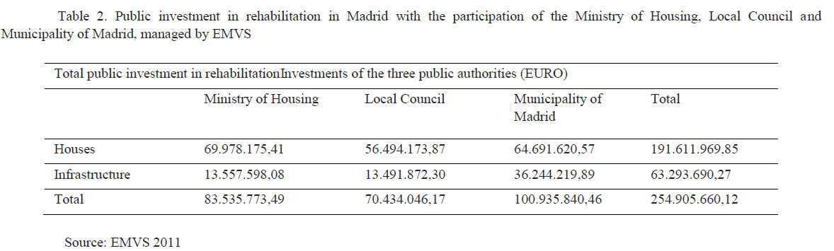

It can be observed that the Ministry of Housing received the most funds for housing repair, followed by the Municipality of Madrid. The Municipality of Madrid, followed by the ministry and the council, allocated the most funds for infrastructure renovation. Then there are partnerships between states in other European projects, such as the INSPIRE programme, which involves eight nations, including Spain. The project's major goal is to look into new directions in the field of energy rehabilitation for homes and businesses. The initiative began in 2009 and was partially sponsored by European money. Its goal is to design and demonstrate whole building energy rehabilitation using cutting-edge technology on building facades, energy producing systems, and renewable energy consumption. On the other hand, there is another group of project issues on the table.

Historical and cultural preservation of historical buildings and archaeological monuments, as well as rehabilitation and revitalization of historical sections of the city. Another important category is the rehabilitation projects of internationally renowned hotel brands (luxury 5-star hotels) that are intended to boost the capital status by hosting large international events.

**Urban regeneration in Italy**

As previously indicated, the topic of sustainable urban regeneration will be a focus of development policies in all countries in the next years. For example, city development difficulties are and will continue to be a major concern for Italian architects in the next years. Cities in Italy, as in most other nations, are in jeopardy as a result of energy depletion and the bad state of the postwar building fund (CNAPPC, 2011). The National Council of Architects, Planners, and Landscape Architects (CNAPPC) of Italy believes that there has been a true urban dehumanisation, as evidenced by the lack of public spaces, increased land consumption to alarming levels, uncontrolled growth in the number of vehicles, excessive consumption and high prices for energy, waste, and recyclable materials. Programs for urban redevelopment in general The goal is to improve the quality of urban life in order to increase the city effect. Strategic directions were identified, and conditions were created for strengthening and enhancing social capital, attracting financial resources to transform public and private spaces for the regeneration of historical centres, housing districts, private homes, and the landscape through these programmes. Suburbs should not be overlooked; in fact, their rehabilitation should be the beginning point for resolving tough problems at the urban and environmental levels (both in terms of construction as well as environmental).

(Real Estate and Planning Economic and Social Research Center), According to the study, half of Italian inhabitants believe they live in earthquake-safe buildings, whereas just 6% of respondents live in safe residences, and only 10% of the 24 million Italians living in seismic areas believe they are secure in an earthquake. Another issue is indoor air pollution, with 83.3 percent believing that their home is impacted by the use of unhealthy materials, despite the fact that the majority of structures were built before 1991, prior to the implementation of legislation governing the main harmful elements used in construction (Regioni e Ambiente, 2012). Given that the beneficiary of sustainable urban regeneration is a citizen, he has the right to know the truth about the safety of the building in which he lives and has invested, often relying on mortgages for the rest of his life. As a result, the authorities, through their actions in the city,

The quality of life and security of inhabitants must be improved as part of the redevelopment strategy. The Government, Parliament, the National Council of Architects (CNAPPC), and the National Association of Constructors (ANCE) in Italy proposed the creation of a national plan for sustainable urban regeneration, with the following goals: • security, maintenance, and restoration of public and private urban heritage; • drastic reduction of energy and water consumption by the population; • valuing of public spaces, urban green areas, and housing district services; (Regioni e Ambiente, 2012).

1. **CONCLUSION**

Based on the findings of this research, it can be concluded that all countries have launched various urban rehabilitation schemes, both in their capitals and in their other cities. These are integrated rehabilitation projects in which new urban actors, as well as traditional urban actors, participate. These initiatives are also funded in part by European funding, which account for 50% of the total project cost. In addition, the conclusion is that sustainable urban rehabilitation is an absolutely necessary and irreversible process aimed at revitalizing urban structure, rehabilitating public use areas, rehabilitating entire urban infrastructure, rehabilitating residential buildings, including total energy rehabilitation, rehabilitating monuments and historical areas, rehabilitating collective use equipment, and improving mobility and urban transport. The conclusion is also that integrated sustainable urban regeneration is a synthesis of feasible solutions, through which existing cities are supported by implementing bold policies, rebuilding and renewing structures and public spaces, avoiding the use of land, and conserving resources., reducing energy use, enhancing traffic flow, and streamlining the process creation of garbage Urban rehabilitation entails enhancing one's quality of life while also investing in the future. It's a large area. undertaking that is tough but not impossible, yet must be completed as soon as feasible.

1. **REFERENCES**

* Albu L.L. (2006), Analysis of very long-term sustainability factors, National Institute of Economic Research; Retrieved 12 march 2013, from:
* http://www.ince.ro/IPE-2006-site.pdf;ieved 26 march 2013, from: http://www.hotnews.ro/stiri-arhiva-

1144187-orice-proiect-este-unul-regenerare-urbana.htm;

* http://www.constructiibursa.ro/s=stiri&articol=9521.html;ustainable
* http://www.theplan.it/J/attachments/1987_invito_28%20ottobre_INTERNO%20.pdf;
* http://www.elmundo.es/elmundo/2012/06/21/suvivienda/1340305386.html?a=c8b73098c3e973bb5e03f54088990903&t=1363938420;
* from:http://www.five.es/descargas/archivos/Regenera/02_Agustin%20Arroyo_RioManzanares_EMVS.pdf;
* http://eraikal.blog.euskadi.net/blog/2013/03/22/rehabilitacion-de-la-ciudad-de-los-angeles-de-madrid/;26 march 2013, from: http://www.b365.ro/cum-va-arata-bucurestiul-in-2013-cele-mai-importante-proiecte-ce-se-vor-inaugura-incapitala_185847.html;
* Ministry of Public Works Develop - principles and practices in Europe - "A
* http://www.mdrl.ro/_documente/publicatii/2007/Brosura%20Ghid%20informativ%20privind%20Regenerarea%20Urbana%20-%20principii%20si%20practici%20europene.pdf;25 march2013, from:
* http://www.lexcivitas.ro/images/stories/norme/Declaratia-Toledo.pdf;
* http://www.primariasector1.ro/strategie-regenerare-urbana.html