T.Nagamani1 , P.Deekshith2 , P.Karthik3, V.Vijaykumar4 K.Surendrababu5 ,

Dept of ECE,SREC, Nandyal. Gmail: t.nagamani11@gmail.com

**Abstract**

Due to its capability to instantly see the vascular distribution within a thyroid nodule, contrast-enhanced ultrasonography (CEUS) has become a preferred imaging modality for thyroid nodule detection. A variety of learning-based techniques have recently been developed with the goal of mining pathologically-related enhancing dynamics and making predictions in one step while ignoring a native diagnostic dependency. In clinics, the identification of pathological kinds always comes after the distinguishing of benign from malignant nodules. In this study, we present a novel hierarchical temporal attention network (HiTAN) that integrates dynamic enhancement feature learning and categorization of nodules into a complex hierarchy.

This technique, specifically, breaks down the diagnosis of nodules into a two-stage classification work that is ordered, with diagnostic reliance modeled by Gated Recurrent Units (GRUs).Along the hierarchical prediction path , we also create a local-to-global temporal aggregation (LGTA) operator to achieve a thorough temporal fusion. Local temporal information is specifically described as common enhancement patterns seen in the direction of perfusion representation discovered at the differentiation level. The next step is to incorporate global enhancing dynamics into each recognized salient pattern using an attention mechanism. On the gathered CEUS thyroid nodule dataset, we assess the proposed HiTAN approach in this work. The effectiveness of dynamic patterns learning, fusion, and hierarchical diagnosis mechanisms has been well tested alone dynamic enhancement characteristics fusion, currently rely on manually created feature extraction from a single CEUS image without data-driven enhancement pattern representations.

Key words: CEUS, HiTAN, GRU, LGTA, Thyroid nodule, patterns learning, fusion, and hierarchical diagnosis.

**I. Introduction**

Despite having distinct clinical definitions, these variables' numerical recordings frequently exhibit subjectivity. Few learning-based methods, much alone dynamic enhancement characteristics fusion, currently rely on manually created feature extraction from a single CEUS image without data-driven enhancement pattern representations. Third, whereas our method has taken advantage of the more difficult problem of pathological recognition, which contains a hierarchical lesion recognition mechanism, existing methods largely concentrate on the binary separation of benign and malignant nodules. Whereas our approach, which includes a hierarchical lesion recognition mechanism, has taken advantage of the more difficult problem of pathological recognition.With the aid of dynamic CEUS imaging, we suggest the hierarchical temporal attention network (HiTAN) technique for classifying various nodule kinds. The suggested HiTAN builds a hierarchical classifier in which fine-grained nodule detection is made conditional on the knowledge acquired from coarse-grained classification in order to model the diagnostic reliance of various phases.

Additionally, since the global perfusion representation recovered at the coarse-grained step directs the development of the temporal attention score, the hierarchical relationship also includes of automatically selected local key frames. Since the global perfusion representation acquired at the coarse-grained stage serves as a reference for the development of the temporal attention score. This technique, which benefits from task-oriented, hierarchical feature representation learning, can quantify various perfusion patterns with increased description power. The inclusion of a hierarchical nodule classification mechanism and the design of a local-to-global temporal fusion module, which models a thorough analysis of local enhancement patterns (such as ring-like enhancement) and global perfusion tendency (such as concentric or dispersed enhancement, fast wash-in or slow fade-o), are two additional major advantages over general CNN-based video classification models.

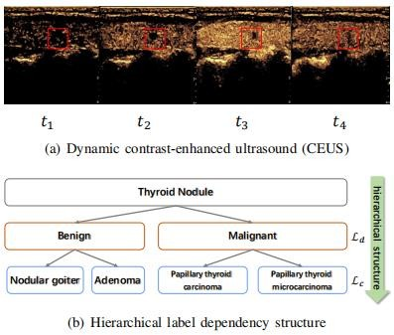

Fig1.1.Dynamic CEUS

**II. Module Description:**

**2.1 Contrast-enhanced ultrasound**

Due to its capability to instantly see the vascular distribution within a thyroid nodule, contrast-enhanced ultrasonography (CEUS) has become a preferred imaging modality for thyroid nodule detection. A variety of learning-based techniques have recently been developed with the goal of mining pathologically-related enhancing dynamics and making predictions in one step while ignoring a native diagnostic dependency. Since the global perfusion representation acquired at the coarse-grained stage directs the development of the temporal attention score, the hierarchical relationship also includes of automatically selected local key frames.

**2.2 Hierarchical**

In this study, we present a novel hierarchical temporal attention network (HiTAN) that integrates dynamic enhancement feature learning and hierarchical nodules classification into a deep framework for thyroid nodule identification using dynamic CEUS imaging. The diagnosis of nodules is broken down specifically into a two-stage classification task that is ordered, with diagnostic reliance modelled by Gated Recurrent Units.

In the therapeutic workflow, a hierarchical (coarse-to-fine) identification procedure is essential. According on a few typical enhancement patterns, radiologists typically first evaluate if a lesion is benign or malignant. Then, they further differentiate between different pathological types within the candidate set of benign (malignant) types.

**2.3 Temporal attention**

To describe a coarse-to-fine diagnostic process, from coarse-grained (benign/malignant) distinction to fine-grained (pathological type) characterization, a hierarchical temporal attention network (HiTAN) was developed. In order to simulate the complex temporal relation, a local-to-global temporal aggregation mechanism could be incorporated in this fashion.

In this study, we present a novel hierarchical temporal attention network (HiTAN) that integrates dynamic enhancement feature learning and hierarchical nodules classification into a deep framework for thyroid nodule identification using dynamic CEUS imaging. This technique, specifically, breaks down the diagnosis of nodules into a two-stage classification work that is ordered, with diagnostic reliance modelled by Gated Recurrent Units.

**2.4 Thyroid nodule**

Using thyroid nodules as an example, homogeneous and ring enhancement are two typical patterns for benign nodules, whereas hypo-enhancement and heterogeneous enhancement are two important markers of malignancy, particularly for nodules with a diameter of 10 mm or smaller.However, due to the operator-dependent diagnostic technique, today's clinical decisions heavily rely on the radiologists' competence (e.g., identifying an optimal frame where the lesion boundary is well-distinguished from surrounding parenchyma; assessing perfusion patterns by observing the whole sequence back and forth).

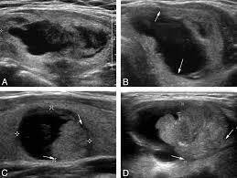

Fig.2.4 Thyroid nodule

**2.5 Technique:**

To overcome the informational constraint, we anticipate that a sizable multi-modal thyroid US dataset (e.g., B-mode US, colour Doppler US, and elastography US, etc.) may be gathered. By that time, a multi-modal US analysis platform that integrates this kind of video classification methodologies with traditional radionics analysis procedures might deliver more accurate diagnosis outcomes.Second, based on the segmentation mask produced by CEUS-Net, informative perfusion zones are defined, and the bounding box is increased by a fixed factor to include the blood supply data of the surrounding parenchyma.The capacity for dynamics learning may be further aided if this parameter was made learnable, i.e., the fraction of normal tissues contained was adaptable to different themes.

The improved model interpretability, which results from the integration of a hierarchical nodule classification mechanism and the design of a local-to-global temporal fusion module that models a thorough analysis of local enhancement patterns, is another significant advantage over general CNN-based video classification models.

**III. Methodology:**

1) Frame level enhancement representation learning module;

2) Hierarchical lesion recognition module;

3) Local-Global temporal aggregation module.

We refer to the coarse-grained classification of benign (malignant) tissue as "differentiation" and the fine-grained pathological recognition as "characterization" in our technique is assessed using thyroid nodule datasets that we have gathered. Experimental results showed that our suggested HiTAN technique can not only outperform those competing methods in terms of diagnostic performance, but it can also recognize salient perfusion patterns with significant diagnostic value. We could see that the majority of research that have been done so far have focused on measuring temporal dynamics and making diagnostic predictions at a certain point, either by differentiating between benign and malignant tissue or by identifying pathologies.

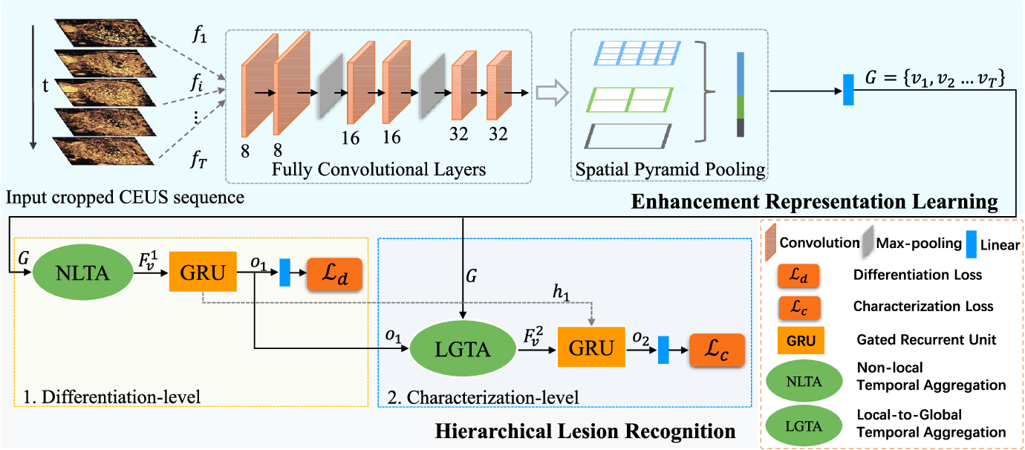

Fig. 3.1 Frame of Hi TAN

**IV. Results:**

Results of six groups of studies using various combinations of nodule kinds that were classified. Each type's sensitivity, mean accuracy, macro precision, macro recall, and macro f1-score (%) were provided. According to the local structures of the face picture, the terms a and b in "a b" represent for the mean and standard deviation. Elastic Bunch Graph Matching (EBGM) is one of the most effective works in the Feature-based technique [50, 51]. To create a face representation in this method, the Gabor response characteristics are computed from various locales and rotations of the face image. An Artificial- NeuralNetwork (ANN) kind of structural classifier is applied for recognition based on this face representation.

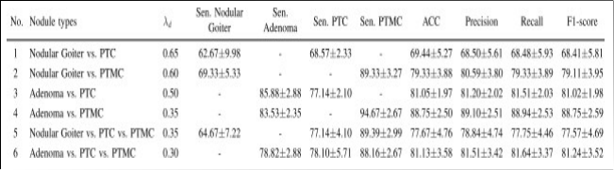

Table: 4.1 Nodule types and measurements values

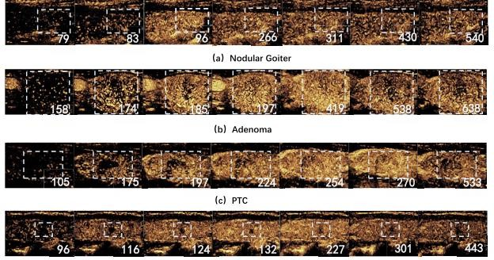

Fig .4.1 Delineated contrast regions

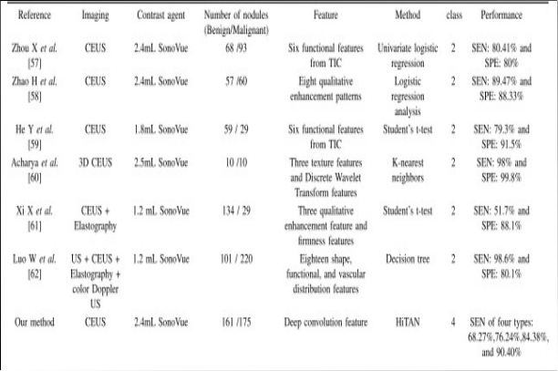

Table 4.2 State of the thyroid studies

## Simulation Results

|  |
| --- |
|  |
|  | C:\Users\admin\AppData\Local\Temp\ksohtml5452\wps3.png |

fig 4.3. Output simulation

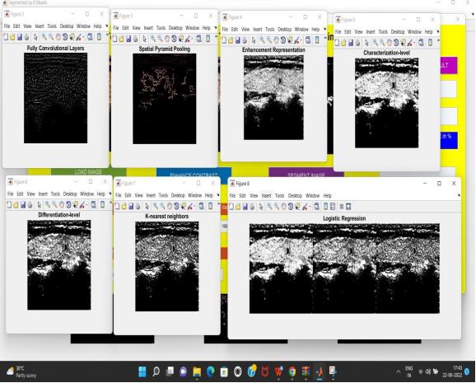

fig .4.4 Output images

**V. Conclusion:**

A hierarchical temporal attention network (HiTAN) was suggested in this paper to represent a coarse-to-fine diagnostic approach, that is, from coarse-grained (benign/malignant)differentiation to fine-grained (pathological type) classification. In order to simulate the complex temporal relation, a local-to-global temporal aggregation mechanism could be incorporated in this fashion.

The efficiency of our method on automatic enhancement pattern representation, temporal modelling, and hierarchical dependence has been thoroughly assessed on our collected thyroid nodule dataset. Our suggested solution has outperformed or at least been on par with various cutting-edge CAD methods in terms of recognition performance.The dynamic enhancing properties are fully taken into consideration in our devised temporal fusion and hierarchical recognition process, which is more significant and leads to a more understandable model prediction.

**VI .Future Work:**

By that time, a multi-modal US analysis platform that fuses traditional radiomic analysis methods with these kinds of video classification algorithms could be able to provide more accurate diagnosis outcomes.On the basis of the segmentation mask produced by CEUS-Net, informative perfusion zones are identified, and the bounding box is extended by a fixed factor to include the blood supply data of the surrounding parenchyma.Even though we've run a number of studies to talk about the ideal expanding proportion value, it still isn't adaptable enough to be set as a fixed proportion for all CEUS sequences.

The capacity for dynamics learning may be further aided if this parameter was made learnable, i.e., the fraction of normal tissues contained was adaptable to different themes. If our data size is large enough, another workable strategy is to use the ROI-Pooling to concentrate on informative perfusion zones and add a weakly-supervised detection branch to the original classification network.

**Reference:**

[1] P. Dijkmans, L. Juffermans, R. Musters, A. van Wamel, F. Ten Cate, W. van Gilst et al., “Microbubbles and ultrasound: from diagnosis to therapy,” European Journal of Echocardiography, vol. 5, no. 4, pp. 245– 246, 2004.

[2] K. Seitz, T. Bernatik, D. Strobel, W. Blank, M. Friedrich-Rust, H. Strunk et al., “Contrast-enhanced ultrasound (CEUS) for the characterization of focal liver lesions in clinical practice,” Ultraschall in Der Medizin, vol. 31, no. 05, pp. 492–499, 2010.

[3] I. Sporea, R. Sirli, A. Martie, A. Popescu, and M. Danila, “How useful is contrast enhanced ultrasonography for the characterization of focal liver lesions?” Journal of Gastrointestinal & Liver Diseases, vol. 19, no. 4, 2010.

[4] M. Tang, H. Mulvana, T. Gauthier, A. Lim, D. Cosgrove, R. Eckersley et al., “Quantitative contrast-enhanced ultrasound imaging: A review of sources of variability,” Interface Focus, vol. 1, no. 4, pp. 520–539, 2011.

[5] S. Delorme and M. Knopp, “Non-invasive vascular imaging: Assessing tumour vascularity,” European Radiology, vol. 8, no. 4, pp. 517–527, 1998.

[6] K. Wei, E. Le, J.-P. Bin, M. Coggins, J. Thorpe, and S. Kaul, “Quantification of renal blood flow with contrast-enhanced ultrasound,” Journal of the American College of Cardiology, vol. 37, no. 4, pp. 1135–1140, 2001.

[7] J. Folkman, “Role of angiogenesis in tumor growth and metastasis,” in Seminars in Oncology, vol. 29, no. 6, 2002, pp. 15–18.

[8] G. Russo, M. Mischi, W. Scheepens, J. J. De la Rosette, and H. Wijkstra, “Angiogenesis in prostate cancer: Onset, progression and imaging,” BJU International, vol. 110, no. 11c, pp. E794–E808, 2012.

[9] J. Zhan and H. Ding, “Application of contrast-enhanced ultrasound for evaluation of thyroid nodules,” Ultrasonography, vol. 37, no. 4, p. 288, 2018.

[10] S. Kondo, K. Takagi, M. Nishida, T. Iwai, Y. Kudo, K. Ogawa et al., “Computer-aided diagnosis of focal liver lesions using contrast-enhanced ultrasonography with perflubutane microbubbles,” IEEE Transactions on Medical Imaging, vol. 36, no. 7, pp. 1427–1437, 2017.