**Gradient Compass-Based Adaptive Multimodal Medical Image Fusion**

**G.SOWMYA1 Y. JYOTHIRMAI2 G. SIRISHA2 T. BHARGAVI2 K. GREESHMA GAYATHRI2**

*1Department of Electronics and Communication, Santhiram Engineering College, India,* E-mail:

sowmya.ece@srecnandyal.edu.in

*2, Department of Electronics and Communication, Santhiram Engineering College, India*

**ABSTRACT**

In medical imaging, the use of different imaging modalities has significantly enhanced the diagnostic information available to physicians. Each type of modality exhibits unique information about the subject being imaged. In many cases, physicians are interested in multimodal information about the same organ, which is complementary in nature and its fusion is often required. A lot of methods are proposed to address the medical image fusion problem. However, the main downside of all such methods is the loss of key features from the input images to the fused image. Additionally, such methods also introduce unwanted artifacts in the fused image. In this work, we present a method for multimodal medical image fusion based on the gradient compass in the spatial domain, which can effectively fuse a pair of multimodal medical images. The primary objective of this work is to overcome the limitations of mono modal medical images by merging the two types of medical images i.e., CT which is suited for viewing boney structures and MRI is appropriate for examining tissue structure, this can increase the visual experience by transferring correct and sufficient information from the source images to the fused medical image. In the proposed method an edge detail is extracted from the source multi modal medical images in eight different directions, which provides significant data for the construction of an edge map of the source medical images. With the help of constructed edge maps two detail medical images are generated, by utilizing statistical properties of the detail medical images weight matrices are obtained and finally adaptive pixel fusion is performed between source CT and MRI images.

**INTRODUCTION:**

Digital image processing is an area characterized by the need of extensive experimental to establish the viability of proposed solutions for a given problem. An important characteristic underlying the design of image processing is the significant level of testing and experimentation that normally is required before arriving at an acceptable solution. It plays a major role in reducing the cost and time required to arrive at a viable system implementation.

Image fusion is a sub-field of image processing in which more than one image are fused to create an image where all the objects are in focus. Image fusion is most significant importance due to its application in medical science, forensic and defense departments. Image fusion process is performed in multi-sensor and multi-focus images of the same scene. Multi sensor images of the same are captured by different sensors where multicast images are captured by the same sensor. In multi-focus images, the objects in the scene which are closer to the camera are in focus and the farther objects get blurred.

**LITERATURE SURVEY:**

This project describes, the main objective of the image fusion is to merge features from several different input images into one image which becomes more reliable and easier to understand. In this project a survey is taken into account on different earlier methods used in fusion of multimodal medical images. Commonly techniques used for image fusion can be classified into various levels. Techniques used for medical image fusion can be classified into three, namely feature based image fusion, decision level image fusion, and pixel intensity-based image fusion. Feature based medical image fusion. The feature-based image fusion algorithms are usually combines the region of interest in multiple input multimodalities. Here various features are extracts from the images like edges, corners, texture parameters, lines etc., from input modalities and combine them into one feature image for further processing. Decision level medical image fusion. The decision based fusion techniques mainly depends on the training data set and perform fusion. The dictionary learning fusion is commonly using decision level technique. The results that were obtained from different algorithms are denoted as confidences rather than decisions, then it is called soft fusion, and otherwise it is called hard fusion. Pixel intensity-based image fusion. The pixel based medical image fusion techniques is divided in to following sub stages such as, preprocessing, decomposition, fusion rules and fusion performance evaluation . The pixel level image fusion is preferably using in medical image fusion due to the key advantages over feature based and decision based techniques. Visual clarity is very informative in pixel intensity-based Multimodal medical images give integral data like auxiliary image also higher spatial determination gives more life system data while the functional image contains useful data of tissues. There are many different methods used in medical field for the fusion of different modalities in the medical images.

**METHODOLOGY**

Proposed multi modal medical image fusion method fuse two images of the same organ having different modalities with the help of gradient compass on pixel level. Here image ‘‘A’’ is Computed Tomography (CT) with anatomical information regarding bones, CT technology utilizes X-rays to generate medical images of the internal organs of the body and image ‘‘B’’ is Magnetic Resonance Image (MRI) with anatomical information of the tissues. MRI uses and radio frequency pulses and powerful magnetic fields to make detailed medical images of the internal body structures of an interest. The proposed method is further divided into four sub steps

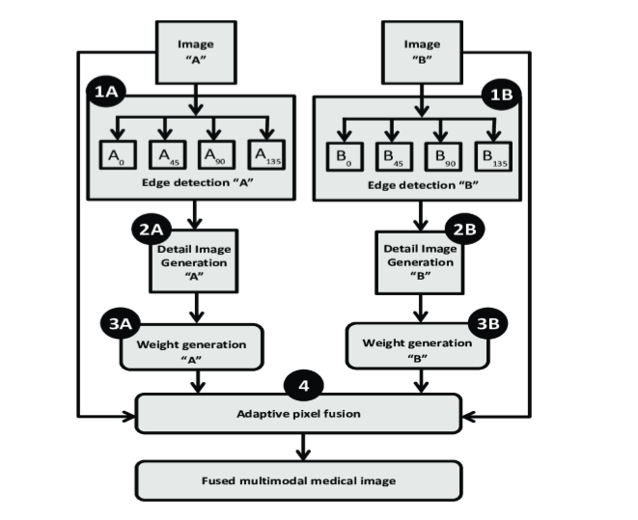

Fig 1.Block diagram of proposed model

## Multimodal Medical Image Fusion set 1 Images

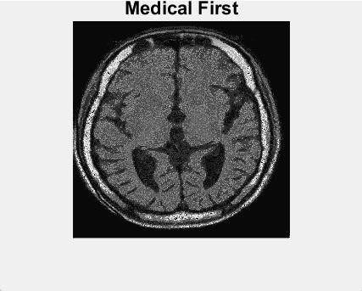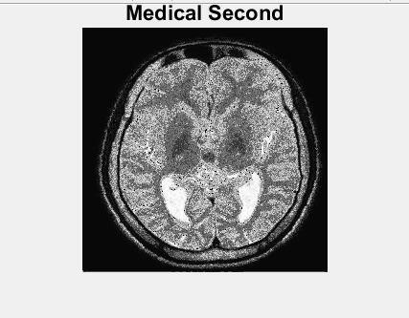

Fig. 2(a): Image 1 Fig. 2(b): Image 2

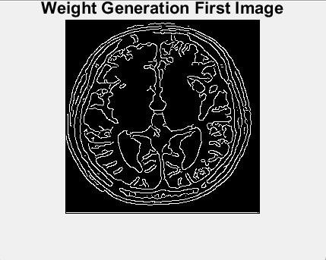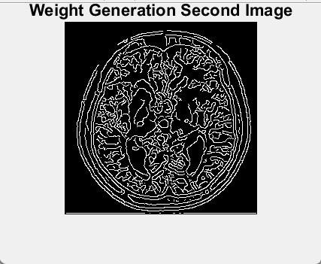

Fig. 2(c): weighted generation Fig. 2(d): weighted

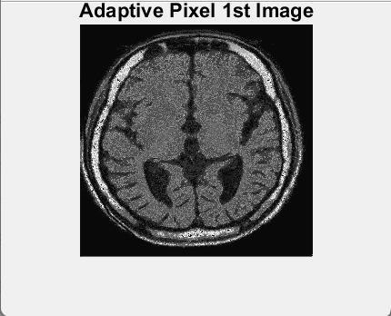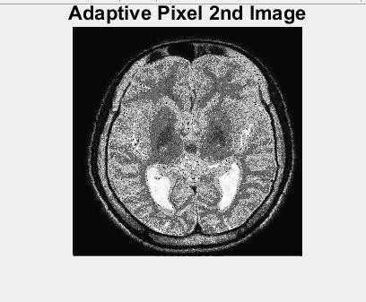

Fig. 2(e): Adaptive pixel Fig. 2(f): Adaptive pixel

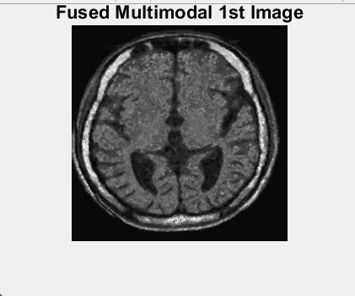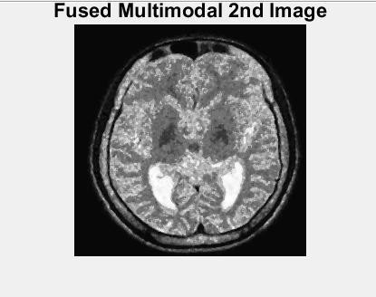

Fig. 2(g): Fused multimodal Fig. 2(h): Fused multimodal

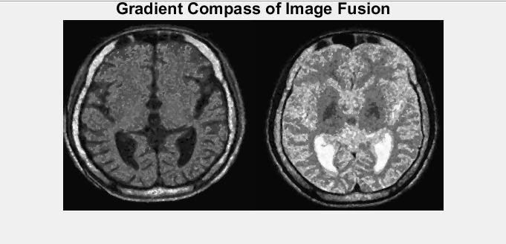

Fig. 2(i): Gradient Compass of Image Fusion

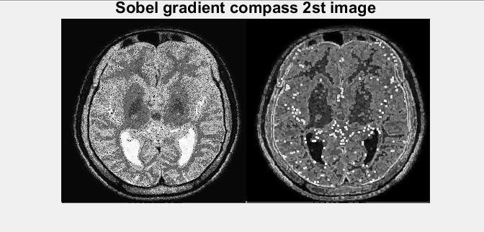

Fig. 2(k): Sobel gradient compass

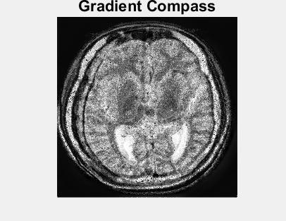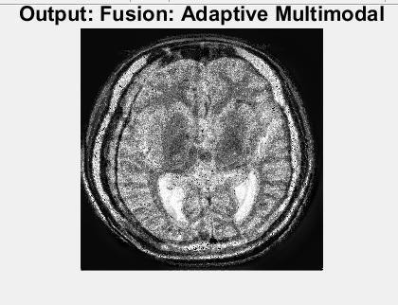

Fig. 2 (l): Gradient Compass Fig. 2(m): Fusion Image

|  |  |  |  |  |  |  |
| --- | --- | --- | --- | --- | --- | --- |
| Method  Fusion Metrics | MIN | PCA | DWT- MIN | DCT- AVG | DCT- PCA | Proposed Method |
| Standard Deviation | 58.2056 | 68.9913 | 56.1010 | 67.6788 | 67.8210 | 72.4671 |
| SSIM | 0.6247 | 0.6292 | 0.6290 | 0.6112 | 0.6014 | 0.6985 |
| PSNR | 10.7097 | 12.2519 | 11.2624 | 12.5555 | 13.0561 | 13.2423 |

**Table 1**: Tabular column for set 1 images

### CONCLUSION:

In the current clinical setup medical image fusion algorithms are a valuable tool for researchers and medical experts in the fields of diagnostics, diseases evolution, treatment planning and medical research, without medical image fusion technology the domain of medical image processing is considered incomplete. As multimodal clinical scans of an organ possess significant information, to combine this vital information into a single representative medical imagery, medical fusion is a prime step, owing to its importance; in the last few years multimodal medical image fusion attracts much attention and a lot of research has been done for the improvement and development of new multimodal medical image fusion methods. In this project, an efficient gradient compass based adaptive multimodal medical image fusion technique is presented to fuse Computed Tomography (CT) and Magnetic Resonance Imaging (MRI) images of the brain. Several image pairs of the brain MRI and CT are used to assess the performance of the proposed method. The proposed algorithm has shown good performance as compared to other techniques in terms of visual quality and fusion performance parameters.

### FUTURE SCOPE:

The future work will focus on the following areas: firstly, the experimentation on larger study sets can be performed to measure the robustness of the proposed algorithm and its effectiveness for diagnosis and analysis. Secondly it can be designed and tested on clinical study sets so that it may be included in a Computer-Aided Detection and Diagnosis (CADD) tool.

Some image processing applications require an accurate determination object boundary. In future research, the present algorithms can be extended with the help of morphological operations to extract the boundary of the medical objects which in turn useful in image topology.

# REFERENCES

1. J. Woo, M. Stone, and J. L. Prince, ‘‘Multimodal registration via mutual information incorporating geometric and spatial context,’’ IEEE Trans. Image Process., vol. 24, no. 2, pp. 757–769, Feb. 2015.
2. J. S. Duncan and N. Ayache, ‘‘Medical image analysis: Progress over two decades and the challenges ahead,’’ IEEE Trans. Pattern Anal. Mach. Intell., vol. 22, no. 1, pp. 85– 106, Jan. 2000.
3. W. G. Bradley, ‘‘History of medical imaging,’’ Proc. Amer. Phil. Soc., vol. 152, no. 3, pp. 349–361, 2008.
4. D. Geoff, Digital Image Processing for Medical Applications. New Delhi, India: Cambridge Univ. Press, 2009.
5. M. Moseley and G. Donnan, ‘‘Multimodality imaging: Introduction,’’ Stroke, vol. 35, pp. 2632–2634, Sep. 2004.
6. J. A. Maintz and M. A. Viergever, ‘‘An overview of medical image registration methods,’’ in Proc. Symp. Belg. Hospital Physicists Assoc. (SBPH/BVZF), vol. 12, 1996, pp. 1–22.
7. S. Li, X. Kang, and J. Hu, ‘‘Image fusion with guided filtering,’’ IEEE Trans. Image Process., vol. 22, no. 7, pp. 2864–2875, Jul. 2013.
8. B. Zitová and J. Flusser, ‘‘Image registration methods: A survey,’’ ImageS Vis. Comput., vol. 21, no. 11, pp. 977–1000, Oct. 2003.
9. L. G. Brown, ‘‘A survey of image registration techniques,’’ ACM Comput. Surv., vol. 24, no. 4, pp. 325–376, 1992.
10. F. Liu, L. Chen, L. Lu, A. Ahmad, G. Jeon, and X. Yang, ‘‘Medical image fusion method by using Laplacian pyramid and convolutional sparse representation,’’ Concurrency Comput., Pract. Exper., vol. 32, no. 17, p. e5632, Sep. 2020.
11. S. Maqsood and U. Javed, ‘‘Multi-modal medical image fusion based on two-scale image decomposition and sparse representation,’’ Biomed. Signal Process. Control, vol. 57, Mar. 2020, Art. no. 101810.
12. S. Karthick and S. Maniraj, ‘‘Different medical image registration techniques: A comparative analysis,’’ Current Med. Imag. Formerly Current Med. Imag. Rev., vol. 15, no. 10, pp. 911–921, Nov. 2019.
13. F. E.-Z.-A. El-Gamal, M. Elmogy, and A. Atwan, ‘‘Current trends in medical image registration and fusion,’’ Egyptian Informat. J., vol. 17, no. 1, pp. 99–124, Mar. 2016.
14. Y. Liu, X. Chen, H. Peng, and Z. Wang, ‘‘Multi-focus image fusion with a deep convolutional neural network,’’ Inf. Fusion, vol. 36, pp. 191–207, Jul. 2017.
15. H. Li, H. Qiu, Z. Yu, and B. Li, ‘‘Multi focus image fusion via fixed window technique of multi scale images and non-local means filtering,’’ Signal Process., vol. 138, pp. 71–85, Sep. 2017.
16. B. Meher, S. Agrawal, R. Panda, and A. Abraham, ‘‘A survey on region-based image fusion methods,’’ Inf. Fusion, vol. 48, pp. 119–132, Aug. 2019.