**FISH AGGREGATING DEVICE, DOES IT INCREASE THE EFFECTIVENESS OF FISHING ACTIVITY?**

**Lantun Paradhita Dewanti, Izza Mahdiana Apriliani, Heti Herawati**

Fisheries Department, Faculty of Fisheries and Marine Science, Universitas Padjadjaran, Bandung, Indonesia

**ABSTRACT**

The use of the fish aggregating device (FADs) in fishing activities has become a fishing tool that is widely used by fishers in Indonesia. As a function of artificial habitat, FADs are the choice of fishers in the fishing operation of several types of fishing gear because they can be a shelter for several types of fish as the main catch commodity. fish attracted around FADs are caused by several factors, including FADs as a shading place for certain types of fish, as a feeding ground, as a substrate for placing eggs, as a shelter from predatory fish attacks, and as a point of contact and navigation reference (meeting point) for migratory fish. This paper aims to review a number of research that has been carried out regarding the use of FAD in various sample locations. The method used is a literature study by collecting papers in accordance with the chosen theme. The analysis was carried out descriptively qualitative. The results of the study show thatThe effectiveness of using FADs from various research results shows mixed results. However, in general, the use of these FADs increases the effectiveness of fishing operations. Each caught commodity has different characteristics, different water areas, and different fishing gear. This causes the various types of FADs that exist throughout the Indonesian Territory.

**Keywords:** fishing, fisheries, fish aggregating device, fish commodity

1. **INTRODUCTION**

Indonesia has a total estimated potential fish resources of 12.01 million tons per year with a total allowable catch of 8.6 million tons per year. The estimated potential is divided into nine groups of fish resources, namely demersal fish, reef fish, small pelagic, squid, penaeid shrimp, lobsters, small crabs, crabs, and large pelagic [1]. These fish resources are spread over 11 fisheries management areas in Indonesia. The eleven regions have different characteristics, in consequence, the management and wealth of fish resources, each has its own differences. FADs have been operated in Indonesia since 2000 as a tool for catching tuna. To increase the effectiveness of fishing, the use of FADs is an option for Indonesian fishermen. In subsequent developments, trolling line fishing in the southern waters of Java Island began to use them to catch tuna [2].

Simbolon et al. [3] stated that catch productivity around FADs can increase catch productivity. FADs are expected to increase capture fisheries productivity and lower fishing operating costs because fishermen can take into account the distance between the port and the fishing area (where FADs are placed) to be addressed. The use of FADs can save operational costs, save time to catch areas, and save fuel [4]. FADs commonly used by fishermen and entrepreneurs throughout Indonesia are FADs that are installed permanently in one water, so they cannot be moved to other waters [5]. Samples & Sproul [6] stated that the fish attracted around FADs are caused by several factors, including FADs as a shading place for certain types of fish, as a feeding ground, as a substrate for placing eggs, as a shelter from predatory fish attacks and as a point of contact and navigation reference (meeting point) for migratory fish. The development of FAD construction technology can be made by modifying the main components or creating new structures according to the objectives and functions of FADs [7]. Productivity of different FADs can be caused by different constructions, including various attractor lengths, installation locations that are not in potential fishing zones, as well as physical water factors including depth and distance of FADs from the shoreline [8]. This paper aims to review a number of research that has been carried out regarding the use of FAD in various sample locations.

1. **METHOD**

The method used is a literature study by collecting papers in accordance with the chosen theme. The analysis was carried out descriptively qualitative

1. **RESULTS AND DISCUSSION**
   1. FADs Constructions

**Fixed FAD equipped with an anchor**

In general, the construction of anchored FADs in tuna fisheries consists of buoys in the form of bamboo rafts, cork or pontoons made of steel/fiberglass, attractors made of coconut or palm leaves, rigging made of natural materials, especially rosella fiber, swivels of steel and weights/anchors of bamboo. concrete materials [9].

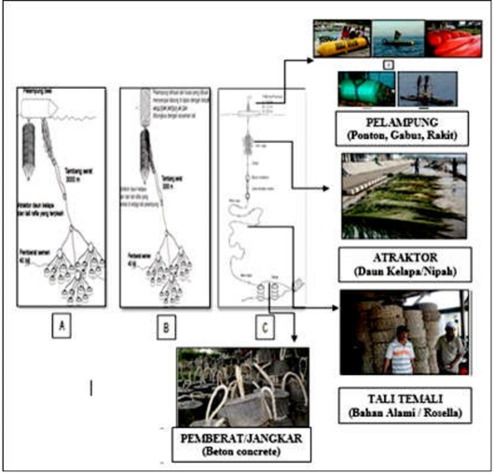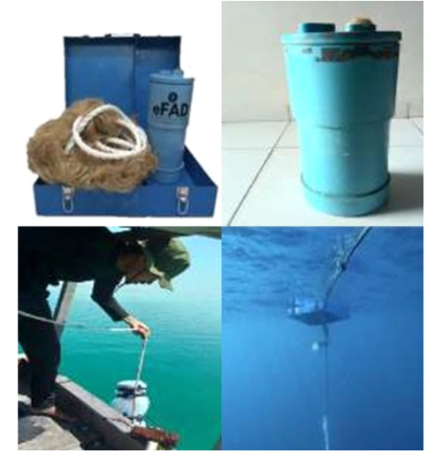

Figure 1. a. Fixed FAD equipped with an anchor [9]; b. Portable FADs [10]

**Portable FADs**

Portable FADs with a length of 53 cm, a width of 20 cm and a height of 40 cm are assembled in an operation consisting of a suitcase that functions as a buoy and also puts a portable FAD, a rope as a tie rope and the main rope for FADs 9 meters long, an electric fish attractor (EFA) with a fiber frame that emits sound with a frequency of 11,000-15,000 ballast made of a hammer made of iron weighing 5 kg [10].

**FADs on bamboo rafts and plastic drums**

Both types of FADs use the same type of attractor, namely coconut leaves, but the number of attractors in bamboo FADs is higher (15 coconut leaf midribs) when compared to plastic drum FAD attractors (10 coconut leaf midribs). Installation of sample FADs is located around the coast with water depths ranging from 200-300 m [3].

**Squid FAD**

The main ingredient of this research is squid FAD which has been modified. Modified types of squid FADs consist of 2 types, namely box-shaped squid FADs with a size of 75 x 50 x 35 cm3 with a wooden skeleton and a -shaped squid FAD cylindrical from used drums [11].

**Sea urchin FADs**

Portable FADs whose use can be used at sea and on land [12]

- The construction of the sea urchin FAD consists of the middle ball and the legs of the sea urchin FAD.

- The legs of sea urchin fish FADs are made of pipe material and are used as shelters or fishing aids.

- The weight of one sea urchin construction reaches weight of 3 Kg.

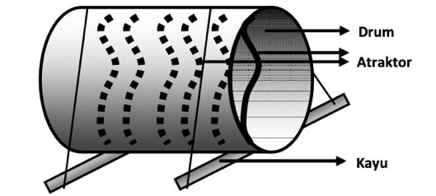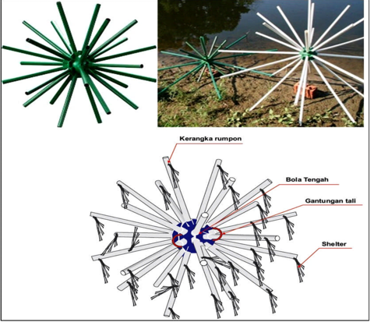

Figure 2. a. Squid FADs [11]; b. Sea Urchin FADs [12]

* 1. **FADs Effectiveness**

The effectiveness of using FADs from various research results shows mixed results. However, in general the use of these FADs increases the effectiveness of fishing operations. Each caught commodity has different characteristics, different water areas, different fishing gear. This causes the various types of FADs that exist throughout the Indonesian Territory.

Table 1. Various Research using FADs for increase the fishing production

|  |  |  |  |
| --- | --- | --- | --- |
| **No.** | **FADs Effectiveness** | **Location** | **Source** |
| 1. | Attachment of squid eggs was more effective on cylindrical FADs | Bangka Belitung Province (FMA 711) | Syari et. al. 2014 [11] |
| 2. | 94% have the perception that portable FADs can increase catch productivity, but there are also 60% of respondents who think that the use of portable FADs has the potential to create social conflict | Panggang Island, Seribu Island District (FMA 712) | Simbolon et. al. 2022 [10] |
| 3. | Type of bamboo FAD was more efective compared with the plastic drum FAD type. Purse seine fishing was more efective compared with gillnet and troll line fishing that operated around rumpon | Key Kecil Island, Maluku (FMA 715) | Simbolon et. al. 2011 [3] |
| 4. | The effectiveness of purse seine operated around FADs is 74.77% and purse seines that are not operated around FADs have an effectiveness value of 25.23%. | Pusong, Lhokseumawe Citu, Nagroe Aceh Darusalam (FMA 571) | Chaliluddin et. al. 2018 [4] |
| 5. | Yellowfin tuna caught in the waters around the Indian Ocean FADs are dominated by fish that have experienced gonadal maturity or are suspected of having spawned. | South Bali and Lombok (FMA 573) | Muhammad 2012 [13] |
| 6. | The productivity of ring trawlers and handlines in Pacitan which is operated around deep sea FADs has decreased | West Indian Ocean Indonesia (FMA 573) | Prayitno 2017 [14] |

1. **REFERENCES**
2. Ministerial Decree KP 87 2022
3. Nurani, T. W., Wahyuningrum, P. I., Maarif, R., & Wiratama, B. (2012). Performance Catch of Tuna From Troll Line in FADs. Marine Fisheries: Journal of Marine Fisheries Technology and Management, 3(1), 1-6.
4. Simbolon, D., Jeujanan, B., & Wiyono, E. S. (2011). The Effectiveness of Using FADs in Fishing Operations in Kei Kecil Waters, Southeast Maluku. Marine Fisheries/ : Journal of Marine Fisheries Technology and Management, 2(1), 19–28. https://doi.org/10.29244/ jmf.2.1.19-28
5. Chaliluddin, M. A., Aprilla, R. M., Affan, J. M., Muhammadar, A. A., Rahmadani, H., Miswar, E., & Firdus, F. (2018). The effectiveness of using FADs as fishing grounds in Pusong Waters, Lhokseumawe City. Depik, 7(2), 119-126.
6. Yusfiandayani, R., Jaya, I., & Baskoro, M. S. (2013). Assessment of Portable FADs for sustainable management of tuna and skipjack. In Proceedings of the Seminar on PPM IPB Results (Vol. 1, pp. 274-291).
7. Samples, K. C., & Sproul, J. T. (1985). Fish Aggregating Devices and Open-Access Commercial Fisheries: A Theoretical Inquiry Bulletin of Marine Science, 37(1), 305-317.
8. Kholis, M. N., Amrullah, M. Y., Martasuganda, S., & Saputra, F. (2020). Study on the Construction Design of Lubuk Larangan FADs in Bungo Regency, Jambi Province. PELAGICUS, 1(2), 71-81.
9. Nurwahidin, N., Musbir, M., & Kurnia, M. (2016). ANALYSIS OF PURSE SEINE PRODUCTIVITY USING FAD FISHING ASSISTANCE IN BONE BAY WATERS. Science and Technology Journal of Fisheries Resource Utilization, 3(6).
10. Wudianto, W., Widodo, A. A., Satria, F., & Mahiswara, M. (2019). Study of deep sea FAD management as a tool for catching tuna in Indonesian waters. Journal of Indonesian Fisheries Policy, 11(1), 23-37.
11. Simbolon, D., Yusfiandayani, R., Putra, D. R., & Limbong, M. (2022). IMPACT OF THE USE OF PORTABLE FADS ON PRODUCTIVITY, DEGRADATION OF FISH RESOURCES AND POTENTIAL SOCIAL CONFLICT OF TRADING FISHING. Indonesian Journal of Fisheries Research, 28(1), 7-17.
12. Syari, I. A., Kawaroe, M., & Baskoro, M. S. (2016). Comparison of the Effectiveness of Squid FADs by Season, Depth and Type of FAD. Indonesian Journal of Fisheries Research, 20(1), 63-72.
13. Murtado, H., Murtadho, M., & Santoso, A. E. (2019). TESTING FISH FISH FAD FRAMEWORK FOR LAND PUBLIC WATERS. Resource and Capture Engineering Research Bulletin, 16(2), 97-98.
14. Muhammad, N., & Barata, A. (2016). Size structure of yellowfin tuna (Thunnus albacares) caught in hand-line around FADs in the Indian Ocean south of Bali and Lombok. BAWAL Widya Capture Fisheries Research, 4(3), 161-167.
15. Prayitno, M. R., Simbolon, D., Yusfiandayani, R., & Wiryawan, B. (2017). Productivity of Fishing Gears Operated Around Deep Sea Fish Aggregating Devices. Marine Fisheries: Journal of Marine Fisheries Technology and Management, 8(1), 101-112.