**Despite Non-Uniform Motion Blur, Illumination, and Noise, Face Recognition**

**V.Nagamani1**, **S. Shakeer2, K. Ramesh3, G. Venkata Dastagiri4, S. Mouneswar5**

1Assistant Professor, ECE Department, Santhiram engineering college, Nandyal, AP, India.

2Student, ECE Department, Santhiram engineering college, Nandyal, AP, India.

3Student, ECE Department, Santhiram engineering college, Nandyal, AP, India.

4Student, ECE Department, Santhiram engineering college, Nandyal, AP, India.

5Student, ECE Department, Santhiram engineering college, Nandyal, AP, India.

**ABSTRACT**

Existing methods for performing face recognition in the presence of blur are based on the convolution model and cannot handle non-uniform blurring situations that frequently arise from tilts and rotations in hand-held cameras. In this paper, we propose a methodology for face recognition in the presence of space-varying motion blur comprising of arbitrarily-shaped kernels. We model the blurred face as a convex combination of geometrically transformed instances of the focused gallery face, and show that the set of all images obtained by non-uniformly blurring a given image forms a convex set. We first propose a non-uniform blur-robust algorithm by making use of the assumption of a sparse camera trajectory in the camera motion space to build an energy function with l1-norm constraint on the camera motion. The framework is then extended to handle illumination variations by exploiting the fact that the set of all images obtained from a face image by non-uniform blurring and changing the illumination forms a bi-convex set. Finally, we propose an elegant extension to also account for variations in pose.

**Keywords:** Image Smoothing – wavelet Transform – Bi-convex set.

**1. INTRODUCTION**

Face detection and recognition has been one of the most popular research topic in computer vision and pattern recognition throughout the past decades. It has many attractive practical applications in systems including but not limited to surveillance, information security, and consumer digital imaging. Compared to other numerous biometrics (such as fingerprint, iris recognition and signature recognition etc.), the face biometric is nonintrusive and requires only minimal cooperation of the enrolled subjects. Thus, face biometric is often preferred in many public and mobile applications where cooperation of the subjects is highly challenging. Recently, face detection and recognition applications on mobile devices (such as smartphones and tablet computers) has gained tremendous attention in both industry and research studies due to the rapid growth of mobile device market and its high demand. There is an strong urge for performance enhancement of face detection and recognition under the requirements of mobile device applications. Face detection and recognition are often used in combination in a typical automated face pattern recognition system (e.g., face authentication system as illustrated in Figure 1.1). Most often, the face detection component is applied in the early stages to find and locate possible human faces from an input image. Face boxes (a set of coordinates and dimensions relative to the origin of the image) are usually marked as the output of detected faces. Facial land marking algorithms are applied to the detected face regions to accurately locate and align key facial features such as eyes, nose and mouth. Lastly, face recognition is applied to the extracted and pre-processed face image for recognition tasks such as: verification, identification and watch list.

**2. METHODOLOGY**

**2.1 Face Detection**

In general, face detection is treated in two different cases: frontal face detection and multiview face detection. Frontal face detection restricts the face captured in the image to be in up-straight frontal position with limited in-plane rotation. In contrast, multi-view face detection does not have such restriction and thus it is more difficult compared to frontal face detection. Usually, multi-view face detection is achieved by making extension to the frontal view face detection techniques. In the scope of this thesis, the main task of face detection is to automatically locate possible frontal human face(s) from an input image using computer vision techniques. The image is usually considered to be a digital still image captured in visible spectrum and the intensity of the image is represented using unsigned integer values with range [0, 255]. In addition, this thesis will mainly focus on face detection using grayscale (luminance component of color images) face images. The rich texture information embedded in the luminance component of an face image is believed to be extremely useful and powerful in distinguishing face images from non-face images. Although there are numerous face detection approaches developed throughout the past decades, this thesis seeks to formulate face detection as the following face object classification/detection problem due to its proven effectiveness in existing research studies. Given an grayscale input image I , a finite set of overlapping scanning windows W is extracted from the image. Each scanning window wi ∈ W belongs to either of 2 classes C = {c1, c2}: face class and non-face class. A class label is assigned to each scanning window wi through face classification using a pre-trained statistical model. Eventually, the detection result outputs the scanning windows labeled as face class. Tuples such as {xi , yi} where i indicates the i-th detected face are used to indicate the location of scanning window relative to the origin of the image and {hi , wi} indicates the dimension of the scanning window. The correctness of face detection can be determined by comparing the detected faces against manually marked ”ground truth” faces.

**2.2 Face Recognition**

Most of realistic face recognition applications can be generalized into the following three main categories: verification, identification and watch list. The face verification task is considered to be a 1 : 1 identity matching problem. In such task, a face image with an identity claim is presented to the system. The system will compare the presented face image to the face image(s) of the same registered identity in the database to make decision on whether accepting or declining the identity claim. In contrast, the face identification task is a 1 : N matching problem. The face image is presented to the system without an identity claim and the system will search through existing identities in the face database to match the presented face image. Usually, it is assumed that the presented face image belongs to one of the subjects in the database. Lastly, the watch list task is usually very similar to the identification task. However in watch list task, the query subjects are usually larger than the subjects in the database and hence the query subject may not exist in the database. The system should first determine whether the query subject is within the database and then identify the subject. The main focus of this thesis is face identification applications and face recognition is referred to identification applications throughout the remaining of this thesis. The input face image to the face recognition system is considered to be the detected and aligned face portion of a color digital still image captured in visible spectrum. Thus, the face recognition task is treated as a N class classification problem: Given a gallery database G containing face images of N known subjects, each unknown probe face image in dataset Q belongs to one of the N classes C = {c1, c2, · · · , cN } corresponding to the identities of the known subjects. The face recognition system assigns a class label to each of the probe image using statistical classification algorithms.

**2.3 Key Challenges**

Both face detection and face recognition have been very difficult problems throughout the past decades. Although existing methods can deliver excellent detection or recognition performance under well controlled conditions, many challenges from realistic applications still remain unsolved. Thus, a summary of challenges for both face detection and recognition are provided in this section. Since there are great similarities in face detection and face recognition through holistic face image analysis, there are some common challenges for both face detection and recognition due to the quality of the face image, as well as the application limitations.

**3.MODELING AND ANALYSIS**

**3.1.Boosting Machine Learning Technique**

Boosting Machine Learning technique is an essential component in Boosting-based face detection approach. In particular, each extracted feature is considered to be a weak classifier, and it has very limited discriminative power because of the simplicity in computation. The Boosting Machine Learning technique applies a voting scheme to select a number of most discriminative weak classifiers to construct a strong classifier. In specific, the AdaBoost Machine Learning technique is used to train the face classification model in Viola-Jones face detector. The strong classifier Hi is the linear combination of selected weak classifiers hp as ,Hi(x) = X p∈Mi αphp(x) (2.1) where Mi is the number of weak classifiers to be selected. The parameter αp is learned from the algorithm in minimizing the overall classification cost: J = arg min p ( X T t=1 wt(yt − hp(xt))2 ) (2.2) where yt is the class label and xt is the extracted features from training image t. Usually, the weighted (wt) sum-of-squared error cost function is considered.

### 3.2 Using MATLAB Editor to Create M-Files

### The MATLAB editor is both a text editor specialized for creating m-files and a graphical MATLAB debugger. The editor can appear in window by itself, or it can be a sub window in the desktop. M-files are denoted by the extension. The MATLAB editor window has numerous pull-down menus for tasks such as savings, viewing and debugging files. Because it performs some simple checks and also uses colour to differentiate various elements of code, this text editor is recommended as the tool of choice for writing and editing m-functions. To open the editor type, edit at the prompt opens the m-file filename. m in an editor window is ready for editing. As noted, that the file must be in the current directory or in a directory in the search path.

**4.RESULTS**

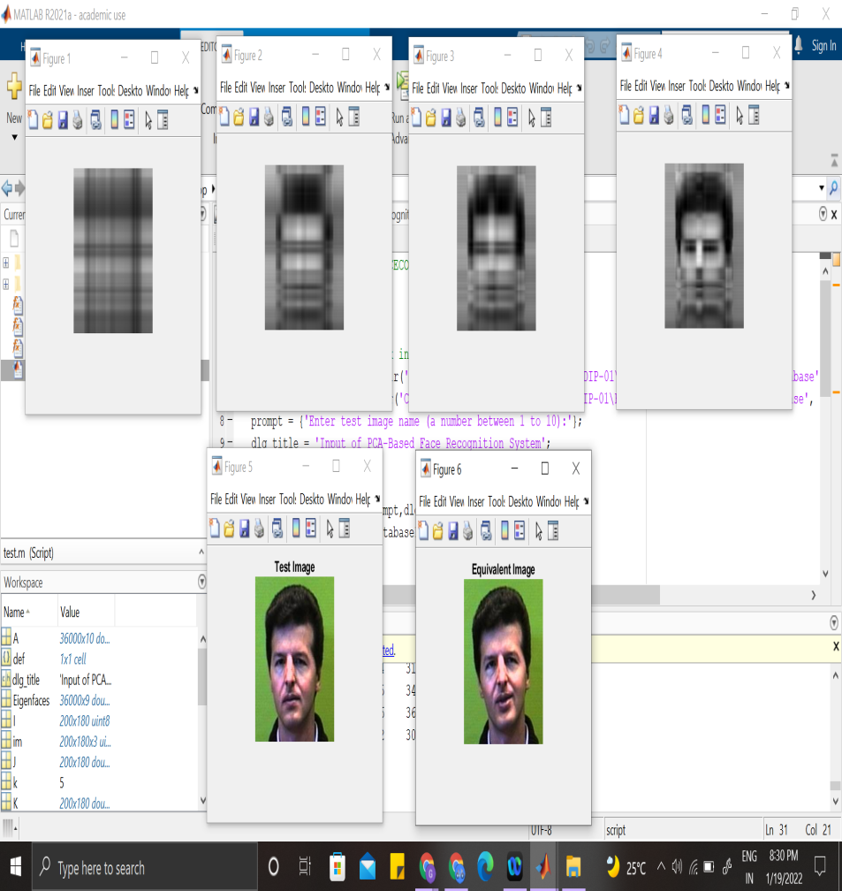

**Figure 1:** Simulation results

**5.Conclusion**

Face detection and recognition have been very popular topics in computer vision and pattern recognition. They are often applied together in systems which require face analysis such as a face authentication system. Resulting from the rapid expansion of mobile device market, face detection and recognition has found many new applications on mobile devices. Although many effective techniques were developed through the past for both face detection and recognition, relatively few research works focus on their applications on mobile devices. The application of face detection and recognition on mobile devices introduce many new challenges to the task. For example, heavy illumination variation is one of the most frequently occurring challenge with mobile device applications and it causes severe performance degradations to both face detection and recognition. There is an strong urge for performance enhancement of face detection and recognition under the requirements of mobile device applications. In this thesis, we propose a face authentication system for mobile device applications. The proposed face authentication system uses Local Binary Patterns (LBP) feature extraction and its variants to address many practical problems such as illumination variation, pose variation, low image resolution and computation efficiency. In specific, a spatially enhanced LBP variant is adopted in the proposed system because it is found to contain higher power for discrimination as well as robust to many complications. In order to maximize every component (face detection and face recognition) of the proposed face authentication system, the face detection and face recognition components were investigated separately in two chapters of the thesis. One major contribution of this thesis is to propose a face detector for mobile device applications by utilizing a novel combination of two LBP feature extraction variants: Co-occurrence of Adjacent Local Binary Patterns (spatially enhance LBP variant) and Local Binary Patterns. The two LBP feature extractors are grouped in cascade based on the well-known Viola-Jones face detector framework. In the early stages of the cascade, LBP features are extracted due to its simplicity and adequate discriminative power for rapid rejection of the non-face candidates. A more powerful LBP feature extraction, the Co-occurrence of adjacent LBP feature extraction is applied in the later stages since the discriminative power of simple LBP features are limited for complicated cases. Compared to the simple LBP, Co-occurrence of adjacent LBP features are able to provide description to the texture patterns with higher accuracy and hence resulting in higher discriminative power and stability in the extracted features. Thus, the Co-occurrence of adjacent LBP features are applied in the later stages of the face detector cascade to ensure the overall accuracy. The second contribution of this thesis is to propose a face recognition system using a novel LBP feature extraction method so-called Co-occurrence of adjacent Local Color Vector Binary Patterns (Co-occurrence of adjacent LCVBP). Compared to the baseline LBP, there are major enhancements of the proposed feature: (1) it extracts robust texture patterns from the color channels of the face image by adopting the method proposed in LCVBP [10] (2) it encodes the spatial correlation between the extracted texture patterns by adopting the method proposed in Co-occurrence of adjacent LBP [2]. Through conducted experiments, the proposed feature extraction method is found to be robust against illumination variation, pose variation and the small-sample-size (SSS) problem.

**Future Work**

As shown in the conducted experiments, the proposed methods (face detection and recognition) is not perfect under all conditions. There are still many further improvements can be done on the proposed system.

**Face Detection**

Although the adopted Co-occurrence of adjacent feature extraction has many advantages, choosing the most optimal parameter S and R is not a simple task. As explained previously, the choice of these two parameters will affect stability and discriminative power of the extracted features. Relatively large values of S and R is able to target texture patterns in large scale, but it also decreases the amount of extracted texture patterns, causing instability to histogram features. Therefore, these two parameters should be tuned depending on the face image size, contents, objective of the application and many other factors. For the experiments in this thesis, these two parameters are selected through conducted experiments. Although the experimentally selected values show robustness to many complications, a systematic approach in selecting these parameter values is lacking. Possible future research efforts can be spend on investigating a systematic and adoptive approach in selecting these two parameters. As indicated by conducted experiments, the proposed face detector performs better under normal lighting conditions and large degradation still exist under extreme illumination complications. There are other LBP feature variants, such as the MultiBlock LBP (MB-LBP) are more robust to the extreme illumination complications. Although these methods could not be directly applied in the propose system due to other drawbacks such as computation complexity, future research effort could be spend on adopt the advantages from other LBP feature variants (such as MBLBP) to make the proposed face detector more robust against extreme illumination complications.

**Face Recognition**

Same as aforementioned, the performance of spatially enhanced LBP variant, Cooccurrence of adjacent LBP depends on its parameters S and R. A systematic and adoptive approach should be investigated to maximize its performance. As suggested by the conducted experiments, the proposed feature extraction could be effected by severe degradation of the image quality. A possible improvement to the proposed method is to adopt other LBP feature variants which are more robust to noise. For example, the Local Ternary patterns (LTP) [14] are reported to be more robust against noise due to its ternary threshold scheme. The proposed feature extraction has high discriminative power and robustness to many complications, but it also has an increased length of feature vector. The increase feature vector length will result in significantly increased amount of offline training time. To solve the long offline training time problem, either an effective feature length reduction method or a more effective training algorithm should be investigated.

**6.APPLICATIONS:**

**Security and Defense:** Personal security includes gaining access to personal information and most popularly personal mobile devices.

**Retail and Marketing:** he use of technology has become popular in retail outlets to prevent shoplifting and reduce crime within their stores.

**Healthcare:** Possibly one of the most important Applications of Facial Recognition technology is in the healthcare sector. Doctors and healthcare officials alike can use facial recognition to access patient’s medical records as well as monitor and diagnose certain diseases.

**7. REFERENCES**

1. <http://www.face-rec.org>
2. Shemi P M, Ali M A, A Principal Component Analysis Method for Recognition of Human Faces: Eigen faces Approach, International Journal of Electronics Communication and Computer Technology (IJECCT),Volume 2 Issue 3 (May 2012).
3. M. Turk, A. Pentland: Face Recognition using Eigenfaces, Conference on Computer Vision and Pattern Recognition, 3 – 6 June 1991, Maui, HI , USA, pp. 586 – 591.
4. Zhao, R. Chellappa, P. J. Phillips, and A. Rosenfeld, “Face recognition: A literature survey,” ACM Comput. Surv., vol. 35, pp. 399–458, Dec. 2003.
5. R. Fergus, B. Singh, A. Hertzmann, S. T. Roweis, and W. T. Freeman, “Removing camera shake from a single photograph,” ACM Trans. Graph., vol. 25, pp. 787–794, July 2006.
6. Q. Shan, J. Jia, and A. Agarwala, “High-quality motion deblurring from a single image,” ACM Trans. Graph., vol. 27, pp. 73:1–73:10, Aug. 2008.
7. A. Levin, Y. Weiss, F. Durand, and W. T. Freeman, “Understanding blind deconvolution algorithms,” Pattern Analysis and Machine Intelligence, IEEE Transactions on, vol. 33, pp. 2354–2367, Dec. 2011.