**A SMART HELMET FOR AIR QUALITY AND HAZARDOUS EVENT DETECTION FOR THE MINING INDUSTRY**

**G.Sowmya D.Venkateswara Reddy , M.Thirumalesh ,M.Hari Krishna , G.Hemanth**

**ABSTRACT**

A smart helmet has been developed that is able to detect of hazardous events in the mines industry. In the development of helmet, we have considered the three main types of hazard such as air quality, helmet removal, and collision (miners are struck by an object). The first is the concentration level of the hazardous gases such as CO, SO2, NO2, and particulate matter. The second hazardous event was classified as a miner removing the mining helmet off their head. An IR sensor was developed unsuccessfully but an off-the shelf IR sensor was then used to successfully determine when the helmet is on the miner’s head. The third hazardous event is defined as an event where miners are struck by an object against the head with a force exceeding a value of 1000 on the HIC (Head Injury Criteria). An accelerometer was used to measure the acceleration of the head and the HIC was calculated in software. The layout of the visualization software was completed, however the implementation was unsuccessful. Tests were successfully done to calibrate the accelerometer. PCB’s that were designed and made included a breakout board and a prototype board. A whole software implementation was done based on Contiki operating system in order to do the control of the measuring of sensors and of calculations done with the measured values. This paper presents the undertaken design detailing solutions to issues raised in previous research**.**

**Keywords:** Helmet, Mining, Industry

**1. INTRODUCTION**

Industrial safety is one of the main aspects of industry specially coal mine industry. Coal mines involves various risk factors which affects the health of miners. Miner’s removes their helmet may cause hazardous. Sometimes miners collide with the heavy objects like mining objects, hard rock which risks their life. Another factor that affects the miners is the inhalation of hazardous gases that provokes them in danger .In this situation miners are not able to communicate with the outside world. In this case the smart helmet system becomes an essential and helpful measure to protect the miners from various accidents. This project aims at designing a smart helmet for hazardous event detection, monitoring the surrounding environmental conditions.

**1.1 INTERNET OF THINGS**

Connecting regular things installed with gadgets, programming, and sensors to web empowering to gather and trade information without human collaboration called as the Internet of Things (IoT).The term "Things" in the Internet of Things alludes to everything without exception in everyday life which is gotten to or associated through the web.

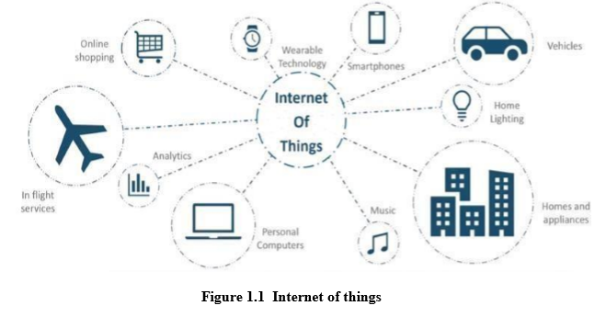

**2. LITERATURE SURVEY:**

As of 2016, the vision of the Internet of things has developed because of a combination of different advancements, including pervasive remote correspondence, continuous investigation, AI, ware sensors, and installed framework. This implies the customary fields of implanted frameworks, remote sensor systems, control frameworks, robotization (counting home and building computerization), and others all add to empowering the Internet of things.

The idea of a system of savvy gadgets was talked about as right on time as 1982, with an adjusted Coke machine at Carnegie Mellon University turning into the main Internet- associated apparatus, ready to report its stock and whether recently stacked beverages were cold. Imprint Weiser's fundamental 1991 paper on pervasive registering, "The Computer of the 21st Century", just as scholastic settings, for example, Unicom and Per Com created the contemporary vision of IoT. In 1994 Reza Raji depicted the idea in IEEE Spectrum as little parcels of information to an enormous arrangement of hubs, to incorporate and mechanize everything from home machines to whole processing plants". Somewhere in the range of 1993 and 1996 a few organizations proposed arrangements like Microsoft's at Work or Novell's NEST. Be that as it may, just in 1999 did the field begin gathering energy

**3. METHODOLOGY**

In the proposed system there are three types of safety modules

1. Intimation of hazardous gases in short time.

2. Head injury criteria.

3. Making sure worker has put on safety helmet

**3.1TRANSMISSION NODE:**

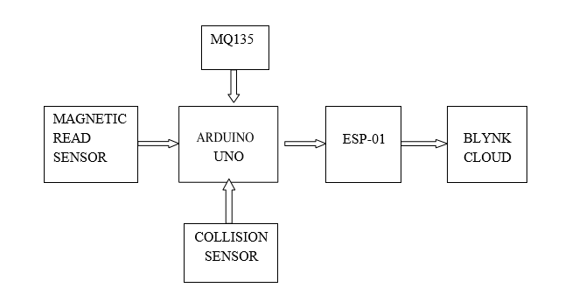Fig2: Transmission node

3.2 RECEIVING NODE:

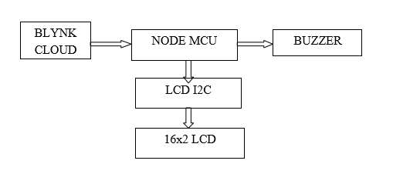

Fig 3: Receiving node

**4. FUNCTIONING OF THE SYSTEM**

A brilliant protective cap has been built up that can identify of perilous occasions in the mines business. In the advancement of protective cap, we have considered the three fundamental sorts of perilous occasions, for example, air quality, cap expulsion, and impact (excavators are struck by an object).The first is the focus level of the risky gases, for example, CO,SO2, NO2, and particulate issue. The second risky occasion was named a digger expelling the mining cap of their head. The third perilous occasion was named an excavators slam into the substantial articles like mining objects, hard rock which chances their life.

A Magnetic Read sensor was then used to effectively decide when the protective cap is on the digger's head or not. On the off chance that the cap isn't on the digger's head. The data will send to accepting hub by means of BLNK cloud and Buzzer rings.

At the recipient hub, Node MCU gets the information sent by the Transmission Node and it shows the information on the LCD. LCD is interfaced to Node MCU by means of LCD I2c connector. At the point when the information got is above than the edge esteem it sends information to the Receiving Node by means of BLYNK Cloud and Buzzer rings if there is any risky gases discharges in the coal mineshafts.

**4.1 Experimental setup:**

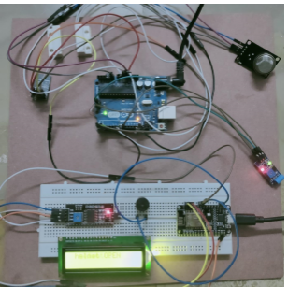

Fig 4: Experimental setup

**4.1.1 AIR QUALITY TEST**

Air quality test is done by air quality sensor MQ 135.MQ 135 sensor measures a wide range of gases like LPG,CO and CO2 .This sensor detect critical levels of dangerous poisonous gases which are hazardous for human health in the mining industry and it has been indicated through alerting unit and the data is displayed in LCD as shown in fig 7.1 The data is transmitted to monitoring section by using IOT technology.

**4.1.2 HELMET REMOVAL TEST**

Helmet removal test is done by using magnetic reed sensor. When helmet is removing then helmet removal event is detected and displayed in LCD “HELMET OPENED” as shown in fig 7.2 and it has been indicated through alert unit(buzzer)

**CONCLUSION**

The paper builds a middle ware of protection with remote observations and gives audio alerts. This system observes the parameters like hazardous gases, humidity, and temperature and fire condition present in underground mining section. This system displays all these parameter in LCD at the underground area where sensor unit introduced. It will be helpful to every one of excavators present inside mine unit spare their life before any loss happens. This framework likewise records every one of the information in hyper terminal in the PC for further review. This is a light weight with low cost smart and lifelong system.

**FUTURE SCOPE**

The frame work can be enhanced by adding all the more estimating gadgets to check the excavator’s circulatory strain and heart rate. In future, it could likewise be utilized for auxiliary administrations.

**REFERENCES**

[1] M. A. Hermanus, “Occupational health and safety in mining—status,new developments, and concerns,” The Journal of The SouthernAfrican Institute of Mining and Metallurgy, vol. 107, pp. 531-538, Aug.2007.

[2] A.P. Squelch, “Virtual reality for mine safety training in South Africa”The Journal of The South African Institute of Mining and Metallurgy,pp. 209-216, July 2001.

[3] C. Qiang, S. Ji-ping, Z. Zhe and Z. Fan, “ZigBee Based Intelligent Helmet for Coal Miners,” IEEE World Congress on Computer Science and Information Engineering (WRI 2009), 31 Mar. -2 April 2009, vol.3, pp. 433–435, 2009.

[4] H. Hongjiang and W. Shuangyou, “The application of ARM andZigBee technology wireless networks in monitoring mine safety system,” IEEE International Colloquium on Computing,Communication, Control, and Management (ISECS 2008), 3-4 Aug.2008, Guangzhou, pp. 430–433, 2008.

[5] X. Liu, J. S. Huang and Z. Chen, “The research of ranging with timingover packet network for the mine safety application,” Journal ofNetworks, vol. 7, no. 7, pp. 1054–1062, Jul. 2012.

[6] R. S. Nutter, “Hazard evaluation methodology for computer-controlled mine monitoring/control systems,” IEEE Trans. on IndustryApplications, vol. IA-19, no. 3, pp. 445445-449, May/June 1983.

[7] R. S. Nutter, “A distributed microprocessor monitoring and control system for coal mines,” in Proc. 4th WVU Conf. on Coal MineElectro-technology, Aug. 2-4, 1978.

[8] R. S. Nutter and M. D. Aldridge, “Status of mine monitoring and communications,” IEEE Trans. on Industry Applications, vol. 24, no. 5,pp. 820-826, Sep./Oct. 1998.

[9] A. D. Kock and J. W. Oberholzer, “The development and application of electronic technology to increase health, safety, and productivity in the South African coal mining industry,” IEEE Trans. on Industry Applications, vol. 33, no. 1, pp. 100-105, Jan/Feb. 1997