**EFFECTIVE APPLICATION OF PPP IN AFFORDABLE HOUSING PROJECTS IN INDIA**

**Ar. Kritika Gupta**

Madhav Institute of Technology & Science, Gwalior, Madhya Pradesh , India

**ABSTRACT**

In developing India, we are facing a housing crisis to meet the growing urbanization of the population in search of work. (Sangma, 2019) If housing projects are done properly then we provide housing with a minimum amount of value i.e., Budget Housing. Private government partnerships are one of the solutions to the successful completion of affordable housing projects. However, the use of PPP in affordable housing projects is very limited and success stories are limited. (SINGH, September 2011) Therefore, the purpose of this paper is to identify and analyze the key success factors for the successful implementation of PPP in AH projects. The questionnaire was designed and distributed to various respondents to obtain information about the various PPP projects. Considering the government's limitations on funding, the Indian government has introduced a PPP model for risk sharing with a public authority on housing (Sangma, 2019). This study aims to provide a high-quality PPP model design for the implementation of affordable housing. This research paper is an exploratory study to understand the challenges and possible models of affordable housing and comparative analysis across all public and private partnership models. (SINGH, September 2011) This model makes the appropriate distribution of risks, obligations, rewards, and penalties, and creates incentives to create value.

**Keywords:** Affordable housing, Economic Weaker Section (EWS), Lower Income Group (LIG), Public-Private Partnership.

1. **INTRODUCTION (Font-Times New Roman, Bold, Font Size -12)**

Affordable housing as the name itself suggests affordable housing units is the weakest category of society whose income is less than the average income category of middle-income families defined by the Indian government. Affordable housing to meet the needs of the low-income groups (LIG) and the weak economic sector (EWS). Since 2015 the urban population has grown at an average of 2.1% annually. If it continues like this in 2022 it will lead to a shortage of almost 30 million units in urban areas. Considering the government's limitations on funding, the Indian government has introduced a PPP model for risk sharing with a public authority on housing.

Public Private Partnerships (PPP) are the provision, long-term performance, and maintenance of public infrastructure by private companies. It will be initiated by the public sector with a clearly defined project. Developing PPP projects is a necessary task for the many different skills that are rarely required in public sector projects. The success of PPP projects depends on the strong government sector, they must have the ability to identify, develop, negotiate, procure, and manage the project in a transparent process. (News, 2019)

The Department of Housing estimates the housing shortage [2] of the 18.78 million 99% of the real estate sector (EWS) and low-income groups (LIG). Due to the growing shortage of annual controls introducing PPPs in the housing sector is the only option to accelerate construction. PPP is not new to India in infrastructure development. In houses as well, PPP was used as a pilot project in several provinces such as Andhra Pradesh and Maharashtra. But the result is not the level expected by the Indian government. It leads to housing shortages. Figure 1 shows the housing shortage in India until 2012. (Affairs, 2019)

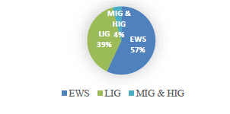

|  |
| --- |
| Fig.1: Ministry of housing & urban affairs 2012 |

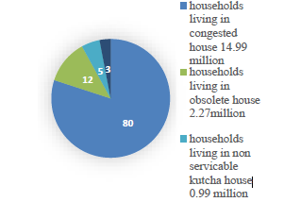

|  |
| --- |
| Fig. 2: Ministry of housing & urban affairs 2012  shows the percentage of households living in different types of houses as per the ministry of housing and urban affairs 2012. |

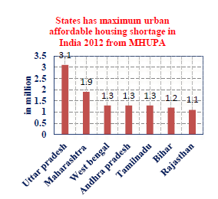

Fig. 3 Ministry of housing and urban affairs housing shortage 2012

Housing shortages identify the worst-affected provinces at around 7.61 million. The main reason for the gap is the lack of private participation in the sector. In June 2017 the Indian government introduced a new [4] housing investment policy by an independent investor by providing medium and national assistance to Urban Local Bodies (ULBs). (Gregor Herda, May 2017)

* In-situ informal settlements (ISSR): Use this land as a resource, informal settlement development by private partners, and the central government providing a 1lac subsidy for each house.
* Credit Assistance Program (CLSS): This program provides institutional loans to EWS, LIG ​​, and MIG households by purchasing interest-bearing housing loans and reduces mortgage lending.
* Affordable Housing: The main purpose of this policy was to provide financial assistance to private builders to participate in the development of affordable housing. This central government policy, calls for 1.5lac per EWS house and builds at least 35% of EWS housing units in this project.
* Construction/development of a beneficiary-led house: In this program, the median assistance is 1.5lac per family in building new or expanding EWS and LIG houses (Gregor Herda, May 2017).

Models for Public and Private Partnerships for Affordable Housing

Six models are provided by the central government to speed up the construction of existing houses

* Land-based government-subsidized housing
* Mixed development support
* Pension-based housing
* Annuity cum capital grants based on affordable housing
* Real estate ownership relationships
* Real estate rental

housing Incorporating public-private partnerships in non-new housing in Indian states such as Andhra Pradesh, Maharashtra, etc., forming housing units but not reaching the required units. Public Opinion and Review of J. Rosie Tighe are factors that influence other social policy attitudes, especially stereotypes and stereotypes. According to Dr. Vidya telling, Dr. Vaisakha has undermined public-private partnerships in India's framework. This paper outlines several issues and challenges encountered in the development of the PPP model. In a case study of affordable housing, G. Vinay Kumar and Ganta Srinivas in this paper model have proposed the construction of affordable housing with affordable materials. Affordable housing can be obtained through a functional planning program using local materials. (SINGH, September 2011)

A critical review of low-cost urban housing in India according to Maulik G. Gangani, Hitendra N. Suthar, and Dr. Jayesh Kumar. This study aims to study the problem of urban housing in India and seeks to identify how we can relocate rural areas to urban areas and provide housing needs for people below the poverty line (BPL). By providing affordable housing strategies that will save, accelerate, and improve quality (SINGH, September 2011)

* 1. **Aim**

To study the application of the PPP mode of procuring housing projects in the Indian context

**1.3 Objective**

* To identify the existing rise and fall of PPP in Indian cities.
* To identify and analyze the public-private partnership concept implication in affordable housing projects for literature review and case studies.

To identify various conceptual approaches and undertake affordable housing projects in PPP mode.

* 1. **Need**

A key requirement is that the relationship between Government and the Private Sector as a strategy to start affordable housing is to consolidate the capacity of private and public sector companies to overcome the challenges facing affordable housing and achieve better outcomes.

However, the success of PPP as a strategy will largely depend on the creation of PPP frameworks that facilitate appropriate risk sharing, obligations, rewards, and penalties, and create value-generating incentives. This is in the context of the policies and contractual frameworks that will be developed for the various PPP strategies to address the challenge of affordable housing. (MOHUA, 2017)

* 1. **Outcomes**

Government officials, in general, are expected to consider affordable housing projects, project budgets, and implement projects. The intended learning outcomes of this skills development work are in line with the above-mentioned roles of government officials. As a result of the training provided to them under these skills-building projects, students are expected to:

* Assist the participating state to implement PPP programs effectively and efficiently
* Enhancing the capacity of PPP cells in participating businesses to prepare, evaluate and analyze PPP infrastructure.
* Significantly improve overall progress monitoring for PPPs in infrastructure at both mid-provincial levels through the well-connected database.
* Increasing awareness of potential private sector partners on the project cycle of PPP infrastructure projects and Government expectations on value for money.
* Over time, increased private sector participation in infrastructure development and management across the country. (Sangma, 2019)

1. **BASIS OF PUBLIC-PRIVATE PARTNERSHIPS**

Some of the key conditions for marking a secret government program are considered in the definition of the National PPP policy. Although each PPP contract differs depending on the circumstances of the case, each of them is still based on certain natural factors that are common to those contracts. However a few other desirable conditions for a good and fair PPP are related to speculation on risk, payment method, whether the payment will be in cash from the public sector based on performance or will be charged by consumers using the service, incentives, and penalties in the system to ensure the private sector is measured against and service delivery, identifying a minimum of technical data without compromising new design opportunities and the time frame for project transfer or private business enterprise. (SINGH, September 2011)

**2.1 Basic Strategy for Public-Private Partnerships for Affordable Housing**

An important strategy under the Private Partnerships strategy to initiate affordable housing is to consolidate the capacity of the private and public sectors to overcome the challenges facing affordable housing and achieve the best possible outcomes. However, the success of PPP as a strategy will largely depend on the creation of PPP frameworks that facilitate appropriate risk sharing, obligations, rewards, and penalties, and create value-generating incentives. This is in the context of the policies and contractual frameworks that will be developed for the various PPP strategies to address the challenge of affordable housing. (SINGH, September 2011)

**2.2 Resolving the Affordable Housing Challenge: Other PPP Strategic Options (SINGH, September 2011)**

In the last chapter, access problems and land costs, construction and efficiency inefficiencies, and lack of access to affordable finance have been identified as significant barriers to the provision of affordable housing. The various ways in which PPP can try to address these barriers are outlined below:

* + 1. **Enhancing Access to Low-Cost Land:**

The issue of acquisition and cost of land in good condition is important in the case of affordable housing. Depending on the location of the project, land costs can vary anywhere from 20 to 60% of the total project cost. However, the ability to regulate private-owned land in terms of affordable housing is limited. With appropriate PPP structures, the private sector can be encouraged to do so through one or more of the following strategies.

a. Private Land for Affordable Housing: Under this strategy, the government wants to use its power and make money to control land use. To permit private companies to use the parcels of land they own, the government may need part of that land or other land to be affordable housing. All schemes that seek to trade with the highest FAR / FSI granted to the private sector to obtain affordable housing fall into this category. This type of PPP is a separate type of subsidy where private companies are made to direct a portion of the higher income provided by the higher FAR / FSI to provide affordable housing.

b. Private Land for Affordable Housing in exchange for a high-quality building permit: Under this strategy, Government wants to make money through its ability to regulate real estate development and use it to acquire an independent industry to provide real estate and affordable housing. Private sector builders need to provide affordable housing as a condition that will be allowed to build high-quality housing in a profitable market. It can be safely assumed that under this strategy the builder, effectively, will transfer a large portion of the "burden" of the cost of creating affordable housing to the buyers of the upper part of the project. Thus, high-income customers will effectively provide affordable housing, in the form of various subsidies built under this PPP strategy, to low-income customers.

c. Government Land for Affordable Housing by opening unused/underutilized sub-government parcels: This could be a direct way to improve the area, available for affordable housing. Many Central and Regional government departments and agencies have large tracts of land, in addition to their demands for the foreseeable future, which are the most abused and often illegally encroached upon. Strategic policy and effort can make those areas less affordable and more accessible to the private sector, at a lower cost, developing and building affordable housing projects with private funding and success under appropriate PPP buildings. Housing built under this PPP strategy will be a means of subsidizing inclusive public housing for low-income clients.

d. The cost of affordable urban development: In the cities of India such as Mumbai, Delhi, and Kolkata, much of the world's most expensive land can now be found covered in slums. Even when areas are privately owned and upgraded, they usually have a large number of single-story or double-story ramshackle houses under the roof of the CI sheets. These structures are more like temporary structures than urban buildings in the expensive world. Significantly, governments also play a market role by providing regulatory oversight and the role of referee and trustee who help build trust and trust between small real estate owners and tenants to participate in redevelopment and major engineers. . A large part of the value created can be directed to the provision of affordable housing.

**2.2.2 Reducing Costs through Efficiency Gains in Construction and Operations:**

Private companies can be expected to contribute to effective profitability in land development, construction, operation, and affordable housing through technology, better management, and construction processes. In addition, the private sector should be expected to bring in the economy at a rate from major projects and by involving a large number of private partners. Delivery of projects at low cost and, without cost and over time, can contribute to the availability of affordable housing. To achieve these positive outcomes, PPP projects will need to be structured in such a way that they create the right motivations for the efficient performance of private industry partners.

* + 1. **Access to Financing and Capital Markets:**

Traditionally, Public Private Partnerships have also been seen as a source of private funding for the project. The private sector partner can be expected to contribute to affordable housing. Limited donations may be collected for this purpose with CSR1 funding. However, direct funding, if considered, will need to come primarily from governments. The private sector may be called upon to provide or direct commercial financing to obtain a fair return on investment in affordable housing. This may take some form of financing to cover the cost of real estate, subject to reimbursement, total amount or installments, investments, and reasonable return on the successful delivery of affordable housing. In addition, maintenance costs may be incurred by the private sector if affordable housing is rented or rented out. Such planning will transfer medium to long-term quality and the risk of care to a private industry partner. This can therefore contribute to better construction, quality, and maintenance of created goods. Alternatively, the budget for affordable housing under any project can be directly linked to a mortgage or a small mortgage. However, such schemes can incur significant labor costs and related credit risk costs. (SINGH, September 2011).

1. **SIGNIFICANCE**

The huge investment needed to improve the housing of all people in the country may be difficult to meet with Government (Institutions and Countries) given their financial constraints. Any efforts in that regard are likely to increase Government debt. The private sector, in terms of its potential (both in terms of funding and project implementation), will therefore be a necessary partnership in developing and delivering housing infrastructure to vulnerable sections of society at affordable prices. Therefore, the participation of private companies in partnership with state-owned enterprises to develop affordable housing is a need of the hour. (N.S.R.K. Prasad Kethineni, April 2019)

The benefits of public-private partnerships are many and well documented. The major benefits of acquiring infrastructure projects under PPP mode can be summarized by:

* PPPs allow access to many private sector resources
* PPPs allow the public sector to benefit from the private sector in technology, experience, and efficiency
* PPPs allow the public sector to transfer project-related risks to the private sector. (N.S.R.K. Prasad Kethineni, April 2019)

1. **LIMITED SUCCESS AND ITS REASON**

Land Acquisition and Land Acquisition were approved by the government to initially construct land within the market as required and at a cost determined by the government. it was thought that this would help stabilize the land’s market value. Under this heading, city-level development authorities (or State-owned Housing Boards) will acquire large parts of the land and release it `on demand '. In hindsight, provision may not always be in line with growing demand for a variety of reasons, namely:

* the time it takes to acquire land under the Land Acquisition Act;
* the uncontested management of the supply of land by the event officer who is hungry for the land marketplace
* the gradual release of land by an official. The impact was the only intended target. Land costs are likely to increase much more rapidly than they would otherwise be without the effect of the public sector within the global market. (N.S.R.K. Prasad Kethineni, April 2019)

**4.1 Legislative Policies**

Legal policies are often considered the cheapest solution for policymakers to achieve desirable goals. Two such policies regarding housing are the Rent Regulation Act and the Urban Land Ceiling and Regulation Act. under this, the burden of subsidizing housing is removed from the government. in the human category. Under the Rent Management Act, the tenant subsidies are now the responsibility of the landlord and under the ULCRA by `excessive 'landowners who would produce the land at a costly cost to the province for many services as well as housing. Hiring management rules apply to all provinces of the country. Living conditions within `controlled 'buildings are governed by the provisions of the rules. The most important provisions of the RCA include:

* hiring reviews and controls,
* limits on dismissal and,
* the owner of the property to maintain the "living conditions".

Under the rules, a tenant has legal protection and can only be evicted for reasons set out in the Act. The long-term effects of this practice have been a decrease in the provision of rental housing in the market, rising taxes, the rapid collapse of houses, the rationale for real estate investment and rental housing, in particular, the emergence of black money, and much more. wrong actions within the rental housing market. RCAs are the only active component. The beneficiaries are mostly residents of former settlements. The poor have never benefited. They had no time or money to go to court as long as the provisions of the RCA were not complied with. (N.S.R.K. Prasad Kethineni, April 2019)

**4.2 Financial and Fiscal Policies**

Given the financial value of raising ATP housing, the Government. India had used every fiscal and fiscal policy to expand the flow of funds to homes to reduce their prices. Under the monetary policy, commercial banks have been instructed to lend a portion of their development to make it an important sector. Housing is selected in partnership with the priority sectors. The government's economic policy has been strengthening the housing sector since 1996. A variety of business venture benefits to encourage real estate investment are provided. (N.S.R.K. Prasad Kethineni, April 2019)

1. **TRENDS**

Existing PPP regional/international trends include legislating/transforming public-private partnerships, project management, development of PPP resources, focusing on measuring outcomes, building frameworks for PPP contract negotiation, new models and funding mechanisms, promoting public cooperation independence, and power. building and creating awareness between government officials and lenders, using PPPs to innovate, etc. (News, 2019)

* However, for this module, infrastructure funding mechanisms, particularly PPPs and the latest developments in thinking and implementing new contractual frameworks in public and private partnerships, are as important as they could be. PPP Projects for Affordable Housing in India.
* Another reason for this slight focus is that the framework or PPPs for affordable housing are already in place and as PMAY (U) will expire 5 years soon, the focus should be on implementation rather than policy implementation, especially as it is just over 58.6% (from 11 July 2020) of the need for housing. (News, 2019)
* Focus on the Sustainable Development Goals (SDGs)

The SDGs are now an important condition for international development banks (MDBs) and development organizations to finance PPP projects, translating into renewed focus on PPPs for community housing, community health care, and community education.2

* This focus on development finance institutions (DFIs) in the SDGs (public housing is compiled under the SDGs) may be assessed by government agencies in assessing funding for projects/basket of relevant projects, including those in PPP mode. (News, 2019)
* Assessing Islamic Funds for Public and Private Partnerships Islamic Finance, a $ 2 trillion investment market compliant with Sharia has been an undisclosed way to fund PPP projects. The World Bank and the Islamic Development Bank Group (Is DB) have examined, through a series of publications, how Islamic Finance has been used in PPP projects and provided guidelines and agreements for various bodies. As a result, there is a global interest in evaluating Islamic Funds to fund PPP projects. Some of the success stories of Muslim-funded PPPs are Queen Alia International Airport in Jordan, East Klan Valley Expressway project in Malaysia, the Karachi-Thattadual Carriageway project in Pakistan, the boxing project in Djibouti, the integrated health campus in Konya, Turkey, Prince Mohammad Bin Abdelaziz International Airport in Saudi Arabia, etc. Islamic Finance may be evaluated using agencies to fund projects/basket of appropriate PPP projects. (News, 2019)
* The emergence of Recycling as an option to fund infrastructure Asset Recycling, also called Capital Recycling, has gained a lot among PPP employees, investors, and government agencies around the world. Clive Harris and Stephanie Creed describe the Recapitalization process as a process that restores previous taxpayers' funds confined to old assets to pay for new or renewed assets. Australia was the first country to adopt this model in 2013 and its success has inspired the US, Indonesia, India, etc. to evaluate the infrastructure support model. Recycling of assets is an appropriate way to deal with the acquisition of raw materials for built units. (News, 2019).

1. **GOVERNMENT APPROACH TOWARDS AFFORDABLE HOUSING**

Whereas the high rate of urbanization, coupled with the high rate of migration from rural areas emphasizes limited urban infrastructure; The efficient use of urban land (low FAR / FSI) has increased the cost per unit area. In addition, the lack of growth in housing development in terms of building capacity, staffing, building materials, and affordability will likely pave the way for greater consideration for the government to provide a framework for housing development. Most housing development may need to be done for the EWS / LIG

(In both rural and urban areas), and part of affordable urban housing in need of renewed focus on the local and provincial government. To achieve the desired result promptly, the priorities of the government will be; (Gregor Herda, May 2017)

* Planning and efficient use of land once

The Urban Development Framework (ULB) and the Urban Development Authority (UDAs) need to be empowered to implement the necessary measures to improve affordable housing. They will need to plan for possible affordable housing plans in the city's main plan. They must develop themselves or sift the developer with healthy motives for developing these global parcels. The government needs to ensure the availability of adequate housing and infrastructure through computerized world records, the use of Spatial Information Systems, and the implementation of major programs. (Gregor Herda, May 2017)

* Promoting the Involvement of Independent Developers

To promote private participation in the affordable housing industry, it is important to understand the pressing and dragging aspects of this sector - Government needs to accelerate efforts to expand broadly and significantly increase the public-private partnerships introduced in the past. ULBs and UDAs can be directed to promote independent developers in the affordable housing sector by providing them with a more economical, high FSI, single window.

authorization approval, tax subsidy, and cost reduction of EDC and IDC. This will help to encourage more developer participation in building affordable homes. (Gregor Herda, May 2017)

* Reduction in Interest Rates

The government needs focused measures to empower EWS / LIG households such as low-interest rate loans in the EWS & LIG sector, micro-finance, and other new financial mechanisms. This will help end users get affordable housing loans and reduce overcrowding in affordable schemes. Another way to reduce developer costs would be to provide affordable construction funding and get adequate long-term support throughout the life cycle of the project. REITs and REMFs can be great opportunities to earn money

in real estate development as long as the tax uncertainty is removed. (Gregor Herda, May 2017)

1. **CASE STUDY (International)**

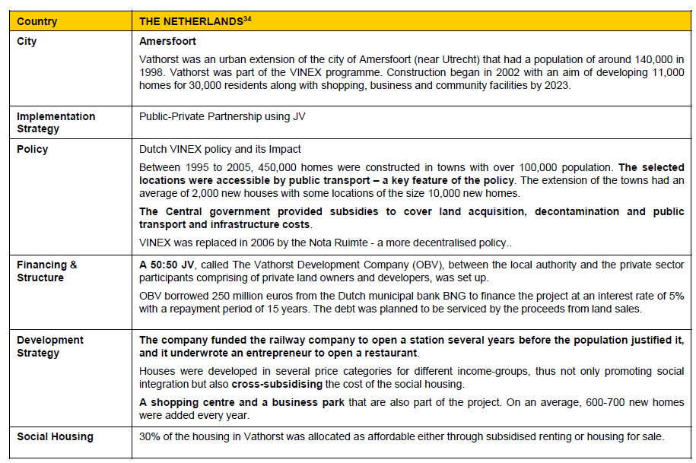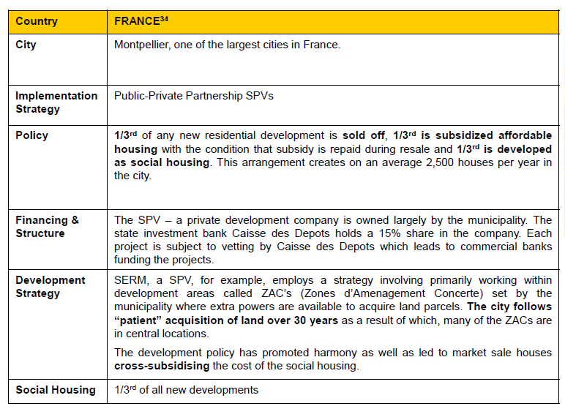**7.1 CASE STUDY (National)**

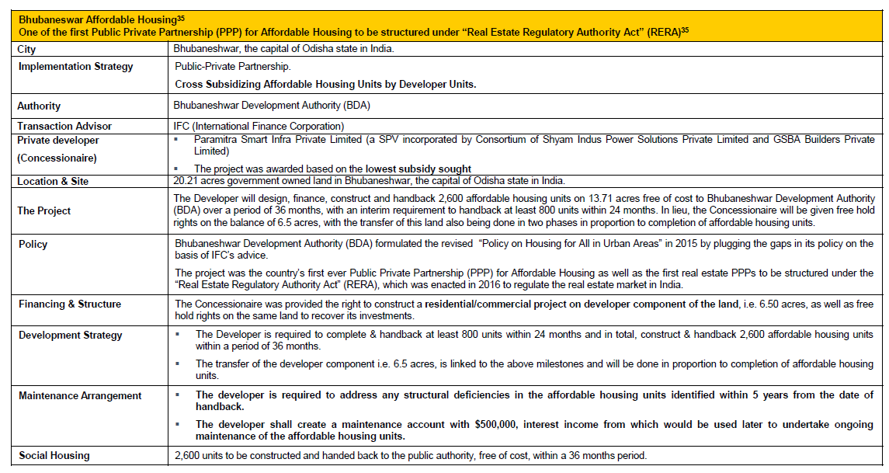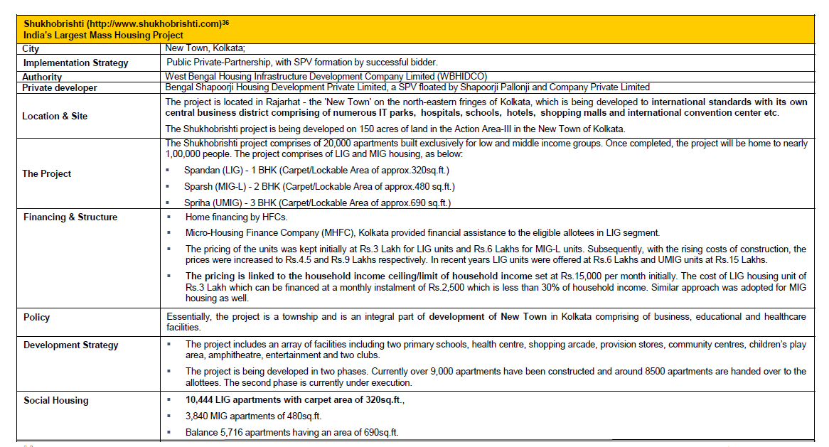

1. **PROBLEMS, CHALLENGES, AND RISKS IN PPPS**

The PPP sector in India is still new and recent. To gauge the effects and impact of any economic phenomenon, a passage of a minimum period is imperative. Only then and then can meaningful conclusions be drawn. As said earlier the public-private partnerships in India are only 12 to 15 years old (or new) and a major part of the activity on those grounds has taken place during the last 7 to 10 years. The reports and reviews which have come out about the PPP sector in India point toward the positive stance taken by the economy towards such partnerships. The enabling environment created by the central and the state governments to harness the private sector investments in such projects has generated a very conducive environment for such partnerships. Yet there are some instances and cases where the PPPs have not been an outright success. The literature and the particular case studies on the subject reflect that most of the problems that have been encountered and experienced in these have emerged along the way and the fact remains that these problems. (N.S.R.K. Prasad Kethineni, April 2019)

could not be envisaged or imagined by both the parties at the time of entering into the contract. PPPs are long-term in nature and this fact makes them more vulnerable to bottlenecks. It is because more the time involved, the greater the probability of a problem cropping up. The formulation of every PPP contract is unique. No two PPP contracts are the same. It is thus *difficult to standardize* a PPP format. This is because the parameters used in the structuring of PPP cannot be the same every time and therefore a PPP can differ on various grounds such as the nature and type of infrastructure required, the sector involved, the model adopted, etc. (N.S.R.K. Prasad Kethineni, April 2019)

The stake of the Central and State governments and the revenue, responsibility, and risk sharing in the project are circumstantial and are likely to vary from one contract to another. Thus, apart from sharing the construction of the infrastructure by the public and the private sector which can be on technical and financial grounds nothing else can be standardized for such partnerships. According to a research article ‘How to improve PPP projects in India: learning from the past’3, any PPP project has to mainly pass through four main phases project preparation, project procurement, project development, and operations. Careful handling, planning, and clear-cut demarcating lines of work are required at every stage. (N.S.R.K. Prasad Kethineni, April 2019)

The framing of contracts can define only the formal mechanism of fulfilling the contract. However, it is difficult to incorporate steps and solutions to circumstantial issues which may crop up while the project is underway in a PPP contract. Currently, there is no *PPP regulation* in India. Since the whole concept of public-private partnership is quite new in our country, enough thought has probably not been given to this aspect. However, the National PPP Policy 2011 draft has been put up for further suggestions and comments. The above problem of the non-standardization of PPP contracts can to some extent be taken care of by creating an independent regulatory PPP body. This may lead to better and more robust participation by the private sector and also attract more international funding. which is certainly not without reason. The entire process of creating a PPP arrangement is very long and ridden with a lot of formalities. There have been many cases where the private party has gained undue political favours from their public sector counterpart making the whole process seem dubious. (SINGH, September 2011)

1. **CONCLUSION**

A variety of emerging and financial options are available to assist in the provision, as well as access to AH. planning methods accept mandatory requirements such as development taxes, development contributions, liaison fees, and the proposed spatial planning; voluntary tools such as negotiated or voluntary design agreements; and incentives such as various levels of development, bonus design, acceleration, and conditions arising from traditional planning rules. funding mechanisms include financial assistance, subsidy, and developer tax exemptions as well as rental assistance for eligible income homes. (SINGH, September 2011)

The unavailability of desired housing may be a barrier for most people. The inability to afford affordable housing may be an understatement for the poor. However, a housing policy that targets the decline of housing for the poor alone has a much lower chance of success than a policy that takes a collective view of housing evils in all sections of the population. Housing policy should be considered in this area. (SINGH, September 2011)

The various programs for affordable housing for the poor, approved by the Central and Provincial governments, are prudent indicators of limited success and failure to achieve desirable goals. Incorporating lessons learned from these programs into new programs will improve the chances of success of new programs. (SINGH, September 2011)

A key component of AH acquisition could be another cost-effective housing market that could respond to the needed changes very quickly and at a much lower cost. Extending state control should be the first step at this time. Improved housing quality by reducing transaction costs (sold or bought or leased) is another. it is necessary to have a lot of options out there to suit the different needs of different categories of people and there is the quality between different types and sizes of houses. you do not have to think about individuals or families in terms of income levels and consider providing (say) homes with larger MIG sizes compared to those in EWS or LIG. The unavailability of popular housing leads to poor decisions (wasteful learning). Therefore, single men or women or newlyweds (MIGs) may also be happy with one-and-a-half studio apartments or living rooms but are forced to `choose '2-room apartments. Similarly, former retirees would prefer to live in some 'old age' or nursing home instead of being forced to live in crowded cities. (Sangma, 2019)

This increase in demand (in the main case) and ice in supply (in the second case) leads to an increase in the cost of production. there is a need to think about making houses for special groups. this may be an additional effective housing aid not only for these groups but also for the community.

1. **REFERENCE**

1. 2008. Deepak Parekh Committee. *Affordable Housing for All*. Delhi: National Real Estate Development Council under the Ministry of Housing and Urban Poverty Alleviation. http://www.naredco.in/pdfs/report-high-level-task.pdf (retrieved on 4 Jan 2016).
2. 2006. Government of India. Constitution of India. Seventh Schedule, Article 246. doi:12/12/2014.
3. 2003. Government of India, Centre for Good Governance. *Housing for the Poor in India*. Delhi: Centre for Good Governance. <http://www.cgg.gov.in/workingpapers/WP-4-PKM> Housing%20for%20the%20Poor.pdf (retrieved on 6 Dec 2015).
4. 2011. Government of India, Ministry of Home Affairs. Census of India. http://www.censusindia.gov.in (retrieved on 4 Dec 2015).
5. 2013. Government of India, Ministry of Housing and Urban Poverty Alleviation (MHUPA). *Affordable Housing in Partnership: Scheme Guidelines*. New Delhi: MHUPA. http://mhupa.gov.in/w_new/ahp-guidelines.pdf (retrieved on 2 Jan 2016).
6. 2007.Government of India, Ministry of Housing and Urban Poverty Alleviation, National Buildings Organization (NBO). *Report of the Technical Group on Estimation of Urban Housing Shortage*. New Delhi: Government of India, Ministry of Housing and Urban Poverty Alleviation. http://mhupa.gov.in/ministry/housing/housingshortage-rept.pdf (retrieved on 29 Dec 2015).