**Effect of varying ageing time on the thermal properties of**

**Al-7.5%Si-0.45%Mg alloy for brake disc application**

**Audharr Bello Waziri1*, Maidawa Haruna2, Okatengwu Bello Umaru1, Nuhu Mohammed1 Musa David Azi1 and Godit Nenman James1**

**1Department of Mechanical/Production Engineering, Abubakar Tafawa Balewa University Bauchi, Bauchi State Nigeria.**

**2Department of Mechanical Engineering, Nigerian Army University Biu, Borno State Nigeria.**

**Correspondence:** [**buokatengwu@atbu.edu.ng**](mailto:buokatengwu@atbu.edu.ng)

Abstract

An investigation of the thermal analysis on Al-7.5%Mg-0.45%Si alloy for its application in brake disc have been investigated. The alloy was produced using the chill casting method and solution heat treated to 540oC for 1 hour, quenched in warm water (60oC) followed by ageing at 180oC for 1-5 hours respectively. The analysis performed on the heat treated/non-heat-treated alloy was Differential Scanning Calorimetry (DSC)/Thermogravimetry analysis (TGA) and Scanning Electron Microscopy (SEM)/X-ray Diffractometry (XRD) analysis respectively. Results of the DSC/TGA analysis showed the formation of precipitates which became harder with increasing ageing time thereby improving the thermal condition of the material. The SEM/XRD analysis further showed these precipitates to include Al9Si, AlFeMg3Si6, Al8FeMg3Si6, Al12Mg17, CrFe4, Al9Si, Al8Cr5, Mg2Si and Al15(Mn, Fe)3Si2. The weight loss in the material was lowest after 3 hours with 3.5% and 2.5% loss in the first and second degradation, while the control samples recorded 6% and 5% weight loss. The improvement for the heat-treated sample is as a result of diffusion of precipitates and homogenization of the matrix. In conclusion, the heat treatment performed have shown that over ageing of the samples can increase the loss in weight due to the loss in the strength of the material investigated.

Keywords: Chill casting, Solution heat treatment, Ageing time, Aluminium alloy, Differential scanning calorimetry, thermogravimetric study

Introduction

Al-Si-Mg alloys are widely used in manufacturing various automotive structural parts owing to the excellent mechanical properties, such as good weldability, desirable corrosion resistance and wear resistance [1-4]. However, the coarse eutectic Si phase, segregation of solute and casting defects involving the shrinkage cavities and porosity appear in cast Al-Si-Mg alloys, which seriously weaken the ductility and fracture strength. To acquire the desirable microstructures and properties, several heat treatment methods were developed, including solution treatment, annealing, quenching, natural ageing, as well as artificial ageing [5].

Some efforts have been made to study the effects of solution temperature, ageing temperature, holding time, cooling speed and element addition on the final microstructures and synthetical properties of Al-Si-Mg alloys [6]. Zhang et al. [7] found that raising the solution temperature from 500℃ to 560℃ will reduce the stress concentration between brittle Si particles and α-Al matrix, while improving ductility for Al-7Si-0.3Mg alloy. Timelli et al. [8] found that a solution treatment at 525℃ for 60 minutes will spheroidize eutectic Si particles and improve the elongation to fracture of die-cast Al-Si-Mg alloy. Long et al. [9] discovered that a drawn-out solution treatment causes the enrichment of Mg atoms near the porosity in α -Al matrix, and weakens the aging strengthening of an Al-7Si-0.3Mg alloy. Cai et al. [10] found that a homogenization treatment can eliminate the dispersoids free zones (DFZs) in the vicinity of grain boundaries, and refine the grain size and dispersoids for an equal channel angular extrusion (ECAE) processed Al-Mg-Si alloy. Liao et al. [11] found that the pre-aging process of 120℃ /14 h+170℃ /6 h can improve the elongation of an Al-7Si-0.3Mg alloy by two times, compared to single peak ageing. Dang et al. [12] through differential scanning calorimetry (DSC) analysis and hardness measurements, discovered that the natural ageing hardening is ascribed to the precipitation of Guinier–Preston (GP) zones for a refined A356 alloy. Li et al. [13] found that the hardness’s peak plateau is attributed to the continuous transformation from GP zone to transition phase for an aging-harden Al-Si-Mg alloy at 175℃. Colombo et al. [14] found that the addition of 0.22 wt.% Er can relatively reduce the casting defects and acquire the best synthetic mechanical properties of an Al-Si-Mg alloy. Tsai et al. [15] found that the eutectic Si particles can be well refined until the content of La element approaches to 1.0 wt.%. Riestra et al. [16] studied the effects of Si modification and grain size on the microstructure and tensile properties of the Al-10Si cast alloy, and found that the decrease in secondary dendrite arm spacing (SDAS) can successfully improve the tensile properties of an Al-10Si alloy. During the heat treatment of aluminium alloy, the Mn-containing dispersoids precipitate from α -Al matrix during the solution of Al-Mg-Si-Mn and Al-Mn-Fe-Si alloys [17,18]. The distribution, content and diameter of Mn-containing dispersoids greatly affect the material properties such as the yield and ultimate tensile strengths [19,20].

The thermal conductivity is defined as the amount of heat transmitted, due to unit temperature gradient, under steady conditions in a direction normal to a surface of unit area, when the heat transfer is dependent only on the temperature gradient. Its unit is W/mK. 6000 series of aluminium alloys are heat-treatable alloy which consist of Mg and Si as the major elements with other minor elements such as Cu, Zn, Fe, Ti. It is estimated that about 90 % of aluminium extruded products are made of 6000 series alloys and they are widely used in several industries such as aircraft and building since they have good formability, resistant to corrosion and high strengthening potential [21]. Al-6063 alloy is low strength alloy from the 6000 series group. This alloy is referred to as architectural alloys and decorative alloy [22]. In this material, all alloying elements and impurities contribute in various degrees of strengthening of aluminium matrix through solution hardening and dispersion hardening [23].

Heat treatment is the common method being used in the industries to modify the thermal properties of the aluminium alloys. The basic stages of heat treatment are solution treatment, quenching and ageing treatment. During thermally ageing process, time and temperature are the main parameters that needed to be considered to obtain the optimum thermal properties of the alloy. Basically, the presence of Mg and Si contents in the aluminium alloy produces the magnesium silicate (Mg2Si precipitates). The semisolid casting process improves the quality of Al-7.5% aluminum alloys by inducing qualitative casting with low shrinkage problems and beneficial microstructural characteristics. This casting technique, as well as the solution heat treatment process, plays a positive role in modifying the morphology of forming spheroid Si phases and fragmented iron intermetallic phases [24,25]. Due to the well-known characteristics of Al-7.5% semi solid alloys, they are used in fabrication of automotive parts, i.e., suspension control arm. The most common problems in these parts are mostly related to mechanical failure issues that may be affected by the surface quality due to hardness problems and by the strength and ductility of such alloys. The thermal treatment parameters, temperatures, and times have a significant effect on enhancing the performance of the alloys investigated [26]. Therefore, this work is aimed at studying the effect of varying ageing time on the thermal properties of Al-7.5%Si-0.45%Mg alloy for its application in automobile brake disc.

Experimental procedures

Materials and equipment used

The materials used in this research include; High purity aluminium (Al) wires sourced from Northern Cable Company (NOCACO) Kaduna-Nigeria, pure silicon powder (Si), Magnesium (Mg) and elemental sodium (Na) for modification. Others are moulding boxes and crucible that were sourced from Metallurgical and Materials Engineering Department, Ahmadu Bello University, Zaria- Nigeria. The equipment used includes: Muffle electrical resistance furnace of capacity 1200oC (used for the heat treatment process), Labtech water heater (comprised of the heating coil, used for heating the water for quenching), Polishing machine, Scanning Electron Microscopy (SEM) machine from the Nigerian Geological Survey Center, Kaduna-Nigeria, Rigaku Miniflex XRD machine from Metallurgical and Materials Engineering Department, Ahmadu Bello University, Zaria- Nigeria, thermogravimetric Analysis (TGA) from the Nigerian Geological Survey Center, Kaduna-Nigeria (used for thermal analysis).

Production of the aluminium alloy

Aluminum scraps was collected from Northern cable company (NOCACO) Kaduna state, magnesium and silicon were obtained in its powdered form from a metal shop in Jos, Plateau State-Nigeria. The aluminum scraps were charged into the crucible in the charcoal furnace and left to super heat to 700 $℃$ followed by addition of 7.5% Si to the melt. The melt was then mixed thoroughly to ensure uniform distribution of the silicon. After 5 mins of mixing, the crucible was removed from the furnace and 0.45% magnesium was then added, stirred properly and poured into the produced mould.

Machining of the produced aluminium alloy

The alloy was mounted on a lathe machine, faced and cut to standard sizes for testing in the Department of Metallurgical and Materials Engineering, Ahmadu Bello University, Zaria. The sample sizes for testing were machined to (20 × 20 mm) for SEM, (20 × 3 mm) for XRD and (3×3 mm) for TGa analysis respectively.

Heat treatment process of the alloy

The produced Al-Si-Mg alloy was heat treated to a solution heat treatment temperature of 540 $℃$, left for 30 mins to homogenize and quenched in warm water (60 $℃$). The quenched samples were aged at 200 $℃$ for 1-5 hours.

Thermal analysis determination

Thermal analysis was done using the thermogravimetric analyzer (TGA) to determine the overall mass of the sample as a temperature dependent property. The process was done by strategically placing our sample into the machine with set temperatures of between 200℃ to 500℃ under strict atmospheric controls and simultaneously measuring changes in weight and shown in Plate I.

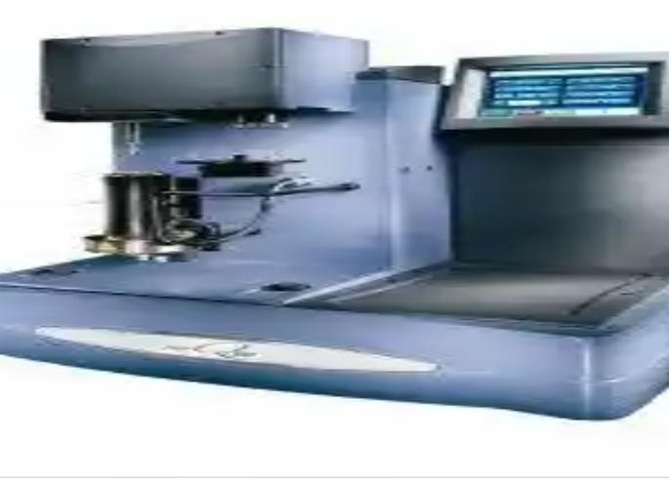

Plate I: Schematic representation of a thermogravimetry analyzing machine (TGA)

Scanning electron microscopy (SEM) analysis

The machined samples were placed and positioned on the stage in the chamber of the microscope before a vacuum was created in the chamber via a series of pumps. Scan coils control the position of the electron beam above the objective lens. These coils allow for the beam to scan across the surface of the sample, enabling information about a defined area collated. The pictorial view is shown in Plate II.

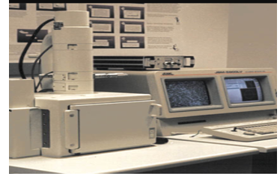

Plate II: Schematic representation of a Scanning Electron Microscopy (SEM)

The interaction between the samples and the electron creates a number of signals in the form of secondary electrons, backscattered electrons, and characteristic X-rays which are then detected. The detector then creates images which are displayed on the computer. This process is repeated for other samples and results are presented accordingly.

X-ray diffractometer (XRD) analysis

The crystalline phases present in the samples were identified in the Shell Laboratory of Mechanical Engineering Department, Ahmadu Bello University, Zaria, using a Rigako Miniflex 300 machine. The samples were made into powder and the powder accumulated on a double-stick tape attached to a glass. The accumulated samples were exposed to an X-ray generator running at 25 kV. The 2Ɵ angle for the machine ranges from 5o to 80o and was used to identify the phases present by comparing the measured d-spacing in the diffraction pattern and shown in Plate III.

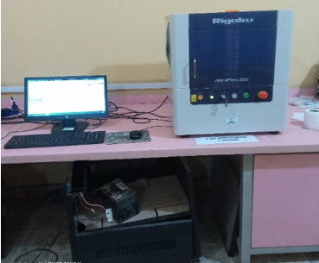

Plate III: Schematic representation of a Scanning Electron Microscopy (SEM)

Results and discussion

Variation of thermal analysis with heat treatment of Al-7.5%Si-0.45%Mg alloy

Thermogravimetric analysis curves of non heat-treated and heat-treated Al-7.5%Si-0.45%Mg alloy with varying ageing time is shown in Figures 1-4 respectively. Thermogravimetric study of the alloy helps us to determine how stable and potent the heat treatment done to the alloy will be over time. In the TGA for the control samples i.e. Figure 1, the first degradation was observed at 100.94oC, the second degradation at 345.90oC while the third degradation occurred at 641.89oC.

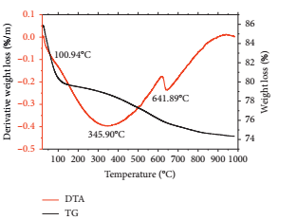

Fig. 1 TGA/DTA curves showing the degradation pattern of the control Al-7.5%Si-0.45%Mg alloy

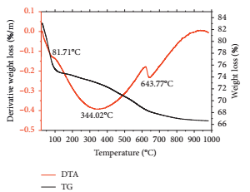

Fig. 2 TGA/DTA curves showing the degradation pattern of the heat-treated Al-7.5%Si-0.45%Mg alloy after 1 hour of ageing time.

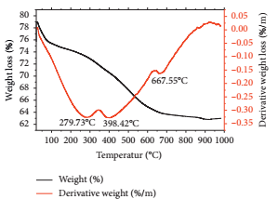

Fig. 3 TGA/DTA curves showing the degradation pattern of the heat-treated Al-7.5%Si-0.45%Mg alloy after 3hrs of ageing time

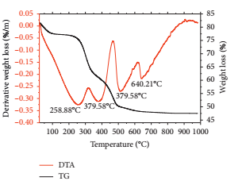

Fig. 4 TGA/DTA curves showing the degradation pattern of the heat-treated Al-7.5%Si-0.45%Mg alloy after 5hrs of ageing time.

After 1 hour of ageing, the first degradation occurred at 81.71°C, the second one occurred at 344.02°C, while the third degradation is at 643.77°C, as shown in Figure 2. Abdulwahab et al. [27] and Umaru et al. [28] have observed that at the onset of heat treatment, precipitates are nucleated which are yet to be fully grown which was observed in this study. Therefore, the first degradation for the control sample and samples heat treated after 1 hour occurred at about the same temperature, which was as a result of the nucleation of precipitates. In another study, Abdulwahab et al. [29] discovered that these precipitates nucleated also in the control samples which is possible as a result of natural ageing on the material. The percentage loss in the first and second degradation for the control sample was 6 and 5% respectively. For heat treatment after 1 hours of ageing time, 8.5% weight loss was recorded in the first degradation, while 6.5% weight loss was recorded in the second degradation. The similarities in the degradation patterns of control samples and samples heat treated at 1 hours of ageing was the formation of precipitates which occurred from 100°C for the control samples to 87.17°C after 1 hours of ageing.

The first, second, and third degradations after 3 hours of ageing occurred at 279.73, 398.42, and 667.55°C, respectively with a weight loss of 3.5, 10.0, and 2.5% (Figure 3). For heat treatment after 5 hours of ageing, the first degradation occurred at 258.88°C, whereas the second degradation occurred twice at 379.58°C and the third at 640.21°C (Figure 4). The weight loss in the heat treatment after 3 hours was 4.5, 18.5, and 8%, respectively for the first, second, and third degradation. Initially, precipitates occurred in the control samples at 100°C. However, the presence of the heat treatment in the alloy have led to the formation of harder surface as a result of the formation of more uniform precipitates, which tend to slow the movement of dislocation in the material, thereby hardening its surface.

Figures 1-4 confirmed that the degradation of this alloy were very similar and occurred at a steady rate. The curve for Figures 3 and 4 showed that degradation occurred at a slow pace compared with Figures 1 and 2. The curve for heat treated samples showed a gradual degradation, whereas the curve for the control sample showed a fast and sharp irregular degradation pattern. The results indicate that the presence of the heat treatment increases the thermal stability of the precipitates formed.

Examination of the morphology and phases of the control and heat-treated Al-7.5%Si-0.45% Mg alloy

The SEM microstructure of the non-heat treated and heat-treated Al-7.5%Si-0.45%Mg alloy is shown in Plates (IV-VII).

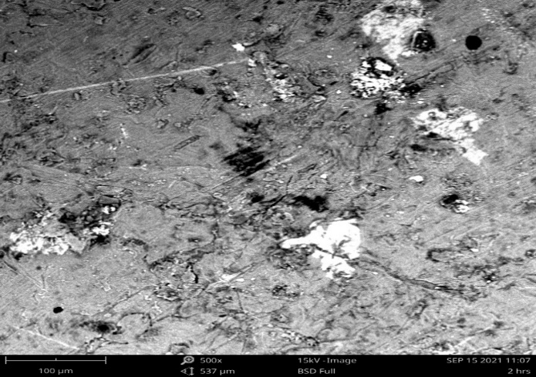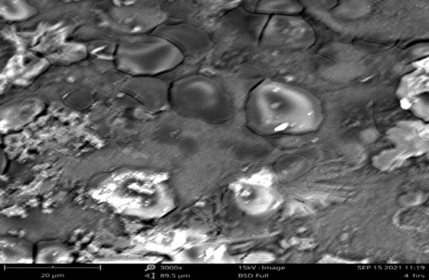

Plate IV: SEM /EDX Analysis of control Plate V: SEM /EDX Analysis of Al-7.5%Si-

sample (Al-7.5%Si-0.45%Mg) alloy. 0.45%Mg sample after 1 hour of ageing time.

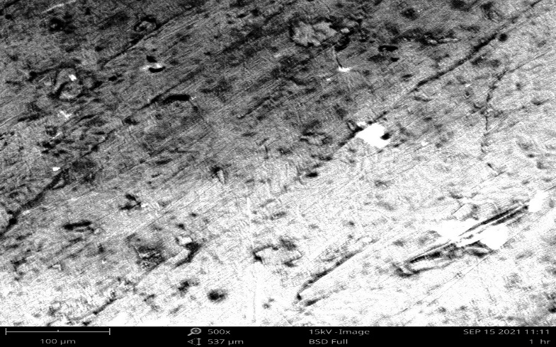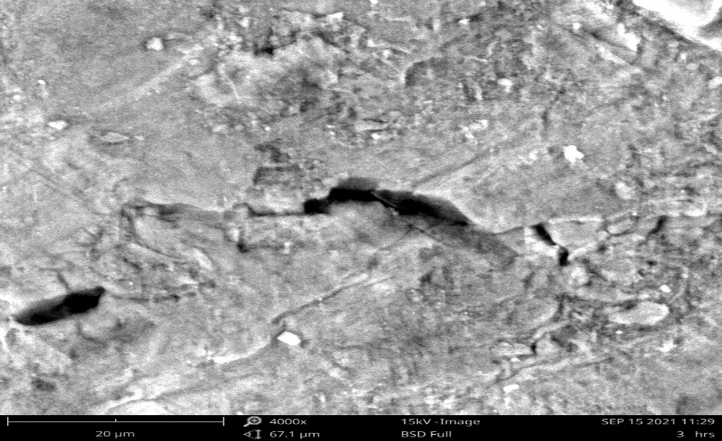

Plate VI: SEM /EDX Analysis of Al-7.5%Si- Plate VII: SEM /EDX Analysis of Al-7.5%Si-

0.45%Mg sample after 3 hours of ageing time 0.45%Mg sample after 5 hour of ageing time

The SEM analysis show the formation of the precipitates in the matrix of the alloy. For the control samples, there is more thermal degradation on the material (Plate IV), which reveal the fact that the precipitates have not been formed in the matrix which is similar to the report of Kliauga et al. [30]. With increasing ageing time, more intermetallic phases of Al9Si, Al8Mg3FeSi6, Mg2Si and other strengthening phases are observed, which have reduced the dehydration of the heat-treated alloy as shown in the thermal property determination using DTA analysis and similar to the report in Umaru et al. [28].

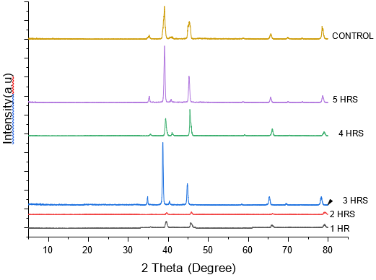

Fig. 5 Superimposed XRD pattern of Al-7.5%Si-0.45%Mg alloy (control and samples heat treated at 1-5 hours of ageing)

The precipitates discussed in this study have been identified in the XRD analysis presented in Figure 5. The XRD show similar peaks which differ in their intensity level. Abdulwahab et al. [31] in his study confirmed the presence of seven peaks which indicated 2Ɵ values at 35, 38, 40, 45, 65, 69 and 78 which is also similar to this study. These peaks show the presence of Al9Si, AlFeMg3Si6, Al8FeMg3Si6, Al12Mg17, CrFe4, Al9Si, Al8Cr5, Mg2Si and Al15(Mn, Fe)3Si2 strengthening phases. The XRD scan have shown similar peaks for the control and heat-treated alloy which have been reported to be as a result of using the same alloy.

Conclusions

From the discussions made, the following conclusions can be drawn

1. The chill cast aluminum alloy was produced using 7.5% Silicon, 0.45% Magnesium and 92.05% Aluminium and machined to standard test samples for thermal and microstructural analysis.
2. The heat treatment was done on the alloy, and thermal analysis performed showed that precipitates were formed in the heat-treated samples which led to the formation of harder surfaces thereby slowing the movement of dislocation and improving the thermal condition of the material.
3. SEM microstructural analysis performed show the formation of precipitates of Al9Si, Al8Mg3FeSi6, Mg2Si and other strengthening phases observed, which reduced the dehydration of the alloy. The XRD study further identified seven peaks corresponding to the precipitates formed in the SEM analysis discussed.

List of Abbreviations

Al-7.5%Si-0.45%Mg Aluminium-7.5 percent silicon-0.45 percent magnesium

DSC Differential scanning calorimetry

TGA Thermogravimetric analysis

SEM Scanning electron microscopy

XRD X-ray differactometry

Si Silicon

Al-Si-Mg Aluminium-Silicon-Magnesium

α-Al Primary aluminium

Mg Magnesium

DFZ Dispersoids free zones

ECAE Equal channel angular extrusion

GP Guinier–Preston

Cr Chromium

SDAS Secondary dendrite arm spacing

Mn Manganese

Mg2Si Magnesium silicate

NOCACO Northern cable company

Declarations

Availability of data and material  
Data sharing is not applicable to this article as no datasets were generated or analyzed during the current study.

Competing interests  
The authors declare that there are no competing interests in this study.

Funding  
No funding was received for conducting this study.

Authors’ contributions  
The four authors UOB, MH, MDA and GNJ all made substantial contributions in realizing this manuscript. All authors read and approved this submission.

Acknowledgements  
Not applicable.

References

1. Roy MJ, Maijer LD (2012) Constitutive behavior of as-cast A356. Mater. Sci. Eng. A. 548: 195–205.

2. Remoe MS, Marthinsen IK, Westermann K, Pedersen J. and Røyset CM (2017) The effect of alloying elements on the ductility of Al-Mg-Si alloys. Mater. Sci. Eng. A. 693: 60–72.

3. Xiao Q, Liu HQ, Yi DQ, Yin D, Chen Y, Zhang Y, Wang B (2017) Effect of Cu content on precipitation and age-hardening behavior in Al-Mg-Si-xCu alloys. J. Alloys Compd. 695: 1005–1013.

4. Liao HC, Wu Y.N, Zhou KX, Yang J (2015) Hot deformation behavior and processing map of Al-Si-Mg alloys containing different amount of silicon based on gleebe-3500 hot compression simulation. Mater. Des. 65: 1091–1099.

5. Immanuel RJ, Panigrahi SK (2015) Influence of cry rolling on microstructure and mechanical properties of a cast hypoeutectic Al–Si alloy. Mater. Sci. Eng. A 640: 424–435.

6. Ding LP, Jia ZL, Zhang ZQ, Sanders RE, Liu Q, Yang G (2015) The natural aging and precipitation hardening behavior of Al-Mg-Si-Cu alloys with different Mg/Si ratios and Cu additions. Mater. Sci. Eng. A. 627: 119–126.

7. Zhang DL, Zheng LH, John DH (2002) Effect of a short solution treatment time on microstructure and mechanical properties of modified Al-7wt.% Si-0.3 wt.% Mg alloy. J. Light Metals. 2: 27–36.

8. Timelli G, Lohne OL, Arnberg H, Laukli I (2008) Effect of solution heat treatments on the microstructure and mechanical properties of a die-cast Al-Si-7Mg-Mn alloy. Metall. Mater. Trans. A 39: 1747–1758.

9. Long HC, Chen JH, Liu CH, Li DZ, Li, YY (2013) The negative effect of solution treatment on the age hardening of A356 alloy. Mater. Sci. Eng. A 566: 112–118.

10. Cai M, Robson JD, Lorimer GW (2007) Simulation and control of dispersoids and dispersoid-free zones during homogenizing an Al-Mg-Si alloy. Scr. Mater. 57: 603–606.

11. Liao HC, Liao YN, Wu KD (2013) Hardening response and precipitation behavior of Al-7%Si-0.3%Mg alloy in a pre-aging process. Mater. Sci. Eng. A 560: 811–816.

12. Dang B, Dang YB, Li F, Liu Q, Zuo MCL (2014) Effect of T4 heat treatment on microstructure and hardness of A356 alloy refined by Ga + In + Sn mixed alloy. Mater. Des. 57: 73–78.

13. Li RX, Li RD, Li YH, Zhao LZ, He CX, Li HR, Guan ZQH (2004) Age-hardening behavior of cast Al-Si base alloy. Mater. Lett. 58: 2096–2101.

14. Colombo MC, Gariboldi E, Morri A (2017) Er addition to Al-Si-Mg-based casting alloy: effects on microstructure, room and high temperature mechanical properties. J. Alloys Compd. 708: 1234 –1244.

15. Tsai YC, Chou CY, Lee SL, Lin CK, Lin JC, Lim SW (2009) Effect of trace La addition on the microstructures and mechanical properties of Al–7Si–0.35Mg aluminum alloys. J. Alloys Compd. 487: 157–162.

16. Riestra MR, Ghassemali E, Bogdanoff T, Seifeddine S (2017) Interactive effects of grain refinement, eutectic modification and solidification rate on tensile properties of Al-10Si alloy. Mater. Sci. Eng. A. 703: 270–279.

17. Hu RH, Ogura T, Tezuka H, Sato T, Liu Q (2019). Dispersoid formation and recrystallization behavior in an Al-Mg-Si-Mn alloy. J. of Mat. Sci. Tech. 26: 237–243.

18. Du QD, Poole WJ, Wells MA, Parson NC (2013) Microstructure evolution during homogenization of Al-Mn-Fe-Si alloys: modeling and experimental results. Acta Mater. 61: 4961–4973.

19. Muggerud AM, Mørtsell EA, Li Y, Holmestad R (2013) Dispersoid strengthening in AA3xxx alloys with varying Mn and Si content during annealing at low temperatures. Mater. Sci. Eng. A 567: 21–28.

20. Li YJ, Muggerud AMF, Olsen A, Furu T (2012) Precipitation of partially Coherent α -Al (Mn, Fe) Si dispersoids and their strengthening effect in AA 3003 alloy. Acta Mater. 60: 1004–1014.

21. Ding XP, Cui H, Zhang JX, Li HX, Guo MX, Lin Z, Zhuang LZJ, Zhang S (2015) The effect of Zn on the age hardening response in an Al–Mg–Si alloy. Mater. Des. 65: 1229-1235.

22. Siddiqui RA, Abdullah HA, Al-Belushi KR (2000) Influence of ageing parameters on the mechanical properties of 6063 aluminium alloys. J. of Mat. Proc. Tech. 102: 234-240.

23. Panigrahia SK, Jayaganthan R (2011) Influence of solutes and second phase particles on work hardening behavior of Al 6063 alloy processed by cryorolling. Mater. Sci. Eng. A. 528: 3147- 3160.

24. Rosso M (2005) The influence of casting process on quality and performances on Al based automotive components. In proceedings of the 13th international scientific conference on achievements in mechanical and materials engineering. Gliwice-Wista, Poland. 547–550.

25. Askeland DR, Phule PP (2003) The science and engineering of materials. 4th ed. Thomson brooks: Pacific Grove, CA, USA, 373, 374.

26. Fridlyander IN, Sister VG, Grushko OE, Berstenev VV, Sheveleva LM, Ivanova LA (2002) Aluminum alloys: promising materials in the automotive industry. Met. Sci. Heat Treat. 44: 365–370.

27. Abdulwahab M, Umaru OB, Bawa MA, Adams SM, Fatai SB (2017) Wear behaviour of Al/15% mellon shell ash particulate composite. Nig. Res. J. of Engg. and Env. Sci. 2(1): 108-114.

28. Umaru OB, Jatau J, Muhammad M, Tokan A (2019) Conditioning the heat treatment of A356 aluminium alloy and validation of wear rate for break disc application. Inter. J. of Eng. Res. and Tech. 8(11): 12-21.

29. Abdulwahab M, Popoola, API (2011) Effect of multiple-step thermal ageing treatment on the hardness characteristics of A356.0-type Al-Si-Mg alloy*.* Mat. and des. A. 32(3): 1159-1166.

30. Kliauga AM, Vieira AP, Ferrante M (2008) The influence of impurity level and tin addition on the ageing heat treatment of the 356-class alloy. [Mat. Sci. and Eng. A](https://www.researchgate.net/journal/Materials-Science-and-Engineering-A-0921-5093) 480 (12): 5-16.

31. Abdulwahab M, Madugu IA, Yaro SA (2012) Effects of temper conditions and step-quenching-ageing on the hardness characteristics and yield strength of A356.0-type Al-Si-Mg alloy. Silicon 4: 137–14.